Neoplastic Myocarditis as a Manifestation of Bronchogenic Carcinoma
ABSTRACT :
Background :
Myopericarditis, an inflammatory syndrome involving both the myocardium and pericardium, is typically idiopathic or viral in origin. Neoplastic causes are rare but should be considered in the presence of atypical features or systemic signs.
Case Summary :
We report the case of a 50-year-old male, chronic smoker, admitted to the intensive cardiac care unit for hemodynamically significant pericardial effusion. Initial work-up revealed an inflammatory syndrome, myocardial injury with elevated troponin, and large circumferential pericardial effusion. Pericardial drainage yielded hemorrhagic exudate, with cytological analysis identifying malignant adenocarcinoma cells. Imaging studies showed suspicious pulmonary and hepatic lesions, and cardiac MRI confirmed myocarditis. Coronary angiography ruled out ischemia. The patient was diagnosed with myopericarditis secondary to lung adenocarcinoma and referred for oncological management.
Discussion :
This case illustrates a rare presentation of lung cancer manifesting initially as myopericarditis with pericardial tamponade. Cardiac involvement in malignancy may result from direct invasion, lymphatic spread, or paraneoplastic mechanisms. Cardiac MRI and cytological analysis of pericardial fluid were pivotal in the diagnostic process. Early recognition of neoplastic myopericarditis is essential for prompt oncological referral and tailored management.
Conclusion :
Clinicians should consider malignancy in the differential diagnosis of myopericarditis, particularly in the presence of hemorrhagic effusion or systemic signs. Cardiac MRI and pericardial fluid analysis remain essential diagnostic tools in such contexts.

KEYWORDS :
Myopericarditis, Lung Adenocarcinoma, Cardiac MRI, Heart Failure, Pericardial Effusion, Troponin, Coronary Angiography.

INTRODUCTION :
Acute myocarditis and pericaditis are usually accompanied, each disease has some degree of involvement which is charactized by pericadial effusion associated to an elevation of cardiac troponins [1]. “They share common etiologic agents and a spectrum of myopericardial inflammatory syndromes.The term “myopericarditis” indicates a primarily “pericarditic syndrome” and it is responsible for the majority of cases encountered in clinical practice while "perimyocarditis" is a primary myocarditic disease ” [2]. But pratically, the two terms are often used interchangeably without a specific reference to the predominant type of cardiac involvement.

Case presentation :

We present the case of a 50-year-old patient who was admitted to the Cardiology Department of Ibn Rochd Unversity Hospital, Casablanca, in the cardiology intensive care unit for management of a pre-tamponnade.

The patient had no particular pathological antecedents, apart from active smoking (40 packs.year).

His history of illness dates back 3 weeks prior to admission, with the onset of aggravating dyspnea associated with cough, all evolving in a context of altered general condition.

On admission, the patient was conscious, oriented, dyspneic at rest and hemodynamically stable, with no signs of peripheral hypoperfusion. Cardiovascular and pleuropulmonary examinations were unremarkable, with no signs of left or right heart failure.

The electrocardiogram showed regular sinus tachycardia at 120 bpm, with no rhythm, conduction or repolarization disturbances consistent with ischemia.

Biological tests revealed anemia at 10.3 g/dl, normocytic with mean corpuscular volumeat 84.5 fl, thrombocytosis at 364,000/l and normal leukocytes at 9,400/l. Troponin levels were negative initially, but became positive at follow-up, reaching 3,500 ng/l. A hepatic cholestasis syndrome with alkaline phosphatase at 150 IU/l, Gamma-Glutamyl Transferase at 177 IU/l, and hepatic cytolysis with Aspartate Aminotransferase at 900 IU/l, Alanine Aminotransferaseat 720 IU/l, normal bilirubin at 6 umol/l. Inflamatory syndrome with C-Reactive Protein at 210 mg/l. Blood ionogram, renal function, Brain natriuretic protein level and haemostasis were all normal.

A thoracoabdomino-pelvic CT scan revealed a large pericardial effusion with multiple suspicious nodular lesions of the left upper lobe and supra-centimetric necrotic mediastinal and subclavicular adenopathies, as well as moderate hepatomegaly with multiple suspicious hepatic nodules and no suspicious bone lesions. (Figures 1-5)

An echocardiogram performed in the emergency department revealed a large pericardial effusion measured at 33 mm subcostally and circumferential, with a dilated inferior vena cava and collapsed left atrium. (Figures 6-8)

In view of the pericardial effusion, the patient was transferred to the Cardiology ICU for further management.

Transthoracic echocardiography in the ICU reveals :
Non-dilated, non-hypertrophic left ventricle with preserved LVEF.
No significant aortic or mitral valve disease.
Circumferential pericardial effusion measured at 2 cm latero LV, 3 cm subcostally with RA and RV notch.
Inferior vena cava dilated to 3 cm, poorly perfused

The patient subsequently underwent subxiphoid pericardial drainage, with removal of 500 ml of hematic fluid immediately after insertion. The drain was maintained for 3 days, with evacuation of a further 1 liter, prior to removal.

Subsequent ultrasonographic examinations revealed a marked improvement in the pericardial effusion, which had become small without recurrence. On the other hand, severe LV dysfunction of 30% was discovered.

An etiological work-up was then carried out:

A biochemical study of the pericardial effusion revealed an exudative fluid, while a cytological study revealed multiple large irregular adenocarninomatous cells. Anatomical pathology confirmed the presence of cells suspicious of small-cell carcinoma. The bacteriological study was negative.

With regard to left ventricular dysfunction, and in light of the elevated troponin levels, a coronary angiogram was performed and returned normal (Figures 9-12). A cardiac MRI was then ordered, revealing myopericarditis extending to the anterior wall and interventricular septum, with global hypokinesia predominating in the anterior wall, and left ventricular dysfunction with LVEF at 44% (Figures 13-16).

We confirmed myopericarditis, but first suggested a neoplastic origin given the context.

The patient was then put on heart failure treatment with DAPAGLIFLOZINE, BISOPROLOL and SACCUBITRIL/VALSARTAN, as well as COLCHICIN for the pericardial effusion.

Given the strong suspicion of a neoplastic origin, the patient was transferred to the Pneumology Department for further management, including bronchoscopy and mediastinal adenopathy biopsy.

DISCUSSION :

The myopericarditis is a pericarditic syndrome associated to a variable degree of myocardial involvement. In clinical practice, it refers to a mixed inflammatory myocardial and pericardial involvement.

Given our patient’s context of malignancy associated with confirmed myopericarditis, we have linked these two conditions, especially with the confirmation of myocarditis by MRI and the absence of an ischemic cause after a normal coronary angiography.

This neoplastic origin could be due to some direct influence of malignant cells within the pericardium or due to some paraneoplastic property of malignancy in general, or some special properties of lung adenocarcinoma in particular. How malignancy might cause such myocardial infl ammation is unknown.

While the direct link of cause and effect cannot be made with certainty, the case should be instructive to other clinicians who encounter similar lifethreatening presentations of cardiac decompensation in malignancy.

Cancer cells can reach the heart by direct extension or through systemic veins, pulmonary veins, or the regional lymphatic system, invading the pericardium/epicardium, the myocardium, the endocardium, or infiltrating the luminal cavity/great veins and the regional lymphatics.

“In reviewing three studies, totaling 4,443 autopsies in patients with malignancy ” [3-5] , the cardiac metastasis prevalences were respectively 9.7, 15.4, and 10.7% with an average of 13.3%.

Amongst those with cardiac metastases, an average of 60% was seen for pericardium/epicardium involvement (77%, 53 and 75, respectively), and an average of 38% was seen for myocardial involvement (19, 42 and 38, respectively).

For the above three series, the percentages of cardiac metastases from lung carcinoma were, respectively, 18, 28 and 20%. Just like in our case, where myocarditis was linked to lung cancer based on the thoracic CT scan results and the analysis of the pericardial fluid.

“Malignancy may be associated with disseminated intravascular coagulation or thrombotic microangiopathy, leading to thromboses of small arterioles. Cardiac involvement may be part of the clinical presentation ” [6] .
“Our patient did not have any evidence of coagulation dysfunction or platelet consumption during the hospitalization. Malignancy may also be complicated with nonbacterial endocarditis ” [7,8] and associated thromboembolism [9] . There was no evidence of transient coronary thromboembolism by a process of nonbacterial endocarditis in our patient not only because there was no evidence of cerebral, renal, dermal, or other organ involvement by thromboembolic processes, but also because serial echocardiographic studies did not identify any microvegetation.

Clinical presentation & diagnosis

Myopericarditis could be subclinical. For the symptomatic cases, we can see systemic manifestations of infection or inflammation, such as fever, myalgias and gastrointestinal symptoms.

Cardiac manifestations include positional or pleuritic chest pain which is the most common symptom may pose a diagnostic problem due to the difficulty to distinguish from ischemic pain, particularly since signs of myocardial involvement can simulate an acute coronary syndrome on ECG as reported in acute myocarditis [10-14]. Dyspnea or palpitations could be also reported.

Laboratory signs of inflammation are common in patients with myopericarditis and include elevations in white blood cell count, erythrocyte sedimentation rate and serum C-reactive protein concentration. Our patient presented an inflamatory syndrom with a high level of CRP.

Cardiac biomarker elevation :
Biomarker elevation is present in a substantial minority of patients presenting with acute pericarditis but it’s mainly associated to the myocarditis side. In a series of patients with acute idiopathic or viral pericarditis, serum cardiac troponin I (cTnI) ≥1.5 μg/l was detected in 8–22% of patients. Coronary angiography was performed in most patients with serum cTnI ≥1.5 μg/l and was normal in all [1]. This argues in favor of a diagnosis of myocarditis associated with pericarditis.
Troponin increase is roughly related to the extent of myocardial inflammatory involvement, and unlike acute coronary syndromes does not seem to carry an adverse prognosis [1,15].

Electrocardiogram :
ECG changes are common in myopericarditis; these changes reflect some degree of epicardial or myocardial involvement since the parietal pericardium is electrically silent.

In a series of 274 patients with acute pericarditis, 40 had myopericarditis as defined by serum troponin I elevation [15]. The following findings occurred significantly more often in the patients with myopericarditis:

• Atypical ECG changes characterized by localized ST elevation (inferolateral or anterolateral) and T-wave inversion before ST-segment normalization (42 vs 21%).
• Cardiac arrhythmias (65 vs 17%) including supraventricular or ventricular ectopic beats, as well as nonsustained ventricular tachycardia.

Our patient presented just a sinusal tachucardia witout any other abnomality.

Echocardiography :
“In patients with myopericarditis, echocardiography often provides more evidence about the pericardial side. Echocardiography enables noninvasive detection of impaired left ventricular systolic function, even when asymptomatic ”. [16,17].
In myopericarditis, left ventricular dysfunction is absent, while it is generally mild, global or segmental in perimyocarditis.

MRI :
“Magnetic resonance imaging (MRI) can delineate a thickened pericardium allowing to measure its thickness. Contrast enhancement may show areas of inflammation, while MRI is superior to echocardiography in defining the nature of the effusion. MRI may also detect myocardial edema and damage in myocarditis. Myocardial inflammatory involvement may be confirmed by CMR ” [18].

Classical CMR imaging for myocarditis includes T2-weighted imaging for assessment of edema, T1-weighted imaging before and after contrast administration for evaluation of hyperemia and assessment of late gadolinium enhancement.
The MRI abnormalities may persist at least one month after the onset of symptoms.

Two studies [19,20] have shown 100% sensitivity and specificity for myocarditis detection by MRI. Overall diagnostic sensitivity was 86% (83 of 96 cases) and specificity was 95% (56 of 59 controls) [21].

“CMR has a major role in the differential diagnosis between myocardial infarction with normal coronary arteries, myocarditis, myopericardial syndromes and pericarditis ” [22,23].

Diagnostic criteria :
“Acute pericarditis is diagnosed by the presence of two or more of the following features:
chest pain, pericardial friction rub, ECG changes (diffuse ST-segment elevation or PR depression) and pericardial effusion. A clinical diagnosis of myopericarditis can be performed in patients with a definite diagnosis of acute pericarditis and elevation of cardiac markers of injury (troponin I or T, creatine kinase- MB [CK-MB] fraction) without new onset of focal or diffuse depressed left ventricular function by echocardiography or cardiac magnetic resonance (CMR). Perimyocarditis may be diagnosed in patients with clinical criteria for acute pericarditis, elevation of cardiac markers of injury, and/or new onset of focal or diffuse depressed left ventricular function by echocardiography or CMR. The rationale for these diagnostic criteria is that pure pericardial or predominant pericardial inflammatory involvement is not characterized by significant impairment of myocardial function and focal or diffuse abnormalities of ventricular wall motion or function that, on the contrary, denote a substantial myocardial inflammatory involvement, and a predominant myocarditic syndrome ”.[37]

“Histopathological confirmation of the presence of myocarditis requires an endomyocardial biopsy it’s the gold standard for the diagnosis of myocarditis but this is usually not performed in patients without a symptomatic left ventricular systolic dysfunction refractory to conventional therapy, or sustained arrhythmias. Given the risks of biopsy and the limited benefits under a therapeutic point of view, it has been suggested to limit the use of endomyocardial biopsy in patients with significant myocardial involvement with left ventricular dysfunction and symptoms not responsive to conventional medical management ” [24,25].

“Furthermore, recently published data have compared the diagnostic performance of CMR imaging compared with endomyocardial biopsy. In 132 patients with suspected acute myocarditis (≤14 days) or chronic myocarditis (defined as symptoms >14 days), the overall diagnostic sensitivity, specificity and accuracy was 76, 54 and 68%, respectively, and was better in the setting of acute cases (81, 71 and 79%, respectively). Thus, in clinical practice, CMR is useful for noninvasive diagnosis especially in patients with recent symptoms onset (<2 weeks) ” [26].

“An alternative approach is based on the use of pericardioscopic guidance in order to enhance pericardial and epimyocardial sampling efficiency ” [27,28].

Therapy & management :
“Either for acute pericarditis or myopericarditis there is a lack for adequate controlled clinical trials. Hospitalization is recommended for diagnosis and monitoring in patients with myocardial involvement ” [1,29].

More recently, published studies on myopericarditis and perimyocarditis [15, 30–32] have described “adopted empirical anti-inflammatory therapies. Aspirin (1000–1500 mg/day as mean doses) or = (ibuprofen 1200 mg/day as mean dose or indomethacin 75 mg/day as mean dose) were prescribed in most cases (>95%) for 7–10 days until symptoms resolution, while corticosteroids were prescribed as a second choice (i.e., prednisone 0.2–0.5 mg/day but up to 1 mg/kg/day for 1–2 weeks until symptoms resolution then gradually tapered) in case of contraindication, intolerance or failure of aspirin/NSAID ”.
“There are insufficient data to recommend the use of colchicine, which is a well-established adjunctive treatment for acute and recurrent pericarditis, although data for pericarditis suggest that it should be considered before corticosteroids to reduce recurrence risk and corticosteroid dependence ” [33].

“Despite the lack of specific therapies for most cases, several nonspecific recommendations are important. Rest and avoidance of physical activity beyond normal sedentary activities is recommended in all patients with myocarditis and myopericarditis ” [34].

Prognosis :
“Few recent observational studies have been published on the outcome of myopericarditis and perimyocarditis ” [14, 30-32]. “In a retrospective pediatric study, 12 patients with myopericarditis were identified out of 880 patients admitted for chest pain in a 10-year period. Despite troponin elevation, the clinical evolution was benign in a short-term follow-up with no reported deaths and normal LV function during a follow-up period ranging from 2 weeks to 3 years ” [31].

“In an Italian prospective study, the 12-month outcome of 40 consecutive cases with myopericarditis was reported to be benign with no deaths and normalization of echocardiographic, electrocardiographic and treadmill testing data in 98% of cases ” [14].

“A subsequent French study on 14 cases of myopericarditis reported 21% mortality (two cases of sudden death and one case of cardiac death due to cardiac tamponade) after 20 months ” [30]. “Conversly, data from the Trieste registry (Italy) on 62 consecutive cases with perimyocarditis showed a relatively benign outcome at 1 year with no deaths and clinical resolution in 95% of cases ” [32].

“Fatal cases have been reported only in case reports with viral infections presenting with prevalent or exclusive myocardial involvement with heart failure signs or symptoms at presentation ” [35-37].

Conclusion
Neoplastic myocarditis remains a rare and often under-recognized cardiac manifestation of malignancy. This case highlights the importance of considering myocardial infiltration in the differential diagnosis of acute myocarditis, particularly in patients without typical viral prodromes or with risk factors for cancer. Early and accurate diagnosis through multimodal imaging and histological confirmation is essential, as it profoundly influences therapeutic strategy and prognosis. Clinicians should maintain a high index of suspicion for neoplastic cardiac involvement when facing atypical clinical presentations, as the heart may be the initial site revealing an otherwise occult malignancy.

TAKE HOME MESSAGES :
- Neoplastic myocarditis is a rare but important differential diagnosis in patients presenting with acute myocarditis-like symptoms, especially in those with cancer risk factors.
- Cardiac involvement may be the first manifestation of an underlying malignancy, including bronchogenic carcinoma.
- Multimodal imaging (echocardiography, cardiac MRI, CT scan) and histological analysis are key to confirming the diagnosis of neoplastic myocardial infiltration.
- Electrocardiographic and biochemical signs (e.g. ST changes, troponin elevation) may mimic acute coronary syndromes or viral myocarditis, delaying diagnosis.
- Early identification of neoplastic myocarditis is crucial for prognosis and may significantly impact therapeutic decision-making.

Ethical Approval:
As per international standards or university standards written ethical approval has been collected and preserved by the author(s).
Consent
As per international standards or university standards, patient(s) written consent has been collected and preserved by the author(s).

ABBREVIATIONS AND ACRONYMS :
CT : Computed Tomography
ICU : Intensive Care Unit
LVEF : Left Ventricular Ejection Fraction
LV : Left Ventricule
RA : Right Atrium
RV : Right Ventricule
MRI : Magnetic Resonance Imaging
ECG : Electrocardiogram
CRP : C-reactive protein
CMR : Cardiovascular Magnetic Resonance
NSAID : Non-Steroidal Anti-Inflammatory Drug

Disclaimer (Artificial intelligence)

Option 1:

Author(s) hereby declare that NO generative AI technologies such as Large Language Models (ChatGPT, COPILOT, etc.) and text-to-image generators have been used during the writing or editing of this manuscript.

Option 2:

Author(s) hereby declare that generative AI technologies such as Large Language Models, etc. have been used during the writing or editing of manuscripts. This explanation will include the name, version, model, and source of the generative AI technology and as well as all input prompts provided to the generative AI technology

Details of the AI usage are given below:
1.
2.
3.

REFERNCES :
- Imazio M, Demichelis B, Cecchi E et al. Cardiac troponin I in acute pericarditis. J. Am. Coll. Cardiol. 42(12), 2144– 148 (2003).

- Spodick DH. Myopericarditis/perimyocarditis. In: The Pericardium. A Comprehensive Textbook. Marcel Dekker, Inc. NY, USA, 114–125 (1997).

- Nakayama R, Yoneyama T, Takatani O, Kimura K: A study of metastatic tumors to the heart, pericardium and great vessels. I. Incidences of metastases to the heart, pericardium and great vessels. Jpn Heart J 1966; 7: 227– 234.

- Mukai K, Shinkai T, Tominaga K, Shimosato Y: The incidence of secondary tumors of the heart and pericardium: a 10-year study. Jpn J Clin Oncol 1988; 18: 195–201.

- Klatt EC, Heitz DR: Cardiac metastases. Cancer 1990; 65: 1456–1459.

- Case records of the Massachusetts General Hospital. Weekly clinicopathological exercises. Case 33–1994. A 41-year-old woman with thrombocytopenia, anemia, and sudden death. N Engl J Med 1994; 331: 661–667.

- Deppisch LM, Fayemi AO: Non-bacterial thrombotic endocarditis: clinicopathologic correlations. Am Heart J 1976; 92: 723–729.

- Lopez JA, Ross RS, Fishbein MC, Siegel RJ: Nonbacterial thrombotic endocarditis: a review. Am Heart J 1987; 113: 773–784.

- Case records of the Massachusetts General Hospital: Weekly clinicopathological exercises. Case 28–1997. A 67-year-old woman with increasing neurologic defi cits and a history of breast and ovarian cancer. N Engl J Med 1997; 337: 770–777.

- Dec Jr GW,Waldman H, Southern J, Fallon JT, Hutter Jr AM, Palacios I. Viral myocarditis mimicking acute myocardial infarction. J Am Coll Cardiol 1992;20:85–9.

- Sarda L, Colin P, Boccara F, et al. Myocarditis in patients with clinical presentation of myocardial infarction and normal coronary angiograms. J Am Coll Cardiol 2001;37:786–92.

- Miklozek CL, Crumpacker CS, Royal HD, Come PC, Sullivan JL, Abelmann WH. Myocarditis presenting as acute myocardial infarction. Am Heart J 1988;115:768–76.

- Angelini A, Calzolari V, Calabrese F, et al. Myocarditis mimicking acute myocardial infarction: role of endomyocardial biopsy in the differential diagnosis. Heart 2000;84:245–50.

- Karjalainen J, Heikkila J. Incidence of three presentations of acute myocarditis in young men in military service. A 20-year experience. Eur Heart J 1999;20:1120–5.

- Imazio M, Cecchi E, Demichelis B, et al. Myopericarditis versus viral or idiopathic acute pericarditis. Frequency, clinical clues to diagnosis, and prognosis. Heart 2007 [Electronic publication ahead of print].

- Nieminen MS, Heikkila J, Karjalainen J. Echocardiography in acute infectious myocarditis: relation to clinical and electrocardiographic findings. Am J Cardiol 1984;53:1331–7.

- Pinamonti B, Alberti E, Cigalotto A, et al. Echocardiographic findings in myocarditis. Am J Cardiol 1988;62:285–91.

- Friedrich MG, Sechtem U, Schulz-Menger J et al.; International Consensus Group on Cardiovascular Magnetic Resonance in Myocarditis. Cardiovascular magnetic resonance in myocarditis: a JACC White Paper. J. Am. Coll. Cardiol. 53(17), 1475–1487 (2009).

- Gagliardi MG, Bevilacqua M, Di Renzi P, Picardo S, Passariello R, Marcelletti C. Usefulness of magnetic resonance imaging for diagnosis of acute myocarditis in infants and children, and comparison with endomyocardial biopsy. Am J Cardiol 1991;68:1089–91.

- Friedrich MG, Strohm O, Schulz-Menger J, Marciniak H, Luft FC, Dietz R. Contrast media-enhanced magnetic resonance imaging visualizes myocardial changes in the course of viral myocarditis. Circulation 1998;97:1802–9.

- Roditi GH, Hartnell GG, Cohen MC. MRI changes in myocarditis — evaluation with spin echo, cine MR angiography and contrast enhanced spin echo imaging. Clin Radiol 2000;55:752–8.

- Kim EY, Chang SA, Lee YK, Choi JO, Choe YH. Early non-invasive diagnosis and treatment of acute eosinophilic myopericarditis by cardiac magnetic resonance. J. Korean Med. Sci. 26(11), 1522–1526 (2011).

- Stensaeth KH, Fossum E, Hoffmann P, Mangschau A, Klow NE. Clinical characteristics and role of early cardiac magnetic resonance imaging in patients with suspected ST-elevation myocardial infarction and normal coronary arteries. Int. J. Cardiovasc. Imaging 27(3), 355–365 (2011).

- Cassimatis DC, Atwood JE, Engler RM, Linz PE, Grabenstein JD, Vernalis MN. Smallpox vaccination and myopericarditis: a clinical review. J Am Coll Cardiol 2004;43:1503–10.

- Magnani JW, Dec GW. Myocarditis: current trends in diagnosis and treatment. Circulation 2006;113:876–90.

- Lurz P, Eitel I, Adam J et al. Diagnostic performance of CMR imaging compared with EMB in patients with suspected myocarditis. JACC Cardiovasc. Imaging 5(5), 513–524 (2012).

- Maisch B, Ristic A. Practical aspects of the management of pericardial disease. Heart 2003;89:1096–103.

- Seferovic PM, Ristic AD, Maksimovic R, et al. Diagnostic value of pericardial biopsy: improvement with extensive sampling enabled by pericardioscopy. Circulation 2003;107:978–83.

- Imazio M, Trinchero R. Myopericarditis: etiology, management, and prognosis. Int. J. Cardiol. 127(1), 17–26 (2008).

- Machado S, Roubille F, Gahide G et al. Can troponin elevation predict worse prognosis in patients with acute pericarditis? Ann. Cardiol. Angeiol. (Paris) 59(1), 1–7 (2010).

- Kobayashi D, Aggarwal S, Kheiwa A, Shah N. Myopericarditis in children: elevated troponin I level does not predict outcome. Pediatr. Cardiol. 33(7), 1040–1045 (2012).

- Buiatti A, Merlo M, Pinamonti B, De Biasio M, Bussani R, Sinagra G. Clinical presentation and long-term follow-up of perimyocarditis. J. Cardiovasc. Med. (Hagerstown) doi:10.1714/1188.13164 (2012) (Epub ahead of print).

- Imazio M, Brucato A, Forno D et al. Efficacy and safety of colchicine for pericarditis prevention. Systematic review and meta-analysis. Heart 98(14), 1078–1082 (2012).

- Martin M, Le W, Marc D, Tischler. Pericardial diseases. In: Brauwald’s Heart Diseases. A Textbook of Cardiovascular Medicine. (9th Edition). Saunders/Elsevier, PA, USA (2012).

- Davoudi AR, Maleki AR, Beykmohammadi AR, Tayebi A. Fulminant myopericarditis in an immunocompetent adult due to pandemic 2009 (H1N1) influenza A virus infection. Scand. J. Infect. Dis. 44(6), 470–472 (2012).

- Puzelli S, Buonaguro FM, Facchini M et al.; Surveillance Group for Pandemic H1N1 2009 Influenza Virus in Italy; Campania H1N1 Task Force. Cardiac tamponade and heart failure due to myopericarditis as a presentation of infection with the pandemic H1N1 2009 influenza A virus. J. Clin. Microbiol. 48(6), 2298–2300 (2010).

- Imazio, M., & Cooper, L. T. (2013). Management of myopericarditis. Expert review of cardiovascular therapy, 11(2), 193-201.

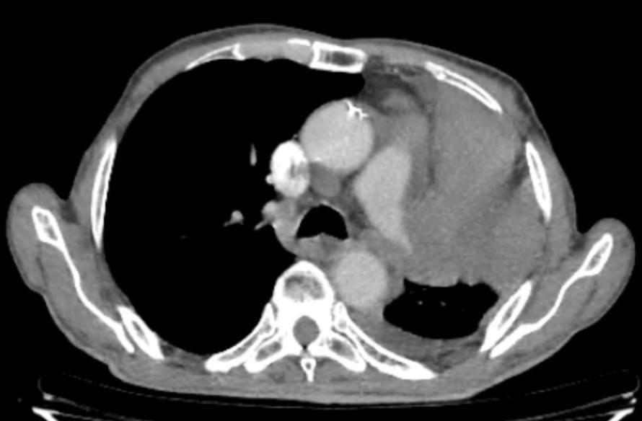
Fig.1 : Thoracoabdomino-pelvic CT scan

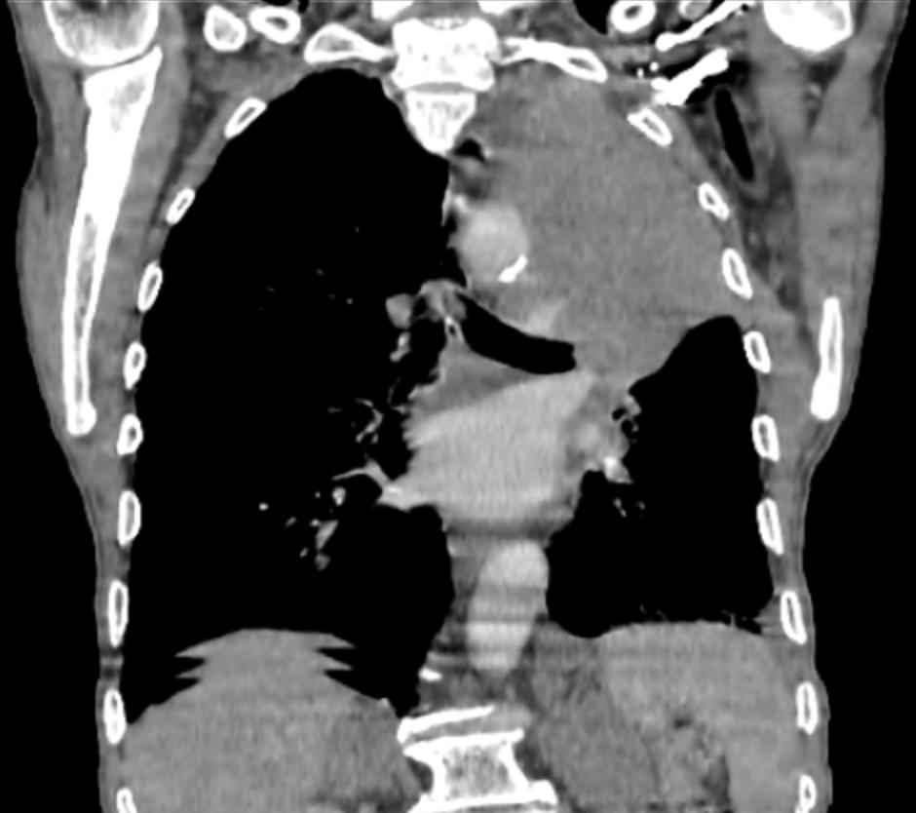

Fig .2 Thoracoabdomino-pelvic CT scan
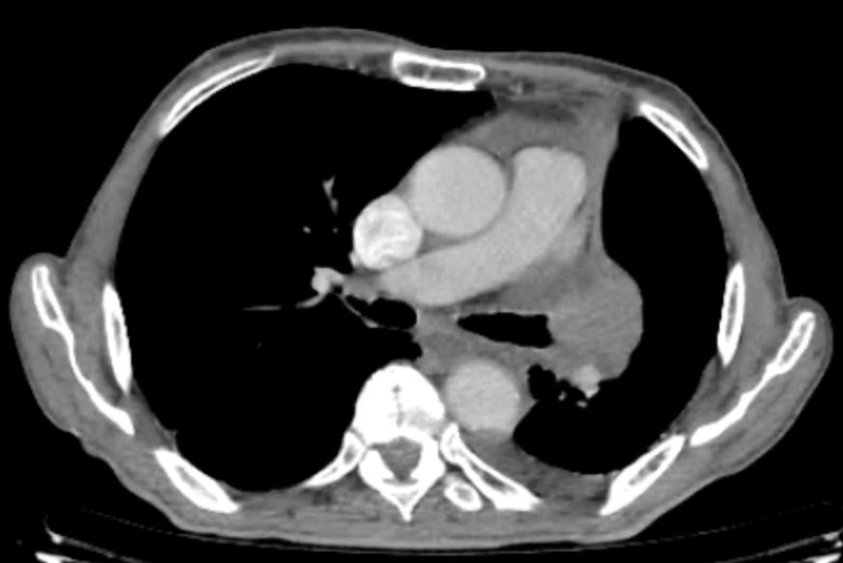
Fig .3 Thoracoabdomino-pelvic CT scan

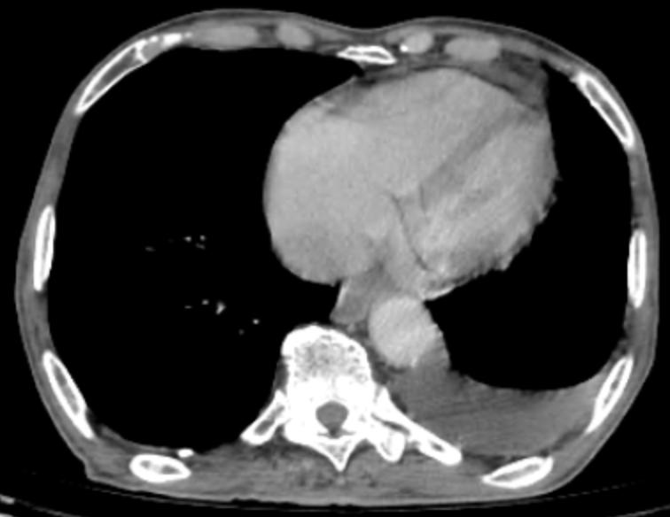
Fig.4 Thoracoabdomino-pelvic CT scan

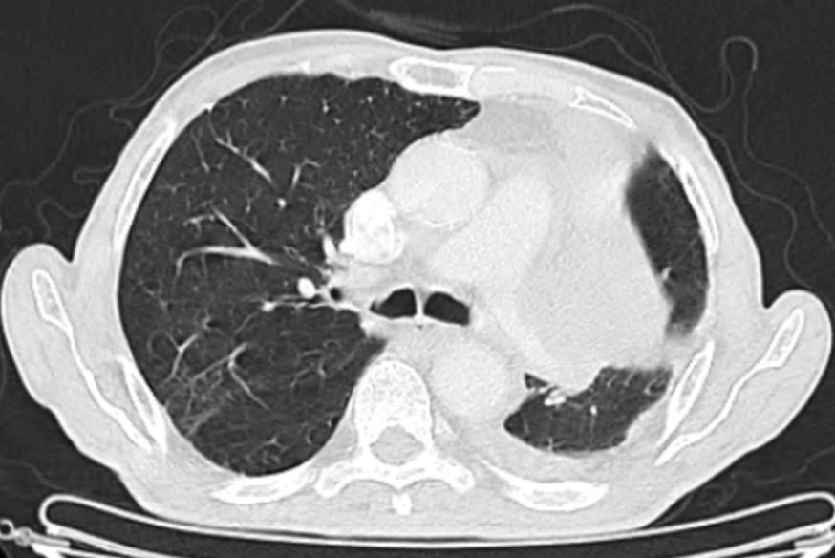
Fig.5 Thoracoabdomino-pelvic CT scan
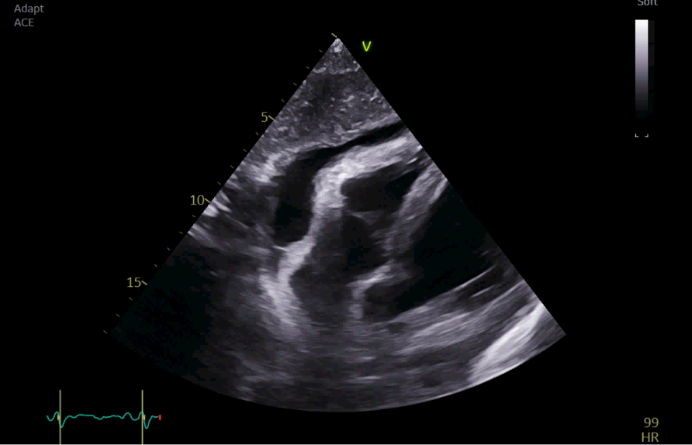
Fig .6 Echocardiogram view
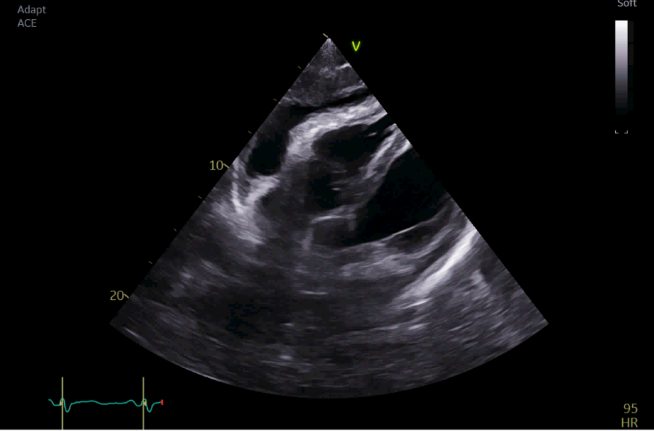
Fig. 7 Echocardiogram view
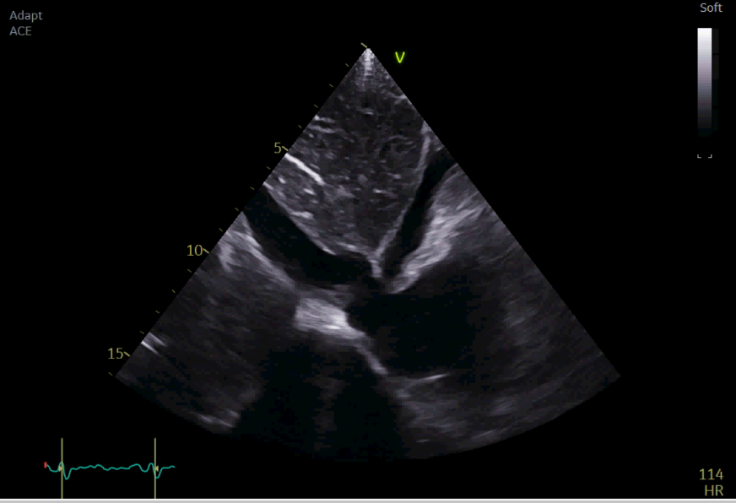
Fig .8 Echocardiogram view

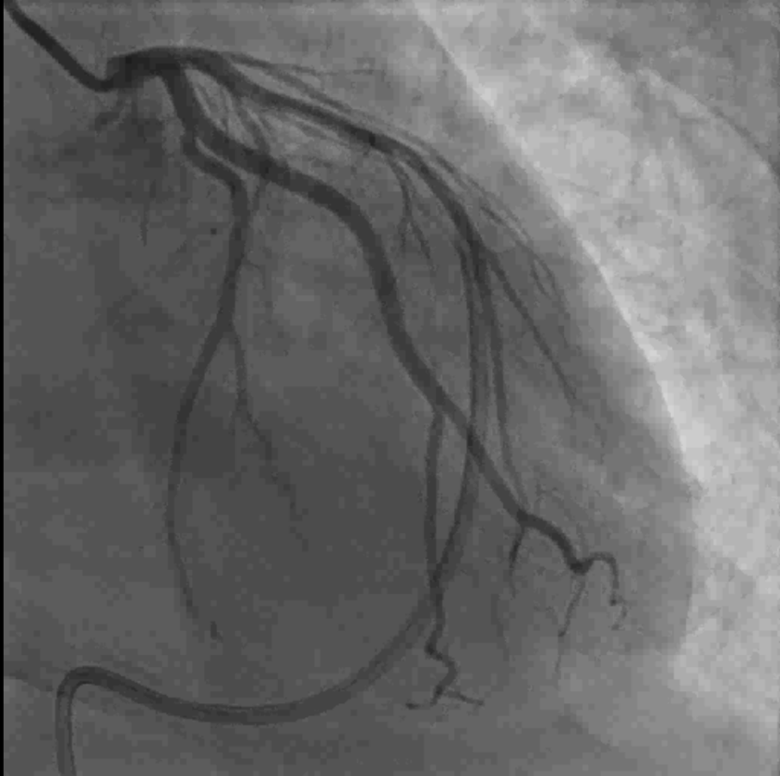

Fig. 9 Coronary angiogram was performed due to left ventricular dysfunction
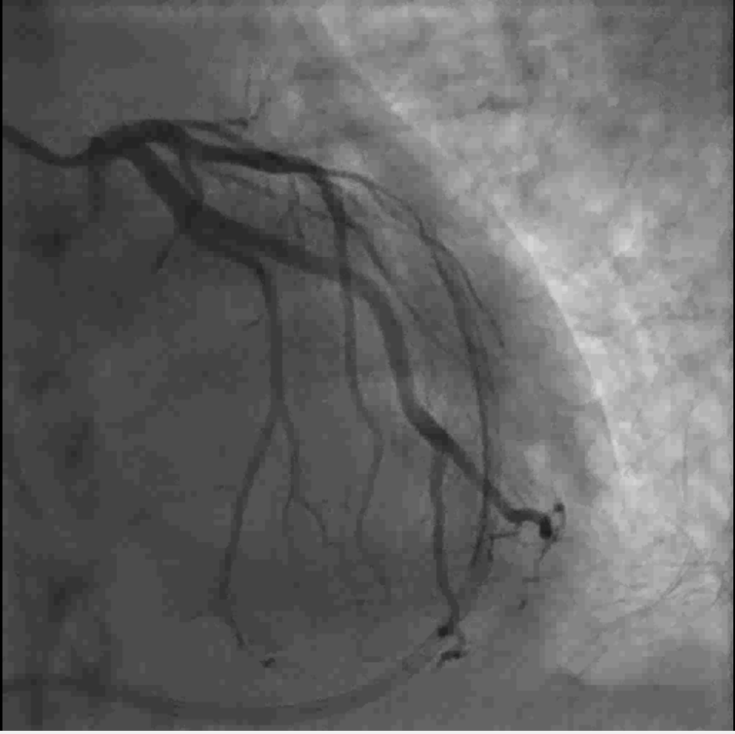
Fig .10 Coronary angiogram was performed due to left ventricular dysfunction
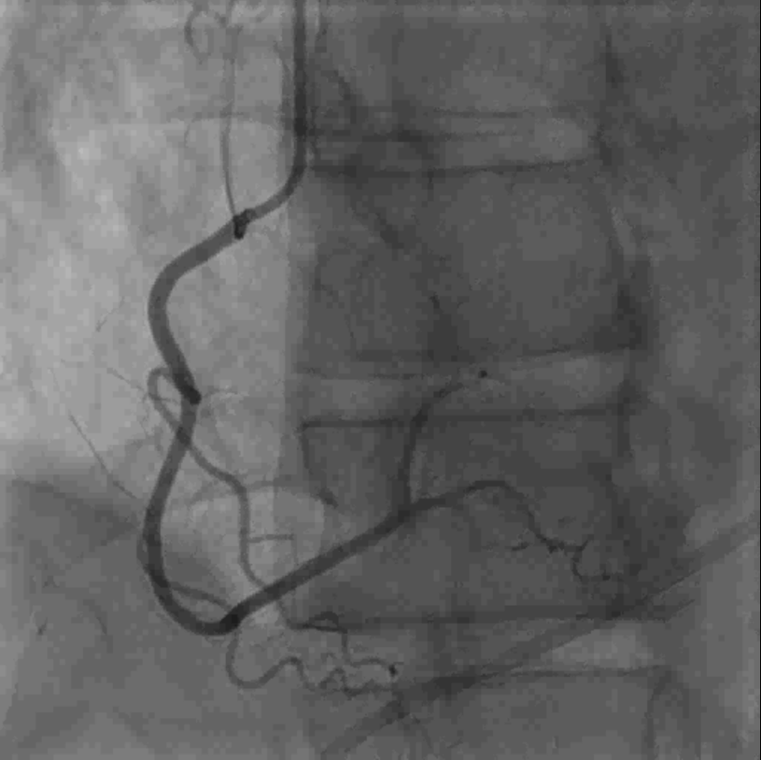
Fig .11 Coronary angiogram was performed due to left ventricular dysfunction
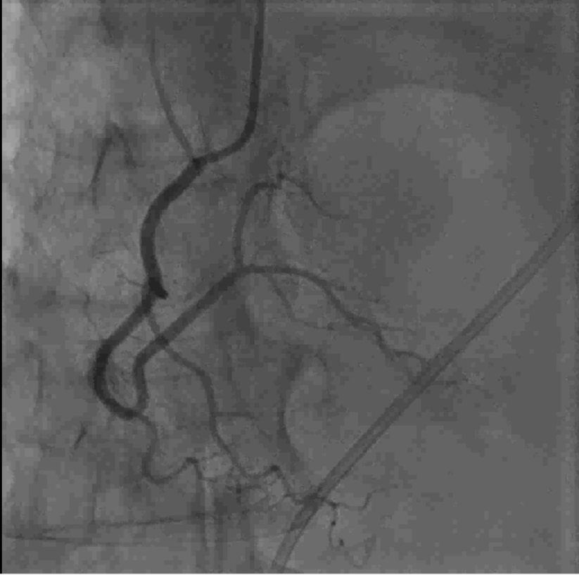

Fig .12 Coronary angiogram was performed due to left ventricular dysfunction
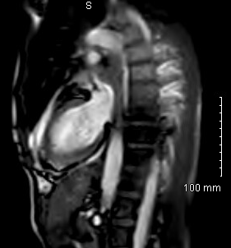
Fig.13 Cardiac MRI View
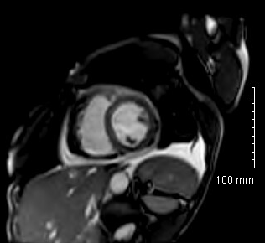
Fig.14 Cardiac MRI View
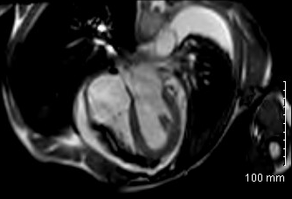
Fig .15 Cardiac MRI View

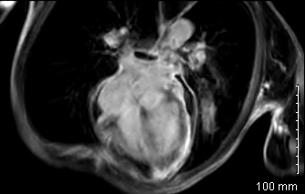
Fig.16 Cardiac MRI View

