**Left ventricular non-compaction cardiomyopathy among patients at the Bogodogo University Hospital**

# Abstract

**Introduction:** Left ventricular non-compaction (LVNC) is a rare congenital cardiomyopathy characterised by the presence of deep trabeculations and intertrabecular recesses in the left ventricle. The aims of this study is to describe the epidemiological, clinical, paraclinical, therapeutic and evolutionary aspects of NCVG at Bogodogo University Hospital.

**Patients and method:** This was a descriptive cross-sectional study conducted in the cardiology department of the Bogodogo University Hospital Center from March 2017 to March 2024. All patients hospitalised for non-compaction of the left ventricle (NCVG) were included. The various parameters identified were epidemiological, clinical, paraclinical, therapeutic and evolutionary including the outcomes.

**Results:** During the study period, we systematically collected data from six patients, including 4 women and 2 men**.** The prevalence of HNV in our study was 0,01% of all patients. The mean age of our patients was 35.83 ± 5 years. All patients were admitted with heart failure. The rhythm disorders found were atrial fibrillation and ventricular tachycardia in two patients. In all patients, the ratio of non-compacted area to compacted area was greater than 2. Only one patient had undergone Cardiac Magnetic Resonance Imaging (MRI). Diuretics were used in 80% of patients. Only one patient died.

**Conclusion:** LVNC is a cardiomyopathy that is under-diagnosed in our context. Improvements in paraclinical investigations in recent years would make it possible to better study the prevalence of this pathology.

**Keys words:** non-compaction, Left ventricular, Ouagadougou, cardiomyopathy

# INTRODUCTION

LVNC is a rare congenital cardiomyopathy characterised by hypertrophy with or without dilatation of the left ventricle with deep trabeculations and intertrabecular recesses [1]. Once considered an unclassified cardiomyopathy, the left ventricular non-compaction phenotype is no longer considered a cardiomyopathy per se, but is instead referred to as hypertrabeculation which may occur in isolation or in association with left ventricular hypertrophy, dilatation and/or systolic dysfunction [2,3]. The diagnosis of LVNC is established on the basis of echocardiographic criteria which can be clarified by cardiac

MRI [4,5]. The lack of cardiac MRI and the multitude of cardiomyopathies of undetermined origin do not facilitate the identification of this new nosological entity in our context, making its prevalence still underestimated [5-7]. In Burkina Faso, no study has been carried out on LVNC. Scientific research will explore the underlying causes, diagnostic criteria, and treatment options for LVNC, and thus, a better understanding of LVNC is essential for improving patient outcomes of NCVG at Bogodogo University Hospital.

**2. PATIENTS AND METHODS**

**2.1 Study population and variables**

This was a prospective descriptive cross-sectional study conducted in the cardiology department of the Bogodogo University Hospital from March 2017 to March 2024. Patients were included for whom the diagnosis of Non-Compaction of the Left Ventricle (NCVG) was retained on the basis of the echocardiographic. The diagnosis was established by the adoption of the Jenni criteria for the echocardiographic (assessment of morphological features on the parasternal view of the short axis at different cardiac levels) [6]. These criteria emphasise a two-layered structure of the left ventricular wall, comprising a thin compacted epicardial layer and a markedly thicker endocardial layer, marked by excessive trabeculations and deep cavities. A diagnostic feature is a ratio of uncompacted to compacted myocardium greater than 2:1 at the end of systole, together with colour Doppler evidence of blood flow in the intertrabecular cavities and a distinctive pattern of trabeculation affecting the left and potentially the right ventricle [7]. Despite its usefulness, we tried to make verry precaution, particularly to avoid overdiagnosis in individuals without other clinical manifestations of LVNC or to avoid mislabelling normal variants as pathological [8]. The various parameters identified were epidemiological, clinical, paraclinical, therapeutic and evolutionary.

**2.3 Statistical analysis**

The data collected were entered and analyzed statistically using the Epi-info software, French version 7.2.5.0. The database was analyzed using the Analysis module of the Epi info software. Graphs were produced using the Excel module of the MS Office 2007 suite. The different variables were described by calculating proportions for the qualitative variables, and position and dispersion parameters for the quantitative variables.

**3. RESULTS**

During the study period, we admitted 2,598 patients, including six cases of non-compaction of the left ventricle, i.e. a hospital prevalence rate of 0.2%. Figure 1 shows the flow chart for our patients. Four were women and two men. The mean age of our patients was 35.83 ± 5 years. Among the medical histories, we noted several cases of rehospitalisation in peripheral facilities for heart failure of undetermined aetiology. Among the cardiovascular risk factors, 02 patients were hypertensive, 02 patients smoked and 05 were sedentary. All patients were admitted with heart failure (n=6), including two with cardiogenic shock. The rhythm disorders found were atrial fibrillation and ventricular tachycardia (Figure 2) in two patients. All patients had hypertrabeculation, with a ratio of non-compacted area to compacted area greater than 2 (Figures 3). Only one patient had undergone cardiac MRI (Figure 4). In terms of treatment, diuretics were used in 80% of patients. One patient was resuscitated with an electric shock. Table 1 summarises the clinical, paraclinical, therapeutic and evolutionary characteristics of the patients.

Table 1**: Clinical, paraclinical, therapeutic and developmental characteristics of patients**

|  |  |  |  |  |  |  |
| --- | --- | --- | --- | --- | --- | --- |
| **Variables** | **Patients** 1 | **Patients** 2 | **Patients** 3 | **Patients** 4 | **Patients 5** | **Patients** 6 |
| Gender | M | F | M | F | F | F |
| Age (years) | 39 | 54 | 41 | 14 | 59 | 08 |
| Cardiovascular risk factors | Smoking Sedentary lifestyle | HTA  Sedentary lifestyle | Smoking Sedentary lifestyle | Sedentary lifestyle  Obesity | HTA  Type 2 diabetes Sedentary lifestyle | No |
| Medical history | No antecedents | 3 hospitalisations for heart failure | Hospitalization for heart failure | 4 hospitalisations for heart failure | Hospitalization for unbalanced diabetes + heart failure | No antecedents |
| Functional signs | Dyspnoea  Palpitations  Anguish | Dyspnoea  Palpitations  Oily cough  Oedema of the  IM | Dyspnoea  Oily cough  Oedema of the  IM | Orthopnea  Dizziness  Oedema of the IM | Orthopnea  Oily cough  Edema of the IM | Dyspnoea Palpitations |
| Physical signs | Tachycardia  Collapse  Polypnoea | Congestive heart  failure  Auscultatory arrhythmias | Congestive heart failure + hydrops | Cardiogenic shock + hydrops | Congestive heart failure | Congestive heart failure |
| Electrical signs | Tachycardia  Ventricular  Supported | Atrial fibrillation | Regular sinus tachycardia | Regular sinus tachycardia Atrial and ventricular extrasystoles | Regular sinus tachycardia Isolated ventricular extrasystoles | Regular sinus tachycardia |
| Echocardiograp hic signs | Hypertrabecula tions  Ratio of noncompacted area to compacted area: 2.41 | Hypertrabeculati ons  Ratio of noncompacted area to compacted area: 2.32 | Hypertrabeculati ons  Ratio of noncompacted area to compacted area: 2.33 | Hypertrabeculatio ns  Ratio of noncompacted area to compacted area:  2.4  Mobile apical thrombi | Hypertrabeculatio ns  Ratio of noncompacted area to compacted area:  2.46 | Hypertrabecula tions  Ratio of noncompacted area to compacted area: 2.20 |
| Cardiac MRI | Ratio of noncompacted area to compacted area: 3.4 | Not done | Not done | Not done | Not done | Not done |
| Biological signs | Kalemia: 2.98 umol/L | Natraemia 130 umol/L  Chloraemia at 90 umol/L | Kalemia:  3mmol/L Magnesium:  0.58mmol/L | Natraemia: 130 mmol/L  Kalaemia: 3 mmol/L Magnesium:  0.53mmol/L | Blood glucose:  11.9mmol/L Magnesium:  0.53mmol/L | Haemoglobin  level at 11 g/dL |
| Treatments | External electric shock (200; 300J)  Amiodarone Potassium  chloride | Furosemide  Potassium  Captopril  Spironolactone  Digoxin  Enoxaparin then  Acenocoumarol | Furosemide  Potassium  Captopril  Spironolactone  Magnesium | Furosemide  Potassium  Dobutamine  Dopamine  Captopril  Spironolactone  Magnesium | Furosemide  Potassium  Captopril  Spironolactone  Magnesium Digoxin  Insulin then  Ampaglyphosine | Furosemide Potassium chloride Captopril  Spironolactone |
| Evolution | Return to sinus rhythm  Discharge after 7 days. | Regression of heart failure  Return home in  12 days | Regression of heart failure Correction of ionic disorders Return home in  14 days | Persistent heart failure  Death after 10 days from  cardiogenic shock | Regression of heart failure Blood sugar balance Return home in  10 days | Regression of heart failure  Return home in  04 days |

# 4. DISCUSSION

The aim of this study was to describe the epidemiological, clinical, paraclinical, therapeutic and evolutionary aspects of LVNC at Bogodogo University Hospital. Six cases of noncompaction were diagnosed, all on the basis of Doppler echocardiography criteria. The monocentric nature of the study and the fact that cardiac MRI was not performed in most of our patients mean that these results cannot be considered fully. However, the innovative nature of this study and the use of unanimously accepted criteria are its strengths. The prevalence in adults is unknown but appears to be low, while LVNC is the third most common cause of cardiomyopathy in children after dilated and hypertrophic heart disease. [7, 8].

Clinically, LVNC, which is generally asymptomatic, can be revealed by symptoms of heart failure, rhythm disorders and thromboembolic events [8,9]. The circumstances in which LVNC is discovered are very varied, as the symptoms are highly polymorphic. Five of our patients were admitted with symptoms of congestive heart failure. In the literature, there are no symptoms specific to LVNC and this disease, initially described in young patients, has subsequently been individualised in all age categories with a predominance of males [10]. However, in our series, women were the most represented, with a sex ratio of 0.5. The low consultation rate among men, the difficulty of diagnosis and our ubiquitous working conditions all help to explain this difference.

One patient was found to have AF, as well as VT. In fact, these rhythm disorders are frequent in LVNC and are the main cause of concern in this condition. AF and VT were found respectively by R. Jenni and Towbin JA in 25% and 47% of patients with symptomatic LVNC [11,12]. These arrhythmias are due to myocardial fibrosis of the noncompacted zone which constitutes an arrhythmogenic substrate responsible for anarchic excitations [13,14].

The diagnosis can be made on echocardiography, CT scan and cardiac MRI, based on the presence of criteria leading to suspicion, which are as follows [11] the presence of multiple left ventricular trabeculations; the presence of deep intertrabecular recesses; colour Doppler flow within the recesses and in communication with the left ventricular cavity and when the ratio of non-compacted area to compacted area is greater than 2 [11]. These criteria were used to diagnose LVNC in almost all our patients. These trabeculations must be located at the apex on the lateral and inferomedial segments [7]. However, the diagnosis is often difficult because the borderline between "physiological" hypertrabeculation and pathological trabeculation is not obvious, and trabeculations that do not meet the criteria for LVNC are sometimes observed in relatives of affected subjects [15]. From an aetiological point of view, no cause has yet been identified and the arrest of intrauterine development of normal myocardium remains the main explanation [16].

In terms of treatment, furosemide, captopeil and spironolactone were the most commonly used. However, there are no recommendations for the management of patients with LVNC.

Its current treatment is therefore that of any cardiomyopathy, based on conventional treatment of heart failure and associated complications [17,18]. Not all authors agree on the indication for anticoagulant or antiarrhythmic treatment as primary prevention, given the risk of serious arrhythmia. For some, anticoagulation should be systematic in all patients [19,20] others recommend anticoagulation in cases of LV dysfunction, atrial fibrillation, a history of embolic events or for patients with known ventricular thrombi [21]. In our study, only atrial fibrillation benefited from curative anticoagulation. Antiarrhythmic treatment is therefore not indicated for the primary prevention of ventricular arrhythmias or sudden death in patients with LVEF unless the LVEF is severely reduced (˂35%) [13].

# 5. CONCLUSION

LVNC is a cardiomyopathy that is under-diagnosed in our context. The clinical presentation is non-specific and may be revealed by heart failure, a rhythm disorder or embolism-related complications. Management is based on the principles of treating heart failure and associated complications. Despite its formidable complications, there is no universally accepted preventive treatment. This study shows that, although rare, it should be investigated in the presence of refractory heart failure. Improvements in paraclinical investigations in recent years will shed light on the prevalence of this condition.

**6.** **LIMITATIONS OF THE STUDY**

Limitations were noted in our study because Cardiac MRI tests used to confirm LVNC has not be performed in all patients. Other limitations of this study are its single-center design and the absence of investigations with an aetiological aim.

**Consent**

Our study does not involve any risk for the participants. Participation in the study offers no financial remuneration and does not expose the patient to any additional risk other than that associated with his or her pathology. The study does not require the doctor to perform any additional act other than that which he or she undertakes for the patient concerned. The confidentiality of patients' personal information was respected during data processing.

**ETHICS Approval**  
Approval was obtained from the ethics committee of Bogodogo University Hospital. The procedures used in this study adhere to the tenets of the Declaration of Helsinki.

**CONFLICT OF INTEREST STATEMENT**  
The authors state that they have no conflicts of interest that might have influenced the outcome of this research.

**DATA AVAILABILITY STATEMENT**

The data that support the findings of this study are available on request from the corresponding author. The data are not publicly available due to privacy or ethical restrictions.

**TRANSPARENCY STATEMENT**  
The lead author affirms that this manuscript is an honest, accurate, and transparent account of the study being reported; that no important aspects of the study have been omitted; and that any discrepancies from the study as planned (and, if relevant, registered) have been explained.

Disclaimer (Artificial intelligence)

Author(s) hereby declare that NO generative AI technologies such as Large Language Models (ChatGPT, COPILOT, etc.) and text-to-image generators have been used during the writing or editing of this manuscript.

# References

1. Paule P, Braem L, Mioulet D, Jop B, Théron A, Gil JM, et al [Left ventricular noncompaction: a cardiomyopathy in young individuals. Description of first cases in Africa]. Med Trop. 2007;67(6):587-93.
2. Di Lisi, D., Macaione, F., Damiani, F., Ganci, L., Mirabella, M., Madaudo, C., ... & Novo, G. (2024). What happened to the left ventricular non-compaction cardiomyopathy? to be or not to be: This is the question. *Current Problems in Cardiology*, 102787.
3. Nemes, A. (2023). Myocardial mechanics and associated valvular and vascular abnormalities in left ventricular noncompaction cardiomyopathy. *Journal of Clinical Medicine*, *13*(1), 78.
4. Fennira S, Tekaya MA, Kraiem S. Left ventricular non-compaction: what you need to know! Annals of Cardiology and Aneiology. 2019;68(2):120-4.
5. Mipinda JB, Ibaba J, Nkoghe DD, Kombila PA. Familial form of isolated noncompaction of the left ventricle; case of a mother and son observed in Gabon. Annals of Cardiology and Aneiology. 2013 ;62(1):56-9.
6. Llerena-Velastegui, J., Velastegui-Zurita, S., Santander-Fuentes, C., Dominguez-Gavilanes, D., Roa-Guerra, A., de Jesus, A. C. F. S., ... & Benitez-Gutierrez, D. (2024). Advances and challenges in the diagnosis and management of left ventricular noncompaction in adults: a literature review. *Current Problems in Cardiology*, 102571.
7. Jordan Llerena-Velastegui, Carolina Santander-Fuentes, Alejandra Roa-Guerra, Sebastian Velastegui-Zurita, Daniel Dominguez-Gavilanes, Ana Clara Fonseca Souza de Jesus and al. Advances and challenges in the diagnosis and management of left ventricular noncompaction in adults: A literature review; Current Problems in Cardiology 49 (2024) 102571
8. Fuchs TA, Erhart L, Ghadri JR, et al. Diagnostic criteria for left ventricular non-compaction in cardiac computed tomography. PLoS One. 2020;15(7), e0235751. https://doi.org/10.1371/journal.pone.0235751. PMID: 32649698PMCID: PMC7351212
9. Anwer, S., Heiniger, P. S., Rogler, S., Erhart, L., Cassani, D., Kuzo, N., ... & Tanner, F. C. (2021). Left ventricular mechanics and cardiovascular outcomes in non-compaction phenotype. *International Journal of Cardiology*, *336*, 73-80.
10. Paule P, Braem L, Mioulet D, Jop B, Théron A, Gil J-M, et al. Non-compaction of the left ventricle, a cardiomyopathy of the young subject: first African observations.
11. Jenni R, Oechslin E, Schneider J, Jost CA, Kaufmann PA. Echocardiographic and pathoanatomical characteristics of isolated left ventricular non-compaction: a step towards classification as a distinct cardiomyopathy. Heart . BMJ Publishing Group Ltd; 2001 .86(6):666-71.
12. Towbin JA, Lorts A, Jefferies JL. Left ventricular non-compaction cardiomyopathy. Lancet. 2015;386(9995):813‑25.
13. Spectrum of Cardiac Arrhythmias in Isolated Ventricular Non-Compaction - PubMed
14. Casella M, Pieroni M, Dello Russo A, Pennestrì F, Meduri A, Natale L, et al. Characterization of the electroanatomic substrate in a case of noncompaction left ventricle. J Cardiovasc Med (Hagerstown). 2008;9(6):636-8.
15. Petersen SE, Selvanayagam JB, Wiesmann F, Robson MD, Francis JM, Anderson RH, et al. Left ventricular noncompaction. Journal of the American College of Cardiology [Internet]. American College of Cardiology Foundation; 2005;46(1):101-5.
16. Redfield MM, Jacobsen SJ, Burnett JC Jr, Mahoney DW, Bailey KR, Rodeheffer RJ. Burden of Systolic and Diastolic Ventricular Dysfunction in the Community:

Appreciating the Scope of the Heart Failure Epidemic. JAMA .2003 ;289(2):194-202.

1. null null, Hunt SA, Abraham WT, Chin MH, Feldman AM, Francis GS, et al. 2009 Focused Update Incorporated Into the ACC/AHA 2005 Guidelines for the Diagnosis and Management of Heart Failure in Adults. Circulation [Internet]. American Heart Association; 2009;119(14):e391-479.
2. Biagini E, Ragni L, Ferlito M, Pasquale F, Lofiego C, Leone O, et al. Different types of cardiomyopathy associated with isolated ventricular noncompaction. Am J Cardiol. 2006;98(6):821-4.
3. Nemes, A. (2023). Myocardial mechanics and associated valvular and vascular abnormalities in left ventricular noncompaction cardiomyopathy. *Journal of Clinical Medicine*, *13*(1), 78.
4. Stöllberger C, Blazek G, Dobias C, Hanafin A, Wegner C, Finsterer J. Frequency of Stroke and Embolism in Left Ventricular Hypertrabeculation/Noncompaction. The American Journal of Cardiology. 2011;108(7):1021-3.
5. Stöllberger C, Finsterer J. Left Ventricular Hypertrabeculation/Noncompaction and Stroke or Embolism. Cardiology 2005;103(2):68-72.

Total population n=2598

Other diagnoses than heart failure n= 1902

Patients with heart failure n= 696

Patients without LVNC n= 690

Patients with LVNC n= 6

Deceased n= 1

Survivors n=5

Figure 1 : Patient flow diagram

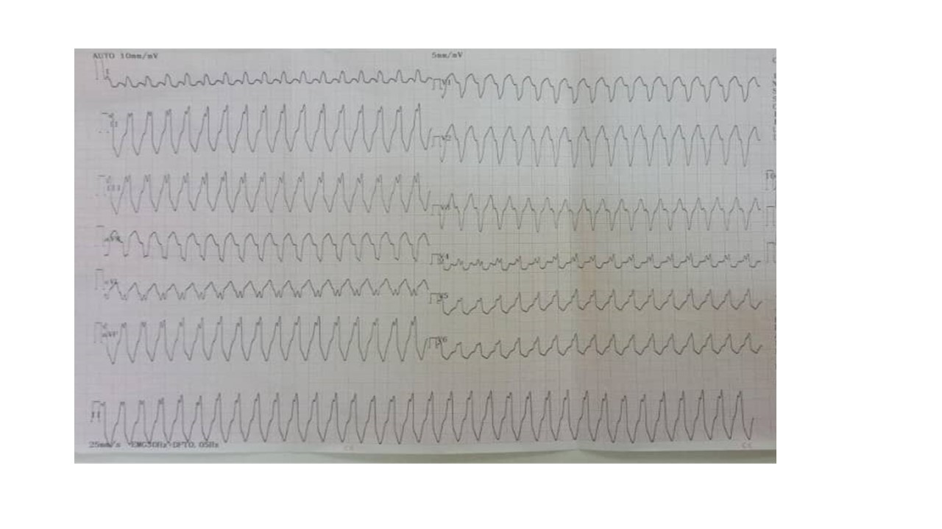

Figure 2 : Standard 12-lead electrocardiogram showing regular tachycardia with wide QRS (128 ms duration), atrioventricular dissociation and a ventricular rate of 204 cycles per minute, suggestive of ventricular tachycardia.

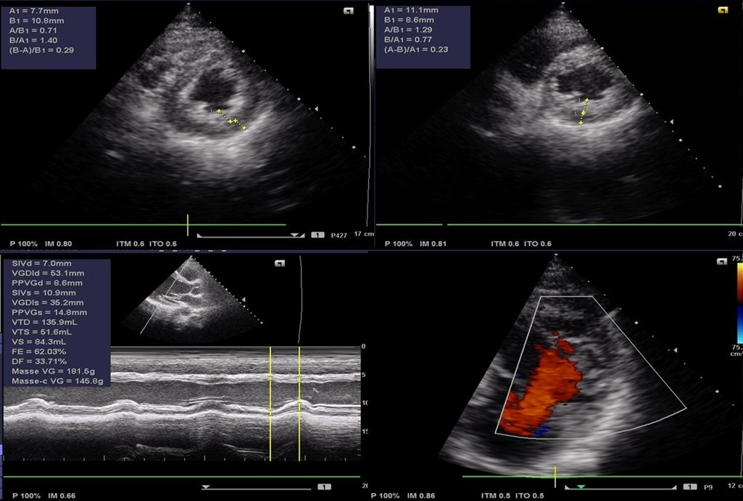

Figure 3 : Transthoracic Doppler echocardiography showing well-vascularised left intravascular hypertrophy with preserved left ventricular ejection fraction

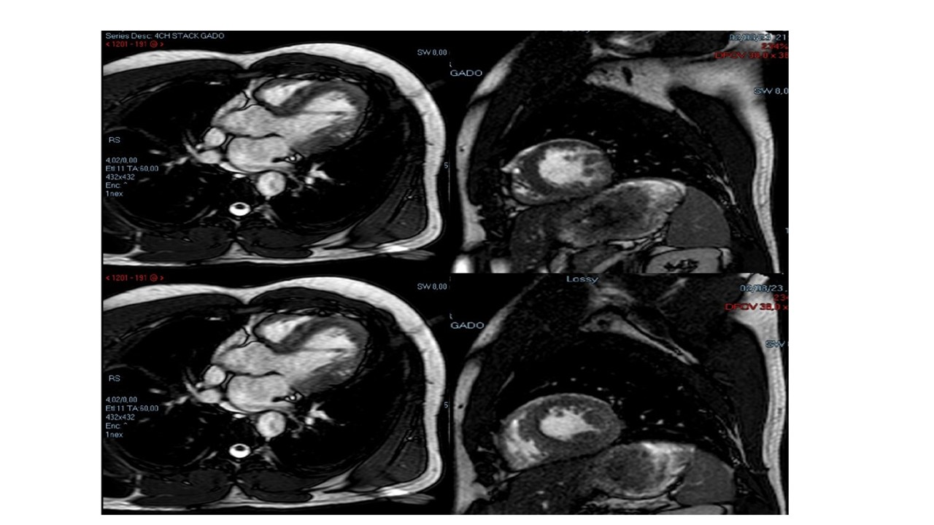

Figure 4 : Cardiac magnetic resonance imaging showing well-vascularised left intravascular hypertrection, with preserved left ventricular ejection fraction