Compression of the palmar digital nerve of the index finger by a lipoma : A case report

Abstract
Lipomas are common benign soft tissue tumors but are rare in the hand. Hand lipomas are typically asymptomatic ; however, in some cases, compression of peripheral nerves such as the median nerve or its branches can lead to pain and neurological symptoms. The intricate anatomy of the hand makes the surgical treatment of tumors in this region particularly challenging.
The treatment of choice is surgical excision, which is associated with a low recurrence rate.
We present a case of a palmar lipoma located in the thenar region, resulting in compression of the palmar digital nerve of the index finger. The patient experienced clinically significant paresthesia of the index finger suggestive of carpal tunnel syndrome. Complete surgical excision led to resolution of symptoms.
Keywords : Lipoma, Index finger, Nerve compression, Hand surgery.

Introduction
“ Lipomas are common benign soft tissue tumors ” [1]. “ Lipomas are classified according to the anatomical location of the fat cells : dermal, subcutaneous, and subfascial lipomas, or tumors directly related to muscle, bone, synovium, or nerve ” [2]. “ Lipomas are rarely found in the hand ” [3] and “ most grow very slowly and are asymptomatic. However, depending on their location, lipomas can cause neurological symptoms and tenderness ” [4]. “ In the literature, rare cases of lipoma induced peripheral nerve compression (such as carpal tunnel syndrome) have been reported ” [5,6].
We report a case of a palmar lipoma, causing compression of the palmar digital nerve of the index finger, and successfully treated surgically.
Clinical Case
A 54-year-old right-handed housewife with no significant past medical history presented with a 6-month history of pain and paresthesia in the right index finger. Symptoms had developed gradually, without any preceding trauma, and were exacerbated by manual activities. The patient had initially consulted a general practitioner, where a preliminary diagnosis of carpal tunnel syndrome was suggested. An electromyographic (EMG) study was subsequently requested revealing a moderate carpal tunnel syndrome. On physical examination, a painless soft tissue mass was noted in the thenar eminence of the right hand, measuring approximately 3.0 × 4.0 cm. The mass was soft in consistency, fixed to the deep tissues, and elicited a positive Tinel’s sign at the site (Figure 1). Sensory testing revealed hypoesthesia in the radial hemipulp of the right index finger (graded S2), while the median nerve demonstrated preserved sensory and motor function (S4 M5). Tinel’s sign at the wrist was negative, as was Phalen’s test.

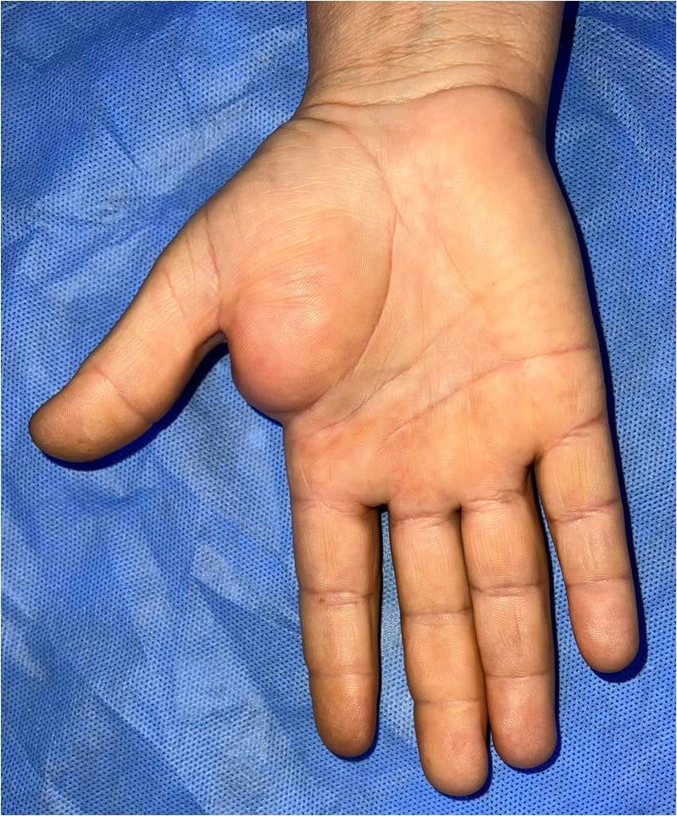
Figure 1 : Clinical aspect of the soft tissue mass in the thenar eminence of the right hand

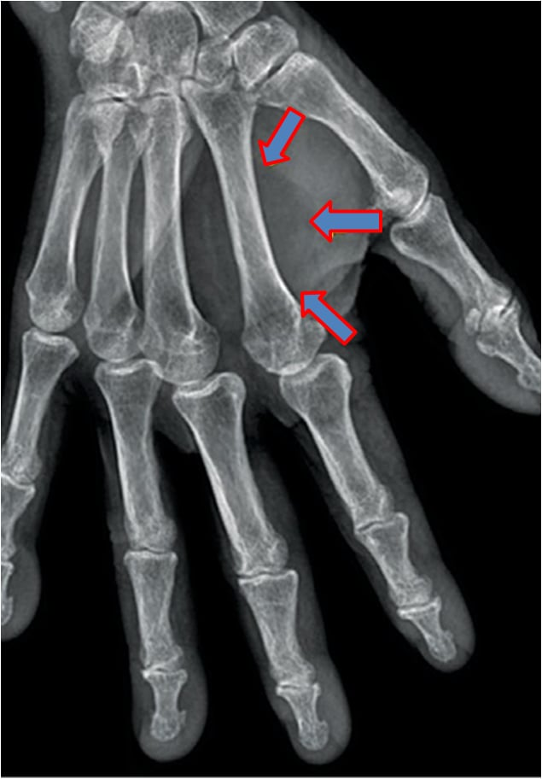
A standard radiograph showed soft tissue enlargement between the first and second metacarpals (Figure 2).

Figure 2 : A standard radiograph of the hand showing soft tissue enlargement

Magnetic resonance imaging (MRI) revealed an intramuscular lipomatous mass in the thenar muscles measuring 5.0 × 3.0 cm, in close contact with the flexor tendon sheath and the radial digital nerve of the index finger (Figure 3).

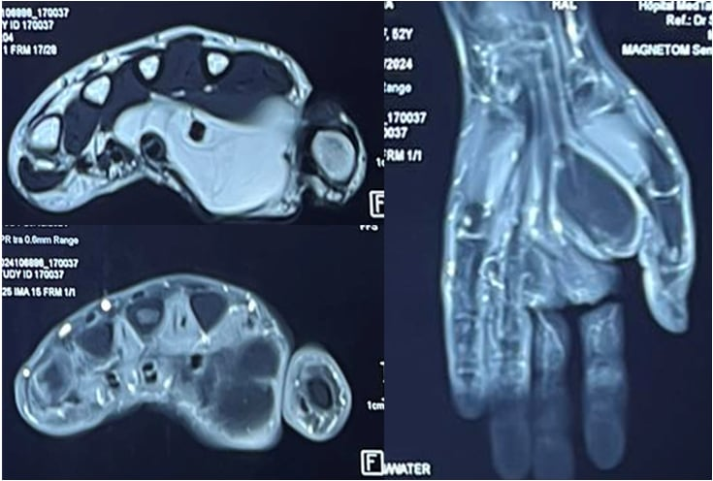
Figure 3 : MRI revealing an intramuscular lipomatous mass
: the flexor tendon sheath of the index finger
: the radial digital nerve of the index finger
The patient underwent complete surgical excision of the mass. Macroscopically, the lesion appeared as lobulated, yellow adipose, well-encapsulated mass.
Intraoperatively, the mass was compressing the radial collateral nerve of the index finger (Figure 4). The motor branch of the median nerve was identified and protected. It did not course through the tumor but was closely adherent to its surface.
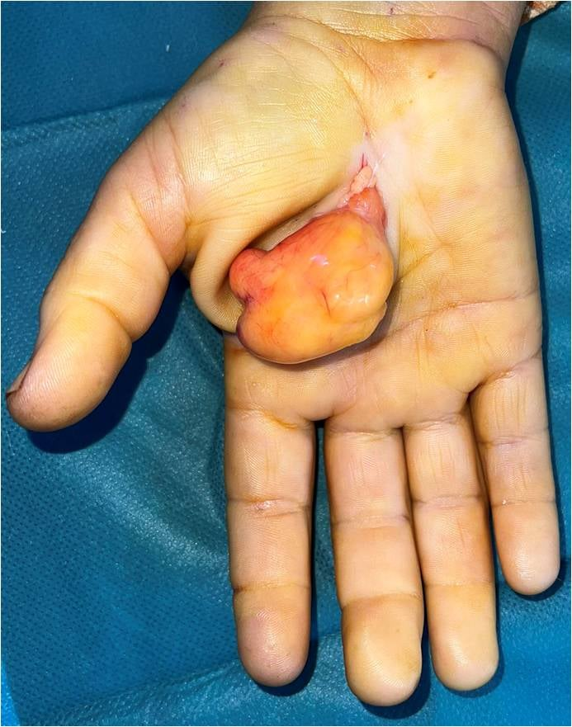
Figure 4 : Intraoperative appearance of the mass

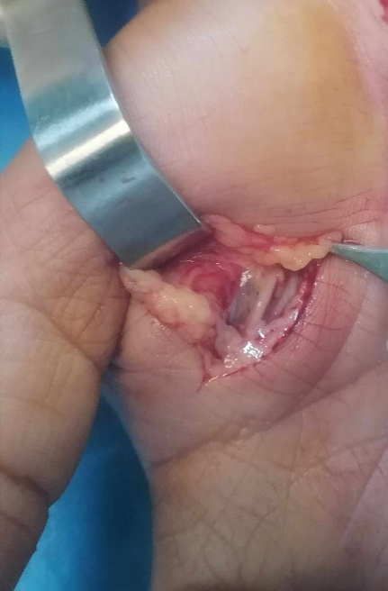
Neurolysis of the nerve was also performed (Figure 5).

Figure 5 : Aspect of the radial collateral nerve of the index finger

Histopathological examination confirmed the presence of mature adipose tissue without atypia, necrosis, or hemorrhage, and surrounded by a synovial membrane consistent with a lipoma of tenosynovial origin (Figure 6).

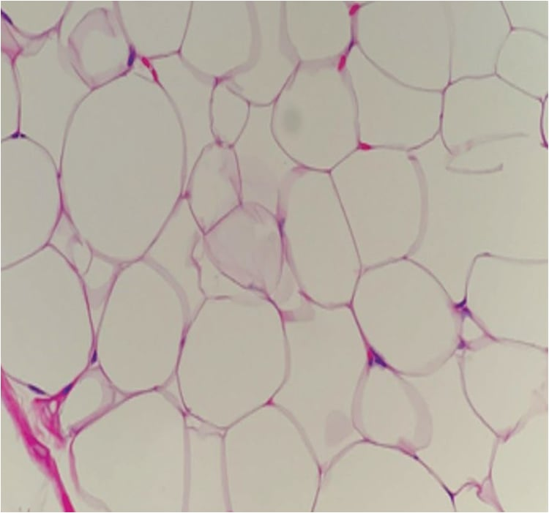
Figure 6 : Histopathological aspect of a lipoma

In the post operative course, the patient experienced complete resolution of pain and paresthesia in the right index finger. At two-year follow-up, there were no signs of recurrence or residual symptoms.

Discussion
“ Lipomas of the hand typically form in the subcutaneous layer. When they develop in the submuscular layer, they are usually located beneath the thenar muscles and can also occur in deep structures of the palms, such as the carpal tunnel or Guyon's canal ” [7]. Deep palmar lipomas can be difficult to detect and diagnose correctly because they are located beneath the palmar fascia and are not easily palpable, as in our case.
“ Although numerous cases of tendon sheath lipomas associated with lower limb tendons have been reported, cases localized to the hand are rare in the literature ” [8, 9]. “ There are two types of tendon sheath lipomas: discrete solid masses of adipose tissue (as in our case) and adipose tissue associated with hypertrophied synovial villi (or arborescent lipoma) ” [10]. Tendon sheath lipomas were first described by Bryan et al [11] and 30 cases of lipomas arising in the hand were included in the review between 1922 and 1956 [11]. Recent reports of lipomas arising from the flexor tendon sheath or tenosynovium are very rare and usually lead to carpal tunnel syndrome [12-13-14-15] and rarely affect the wrist [12]. “ Cases of intramuscular lipomas of tenosynovial origin arising distal to the carpal tunnel are exceptional ” [16].
In cases of subfascial lipoma, a plain radiographic examination usually reveals an oval or circular mass with a decreased radiographic density. Ultrasound is a simple, inexpensive, available, and harmless examination that can show us the tumor and its anatomical associations with surrounding structures but is operator dependent. It is worth noting that MRI is the most useful diagnostic imaging tool in such cases. Capelastegui et al [17] found that “ in 134 cases, MRI was able to determine the cause of the palpable mass with a diagnostic accuracy of 94%. Contrast-enhanced T1 images generally show high signals, while contrast-enhanced T2 images show moderate to high signals, with the same intensity as the subcutaneous fat layer. In addition, understanding the positional relationship between lipomas and surrounding tissues is useful in establishing a surgical treatment plan. The literature reports few cases of malignant transformation of lipomas ; it is most often a problem of differential diagnosis between lipoma and grade 1 liposarcoma ” [1]. “ The frequency of recurrence is approximately 5%. However, the frequency of recurrence of deep and infiltrating lipomas is high, often due to incomplete tumor resection aimed at preserving the surrounding neurovascular and muscular tissue ” [18, 19].
Conclusion
Hand lipomas are rare and typically present in an asymptomatic manner, although they may, in some cases, lead to neurological signs. The treatment involves meticulous surgical excision. The patient experienced clinically significant paresthesia of the index finger suggestive of carpal tunnel syndrome. Complete surgical excision led to resolution of symptoms.

Ethical Approval:

As per international standards or university standards written ethical approval has been collected and preserved by the author(s).

Consent
As per international standards or university standards, patient(s) written consent has been collected and preserved by the author(s).

Disclaimer (Artificial intelligence)
Option 1:
Author(s) hereby declare that NO generative AI technologies such as Large Language Models (ChatGPT, COPILOT, etc.) and text-to-image generators have been used during the writing or editing of this manuscript.
Option 2:
Author(s) hereby declare that generative AI technologies such as Large Language Models, etc. have been used during the writing or editing of manuscripts. This explanation will include the name, version, model, and source of the generative AI technology and as well as all input prompts provided to the generative AI technology
Details of the AI usage are given below:
1.
2.
3.

References

- Nadar MM, Bartoli CR, Kasdan ML. Lipomas of the hand: a review and 13 patient case series. Eplasty 2010;10:e66.
- Al-Qattan MM, Al-Lazzam AM, Al Thunayan A, Al Namlah A, Mahmoud S, Hashem F, et al. Classification of benign fatty tumours of the upper limb. Hand Surg 2005;10:43-59.
- Ben-aissi M, Hani R, Boufettal M, Lamrani MO, Berrada . Lipome de l’index avec compression nerveuse: à propos d’un cas rare avec revue de la littérature. Revue Marocaine de Chirurgie Orthopédique et Traumatologique 2018 ; 72 : 47-51.
- Fazilleau F, Williams T, Richou J, Sauleau V, Le Nen D. Median nerve compression in carpal tunnel caused by a giant lipoma. Case Rep Orthop 2014;2014:654934.
- Azwa N, Shalimar A, Jamari S. A Palmar Lipoma with Median and Ulnar Nerve Compressive Symptoms. Malaysian Orthopaedic Journal 2007;1:33-5.
- Sbai MA, Benzarti S, Msek H, Boussen M, Khorbi A. Carpal tunnel syndrome caused by lipoma: a case report. Pan Afr Med J 2015;22:51.
- Grivas TB, Psarakis SA, Kaspiris A, Liapi G. Giant lipoma of the thenar--case study and contemporary approach to its aetiopathogenicity. Hand (N Y) 2009;4:173-6.
- Atik OŞ. What are the expectations of an editor from a scientific article? Jt Dis Relat Surg 2020;31:597-8.
- Hyun-Woo Kim, Kyu-Jo Lee, Syung-Kyun Choi, Il-Tae Jang, Hyun-Jin Lee ¹. A large palmar lipoma arising from flexor tenosynovium of the hand causing digital nerve compression: A case report. . 2021;32(1):230-233.
- Gurich RW Jr, Pappas ND. Lipoma of the Tendon Sheath in the Fourth Extensor Compartment of the Hand. Am J Orthop (Belle Mead NJ) 2015;44:561-2.
- Bryan RS, Dahlin DC, Sullivan CR. Lipoma of the tendon sheath. J Bone Joint Surg [Am] 1956;38-A:1275-80.
- Sonoda H, Takasita M, Taira H, Higashi T, Tsumura H. Carpal tunnel syndrome and trigger wrist caused by a lipoma arising from flexor tenosynovium: a case report. J Hand Surg Am 2002;27:1056-8.
- Vekris MD, Lykissas MG, Beris AE. Median nerve compression secondary to lipoma arising from flexor tenosynovium: a case report. Hand Surg 2007;12:83-6.
- Kremchek TE, Kremchek EJ. Carpal tunnel syndrome caused by flexor tendon sheath lipoma. Orthop Rev 1988;17:1083-5.
- Inglis AE, Straub LR, Williams CS. Median nerve neuropathy at the wrist. Clin Orthop Relat Res 1972;83:48-54.
- Choi JY, Choi YJ, Jung SN, Seo BF. Giant lipoma in the index finger of the dominant hand of a swimmer: A case report. Jt Dis Relat Surg. 2023 Apr 27;34(2):469-473.
- Capelastegui A, Astigarraga E, Fernandez-Canton G, Saralegui I, Larena JA, Merino A. Masses and pseudomasses of the hand and wrist: MR findings in 134 cases. Skeletal Radiol 1999;28:498-507.
- Murphey MD, Carroll JF, Flemming DJ, Pope TL, Gannon FH, Kransdorf MJ. From the archives of the AFIP: benign musculoskeletal lipomatous lesions. Radiographics 2004;24:1433-66.
- M.A Sbai, A. Khorbi N, S. Daas. Ben Hmida, M. Souissi, R. Marzouk, M. Tebib. Le lipome digital : à propos de 5 cas. Tunisie orthopédique. 2011 : 1, 1 ; 61- 63.

