*Case report*

A Rare Case of Mature Cystic Neonatal Sacrococcygeal Teratoma

.

ABSTRACT

|  |
| --- |
| **Introduction:** Sacrococcygeal teratoma (SCT) is a rare germ cell tumour but the commonest neoplasm during neonatal periods.  **Aim:** We report a rare case of neonatal pure mature cystic sacrococcygeal teratoma (SCT) Type III, who underwent excision of the tumour and coccygectomy, which was the first to be done in Malacca Hospital (a tertiary state hospital in Malacca, Malaysia) since the starting of the paediatric surgery service in the year 2019.  **Discussion:** Postoperatively, the child develops voiding dysfunction due to neurogenic bladder. This was managed by clean intermittent self-catheterisation by the parents and subsequently resolved spontaneously. Histopathological examination revealed that the cyst wall contained all three germ cell lineages, consistent with a pure mature cystic teratoma.  **Conclusion:** Pure mature cystic SCT is rare but benign in nature if diagnosed before the age of 6 months of life and has a good surgical outcome with manageable post-treatment sequelae such as neurogenic bladder and postoperative distinct scar. Surveillance up to at least 5 years is crucial, as it poses the risk of recurrence with potential malignant features. |

*Keywords: Sacrococcygeal, teratoma, neonate, excision, coccygectomy, sequelae*

1. INTRODUCTION

A sacrococcygeal teratoma (SCT) is a neoplasm arising from the caudal end of the spine, usually protruding from the inferior end of the infant’s spinal column, displacing the anus forward (Pringle 2017). It is a rare germ cell tumour with an incidence of 1:40,000 live births (Hambraeus 2016) but made up of 70% of all childhood teratomas, with a girls-to-boys ratio of 4:1 (Swamy 2008). They arise from the totipotent cells of Hensen’s node and contain tissue derived from more than one germ layer, either from endoderm, mesoderm and ectoderm, which contain neural elements, squamous and intestinal epithelium, skin appendages, teeth, and sometimes calcium (Srivastava 2010). Hensen’s node, also known as the primitive knot, is an enlarged group of cells located in the anterior portion of the primitive streak where gastrulation, the formation of the three germ cell layers, begins and plays a major role in the anterior-posterior axis specification, development of chordamesoderm and later notochord development (Doty 2011). Totipotent cells are embryonic stem cells that are present during the first few cell divisions post-fertilisation and can form any of the different types of cells in the body. These cells normally degenerate and disappear; however, if they escape the control of embryonic inductors and organisers, a teratoma results (Kainer 2018).

2. PRESENTATION OF CASE

A newborn baby girl with an antenatal scan showing bladder exstrophy was referred to the paediatric surgery team. She was born at term at 37 weeks via emergency caesarean section. Post-natal examination showed no signs of dysmorphism, but a large gluteal cystic mass was found extending anteriorly, causing the anal opening to be pushed and located anteriorly. The transillumination test for the mass was positive. An ultrasound of the mass revealed a sacrococcygeal cystic mass with intrapelvic extension, suggestive of an SCT. However, there was a diagnostic dilemma on whether the cystic mass is truly an SCT (which is quite rare for pure mature cystic SCT) or an anterior sacral myelomeningocele.

On Day 3 of life, an MRI of the pelvis and whole spine showed a large dumbbell-shaped, multiseptated cystic mass in the sacrococcygeal area that measured 13.8cm in cranio-caudal length, with an intra-abdominal component measuring 4.0cm (AP) x 5.2cm (CC) and extra-abdominal components measuring 5.4cm (AP) x 8.8cm (CC). There was no enhancing solid component seen within the mass. The mass causes bilateral hydronephrosis and hydroureter with mild mass effect to the urinary bladder and mild herniation into the lower sacral foramina, appearing as an SCT type III (Figure 1). Blood tests showed a high level of serum Alpha Fetoprotein (AFP) of 13434.2 IU/ml (normal is 0-6.6), an increased level of serum lactate dehydrogenase (LDH) at 305 (normal is 120-246), and a normal B-hCG at less than 2U/L (normal is 0-10).

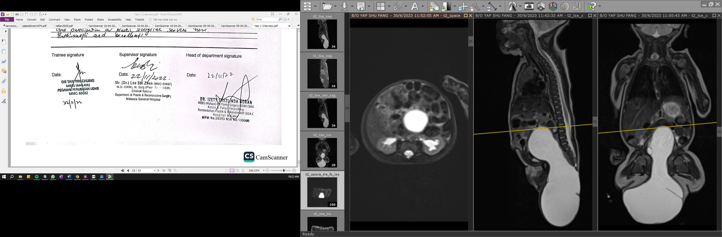

*Figure 1: MRI Pelvis and Whole Spine on Day 3 of Life*

On day 7 of life, we proceeded with the excision of SCT Type III and coccygectomy in prone position via a perineal approach (Figure 2). After removing the tumour, we reconstructed the excess skin and closed it in a ‘Mercedes Benz sign’ fashion, incorporating a drain. The drain was removed 4 days after the surgery.

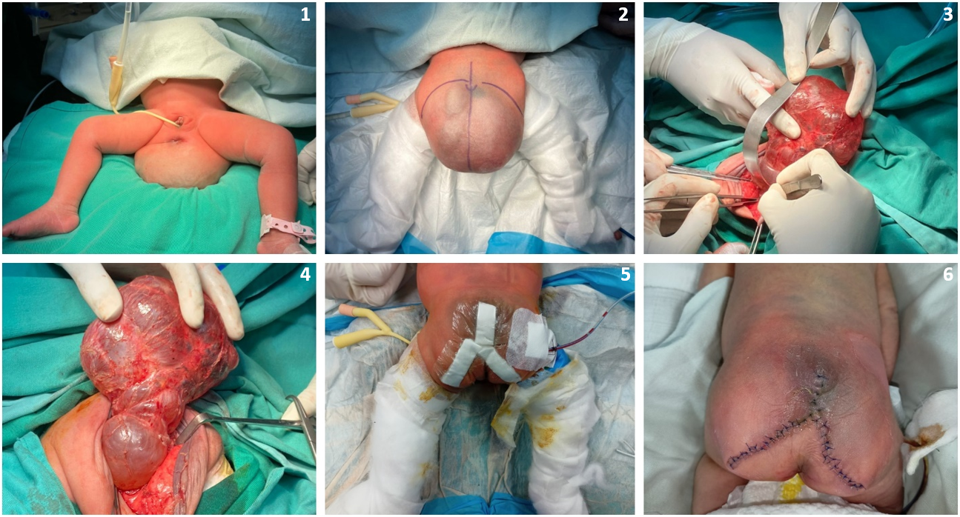

*Figure 2: Intraoperative images during excision of SCT Type III (images 1-5); wound inspection 4 days after surgery (image 6).*

Postoperatively, following the removal of the urinary catheter, the child developed urinary retention and urinary stress incontinence. In view of the difficulty for the parents to perform clean intermittent self-catheterisation (CISC) for the child, a decision was made for a temporary urinary catheter. She was later discharged home 16 days after surgery with an indwelling urinary catheter, which was changed every 2 weeks regularly.

During her clinic review 3 months after the surgery, the repeated serum AFP has also dropped to 95.2 IU/ml (0-6.6) from the previous 13,000. She had no other postoperative complication apart from voiding dysfunction due to neurogenic bladder. The parents were able to perform CISC later; thus, the indwelling urinary catheter was removed. The histopathology examination of the cyst wall showed components of three germ cell lineages, including the brain, choroid plexus, squamous epithelium, anucleate keratin flakes, mature adipocytes, blood vessels, skeletal muscle bundles and glands lined by mucinous-type epithelium. Scattered psammoma bodies were observed with inapparent mitosis seen, without the presence of an immature component or evidence of malignancy. The coccygectomy specimen revealed no malignant tissue. These features aligned with a pure mature cystic teratoma.

In her subsequent clinic follow-up, the 3-monthly serum AFP level continued to drop and normalised at the level of 4.4 IU/ml at the age of 1 year and 5 months old. Her surgical scar was well healed (Figure 3), and the parents were happy with her recovery and growth after the treatment.

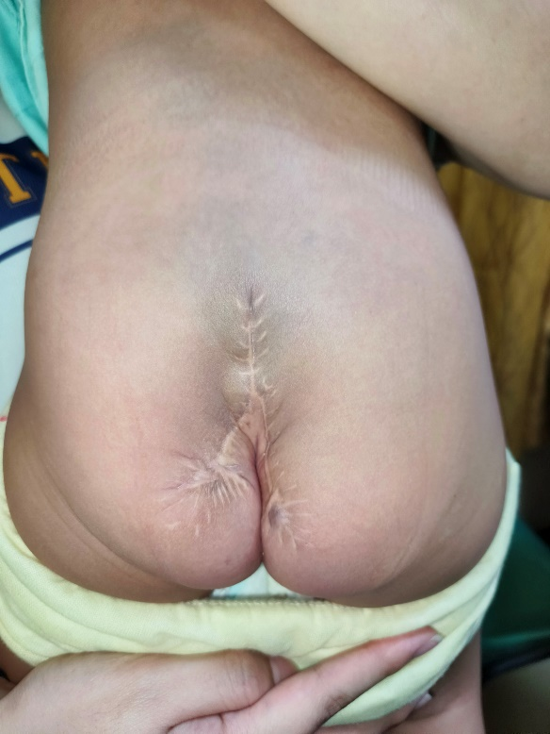

*Figure 3: Surgical scar during recent clinic visits at age of 1 year 10 months old*

3. discussion

SCTs are rarely malignant (2%) if diagnosed before the age of 6 months of life, but if diagnosed after 6 months of life, they will have a malignancy rate of up to 65%. The Altman classification is the most used classification for SCT, according to the anatomical presentation of the lesion (Altman 1974).

Table 1: Altman Classification of SCT

|  |  |  |
| --- | --- | --- |
| Altman classification of sacrococcygeal teratomas 6 . | | |
| **Type** | **Description** | **Malignant risk** |
| Type I (46.7%) | Tumours predominantly external (sacrococcygeal) with only a minimal presacral component | 8% |
| Type II (34.7%) | Tumours presenting externally but with a significant intrapelvic extension | 29% |
| Type III (8.8%) | Tumours were apparent externally, but the predominant mass was pelvic and extended into the abdomen. | 34% |
| Type IV (9.8%) | Presacral with no external presentation | 38% |

With the advancement in diagnostic interventions, SCTs are being diagnosed earlier during the prenatal period in the first trimester via detailed ultrasound scan (Lee MY 2011), comprising 25% of the pregnancies. The risk factors that predict an adverse outcome of a prenatally diagnosed SCT include tumour size, growth rate, vascularity, solid morphology and the presence of polyhydramnios, cardiac decompensation, large size placenta or hydrops fetalis (Hambraeus 2016). Tumoural appearance on ultrasound may be solid (most frequently), cystic or mixed. In 15% of cases, it can be purely cystic (Woodward PJ 2005). Our case represents a rare instance of purely cystic SCT Type III, in contrast to solid or mixed solid-cystic SCT.

SCT can be classified into mature teratomas (MT), immature teratomas (IT) or malignant teratomas (features of yolk sac tumours with choriocarcinoma, embryonal carcinoma or rarer form sarcomas or neuroblastomas). MT and IT usually demonstrate benign clinical behaviour; however, they may recur with malignant features (Lo Curto M 2007).

20% of the SCTs are associated with congenital abnormalities (polydactyly, microtia, atrial septal defect, cleft lip, hypospadias, club foot, hydronephrosis, hip dysplasia, vertebral abnormalities and Trisomy 13), and in this case the child was born with bilateral hydronephrosis and hydroureter (Rattan KN 2021, Lahdenne P 1991, Lubala TK 2015). High serum AFP level is attributed to the production by the yolk sac tumour (i.e., SCT), foetal liver and foetal gastrointestinal tract. After excision of SCT, AFP has a progressive decrease up to 9 months mean time to normalisation and should not be confused with tumoral relapse (Barreto MW 2006). Thus, serial monitoring of AFP 3 monthly may be helpful in the detection of recurrence, for instance, in this case, which showed a 99% reduction of serum AFP in 5 months’ time. Recurrence is also commonly associated with incomplete resection of the coccyx or inadequate treatment of malignant cases, either due to loss to follow-up or lack of neoadjuvant or adjuvant treatment whenever indicated (Lo Curto M 2007). It was recommended for SCT patients to be followed up for at least 5 years with no maximum time for follow-up to monitor for recurrence and management of post-treatment sequelae (Santos VDN 2022).

Functional sequelae of SCT include urinary tract (commonest) and bowel dysfunction, owing to prenatal compression of surrounding pelvic structures and surgical trauma. Other postoperative complications include surgical site infection and wound dehiscence, which is justifiable by the proximity of the surgical site to the anus with colonic bacteria and partially associated with lack of local hygiene and systematisation in surgical dressings (Santos VDN 2022). Children after SCT excision often have a distinct scar and irregular buttock contour as well, caused by the tumour’s fragmentation of gluteal musculature. However, they exhibit a favourable overall health-related quality of life (HRQoL) during childhood (Hambreus M 2020).

4. Conclusion

In conclusion, pure mature cystic SCT is rare, comprising only 15% of the SCT cases. Mature SCT is usually benign and has a favourable surgical outcome with manageable post-treatment sequelae such as neurogenic bladder and postoperative distinct scars. However, surveillance is crucial, as it still poses the risk of recurrence with potential malignant features for at least 5 years with no maximum limit of time for follow-up.

Consent

Author(s) declare that written informed consent was obtained from the patient’s parents for publication of this case report and accompanying images. A copy of the written consent is available for review by the Editorial Board members of this journal.

**DISCLAIMER (ARTIFICIAL INTELLIGENCE)**

Authour(s) hereby declare that Scribbr AI-Proofreading (<https://www.scribbr.com/ai-proofreader/>) has been used for proofreading of the manuscript to correct grammatical errors, sentence structures and consistency.

References

1. Pringle KC. Sacrococcygeal teratoma. 4th edition ed. Boca Raton: CRC Press; 2017.
2. Hambraeus M, Arnbjornsson E, Borjesson A, Salvesen K, Hagander L. Sacrococcygeal teratoma: A population-based study of incidence and prenatal prognostic factors. *J Pediatr Surg* 2016; **51**(3): 481-5.
3. Swamy R, Embleton N, Hale J. Sacrococcygeal teratoma over two decades: birth prevalence, prenatal diagnosis and clinical outcomes. *Prenat Diagn* 2008; **28**(11): 1048-51.
4. Srivastava A, Jaiswal AK, Jain K, Behari S. Sacrococcygeal teratoma. *J Pediatr Neurosci* 2010; **5**(1): 30-1.
5. Doty, Maria, DeRuiter, Corinne, "Hensen's Node". Embryo Project Encyclopedia ( 2011-06-21 ). ISSN: 1940-5030 <https://hdl.handle.net/10776/2281>
6. Kainer F. 31 - Sacrococcygeal Teratoma and Fetus in Fetu. In: Copel JA, D'Alton ME, Feltovich H, et al., eds. Obstetric Imaging: Fetal Diagnosis and Care (Second Edition): Elsevier; 2018: 146-50.e1.
7. Altman RP, Randolph JG, Lilly JR. Sacrococcygeal teratoma: American Academy of Pediatrics Surgical Section Survey-1973. *J Pediatr Surg* 1974; **9**(3): 389-98.
8. Lee MY, Won HS, Hyun MK, Lee HY, Shim JY, Lee PR, Kim A. Perinatal outcome of sacrococcygeal teratoma. *Prenat Diagn* 2011; **31**(13): 1217-21.
9. Woodward PJ, Sohaey R, Kennedy A, Koeller KK. From the archives of the AFIP: a comprehensive review of fetal tumors with pathologic correlation. Radiographics. 2005;25(1):215–242.
10. Lo Curto M, D'Angelo P, Cecchetto G, et al. Mature and immature teratomas: results of the first paediatric Italian study. *Pediatr Surg Int* 2007; **23**(4): 315-22.
11. Rattan KN, Singh J. Neonatal sacrococcygeal teratoma: Our 20-year experience from a tertiary care centre in North India. *Trop Doct* 2021; **51**(2): 209-12.
12. Lahdenne P, Heikinheimo M, Jaaskelainen J, Merikanto J, Heikkila J, Siimes MA. Vertebral abnormalities associated with congenital sacrococcygeal teratomas. *J Pediatr Orthop* 1991; **11**(5): 603-7.
13. Lubala TK, Mukuku O, Shongo MP, Mutombo AM, Lubala N, Luboya ON, Lukusa-Tshilobo P. Sacrococcygeal teratoma in a female newborn with clinical features of trisomy 13: a case report from Central Africa. *Int Med Case Rep J* 2015; **8**: 333-6.
14. Barreto MW, Silva LV, Barini R, Oliveira-Filho AG, Sbragia L. Alpha-fetoprotein following neonatal resection of sacrococcygeal teratoma. *Pediatr Hematol Oncol* 2006; **23**(4): 287-91.
15. Santos VDN, Coelho SO, Vieira AA. Sacrococcygeal teratoma: evaluation of its approach, treatment and follow-up in two reference children cancer centers in Brazil / Rio de Janeiro. *Rev Col Bras Cir* 2022; **49**: e20223341.
16. Hambraeus M, Hagander L, Arnbjornsson E, Borjesson A, Stenstrom P. Health-related quality of life and scar satisfaction in a cohort of children operated on for sacrococcygeal teratoma. *Health Qual Life Outcomes* 2020; **18**(1): 102.