Case report

Mycotic Aneurysm of Brachial Artery: A Rare Sequelae of Septicaemia

.
ABSTRACT

Introduction: We present a rare case of brachial artery mycotic aneurysm caused by Staphylococcus Aureus. It is a potentially limb or life threatening condition¹. Most cases described in literature are related to drug abuse, catheterization procedure or infective endocarditis. We would like to highlight an unusual complication of brachial artery mycotic aneurysm in arteriovenous fistula that was never been cannulated.

Case Summary : 18 years old girl with end stage renal failure was referred from district hospital with impending rupture of left brachiocephalic fistula pseudoaneurysm which was yet to cannulate. She complaint of fever, redness, numbness and pain over left brachiocephalic fistula site for two days. Five months prior to current presentation, she was admitted for Methilin-Resistant Staphylococcus Aureus septicaemia complicated with parapneumonic effusion. Three months prior, left brachiocephalic fistula was created. Examination revealed a 5x5 cm pulsatile, tender mass with blistering skin over left cubital fossa. Ultrasound doppler confirmed a pseudoaneurysm over left brachiocephalic fistula. Patient underwent surgical exploration and repair. Intraoperatively, large pseudoaneurysm at the site of previous anastomosis line was found with pus collection. Overlying skin and pseudoaneurysm were excised en mass and arterial defect was repaired by transection and end-to-end anastomosis. A week post operation was complicated by brachial artery anastomosis dehiscence. She then underwent surgical exploration and ligation of left brachial artery. During hospitalization, multiple bedside debridement was done to aid in wound healing. Intraoperative culture grew Staphylococcus Aureus which was sensitive to Cephazolin. Upon discharge, wound was healing, paresthesia improved and she was discharge with 6 weeks course of antibiotic.
Discussion: It is important to recognize mycotic aneurysm of brachial artery. Early antibiotic and surgical intervention after a prompt diagnosis are essential to avoid further sequelae of infective endocarditis and mycotic aneurysm.

Keywords: Brachial artery, mycotic aneurysm, upper limb mycotic aneurysm

1. INTRODUCTION

An aneurysm is an abnormal focal arterial dilation. Pre-existing aneurysms can become secondarily infected, but aneurysmal degeneration of the arterial wall can also be the result of infection that may be due to bacteraemia or septic embolization, as in the case of mycotic aneurysm.
The name mycotic aneurysm was coined by Osler to describe aneurysms associated with bacterial endocarditis [1,2]. These were noted to have the appearance of "fresh fungus vegetations"; however, the majority of mycotic aneurysms are caused by bacteria.
Mycotic aneurysm is a serious clinical condition that is associated with significant morbidity and mortality. The infection weakens the vessel wall, making it susceptible to dilation, and can lead to potentially life or limb-threatening complications if not promptly diagnosed and treated.
Mycotic aneurysms are uncommon in the extremities, and it is especially rare for them to occur in the brachial artery. Therefore, it is crucial to have prompt diagnosis, intervene early to improve survival. In this case report, we describe our encounter of this uncommon condition presented to us in Sarawak General Hospital.

2. case presentation

We present a rare case of brachial artery mycotic aneurysm (BAMA) caused by Staphylococcus Aureus. It is a potentially limb or life threatening condition [1]. Most cases described in literature are related to drug abuse, catheterization procedure or infective endocarditis [2,3] . We would like to highlight an unusual complication of BAMA in arteriovenous fistula that was never been cannulated.
A 18 years old girl with end stage renal failure was referred from district hospital with impending rupture of left brachiocephalic fistula pseudoaneurysm which was yet to cannulate. She complaint of fever, redness, numbness and pain over left brachiocephalic fistula site for two days. Five months prior, she was admitted for Methicillin-Resistant Staphylococcus Aureus septicaemia which was complicated with parapneumonic effusion. Three months prior, left brachiocephalic fistula was created in district hospital.
Examination revealed a 5x5cm pulsatile, tender mass with blistering skin over left cubital fossa. Ultrasound doppler confirmed pseudoaneurysm over left brachiocephalic fistula.
Patient underwent surgical exploration and repair. Intraoperatively, large pseudoaneurysm at the site of previous anastomosis line was found with pus collection. Overlying skin and pseudoaneurysm were excised en mass and arterial defect was repaired by transection and end-to-end anastomosis.

One week post operation was complicated by brachial artery anastomosis dehiscence. She then underwent surgical exploration and ligation of left brachial artery. (Figure 1)
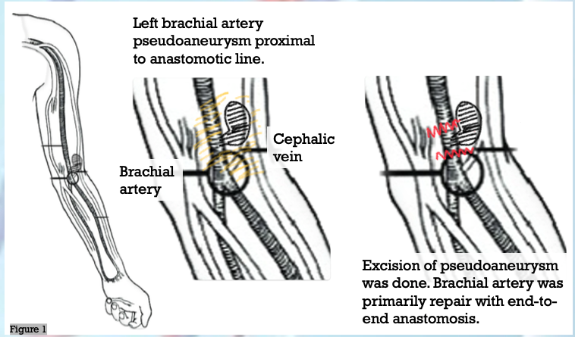
Figure 1: Schematic diagram of intra-operative findings. Pseudoaneurysm was excised then primary repair of brachial artery was done. Post repair, left radial artery and ulnar artery pulses intact.
During hospitalization, multiple bedside debridement was done to aid in wound healing. Intraoperative culture grew staphylococcus aureus which was sensitive to Cephazolin. Upon discharge, wound was healing, paraesthesia improved and she was discharge with six weeks course of antibiotic.

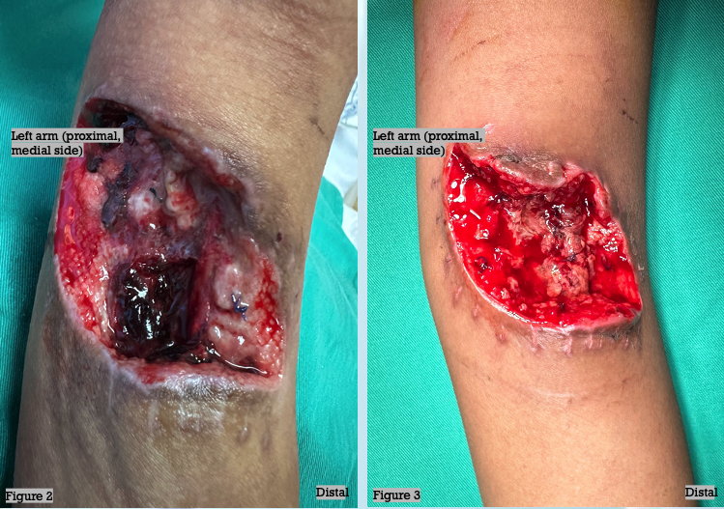
Figure 2: Unhealthy wound base with slough and blood clot covering underlying brachial artery and cephalic vein
Figure 3: Wound condition over left cubital fossa healthy prior discharge.

3. discussion

Mycotic aneurysm in upper extremity peripheral arteries are rare. Unlike the more typical atherosclerotic aneurysms, these infected aneurysms result from bacterial entry into the artery via direct puncture [1,2]. Missed or delayed diagnosis carries potentially devastating morbidity resulting in limb loss or even posing a life-threatening condition.

Clinically, peripheral mycotic aneurysms are identified by their expanding, throbbing, and painful swelling, often accompanied by redness and induration of the surrounding tissue. These symptoms are typically observed in individuals with a history of intravenous drug use [3]. However, fistulas that have never been cannulated, can undergo aneurysmal dilatation [4,5].

Physical examination might uncover decreased temperature, a palpable thrill or audible bruit, discoloration, loss of pulsation, and paraesthesia in the affected area due to limb-threatening ischemia or, less commonly, nerve compression. Pseudoaneurysms can be distinguished from true aneurysms by the absence of all three layers of the blood vessel walls and by analyzing the waveform in duplex Doppler ultrasound [3,6]. These aneurysms also will present with local infection and sometimes generalized bacteraemia as part of the aetiology of the aneurysm if local infection [7,8].
Creation of arteriovenous fistula in patient with recent MRSA septicaemia should be avoided.
In our case, source of sepsis should be eliminated completely before creation of fistula take place.
Most mycotic aneurysms are treated with antibiotic therapy combined with surgical debridement with or without revascularization [5,6]. For our patient, we had excised and ligated the brachiocephalic fistula then initiated antibiotic therapy while closely monitor wound condition. Multiple wound debridement was done to aid in wound healing.
Complications of mycotic aneurysms are bleeding and, to a lesser extent, limb-threatening ischemia. Due to its aetiology and risk of infection, rupture of a mycotic aneurysm is treated with emergency ligation and debridement of the wound (when necessary). However, in case of threatened distal circulation, revascularization needs to be considered to avoid amputation in the future [7,8].
Although peripheral mycotic aneurysms are uncommon, delayed treatment or nontreatment can lead to serious complications such as sepsis, spontaneous aneurysm rupture, and death [6,8]. Maintaining clinical suspicion for peripheral mycotic aneurysms is essential for early diagnosis, and coordination of timely medical and surgical management is critical to prevent these severe complications [9-12].

4. Conclusion

This case report demonstrates a patient with mycotic aneurysm of brachial artery after brachiocephalic fistula creation following recent MRSA septicaemia. It is important to ensure patient has no recent infection before creation of arteriovenous fistula. Early antibiotic and surgical intervention after a prompt diagnosis are essential to avoid further sequelae of infective endocarditis and mycotic aneurysm.

Consent

As per international standard or university standard, patient(s) written consent has been collected and preserved by the author(s).
Ethical approval

As per international standard or university standard, patient(s) written consent has been collected and preserved by the author(s).

COMPETING INTERESTS DISCLAIMER:
Authors have declared that they have no known competing financial interests or non-financial interests or personal relationships that could have appeared to influence the work reported in this paper.

DISCLAIMER (ARTIFICIAL INTELLIGENCE)

Author(s) hereby declare that NO generative AI technologies such as Large Language Models (ChatGPT, COPILOT, etc.) and text-to-image generators have been used during the writing or editing of this manuscript.

References
- Batista S, de Barros Oliveira L, et al. (2024). Endovascular treatment of mycotic aneurysms: An update meta-analysis. Clinical Neurology and Neurosurgery. Jan 1;236:108068.
- Klusch, V.; Aper, T.; Sonnenschein. (2023). A Hyperdynamic Arteriovenous Fistula Aneurysm After Long Time Renal Transplantation. Vasc. Endovasc. Surg., 57, 182–185.
- Barac, S.; Rata, A.; Popescu, A.; Onofrei, R.; Chiriac, S. (2022). True Brachial Artery Aneurysm in Patients with Previous Arterio-Venous Fistula Ligation and Immunosuppressant Therapy for Renal Transplantation: Case Report and Literature Review. Healthcare, 10, 470.
- Lee JY, Kim H, Kwon H et al. (2021). Delayed rupture of a pseudoaneurysm in the brachial artery of a burn reconstruction patient. World J Emerg Surg WJES, 8(1),21.
- Gavriilidis, P.; Papalois, V. A (2021). Systematic Review of The Brachial Vein Arteriovenous Fistulas as a Viable Option for Haemodialysis Access. J. Vasc. Access 2021, 22, 947–954.
- Meola, M.; Marciello, A.; Di Salle, G.; Petrucci, I. (2021). Ultrasound Evaluation of Access Complications: Thrombosis, Aneurysms, Aseudoaneurysms and Infections. J. Vasc. Access, 22, 71–83.
- Senarslan, D. A., Yildirim, F., & Tetik, O. (2019). Three Cases of Large-Diameter True Brachial and Axillary Artery Aneurysm and a Review of the Literature. Annals of vascular surgery, 57, 273.e11–273.e15.
- Simson R, Jacobs T, Kulkami, S (2019). Mycotic Aneurysm of Brachial Artery Secondary to Infective Endocarditis. EJVES short reports, 46,9-11.
- Salzler, G. G., Long, B., Avgerinos, E. D., Chaer, R. A., Leers, S., Hager, E., Makaroun, M. S., & Eslami, M. H. (2018). Contemporary Results of Surgical Management of Peripheral Mycotic Aneurysms. Annals of vascular surgery, 53, 86–91
- Cox N, Sahnan K, Yee CP (2015). Brachial artery pseudoaneurysm arising from the stump of a ligated arteriovenous fistula. BMJ Case Reports, 2015, bcr2014206993.
- Leon L, Psalms S, Mills JL (2008). Infected Upper Extremity Aneurysms: a review. European journal of vascular and endovascular surgery: the official journal of European Society for Vascular Surgery, 35(3), 320-331.
- How P, Sikkel,M.B, & Law,N (2006). Mycotic aneurysm of the brachial artery secondary to hospital acquired methicillin-resistant Staphylococcus Epidermidis in a complicated case of infective endocarditis. Annals of vascular surgery, 20(5), 684-686.

