**Case Report**

**Consequences of Mismanagement in Malignant Parotid Tumors: A Report of Two Challenging Cases**

**ABSTRACR**

|  |
| --- |
| Malignant salivary gland tumors are a diverse group of neoplasms with unpredictable biological behavior and recurrence patterns, Recurrence rates of malignant parotid tumors vary across studies, influenced by differences in sample characteristics and follow-up protocols, Overall, reported rates range from 10% to 50%, however several factors contribute to recurrence malignant parotid gland tumors include tumor histology, initial surgical treatment, margin condition, perineural and lymph nodes involvement, we present a two cases of recurrent malignant parotid gland tumors, in which recurrence is likely due to incomplete initial resection of the tumor. The first case involved a 30-year-old male diagnosed with intermediate-grade mucoepidermoid carcinoma (stage III), who experienced recurrence five months post-surgery. The second case was a 55-year-old female with carcinoma ex pleomorphic adenoma (stage II), recurring two months after primary excision without adjuvant therapy. Both patients underwent revision surgery involving total parotidectomy, selective neck dissection (level IIa), and facial nerve preservation, followed by postoperative radiotherapy. These cases highlight the clinical and surgical challenges of recurrent malignant parotid tumors, emphasizing the need for accurate preoperative assessment, complete excision with adequate margins, and timely adjuvant therapy to improve disease control and patient outcomes. |

*Key words: head and neck oncology, malignant salivary gland, parotid cancer. recurrent parotid tumors*

**1. INTRODUCTION**

Malignant salivary gland tumors are rare neoplasm that account for 5% of all head and neck cancer.More than 25 different types are recognized [1]. Many risk factors attribute to the recurrence of malignant salivary gland tumors, one of the most important factors is incomplete tumor resection, which can lead to recurrence within six months due to persistent tumor cells [2]. The most effective strategy for managing recurrent salivary gland tumors is to prevent their occurrence initially, this can be achieved through proper utilization of preoperative investigations, including imaging which provides valuable information that assists in treatment planning. In particular, imaging helps determine the tumor relation­ship to surrounding structures and demonstrates tumor extension. Additionally, fine needle aspiration biopsy plays a crucial role in correctly establishing the diagnosis as benign or malignant, with accuracy ranging from 81% to 98%. During surgery, the extent of resection for a malignant tumor is determined by factors such as tumor size, facial nerve involvement, and lymph node metastasis. Furthermore, Postoperative, adjuvant radiotherapy has been shown to decrease the recurrence rate in high-risk parotid tumors. The appropriate application of all these measures significantly reduce the recurrence of malignant salivary gland tumors [3,4,5].

**2. CASE REPORT 1**

A 30 year old male presented to the department of oral and maxillofacial surgery at alsalam teaching hospital with recurrent swelling in the parotid gland, the patient chief complaint was discomfort and progressive swelling. He had a history of a mass at the same site five months ago, for which he underwent surgical resection at another institution, the post-operative histopathological report from that surgery revealed a low grade mucoepidermoid carcinoma. Clinical examination showed a fixed mass in the parotid gland with normal facial nerve function and no palpable lymph nodes in the neck. A clinical diagnosis of recurrent malignant parotid tumor was established (Fig.1).

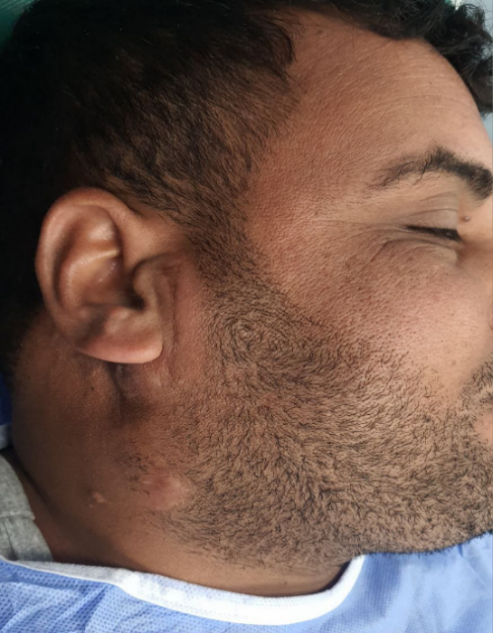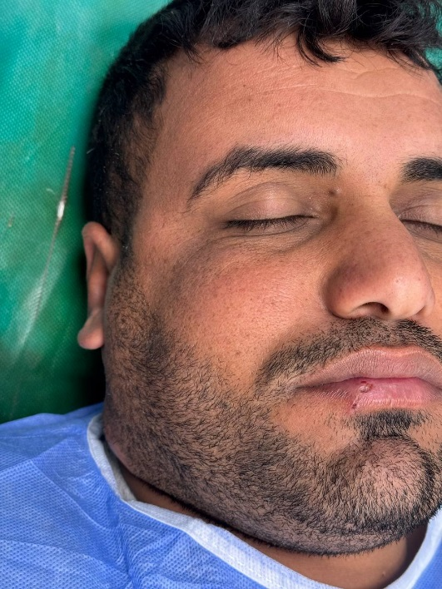

Fig .1. Swelling in the right side (black arrow)

Patient was sent for an MRI to determine the extent of the tumor and lymph nodes status, which showed an irregular mass occupying the parotid region and normal lymph nodes in the neck (Fig.2).

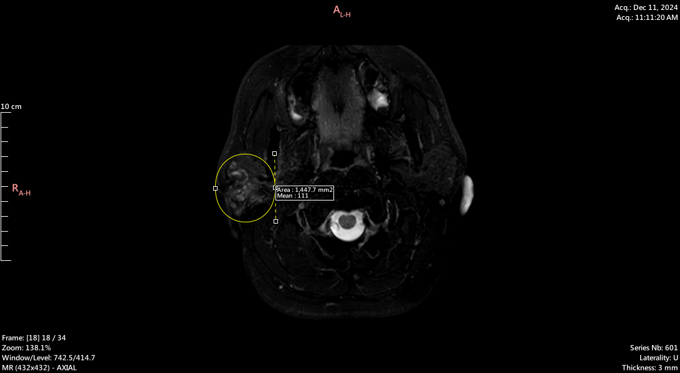Fig. 2. MRI T2W demonstrated irregular mass (yellow circle)

The treatment plan included total parotidectomy, facial nerve preservation and selective neck dissection at level 2A (Fig.3)

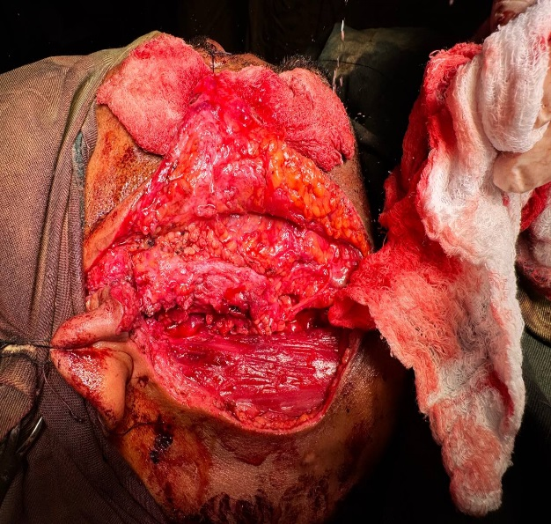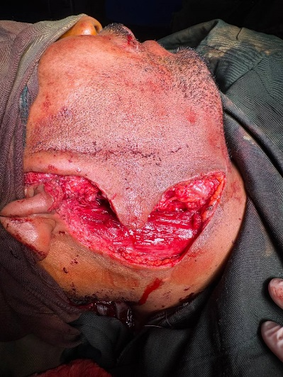

A

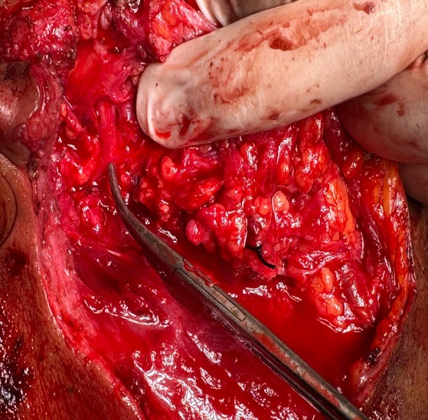

C

B

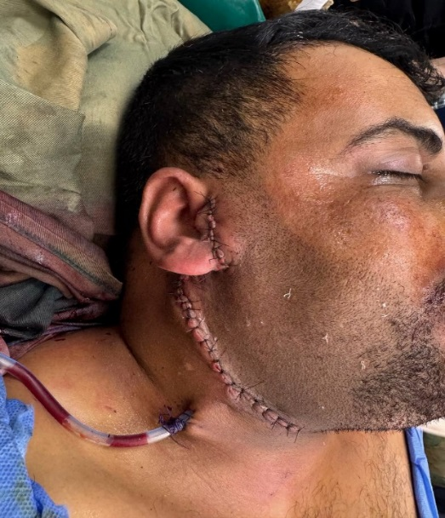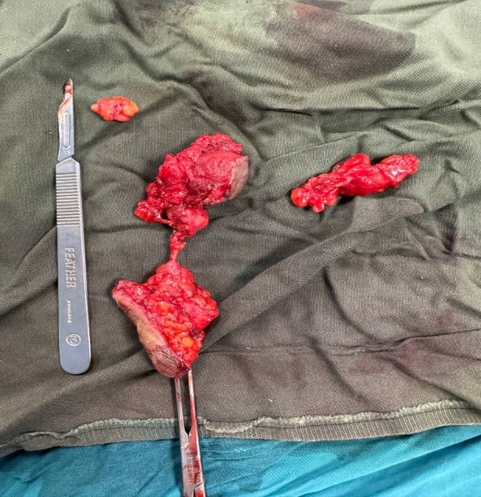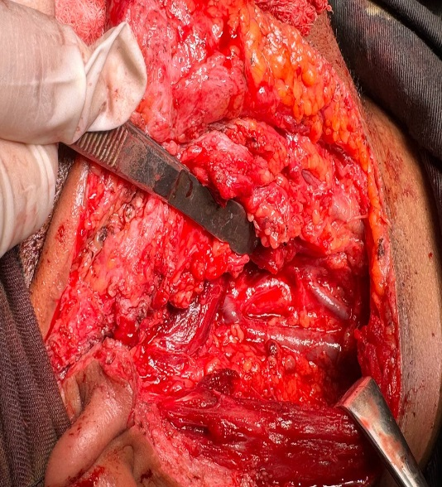

F

E

D

Fig .3. (A) surgical incision(modified Blaire) extended to perform selective level 2A neck dissection.(B) tumor exposed.(c) tumor excision with preservation of the facial nerve(black arrow).(D) selective neck dissection, level 2A.(E) tumor specimen(white arrows) and selective lymph nodes removal(yellow arrows).(F) skin closure.

Histological examination reveals intermediate-grade mucoepidermoid carcinoma infiltrating the extra parotid tissue reaching the subcutaneous tissue.the tumor was totally excised with a free margin of 3 mm all around, metastatic lymph nodes were observed in only one lymph node,histopathological staging( stage III,pT3 N1 M0) according to the American joint committee on cancer 8th edition

Day one post-operative, facial nerve function was intact, except for the mandibular nerve branch, which was resected along with the tumor (Fig.4)

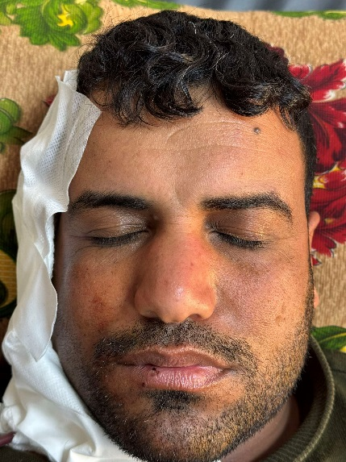 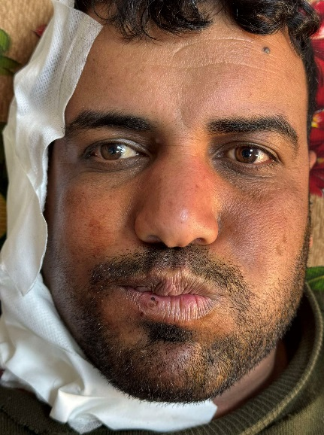 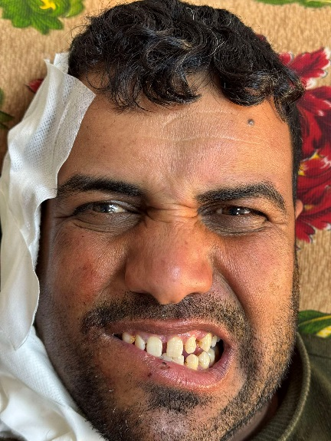

Fig. 4. Day one post-operative intact facial nerve branches except marginal mandibular nerve.

The patient was discharged on day one in stable condition and was referred for radiotherapy as part of treatment plan.

**3. CASE REPORT 2**

A 55 year old female was referred to the department of oral and maxillofacial surgery at alsalam teaching hospital due to recurrent swelling in the parotid gland. The patient chief complaint was discomfort and rapid swelling. She had a previous history of a tumor at the same site two months ago, for which she underwent surgical resection at another hospital. The post-operative histopathological report from the previous surgery showed carcinoma ex pleomorphic adenoma, the patient didn’t receive adjuvant treatment. Clinical examination revealed a hard immobile mass in the parotid gland with normal facial nerve function and no palpable lymph nodes in the neck, the Patient was sent for an MRI to determine the extent of

the tumor and the status of the lymph nodes, which showed an ill- demarcated mass occupying the parotid region and normal lymph nodes in the neck, the clinical diagnosis was recurrent malignant parotid tumor (Fig.5).

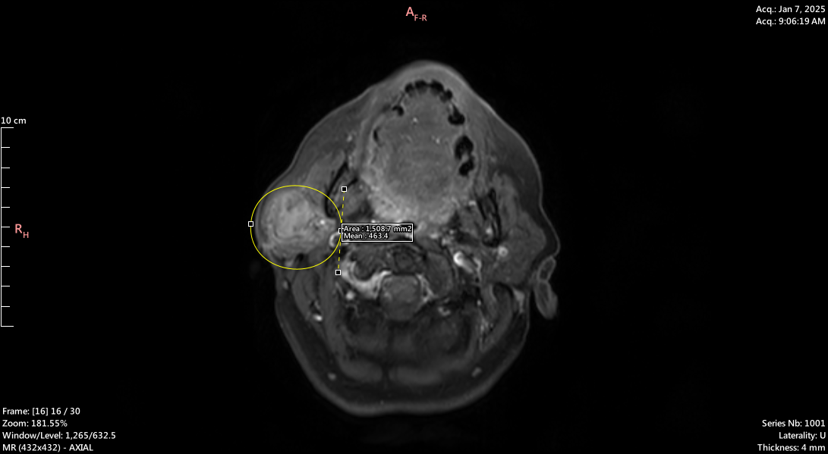

Fig. 5. MRI T1W reveal irregular mass in the right parotid gland (yellowish circle)

The treatment plan included total parotidectomy, facial nerve preservation and selective neck dissection level 2A (Fig.6).

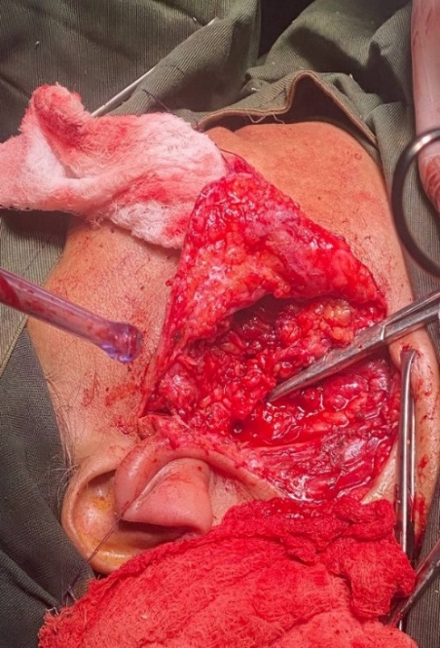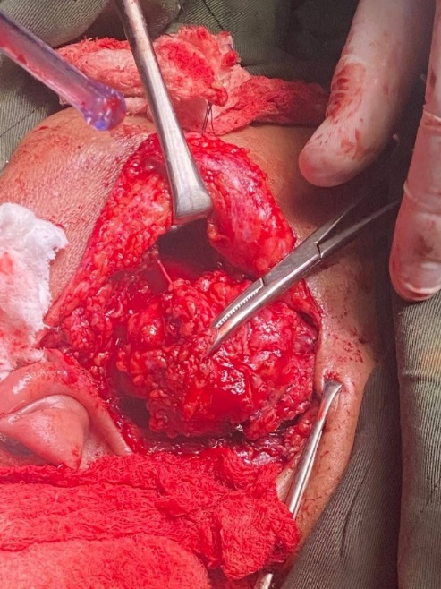

C

B

A

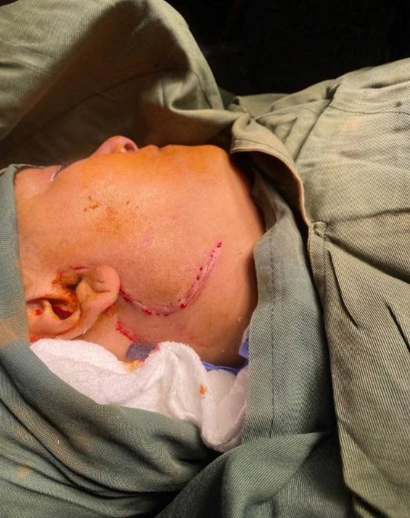

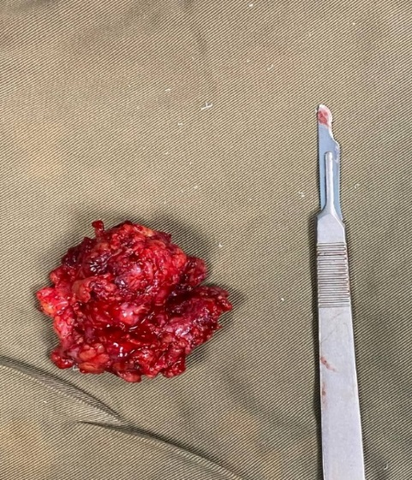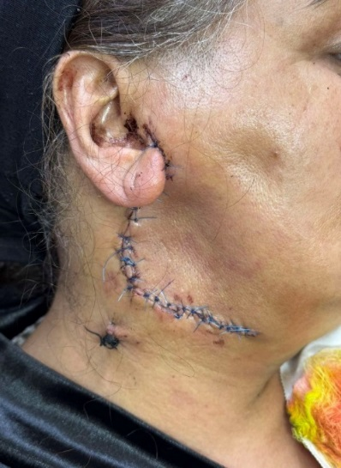

D

E

Fig .6. (A) Skin marking with previous surgery.(B) tumor within parotid bed.(C) complete clearance of the parotid bed with preservation of facial nerve and selective lymph node level 2A dissection.(D) tumor specimen.(E) post-operative closure.

Histological examination shows invasive carcinoma, completely excised with a free surgical margin 4mm all around, with no evidence of lymph nodes involvement. histopathological staging( stage II,pT2 N0 M0) according to the American joint committee on cancer 8th edition

Day one post-operative facial nerve function was intact except for the marginal mandibular nerve branch which was resected with the tumor

The patient was discharged on day one in stable condition and was sent for radiotherapy as part of treatment (Fig.7).

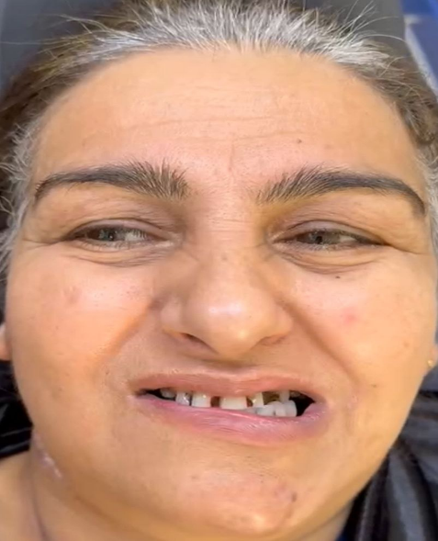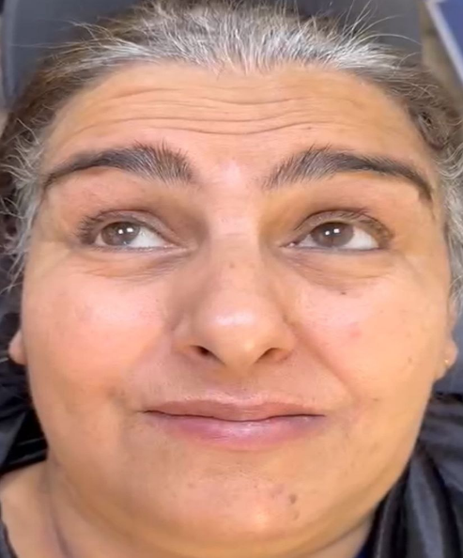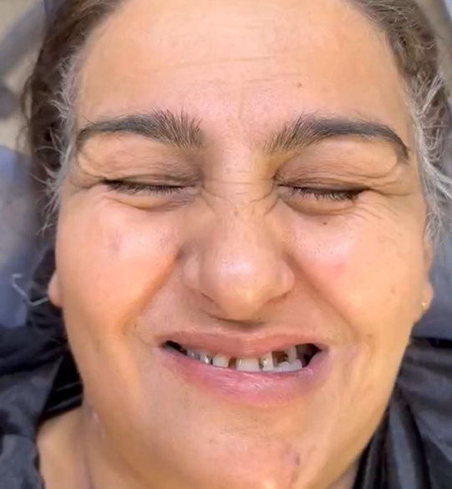

Fig .7. One week post-operative intact facial nerve branch except marginal mandibular nerve.

**4. DISCUSSION**

Malignant salivary gland tumors are rare neoplasms that present therapeutic challenges, particularly in recurrent cases [6]. Recurrence rates of malignant salivary gland tumors demonstrate significant variation based on the length and method of follow-up [7]. Fortunately, parotid recurrences most commonly present as local recurrences and less commonly as distant recurrences [6]. Malignant salivary gland tumor are quit challenging as they can be misdiagnosed as benign tumors [8]

In these two cases there was unappropriated management resulting in recurrence, the first challenge was fibrosis which made it difficult to differentiate between the tumor and the fibrotic tissue. This, in turn made complete tumor eradication challenging. Additionally, fibrosis promotes a tumor microenvironment which significantly enhancing cancer behavior and acting as a physical barrier to chemotherapy [9, 10]. In both cases, the marginal mandibular nerve was surrounded by the tumor due to altered anatomical planes from previous surgery.as a result, tumor removal could not be performed without sacrificing the nerve, leading to aesthetic and functional deformities that affected the patients, quality of life [11].

Incomplete tumor excision disrupts both the tumor and the surrounding normal tissue, leading to tumor cell seeding into healthy tissue and metastasis to other sites [12]. One of the most significant impacts of tumor recurrence is its effect on the patient’s psychological condition, often leading to depression, loss of hope for healing, anxiety, and fear of death [13]. Recurrent malignant salivary gland tumors are considered high risk tumor so aggressive treatment is required in almost all cases with adjuvant radiotherapy to gain sufficient local control and disease free outcomes [14, 15]. For all these challenges and implications, the importance of pre-surgical planning for salivary gland tumors is highlighted. This involves a thorough diagnostic work-up, including imaging and fine needle aspiration cytology (FNAC), which are critical for accurate tumor characterization and surgical strategy. Imaging studies, such as MRI or CT scans, provide detailed information about tumor size, location, extension, and its relationship to surrounding structures, including the facial nerve and lymph nodes. This helps determine the extent of resection needed and plan for facial nerve preservation or lymph node dissection if necessary [16,17]. FNAC plays a crucial role in confirming the diagnosis of malignancy, distinguishing between benign and malignant tumors, and providing valuable information on tumor histology, which can guide the surgical approach [18]. Together, imaging and FNAC contribute to a comprehensive pre-surgical assessment, ensuring the surgical team has all the necessary information to plan an effective and individualized treatment strategy. This planning minimizes risks, optimizes surgical outcomes, and supports decisions about adjuvant treatments, such as radiotherapy, ultimately improving the patient's overall prognosis and quality of life.

**5. CONCLUSION**

Recurrent malignant salivary gland and their complications can be avoided through accurate preoperative assessment, including thorough history taking, clinical examination, and investigations such as MRI, CT scan, and fine needle aspiration cytology, This approach ensures an accurate diagnosis and allows for the selection of the most appropriate surgical and adjuvant treatments when indicated.

**Ethical Considerations**

Compliance with ethical guidelines

Informed consent was obtained from patients, to publish these cases for academic purpose.

**ETHICAL APPROVAL**

As per international standards or university standards written ethical approval has been collected and preserved by the authors

**DISCLAIMER (ARTIFICIAL INTELLIGENCE):**

Author(s) hereby declare that NO generative AI technologies such as Large Language Models (ChatGPT, COPILOT, etc) and text-to-image generators have been used during writing or editing of this manuscript

**COMPETING INTERESTS**

Authors have declared that no competing interests exis

**References**

1. Bell, R. B., Dierks, E. J., Homer, L., & Potter, B. E. (2005). Management and outcome of patients with malignant salivary gland tumors. *Journal of oral and maxillofacial surgery*, *63*(7), 917-928.‏.

2. Mehanna, H., Kong, A., & Ahmed, S. K. (2016). Recurrent head and neck cancer: United Kingdom national multidisciplinary guidelines. *The Journal of Laryngology & Otology*, *130*(S2), S181-S190.‏

3. Merdad, M., Richmon, J. D., & Quon, H. (2016). Management of Recurrent Malignant Salivary Neoplasms. *Advances in Oto-rhino-laryngology*, *78*, 168-174.‏

4. Lee, Y. Y. P., Wong, K. T., King, A. D., & Ahuja, A. T. (2008). Imaging of salivary gland tumours. *European journal of radiology*, *66*(3), 419-436.‏

**5.** Shah, J. P. (2020). Head and neck oncology and surgery (5th ed.). Elsevier..

6. Nachtsheim, L., Jansen, L., Shabli, S., Arolt, C., Quaas, A., Klussmann, J. P., ... & Wolber, P. (2025). Recurrence after primary salivary gland carcinoma: Frequency, survival, and risk factors. *Head & Neck*, *47*(1), 47-56.‏

7. Prekazi-Loxha, M., Rusinovci, S., & Stubljar, D. (2019). Rates of tumour recurrences and metastases after surgical removal of malignant salivary gland tumours throughout 5-years of follow-up: a retrospective single-centre study. *Oral and Maxillofacial Surgery Cases*, *5*(3), 100105.‏

8. Peravali, R. K., Bhat, H. H. K., Upadya, V. H., Agarwal, A., & Naag, S. (2015). Salivary gland tumors: a diagnostic dilemma!. *Journal of maxillofacial and oral surgery*, *14*, 438-442.‏

9. Chandler, C., Liu, T., Buckanovich, R., & Coffman, L. G. (2019). The double edge sword of fibrosis in cancer. *Translational Research*, *209*, 55-67.‏

10. Chen, H., Xu, X., Li, J., Xue, Y., Li, X., Zhang, K., ... & Li, M. (2024). Decoding tumor-fibrosis interplay: mechanisms, impact on progression, and innovative therapeutic strategies. *Frontiers in Pharmacology*, *15*, 1491400.‏.

11. Kudva, A., Babu, K., Saha, M., Puri, S., Pandey, L., & Gunashekhar, S. (2021). Marginal mandibular nerve—a wandering enigma and ways to tackle it. *The Egyptian Journal of Otolaryngology*, *37*, 1-20.‏

12. Alieva, M., van Rheenen, J., & Broekman, M. L. (2018). Potential impact of invasive surgical procedures on primary tumor growth and metastasis. *Clinical & experimental metastasis*, *35*, 319-331.‏

13. Smith, H. R. (2015). Depression in cancer patients: Pathogenesis, implications and treatment. *Oncology letters*, *9*(4), 1509-1514.‏

14. Gillespie, M. B., Albergotti, W. G., & Eisele, D. W. (2012). Recurrent salivary gland cancer. *Current treatment options in oncology*, *13*, 58-70.‏

15. Lin, C. C., Tsai, M. H., Huang, C. C., Hua, C. H., Tseng, H. C., & Huang, S. T. (2008). Parotid tumors: a 10-year experience. *American journal of otolaryngology*, *29*(2), 94-100.‏

16. Coudert, H., Mirafzal, S., Dissard, A., Boyer, L., & Montoriol, P. F. (2021). Multiparametric magnetic resonance imaging of parotid tumors: a systematic review. *Diagnostic and Interventional Imaging*, *102*(3), 121-130.‏

17. Thakkar, M., Brahmbhatt, P., & Raychaudhuri, C. (2017). Evaluation of salivary gland tumors by ultrasonography and CT-scan.‏

18. Dhanani, R., Iftikhar, H., Awan, M. S., Zahid, N., & Momin, S. N. A. (2020). Role of fine needle aspiration cytology in the diagnosis of parotid gland tumors: analysis of 193 cases. *International Archives of Otorhinolaryngology*, *24*(04), e508-e512.‏