**Case Report**

**Refracture and Realignment of a Malunited Mandibular Fracture: A Case Report**

**Abstract**

The main goal of reconstructing mandibular fractures is achieving high stability at the fracture lines as well as prevention of possible complications. Recent studies have evaluated the post-operative complications of reduction and fixation of mandibular fractures; nonunion, malunion, infection, wound dehiscence and metal failure (in cases of open reduction and internal fixation (ORIF). Risk factors which could contribute in the formation of such complications include; panfacial fractures, external wound severity, incisional approach, premature restoration of full masticatory functions as well as general conditions deferring the healing process e.g., diabetes mellitus, immunosuppressive drugs and alcoholism. Our article is devoted to discuss the outcomes of reconstruction of an old malunited mandibular fracture in a 28-years-old male patient by refracture and re-stabilization using intermaxillary mandibular fixation (IMF). The management plan takes inconsideration restorion of normal occlusion, stability at the fracture lines, and preventing the risk factors that lead to the fracture malunion and malocclusion. This strategy, which emphasized a multidisciplinary approach combining surgical competence and patient-specific factors, had positive results accomplishing anatomical reduction and mastication with positive results. The Post-operative anatomy, with proper occlusion enabled the patient to tolerate a normal diet with no complications.

**Keywords.** Mandibular fracture, malocclusion, malunion, intermaxillary fixation.

**Introduction**

A mandibular fracture is a disorder of discontinuity of the mandibular bones brought on by pathological circumstances or facial trauma. Despite the mandible's higher resistance to impact forces than other face bones, mandibular fractures are very common. Traffic accidents represents about (40–42%) of the leading causes of maxillofacial fractures, in addition to falls, assault, sports injuries, and occupational injuries. Males are much more subjected than females (5:1) with average ages withing the second and third decades of age respectively [1-3].

Based on their anatomical location, mandibular fractures can be categorized as follows: coronoid process (1–2%), ramus (2–4%), condyle (20–26%), angle (15–26%), symphysis/parasymphysis (30–50%), and body (21–36%). The treatment of face bone fractures has changed significantly as the medical field has advanced. Costello first thoroughly detailed the diagnosis and treatment of mandibular trauma in 1975[4-6].

In general, the average rate of complications following mandible fracture fixation is 58%. Open reduction and internal fixation (ORIF) of mandibular fractures leads to rapid improvement of stability, more rapid healing, and faster recovery incomparison to intermaxillary fixation, yet, it elevates the risk of infection with an average rate about 12.5% due to the placement of foreign materials at the fracture site, in addition, there is no single empirical peri-operative antibiotic thereby could be effective against all endogenous flora, and even may allow for opportunistic infection of resistant bacteria [7,8].

The incidence of postoperative malunion (2.9%), malocclusion (7.6%), and unplanned reoperation (9.5%). Alcohol use, smoking at the time of surgery, displaced fractures >2 mm and patients with highMethotrexate Intolerance Severity Score (MISS) were significant risk factors for postoperative complications following mandibular fracture reduction [9,10].

**Case report**

A 28-year-old male patient who was operated by our team one year ago due to a bilateral parasymphyseal mandibular fracture due to an assault during a quarrel. The patient was operated by closed reduction (MMF). The patient had been discharged after a week after restoring his normal occlusion. During the follow-up after discharge, the patient didn’t regularly attend the scheduled visits at the outpatient clinic, furthermore, he independently removed the elastic materials after 2 weeks and started eating solid foods without refereeing to us, indeed he is also a heavy smoker. One month following discharge, he attended our outpatient clinic complaining from oral malocclusion and dripping of food and fluids during mastication. By examination, the patient had mild facial edema [Figure 1] with increased mandibular right-angle volume [Figure 2].

By Oral examination; we found a malocclusion deformity; Anterior open bite [Figure 3] extending to the level of the first premolars bilaterally disfiguring the face with difficult chewing and drippling of food, fluid and even saliva as described by the patient. Panorama x-ray revealed the presence of non-united fracture line between the canine and first premolar at the right side of the mandible, malunited fracture line between the canine and first premolar at the left side of the mandible, beside spacing of the segment in between, resulting in anterior open bite [Figure 4].

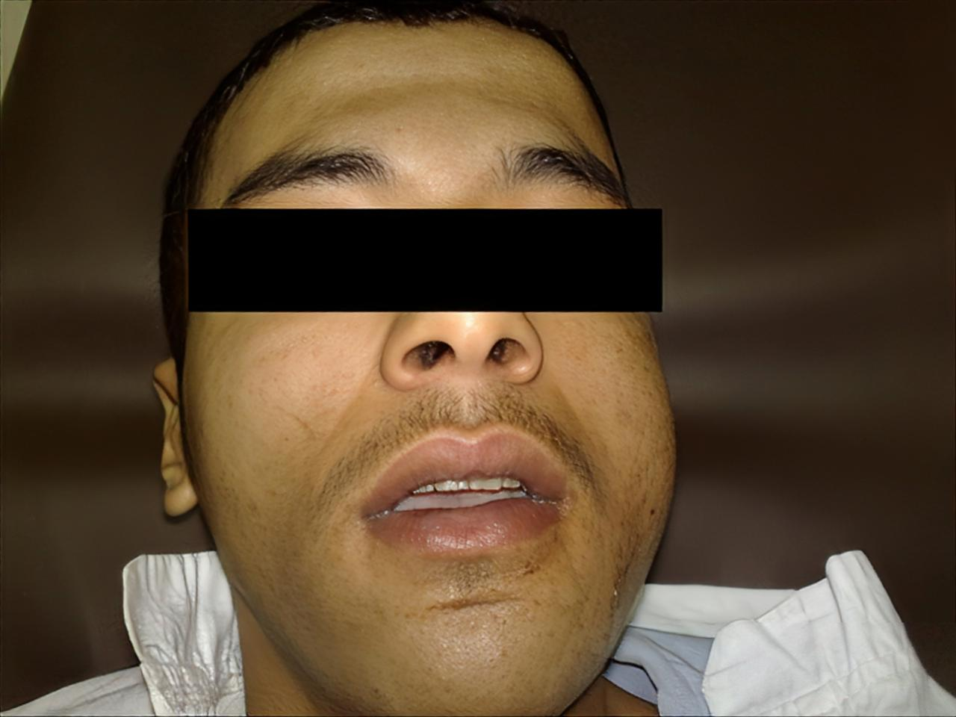

**Figure 1.** Facial edema.

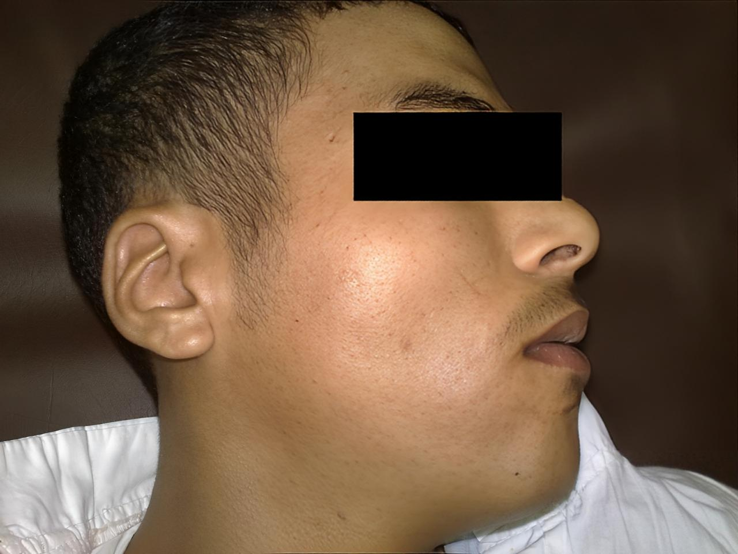

**Figure 2.** Increased mandibular right-angle volume.

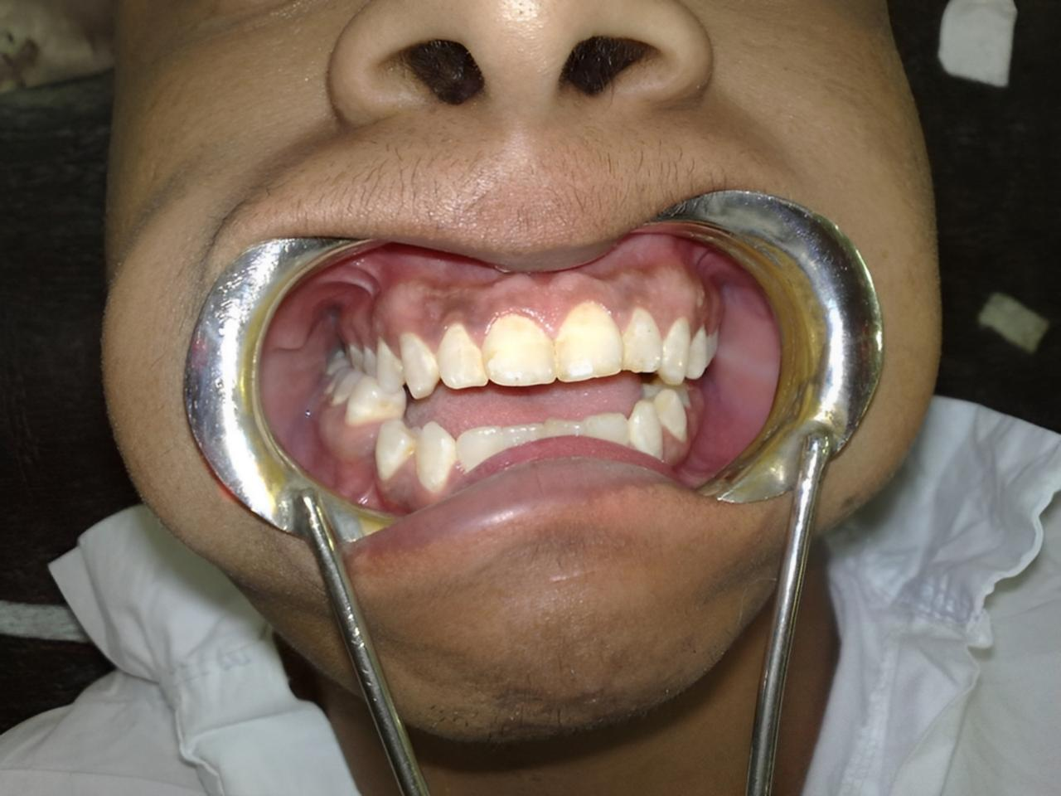

**Figure 3**. Anterior open bite extending to the level of the first premolars bilaterally.

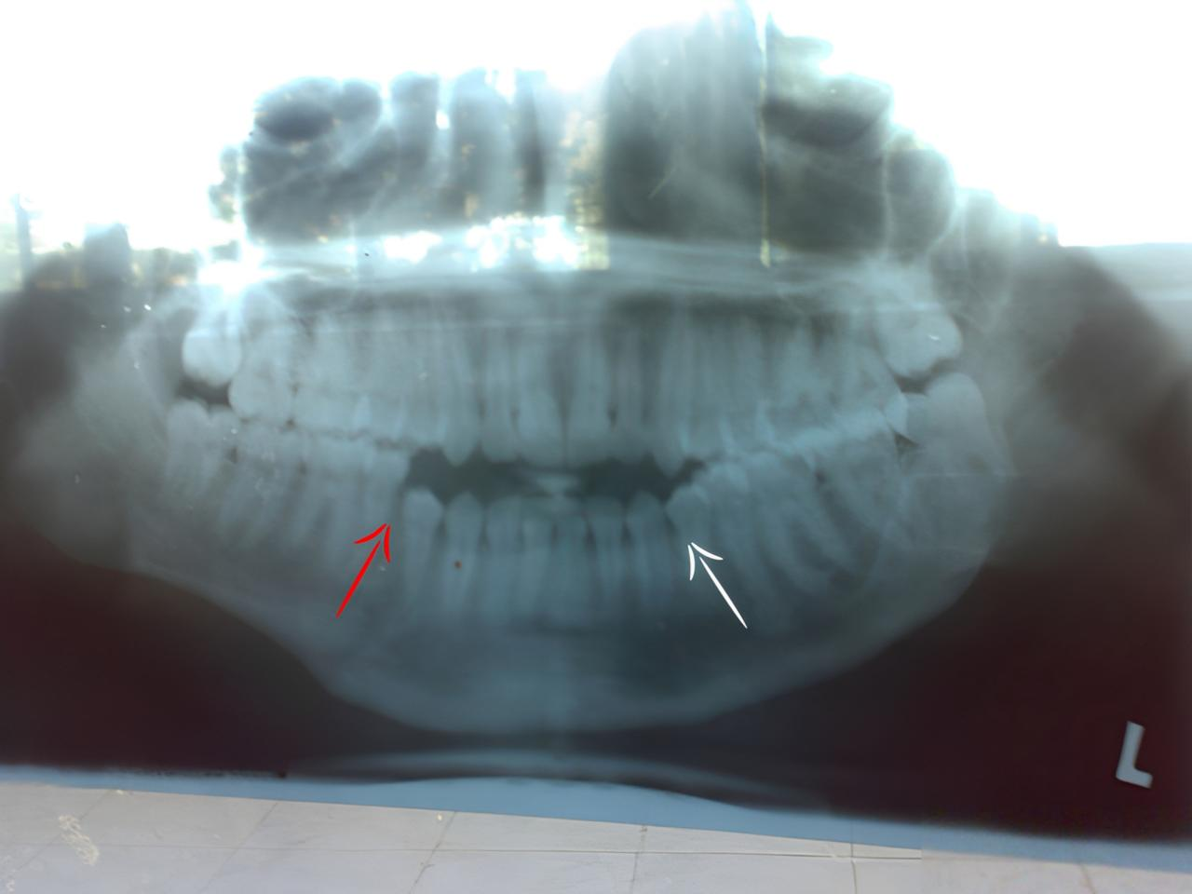

**Figure 4**. Panorama X-rays showing presence of non-united fracture line between the canine and first premolar at the right side of the mandible (Red arrow), malunited fracture line between the canine and first premolar at the left side of the mandible (White arrow) and anterior open bite in-between.

**Surgical technique and Management**

After preparation and under general anathesia with nasal intubation, refracture of the old malunited fracture lines was achieved by hammer and chisel [Figure 5] freeing both ends of the fracture lines, followed by debridement of the freed lines from the embedded soft tissues. The mandible was manually reduced restoring the normal occlusal line eliminating the deformity. The fractures were refixed probably by closed reduction by maxillary mandibular fixation (MMF), oral pack was removed and the oral cavity was closed using elastic materials [Figure 6].

Operative-time: 1 hour.

Following a smooth extubation in the operating room, the patient was transferred to the observation area in the recovery area. Postoperative panorama revealed normal oral occlusion with no deformity [Figure 7].

Oral fluids were started through the retromolar space four hours later. The postoperative pain was effectively managed with IV perfalgan solution. Amoxicillin-clavulanate and metronidazole were given intravenously for 48 hours following surgery. The patient was discharged on the 5th day.

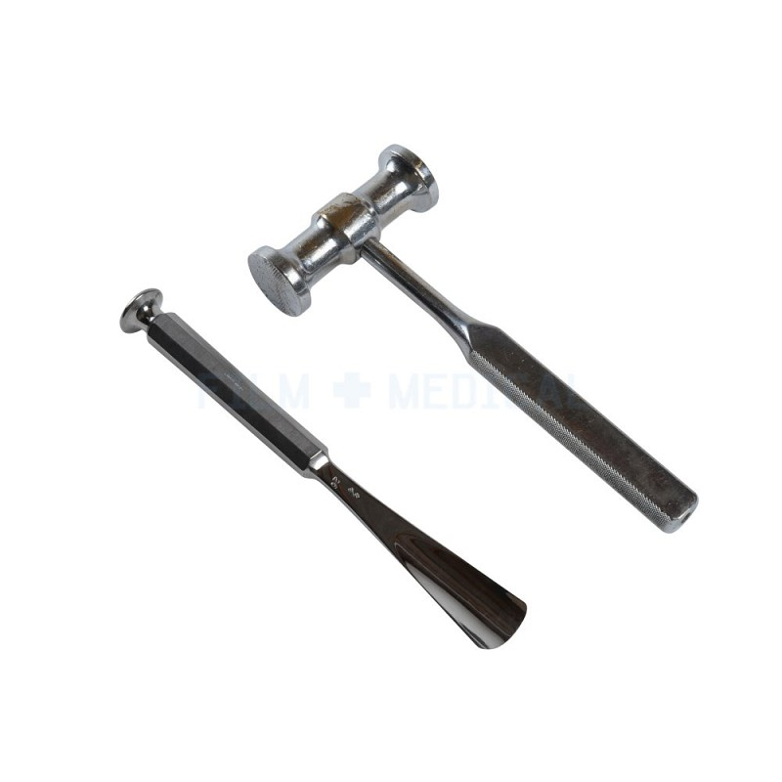

**Figure 5.** Surgical hammer and chisel.

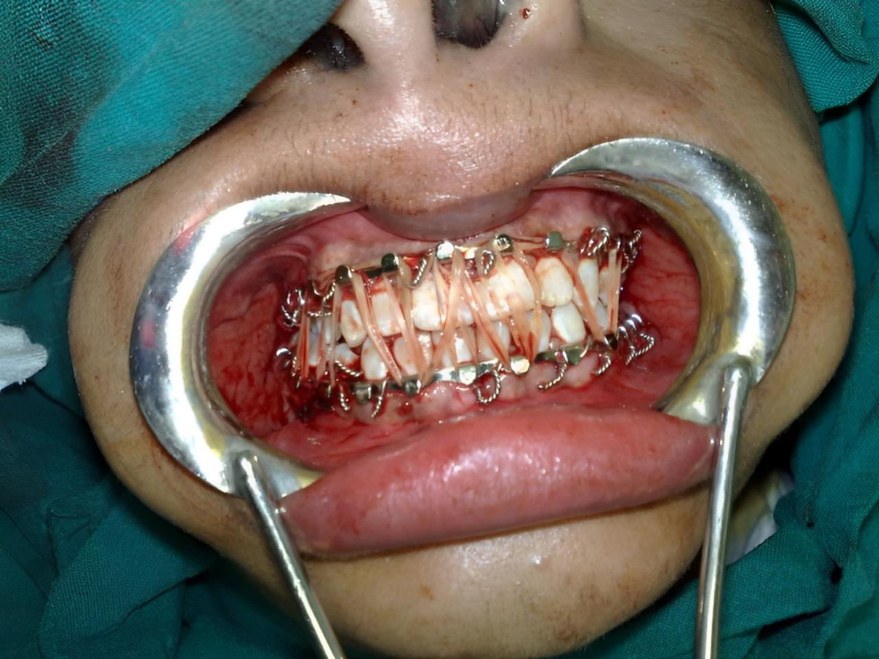

**Figure 6.** MMF and closing the oral cavity using elastic materials after eliminating the deformity with restorion of normal oral occlusion.

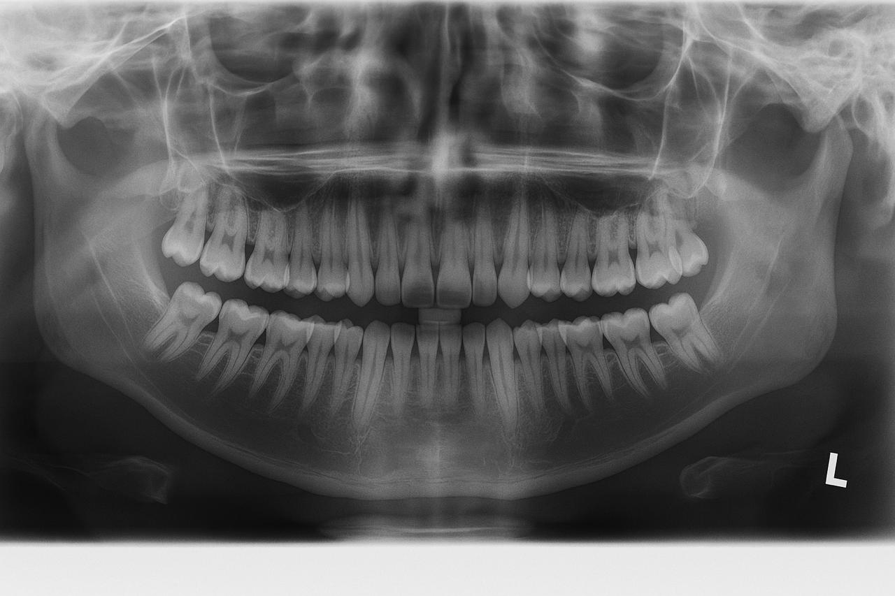

**Figure 7.** Postoperative panorama revealed normal oral occlusion.

**Results**

The patient attended regular visits at the outpatient clinic, followed the instructions in order to avoid re-deformity. The elastic materials were taken off in the outpatient clinic after one month. The patient started eating semisolid foods. The metals were removed 2 weeks later. Proper occlusion enabling to tolerate a normal diet was achieved successfully [Figure 8]. After all functional and aesthetic aspects were fully restored, the patient returned to his pre-injury way of life.

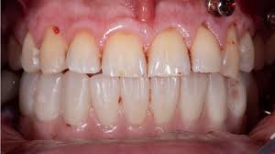

**Figure 8.** Post-operative anatomy. Proper occlusion enabling to tolerate a normal diet.

**Discussion**

Inspite that the postoperative instructions which have been explained to the patient by one of our surgical team members, and were also clearly written in the patient’s follow-up card ; maintenance of regular oral hygiene, attendance of regular checks at the outpatients’ clinic, avoidance of premature removal of the elastic metatrails until removed by our team 1 month postoperatively , avoidance of premature feeding of semisolids and solid foods till after removal of the elastic materials by 2 and 4 weeks respectively with avoidance of smoking during the short-term follow-up or at least decrease the number of smoked cigarettes, the patient had neglected the above mentioned instructions, besides he didn’t made any follow-up panoramas in order to assess the healing process, all these factors togther have created the ideal circumstances for postoperative mandibular malunion. After few months, the patient started to complain from drippling of food, fluids and saliva respectively, pain accompanying mastication, till he has developed the mentioned deformity; the anterior open bite due to malunion of his bilateral mandibular fractures. After six months, the patient finally attended our outpatients’ clinic. Panorama x-rays was done, which revealed the presence of a non-united fracture line between the canine and first premolar at the right side of the mandible and malunited fracture line between the canine and first premolar at the left side of the mandible with an anterior open bite in-between. The patient was reinstructed to attain regular follow-ups with us for one whole year till bone healing was achieved completely with the avoidance of the risk factors of recurrence, in addition to improvement of his healing process through the adjustment of his minerals’ profile; hypocalcemia and giving him dietary supplements consisting of multivitamins and minerals. This strategy had qualified the patient to the next step; refracture the malunited old fracture and archive a stable alignment at the fracture line after one year of the operation.

In case of postoperative infection, failure to use antibiotics is not a risk factor for causing malunion or other healing complications, on the other hand, and drug abuse delay the process of healing [11]. On the other hand, In the study of Hsieh, Tsung-yen, et al., that was carried on patients with postoperative complications following mandibular fracture fixation; Wound dehiscence and/or surgical site infection, bony nonunion, and hardware exposure, it was found that in nearly 65% of the patients who was treated conservatively using antibiotics without surgical intervention, required a return to the operating room for incision and drainage, hardware removal, or revision open reduction with internal fixation of fractures [12].

**Conclusion**

Avoiding the risk factors of postconstruction deformities beside refracture of malunited fractures with proper realignment and reduction-fixation is the ideal strategy of mangment of malunited mandibular fractures.

**CONSENT**

Patient’s informed written consent was taken to publish his case for academic purpose.

**ETHICAL APPROVAL**

As per international standards or university standards written ethical approval has been collected and preserved by the authors.

**DISCLAIMER (ARTIFICIAL INTELLIGENCE)**

Authors hereby declare that NO generative AI technologies such as Large Language Models (ChatGPT, COPILOT, etc.) and text-to-image generators have been used during the writing or editing of this manuscript.

**References.**

1. Salem, S., Mekhaeel, M. S. F., Protasov, A., Nada, T., Mohamed, A., & Noureldin, S. (2024). Outcomes of a pediatric facial fracture reconstruction: Case report. *Archiv Euromedica*, 14(6), 1-8. <https://doi.org/10.35630/2024/14/6.604>
2. Iyer J, Hariharan A, Cao UMN, Tran SD. Acquired Facial, Maxillofacial, and Oral Asymmetries—A Review Highlighting Diagnosis and Management. *Symmetry*. 2021; 13(9):1661. <https://doi.org/10.3390/sym13091661>
3. Almeida, Rafael Santiago de, Willian Caetano Rodrigues, Marco Túllio Becheleni Ávila Guimarães, Saulo Gabriel Moreira Falci, Shajadi Carlos Pardo Kaba, Eduardo Hochuli Vieira, and Élio Hitoshi Shinohara. 2024. “Three-Dimension Grid Plate Effecting in Mandibular Fracture Fixation”. *Archives of Current Research International* 24 (10):205-12. https://doi.org/10.9734/acri/2024/v24i10923
4. Sneha A, Pendem S, Krishnan M, Dhasarathan P, Aravindan V. Impacted Mandibular Fracture: A Report of a Rare Case. Cureus. 2023:14;15(5):e38999. https://doi.org/10.7759/cureus.38999
5. Sameh, Salem, Mohamed Ahmed Eissa, Mekhaeel, Shehata Fakhry Mekhaeel, Protasov, Vitalevitch Andrey, Taha, Nada Ahmed Mohamed Elsayed, and Elshliby, Abdelrahman Gomaa Zaky. 2025. “Management of Pediatric Fracture Mandible by Closed Reduction Technique: A Case Report”. Asian Journal of Case Reports in Surgery 8 (1):119-26. <https://doi.org/10.9734/ajcrs/2025/v8i1609>
6. Mekhaeel, Mekhaeel, Shehata Fakhry, Salem, Mohamed Ahmed Eissa Sameh, Protasov, Vitalevitch Andrey, Elshliby, Abdelrahman Gomaa Zaky, and Taha, Nada Ahmed Mohamed Elsayed. 2025. “Rehabilitation of Pediatric Mandibular Fracture Following Dashboard Injury: Case Report”. Asian Journal of Case Reports in Surgery 8 (1):155-61. https://doi.org/10.9734/ajcrs/2025/v8i1616
7. Odom E, Snyder-Warwick A.  Mandible Fracture Complications and Infection*. Plastic and Reconstructive Surgery.* 2016;138(2), 282e–289e*.* https://doi.org/10.1097/prs.0000000000002
8. Shakir A, Abate D, Tebeje F, Weledegebreal F. Magnitude of Surgical Site Infections, Bacterial Etiologies, Associated Factors and Antimicrobial Susceptibility Patterns of Isolates Among Post-Operative Patients in Harari Region Public Hospitals, Harar, Eastern Ethiopia. *Infection and Drug Resistance*. 2021;*14*,4629–4639. <https://doi.org/10.2147/IDR.S329721>
9. Resnick B, Hassan B, Er S, Pope B, Lamaris G, Grant M, Pan J. Risk Factors for Postoperative Complications Following Mandibular Fracture Repair. The Journal of Craniofacial Surgery 36(1):p 66-70, January/February 2025. <https://doi.org/10.1097/SCS.0000000000010759>
10. Kabil H, Sherif N, Elhusseiny, M, et al*.* Validation of Methotrexate Intolerance Severity Score (MISS) questionnaire to measure methotrexate intolerance among rheumatoid arthritis Egyptian patients. *Egypt Rheumatol Rehabil*. 2024;51, 27. <https://doi.org/10.1186/s43166-024-00261-w>
11. Furr, A. M., Schweinfurth, J. M., & May, W. L.  Factors Associated with Long-Term Complications after Repair of Mandibular Fractures. *The Laryngoscope.* 2006;116(3), 427–430*.* <https://doi.org/1097/01.mlg.0000194844.87>
12. Hsieh, Tsung-yen, et al. "Risk factors associated with complications after treatment of mandible fractures." *JAMA facial plastic surgery*. 2029;21.3:213-220. [https://doi.org/10.1001/jamafacial.2018.183](https://doi.org/10.1001/jamafacial.2018.1836)