**Birdshot's chorioretinopathy in a young patient with a good response to the combination of corticosteroids and cyclophosphamide**

**Abstract :**

Birdshot's chorioretinopathy is a well-known form of posterior uveitis, often chronic, bilateral and of unknown etiology. Its prevalence varies between 0.69 and 1.73 cases per 100,000 population. It is characterized by multiple, distinctive, hypopigmented choroidal lesions, and is strongly associated with human leukocyte antigen (HLA)-A29. The mean age at presentation is 53 years, with a slight female predominance (54.1%). It is a slowly progressive disease accompanied by profound visual dysfunction that may not be reflected by visual acuity unless associated macular edema is present. We report the case of a young 21-year-old patient who presented for an etiological work-up of bilateral ocular involvement with profound visual acuity impairment probably complicating macular edema, and in whom the diagnosis of Birdshot chorioretinopathy was retained with HLA A29 positive after exclusion of other etiologies of posterior uveitis and who responded well to a combination of corticosteroid boluses and cyclophosphamides relayed by azathioprine**.**

The incidence of Birdshot chorioretinopathy in young is rare so this article throws light to consider birdshot chorioretinopathy as cause of posterior uveitis in young; as well as the efficacy of the combination of corticosteroids and cyclophosphamides in this pathology whose treatment is not consensual.

**Keywords :** Birdshot chorioretinopathy, posterior uveitis, HLA-A29, corticosteroid, cyclophosphamide, azathioprine.

**Introduction :**

Birdshot chorioretinopathy (BCR) is presumably an auto-immune disease of the eye. It is a rare form of posterior uveitis, often chronic, bilateral and of unknown etiology. Its prevalence varies between 0.69 and 1.73 cases per 100,000 population. It usually occurs in the fifth decade of life with a slight female predominance (54.1%) (1). « The exact pathogenesis remains poorly understood, but the disease is strongly associated with the human leucocyte antigen (HLA)-A29 allele » (2).  « Histologic analyses of eyes with BCR revealed non-granulomatous nodular infiltration of the choroid and lymphocytic infiltrates » (3) (4). « The disease is strictly localized to the eye, characterized by multiple, distinctive, hypopigmented [choroidal lesions](https://www.sciencedirect.com/topics/pharmacology-toxicology-and-pharmaceutical-science/choroid-disease" \o "Learn more about choroidal lesions from ScienceDirect's AI-generated Topic Pages), with no extraocular manifestations or systemic disease associations » (5).

BCR is rarely observed in young patients. We report the case of a young patient with Birdshot chorioretinopathy, confirmed by ophthalmological examinations and genetic study, which progressed well under corticosteroid therapy and cyclophosphamid relayed by azathioprine for 2 years .

**Case report :**

A 21-year-old patient with no specific pathological history admitted for etiological assessment of nyctalopia and bilateral ocular damage consisting of visual acuity at 2.0 logMAR bilaterally. On angiography, multiple whitish ovoid choroidal plaques of peripapillary arrangement with hyperfluorescence of retinal vessels (Figure 1,3), associated with macular edema confirmed on optical coherence tomography (OCT) macular (Figure 2,4).

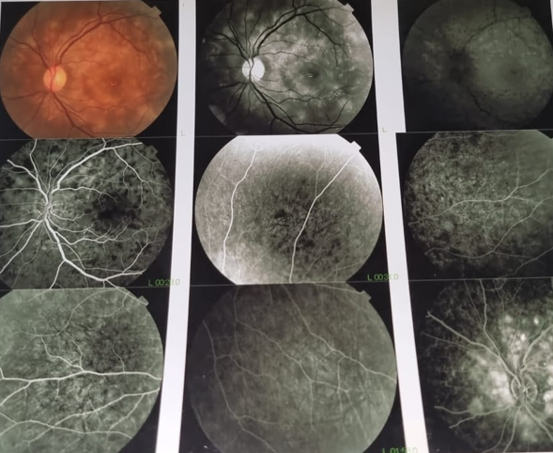

Figure 1 : initial angiographic appearance of the left eye

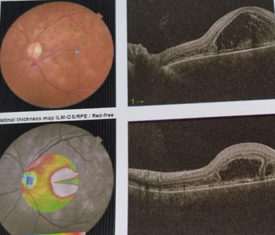

Figure 2 : diffuse macular edema on OCT of the left eye

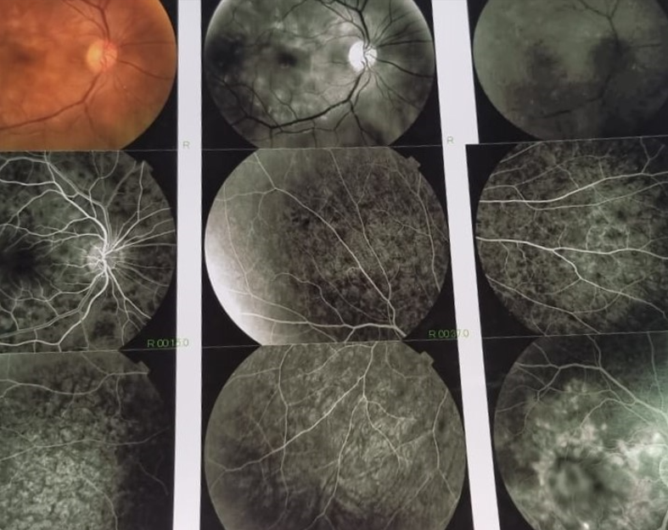

Figure 3 : initial angiographic appearance of the right eye

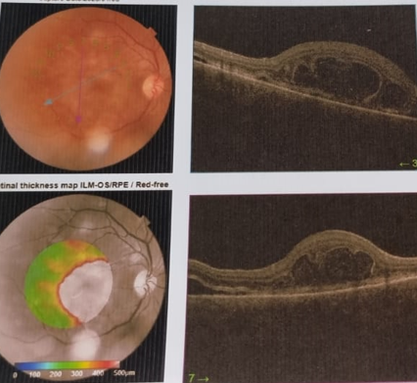

Figure 4 : diffuse macular edema on OCT of the right eye

The questioning and clinical examination did not reveal any associated extraocular signs in favor of an infectious or inflammatory origin. Given this picture, an infectious origin, notably viral (HSV, EVB, CMV, HIV, HVB, HVC), syphilitic, toxoplasmic or tuberculosis, was first ruled out, with a negative immunological and sarcoidosis work-up. A work-up in the sense of Vogt-Koyanagi-Harada disease, consisting of brain imaging, lumbar puncture and audiogram, was unremarkable. Genetic studies revealed the presence of HLA A29, confirming the diagnosis of Birdshot chorioretinopathy. In view of the severity of ocular damage, the patient received 3 boluses of methylprednisolone 1g and 3 boluses of cyclophosphamide 1g monthly, followed by corticosteroid therapy of 20mg/day with gradual tapering and azathioprine 150mg/day for 2 years. Visual acuity improved: 0.0 logMAR bilaterally, with complete regression of macular edema and improvement in angiographic control signs (figure 5,6) after 2 years of treatment.

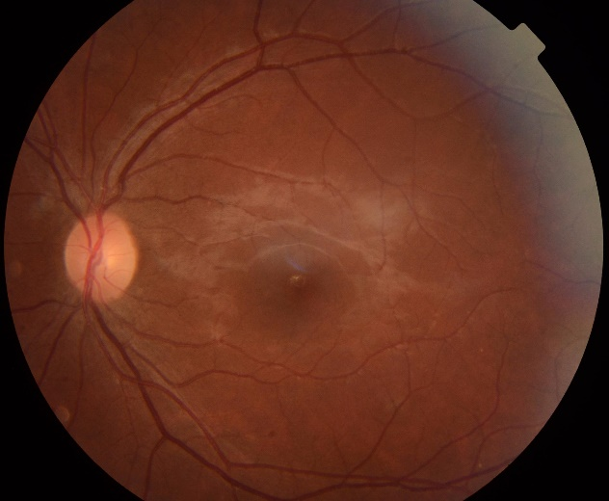

Figure 5 : control retinography of the left eye 2 years after the start of treatment

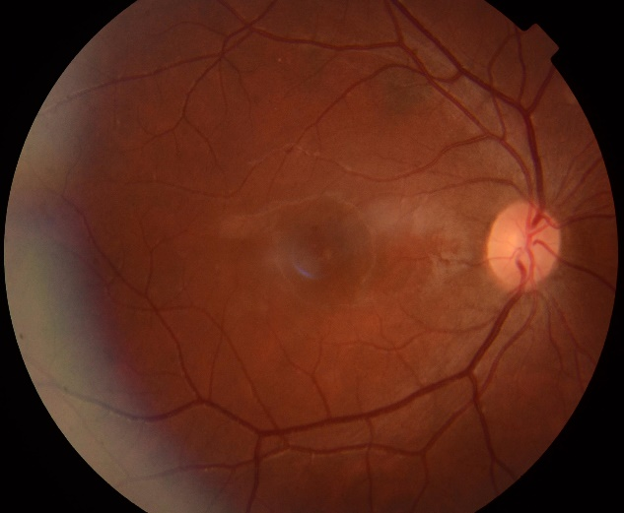

Figure 6 : control retinography of the right eye 2 years after the start of treatment

**Discussion :**

Birdshot chorioretinopathy (BSCR) is a relatively rare subtype of noninfectious posterior uveitis.

« The typical BSCR patient is a Caucasian female in the third to sixth decade of life. In a systematic review of over 500 patients, the mean age of presentation was 53 years » (5). Unlike what has been reported in the literature, our patient is a young male. Children and adolescents are rarely affected. A review of the literature revealed at least seven previous paediatric cases, but these were not well described, with insufficient examination findings to support the clinical diagnosis. The youngest was a 6-year-old child, five patients were under 16 years of age and one case was 15 years old, all of which have been reported in various journals (5) (6).

The BCR « is strongly correlated with the human leukocyte antigen (HLA)-A29 allele even though this is not required for the diagnosis » (7). Its clinical diagnosis is « based on the following features: bilateral disease, low grade or absent anterior segment inflammation, low grade to moderate vitreous inflammation, and yellow-white choroidal spots known as “birdshot lesions” clustered around the optic nerve and radiating towards the periphery » (8). In our case, the clinical picture was consistent with BCR and the positive HLA-A29 confirmed our clinical diagnosis.

In most patients, visual acuity declines very slowly, but remains fairly well preserved overall. macular edema is the main cause of visual acuity deterioration, as in our patient's case.

Several infectious or inflammatory pathologies can mimic the signs of BSCR, particularly in the early stages of the disease. the presence of systemic signs, granulomatous precipitates, synechiae, or a hypopyon theoretically exclude the diagnosis, and should suggest another etiology, such as sarcoidosis, tuberculosis, syphilis, or vogt-koyanagi-Harada (9). An exaustive work-up in the sense of infectious and inflammatory etiologies was fairly negative, which led to the suspicion of BSCR, which was finally confirmed.

« Systemic corticosteroids are commonly used in the management of acute inflammatory manifestations of the disease. However, their efficacy is limited for long-term control of the disease at a low dose, and their side effects prevent their long-term use at a high dose » (10). « They are usually associated with an immunosuppressive or biological drug, allowing the tapering of oral corticosteroid to a level which is safe for long-term use (<7.5 mg/d). The immunosuppressive drugs can be used alone or in combination in refractory cases » (11). « Ciclosporin is an effective treatment to maintain visual acuity and limit the disease progression » (11) (10). « However, the use of cyclosporin is limited by its side effects of nephrotoxicity and hypertension. Tacrolimus is another immunosuppressive drug inhibiting the T-cell proliferation. The safety profile of tacrolimus is better than ciclosporin in term of renal toxicity and risk of hypertension » (12). « Antimetabolites agents such as azathioprine, methotrexate, or mycophenolate mofetil (MMF) have been used as steroid sparing agents with favorable results. MMF is a widely used drug, which has been proven effective and well tolerated » (13).

« Biologic agents have been used successfully to treat BSCR. The TNF alpha inhibitors infliximab, a monoclonal chimeric antibody, and more recently adalimumab, a humanized anti-TNF alpha antibody have been used for the treatment of BSCR patients refractory to conventional immunosuppressive therapy. Daclizumab, a monoclonal antibody against the IL-2 receptor of T cells, was effective in decreasing inflammation in 8 patients with BSCR whose disease was either refractory or were intolerant to immunosuppressive therapy » (14).

« Evidence supporting the use of anti-IL6 receptor, tocilizumab, is limited to a case series showing inflammation being controlled by BCR refractory to anti-TNF-alpha treatment » (15) (16).

Despite the limited data on the efficacy of cyclophosphamide in BCR, it was decided to treat the patient with a combination of corticosteroid therapy and cyclophosphamide, due to the patient's lack of resources for biotherapy and MMF, and the severity of ocular involvement and risk of relapse of the disease with a good therapeutic response (resorption of macular edema and normalization of visual acuity). Azathioprine relay maintained the good therapeutic response of the combination of corticosteroids and cyclophosphamides.

**Conclusion :**

Birdshot uveitis is a rare but clinically significant disease that mostly affects middle-aged persons. It is a potentially severe and blinding chronic uveitis. Knowledge of the clinical picture enables an early diagnosis and, consequently, early management to avoid complications that can be irreversible. This manuscript presents a rare case of Birdshot uveitis in ayoung patient, emphasizing the need for awareness. Despite being a low-priority differential diagnosis, Birdshot uveitis should be considered in young patients with compatible clinical features.

Ethical Approval:

As per international standards or university standards written ethical approval has been collected and preserved by the author(s).

Consent

As per international standards or university standards, patient(s) written consent has been collected and preserved by the author(s).

Disclaimer (Artificial intelligence)

Option 1:

Author(s) hereby declare that NO generative AI technologies such as Large Language Models (ChatGPT, COPILOT, etc.) and text-to-image generators have been used during the writing or editing of this manuscript.

Option 2:

Author(s) hereby declare that generative AI technologies such as Large Language Models, etc. have been used during the writing or editing of manuscripts. This explanation will include the name, version, model, and source of the generative AI technology and as well as all input prompts provided to the generative AI technology

Details of the AI usage are given below:

1.

2.

3.

Références :

1. ***A.E. Yahyaoui 1, M.S. Hamdi 1, I.I. Kechaou 2, C. Eya 1, S. Azzabi 3, K. Chakib 4, A. Hariz 3, I. Boukhris 1, L. Ben Hassine 3 , Vascularite rétinienne dans la choriorétinopathie de Birdshot, La Revue de Médecine Interne Volume 43, Supplement 1, June 2022.***

**2*. Brézin, A.P.; Monnet, D.; Cohen, J.H.M.; Levinson, R.D. HLA-A29 and birdshot chorioretinopathy. Ocul. Immunol. Inflamm. 2011, 19, 397–400. [Google Scholar] [CrossRef].***

**3.  *Gaudio, P.A.; Kaye, D.B.; Crawford, J.B. Histopathology of birdshot retinochoroidopathy. Br. J. Ophthalmol. 2002, 86, 1439–1441. [Google Scholar] [CrossRef].***

**4*. Pulido, J.S.; Canal, I.; Salomão, D.; Kravitz, D.; Bradley, E.; Vile, R. Histological findings of birdshot chorioretinopathy in an eye with ciliochoroidal melanoma. Eye 2012, 26, 862–865. [Google Scholar] [CrossRef].***

**5. *Kayur H. Shah MD, Birdshot Chorioretinopathy, Survey of Ophthalmology,November–December 2005, Pages 519-541.***

**6. *P Pivetti-Pezzi, Uveitis in children, Eur J OphthalmolEur J Ophthalmol. 1996 Jul-Sep;6(3):293-8 doi: 10.1177/112067219600600313.***

**7. *Kiss S, Anzaar F, Foster C Birdshot retinochoroidopathy. Int Ophthalmol Clin 2006, 46:39–55, .***

**8. *Ralph D Levinson 1, Antoine Brezin, Aniki Rothova, Massimo Accorinti, Gary N Holland, Research criteria for the diagnosis of birdshot chorioretinopathy: results of an international consensus conference, Am J Ophthalmol. 2006 Jan;141(1):185-7. doi: 10.1016.***

**9. *Levinson, R. D., Brezin, A., Rothova, A., Accorinti, M., & Holland, G. N. (2006). Research Criteria for the Diagnosis of Birdshot Chorioretinopathy: Results of an International Consensus Conference. American Journal of Ophthalmology, 141(1), 185–187. doi:.***

**10. *Kiss, S.; Ahmed, M.; Letko, E.; Foster, C.S. Long-term follow-up of patients with birdshot retinochoroidopathy treated with corticosteroid-sparing systemic immunomodulatory therapy. Ophthalmology 2005, 112, 1066–1071.e2. [Google Scholar] [CrossRef].***

**11. *Minos, E.; Barry, R.J.; Southworth, S.; Folkard, A.; Murray, P.I.; Duker, J.S.; Keane, P.A.; Denniston, A.K. Birdshot chorioretinopathy: Current knowledge and new concepts in pathophysiology, diagnosis, monitoring and treatment. Orphanet J. Rare Dis. 2016.***

**12. *Islam, F.; Westcott, M.; Rees, A.; Robson, A.G.; Kapoor, B.; Holder, G.; Pavesio, C. Safety Profile and Efficacy of Tacrolimus in the Treatment of Birdshot Retinochoroiditis: A Retrospective Case Series Review. Br. J. Ophthalmol. 2018, 102, 983–990. [Goog.***

**13. *Doycheva, D.; Zierhut, M.; Blumenstock, G.; Stuebiger, N.; Deuter, C. Long-term results of therapy with mycophenolate mofetil in chronic non-infectious uveitis. Graefe’s Arch. Clin. Exp. Ophthalmol. 2011, 249, 1235–1243. [Google Scholar] [CrossRef] [PubMe.***

**14. *Sobrin, L.; Huang, J.J.; Christen, W.; Kafkala, C.; Choopong, P.; Foster, C.S. Daclizumab for treatment of birdshot chorioretinopathy. Arch. Ophthalmol. 2008, 126, 186–191. [Google Scholar] [CrossRef].***

**15. *Leclercq, M et al. Tocilizumab for the treatment of birdshot uveitis that failed interferon alpha and anti-tumor necrosis factor-alpha therapy, Clin Rheumatol. 2018 Mar;37(3):849-853.***

**16. *Uveitic Cystoid Macular Edema: Multicenter Study of 25 Patients, Am J Ophthalmol. 2019 Apr:200:85-94. doi: 10.1016/j.ajo.2018.12.019. Epub 2019 Jan 17.***