**Case Report**

**Werner syndrome revealed by a severe metabolic acute pancreatitis: A unique clinical observation.**

**Abstract**

Werner syndrome (WS), or adult progeria, is a rare autosomal recessive disorder characterized by premature aging and multisystem involvement. Its initial presentation through a metabolic emergency remains exceptional.

We report the case of a 41-year-old woman with a history of chronic dexamethasone use (16 years), insulin-dependent diabetes, bilateral femoral head osteonecrosis requiring hip arthroplasties, bilateral cataracts, glaucoma, osteoporosis, hypothyroidism, and uncontrolled hypertension. She was admitted for a third episode of acute pancreatitis. Imaging revealed stage E necrotizing pancreatitis. MRCP excluded a biliary cause. Serum triglyceride level was 112 g/L. The metabolic etiology was retained. Treatment included digestive rest, insulin glargine, analgesics, and antispasmodics, with clinical and biological improvement (TG = 5 g/L).

Physical examination revealed signs suggestive of WS: short stature, bird-like facies, premature graying, diffuse alopecia, cutaneous atrophy, and hallux valgus. Although genetic testing was unavailable, clinical suspicion was supported by the presence of a similarly affected sibling.

This case highlights a rare and severe metabolic manifestation of WS. It emphasizes the importance of recognizing WS in adults presenting with multisystem premature aging and atypical metabolic crises.

**Keywords:** Werner syndrome, adult progeria, hypertriglyceridemia, acute pancreatitis, aging syndromes, case report.

**Introduction**

Werner syndrome (WS) is a progeroid syndrome resulting from biallelic mutations in the WRN gene, encoding a RecQ helicase responsible for DNA repair, telomere maintenance, and replication fidelity [1]. WS leads to premature aging and multisystemic degeneration. The most common features include short stature, cataracts, type 2 or insulin-dependent diabetes, osteoporosis, early graying, and skin atrophy [2,3]. Although WS is primarily associated with chronic complications, acute metabolic manifestations, particularly pancreatitis, are extremely rare and scarcely reported [4].

Here, we present an exceptional case of WS revealed by a severe episode of hypertriglyceridemia-induced acute pancreatitis, adding to the limited data on metabolic presentations of this syndrome.

**Case Report**

A 41-year-old Moroccan woman presented to the emergency department with acute epigastric pain and vomiting. Her medical history was remarkable for:

• Chronic dexamethasone intake for weight gain (16 years)

• Insulin-dependent diabetes diagnosed at age 32

• Bilateral femoral head osteonecrosis with total hip arthroplasty

• Bilateral cataracts and glaucoma

• Osteoporosis

• Primary hypothyroidism on levothyroxine

• Poorly controlled hypertension

She had experienced two prior episodes of acute pancreatitis. Contrast-enhanced CT scan showed stage E necrotizing pancreatitis with extensive peripancreatic collections. MRCP excluded biliary involvement. Laboratory testing revealed triglycerides at 112 g/L. The diagnosis of hypertriglyceridemia-induced pancreatitis was made.

She received digestive rest, subcutaneous insulin glargine, analgesics, and antispasmodics. Her abdominal pain resolved, and triglyceride levels dropped to 5 g/L within 14 days.

On clinical examination, she had:

• Short stature (147 cm)

• Bird-like facies (figure1)

• Premature graying and alopecia (figure1)

• Atrophic skin with sclerodermoid appearance ( figure 1)

• Hallux valgus deformity

• Generalized soft tissue wasting

No neoplasm was identified on initial evaluation. Genetic testing was not feasible due to resource constraints, but a similarly affected brother supported the diagnosis of Werner syndrome.

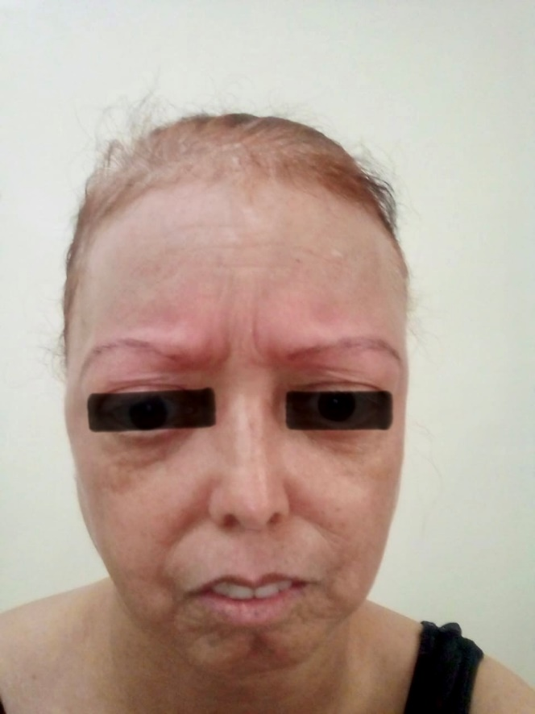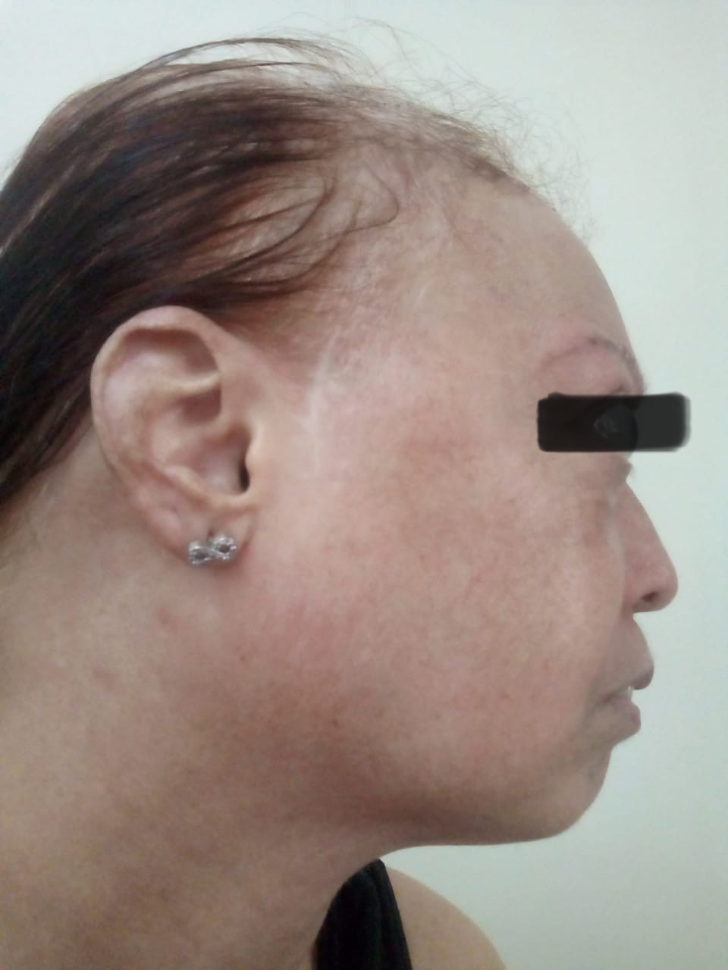

**Figure 1 :** Image illustrating Bird-like facies, premature graying and alopecia Atrophic skin with sclerodermoid appearance in our patient.

**Discussion**

Werner syndrome is a model of segmental progeria, typically diagnosed in the third or fourth decade based on clinical features [1,2]. Our patient exhibited nearly all major criteria. The presence of a similarly affected sibling supports autosomal recessive inheritance [3].

Metabolic and endocrine manifestations are hallmarks of WS. Diabetes mellitus is observed in up to 70% of patients and is often insulin-dependent [4]. Osteoporosis and bilateral femoral head necrosis are consistent with musculoskeletal complications of WS [5]. Cataracts and glaucoma are among the earliest ocular signs [6].

Our case is remarkable because of the initial presentation through a severe episode of acute pancreatitis due to massive hypertriglyceridemia. This metabolic complication is uncommon in WS, although lipid abnormalities are described [7].

The pathophysiological basis of WS lies in WRN gene dysfunction, leading to defective DNA repair, telomere shortening, and genomic instability [1,8]. Recent studies also suggest mitochondrial dysfunction, oxidative stress, and epigenetic deregulation as contributors to the aging phenotype [9]. Moreover, preadipocyte senescence may explain the disturbed lipid metabolism and hypertriglyceridemia observed in this case [10].

**Conclusion**

This case highlights a previously underreported presentation of Werner syndrome, initially revealed by stage E acute pancreatitis related to severe hypertriglyceridemia. The diagnosis was established clinically, with familial support. This case expands the clinical spectrum of WS and stresses the importance of considering WS in patients with unexplained metabolic crises and signs of premature aging.

Disclaimer (Artificial intelligence)

Option 1:

Author(s) hereby declare that NO generative AI technologies such as Large Language Models (ChatGPT, COPILOT, etc.) and text-to-image generators have been used during the writing or editing of this manuscript.

Option 2:

Author(s) hereby declare that generative AI technologies such as Large Language Models, etc. have been used during the writing or editing of manuscripts. This explanation will include the name, version, model, and source of the generative AI technology and as well as all input prompts provided to the generative AI technology

Details of the AI usage are given below:

1. Author(s) hereby declare that NO generative AI technologies such as Large Language Models (ChatGPT, COPILOT, etc.) and text-to-image generators have been used during the writing or editing of this manuscript.

2.

3.

**References**

1. Oshima J, Sidorova JM, Monnat RJ Jr. Werner Syndrome: Clinical Features, Pathogenesis and Potential Therapeutic Interventions. Ageing Res Rev. 2017;33:105-114.

<https://doi.org/10.1016/j.arr.2016.03.002>

2. Goto M. Hierarchical deterioration of body systems in Werner’s syndrome. Mech Ageing Dev. 1997;98(3):239-254.

<https://doi.org/10.1016/S0047-6374(97)00081-8>

3. Huang S, Lee L, Hanson NB, et al. The spectrum of WRN mutations in Werner syndrome patients. Hum Mutat. 2006;27(7):558-567.

<https://doi.org/10.1002/humu.20337>

4. Epstein CJ, Martin GM, Schultz AL, et al. Werner’s syndrome: review of its symptomatology, natural history, pathologic features, genetics and relation to the natural aging process. Medicine (Baltimore). 1966;45(3):177-221. DOI: [10.1097/00005792-196605000-00001](https://doi.org/10.1097/00005792-196605000-00001)

5. Balraj P, et al. Osteoporosis and bone fractures in Werner syndrome. Osteoporos Int. 2021;32(5):845-853.

<https://doi.org/10.1007/s00198-020-05735-1>

6. Takemoto M, Mori S, Kuzuya M, et al. Diagnostic criteria for Werner syndrome based on Japanese nationwide epidemiological survey. J Am Geriatr Soc. 2013;61(5):933–934.

<https://doi.org/10.1111/jgs.12240>

7. Naafs MA, et al. Acute pancreatitis in a case of Werner’s syndrome with severe hyperlipidemia. Neth J Med. 1989;34(3-4):194-9.

<https://pubmed.ncbi.nlm.nih.gov/2725798>

8. Shamanna RA, et al. WRN regulates pathway choice between classical and alternative non-homologous end joining. Nat Commun. 2016;7:13785.

<https://doi.org/10.1038/ncomms13785>

9. Das A, et al. The Werner syndrome protein stimulates repair of oxidative DNA base damage. J Biol Chem. 2007;282(11):9219–29.

<https://doi.org/10.1074/jbc.M610379200>

10. Goh KJ, Chen JH, Rocha N, et al. Preadipocyte senescence in Werner and Bloom syndromes. Sci Rep. 2020;10:7490.

<https://doi.org/10.1038/s41598-020-64136-8>