# *Case report*

**Relapsing Polychondritis with Auricular and Ocular Involvement: A Case Report and Literature Review.**

## Abstract :

## Relapsing polychondritis (RP) is a rare, immune-mediated systemic disorder with an estimated prevalence of 4.5 to 20 cases per million population. It is characterized by recurrent inflammation of cartilaginous and proteoglycan-rich tissues, particularly affecting the auricles, nasal cartilage, respiratory tract, eyes, and joints. Due to its rarity and variable presentation, diagnosis is often delayed, and misdiagnosis can lead to irreversible complications. We report the case of a 48-year-old male with a two-year history of recurrent bilateral auricular chondritis, nasal pain without deformity, ocular inflammation (scleritis), and arthralgias. The diagnosis was made clinically, supported by elevated inflammatory markers (CRP 50 mg/L) and exclusion of autoimmune and infectious differentials through an extensive immunological workup. The patient responded favorably to corticosteroid therapy. This case highlights the importance of early recognition of characteristic features of RP, particularly auricular chondritis with lobular sparing, in facilitating timely diagnosis and treatment. Given the lack of standardized diagnostic biomarkers and the limited evidence from controlled trials, future research should aim to identify reliable diagnostic tools and evaluate targeted therapies in larger cohorts.

## Keywords : Relapsing Polychondritis , Autoimmune Diseases , Immunosuppressive Agents.

## Introduction :

## Relapsing polychondritis is an uncommon systemic inflammatory disorder first describedmin 1923 and further characterized by McAdam in 1976 (1). It is marked by episodic inflammation and progressive destruction of cartilaginous structures throughout the body.

## The disease typically affects adults aged 40–60 years, with no significant gender predominance. Due to its rarity and clinical heterogeneity, diagnosis is often delayed. Approximately 30% of patients have an associated autoimmune disease, most commonly rheumatoid arthritis, systemic lupus erythematosus, or systemic vasculitis (2,3). The pathogenesis remains incompletely understood but is thought to involve immune responses directed against type II collagen and matrilin-1 (4). Recent studies have shed more light on the immunopathogenesis of RP. In addition to humoral responses against type II collagen, matrilin-1, and cartilage-specific proteins, T- cell mediated mechanisms are believed to play a critical role. Elevated levels of pro-inflammatory cytokines such as TNF-α, IL-6, and IL-17 have been reported in active disease. Dysregulation of regulatory T cells (Tregs) and activation of Th1/Th17 pathways may contribute to the chronic and relapsing nature of the disease. Although these findings suggest potential targets for biologic therapy, specific pathogenic biomarkers are still lacking, and the disease remains primarily a clinical diagnosis (1,4,5).

## Case Presentation :

A 48-year-old man presented to our department with a 24-month history of recurrent, painful inflammation of both ears, with sparing of the ear lobules. Episodes were associated with warmth, erythema, and tenderness of the cartilaginous portions. He also reported nasal discomfort, primarily at the base, without any nasal deformity or obstruction. Ophthalmologic assessment during flares revealed unilateral non-infectious scleritis (figure 2), accompanied by photophobia. The patient experienced intermittent joint pain without signs of synovitis or deformities.  
  
On examination, bilateral auricular chondritis was evident (figure 2). The lobules remained unaffected, supporting the diagnosis of RP. There was no tracheal tenderness, dyspnea, or hoarseness, suggesting an absence of airway involvement. Laboratory findings revealed an elevated CRP (50 mg/L), with a normal ESR. A comprehensive autoimmune panel including ANA, rheumatoid factor, anti-CCP, and ANCA (both anti-MPO and anti-PR3) returned negative. Imaging studies including chest X-ray and sinus CT were unremarkable. Audiometry and laryngoscopy did not reveal cochleovestibular or airway involvement.

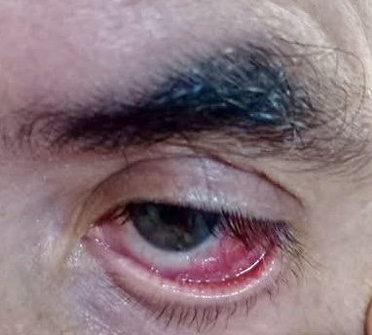

**Figure 1:** scleritis.

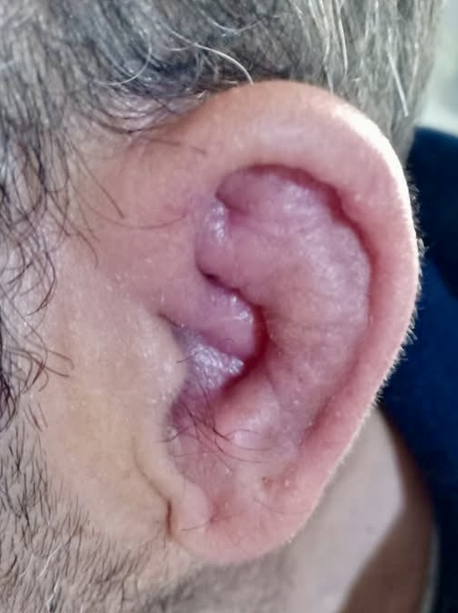

**Figure 2 :** chondritis of the auricle.

Based on McAdam’s criteria : auricular chondritis, nasal chondritis, ocular inflammation, and polyarthralgia, the diagnosis of RP was established (1). The patient was started on oral prednisone at 1 mg/kg/day. At 4-week follow-up, he showed marked clinical improvement with resolution of auricular and ocular symptoms. A steroid-sparing agent (methotrexate) was considered for maintenance therapy (4).

## Discussion:

## RP is a multisystem disease of unpredictable course, either relapsing-remitting orprogressive. Diagnostic confirmation relies on clinical criteria since histologic and serologic findings are not specific. McAdam et al. proposed six diagnostic criteria: bilateral auricular chondritis, seronegative polyarthritis, nasal chondritis, ocular inflammation, respiratory tract chondritis, and cochleo-vestibular dysfunction (1).

## Diagnosis requires at least three of these features. The sparing of the ear lobule is characteristic and helps differentiate RP from infections or trauma. Absence of airway involvement is reassuring, since tracheobronchial inflammation can lead to serious morbidity and mortality. Cardiovascular (e.g., aortitis),neurologic, and renal involvement, although rare, must be monitored (6).

## Corticosteroids are first-line treatment. In steroid-dependent or refractory cases, immunosuppressants such as methotrexate, azathioprine, or mycophenolate mofetil are used (4). Biologic agents (e.g., TNF-α or IL-6 inhibitors like tocilizumab) have shown promise in resistant forms but lack large-scale evidence (7,8). Recent epidemiological data from a UK population-based cohort study have provided clearer estimates on incidence and associated mortality, especially in patients with systemic features (9).Pediatric-onset RP, although uncommon, has been reported and may follow a more severe course, requiring early immunosuppressive strategies (10,11).

## Conclusion :

This case highlights the classic presentation of relapsing polychondritis involving bilateral auricular chondritis with sparing of the lobules, nasal discomfort, scleritis, and elevated inflammatory markers. The diagnosis remains clinical, supported by exclusion of mimicking diseases. Prompt initiation of corticosteroids can result in significant clinical improvement. Long-term management may require immunosuppressive therapy tailored to organ involvement and disease severity.

**Limitations:**

This case report describes a typical presentation of relapsing polychondritis and reinforces the clinical value of McAdam’s criteria in diagnosis. However, being a single case, its findings cannot be generalized to the wider population. No novel diagnostic or therapeutic strategies were tested, and the follow-up period was relatively short.

Furthermore, the absence of histological confirmation, although common in clinical practice, may be viewed as a limitation from an academic perspective. Future prospective studies and multicenter case series are needed to better define prognostic factors and treatment outcomes.

**CONSENT :**

As per international standards or university standards, patient(s) written consent has been collected and preserved by the author(s).

**ETHICAL APPROVAL :**

Ethical approval was exempted by the Ethical Committee at Ibn Roch university hospital for reporting this case.

**COMPETING INTERESTS :**

Authors have declared that no competing interests exist.

Disclaimer (Artificial intelligence)

Author(s) hereby declare that NO generative AI technologies such as Large Language Models (ChatGPT, COPILOT, etc.) and text-to-image generators have been used during the writing or editing of this manuscript.

## References

1. McAdam LP, et al. Relapsing polychondritis: a clinical review. Medicine (Baltimore). 1976;55(3):193–215. Available from: https://pubmed.ncbi.nlm.nih.gov/775252/

2. Damiani JM, Levine HL. Relapsing polychondritis—report of ten cases.Laryngoscope. 1979;89(6 Pt 1):929–46. Available from: https://pubmed.ncbi.nlm.nih.gov/449538/

3. Michet CJ, et al. Relapsing polychondritis: survival and predictive role of early disease manifestations. Ann Intern Med. 1986;104(1):74–8. Available from: https://pubmed.ncbi.nlm.nih.gov/3484422/

4. Kent PD, et al. Relapsing polychondritis. Curr Opin Rheumatol. 2004;16(1):56–61. Available from: https://pubmed.ncbi.nlm.nih.gov/14673384/

5. Dion J, et al. Relapsing polychondritis: an update on clinical features, diagnostic tools, treatment and biological drug use. Autoimmun Rev. 2016;15(5):407–13. Available from: https://pubmed.ncbi.nlm.nih.gov/26852389/

6. Borgia F, et al. Cardiac involvement in relapsing polychondritis: a case report and review. Eur J Intern Med. 2004;15(3):183–6. Available from: https://pubmed.ncbi.nlm.nih.gov/15223218/

7. Yamashita H, et al. Tocilizumab for relapsing polychondritis: efficacy in refractory disease. Rheumatol Int. 2012;32(10):3289–95. Available from: https://pubmed.ncbi.nlm.nih.gov/22101587/

8. Ferrada MA, et al. Treatment of relapsing polychondritis with biologic agents: a single-center experience. Clin Rheumatol. 2014;33(8):1095–101. Available from: https://pubmed.ncbi.nlm.nih.gov/24615371/

9. Hazra N, et al. Incidence and mortality of relapsing polychondritis in the UK: a population-based cohort study. Rheumatology. 2015;54(11):2181–7. Available from: <https://pubmed.ncbi.nlm.nih.gov/26142402/>

10. Sharma A, et al. Relapsing polychondritis: clinical presentations, disease activity and outcomes. Orphanet J Rare Dis. 2014;9:198. Available from: https://pubmed.ncbi.nlm.nih.gov/25491150/

11. Belot A, et al. Pediatric-onset relapsing polychondritis: case series and systematic review. J Pediatr. 2010;156(3):484–9. Available from: https://pubmed.ncbi.nlm.nih.gov/19910236/