An Evaluation of the Types, Growing Conditions, and Production Process of Millet Based on Botanical Features

ABSTRACT
More than a millennium, people have grown millet,a varied family of small-seeded grasses,nutrient dense grain, grown especially in area with poor soils and frequent drought like semi-arid parts of Asia and Africa, as it thrives in poor condition . They are vital crop as it plays a major role in ensuring global food security because of their rich nutritional value, adaptability and its capacity to thrive in harsh condition. A detailed analysis of several millets, such as finger millet, foxtail millet, pearl millet, and others, is given in this chapter. It discusses their distinct botanical traits, ideal growth circumstances, and particular production procedures, including planting, harvesting, and management after harvest. This chapter also discuss the obstacle that prevent the millet production, and the management and technique for the advancement of the millet production . Understanding how different kinds of millets are produced will help us better understand their function and its position in sustainable agriculture and how they might strengthen the resilience of our food chain. This chapter seeks to offer a greater understanding of millets and their role in sustainable agriculture through a detailed analysis.
Key words: Small seeded grasses, nutritional profile, agricultural techniques, millet yield, sustainable agricultural, etc.

1. Introduction
This chapter aims to introduce the reader to millets, their historical significance, types, health benefits,botanical characteristics, their production procedure and role in modern food systems. Millets are a group of wide range cereal grain also known as “ancient grains” that are cultivated especially in arid and semi-arid parts of Asia and Africa. Millets have many health benefits with experiencing in regeneration in modern agriculture and flexibility to harsh growing condition (Miller et al., 2016). Millets are more popular in modern diets as the product are formed such as processed foods like snacks, breakfast cereal, are gluten-free products and are used in kitchen as wholly grain, flour and some beverages (Suman & Chandra, 2025). While they are still traditionally consumed in India as porridge, flatbreads, and fermented foods, their use has spread to salads, baked goods, and even as a rice or couscous substitute in Western countries. As interest in ancient grains continues to grow, millets are being promoted as a sustainable, nutrient-rich sustainable food system supply chain (Calamai et al., 2020). The nutritive value of these product addendum their production’s positive impacts on the environment makes them adequately suited to effectively advance food security globally. Millet is in a right line to be modern diet due to its nutritional value and health impact , advancement of technologies and research ,make it more environmentally friendly than regular millets [1,2,3].
Millets have an impressive nutritional profile. They are a slow-releasing energy source that promotes sustained activity since they are high in complex carbs. people who are at risk for micronutrient shortages. They are also a great substitute for people with celiac illness or gluten intolerance because they are gluten-free [4].
Millets are a “superfood” in the harsh meaning as it contain may health advantages (Rawat et al., 2021). Millets contain micro-nutrients such as magnesium, potassium, zinc, phosphorus, iron, calcium and high in proteins, vital amino acid, carbohydrates, their antioxidant qualities boost immunity. Millets are gluten free that provides a great nutritional alternative for disease like celiac disease and gluten intolerance, it have low glycemic index that aids in blood sugar regulation and advantageous for diabetic [5].
Millets played a significant role in different dishes like Indian rotis, dosa, porridge, African ugali and Chinese congee. Millets have also role in climate change and the United Nation’s nomination of 2023 as International Year of Millets has increase worldwide awareness of millets. As crops that require less water and are resistant to pests and diseases they demand fewer chemical inputs, thus reducing their ecological footprint. They have a shorter growing cycle [6].
2. Types of Millets:
Millets is a type of cereals that belong to Poaceae famiy of grass. Specifically in Asia and Africa, this little round whole grain is cultivated in Nigeria and India. Similar to quinoa and brown rice, millet foods can be prepared to facilitate digestion. Millets come in various varieties. Pearl millet, sorghum millet, little millet, finger millet, foxtail millet and porso millet are most popular type of millets. Millets has high nutritious content, and also advices by many doctors and dietician to include in our diet as breakfast cereals,millet museli is a more nutrient rich variety of millt.
- Pearl Millet (Bajra):
This crop is known as bajra in India, and it is mostly farmed in the states of Gujarat, Rajasthan, Maharashtra, Uttar Pradesh, and Haryana.
- Finger Millet (Ragi):
In India, finger millet is commonly referred to as ragi. The nutritional advantages of ragi millet have made it popular. Ragi flakes are mostly used in infant food and are one of the most widely produced millets in India.
- Foxtail Millet (Kakum/Kangni):
Italian millet, also known as foxtail millet, is typically grown in semi-arid areas. In India, this variety of millets has a very brief growing season.
- Sorghum Millet (Jowar):
It is commonly called Jowar in India. The largest sorghum-producing states in India are Maharashtra and Karnataka. Some varieties of Sorghum are used for ethanol production.
- Proso Millet (Chena / Barri):
Also called broom corn millet, this grain is mostly found in the drier regions of Asia, Australia, Africa, Europe, and North America. You do not need a lot of water to grow this crop.
- Barnyard Millet (Sanwa):
This is one of the millets in India that is grown in certain parts of Andhra Pradesh and Uttarakhand. Its specialty is that it grows even in marginal lands.
- Little Millet (Moraiyo):
It remains crass that with either water logging or drought, this millet can easily be grown. This specific millet is frequently discovered in the Eastern Ghats of India.
- Kodo Millets:
Kodo millet is a type of millet that is easier to digest and has a higher concentration of the amino acid lecithin. It contributes to the strengthening of the nervous system. Kodo is rich in niacin, B6, folic acid and it contains minerals like zinc, calcium, iron, manganese. Being a gluten-free millet, it is great for those who are intolerant to gluten. It can address cardiovascular issues like high blood pressure and cholesterol when taken regularly by postmenopausal women [7].

3. Botanical Characterstics, Growing Conditons and Production Process of Millets

3.1 Pearl Millets (Pennisetium gluacum)
Millions of people around the world rely on pearl millet, scientifically known as Pennisetum glaucum, as a staple crop, especially in arid and semi-arid countries. It is a crucial crop for nutrition and food security because of its remarkable nutritional profile and reputation for enduring adverse weather conditions [8].
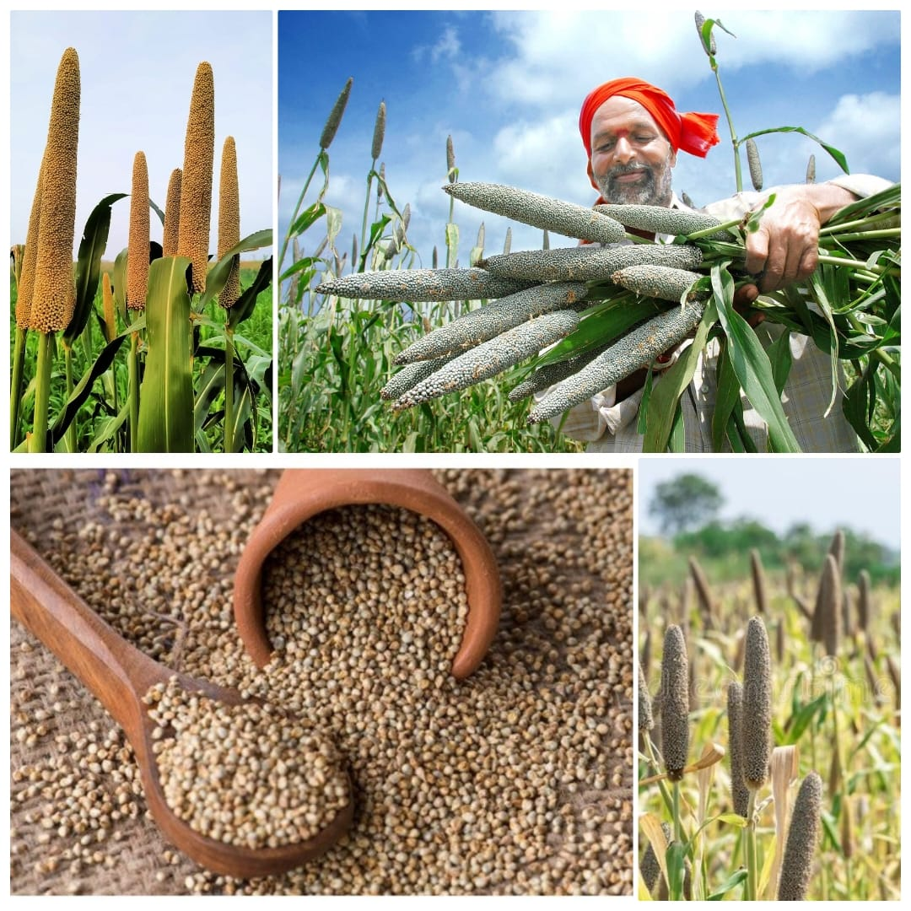
Fig.1: Pearl millets

table 1-Chemical composition of pearl millets
Nutrient | Amount per 100g
Energy | 361 kcal
Carbohydrates | 67 g
Protein | 11.6 g
Fat | 5 g
Dietary Fiber | 8.5 g
Calcium | 42 mg
Iron | 8 mg
Magnesium | 137 mg
Phosphorus | 296 mg
Potassium | 290 mg
Zinc | 3.1 mg
Thiamine (Vitamin B1) | 0.38 mg
Riboflavin (Vitamin B2) | 0.21 mg
Niacin (Vitamin B3) | 2.8 mg

3.1.1 Botanical Description
Pearl millet is a drought-tolerant, erect bunch grass with a vast root system that tillers from the base. Stems range in diameter from 1/2 to 1 inch. The leaf blades of this leafy shrub are 8 to 40 inches in length and 1/2 to 3 inches in width. The ligule is a fringe of hairs that is 0.08 to 0.1 inches long and connects the leaf blade to the leaf sheath. The sheath is frequently hairless and has very few hairs near the collar's base. Similar to the flower of the aquatic plant known as cattail, the inflorescence (flower) is a single raceme that ranges in length from 4 to 20 inches (see figure below). The fruit, also known as the caryopsis, is cylinder-shaped and can be white or pearl, yellow, brown, or purple at times [9].

3.1.2 Growing Conditions
It does better than sorghum and thrives in conditions of water logging and soil moisture stress; it grows best in well-drained sandy loam to loam soils with a pH range of 6.5 to 7.5. This crop may thrive at temperatures exceeding 30°C and with very little yearly rainfall, between 200 and 500 mm. It is one of the most resilient crops and is cultivated in areas that are too hot and dry for the majority of other crops [7,8,9].

3.1.3 Production process of Millets
The first step in producing pearl millet is land preparation, which involves leveling, plow, and enriching the soil with chemical or organic fertilizers to increase fertility. Using conventional or automated techniques, pearl millet seeds are sown directly into the ground, usually during the rainy season, with adequate spacing to guarantee robust plant development. Pearl millet is droughttolerant and grows well in arid or semi-arid environments, thus timely irrigation—even if it is minimal—is crucial in non-rainfed locations. Herbicides or hand weeding are used to control weeds and stop competition for nutrients. As the crop ages, keeping an eye out for pests and diseases like downy mildew is essential to preserving the quality of the produce [7,8,9].

3.2 Finger Millet (Eleusine coracane)
Although finger millet is naturally resistant to pests and diseases, problems like blast disease may need to be monitored occasionally. Harvesting is done by hand or with the use of modest machines after the grains have fully developed and the plants have turned golden brown. Before being stored or turned into flour, malt, or other food items, the grains are cleaned, threshed, and sun-dried to remove moisture. Finger millet, a staple in many areas and a major contributor to the fight against nutritional deficiencies, is well-known for its high calcium and iron content [7,8,9].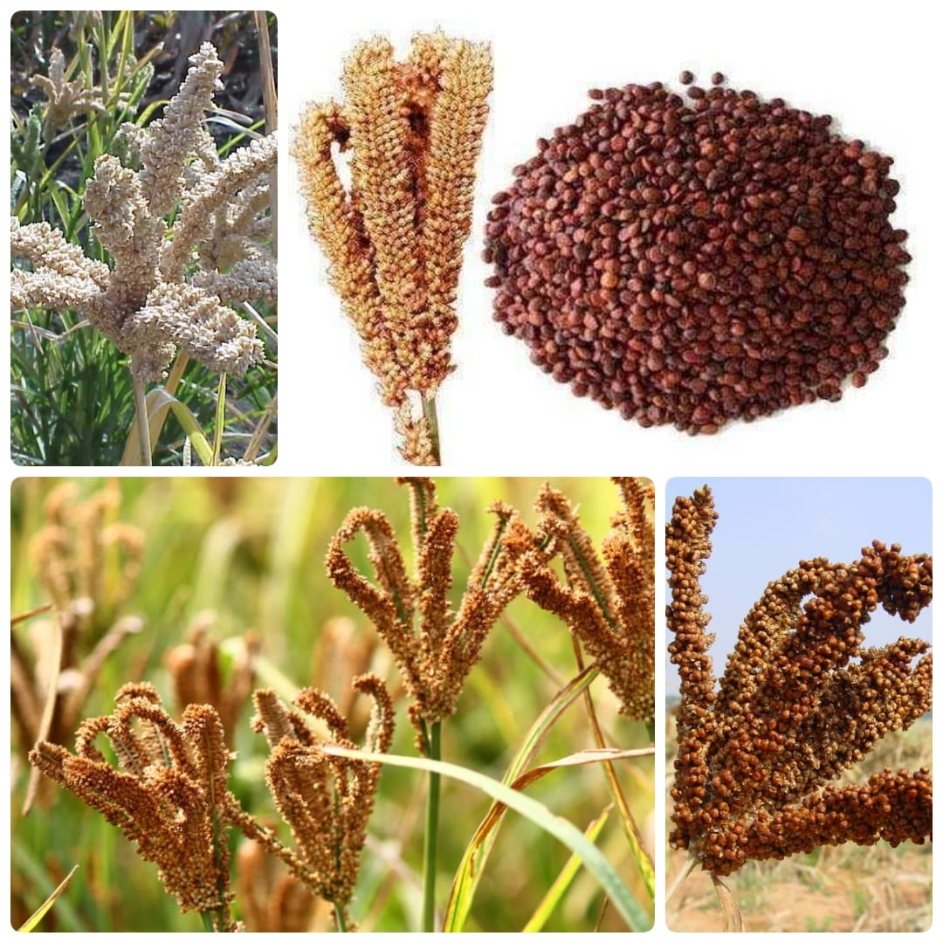
Fig.2: Finger millets
Table 2-Chemical composition of Finger millets:
Nutrient | Amount per 100g
Energy | 336 kcal
Carbohydrates | 72.6 g
Protein | 7.3 g
Fat | 1.3g
Dietary Fiber | 3.6 g
Calcium | 344 mg
Iron | 3.9 mg
Magnesium | 137 mg
Phosphorus | 283 mg
Potassium | 408 mg
Zinc | 2.3 mg
Thiamine (Vitamin B1) | 0.42 mg
Riboflavin (Vitamin B2) | 0.19 mg
Niacin (Vitamin B3) | 1.1 mg

3.2.1 Botanical Characteristic
The annual cereal crop finger millet (Eleusine coracana L.) is distinguished by its resilient and tufted growth pattern. Its fibrous root system reached deep down into the soil, which make it drought-resilient and suitable for dry and semi-arid area. Depending on the species and growth circumstances, the plant's upright stems can grow anywhere from 30 to 130 cm in height. It has grass-like, narrow, linear leaves with a noticeable midrib and a rough texture. The unique characteristic of finger millet is its inflorescence, which is a whorl of thin, finger-like spikes that radiate from a central axis like fingers, usually from 4-7 spikes multiple spikelets are beared. Depending on the cultivation, the tiny, round seeds might be white, reddish-brown, or black in color, and they are encased in a hard outer coating and are high in fibers making it nutritionally rich. Finger millet has both male and female reproductive organs in its blossoms, and it self-pollinates [7,8,9].

3.2.2 Growing condition
Finger millet prosper in a wide range of growing conditions, making it a hardy crop ideal for dry and semiarid climates. It is well-suited to poor, dry soils and can withstand drought, high temperatures, and low rainfall, making it an important crop in locations with irregular or insufficient water supplies. The plant thrives in temperatures ranging from 20°C to 30°C, and while drought-resistant, it prefers moderate rainfall during the growing season. Oftenly finger millet rely heavily on natural rainfall for moisture and is planted during the monsoon season. It thrives on sandy-loam, well-drained soils that range in pH from slightly acidic to neutral, yet it can tolerate both low and relatively high soil fertility. Though extended water-logging might block evolution, the crop is resilient and can withstand both dry spells and short period of flooding. Finger millets has quick cycle of maturation in 3-6 months and depends upon the variety and climate. It is a crucial crop for sustainable agriculture in areas with unpredictable weather patterns because of its capacity to thrive in a variety of difficult situations [7,8,9].

3.2.3 Production process of Finger Millets
The production method of finger millet begins with land preparation, where the soil is ploughed and tilled to generate a fine seedbed. Organic or chemical fertilizers may be applied to boost soil fertility, while finger millet is well-adapted to poorer soils. Seeds are often seeded before the start of the monsoon season, either through broadcasting or line sowing, to ensure proper spacing between plants. This crop thrives in dry and semi-arid areas, requiring little irrigation and relies heavily on rainfall for moisture. Finger millet is relatively resistant to pests and diseases while growing, but common issues such as blast disease must still be monitored. Weed management is critical for avoiding nutrient competition and is frequently done manually or with herbicides. Finger millet is widely prized for its nutritional value, especially its high levels of calcium, iron, cysteine, methionine , tryptophan, phytochemical and dietary fibre (10-15%). When the crop reaches maturity, the plants turn golden, indicating that it is time to harvest, usually 3 to 4 months after sowing. Harvesting is usually done by hand or with small machines to prevent damaging the delicate grains, and after harvest, the grains are threshed, cleaned, and sun-dried to reduce moisture content, ensuring they can be stored safely before being processed into products like flour, porridge, or fermented foods [7,8,9].

3.3 Foxtail Millet (Setaria italica)
Foxtail millet thrives in low-fertility soils and requires little water, relying mostly on rainfall, making it an ideal crop for areas with unpredictable or limited water supply. Weed control is typically done through manual weeding or the application of herbicides. As the plants mature, they form compact, panicle-shaped clusters of small seeds. The crop is usually harvested when the grains are fully mature and the plant begins to dry out [7,8,9].

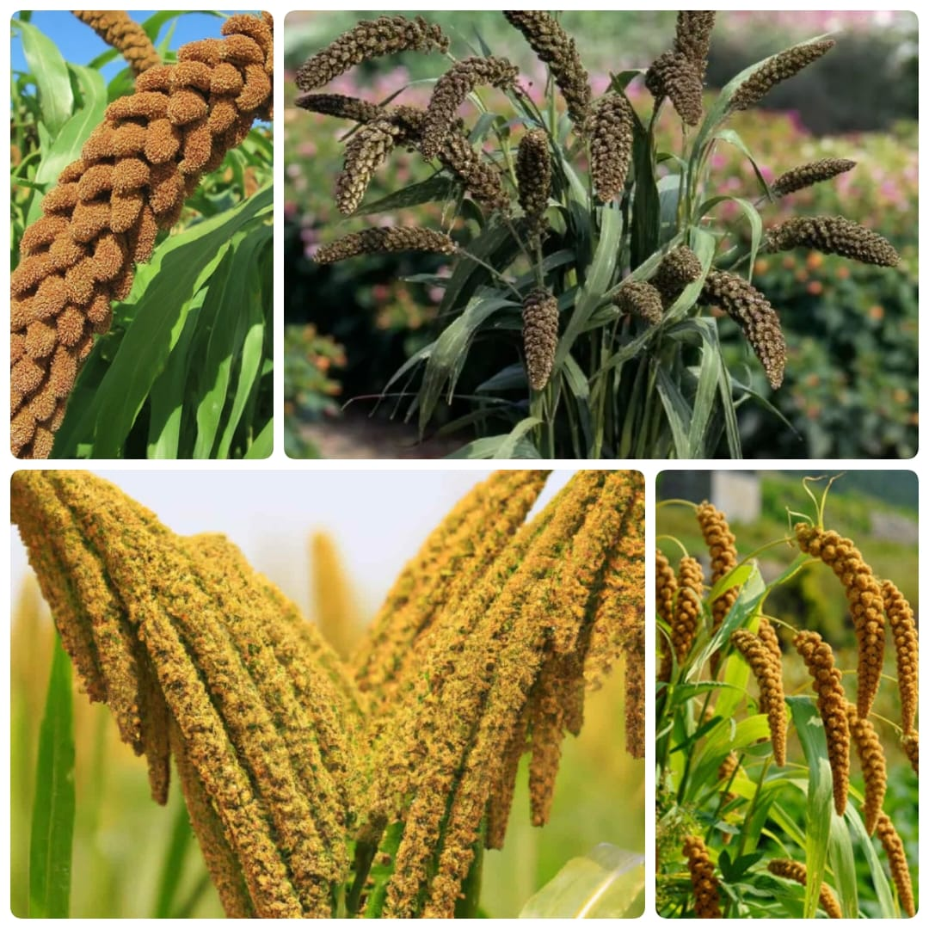

Fig. 3: Foxtail millets

Table 3-Chemical composition of Foxtail millets:
Nutrient | Amount per 100g
Energy | 331 kcal
Carbohydrates | 60-65 g
Protein | 10-12g
Fat | 4-5 g
Dietary Fiber | 7.8 g
Calcium | 30-40 mg
Iron | 3 mg
Magnesium | 80-90 mg
Phosphorus | 240 mg
Potassium | 280 mg
Thiamine (Vitamin B1) | 0.59 mg
Riboflavin (Vitamin B2) | 0.11 mg
Niacin (Vitamin B3) | 3-4 mg

3.3.1 Botanical Characteristics
The robust, drought-tolerant cereal crop known as foxtail millet (Setaria italica) is a member of the Poaceae family of grasses. Its slender, grass-like stems and upright growth habit, which usually reach heights of 60 to 120 cm, are its defining characteristics. The smooth, elongated, and narrow leaves contain parallel veins that extend from the base to the tip. The distinctive inflorescence of foxtail millet, which is characterized by a compact, cylindrical panicle that resembles a "foxtail," is what gives the plant its common name. The tiny, oval-shaped seeds are covered in a hard husk and a range of colors, including yellow, orange, and red. The plant is extremely resistant to heat and drought and may thrive in a variety of soil types, including poor, well-drained soils [7,8,9,10].

3.3.2 Growing condition
Although it thrives in sandy loam to clay loam soils with a pH of slightly acidic to neutral, it is well adapted to poor, well-drained soils. For best growth, foxtail millet needs warm temperatures, ideally between 20°C and 30°C. Although it can withstand dry circumstances once established, it is usually planted in regions with moderate rainfall during the summer monsoon season. Although the crop may need some weed control, which is often accomplished with hand weeding or herbicides, it is comparatively pest-resistant. The plant's short growing season (typically 60 to 90 days) guarantees that it can be harvested before the start of severe heat or dry spells, and its shallow root system enables it to flourish in water-limited environments. Foxtail millet is a crop that is perfect for low-input, sustainable agriculture in marginal areas because of these growing conditions [7,8,9,10].

3.3.3 Production process of Foxtail Millet
Because of its ability to withstand arid circumstances, foxtail millet is produced by first preparing the ground by plow and leveling the soil to make a good seedbed. Usually planted by hand or with the aid of seed drills at the start of the rainy season, foxtail millet requires seeds that are sufficiently spaced apart to promote robust growth. The crop needs little water because it can withstand drought and grows well in light, well-drained soils. One of the most important aspects of the process is weed management, which is often accomplished by hand weeding or applying pesticide to stop competition for nutrients. Although the plants require routine inspection for pests and diseases during the growing season, foxtail millet is comparatively impervious to the majority of prevalent threats. The grains are washed, threshed, and dried completely after harvesting in order to lower the moisture content before being stored. Usually ground into flour or used as a whole grain in a variety of culinary products, foxtail millet provides a healthy substitute for other cereals, particularly in drought-prone regions. It is a crucial crop for food security and sustainable agriculture because of its high fiber, protein, and mineral content [7,8,9,10].

3.4 Sorghum (Sorghum bicolor)
In order to ensure optimal growth, sorghum seeds are sown manually or with the aid of machinery, usually during the rainy season. Due to its low water requirements and ability to flourish in arid environments, the crop is renowned for its tenacity. To provide enough moisture during its growth stages, dry areas may require sporadic watering. Pest management techniques, such as the use of insecticides or natural predators, can shield the crop from harm caused by insects like the sorghum midge. Weed control is essential to prevent competition for nutrients. The plants are harvested after the grain heads are completely ripened and the plants are dry, which typically happens in three to five months after the plants reach maturity [7,8,9,10].

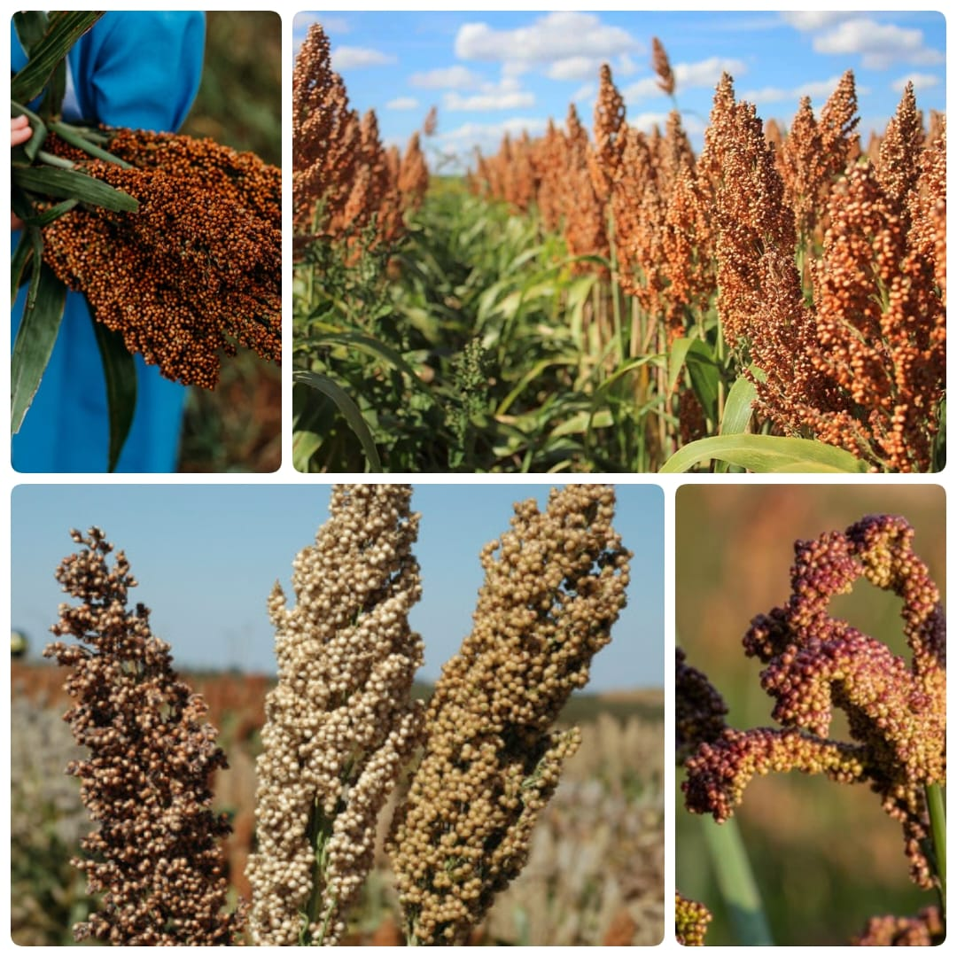
Fig.4: Sorghum millets

Nutrient | Amount per 100g
Energy | 329 kcal
Carbohydrates | 72.0 g
Protein | 10.7 g
Fat | 3.5-4.0 g
Dietary Fiber | 6.3-8.5 g
Calcium | 13-40 mg
Iron | 4.1-3.9 mg
Magnesium | 90-165 mg
Phosphorus | 289 mg
Potassium | 363 mg
Thiamine (Vitamin B1) | 0.4-0.35 mg
Riboflavin (Vitamin B2) | 0.14-0.19 mg
Niacin (Vitamin B3) | 2.1-2.3 mg

Table 4-Chemical composition of Sorghum millets:

3.4.1 Botanical Characteristics
A member of the Poaceae family of grasses, sorghum millet (Sorghum bicolor) is a warm-season cereal grain that can withstand drought. It is distinguished by its robust, tall growth; some types can grow up to 1.5 to 4 meters in height. The plant has long, narrow leaves with noticeable veins that are usually lanceshaped. Sorghum grows well in arid and semi-arid settings because of its strong, fibrous stem, which has a high level of resilience to water stress. Large, compact panicles that protrude from the top of the plant hold the flowers. Depending on the species, the tiny, spherical grains inside these panicles can range in hue from pale yellow to deep red or black [7,8,9,10, 11].

3.4.2 Growing condition
Sorghum millet is an important crop in semi-arid and drought-prone areas because it grows well in warm, dry weather with high temperatures and little precipitation. It thrives in fertile, well-drained soils with a pH between 5.5 and 8.5. Though it benefits from rainfall in its early growth stages, sorghum millet is extremely drought-tolerant and requires little irrigation once established. The plant is usually planted in the rainy season since it germinates faster in moist soil, although it can withstand dry spells and heat because to its resistance to drought. For the crop to flourish as best it can, it needs full sun and mild breeze. Although frequent monitoring is necessary to minimize damage from certain risks like aphids or fungal infections, sorghum millet is also comparatively resistant to pests and diseases. In order to avoid competition for nutrients and water, proper weed control is essential, particularly during the early growth phase [11,12].

3.4.3 Production process of Sorghum
Land preparation, which includes plowing, leveling, and applying synthetic or organic fertilizers to guarantee soil fertility, is the first step in the cultivation of sorghum millet. Then, in the early rainy season, sorghum seeds are planted, either manually or with the aid of automated planters, at the right intervals to encourage robust plant development. Because of its relative drought tolerance, the crop can be grown in arid and semi-arid areas. Sorghum needs little watering throughout growth, but weed control—either by hand or with herbicides—is crucial to lowering competition for nutrients. The cultivation of sorghum millet begins with land preparation, which includes plowing, leveling, and the application of synthetic or organic fertilizers to ensure soil fertility. During the early rainy season, sorghum seeds are planted, either manually or with the help of automated planters, at the appropriate intervals to promote robust plant development. Due to its relative drought tolerance, sorghum can be grown in arid and semi-arid areas, and while it requires little watering during growth, weed control—either manually or with herbicides—is essential to reducing competition for nutrients [11,12].

3.5 Proso Millet (Panicum miliaceum)
Panicum miliaceum, another name for proso millet, is a tiny, resilient cereal grain that has been grown for thousands of years. Due to its ability to withstand drought, it is one of the oldest grains to be farmed and is mostly planted in areas with arid and semi-arid climates. Rich in fiber, protein, and vital minerals like iron and magnesium, the grain is incredibly nutrient-dense. Because proso millet is gluten-free, it's a great substitute for those on gluten-free diets or with celiac disease. It can be substituted for pasta or rice in a number of recipes, including bread and porridge [11,12].

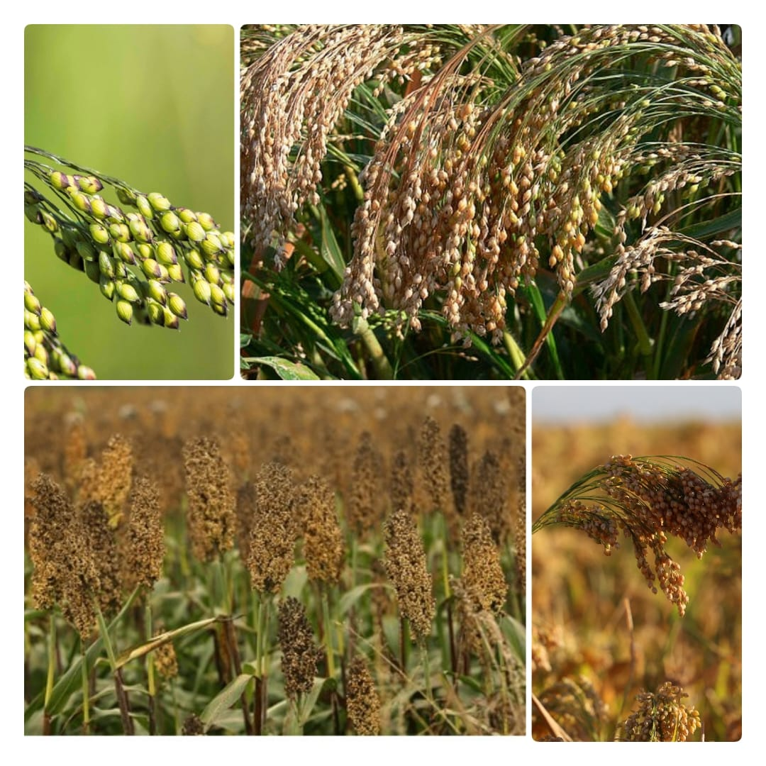 Fig.5: Proso millets

3.5.1 Botanical Characteristics
The warm-season annual grass known as proso millet (Panicum miliaceum) usually reaches a height of 60 to 120 cm. Its stem is upright, circular, and usually branching around the base. Its leaves are small, lanceolate, and have a smooth border. The plant produces small, round seeds that can be yellow, white, red, or brown, and an inflorescence that is compact and spiky, resembling a panicle. The stiff husk that surrounds the seeds is removed during processing so that they can be used or consumed. Proso millet thrives in areas with little rainfall and can withstand high temperatures since it is well suited to dry, marginal soils. In arid conditions, the plant's deep root system facilitates its access to water. Because of its short growing season (about 60 to 90 days), this drought-resistant and resilient crop is a valuable food and fodder crop in regions with short growing seasons [11,12,13].

3.5.2 Growing condition
crop A resilient and drought-tolerant cereal grain, proso millet (Panicum miliaceum) grows well in a range of growing environments. It thrives in areas with short growth seasons and enjoys high temperatures, usually between 70°F and 90°F (21°C and 32°C). Proso millet is a suitable crop for marginal areas since it can grow in poor, well-drained soils with low fertility. Compared to other cereal grains, it needs less water once grown and can withstand both dry and semi-arid environments. Although it thrives on regular rainfall or irrigation, the plant can tolerate some drought and grows best in full sun. Because of its brief maturation period (60–90 days), it can also be cultivated in rotation with other crops or as a second [11,12,13].

3.5.3 Production process of Proso Millet
From cultivation to harvesting and post-harvest management, there are various important processes in the proso millet production process. Proso millet is first cultivated in sandy to loamy soils that drain well, usually in areas with mild temperatures and moderate rainfall. The crop grows for 60 to 90 days after sowing, during which time it produces tiny, drought-tolerant seeds. The plants are harvested, typically by threshing or cutting, once the millet reaches maturity. Following harvesting, threshing—which can be done by hand or with machinery—is the process of separating the grains from the husks. After that, the raw millet seeds can be cleaned to get rid of any contaminants like debris or broken grains. Dehulling, which involves removing the outer husk to increase the grain's edibility and digestibility, is a common post-harvest processing procedure. The millet can be cooked as whole grains, further processed into flour, or utilized in a variety of culinary products like porridge, snacks, or gluten-free dishes, depending on the final product. Proso millet must be stored properly to preserve its quality and avoid spoiling; this is usually done in dry, cool conditions [11,12,13].

3.6 Barnyard Millet (Echinochloa spp.)
It is a drought-tolerant, fast-growing crop that thrives in poor soil conditions, making it a vital staple in locations with limited water supplies. Barnyard millet is a great source of dietary fiber, protein, and vital minerals like iron, magnesium, and phosphorus. Additionally, it has a low glycemic index, which makes it a great option for diabetics or anyone trying to control their blood sugar levels. Gluten-free and health-conscious diets are increasingly using this millet variety, which is frequently used in cooking to make flatbreads’ pilafs and porridge [11,12,13,14].
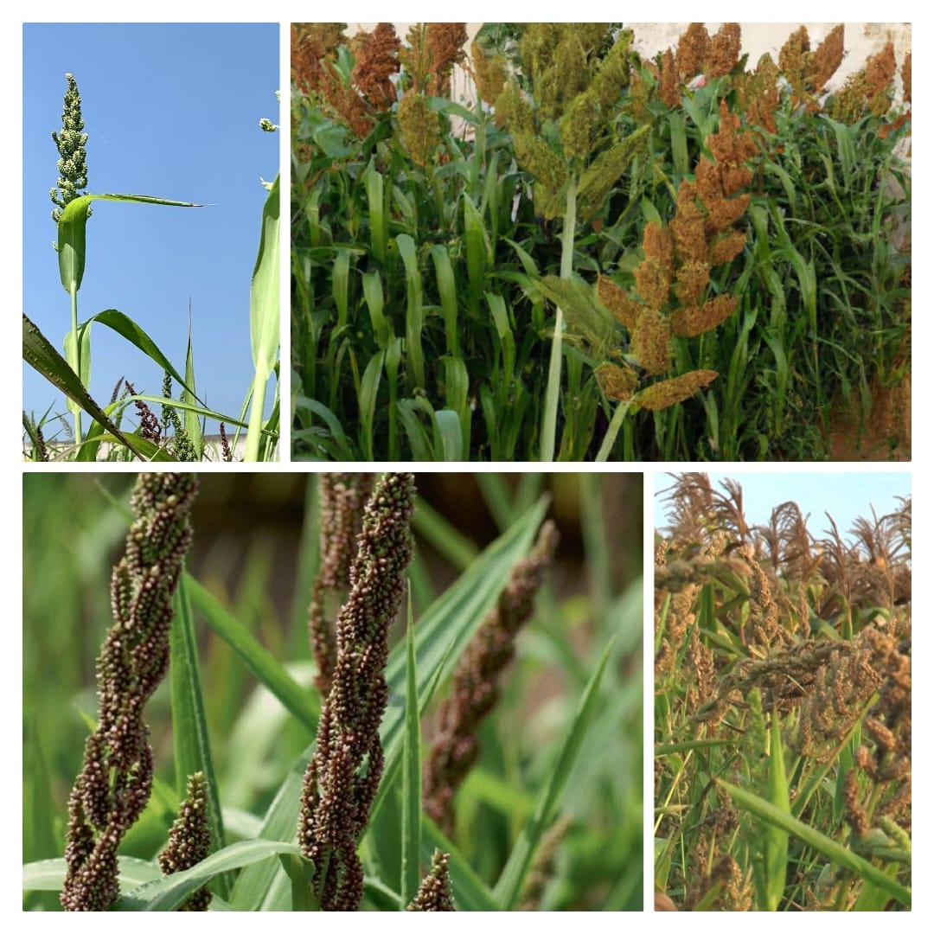
Fig.6: Barnyard millets
Table 5-Chemical composition of Barnyard millet:
Nutrient | Amount per 100g
Energy | 300-350 kcal
Carbohydrates | 55-70 g
Protein | 6-12 g
Fat | 2-4 g
Dietary Fiber | 10-12 g
Calcium | 10-20 mg
Iron | 4-5 mg
Magnesium | 60-80 mg
Phosphorus | 100-150 mg
Potassium | 200-300 mg
Glycemic Index | Low (around 50)

3.6.1 Botanical characteristics
It is distinguished by a comparatively upright growth habit and slender stems that, depending on the surroundings, can grow to a height of 60 to 150 cm. The leaves have a delicate, silky texture and are lanceolate, elongated, and narrow. The panicle-shaped inflorescence is made up of branched spikes that hold tiny grains that range in shape from round to oval. These grains are covered in a hard outer husk and might be white or light brown in color. Barnyard millet is frequently grown in areas with high temperatures and moderate rainfall because it grows well in a range of soil types, especially well-drained, sandy loams. It is a valuable crop in arid and semi-arid locations because of its capacity to adapt to a variety of agroclimatic conditions, as well as its resistance to heat and drought [11,12,13,14,15].

3.6.2 Growing conditions
As long as there is adequate drainage, it can thrive in a variety of soil types, including sandy, loamy, and even poor, infertile soils. Full sun exposure and temperatures between 25°C and 30°C (77°F and 86°F) are ideal. It is a fast-maturing crop that needs a growing season of between 60 to 90 days. Because barnyard millet can withstand dry spells, it is ideally suited for areas with irregular monsoons or little rainfall. But the best results come from planting it after the last frost and allowing it enough time to take root. The plant is a great option for sustainable farming in arid and semi-arid areas because it requires little irrigation and just modest fertilizing [11,12,13,14,15].

3.6.3 Production process of Barnyard Millet
Preparing the land is the first of several crucial processes in the cultivation of barnyard millet. A healthy seed-to-soil contact is ensured by leveling and tilling the soil. A resilient crop that can tolerate drought, barnyard millet is usually planted on sandy loam soils that drain well. Depending on the area and agricultural methods, farmers either broadcast or drill the seeds after the field has been prepared. For best growth, the seeds are often sown during the monsoon season. Barnyard millet is a sustainable option for marginal lands since it needs little irrigation and is resistant to numerous pests and illnesses. Depending on the size of the operation, millet is either harvested by hand or with machines when the crop is ready to be harvested, which is typically when the grains are hard and the plants have turned golden brown.To separate the grains from the panicles, the millet is threshed after harvest. After being washed, the grains could be dried to lower their moisture content and improve storage. Barnyard millet can be turned into whole grain, flour, or even animal feed, depending on the market or consumer demand. Because it is gluten-free, high in fiber, and nutritious, the finished product is a favorite among consumers who are concerned about their health [11,12,13,14,15].

3.7 Little Millet (Panicum sumatrense)
Panicum sumatrense, the scientific name for little millet, is a small, drought-resistant grain that has been grown for generations throughout Asia. Because of its high nutritional value, little millet—which is distinguished by its small, spherical seeds—is frequently seen as a nutritious substitute for wheat and rice. Iron, magnesium, and phosphorus are among the vital elements it contains, along with fiber and antioxidants. People with celiac disease or gluten sensitivity often choose little millet since it is gluten-free. This grain can be crushed into flour for baking, cooked as a whole grain, or added to porridges [11,12,13,14,15,16].
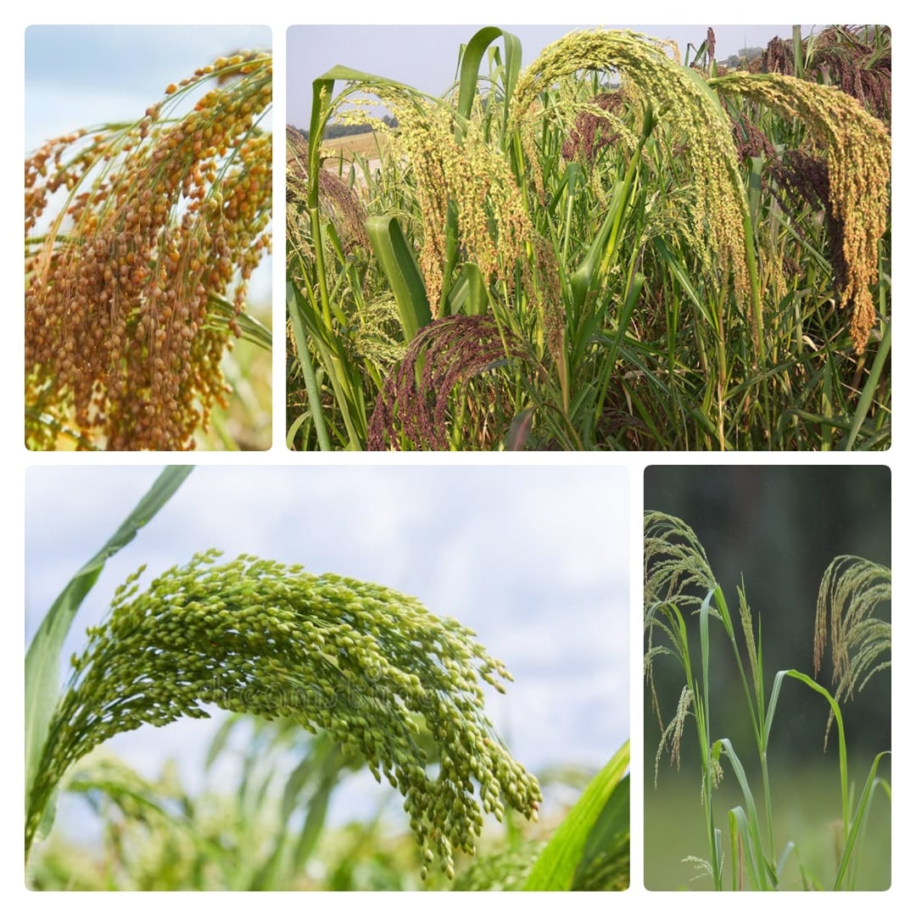
Fig.7: Little millets

Table 6-Chemical composition of Little millets:
Nutrient | Amount per 100g
Energy | 329 kcal
Carbohydrates | 67 g
Protein | 7.7 g
Fat | 4.7 g
Dietary Fiber | 7.6 g
Calcium | 17 mg
Iron | 9.3 mg
Phosphorus | 220 mg
Thiamine (Vitamin B1) | 0.3 mg
Riboflavin (Vitamin B2) | 0.11 mg
Niacin (Vitamin B3) | 2.3 mg

3.7.1 Botanical characteristics:
The Poaceae family includes the little, annual grass known as little millet (Panicum sumatrense). Its tall, branched stem usually reaches a height of 50 to 120 cm. The plant has linear, slender leaves that measure 1 to 2 cm in width and 15 to 30 cm in length. The tiny, round, or oval seeds of little millet are usually light brown, pale yellow, or white in hue. The grain is well-protected by the loose panicle inflorescence and the glume that envelops each seed. The plant can be grown in arid and semi-arid environments since it is drought-resistant, thrives in a variety of soil types, including lateritic and sandy soils, and can tolerate minimal rainfall. It is a crucial crop for sustainable agriculture in marginal farming areas because of its reputation for being resistant to pests and illnesses [11,12,13,14,15,16].

3.7.2 Growing condition
The short-duration, drought-resistant crop known as little millet (Panicum sumatrense) grows well in arid, marginal soils. Because it can withstand high temperatures and low soil fertility, it is commonly planted in areas with little rainfall, such as semi-arid climates. Once established, little millet needs very little water, which makes it perfect for regions with sporadic or infrequent rainfall. Although it can withstand dry spells once established, the crop is typically grown during the monsoon season since it needs soil moisture for germination. Although it may thrive in a range of soil types, including slightly acidic soils, it favors sandy loam soils that drain well. Little millet is susceptible to frost and thrives at temperatures between 25 and 30 degrees Celsius. To increase soil richness and lessen insect burden, it is frequently cultivated in rotation with other crops, such legumes. To maximize output, prompt weed removal and proper spacing are crucial [16,17].

3.7.3 Production process of Little Millet
Little millet (Panicum sumatrense) is produced in a number of important steps, including cultivation, harvesting, and post-harvest processing. Little millet is first cultivated in sandy or loamy soils that drain well, frequently in arid climes. It is appropriate for arid and semi-arid regions because it uses less water. Depending on the local temperature and type, the seeds are usually sowed in the early summer and the plants are left to grow for 60 to 90 days before being harvested. The millet is either harvested by hand or by machine as it reaches maturity. Following harvest, threshing is used to remove the grains from the panicles. After being cleaned, the grains are dried to lower their moisture content and help keep them from spoiling while being stored. To make the grains better suited for human eating, they may occasionally be dehulled or milled to remove the outer husk. Little millet is frequently substituted for rice in a variety of culinary applications and utilized in a variety of food products, including flatbreads and porridge. Due to its low water and input needs during production, tiny millet is a crucial crop for sustainable agriculture in drought-prone areas [16,17].

3.8 Kodo Millet (Paspalum scrobiculatum)
Kodo millet is well-known for its ability to withstand adversity; it grows well in arid, droughtprone regions where other crops would find it difficult. Complex carbs, protein, fiber, and vital micronutrients like potassium, magnesium, and iron are all abundant in it. Kodo millet is a great dietary option for people with gluten sensitivity or those on a gluten-free diet because it is also gluten-free. In addition to being milled into flour for baking or snacking, it is frequently used in a range of traditional foods, such as porridges, upma, and pilafs. Furthermore, it is a good choice for diabetics due to its low glycemic index. Because of its health advantages and climate-adaptability, kodo millet is becoming more and more well-known globally as part of the expanding push towards nutrient-dense, sustainable food sources [16,17].
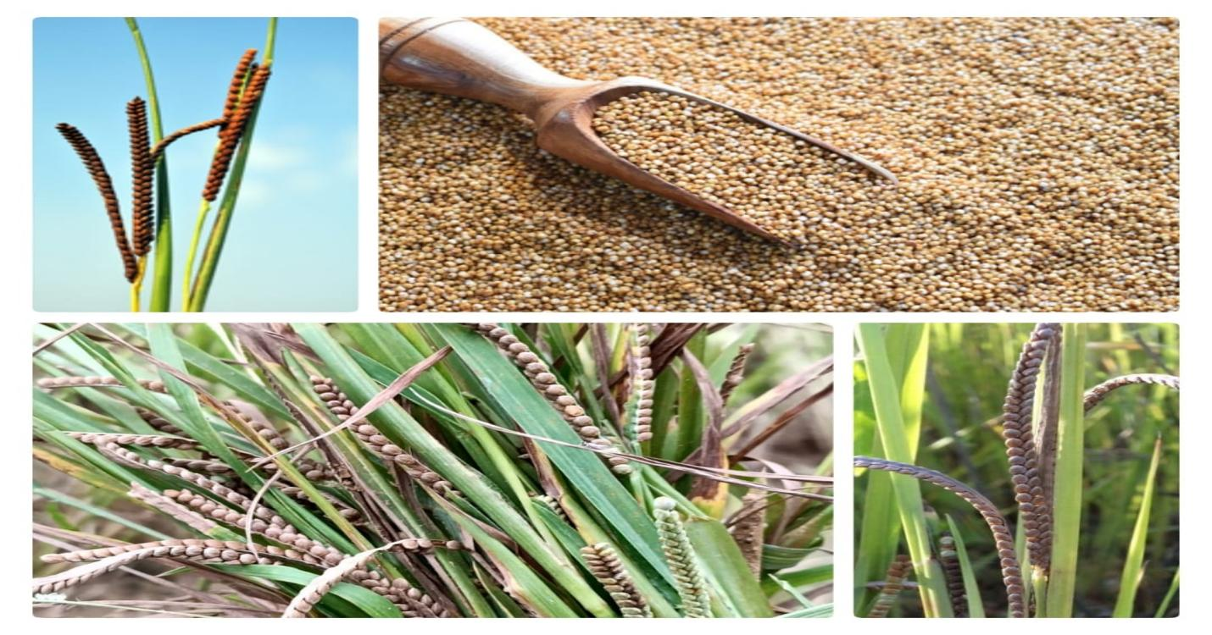
Fig.8: Kodo millets
Table 7-Chemical composition of Kodo millets:
Nutrient | Amount per 100g
Energy | 350 kcal
Carbohydrates | 65.5 g
Protein | 7.5 g
Fat | 3.6 g
Calcium | 27 mg
Iron | 1.8 mg
Magnesium | 121 mg
Phosphorus | 283 mg
Potassium | 148 mg
Zinc | 1.2 mg
Thiamine (Vitamin B1) | 0.08 mg
Riboflavin (Vitamin B2) | 0.14 mg
Folate | 25 micro gram

3.8.1 Botanical characteristics
A member of the Poaceae family, kodo millet (Paspalum scrobiculatum) is a warm-season cereal grain that can withstand drought. It is an annual grass with tufts that reaches a height of 60 to 120 cm. The plant's long, narrow, parallel-veined leaves are usually between 15 and 40 cm long. The inflorescence is a loose, branching cluster of flowers called a panicle, and it contains tiny, oval-shaped seeds that are usually reddish, brown, or gray. A strong, rigid husk surrounds the seeds. Kodo millet is suited for desert areas since it grows well in sandy or loamy soils that drain well and can tolerate little rainfall. It can obtain water from deeper soil levels thanks to its extensive and fibrous root system. Rich in fiber, proteins, and vital minerals, the grain is extremely nourishing and frequently used in traditional Indian and other cultural dishes [16,17].

3.8.2 Growing conditions
The robust, drought-resistant cereal known as kodo millet (Paspalum scrobiculatum) grows well in a range of environments, although it is especially successful in hot, arid areas. It favors sandy or loamy soils that drain well and have a pH between slightly acidic and neutral. Kodo millet is ideal for dryland farming because of its great degree of adaptability to low fertility soils. It can withstand dry spells and is frequently planted in regions with variable rainfall patterns, but it needs moderate rainfall, usually between 600 and 1,200 mm per year. Temperatures between 25°C and 35°C are ideal for the crop. It is perfect for areas with shorter growing seasons because of its short growing cycle, which lasts between 75 to 120 days. Its endurance as a staple crop in marginal areas is further enhanced by the fact that Kodo millet thrives in conditions with low levels of pests and illnesses and benefits from full sunlight [16,17].

3.8.3 Production process of Kodo Millet
Paspalum scrobiculatum, the scientific name for Kodo millet, is cultivated using a sustainable and rather easy agricultural method. The first step in the production process is soil preparation, which usually takes place in dry, semi-arid, well-drained areas. Since millet grows well in less fertile soils with minimal water requirements, the land is tilled and plowed to create a fine seedbed. At the start of the monsoon season, Kodo millet is typically seeded straight onto the field, frequently by hand or with a seed drill. The seeds are sown at a shallow depth because they are tiny and require little room. Since the plants can withstand drought, they need little watering after they sprout. Although the plant is resistant to many pests and diseases, the crop is occasionally weeded and pest-controlled during the growth season. The plants develop after two to three months, and the seed heads are trimmed to harvest the grains. Prior to processing, the collected millet is dried to lower its moisture level. In order to access the edible millet grain, which is then prepared for consumption or further value-added goods, the husk must be removed through milling, frequently using conventional techniques like pounding or contemporary machinery. The production of Kodo millet contributes to food security in arid regions and is praised for its nutritious qualities, especially its high fibre content [16,17].

4. Challenges in Millets production
There are a number of obstacles to millet production, and these might differ depending on economic, environmental, and geographic reasons. The following are some major obstacles:
a. Climate Sensitivity
Temperature Extremes: Millets are susceptible to drastic temperature changes even if they can withstand drought. During the growing season, higher temperatures can lower production, particularly if the plants are under water stress [16,17,18].
Rainfall Variability: Although millets can withstand drought, irregular rainfall patterns can be problematic, particularly in areas where rain-fed agriculture is the primary source of agriculture. Growth phases, especially flowering and grain filling, can be impacted by either too little or too much rain. [16,17,18]
b. Fertility and Quality of soils
Compared to many other cereal crops, millets typically require less fertile soil; yet, suboptimal yields can still result from poor soil quality, particularly nitrogen shortages.
Issues may worsen if appropriate soil management practices, such as crop rotation or organic fertilizer, are not available [16,17,18].

c. Diseases and Pests
Birds, rats, and insects are among the pests that can harm millets, particularly as the grain is filling.
Millet output can also be impacted by disease pressures including rust, blight, and smuts. In contrast to other cereals like rice and wheat, millets are typically less susceptible to illness [16,17,18].

d. Limited Demand and Market Access
Millets frequently have restricted market access, particularly in areas where wheat and rice predominate in the food chain. This can lead to diminished incentives for farmers to plant millet, despite its resilience and nutritional benefits.
Marketability may also be restricted by the absence of value-added and processing products (such millet flour or snacks) [16,17,18].

5. Insufficient Research and Development
Agricultural research and development organizations pay less attention to millet than to main crops like maize, rice, and wheat. As a result, there are now fewer hybrid types, improved pest management techniques, and effective millets farming methods.
One major obstacle is the absence of sophisticated breeding initiatives to enhance millet cultivars for increased yields, resistance to pests, and resilience to climate stress [16,17,18,19].

6. Knowledge and Labor Gaps
Lower productivity may result from many Smallholder farmers' lack of access to resources or training in contemporary millet production methods.
Another difficulty with millet production is that it requires a lot of labor, especially when it comes to postharvest handling, especially in areas where labor is scarce [16,17,18].

7. Handling and Storing after Harvest
Millet is particularly vulnerable to post-harvest losses. Pest infestations, nutritional quality loss, and seed degeneration might result from improper storage.
Losses may be made worse by inadequate infrastructure for post-harvest processing (cleaning, milling, packaging) and storage facilities (such as silos) [16,17,18].

8. Management of Water
Despite its ability to withstand dryness, millets still need proper water management, especially in the early phases of growth and germination. It can be challenging to maintain adequate soil moisture in places with inadequate water infrastructure or erratic rainfall [16,17,18].

9. Cultural Awareness and Preferences
Even though millets are nutrient-dense, they are frequently overlooked in diets, particularly in cities where wheat and rice are prioritized. It can be difficult to alter consumer behaviour and raise awareness of millets' health advantages [16,17,18].

10. Issues with International Trade and Exports
Although millet has the potential to be exported to foreign markets, particularly as a health food, it confronts obstacles due to competition from other main grains and the absence of coordinated export supply chains [16,17,18].

5. Opportunities for Enhancing Millet Production
Improving millet production entails enhancing market systems, research, infrastructure, and agricultural methods in order to boost sustainability and productivity. Due to their hardiness and ability to flourish in arid and semi-arid environments, millets—including types like finger millet, foxtail millet, and pearl millet—are essential for ensuring food security, particularly in light of climate change. The following are a few ways to increase millet production:

a. Better Genetic Research and Varieties
Creating high-yielding cultivator: Productivity can be raised by creating millet types that are resistant to drought, illnesses, and pests.
Varieties of hybrid millet: Different millet strains are crossed to produce hybrids with desired characteristics like faster growth cycles and higher yields.
Enrichment of nutrients: The attractiveness and health advantages of millet can be enhanced by breeding variants with increased nutritional value, such as enhanced protein content or vitamin availability [19].

b. Climate-Resilient and Sustainable Farming Methods Conservation agriculture
Conservation agriculture: By implementing techniques like crop rotation, limited tillage, and agroforestry, millet farming can become more sustainable by increasing soil fertility and utilizing less water.
Water-efficient irrigation methods: In areas with limited water supplies, millet yields can be increased by using drip irrigation or rainwater gathering.
Management of soil health: Increasing soil fertility and structure through the use of biofertilizers, composting, and organic fertilizers can boost millet yield [19, 20].

c. Innovation and Technology in Crop Management
Precision agriculture: Farmers may optimize input use and reduce waste by using sensors, drones, and satellite imagery to monitor crop development, pest infestations, and soil health.
Digital platforms and mobile apps: Using mobile apps to give farmers access to market prices, weather forecasts, and best practices can help them make better decisions.
IPM, or integrated pest management: Reliance on chemical inputs is decreased and the environment is protected by promoting the use of organic insecticides, crop rotation, and natural predators [19, 20].

d. Improved Processing and Handling After Harvest
Value addition: New markets can be opened and the crop's economic worth raised by developing innovative processing methods to produce millet-based goods like flour, snacks, drinks, and even animal feed [19, 20].
Better storage facilities: Purchasing grain storage equipment, such as hermetic bags or silos, lowers post-harvest losses and preserves millet quality until it is sold.
Nutritional processing: Studies aimed at enhancing the nutritional value and shelf life of millet-based processed items may increase their appeal to customers [19, 20].

e. Training and Capacity Building for Farmers
Programs for educating farmers: Productivity and crop resilience can be raised by holding training sessions on sustainable farming practices, irrigation strategies, pest control, and millet cultivation best practices.
Services for extensions: extending private or public extension services to give farmers more information and technical assistance.
Obtaining insurance and credit: Offering farmers crop insurance and reasonably priced loans can aid in their recovery from climate-related shocks and enable them to invest in new technologies [19, 20].

f. Policy and Market Development Encouragement
Promotion of millet: As customers shift to more nutrient-dense and environmentally friendly foods, increasing knowledge of the millet's sustainability and health advantages can boost demand.
Policies of the government: It is possible to guarantee that millet production stays economically feasible for farmers by implementing supporting trade policies, price stabilization systems, and subsidies.
Supply chain improvement: By making investments in cold storage facilities and rural highways, millet can be more efficiently distributed to urban markets, cutting costs and time to market [19, 20].

g. Mitigation of Climate changes
.Drought-resistant cultivars: Farmers can adapt to shifting rainfall patterns brought on by climate change by creating and promoting drought-tolerant millet types.
Carbon sequestration: Promoting agroecological agricultural practices, such as millet, can aid in the soil's ability to store carbon, hence reducing the effects of climate change [19, 20].

h. Cooperation and Alliances
Collaborations in research: Research on millet production and post-harvest technology can be financed and advanced by fortifying alliances between governments, international organizations, academic institutions, and the commercial sector.
Public-private partnerships: Working together, public and private organizations can increase investments in the production, processing, and sale of millet [19, 20].

i. Growing Customer Demand & Awareness
Promoting the health advantages of millet: Raising consumer awareness of millet's high nutritional content and its potential to combat hunger, particularly in poorer nations, may increase demand both domestically and abroad [19, 20].
Culinary innovation: New markets for millet may be opened by promoting its use in a variety of cuisines (such as gluten-free and health-conscious dishes) [19, 20].

6. Conclusion
Millets are immensely nutrient-dense, versatile, and eco-friendly grains with an enormous health advantages. As they are rich in fibre, proteins, vitamins, and minerals, they are well-suited for blood sugar regulation, digestive health support, and general wellness promotion. Millets are an actual super-food that are valuable for small-scale producers, that has adaptability in the kitchen and economic benefits. Millets substitute conventional grains by offering several health advantages as they are a low-carb, high- nutrient grain. With lots of advantages , millet production is prevented by number of obstacles to reach its maximum capability. One of the obstacle is climate change that plays a major role in millet production; as millets are sensitive to variation in rainfall patterns that can affect crop yield, growth, and its quality. But these can be improve by introducing techniques that improve water management. Furthermore, it is challenging for farmers to maximize output due to a lack of modern agricultural techniques and limited availability to high-quality seeds and fertilizers. Economic considerations also come into play; millet is frequently eclipsed by more economically successful crops, which leads to a smaller market and less profitability. Millet output can also be increased by giving local farmers training, accessibility to market, crop practices, focusing on high yielding varieties . Additionally, millet is becoming more and more popular as a nutrient dense and climate-resilient grain that can be used to make value-added goods like flour, snacks, and drinks. A more sustainable agricultural sector and better farmer livelihoods can result from government policies that further accelerate growth, such as infrastructure development, subsidies, and the promotion of millet in international markets.

Disclaimer (Artificial intelligence): Author(s) hereby declare that NO generative AI technologies such as Large Language Models (ChatGPT, COPILOT, etc.) and text-to-image generators have been used during the writing or editing of this manuscript.

7. References
1. Bhat, R. (2020). Millets and Their Health Benefits. Indian Journal of Nutrition.
2. Slinkard, A. E. (2005). Nutritional Quality of Millets. Cereal Chemistry, 82(4), 417-423
3. McDonough, C. M., et al. (2000). "Millets." In Handbook of Cereal Science and Technology (2nd ed.), CRC Press.
4. Rai, K. N., Gowda, C. L. L., & Reddy, B. V. S. (2009). Advances in Pearl Millet Research. Indian Society of Millets.
5. Belton, P. S., & Taylor, J. R. N. (2004). "Sorghum and Millets: Their Composition and Nutritive Value." Journal of Cereal Science, 44(3), 236–250.
6. Devi, P. B., et al. (2014). "Health Benefits of Finger Millet and Pearl Millet." Food Science and Nutrition, 2(3), 344–360.
7. Sharma, N., et al. (2016). "Health Benefits and Utilization of Millets: A Review." Journal of Food Science and Technology, 53(3), 1199–1209.
8. Kumar, A., et al. (2018). "Nutritional Properties and Health Benefits of Foxtail Millet." Agricultural Research Journal, 55(2), 167–172.
9. Rooney, L. W., &, J. M. (2005). "Sorghum Phytochemicals and Their Potential Impact on Human Health." Cereal Chemistry, 82(4), 390–396.
10. Ratnavathi, C. V., et al. (2011). "Nutritional and Health Benefits of Sorghum." Cereal Foods World, 56(3), 127–134.
11. Hunt, H. V., et al. (2008). "Millet Cultivation in Prehistoric Eurasia." The Holocene, 18(4), 665–678.
12. Dwivedi, S. L., et al. (2012). "Nutritional and Health Benefits of Barnyard Millet." Journal of Cereal Science, 55(3), 232–240.
13. Amadou, I., et al. (2013). "Nutritional and Health Benefits of Barnyard Millet." Food Research International, 50(1), 110–119.
14. Rao, B. D., et al. (2017). "Nutritional Profile of Little Millet." Indian Journal of Agricultural Research, 51(1), 54–61.
15. Saleh, A. S., et al. (2013). "A Review of the Health Benefits of Millets." Comprehensive Reviews in Food Science and Food Safety, 12(3), 281–295.
16. Gopalan, C., et al. (2012). Nutritive Value of Indian Foods. National Institute of Nutrition (NIN).
17. Devi, P. B., et al. (2014). "Nutritional and Functional Properties of Millets." Journal of Food Science and Technology, 51(2), 212–220.s
18. Upadhyaya, H. D., et al. (2007). "Millet Germplasm Conservation and Use." Genetic Resources and Crop Evolution, 54, 1005–1020.
19. Saleh, A. S., et al. (2013). "Health Benefits and Market Potential of Millets." Comprehensive Reviews in Food Science and Food Safety, 12(3), 281–295.
20. ICRISAT (2022). Millets for Sustainable Agriculture: Opportunities and Challenges.

21. Suman, S., & Chandra, S. (2025). Introduction to millet and challenges of millet production due to extreme environmental conditions in India: a review. Cereal Research Communications, 53(1), 101-125.
22. Calamai, A., Masoni, A., Marini, L., Dell’Acqua, M., Ganugi, P., Boukail, S., ... & Palchetti, E. (2020). Evaluation of the agronomic traits of 80 accessions of proso millet (Panicum miliaceum L.) under Mediterranean pedoclimatic conditions. Agriculture, 10(12), 578.

23. Miller, N. F., Spengler, R. N., & Frachetti, M. (2016). Millet cultivation across Eurasia: Origins, spread, and the influence of seasonal climate. The Holocene, 26(10), 1566-1575.

24. Rawat, L., Karnatak, A. K., Bisht, T. S., & Kukreti, A. (2021). Minor millets: profile and ethnobotanical scenario. Millets and millet technology, 51-80.

