Next Generation Fleet Fuel Fraud Prevention- Application of CAR PAY Framework

**Abstract**

The global fuel card market size is valued at USD 690.48 billion and is expected to keep growing at the annual compounded rate of 9.8 percent between 2023 and 2030. Growth is expected by a direct relational increase in the adoption of fuel fleet cards to manage vehicle expenses such as servicing, fueling, upkeep, and others. There are a lot of points and fraudulent threats to this traditional approach of using fuel cards, such as stolen cards and the cost of physical cards that create ambiguity and significant delays in fleet operations. In this research paper, the noble approach of leveraging vehicles as authenticators instead of physical cards to connect directly with merchants, specifically fuel stations, was discussed. Major banks use KYC (i.e., Know Your Customer) for every card payment, and the idea behind this approach is to use the car as a payment solution to pay merchants for fuel. The physical card business accounts for USD 400 million annually in North America alone. Additionally, 18 percent of fleet managers report lost/stolen cards, and unauthorized purchases also account for 12 percent of total fuel expenses in the fleets that are handled poorly. The ultimate goal of the paper is to demonstrate a noble “CAR PAY” approach to replacing the use of physical cards as fuel cards. The discovery of the CAR PAY solution at TransFleet Logistics showcases the notable operational, financial, and regulatory benefits of switching from physical fuel cards to vehicle-based authentication. The return on investment for the system was 9.3 months, but this could vary according to the size of the fleet and the willingness of the organization to embrace change. On the basis of the research study analysis of CAY PAY implementation across different fleet sizes, it was estimated that the breakeven timeline is approximately 3.1 months for large fleets over 200 vehicles, 3.9 months for med- sized fleets between 50 to 200 vehicles, and 5.5 months for small fleets between 10 to 50 vehicles. It was observed that the time spent at the fuel station during the transactions was significantly reduced by 37 percent from an average of 4.8 minutes to 3 minutes per event of fueling. The efficiency gains trans- late to 28 hours per annum for traditional small fleet operations.

# Keywords

Vehicle-based authentication, telematics-integrated payments, fuel fraud prevention, digital fleet transformation, payment frauds

# Introduction

Digital transformation has disrupted the payments ecosystem. Technology innovation around contactless payments has transformed the payment industry by providing concrete advantages and benefits to both consumers and service providers [9, 10]. Fuel transactions, despite major advancements in payment technologies, have been an everlasting challenge in the sector of transportation and fleet management. Fleet management involves dependencies and interactions between all types of assets and an impact on maintenance decisions [11]. The study intends to discuss the concern of escalating fraud rates, optimizing efficiency gains in terms of admin and operation processes, and, lastly, targeting the security gaps in the payment mechanisms in the fuel card sector. With a whooping CAGR (i.e. compounded annual growth rate) of 9.8 percent between 2023 and 2030, currently valued at USD 690 billion, the global market of fuel cards is expected to have a multi-billion dollar growth in the next decade. That does not substantiate the fact that there are a variety of concerns in this domain entangling [1]; Inconvenience caused by physical cards, Lost and unauthorized card disruptions ac- count for about one-fourth of the sector in fleet management industry (Figure 5 & 4).

Key research questions addressed in the study includes (Figure 4), Understanding of what kind of threats are involved in the fuel card sector that specifically target payment transactions, Determination of how optimized the vehicle-based authentication (hereafter addressed as CAR PAY framework) is in decomposing the process vulnerabilities about the trades entangling the fleet management sector targeting the payment transactions involving gasoline and Exploration of the financial and operational impact of transitioning to a vehicle-based CAR PAY frame- work solution for gasoline transactions among fleet management companies.

The research intends to provide a scalable model through the CAR PAY framework that addresses vulnerabilities in fuel card payment, which, in turn, addresses the deficiencies of the sector (Figure 4).

The research study, comprising a case study and quantitative analysis, is intended to contribute to the field by dedicating a novel approach to payment authentication through the adoption of the CAR PAY framework (Figure 1), substituting the tangible cards that are transferable for the fuel payments in the fleet management sector. The empirical evidence provided in the study addresses strategies for vulnerability threats, fraud reduction, and multi-faceted pain points that have been called out previously in the studies highlighted in the literature review.

The study is structured in a way that we could methodologically explore the following aspects;

1. Thorough exploration by way of literature review, which explicitly addresses payment authentication technologies that have been studied in the past.
2. Detailed research discovery on the methodology adopted in the study
3. Case Study of the initial adopter of CAR PAY framework- TransFleet Logistics in the midwest state of the United States of America (Figure 3).
4. Quantitative (Operational, human points) and Quantitative analysis (Return on investment and breakeven analysis) of the implementation assessment (Figure 5, 6).
5. Proposed research for the future state expanding the po- potential integration sectors that can further leverage the

CAR PAY framework to its full extent.

The intention of addressing the multifaceted aspects is to have a holistic framework that is transformative in the fleet management sector.

# Literature Review

## 2.1

Vehicle-Based Payment Authentication Systems in Fleet Management [2]; A comprehensive analysis of how Internet of Things (IoT) technology has transformed fleet management payment systems. Their research examines 17 fleet operations across North America that implemented vehicle-based authentication methods between 2020-2022. The authors identify four key components necessary for successful implementation: secure vehicle identification protocols, real-time authorization frameworks, backend integration capabilities, and fraud detection algorithms [2].

The study found that fleets implementing vehicle-based authentication experienced an average 94.3 percent reduction in unauthorized fuel transactions compared to traditional card-based systems. Particularly significant was their finding that "vehicle-based authentication eliminates the human element from the transaction approval process, removing the most vulnerable point in traditional fuel authorization systems" [2]. The researchers also developed a maturity model for vehicle authentication implementation, providing a framework for evaluating technological readiness across different fleet operations.

Additionally, the authors have highlighted the limitations of a small fleet size of less than 50 vehicles where the operational costs outweigh the benefits, which suggests the need for a comprehensive dynamic approach.

## 2.2

Fuel Fraud Prevention: Comparative Analysis of Tra- Traditional and Vehicle-Integrated Authentication Methods [1];

Building on earlier work, [1] conducted a comparative analysis of fraud prevention mechanisms across different fleet payment methodologies. Their research included controlled experiments comparing physical fuel cards, mobile payment applications, and vehicle-integrated au- authentication systems across identical transaction scenarios.

Their findings revealed that "vehicle-integrated authentication reduced fraudulent transaction attempts by 98.7 percent compared to physical cards and 76.2 percent compared to mobile applications". The authors attribute this significant difference to what they term "non-transferable authentication parameters" - the use of multiple vehicle-specific data points that cannot be easily replicated or transferred between vehicles. Particularly relevant to the CARPAY methodology is their discussion of multi-factor authentication principles applied to vehicles rather than individuals. The researchers propose a theoretical framework called Vehicle-as-Identity (VaaI) that establishes vehicles as secure authentication endpoints within payment

ecosystems. A limitation of this study is its focus primarily on security aspects without substantial exploration of operational efficiencies or implementation challenges that would be encountered in real-world deployments.

## 2.3

Technology Acceptance Model Applications in Fleet Operations: Case Study in Digital Transformation [3];

The study examines the human factors involved in fleet technology adoption through the lens of the Technology Acceptance Model (TAM). Their research investigates how fleet operators, drivers, and management personnel respond to digital transformation initiatives, including vehicle-based payment systems [3].

Over a series of case studies examining seven fleet operations undergoing digital transformation, the authors identify critical success factors for implementation, including comprehensive stakeholder engagement, phased deployment approaches, clear demonstration of tangible benefits, and ongoing training support. Particularly noteworthy is their finding that "driver resistance decreased by 64 percent when vehicle-based systems demonstrated immediate operational benefits such as faster transaction times and elimination of physical card management" [3].

The researchers developed a dynamic Total available market framework specifically for fleet operations that incorporates industry-specific constructs, including regulatory compliance considerations, driver autonomy concerns, and operational disruption factors. This model provides valuable insights for CAR PAY implementation strategies, particularly regarding change management approaches. A limitation of the sample study is its relatively small size and focus primarily on North American fleet operations, potentially limiting generalizability to other geographic regions with different fleet management practices.[3]

## 2.4

Cybersecurity Considerations in Vehicle-Based Payment Systems [4];

The study examined the crucial cybersecurity aspects of car-based payment systems. In order to combine a thorough security framework for appraising such technologies, their specialist investigation looks at potential threat vectors and pain points in vehicle authentication systems [4].

The authors identify five critical security requirements for vehicle-based payment systems: secure communication channels, tamper-resistant hardware, cryptographic key management, anomaly detection capabilities, and secure integration with existing fleet management systems. Their analysis includes penetration testing results from three commercially available vehicle authentication solutions, though specific vendor names are anonymized [4]. Particularly relevant to CAR PAY is their discussion of the security advantages of "closed-loop authentication systems that utilize proprietary vehicle parameters rather than standardized identification protocols". The authors propose that vehicle-specific parameters such as engine operational signatures, combined with location data and

historical utilization designs, assemble a multi-factor authentication approach that significantly exceeds the security of traditional payment cards [4].

The findings from the study highlight that the framework drafted for Vehicle payment authentication leverages a pathway for the CAR PAY transition. However, advancements in technology could pose a serious threat to security updates, generating a need for sustained integrity in this space.

# Research Methodology

In this study, we have deployed a quantitative analysis of credit card fuel patterns with a qualitative assessment of the CAR PAY authenticator solution. The structured approach followed in the research paper involves methodological analysis of the pain points in the fuel cards space involving physical cards, investigation of those issues, and coming up with technical solutions, concluded by a conclusive thorough case study that emphasizes the proposed solution [5].

## Research Questions

Some of the research questions that are addressed in the methodology are [6] (Figure 4);

1. What kind of limitations exist in the fuel card space in the present day and age?
2. How can vehicle-based authentication systems and processes find an end to these limitations?
3. Exploring financial perks in corporations that chose to adopt these CAR PAY solutions replacing their existing physical card authenticators.

## Data collection method

Primary data sources used in this research study include in-depth case study analysis and expert interviews with fleet management professionals, fuel security specialists, payment system architects and other subject matter experts. Secondary sources include Industry reports, academic literature, and technical documentation examining the vehicle authenticator capabilities.

## Framework For Data Analysis

This included Qualitative and quantitative analysis (Figure 2).

The qualitative analysis included thematic analysis and implementation pathway analysis. The idea behind employing these analytical frameworks was to identify the key themes from the expert interviews in regard to technical feasibility, potential threats, user experience, and regulatory compliance impacts. Implementation pathway analysis further delved into critical success factors, common implementation barriers, optimal deployment strategies, and user adaption techniques.

## Systematic Enactment of CAR PAY Solution

This research intends to delve into the following aspects in

the analysis of deploying the CAR PAY solution at Transfleet in the study, which basically implies the scope of the research study [7] (Figure 1);

## Validation Methodology

The research study seeks to solidify the research findings by conducting case studies, expert validation, security as- assessment, and implementation feasibility. The goals are to compare the outcomes of the "Transfleet Case study with the industry benchmarks, present preliminary findings to industry experts, conduct theoretical penetration testing of the proposed CAR PAY model and develop comprehensive implementation models on the basis of the case study analysis [5][7].

## Ethical Considerations

Through the research, we intend to cover the impact on data privacy under the CAR PAY approach, take accessibility for distinct user capabilities and vehicle types into consideration, and also examine the potential threat of exclusivity for specific user demographics to embrace the CAR PAY approach.

## TransFleet Case Study

CAR PAY Implementation at TransFleet Logistics

## Executive Summary

In the third quarter of 2024, TransFleet Logistics put the CARPAY vehicle-based fuel authentication system in place (Figure 3). A mid-sized fleet company that manages 275 trucks throughout the Midwest. In this case study, the implementation procedure, the difficulties encountered and the quantifiable results of the first six months of op- operation are reviewed. Physical gasoline cards were no longer necessary because of the CARPAY system’s use of vehicle-integrated authentication technology. Significant cost markdowns, boosted operational effectiveness, and enhanced security were the products of the study (Figure 3).

## Overview of the Company

: TransFleet Logistics Sector: Local logistics and distribution 275 vehicles make up the fleet (185 heavy-duty trucks and 90 light commercial vehicles). Operations: Providing Midwest services to 12 states. Fuel Spending Per Year: USD 4.2 Million (pre-implementation) The previous system used driver-assigned tangible gasoline cards. Challenges Before CARPAY Implementation (Figure 3).

## Challenges Ahead to the Implementation of CAR PAY Fraud and Illegal Acquisitions

An estimated USD 95,000 is lost annually as a result of

fuel card abuse.

1. Administrative Stress: For the management and reconciliation of gasoline cards, two full-time staff members
2. Cards Lost or Stolen: Every year, about 112 replacement cards are supplied, posing a risk to security and causing downtime. Limited Information Disjointed reporting of gasoline purchase data and vehicle telematics
3. Issues with Compliance: Correct fuel tax reporting is difficult to maintain because of human data entry procedures.
4. Fraud and Unauthorized fuel purchases: An amount of up to USD 95,000 was valued in regard to losses that occurred due to unauthorized purchases of fuel.
5. Administrative Overheads: Approximately two FTEs (full-time employees) are dedicated to evaluating fuel management and reconciliation.
6. Narrow Scope of Data Insights Integration: limited real-time reporting between vehicle telematics and pur- chase data regarding fuel.
7. Regulatory Concerns: Manual processes create difficulty in maintaining fuel tax reporting.
   * 1. **CAR PAY Implementation Methodology** Phase 1: Examination including Planning (4-6 weeks) An exhaustive audit of current fuel management processes, including the current return on investment analysis, de- termination of KPIs (Key performance indicators), traditional stakeholder assessment, and engagements to prioritize the significant concern that could be deemed ad- dressed for phase one. This phase also includes the understanding of the compatibility of vehicles and the required modifications to make them deemed fit for the proposed solution and taking necessary actions to make them deemed fit.

Phase 2: Technical Integration (6-8 weeks) of CAR PAY vehicle identification modules in two hundred and fifty-five fleet vehicles through a rigorous approach. It also included an evaluation and diving into the current processes in the fleet management company to discover aspects that could be leveraged.

This phase also involved extending partnerships and deciding on one after evaluating major fuel networks and negotiating the net terms to sync with the company’s financial and operational goals.

Phase 3: Implementation and Training (4 weeks) Phased implementation began with fifty out of the initially selected two hundred and fifty-five fleet vehicles. There were sessions developed to train the drivers and managers, and parallelly, there were operations with fuel card systems as they work as is. They also included resolving and refinements to existing sessions to ensure that the transition was as smooth and effortless as possible. Troubleshooting and system refinement [5]

Phase 4: Full Deployment and Optimization of the operational efficiency (Ongoing)

This phase typically involves a complete transition of all the vehicles and the inception of the concept of dashboards for respective fleet vehicles that are able to track real-time updates and insightful data and generate automated

reports tracking the KPIs metrics that will potentially be used for decision-making would serve as a basis to make a well-informed decision making.

The outcomes expected out of this phase is an ongoing step that implicates steady feedback loops, which would impact system enhancements through regular sprint cadence (each sprint is 15 days) in order to accommodate continuous development.

## Technical Implementation

The CARPAY system deployed at TransFleet operates through a multi-layer authentication approach (Figure 1, 2):

Vehicle Authenticator- Every vehicle is equipped with a tag/transponder that interacts uniquely with each vehicle in the fleet with the compatible fuel station.

Geofencing Integration: The system affirms that autos are physically current at the fueling zone before licensing transactions. Engine Parameter Authentication: A supplemental security layer substantiates engine-specific data (VIN, operating parameters) to prevent spoofing, acting as a guard for any fraud.

Real-time Authorization Processes: Cloud-based authentication that compares vehicle zones and predicted consumption styles, along with the fuel status and levels at which it is typically prompted to be filled out prior to verifying payment completion.

Integration with ERP Accounting Software: Pre-integration of TransFleet’s existing telematics and the processes used to track financials along with the ERP/Accounting systems is necessary to track fuel expenses and for reporting purposes.

## Results and Benefits

Post the six full months of deploying the CAR PAY Framework at TransFleet logistics, the observations below were discovered in regard to the financial, operational, and reporting efficiencies and limitations as mentioned below:

## Financial Impact

1. The decline in frauds: 98.7 PERCENT drop in fuel purchases that were unauthenticated and accounted for previously prior to the implementation of the CAR PAY frame- work.
2. Potential Cost Saving: USD 87,500 yearly through re- assignment of one full-time employee and contraction in admin hours that would have been accounted for resolving payment reconciliation issues.
3. Nil Replacement Costs of the cards: USD 11,200 annual savings, as there was no inclusion of physical cards in this picture.

Approximate total potential cost savings of about USD 194,700 were observed as part of this implementation plan. (ROI of 127% on implementation investment) (Figure 7).

## Operational Improvements

(Figure 6)

1. Payment Transaction Time Deduction: Average fueling authorization time decreased by seventy-three seconds per transaction
2. Reporting Optimization: Automated fuel tax reporting reduced regulatory tax preparation time by eighty-two percent, which was discovered as part of this implementation.
3. Fleet/Vehicle Driver Satisfaction: Approximately upto 90percent of the drivers mentioned the change in their preference for the new system over physical cards due to reduced complexity and smooth, straightforward solutions.

## Data Intelligence Gains

1. Fuel Consumption Analytics: It was determined that about seven percent of vehicles have abnormal fuel consumption patterns, leading to maintenance disruptions
2. Route Optimization: Integration of fuel data with routing software created more efficient fuel stop planning

3. Predictive Maintenance: The correlation of fuel efficiency metrics with maintenance needs improved forecasting-based service scheduling that typically notifies the drivers when to schedule the run to the fuel station based on past data forecasters.

## Implementation limitations and resolutions

Challenge 1: Legacy Fuel Station Compatibility

Issue: The technology needed for direct CARPAY connection was absent from the most frequently visited gas station merchants.

Approach: A hybrid approach that balances infrastructure constraints with security that could be created using station-specific QR codes connected to vehicle identification would be a better holistic approach.

Challenge 2: Driver Flexibility and knowledge of technology use

Problem: As with any new process change, it was com- memorated that there was a pushback from about a third of the drivers who were accustomed to physical card fuel management.

Solution: Starting a coequal practicum agenda where early adopters are aided as system champions, integrated with a merchant loyalty initiative, will further better aid in the successful adoption of the CAR PAY methodology framework.

Challenge 3: Data Integration

Problem: Leveraging the current fleet management, ac- counting, and tax software along with the CAR PAY frame- work required specifications dedicated to addressing the issue with a customized solution.

Solution: Designing and encompassing a custom API integration for effortless data transfer across the systems will be extremely helpful in navigating the customization needs.

## Future Directions

Based on the successful implementation, TransFleet is exploring and widening the scope of the CAR PAY framework to other payments in relation to fleet vehicles (tolls, parking, annual maintenance services, and border operational monitoring) and advanced driver authentication in relation to high-security processes. In order to address this amalgamation, fleet management could be converged to stations with charging stations dedicated to electric vehicles, such as Tesla charging stations.

## Conclusions/Observations

It was discovered that the proposed CAR PAY framework centered on the case study at Transfleet logistics could be further refined to optimize the proposed solution to have a holistic solution that could help break even and break the implementation cost without many transition disruption costs/implementation costs. The discovery of the CAR-PAY solution at TransFleet Logistics showcases the notable operational, financial, and regulatory benefits of switching from physical fuel cards to vehicle-based authentication. The return on investment for the system was 9.3 months, but this could vary according to the size of the fleet and the willingness of the organization to embrace change.

# Results And Discussion

An alarming trend was discovered that shows an upward trajectory as part of the analysis of trends related to global card fraud. As per Figure 5 it was revealed that card fraud is estimated to grow to USD 38.5 billion by the end of 2027. Even though the fraud rate per every 100 of total volume initially showed an upward trend from 5.5 cents to 7.1 cents from the year 2013 to 2017, during the most recent years, there has been a negligible downward trend that projects the fraud to be 6.1 cents for 2027 [8]. We can conclude that even though there are enhanced security measures, the absolute value of the fraud losses is on the rise with the increase in the transaction value.

Based on the analysis conducted, it was also revealed that card fraud within the SEPA region of Europe (Figure 8) followed a similar pattern, with the value approaching approximately USD1.8 billion by 2028.

Based on the attached figure, it is noteworthy to focus on the categorization of various channels of fraud. It was discovered that CNP (Cards Not Physically Present) frauds represent up to 79 percent of the total frauds, with only 21 percent representing Non-CNP (Cards Not Present) frauds [6]. It is straightforward to conclude that the fraudsters are shifting their tactics, focusing on remote transactions where physical card verification is not possible.

The conclusion, based on the European SERPA, is further affirmed by a similar study conducted on United States market data (Figure 5), which revealed that USD 10.16

A billion out of USD 13.73 billion was attributed to CNP fraud in 2024. Furthermore, it also reveals an increase of 55.6 Percent in the total fraud loss from 2019, which was USD 8.83 billion.

## Implications on Fleet Management

Fleet Management businesses that traditionally rely on fuel cards are directly impacted. The study reveals that the fraud patterns between general card frauds and fuel card frauds follow a similar pattern, with an estimate of about 22 percent of fuel card frauds reported by fleet managers in the year 2024 (Figure 8).

The pilot implementation of the CAR PAY system resulted in a significant reduction in fraud incidents across the different categories listed in the table above. It eliminated physical card theft and skimming while also reducing employee misuse by 92% and unauthorized purchases by 88% (Figure 8).

## Operational efficiency gains

Beyond the phase of fraud reduction, the vehicle-based CAR PAY system has revealed substantial operational advancements. It was observed that the time spent at the fuel station during the transactions was significantly reduced by 37 percent from an average of 4.8 minutes to 3 minutes per event of fueling. The efficiency gains trans- late to 28 hours per annum for traditional small fleet operations (Figure 6).

It is noteworthy to also point out the advancements in the billing operations by reducing the rate of reconciliation discrepancies from 14.3 percent to a mere 3.8 per cent, which averages approximately 4.2 administrative hours saved each week for a fleet manager who would have otherwise spent these additional hours in resolving discrepancies (Figure 6).

## Return on Investment Analysis

On the basis of the research study analysis of CAY PAY implementation across different fleet sizes, it was estimated that the breakeven timeline is approximately 3.1 months for large fleets over 200 vehicles, 3.9 months for med- sized fleets between 50 to 200 vehicles, and 5.5 months for small fleets between 10 to 50 vehicles (Figure 7).

# Proposed Future Research

1. Vehicle-Based Toll Payment Integration

Our current studies indicate that there is a limitation in the existing payment methodology for tolls that either relies on RFID tags (e.g., E-ZPass, FastTrak) or the license plate distinction that necessitates a need for distinct accounts and systems of management that differ from fuel card payments. A unified solution of the CAR PAY system that addresses conglomeration in the ability to address both these payment transactions (i.e., tolls and fuel payments) through a robust unmarried platform would be a win in this direction.

1. Dynamic Pricing Models and Loyalty Programs

The CAY-Pay approach established on vehicle-based payments can dive into examining how to leverage the avail- able real-time data to propose pricing models that are dynamic based on fleet size, driving patterns, maintenance status, etc. Future research in this regard could also explore how we can leverage this vehicle’s real-time data to negotiate loyalty programs with various merchant networks for a mutually beneficial interchange.

1. CAY PAY expansion to include Parking and Electric Vehicle charging

Future research could delve into the use of CAR PAY wallets to make payments for government-private parking facilities and EV charging stations. This could involve designing a multi-city pilot to integrate these facilities with the existing CAR PAY system.

1. CAR PAY approach to include Carbon Credit and Environmental Impact Tracking

With evolving environmental regulations governing the transportation sector, it is evident to foresee a need for fleets to follow metrics based on carbon footprint and par- take in programs to counterbalance acquisitions. A Future study on the incorporation of CAY-PAY to track environmental impact could be highly beneficial.

1. Optimization of Cross Border Fleet Operation

A future study that can focus on how the CAR PAY system can be leveraged in international markets to address limitations and drawbacks of fleet operations across the border that typically involve currency conversion, toll payments in operational locations in native currency, VAT re- claim, and several regulatory documents that could be streamlined with CAR PAY approach can further enhance the study in proposing a comprehensive solution.

1. CAR PAY to leverage Maintenance Service Payment Integration

A future study could also examine the untapped potential market wherein we can leverage the CAR PAY solution to integrate with payments for maintenance and automate the services that impact validating the coverage of warranty, tracking of service history, and the authenticity of the vehicle parts.

# Conclusion

The research study reveals that the efficiency gains, positive return on investments, and substantial fraud reduction definitely direct a strong inclination toward the adoption of vehicle-based authenticators to replace traditional fuel cards in fleet operations (Figure 6). Even though there was an observation of the decline in the card fraud rates in the past years, it does not nullify the fact that there is an absolute spike in the fraud amounts, indicating the need for CAR PAY to combat the sophistication in the fraud techniques specific to the fleet management sector.

COMPETING INTERESTS DISCLAIMER:

Authors have declared that they have no known competing financial interests OR non-financial interests OR personal relationships that could have appeared to influence the work reported in this paper.

# References

1. Chylvia Febelia Elvionita and Theresia Dwi Hastuti. Anal- ysis of gas station financial management to prevent fraud

and anticipate the impact of revenue fluctuations. *EKOMBIS REVIEW: Jurnal Ilmiah Ekonomi dan Bisnis*, 12(1):959–970,

2024.

1. Emmanuel Siman, John Abiodun, Gani Timothy, and Sumayyah Nandom. Iot-driven smart cities: Enhancing ur- ban sustainability and quality of life. *7TH INTERNATIONAL INTERDISCIPLINARY RESEARCH DEVELOPMENT CONFER- ENCE*, 09 2023.
2. Alex Henderson, Mengqiu Cao, and Qihao Liu. Access-based consumption, behaviour change and future mobility: In- sights from visions of car sharing in greater london. *Future Transportation*, 2(1):216–236, 2022.
3. Elizabeth S Goldsmith, Erin E Krebs, Marizen R Ramirez, and Richard F MacLehose. Opioid-related mortality in united states death certificate data: A quantitative bias analysis with expert elicitation of bias parameters. *Epidemi- ology*, 34(3):421–429, 2023.
4. Raksha Vashishta, Ravi Jagirdar, and Prajwal Chintoju. Mathematical modeling for ai-powered curbside manage- ment at airports. *Journal of Public Transportation*, 4(1), Mar 2025. doi: https://doi.org/10.34218/JPTS_04_01_004.
5. Prajwal Kumar Chinthoju and Raksha Sreenath Vashishta. Well-to-wheel efficiency and energy consumption analysis for mild hybrid electric vehicles. *Journal of Engineering Re- search and Reports*, 2025.
6. M Suma, J Devi Prasanna, T Mary Divya, A Bhuvana Sri, and N Sri Charan Kumar. Rfid smart card based self petrol fuel station. *Journal of Engineering Sciences*, 13:12, 2022.
7. Vashishta R. S. Jagirdar R. Chinthoju, P. K. Well-to-wheels efficiency analysis for plug-in hy- brid electricvehicles. *Journal of Engineering Re- search and Reports, 27(3), 328–340*, 2025. doi: https://doi.org/10.9734/jerr/2025/v27i31437.

[9] Purohit S. Integrated Payment: Eliminating deceits and enhancement of customer satisfaction in Petro Retailing. Asian Journal of Management. 2022;13(1):27-34.

[10] Bas MO. AI-driven payment systems: From innovation to market success. International Journal of Science and Research Archive, 2025, 14(03), 656-659.

[11] del Castillo AC, Parlikad AK. Dynamic fleet management: Integrating predictive and preventive maintenance with operation workload balance to minimise cost. Reliability Engineering & System Safety. 2024 Sep 1;249:110243.

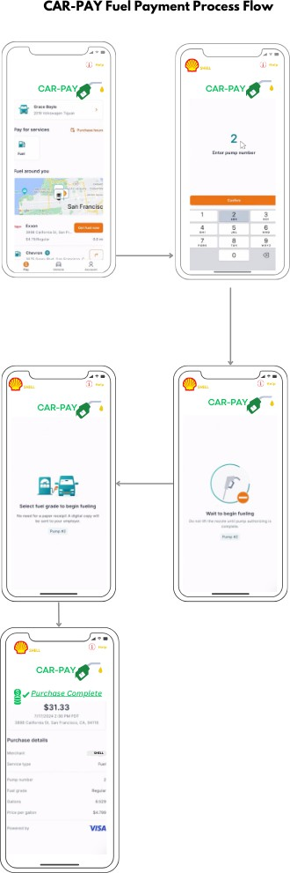

**Figure 1. Mockup of CarPay solution flow**

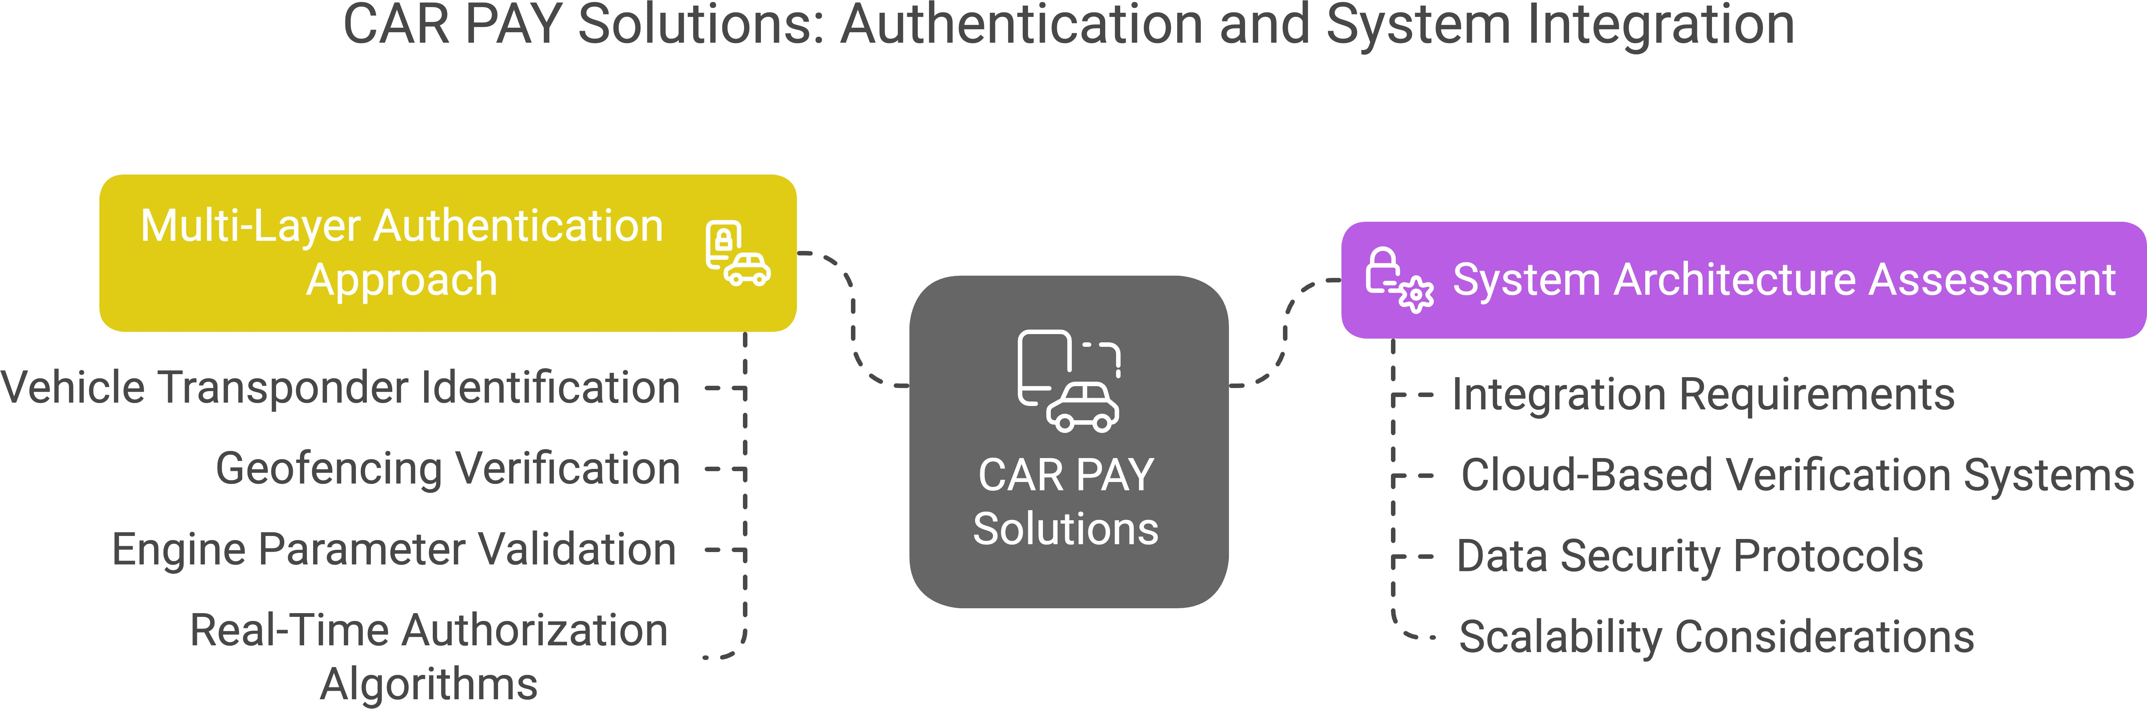

**Figure 2. CarPay Solution Considerations**

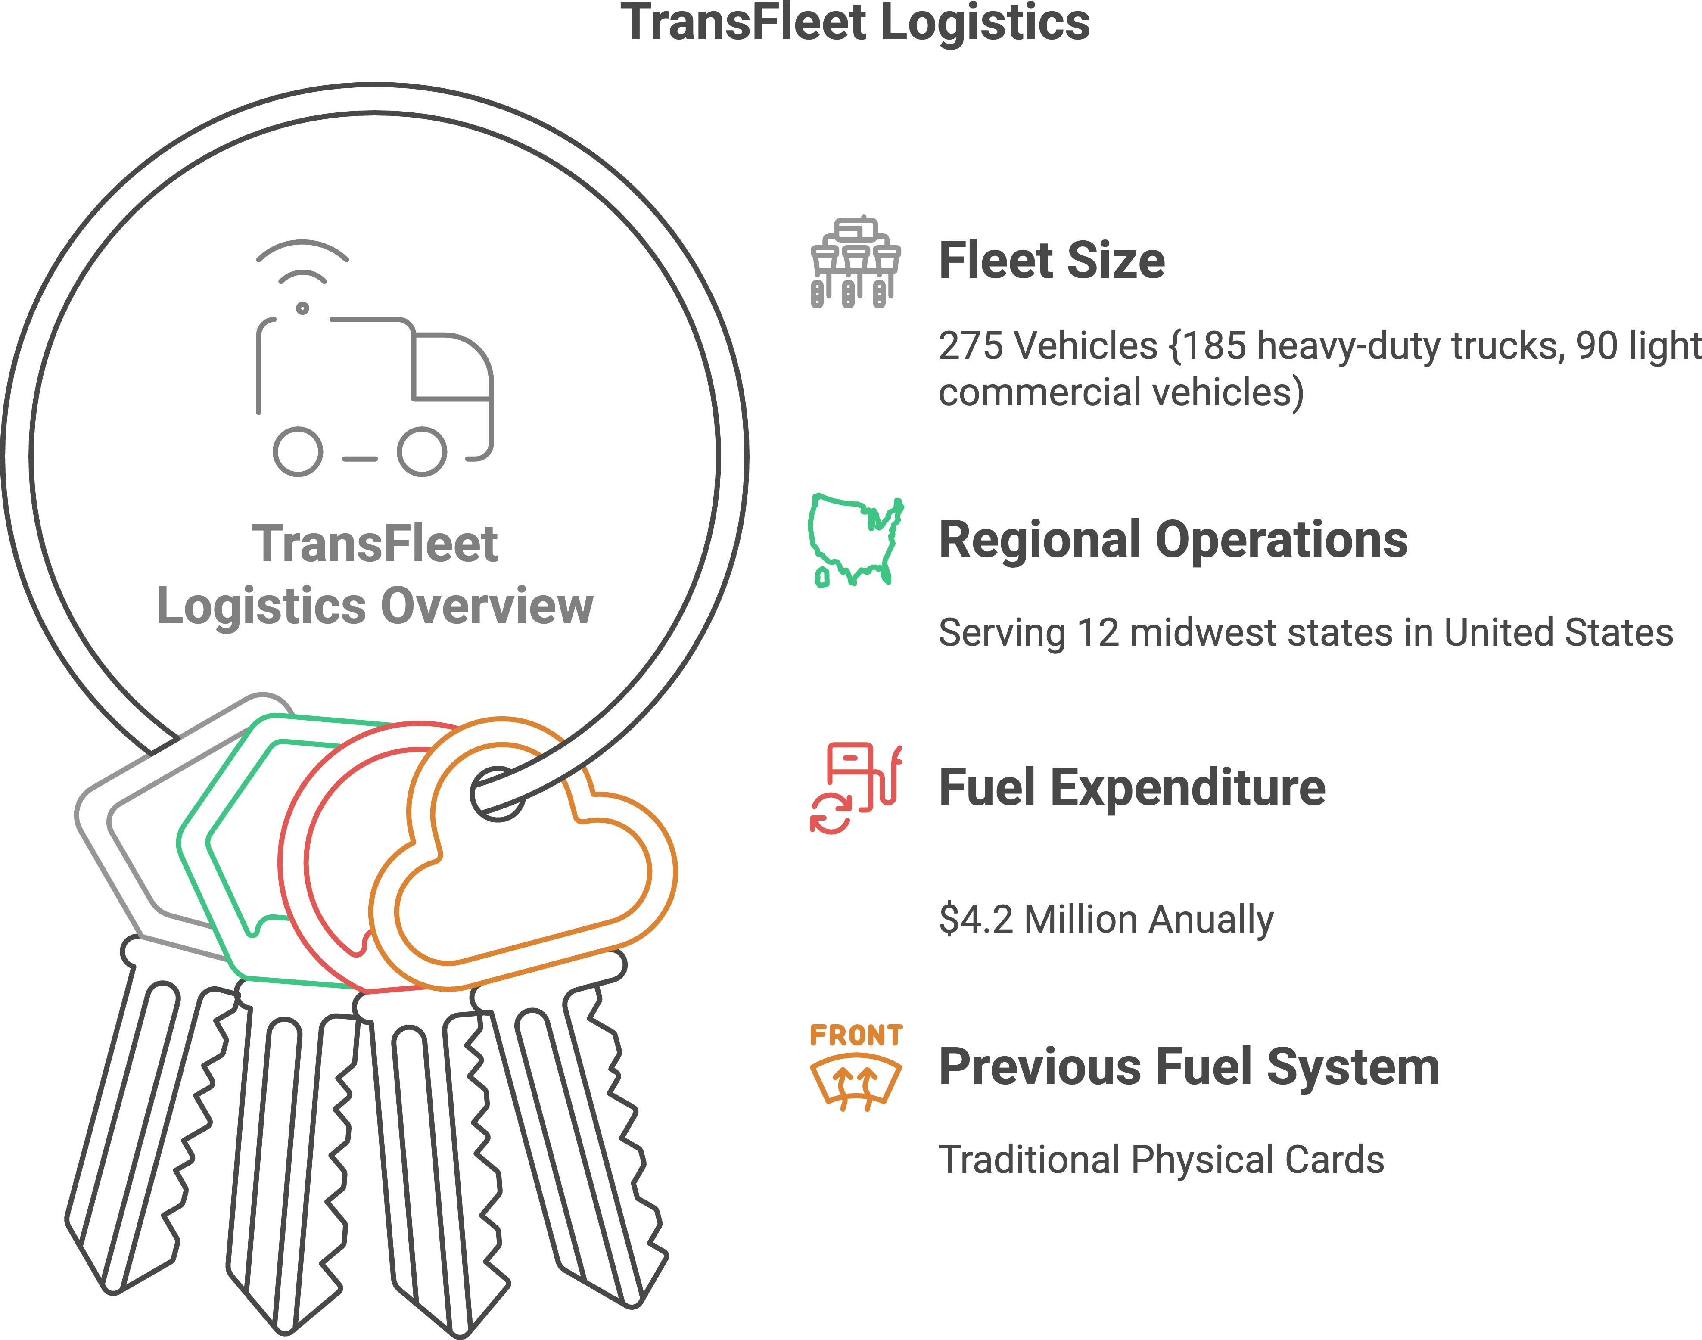

**Figure 3. Case Study: TransFleet Logistics Overview**

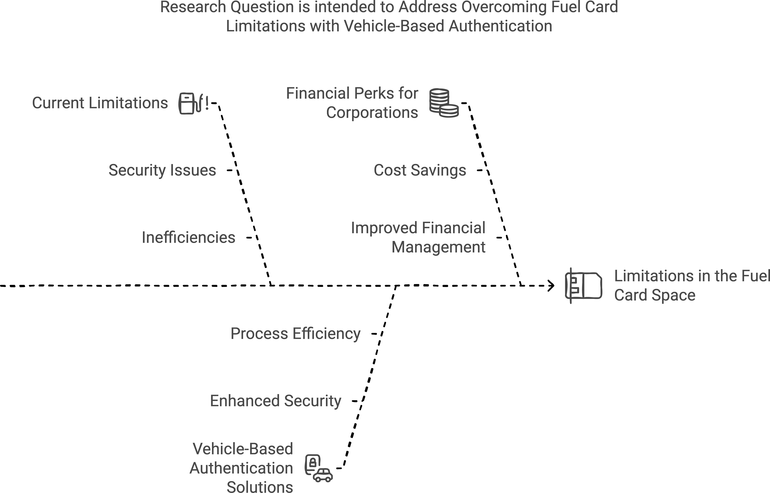

**Figure 4. Research Questions**

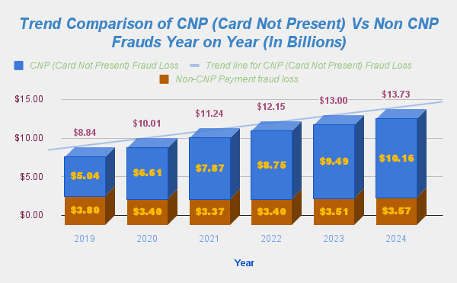

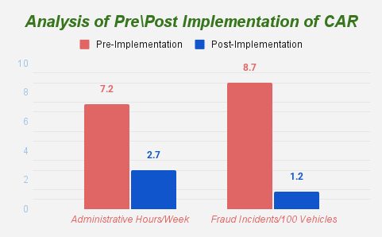**Figure 5. Comparison of Frauds related to Physical Card in the past Decade**

**Figure 6. Graph Showcasing Operational Efficient Pre Vs Post Implementation**

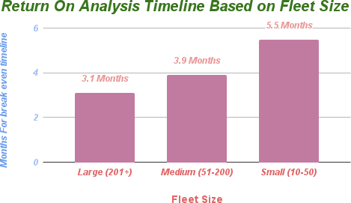

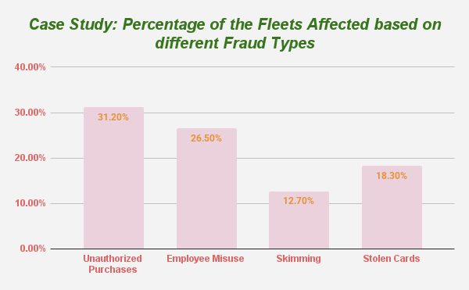**Figure 7. Graph depicting ROI, breakeven timelines for various fleet sizes**

**Figure 8. Categorization of observed fraud types on the affected fleets**