**Mental health challenges and coping mechanisms among mortuary workers in Murang’a county, Kenya**

ABSTRACT

**Background:** Mental health in the workplace has gained global attention, particularly in high-stress professions such as healthcare and mortuary services. Morticians face significant psychological challenges due to their constant exposure to death, grieving families, and hazardous working conditions. However, limited research, especially in low- and middle-income countries, has explored the mental health burden among mortuary workers. This study aims to characterize the mental health challenges among morticians in Murang’a County and identify key factors influencing their well-being.

**Methods:** A cross-sectional study design was employed, involving structured interviews with 20 mortuary workers. Data were collected on sociodemographic characteristics, work experience, mental health stressors, and available support systems. Ethical approval was obtained from the Kenya Medical Training College and Kiambu County Government, ensuring participant anonymity and confidentiality.

**Results:** The study found that the mortuary profession in this setting is predominantly female (64%). Gender-related factors were the leading contributors to mental health challenges (40%), followed by age (30%), marital status (20%), and education level (10%). Work-related stressors included interactions with grieving families (30%), poor remuneration (25%), anxiety (20%), religious conflicts (15%), and stigmatization (10%). Psychosocial support from family (50%) and colleagues (30%) played a crucial role in mitigating stress, while employer support remained minimal (20%).

**Conclusion and Recommendations:** Morticians in Murang’a County face considerable mental health challenges influenced by workplace conditions, gender dynamics, and social stigma. Targeted interventions, including structured mental health support, peer support networks, and resilience training, are crucial to promoting psychological well-being. Organizations managing mortuary services should implement workplace wellness programs, improve remuneration, and foster a supportive work environment. Future research should explore the long-term impact of these interventions and assess regional variations in mental health stressors among mortuary workers.

**Keywords:** Mental health, morticians, workplace stress, psychological well-being, stigma, resilience

**Background**

Since 2020, major organizations throughout the world have identified workplace mental health as one of the most important areas for research and practice (Anger et al., 2024). Since mental health is a crucial component of general health and wellbeing, the local healthcare authorities ought to support coping mechanisms and create a creative strategy to support healthcare professionals' practice. To safeguard healthcare professionals' mental health, workplace mental health support teams or digital mental health support interventions should be available (Htay et al., 2021). Determining the prevalence of mental health issues can be challenging. During the COVID-19 epidemic, the most prevalent mental health condition among healthcare personnel was post-traumatic stress disorder, which was followed by anxiety, depression, and distress (Saragih et al., 2021).

Because of their line of work and frequent contact with victims of violent deaths, morticians are particularly vulnerable to depression and other mental health issues. Exposure to chemical and biological agents, ergonomic circumstances, high temperature fluctuations, workplace aggression, and psychological factors were the main causes of health and safety risks at the morgues (Botha et al., 2022). Few studies have investigated mental health among morticians in low- and middle-income countries (Nakakuwa et al., 2024). Social support networks are crucial in mitigating the negative effects of stress and should be included in occupational and health guidelines for mortuary workers (Molewa et al., 2021). Such support can help mortuary workers cope anxiety associated with risk for highly infectious diseases (Alishaq et al., 2021). The government, stakeholders, and organizations in charge of overseeing mortuaries should not only enact laws and enforce them, but also offer forums (seminars, lectures, webinars, etc.) where knowledge can be exchanged and contemporary industry safe practices can be accomplished. Morticians are a significant group of professionals who deal with work-related risks that could negatively impact their health on a daily basis (Akinyemi et al., 2021). This study explores the mental health challenges faced by the mortuary workers

**Materials and methods**

The mainobjective of this study was to evaluate mental health challenges and coping mechanisms among mortuary workers in Murang’a county. The study adopted a cross-sectional prospective study design where 20 mortuary workers were interviewed using structured questionnaire. Sample size of 20 was calculated using Yamano Taro formular (1967). It should be noted that the population of mortuary workers are few in this county and majority did not want to participate in the study. The study obtained approval from Kenya Medical Training college, department of clinical medicine. The study was also approved by Kiambu county government. All information obtained during the study was anonymized.

**Results**

***Sociodemographic and work experience***

The findings indicate that the mortuary profession in this study is predominantly female, with women making up 64% of the workforce, whereas men represent a smaller proportion at 36%. This suggests that the field may be more attractive to or accessible for women, though further research would be needed to determine the underlying reasons for this gender disparity.

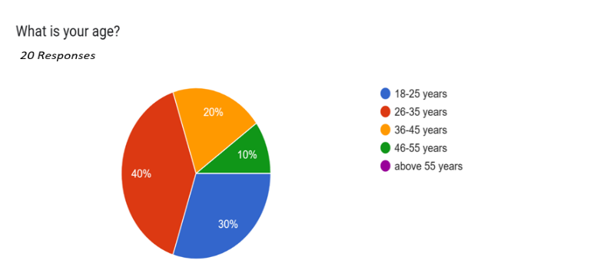

Fig: Age distribution of the respondents

Regarding work experience, half of the morticians (50%) had been in the profession for a period ranging from one to five years, indicating that a significant portion of the workforce is relatively new but has gained some level of experience. Additionally, 30% of the respondents had less than one year of work experience, suggesting a steady influx of newcomers into the field. This could imply a high turnover rate or increasing interest in the profession. Conversely, only 20% of the morticians had between six and ten years of experience, highlighting that fewer individual remain in the field for longer durations. This trend may indicate challenges related to career longevity, such as workplace conditions, job satisfaction, or professional growth opportunities.

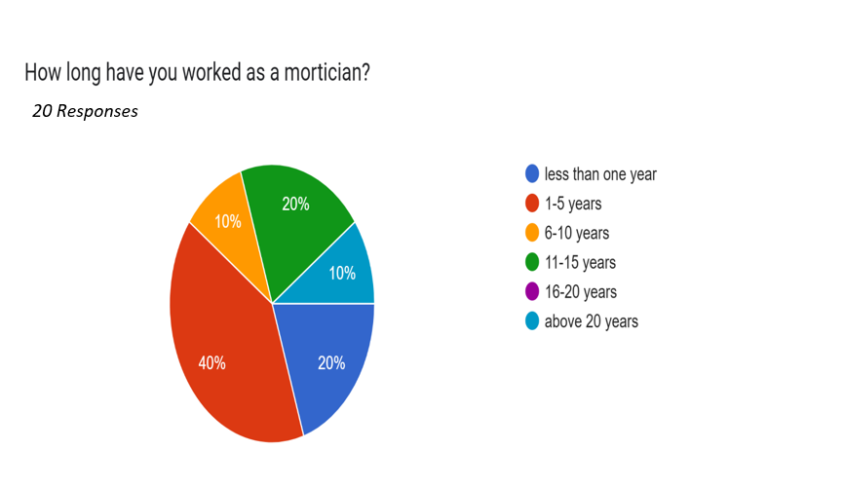

Fig 2- Work experience of the respondents

The results indicate that gender-related factors were the most significant contributors to mental health challenges among the respondents, accounting for 40% of the reported cases. This suggests that gender dynamics, societal expectations, or workplace discrimination may play a substantial role in influencing mental well-being. Further investigation would be needed to determine whether specific gender groups experience more challenges and what underlying factors contribute to this disparity.

Age was identified as the second most influential factor, contributing to 30% of the reported mental health issues. This finding implies that different age groups may face unique stressors, possibly linked to career progression, life transitions, or age-related discrimination.

Marital status accounted for 20% of the reported challenges, indicating that relationship dynamics—whether single, married, divorced, or widowed—could significantly impact mental health. This could be due to factors such as family responsibilities, social support, or emotional stressors associated with different marital situations.

Finally, education level contributed the least, at 10%, suggesting that while academic qualifications may have some influence on mental well-being, other personal and environmental factors appear to have a more substantial impact. This could indicate that mental health challenges are not strongly correlated with educational attainment but may instead be shaped by broader social and professional experiences.

Table 1- Sociodemographic characteristics of the respondents

|  |  |  |
| --- | --- | --- |
| **Factor** | **Frequency** | **Percentage** |
| Gender | 8 | 40% |
| Age | 6 | 30% |
| Marital Status | 4 | 20% |
| Education Level | 2 | 10% |
| **Totals** | **20** | **100%** |

***Work related challenges***

The findings of this study highlight several key factors contributing to challenges faced in the mortuary profession. Among these, dealing with grieving families was the most frequently reported challenge, accounting for 30% of responses. This suggests that morticians often experience emotional strain while interacting with bereaved families, as they must balance professionalism with empathy. The emotional toll of witnessing grief on a regular basis may contribute to psychological distress and burnout, emphasizing the need for adequate training in grief counseling and emotional resilience.

Poor remuneration was the second most common challenge, reported by 25% of the respondents. This indicates that financial dissatisfaction is a significant concern in the profession, potentially affecting job satisfaction, motivation, and retention rates. Low wages may also contribute to stress and anxiety, especially if employees struggle to meet their financial obligations. Addressing salary concerns through better compensation structures and financial incentives could enhance job satisfaction and reduce work-related stress.

Anxiety was another notable factor, reported by 20% of respondents. This suggests that morticians frequently experience work-related stress, likely due to the nature of their job, which involves handling deceased bodies and dealing with the emotional distress of families. The unpredictability of death cases, coupled with the demanding nature of the work environment, may contribute to heightened anxiety levels among professionals in this field.

Religious beliefs were cited as a challenge by 15% of respondents, indicating that personal or societal religious perspectives on death and body handling may create moral or ethical dilemmas for morticians. Some individuals may experience internal conflicts between their professional duties and their spiritual beliefs, leading to emotional distress or discomfort in carrying out their responsibilities. Raising awareness and fostering discussions about the intersection of religious beliefs and professional obligations may help mitigate these challenges.

Lastly, stigmatization was the least frequently reported factor, affecting 10% of respondents. This finding suggests that while societal stigma toward mortuary work exists, it may not be as widespread or impactful as other challenges. However, individuals who experience stigma may feel socially isolated or undervalued, which can negatively affect their mental well-being and professional identity. Public education and awareness campaigns could help reduce stigma and promote greater appreciation for the essential role morticians play in society.

Overall, these findings underscore the need for improved working conditions, mental health support, and policy interventions to address the challenges faced by morticians. Implementing strategies such as emotional support programs, competitive salaries, and community sensitization efforts could enhance job satisfaction and well-being in the profession.

***Psychosocial support***

The findings reveal that family support is the most significant source of emotional and psychological well-being for morticians, with 50% of respondents indicating that they rely on their families for support. This suggests that strong family connections play a crucial role in helping professionals cope with the emotional and psychological demands of their work. Having a supportive family may provide comfort, encouragement, and a sense of stability, which can help mitigate the stress associated with handling grieving families and death-related duties.

Support from colleagues was the second most commonly reported source, with 30% of respondents stating that they relied on their co-workers for emotional and professional support. This highlights the importance of peer relationships in the workplace, as colleagues who share similar experiences may offer understanding, advice, and camaraderie. The presence of a strong support system within the work environment can contribute to improved job satisfaction and resilience against burnout.

Employer support was the least frequently mentioned, with only 20% of respondents indicating that they received assistance from their employers. This suggests that while some morticians benefit from institutional support, many may feel that their employers do not provide adequate resources for mental health and workplace well-being. Limited employer support could indicate a gap in workplace policies, highlighting the need for organizations to implement better employee wellness programs, counseling services, and professional development initiatives to support staff in coping with the challenges of the profession.

Overall, these findings emphasize the critical role of social support networks in the well-being of morticians. Strengthening workplace support systems, enhancing employer engagement, and promoting peer mentorship programs could improve the mental health and job satisfaction of professionals in this field.

**Discussions**

Our findings align with previous research, reinforcing the significant influence of stigma consciousness, rude supervisors, and work-to-family negative spillover on burnout. These stressors contribute to emotional exhaustion and reduced job satisfaction. However, our study also highlights the potential protective role of meaningful work and family-to-work positive spillover in mitigating burnout. By fostering a supportive work environment and promoting work-life balance, organizations may reduce burnout risk and enhance overall well-being (Guidetti et al., 2021). Similarly, career-related stigma, exacerbated by limited awareness of the mortician’s role in providing bereavement support, remains a significant concern. The emotional toll of working closely with grieving families, combined with daily exposure to death, can profoundly impact morticians' psychological well-being and perspective on life. Implementing self-care strategies and reinforcing the value of their role in guiding and supporting families during loss can serve as protective factors, enhancing resilience and motivation in their profession (Kirongo & Mbithi, 2024). Consistent with previous research, this study highlights the psychological distress experienced by morgue workers due to their routine exposure to death and bereavement. To mitigate these challenges, it is crucial to implement targeted interventions aimed at enhancing their psychological well-being. Establishing robust support systems, including counseling services, peer support networks, and stress management programs, can play a vital role in promoting resilience and mental health among morgue workers (Wandati & Githae, 2025).

Mortuary workers, particularly those with limited experience, appear to be at a heightened risk of depression. Factors such as perceived poor health, lower resilience levels, and fears related to blood, injury, and mutilation may contribute to elevated stress levels, ultimately increasing the likelihood of depression. To address these challenges, targeted mental health interventions should be implemented to support all mortuary workers. Additionally, preparatory training that focuses on mental health resilience and coping strategies could be particularly beneficial for inexperienced workers, equipping them with the necessary psychological tools before entering the profession (Nöthling et al., 2015). While these findings are all in agreement with the current study, it should be noted that studies carried out after covid 19 pandemic may have enhanced significance as opposed to pre covid 19. As well, studies were done in different study areas. The findings of the study suggest that mortuary workers have common psychological problems. It should also be kept in mind that the current study was carried out in Murang’a and as such the generalization of the findings may be limited.

***Conclusions and recommendations***

This study reinforces existing evidence on the psychological challenges faced by mortuary workers, emphasizing the significant impact of stigma consciousness, unsupportive work environments, and work-life imbalances on burnout and mental distress. The emotional burden of working with grieving families and continuous exposure to death can contribute to increased stress, depression, and diminished job satisfaction, particularly among inexperienced workers. However, the protective role of meaningful work, supportive supervision, and family-to-work positive spillover highlights potential avenues for mitigating these negative effects. While these findings align with prior research, it is important to recognize potential variations across different study locations and time periods, particularly in the post-COVID-19 era. To address these challenges, we recommend implementing targeted mental health interventions, including structured counseling services, peer support networks, and resilience training programs tailored to mortuary workers. Organizations should foster a supportive work environment by promoting open discussions on mental health, reducing career-related stigma, and ensuring adequate professional development opportunities. Additionally, preparatory training focusing on coping strategies and psychological resilience should be integrated into the induction process for new mortuary workers. Future research should explore the long-term impact of these interventions and assess regional differences in psychological stressors among mortuary workers to inform policy development and workplace mental health strategies.

Disclaimer (Artificial intelligence)

Option 1:

Author(s) hereby declare that NO generative AI technologies such as Large Language Models (ChatGPT, COPILOT, etc.) and text-to-image generators have been used during the writing or editing of this manuscript. Language check was done using Quilbot for windows.

**References**

Akinyemi, O. O., Adenaike, E. M., Ilesanmi, O. S., & Ojezele, S. O. (2021). Perception of risks and safe handling practices of corpses among morticians in Ibadan, Oyo state. *International Journal Of Community Medicine And Public Health*, *8*(6), 2643. https://doi.org/10.18203/2394-6040.ijcmph20211964

Alishaq, M., Jeremijenko, A., Nafady-Hego, H., Al Ajmi, J. A., Elgendy, M., Fadel, R. A. A., Thomas, A. G., Alahmed, M. A. A., Ammar, A., Bensaad, M., Al-Barghouthi, B., Coyle, P., Elgendy, H., Abou-Samra, A.-B., & Butt, A. A. (2021). SARS-CoV-2 infection in mortuary and cemetery workers. *International Journal of Infectious Diseases*, *105*, 621–625. https://doi.org/10.1016/j.ijid.2021.03.012

Anger, W. K., Dimoff, J. K., & Alley, L. (2024). Addressing Health Care Workers’ Mental Health: A Systematic Review of Evidence-Based Interventions and Current Resources. *American Journal of Public Health*, *114*(S2), 213–226. https://doi.org/10.2105/AJPH.2023.307556

Botha, N. N., Ansah, E. W., & Apaak, D. (2022). Health and Safety Hazards Confronting Mortuary Attendants. In *Sustainable Education and Development – Making Cities and Human Settlements Inclusive, Safe, Resilient, and Sustainable* (pp. 257–271). Springer International Publishing. https://doi.org/10.1007/978-3-030-90973-4_21

Guidetti, G., Grandi, A., Converso, D., Bosco, N., Fantinelli, S., Zito, M., & Colombo, L. (2021). Funeral and Mortuary Operators: The Role of Stigma, Incivility, Work Meaningfulness and Work–Family Relation to Explain Occupational Burnout. *International Journal of Environmental Research and Public Health*, *18*(13), 6691. https://doi.org/10.3390/ijerph18136691

Htay, M. N. N., Marzo, R. R., Bahari, R., AlRifai, A., Kamberi, F., El-Abasiri, R. A., Nyamache, J. M., Hlaing, H. A., Hassanein, M., Moe, S., Abas, A. L., & Su, T. T. (2021). How healthcare workers are coping with mental health challenges during COVID-19 pandemic? - A cross-sectional multi-countries study. *Clinical Epidemiology and Global Health*, *11*, 100759. https://doi.org/10.1016/j.cegh.2021.100759

Kirongo, R. J., & Mbithi, B. (2024). Theoretical Review on Risks, Burn out and Interventions among Morticians. *Cross-Currents: An International Peer-Reviewed Journal on Humanities & Social Sciences*, *10*(09), 200–203. https://doi.org/10.36344/ccijhss.2024.v10i09.004

Molewa, M. L., Mbonane, T. P., Shirinde, J., & Masekameni, D. M. (2021). Assessment of occupational health and safety practices at government mortuaries in Gauteng Province: a cross-sectional study. *Pan African Medical Journal*, *38*. https://doi.org/10.11604/pamj.2021.38.76.21699

Nakakuwa, F. N., Kabuku, T., & Mukerenge, N. F. (2024). Mortuary attendants’ experiences of dealing with human dead bodies in Kavango and Zambezi regions: A qualitative study. *Death Studies*, 1–7. https://doi.org/10.1080/07481187.2024.2312376

Nöthling, J., Ganasen, K., & Seedat, S. (2015). Predictors of depression among a sample of South African mortuary workers. *The Journal of Nervous and Mental Disease*, *203*(3), 226–230. https://doi.org/10.1097/NMD.0000000000000260

Saragih, I. D., Tonapa, S. I., Saragih, I. S., Advani, S., Batubara, S. O., Suarilah, I., & Lin, C.-J. (2021). Global prevalence of mental health problems among healthcare workers during the Covid-19 pandemic: A systematic review and meta-analysis. *International Journal of Nursing Studies*, *121*, 104002. https://doi.org/10.1016/j.ijnurstu.2021.104002

Wandati, A. N., & Githae, E. N. (2025). The Stigma of Handling Dead Bodies and the Psychological Well-Being of Mortuary Workers. *Eastern African Journal of Humanities and Social Sciences*, *4*(1), 39–48. https://doi.org/10.58721/eajhss.v4i1.859