**Case Report**

**Lymphomatoid Papulosis in a patient with Non-Hodgkins Lymphoma: Clinical presentation and Management insights**

**ABSTRACT-** Lymphomatoid papulosis is a lymphoproliferative disorder. It is clinically benign and histopathologically malignant. It can resolve spontaneously; however, long-term follow-up is essential, as it can progress to malignant lymphoma in 10–20% of patients. We hereby present a known case of Non Hodgkins Lymphoma, presenting with Lymphomatoid Papulosis, papular lesions over the neck,chest and abdomen. There was no systemic involvement .No specific treatment was given and the lesions healed on their own with no recurrence.

Key words: Lymphomatoid papulosis, lymphoproliferative disorder, skin disease, mycosis fungoides

**INTRODUCTION –** “Lymphomatoid papulosis (LYP) is a chronic, recurrent, self-healing papulonecrotic or papulonodular skin disease. There is increased risk of secondary lymphomas, such as mycosis fungoides and large cell lymphoma (LTCL) in around 10–20% of the patients. The most characteristic feature of this disorder is its benign course and spontaneous resolution combined with aggressive histological characteristics closely resembling lymphoma”[1]. “In case of an extended disease, treatment with methotrexate in a low dose is recommended in order to hasten the regression of the lesions . The overall prognosis is good, and the disease follows a benign course. The term LYP was originally used by Macaulay in 1968 to describe a self-healing dermal eruption which is histologically malignant but clinically benign.”[2] These are CD30+ lesions on IHC [3]. “The available treatment modalities include topical steroids, oral methotrexate, targeted phototherapy, photodynamic therapy, retinoids, and anti-CD 30 monoclonal antibody-drug conjugate. Follow-up is essential as it can progress to malignant lymphoma in a subset of patients”.[5] In the present study, we are reporting a case of a 47- year-old male,a known case of Non Hodgkins Lymphoma, presenting with Lymphomatoid Papulosis, papular lesions over the neck,chest and abdomen.

**CASE PRESENTATION -**

A 47 year-old male presented to the Oncology outpatient department with the complaint of recurrent mildly itchy raised lesions over the neck,chest and abdomen for 6 months,from the starting of symptoms. It was gradual in onset and progressive. Few lesions were associated with mild pain and pus discharge. It was associated with fever. Each lesion would last for a few weeks, later healing by post-inflammatory pigmentation and minimal scarring. The lesions are used to heal spontaneously. The patient was diagnosed with Non Hodgkins Lymphoma 18 months back for which he received 6 cycles of RCHOP (Rituximab 375mg/m2, cyclophosphamide 750mg/m2, doxorubicin 50mg/m2, vincristine 1.4mg/m2, prednisolone 100 mg d1-5) and IFRT(Involved field radiotherapy) was done. Follow up PET CT was disease free. The patient was otherwise healthy, and his family had no similar illness. On examination, there were multiple discrete skin colored to hyperpigmented papules and nodules over the neck,chest and abdomen [Figure 1,2]. The patient also had some residual hyperpigmented macules from previous lesions, with minimal scarring over the trunk. There was no cervical, axillary ,supraclavicular,inguinal lymphadenopathy. The rest of the clinical examination was unremarkable. Based on history and clinical examination, differential diagnosis of LYP, lupus miliaris disseminated faciei, papulonecrotic tuberculid, and insect bite hypersensitivity was kept.

Complete blood count was 4000 TLC, 12.4 Hb, 153000 Platelets. There were no atypical cells in the peripheral blood smear. Histopathological evaluation with hematoxylin and eosin stain revealed focal vacuolization of basal keratinocytes. Dermis showed moderate nodular pattern of infiltration by inflammation cells comprising mainly of lymphocytes and few eosinophils along with presence of few large cells with vesicular nuclei and prominent nucleoli and indistinct cell boundaries [Figure 3a and b]. On Immunohistochemical evaluation, CD(cluster of differentaiation) 3,CD4,CD7,CD8,CD2,CD5 and CD 20 positivity was seen along with the presence of few CD 30 positive cells. A diagnosis of Lymphomatoid Papulosis was made. The lesions were monitored on biweekly follow-ups and they healed with 1 month. Wait and watch strategy was implemented here. The patient is on follow up with no recurrence.

**DISCUSSION** – “LYP is a rare cutaneous Lymphoproliferative Disorder which is characterized by self-healing, recurrent papular lesions . They heal with pigmentation or scarring. Most cases present in 5th Decade” [4,5,6]. “It involves trunks and extremities commonly whereas face, buttocks, and genitalia are less frequently affected. Delle et al. reported a case of a 44-year-old male with self-healing eruption limited to right cheek diagnosed as type A LYP based on histopathological examination”[7] .

“In a case reported by Khondker et al. a 48-year-old male presented with erythematous, painless, nonpruritic plaques, and subcutaneous nodules.The clinical presentation of LYP in children did not differ greatly from the presentation in adults”.[8]

“Satya et al. reported a case of a 16-year-old boy with a 4-year history of asymptomatic papulonodular lesions on the arms, right axilla, trunk, groin, and legs, healing with post-inflammatory hyperpigmentation and atrophic scars. Histopathology and immunohistochemistry studies of lesions were consistent with CD30+ LYP”.[9]I n the present study, the patient presented with lesions over neck, trunk and extremities. These lesions were self healing and no specific treatment was given as in the current study .

“ LYP is further divided into five subtypes based on morphological features and immunohistochemistry. LYP Type A is characterized by wedge-shaped, superficial infiltrate of CD 30+ atypical lymphoid cells along with small lymphocytes, plasma cells, neutrophils, and eosinophils. Type B has perivascular or band-like dermal infiltration of small- to medium-sized lymphocytes with cerebriform nuclei which are CD 30+ or CD 30-, with epidermotropism, resembling mycosis fungoides. LYP type C is characterized by the monotonous population of CD 30+ large atypical cells with fewer inflammatory cells, resembling anaplastic large cell lymphoma (ALCL). Type D histologically simulates an aggressive epidermotropic CD8 + cytotoxic T-cell lymphoma. Type E LYP resembles angiocentric and angiodestructive T-cell lymphoma”[10]. Jain et al.reported “a 40-year-old male who presented with self-healing papulonodular lesions on the trunk and extremities, diagnosed as granulomatous and eccrinotropic LYP ,a rare histological variant”[11]. Wait and watch strategy was used as in the present study.

“The available treatment modalities include topical steroids, oral methotrexate etc. hasten the healing of the lesions or prevent the eruptions of new lesions” [12]. “Low-dose methotrexate between 10 and 25 mg weekly is recommended as the treatment of choice”[13]. Wait and watch strategy may be useful in some cases. Malignant cases may require Photodynamic therapy or Retinoids. The risk of development of malignancy is 2% to 15% after 5 years of evolution. Therefore, long follow ups are required[14].

**CONCLUSION -**

This case highlights the detection of Lymphomatoid papulosis in an already treated case of NHL and its the indolent course and self healing process. It carries good prognosis. Long follow up is required to observe for malignant transformation.

**CONSENT-**

The authors certify that they have obtained all appropriate patient consent forms. In the form, the patient(s) has/have given his/her/their consent for his/her/their images and other clinical information to be reported in the journal. The patients understand that their names and initials will not be published, and due efforts will be made to conceal their identity, but anonymity cannot be guaranteed.

**Ethical Approval:**

As per international standards or university standards written ethical approval has been collected and preserved by the author(s).

Disclaimer (Artificial intelligence)

Author(s) hereby declare that NO generative AI technologies such as Large Language Models (ChatGPT, COPILOT, etc.) and text-to-image generators have been used during the writing or editing of this manuscript.

**REFERENCES -**

1.Huang CH, Hsu CK, Lee JY. Lymphomatoid papulosis in association with mycosis fungoides: A clinical and histopathologic review of five Taiwanese cases. Dermatologica Sin. 2014;32:75–81.

2.Macaulay WL. Lymphomatoid papulosis. A continuing self-healing eruption, clinically benign--histologically malignant. Arch Dermatol. 1968;97:23–30.

3.Kempf W. CD30+lymphoproliferative disorders: Histopathology, differential diagnosis, new variants, and simulators. J Cutan Pathol. 2006;33:58–70.

4.Kunishige JH, McDonald H, Alvarez G, Johnson M, Prieto V, Duvic M. Lymphomatoid papulosis and associated lymphomas: A retrospective case series of 84 patients. Clin Exp Dermatol. 2009;34:576–81.

5.Verma D, Lakhani R, Mendiratta V, Chatterjee P. Lymphomatoid Papulosis: A Case Report. Indian Dermatol Online J. 2023 Nov 24;15(1):95-98.

6.Kavvalou E, Stefanidou M, Krueger-Krasagakis SE, Evangelou G, Koumaki D, Marinos L, Tzardi M, Krasagakis K. Lymphomatoid Papulosis Type A: A Case Report of the "Wait-and-See Strategy" in a 27-Year-Old Male Patient with Extensive Disease. Case Rep Dermatol Med. 2019 Jul 16;2019:1765210.

7.Dalle S, Balme B, Thomas L. Lymphomatoid papulosis localized to the face. Dermatol Online J. 2006;12:9.

8.Khondker L, Shafiq AB. Lymphomatoid papulosis: A rare case report and review of literature. J Pak Assoc Dermatol. 2018;28:108–13.

9.Satya RS, Rao GR, Singh VK. CD30+lymphomatoid papulosis in 16-year-old adolescent boy. Indian J Paediatr Dermatol. 2022;23:234–7.

10.Pai K, Pai S. Angiocentric lymphomatoid papulosis in a child: Uncommon benign clinical entity with malignant histology. Our Dermatol Online. 2015;6:62–4.

11.Jain N, Gutte R, Jadhav P, Khopkar U. Granulomatous and eccrinotropic lymphomatoid papulosis. Indian J Dermatol Venereol Leprol. 2012;78:82–4.

12.Kempf W, Pfaltz K, Vermeer MH, Cozzio A, Ortiz-Romero PL, Bagot M, et al. EORTC, ISCL, and USCLC consensus recommendations for the treatment of primary cutaneous CD30-positive lymphoproliferative disorders: Lymphomatoid papulosis and primary cutaneous anaplastic large-cell lymphoma. Blood. 2011;118:4024–35.

13.Lange Wantzin G, Thomsen K. Methotrexate in lymphomatoid papulosis. Br J Dermatol. 1984;111:93–5.

14.Cordel N, Tressières B, D'Incan M, Machet L, Grange F, Estève É, Dalac S, Ingen-Housz-Oro S, Bagot M, Beylot-Barry M, Joly P., French Study Group on Cutaneous Lymphoma. Frequency and Risk Factors for Associated Lymphomas in Patients With Lymphomatoid Papulosis. Oncologist. 2016 Jan;21(1):76-83.

**FIGURE 1- Showing multiple maculopapular lesions on trunk around 4 mm in size with mild erythema**

**surrounding them.**

**.**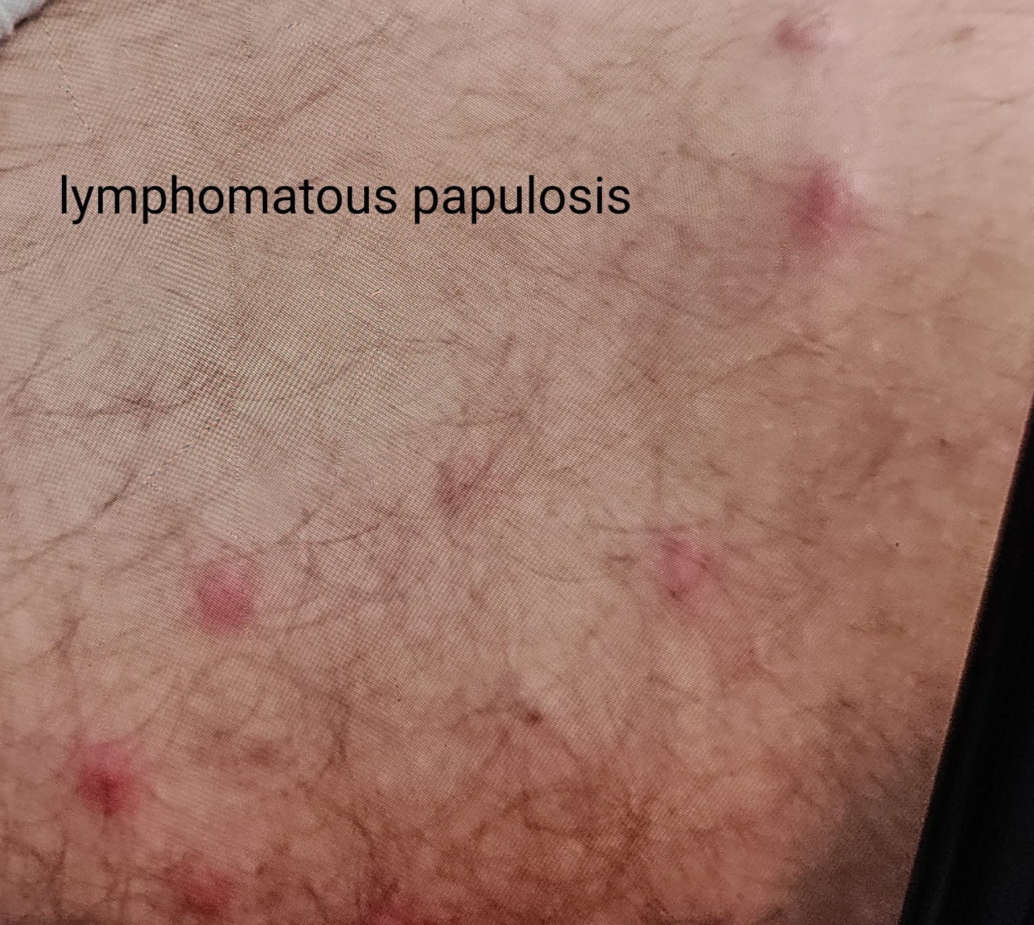

**FIGURE 2-Showing similar lesions around scar site on chest wall**

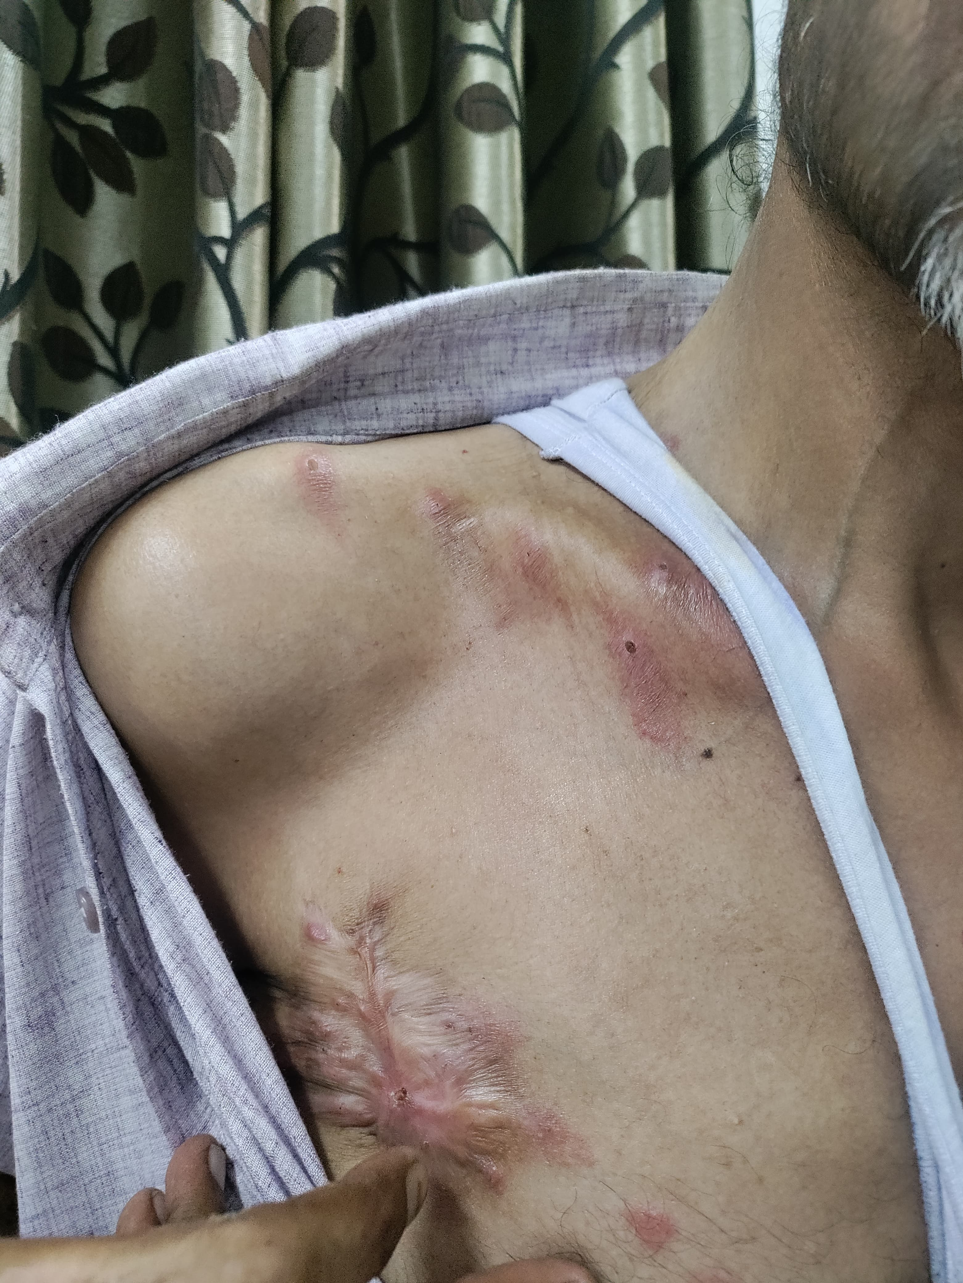

**FIGURE 3(a)-Microscopic images showing Focally thinned epidermis with dense pan-dermal lympho-histiocytic infiltrate creeping in between the collagen bundles and adnexa (H&E, 10x). (b) Lymphohistiocytic infiltrates in the dermis (H&E, 40x)**

**a)**

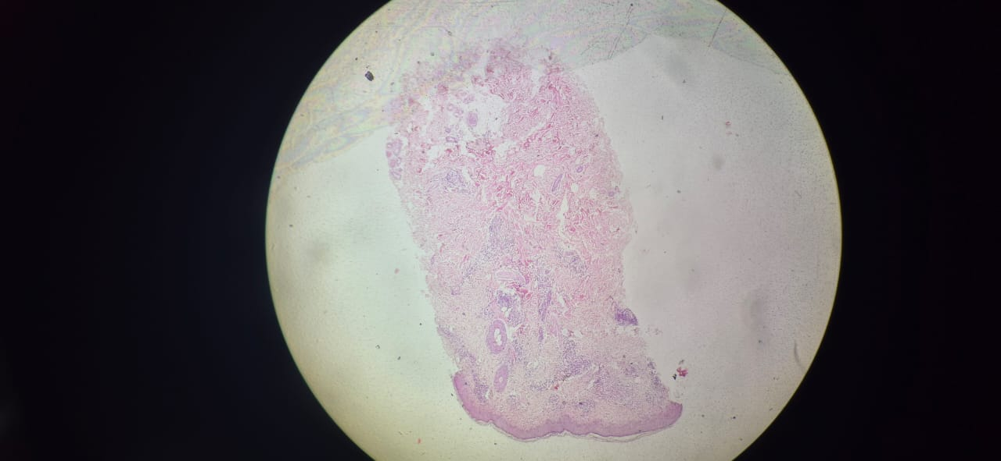

**b)**

