Original Research Article

**Influence of the Restriction of Agro-chemical Supply on Sri Lankan Agriculture: A Case Study on Vegetable Production at Hanguranketha Divisional Secretariat**

**ABSTRACT**

|  |
| --- |
| The central hill country of Sri Lanka is the backbone of vegetable production. Two main groups of vegetables are grown in Sri Lanka based on agroecological adaptability. The upcountry (hilly areas) vegetables constitute crops belong to Cruciferaceae and Solanaceae families which are grown at a commercial scale with the application of high rate of external inputs. Up-country vegetable cultivation is popular in Nuwara Eliya, Badulla, Kandy and Matale districts within the central highland of Sri Lanka. However, the output (yield) and profit substantially varied during the period of COVID-19 pandemic affected Sri Lanka in 2020 and also during the economic crisis followed by (in 2021/22). The resultant impact on the socio-economic structure of agricultural areas affected the vegetable crop value chains largely. Therefore, the present study was done to identify and assess the socio-economic feasibility of field vegetable production in the Hanguranketha AGA division during 2020-22, particularly under agro-chemical import ban imposed by the government in 2021. Altogether 51 small scale commercial vegetable farm units were selected using simple random sampling strategy from a designated population of 100 farmers. The pre-tested questionnaire-based survey key informant interviews and finally one-to-one meetings were conducted to collect primary data from vegetable farmers about their cost of cultivation and income generation. Fertilizer prices were the main cause of increasing production costs under the restrictions in agro-chemical supply for all vegetable crops. Meanwhile increasing farm gate prices due to production setback contributed higher income. Particularly for tomato and beans. Per farmer cost of cultivation and net income have shown a variability among different areas due to variability of the extent of cultivation in *Hanguranketha*, Sri Lanka during 2020-22 under the import ban on agro-chemicals. |

*Keywords: Vegetable cultivation, COVID-19, Economic recession, Hanguranketha, Farmer economy*

**1. INTRODUCTION**

There are two main groups of vegetables grown in Sri Lanka based on their agro-ecological adaptability (Weerakkody and Mawalagedara, 2020). In the upcountry (hilly areas), vegetable crops such as cabbage, carrot, beetroot, cauliflower, knol khol, bean, tomato, and capsicum grown commercially with the application of high degree of external inputs. The other group constitutes the low-country (plains) vegetables, which includes brinjal, bitter gourd, pumpkin, luffa, cucumber and snake gourd which are cultivated less intensively under low input systems (Udara et.al, 2022, Bhowmick, 2022 and AgStat, 2022). They collectively produce more than 900,000 metric tons of fruit and vegetables annually, predominantly under open-field conditions and to meet the local demand. The government also encourages the private sector engagement in commercial cultivation for further expansion of this sub-sector (Bhowmick, 2022, AgStat, 2022).

Agriculture continues to be the mainstay of the national economy through its contribution to the GDP, despite its declining trend due to relatively higher rate of expansion in the alternative sectors of the national economy. At present, the contribution from agriculture to GDP is 8.7 %. According to national statistics, agricultural activities were contracted by 4.6 % in 2022 in value-added terms, compared to the growth of 0.9 % recorded in 2021 (Central Bank Report, 2022). Its share in vegetables is primarily coming from semi-commercialized small farmers whose individual extent of land does not exceed a hectare. In 2021, primary production of vegetables in Sri Lanka was 1.51 million tons. It is a result of an annual increase of 5.48%, since 1972.

During 2020 – 22 the global pandemic, Covid-19 followed by, an economic down-fall affected Sri Lanka (Bhowmick 2022; Central Bank Reports, 2020, 2021 and 2022). As a remedial measure for diminishing foreign exchange reserves, the Sri Lankan authorities introduced an organic agriculture policy, banning the import of agro-chemicals. Consequently, as a group of perishable crops that are highly sensitive to dynamics in soil fertility and biotic stress (pest and diseases), vegetable cultivation was challenged heavily. Particularly Sri Lanka lost its first-place in 2017 in the Food Security Index for South Asia, dropping to 3rd place by 2021 (Economics and Social Status, 2021).

Upcountry vegetable cultivation is the most popular among the farmers in Nuwara-Eliya, Badulla, Kandy, and Matale districts within the central highlands of Sri Lanka. Meanwhile, Hanguranketha AGA division belongs to Nuwara Eliya District, and is predominant in cultivation of a consortium of upcountry as well as low-country vegetables (i.e. tomato, beans, brinjal, cabbage, and capsicum) in a rice-based seasonal pattern (Kodituwakku and Weerahewa, 2014). It is the main source of income for the farmers in this area. Due to Covid-19 pandemic during 2020-21 the pattern of life and livelihoods were severely affected across the country, mainly due to restrictions on local transportation, closure of main whole sale markets (i. e. Dedicated Economic Centers), imposed ban on agro-chemical imports, and limitations in shipping (import-export failures) (Ghose et.al. 2023). Resultantly, the farmers were heavily affected due to insufficient inputs and market opportunities, leading to an economic loss. This was followed by new policy initiatives on the import ban of agrochemicals in the following year (in 2021). Even though the ban was lifted in 2022, a massive increase in the world market prices of fertilizers together with “black-market forces” the market prices of fertilizer went high-up, much higher than the normal range. This situation could have resulted in an increasing overall cost of production (COP) and lesser market supply of vegetables, leading to a drastic increase in retail prices of fresh vegetables. Considering all these issues which affected the agricultural production in Sri Lanka during 2020-22, this study was conducted to investigate how the crisis situation affected the socio-economic feasibility of vegetable crop production in the Hanguranketha area, by assessing the cost of cultivation and income generation during 2020, 2021 and 2022 and investigating the share of change in cost and supply of inputs, crop yields and produce prices in each year.

**2. material and methods**

**2.1 Experimental Design**

Hanguranketha DS division is composed of 5 villages or Grama Niladhari (GN) divisions. Five GN divisions that are adjoining to each other, namely Rikillagaskada, Adikarigama, Maoya, Hewaheta, and Pallebowala were randomly selected for this study (Fig. 1). Either the GN division (five divisions) or vegetable crop species (five crops) were considered the test criteria (as treatments) alternatively while individual farms (8-15) were the replicates. The experimental design was a single factor CRD.

**2.2 Data collection and sampling**

The study assessed the Socio-Economic feasibility of field vegetable production in the Hanguranketha AGA division during the economic recession in 2022 by interviewing farmers and collecting their farm records. “Simple random sampling” was followed as the sampling strategy by considering the population of farmers. Out of 100 total number of full-time commercial vegetable farmers, a sample of 51 farmers (nearly a 50 %) were selected for the study. A pre-structured questionnaire was used to administer the survey and one-to-one interview method was followed in data collection from those actors. The key informant interview is particularly used to collect data and information from selected farmers and field officers belongs to the Department of Agriculture and Department of Agrarian Development in order to verify some of the controversial information. Some data and information were collected from the Provincial Department of Agriculture, Central Province, especially for mapping the farm locations and pre-testing the questionnaire. Furthermore, focus group discussions were held with the members of the farmer organizations in each GN division to obtain cultivation-related details. Officers of the Agriculture Department and Department of Agrarian Services, Natural Resource Management Centre, Divisional Secretariats and Land Use Division, of the relevant study area participated in those discussions.

The questionnaire survey comprised of two parts; (1) For the vegetable farmers, about the existing agronomic practices and assess the costs and benefits while (2) Other value chain actors, to gather secondary data on wholesale and retail prices of vegetables, supply volumes, species diversification need, competition among the suppliers, transportation cost, and government strategies to uplift the vegetable farmers. Institutional support in this regard could be received from the Department of Agriculture and other relevant government and non-governmental institutions. Further, secondary data from monographs, journals articles, newspapers and websites were used to bridge the gaps in essential information.

**2.3 Statistical analysis of primary data**

Data collected from different actors connected to the vegetable farming and rest of the value chains were analyzed by appropriate statistical methods, such as ANOVA and Chi-square procedures (using the statistical software, SPSS), followed by LSD procedure. And the mean and variance of statistically significant parameters (p=0.05) were presented in bar charts, line graphs and tables, as appropriate, using graphic software, MS Excel. Moreover, general facts pertaining to vegetable cultivation were presented in percentages. Finally, the whole exercise was diverted to assess the significance of the region (GN division), crop and year on the variability of cost of production, yield and net income, per farmer basis as well as hectare basis.

**3. results and discussion**

**3.1 age distribution and educational qualifications**

The age distribution of vegetable farmers is shown in figure 1a. The highest fraction (41%) of the respondents were in the age group of 56-75 years while the next highest group of farmers (20 %) were belonging to the 25–36-year range. Our results are supported by Nuskiya (2019) in which the largest group of the up-country vegetable farmers (56 %) were in between 45-65 years while the next largest group (26 %) were in between 25-45 years old category (relatively young). The results clearly indicate the less popularity of vegetable farming among the younger generation in this area. A study was done on the market window and economic efficiency of selected upcountry vegetables in Sri Lanka has also reported that vegetable cultivation is a less attractive livelihood among rural youths (Priyadarshini and Wickremasinghe, 2018).

The majority of farmers (61%) had completed their education up to G.C.E A/L (university entrance). About 73 % farmers had education levels up to G.C.E O/L and only 10% of the farmers had completed a degree. Hence 72.5 % of the vegetable farmers have their basic education (o/l passed) and only 27.5% of farmers were below G.C.E O/L education level (fig. 1b). A study done by Kumara et al. (2015), on the viability of controlled environmental agriculture (CEA) for vegetable farmers in Sri Lanka, also reported that 90 % of protected culture farmers are G.C.E O/L qualified. Protected culture practices need more technical knowledge than conventional farming practices, and it could be the reason for relatively high educational level of CEA farmers, compared to open-field farmers. Nearly 27 % have some kind of professional qualifications (degree and diploma holders) and degree and diploma holder farmers seem to increase because of unemployment in Sri Lanka. This is not a satisfactory situation because they are small-scale field vegetable farmers.

|  |  |
| --- | --- |
|  |  |

**Figure 1: Age distribution of farmers (in years) (A) Educational background (B)**

**3.2 Experience in vegetable farming**

The majority of farmers (82.4 %) had a minimum of 10 years of experience in vegetable farming. Nearly half of them (43.1 %) were having more than 20 years of experience (20 -45 years). An earlier study done on market window and economic efficiency in assessing the profitability of selected upcountry vegetables in Sri Lanka also reported the similar results regarding the experience of vegetable farming among upcountry vegetable farmers (Priyadarshani and Wickramasinghe, 2018). Hence, the majority of farmers can be considered well experience on vegetable crop production and marketing, adopting well with the variable situations in production and marketing.

**3.3 Area of Cultivation**

The total farmland covered in the survey was 31.75 ha. Based on the percentage of farmers cultivated during the 2020-22 period, the most popular vegetable crop was cabbage (28 %), followed by tomato (24 %), beans (21 %), brinjal (17 %) and capsicum (10 %), respectively. Meanwhile as shown in Fig. 2a, there was no yearly variation in the extent of cultivation of each crop by individual farmers during 2020-21. However, the variation of the extent of cultivation among crops within each year was marginally significant, where the highest and lowest were cabbage and capsicum, respectively while the others were in between in both years (Fig. 2a)

The area wise distribution of extent of cultivation by individual farmers indicated apparently higher values in Rikillagaskada and Adikariama in 2020 and also Rikillagaskada, Adikarigama and Maoya in 2021 (Figure 2b).

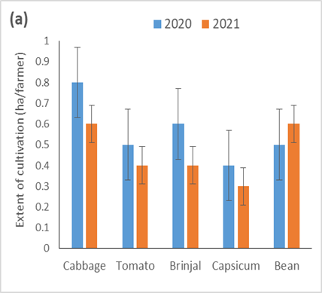

**Figure 2; Variation of extent of cultivation by major vegetables in 2020 and 2021**

**3.4 Use of inputs and the cost of vegetable production**

The main cost components of vegetable cultivation in Hanguranketha were seeds, fertilizer, pesticide and labor. The total cost of cultivation was Rs. 1,53,038±31427 per hectare (approximately U.S. $ 500). Table 1 illustrates detailed cost components on hectare basis. It shows an increase in all cost components along with time. The increase in labor costs and pesticide were not very noticeable but yearly increase in cost of fertilizer was very high (quadruple increase). This could be a reason for the temporary shortage of fertilizer in the input market in 2020 due to restrictions in the local distribution network during the early part of the COVID-19 pandemic in the country. The shortage of chemical fertilizers continued during 2021 and also in the first two quarters of 2022, due to import sanctions imposed on agro-chemicals under the organic agriculture policy brought up by the Sri Lankan government (Weerahewa, and Dayananda, 2023). Skyrocketing of the retail prices of agrochemicals, under imperfect input marketing, during this period aggravated this situation. According to Samaranayake, and Ulpathakumbura (2021), the synthetic fertilizer usage of agricultural lands in Sri Lanka in 2018 was 100 kg per hectare while it suddenly reduced to approximately 25 kgs in 2019-2020. Along with the availability of chemical fertilizers as the import ban was lifted in the second half of 2022, the application rates increased gradually, and thus contributed largely to increase the ultimate cost of cultivation. According to the Table 1, the fertilizer cost has been increased by three times in2021and six times in 2022 than compared to the cost of fertilizer in 2020 (nearly Rs. 4000 per ha). The annual expenditure on agrochemicals (including fertilizer) by Sri Lanka is not stable as Samaranayake, and Ulpathakumbura (2021) reports 60 million USD expenditure in 2015 whereas it was 40 million USD in 2018. Meanwhile, relatively higher other cost components such as labor (Rs. 87,980±1,316) and pesticide use (Rs. 40,330±5,305) and their steadiness during the study period contributed a lot to the overall cost of cultivation (Table 1). Further, a low and steady share of the cost for seeds (planting material) implies their exemption from the import ban and the supply through local seed production sources, except for cabbage.

**Table 1: Cost of cultivation of vegetable production in Hanguranketha during 2020-22**

|  |  |  |  |  |
| --- | --- | --- | --- | --- |
|  | Cost of cultivation (LKR per ha) | | | |
| Year | 2020 | 2021 | 2022 | Mean (2020-22) |
| Labour | 74,002 | 89,803 | 1,00,135 | 87,980±13,162 |
| Fertilizer | 4,088 | 12,446 | 24,415 | 13,650±10,217 |
| Pesticide | 34,211 | 42,322 | 44,455 | 40,330±5,305 |
| Seeds | 8,469 | 10,220 | 14,544 | 11,077.8±3,127 |
| **Total** | 1,20,770 | 1,54,793 | 1,83,550 | 1,53,038±31,427 |

**3.5 Yearly variation in vegetable crop yields during 2020 -2022**

There is a significant yearly difference in vegetable crop yields at Hanguranketha (p=0.003). Compared to 2020 there is a significant yield reduction in 2021 in all five GN divisions in Hanguranketha in 2021. However, further reduction in 2022 was not significant. This could be a result of the limited application of technical inputs, especially chemical (synthetic) fertilizers due to their unavailability and sudden price escalation (Yakandawala, 2023). Further, the gradual reduction in vegetable crop yields over the years implies low use of chemical fertilizer due to 3-4-fold increase in the cost of fertilizer during 2020 – 2022. The highest yield was reported by cabbage in all three years and its mean was significantly higher than all the other vegetable crops. Farmers reported the lowest mean yields for capsicum, which was significantly lower than the other vegetable crops. Yearly means of the yield records of the other three vegetable crops were not significantly different (Figure 3). Apart from this, the farmer-to-farmer variation of crop yields (irrespective of the crop and the year) was also highly significant (p=0.0001), indicating a great deal of variation in crop management among them. Hence the annual reduction of crop yields (especially from 2020 to 2021) has affected all five vegetable crops in the same manner.

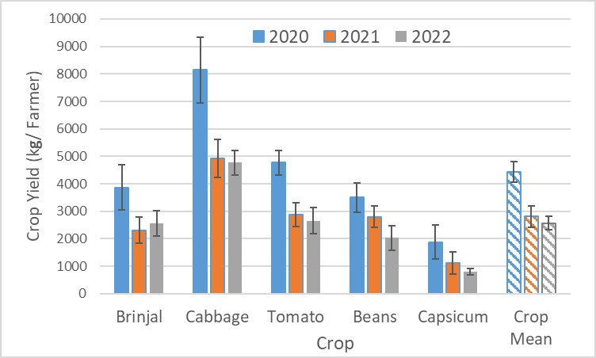

**Figure 3:** **Yearly variation in vegetable crop yields of farmers during 2020 -2022**

**3.6 Fluctuation of farm gate price of vegetables in 2020-2021**

According to the farmers’ records in Hanguranketha, annual/ seasonal fluctuation of the mean farm gate price of five selected vegetable crops during 2020 – 2022 was significant (p=0.03). The mean farmgate prices in 2020, 2021 and 2022 were LKR 106.17,166.32 and 302.96, respectively for all five vegetable crops. The mean retail price increase reported by other national databases tally with this result (Central Bank Report, 2022). Price variation was completely opposite to the yield variation within 2020 – 22, described above (Figure 4). Therefore, the drastic escalation of farm gate prices of vegetables could be a result of a shortage in supply due to limited transportation and higher cost of transportation under the fuel shortage prevailed severely during March 2021 – December 2022 (Nuskiya,2022). For example, farmer’s records indicate that the cost of transportation per unit pack was LKR 218.63±8.51 in 2020 while it increased to LKR 423.53±12.39 in 2021 and further increased to Rs. 582.35±5.39 in 2022, indicating a 194 % and 266 % increase in respective years. This matter severely affected the long-distance transport of upcountry vegetables. The descending order of the farm gate prices were capsicum, beans, tomato, brinjal and cabbage. The pattern was almost the same in every year (Figure 4). As reported above, the vegetable with the highest yield receives the lowest market price (*i. e.* cabbage) while the highest yielding vegetable received the lowest market price (*i. e.* capsicum).

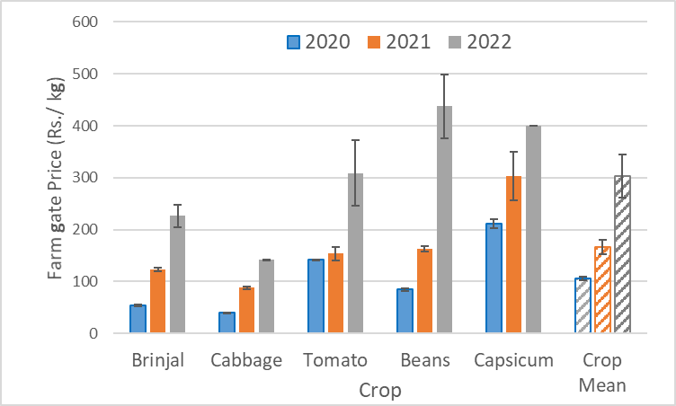

**Figure 4: Fluctuation of farm gate prices of vegetables in 2020-2021**

**3.7 Variation in COP and Net Income among crops (per ha basis)**

According to Figure 5, the cost of production (COP) was not significantly different among crops in all three years. However, the net income was marginally significant among five vegetable crops, cabbage, beans, tomato, capsicum and brinjal in 2020 (p=0.092), 2021 (p=0.122) and 2022 (p=0.071). The highest net income was given by capsicum in 2020, but reduced by more than 50% in 2021 and became the lowest net income earner in 2022. Yield reduction and higher COP in 2022 (due to increasing fertilizer prices) could be the main reason for this result. Net income of brinjal is significantly higher in 2022 compared to 2020 and 2021, manly caused by the increased farm gate price of brinjal, as there was no significant yield increase, l.

In contrast, the net income of cabbage increased drastically in 2022 despite the fact the cabbage yield per hectare was less than in the other two years (Figure 4). The reason for overall increase in COP could be the price hike of fertilizer (nearly quadrupedal increase), compared to the prices prevailed in previous two years. And also, the net income of tomatoes has drastically increased (>400,000 per ha) in 2022 compared to 2020 and 2021 (around 100,000). Since tomato was one of the most popular crops in selected areas, every farmer cultivated tomato every year as well as COP was affordable for farmers compared to other crops. The net income of beans also shows a similar trend as tomatoes and the highest income has been reported in 2022. Despite the yield reduction, increased farm gate prices have led to this income hike in beans.

**Figure 5: Variation in COP and Net Income among crops (per ha basis)**

**3.8. Variation in COP and Net Income among GN divisions (per farmer basis)**

According to Figure 6, there is a marginally significant difference in per farmer cost of cultivation (COP) among GN divisions in 2020 and 2021 (p=0.12) while it was not significant in 2022 (p=0.5). The farmers in Adikarigama were able to maintain it at significantly lower levels than Hewahata. Furthermore, the cost of cultivation in Pallebowala was significantly higher than in Hewaheta, making it the highest among GN divisions. Meanwhile, the cost of cultivation in Rikillagaskada and Maoya was marginally significantly lower than in Pallebowala in both these years. When consider the deviation of per farmer extent of cultivation in GN divisions from its mean (0.6 ha), Hewaheta (0.75 ha) and Pallebowala (5.4 ha) were in the upper and lower extremes, respectively. Even though per-farmer COP in Hewahata was higher, it could be attributed to its higher per-farmer extent of cultivation. However, this logic fails for Pallebowala farmers because of their relatively low per-farmer extent of cultivation.

Net income within GN divisions has been increased in all the GN divisions from 2020 to 2022. For example, in 2020 the net income of Rikillagaskada GN division was less than zero (negative) but, it was increased to nearly LKR 80000 and 190000 in 2021 and 2022, respectively.

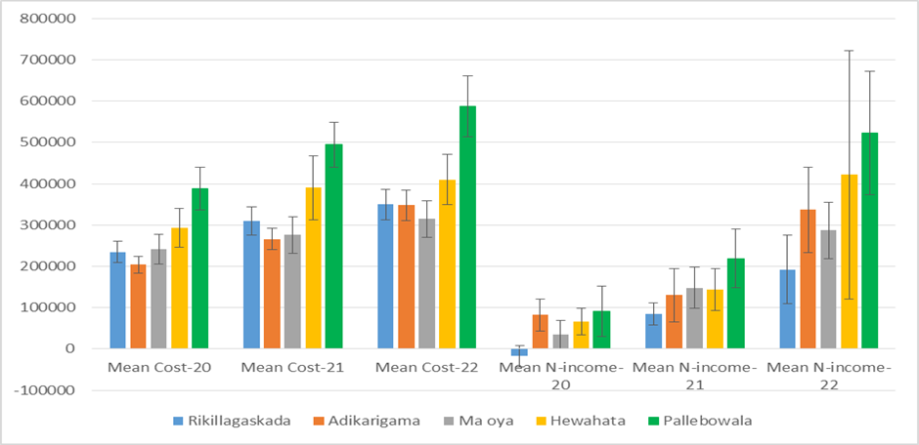

**Figure 6: Variation in COP and Net Income among GN divisions (per farmer basis)**

**3.9 Yearly variation in overall COP and net income**

This Fig. 7 shows, the marginal significant differences in cost of production (COP) of vegetable crops (per ha) within the three consecutive years (p=0.102). The difference between 2020 and 2022 was significant but there was no significant difference between years 2020 and 2021. By 2022, the price of agricultural raw materials has increased unusually. The drastic increase in fertilizer prices (given in Table 1) could be the driving force behind this escalating COP of all crops.

Meanwhile, there was a significant difference in net income (per ha) from 2020 to 2022 (p=0.014). The annual difference in net income from vegetable cultivation has drastically increased from 2020 to 2022 whereas the difference between 2021 and 2022 was also significant but the difference between 2020 and 2021 was not significant. The total vegetable production in the country has reported to be decreased by 1.4 % (from 1.69 mil t in 2020 to 1.67 mil t in 2021 (AGSTAT, 2023). It was further reduced by 4.9 % to 1.59 mil t in 2022. This was owing to the combined impact of variable weather, the fertilizer shortage and increased machinery and transportation costs. (Central Bank, 2021 and 2022). Hence the continuous supply of vegetables to meet the market demand was a challenge as there is a gap between demand and supply. Almost all socio-economic sectors in the society have been affected by the COVID-19 pandemic, and the agriculture sector is no exception ([Gray, 2020](https://www.sciencedirect.com/science/article/pii/S2666049022000093#bb0110); [Rozaki, 2020](https://www.sciencedirect.com/science/article/pii/S2666049022000093" \l "bb0280)). Sri Lanka in March 2020 underwent several waves of the pandemic through 2020 and 2021. The social and economic impact of the pandemic has reduced the agricultural sector's contribution to Sri Lanka's GDP for 2020 by 2.4% compared to 2019 (Central Bank Sri Lanka, 2020). With 25.3% of the country's employed population involved in the agricultural sector, any unfavorable economic conditions in the sector are expected to influence the livelihoods of 2,071,940 individuals ([Department of Census and Statistics Sri Lanka, 2019](https://www.sciencedirect.com/science/article/pii/S2666049022000093#bb0075)). According to a study conducted in Bangladesh, COVID-19 has had a significant impact on farmers growing perishable products such as vegetables (Alam and Khatun, 2021). Vegetable farmers in Sri Lanka are likely to be more financially vulnerable than other farmers due to lack of a guaranteed price for their produce (Sandika, 2012), limited access to community irrigation systems, limited access to good information sources (Perampalam and Perera, 2018), higher transaction costs in marketing (Ratnadiwakara et al., 2008), and lack of input subsidies. Vegetables, unlike rice, are perishable, making them difficult to handle post-harvest if the supply chain is disturbed (Hailu and Derbew, 2015). Because vegetables are perishable, they must be transported to market as soon as possible before they degrade (Sandika, 2012), necessitating prompt marketing. In Sri Lanka, vegetable marketing is governed mainly by the private sector and the role of middlemen is significant ([Vidanapathirana et al., 2018](https://www.sciencedirect.com/science/article/pii/S2666049022000093" \l "bb0335)). Because of this, and due to the lack of a guaranteed price, farmers' profit margins from vegetable selling are relatively low and unpredictable ([Sandika, 2012](https://www.sciencedirect.com/science/article/pii/S2666049022000093#bb0290)). This makes vegetable farmers potentially more prone to shock than other farmers who do not face these problems.

Even though the yields were lower (Figure 3), increased farmgate prices (as described earlier) have increased the overall income of all vegetable crops.

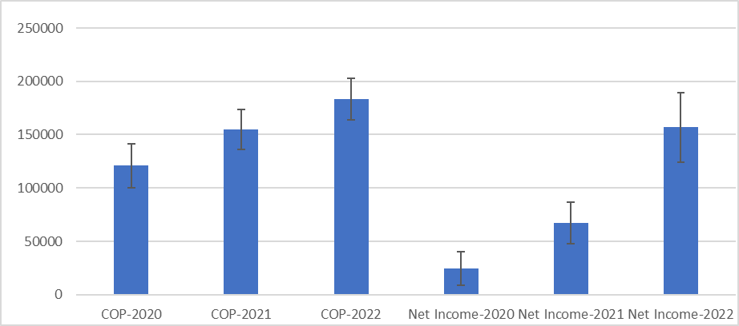

**Figure 7: Yearly variation in cost and income of vegetable crops – per farmer basis**

**4. ConclusionS**

The majority of vegetable farmers in Hanguranketha are old (under the age group 56-75 years), and over half of them are well-educated (having G.C.E. – A.L. qualification). Most of the vegetable farmers in these areas are full-time vegetable growers, and it is their main source of income. The mean area of cultivation had decreased in almost all the crops and areas, except for beans in 2021, compared to 2020. Unusual hike in fertilizer prices were the main contributor to elevated production costs in all areas in 2021 and 2022. Yearly yield variation has a downward trend while the trend of farm gate price variation was upward during 2020-22 for all five vegetables crops, where the highest income was reported for beans and tomato. The variations of cost of production were not significant among vegetable crops in all three years while the net income among vegetable crops were marginally significant. Tomato and beans were the breadwinners in 2021 and 2022. Driven by the variability of the extent of cultivation, per farmer cost of cultivation and net income have shown a variability among different areas within *Hanguranketha* in Sri Lanka during 2020-22.

**COMPETING INTERESTS DISCLAIMER:**

Authors have declared that no competing interests exist.

DISCLAIMER (ARTIFICIAL INTELLIGENCE):

Author(s) hereby declare that NO generative AI technologies such as Large Language Models (ChatGPT, COPILOT, etc.) and text-to-image generators have been used during the writing or editing of this manuscript.

ACKNOWLEDGEMENT:

We are thankful to all the farmers, field assistants and data acquisition officers etc. who were fully cooperative for sharing the data, experience and opinions during the primary and secondary data collection process and also the Director and staff of the Postgraduate Institute of Agriculture (PGIA), Peradeniya, Sri Lanka for their fullest cooperation.

**REFERENCES**

AGSTAT (2022); (2023). AGSTAT, Soio-economic Division, Dept. of Agriculture, Sri Lanka.

http://www. https://doa.gov.lk/sepc-downloads_en/#1583822518501-4cd250c2-4e98

Alam G.M., Khatun M.N, (2021). Impact of COVID-19 on vegetable supply chain and food security: empirical evidence from Bangladesh PLoS One, 16 (3) Article e0248120, 10.1371/journal.pone.0248120

Baker, S. R., Bloom, N., & Steven, J. D.(2016), Measuring economic policy uncertainty, The Quarterly Journal of Economics*,* 131(4), 1593–1636. <https://doi.org/10.1093/qje/qjw024>

Bhowmick, S. (2022). Understanding the Economic Issues in Sri Lanka's Current Debacle, Observer Research Foundation, New Delhi, India. https://www.orfonline.org/wp-content/uploads/2022/06/ORF_OccasionalPaper_357_SriLanka.pdf.

Central Bank of Sri Lanka (2021) & (2022). Annual report, Colombo: Central Bank of Sri Lanka.

Department of Census and Statistics, Sri Lanka (2019). Agriculture statistics of Sri Lanka, Colombo, Department of Census and Statistics Sri Lanka.

Department of Census and Statistics, Sri Lanka (2021). Agriculture statistics of Sri Lanka, Colombo, Department of Census and Statistics Sri Lanka.

Economic and social statistics (2022), Agriculture statistics, Department of Census and Statistics, Sri Lanka (2021). Agriculture statistics of Sri Lanka, Colombo, Department of Census and Statistics Sri Lanka.

Esham M and Usami N (2006) Procurement behavior of the fruit and vegetable industry in Sri Lanka, *The Journal of Agricultural Sciences,* 2(3). http://repo.lib.sab.ac.lk/

Gray, R.S. (2020). Agriculture, transportation, and the COVID-19 crisis. Canadian Journal of Agricultural Economics, 68 (2): 239-243. http:doi: 10.1111/cjag.12235.1875601

Gross, M., & Heinrichs, H. (Eds.). (2010). Environmental sociology (In Persian). Springer. Steg, L., & Vlek, C. (2009). Encouraging pro-environmental behavior: An integrative review and research agenda. Journal of Environmental Psychology, 29(3): 309–317.

Kodithuwakku, S. S., & Weerahewa, J. (2014). Supermarkets and their effects on smallholder vegetable farmers in Sri Lanka: An exploratory case study. *Journal of Agriculture Economics and Rural Development*, *62*(2), 71.DOI: 10.12966/jaerd.05.06.2014

Ghose, D., Fraga, E., & Fernandes, A. (2023). Fertilizer Import Bans, Agricultural Exports, and Welfare: Evidence from Sri Lanka. *Policy Research Working Paper*, *10642*, 793-831.

Hailu, G., & Derbew, B. (2015). Extent, causes and reduction strategies of postharvest losses of fresh fruits and vegetables–A review. Journal of Biology, Agriculture and Healthcare, 5(5), 49-64.

Ranasinghe, S., & Gunawardena, N. (2021). An analysis of Sri Lankan government policies for prevention and control of non-communicable diseases and its risk factors. International Journal of Medical Science and Public Health, 10, 1-13.

ICRA Lanka. (2020). Economic Impact of Covid-19 in Sri Lanka. Retrieved from: http//www.icralanka. Accessed on 16 April 2020.

Khandre S A (2022), A Study of economic crisis special case of Sri Lanka, Journal of East China University of Science and Technology, 65(3), 139-154. http://doi: 10.5281/ZENODO.6826455

Kumara, S. K., Weerakkody, R., & Epasinghe, S. (2015). Viability of controlled environmental agriculture for vegetable farmers in Sri Lanka. Hector Kobbekaduwa Agrarian Research and Training Institute, Colombo (Sri Lanka).

Lu, G., Razum, O., Jahn, A., Zhang, Y., Sutton, B., & Sridhar, B. (2021). COVID-19 in Germany and China: mitigation versus elimination strategy. Global Health Action, 14 (1) http://doi: 10.1080/16549716.2021

Nuskiya, F. (2019). Upcountry vegetable production and marketing: challenge and opportunities, Sri Lanka, SEUSL Journal of Marketing, 4, (2), 21-31.

Priyadarshani, M. D., & Wickramasinghe, Y. M. (2018). A study on market window and economic efficiency in assessing profitability of selected upcountry vegetables in Sri Lanka. Journal of Agricultural Sciences–Sri Lanka, 13(2), 100-109. http://dx.doi.org/10.4038/jas.v13i2.8335

Rozaki, Z. (2020). COVID-19, agriculture, and food security in Indonesia. Reviews in Agricultural Science, 8, 243-260.

Samaranayake, Y. K., & Ulpathakumbura, C. (2021). Effects of Organic and Inorganic Fertilizer Application for Vegetable Cultivation in Sri Lanka, Department of Agriculture, Peradeniya, Sri Lanka.

Sandika, A. (2012). Impact of middlemen on vegetable marketing channels in Sri Lanka. Tropical Agricultural Research and Extention, 14 (3), 58-62.

Ratnadiwakara, D., De Silva, H., & Soysa, S. (2008). Transaction costs in agriculture: From the planting decision to selling at the wholesale market: A case-study on the feeder area of the Dambulla dedicated economic Centre in Sri Lanka. In 3rd Communication Policy Research, South Conference, Beijing, China.

Udara I.W.A.S, Somabandu B.P.S, Jayakody J.A.B.U, Amerasinghe N.D.K, D.I. De Silva and De Zoysa, R. (2022). Problems Faced by the Agricultural Sector and Solutions for the Impending Food Crisis in Sri Lanka, International Journal of Engineering and Management Research, SLIIT*,* 12(5) ,35-43. https://doi.org/10.31033/ijemr.12.5.5

Vidanapathirana, R., Champika, P. J., Rambukwella, R., & Wijesooriya, N. (2018). Quality and safety issues in fruit and vegetable supply chains in Sri Lanka: *A Review*. Hector Kobbekaduwa Agrarian Research and Training Institute (HARTI), Colombo (Sri Lanka).

Weerakkody, W.A.P., & Mawalagedera, S.M.M.R. (2020). Recent Developments in Vegetable Production Technologies in Sri Lanka. pp. 189-214. In. Agricultural Research for Sustainable Food Systems in Sri Lanka (Vol. 1). Springer, Singapore.

Yakandawala, K. (2023). Status of Horticulture in Sri Lanka; Country paper. Proceeding on Second International Conference in Horticulture, https://www.researchgate.net/publication