Evaluation of the Sustainability Status of Cocoa Farming in North Lombok Regency, Indonesia

.
ABSTRACT

Cocoa serves not only as a key raw material for the global food and beverage industry but also contributes significantly to national export value. The primary challenge in cocoa development in North Lombok is low productivity, which remains far below its maximum potential. This study aims to (1) Evaluate the sustainability status of cocoa farming in North Lombok Regency; (2) Analyze the sensitive attributes influencing the sustainability of cocoa farming in North Lombok Regency; (3) Identify key actors in the sustainability of cocoa farming in North Lombok Regency; (4) Identify the factors influencing and being influenced by the sustainability of cocoa farming in North Lombok Regency. This research employs a qualitative method, with a total of 44 respondents selected using Slovin’s formula and proportional sampling. The study areas were determined using purposive sampling, considering that the five districts in North Lombok serve as the main cocoa production centers, possessing high economic potential and making a significant contribution to the well-being of local communities. Four types of data analysis were employed. These include Multi-Aspect Sustainability Analysis to assess the sustainability status, Leverage Analysis to determine sensitive attributes, MACTOR Analysis to identify key actors, and MICMAC Analysis to examine the influencing and influenced factors. The findings of this study indicate that Cocoa farming in North Lombok Regency falls into the sustainable category, with an index score of 61.68. Furthermore, the dimensions of cocoa farming exhibit a sustainable status, suggesting that this farming system can endure and develop in accordance with sustainability principles. The sensitive attributes for each sustainability dimension are as follows: Ecological dimension: Waste disposal. Economic dimension: Dependence on third parties and market reach. Social and cultural dimension: Social funds. Institutional dimension: Women's farmer groups. Technological dimension: Cocoa bean fermentation. Furthermore, the key actors in the sustainability of cocoa farming in North Lombok Regency include various stakeholders, such as cocoa farmers, the local government, the private sector, non-governmental organizations (NGOs), academics, and the mass media. Each actor plays a distinct role in supporting cocoa farming sustainability, ranging from policy formulation, technical assistance, and education to market access. Close collaboration among these actors is a determining factor in improving farmers’ welfare and ensuring the sustainability of the cocoa sector. The factors influencing and being influenced by cocoa farming sustainability include: Ecological dimension: Suboptimal waste disposal management. Economic dimension: Dependence on third parties and limited market access. Social and cultural dimension: The role of social funds in farmer communities. Institutional dimension: The existence and effectiveness of women's farmer groups in supporting cocoa farmers. Technological dimension: Limited adoption of cocoa bean fermentation technology. These factors interact and collectively determine the level of cocoa farming sustainability in the region. The study recommended that local institutions, particularly farmer groups and Women Farmer Groups, should be strengthened through managerial training and the adoption of environmentally friendly technologies. Additionally, the implementation of modern agricultural technologies, such as superior cocoa varieties and improved cocoa bean fermentation, should be encouraged to enhance product quality and market value.

Keywords: Sustainability Status, Cocoa Farming, MSA, MAKTOR, MICMAC.

1. INTRODUCTION

Indonesia has a competitive advantage in the plantation sector due to its tropical climate and abundant natural resources, making it a leading producer of commodities such as palm oil, coffee, tea, rubber, and cocoa. This sector significantly contributes to the national economy through exports and employment opportunities for millions of smallholder farmers (Fikrunnisa et al., 2022). Cocoa is one of the most strategic commodities, with high economic and social value, accounting for 3.94% of Indonesia's total Gross Domestic Product (GDP) in 2021. Indonesia is now the third-largest country producing cocoa in the world, with a production of about 777,750 MT/year (15% of total world cocoa bean production) (Witjaksono & M, 2016; Kongor et al., 2024). In international trade, Indonesia's cocoa exports reached USD 1.26 billion in 2022, with most of the exports consisting of processed products such as cocoa butter and cocoa fat. The primary destinations for cocoa exports include Malaysia, Singapore, the United States, China, Brazil, India, Thailand, the Netherlands, Italy, and Germany. Germany controls 98.63% of Indonesia's cocoa exports (Andriani & Tanjung, 2023; Nisa & Antriyandarti, 2023).
As one of the world's largest cocoa producers, Indonesia plays a crucial role in the agribusiness sector. Cocoa serves not only as a key raw material for the global food and beverage industry but also contributes significantly to national export value. West Nusa Tenggara (NTB), in particular, has a favorable climate that supports cocoa productivity, making it a strategic region for national cocoa production. NTB contributed approximately 10,000 tons of cocoa in 2021, accounting for 5% of the country's total production. The government continues to promote cocoa development through replanting programs and the adoption of more sustainable farming techniques. However, the harvested area and production of cocoa plants in the NTB Province for the past 3 (three) years (2018 – 2020) have fluctuated mainly due to various reasons. For instance, pest and disease attacks such as pod rot and stem cancer. Moreover, many cocoa plants are old (more than 20 years). Apart from that, it was also due to the expansion of areas for food crops, infrastructure and so on (Usman et al., 2023; Fahmid et al., 2018).
North Lombok Regency is one of the regions in NTB with significant potential for cocoa farming. Data from the North Lombok Statistics Agency (BPS) indicates that the cocoa plantation area remained relatively stable from 2021 to 2023, despite fluctuations in production and productivity. Cocoa production declined to 1,623.06 tons in 2022 before recovering to 1,669.06 tons in 2023. Productivity also varied, decreasing from 385.43 kg/ha in 2021 to 360.39 kg/ha in 2022 before slightly increasing again in 2023. These fluctuations highlight the sustainability challenges faced by cocoa farming in the region.
The primary challenge in cocoa development in North Lombok is low productivity, which remains far below its maximum potential. Factors such as the use of suboptimal seedlings, limited access to fertilizers and pesticides, and a lack of modern agricultural technology contribute to this issue. Furthermore, a lack of awareness among farmers regarding cocoa production technologies is another challenge (Boateng et al., 2023). Farmers need training on various cocoa rehabilitation methods, and improved cocoa varieties should be made available at affordable prices to farmers (Awodumila et al., 2020). Additionally, climate change affects cocoa cropping cycles and increases the risk of pest and disease outbreaks, leading to further production declines. Strengthening farmer institutions through cooperatives and farmer groups is essential to enhancing competitiveness and improving market access. Again, sustainable growth in the agricultural sector, including cocoa commodities, will have a broad positive impact on the stability and prosperity of the Indonesian economy, especially for rural households that are largely dependent on agricultural activities (Fajriani et al., 2024; Nurjanah & Oktarina, 2025).
To address these challenges, innovations such as the use of disease-resistant cocoa varieties, more efficient irrigation systems, and organic fertilizers can be implemented. However, limited access to agricultural technology and financial support remains a significant obstacle for smallholder farmers in North Lombok. Therefore, this study is crucial for assessing the sustainability status of cocoa farming in North Lombok Regency. The research aims to evaluate cocoa farming sustainability, analyze the key attributes influencing sustainability, identify key stakeholders, and understand the interrelated factors within the cocoa farming system in the region.

2. methodology

This study employs a qualitative research approach, which aims to understand a phenomenon from the perspective of respondents who are the subject of the study, emphasizing the subjectivity aspect of individual behavior (Poerwandari, 2011). The unit of analysis in this research is cocoa farming in North Lombok Regency. The study area was determined using purposive sampling, focusing on five districts: Pemenang, Tanjung, Gangga, Kayangan, and Bayan. These districts were selected due to their status as the primary cocoa production centers in North Lombok Regency, with high economic potential and significant contributions to local community welfare.
The data sources consist of both primary and secondary data. Data collection techniques include observation, interviews, and documentation. The data analysis methods used in this study vary based on the research objectives: (1) Multiaspect Sustainability Analysis (MSA) is applied to assess sustainability status; (2) Sensitivity Analysis (Leverage Analysis) is used to identify key attributes affecting sustainability; (3) MAKTOR analysis is conducted to determine key actors influencing cocoa farming sustainability; and (4) MICMAC analysis is employed to examine the interrelated factors influencing and being influenced by sustainability in the cocoa farming system.
Data Analysis
Multiaspect Sustainability Analysis (MSA)
MSA is a method designed to evaluate and assess the sustainability conditions of a system or activity at a given time. Using MSA, researchers can identify strengths and weaknesses in resource management and evaluate how current conditions may impact long-term sustainability. MSA does not provide predictions or future condition analyses but focuses on assessing the present situation (Ibrahim et al., 2024). The stages of MSA analysis include:
- Determination of Sustainability Dimensions and Attributes
- Data Collection through Questionnaires or Interviews
- Scoring and Sustainability Value Assessment
- Sustainability Status Analysis
Leverage Analysis (Sensitivity Analysis)
Leverage Analysis is a technique used in MSA to identify the attributes that most influence the sustainability of a system. The formula for calculating Leverage Analysis is as follows:
SV = (Gfn – Mofn) x SM
MACTOR Analysis
The MACTOR (Matrix of Alliances and Conflicts Tactics, Objectives, and Recommendations) analysis, developed by Michel Godet, is used to analyze actor competitiveness, power dynamics, and their attitudes toward sustainability goals in cocoa farming. The process involves identifying key actors, such as farmers, local governments, NGOs, academics, media, and the private sector, to understand their roles and interests. Furthermore, power relations and the level of resistance of actors toward sustainability goals are evaluated using influence and attitude scales. The results of the analysis reveal the dynamics of actor interactions, potential alliances and conflicts, and strategic recommendations for enhancing cocoa farming sustainability in North Lombok Regency.
MICMAC Analysis
The MICMAC (Matrix of Crossed Impact Multiplications Applied to a Classification) method, developed by Arcade, Godet, Meunier, and Roubelat (1999), is used to analyze influential and dependent variables within a system. This method is widely applied in agricultural sustainability analysis, including cocoa farming, to understand the interrelationships among technical, social, economic, and environmental factors. MICMAC categorizes variables into four groups: Influential Variables (high impact with low dependency), Linkage Variables (high impact and highly dependent), Dependent Variables (low impact but highly dependent), and Excluded Variables (neither influential nor dependent). The operational stages of the MICMAC method include: (1) Identifying internal and external variables; (2) Assessing relationships between variables. MICMAC analysis results classify variable relationships into direct, indirect, and potential influences. This information is utilized to develop sustainability improvement strategies for cocoa farming by focusing on variables with significant impacts. MICMAC helps stakeholders understand complex dynamics and determine priority interventions for sustainable cocoa management in North Lombok Regency.

3. results and discussion

3.1 Respondent Characteristics
The respondents in this study are cocoa farmers spread across North Lombok Regency. The characteristics of the respondents include age, gender, education, and farming experience. The details are presented in the following table:
Table 1. Characteristics of Respondents (Cocoa Farmers) in North Lombok Regency in 2025
No | Category | Number of Respondents | Percentage (%)
1 | Age Range (Years)  a. 20-30  b. 31-40  c. 41-50  d. > 50 | 1  4  14  25 | 2,27  9,09  31,82  56,82
2 | Gender  a. Female  b. Male | 2  42 | 4,55  95,45
3 | Education Lavel  a. Elementary School (SD)  b. Junior High School (SMP)  c. Senior High School (SMA)  d. >Senior High School | 21  18  4  1 | 47,73  40,91  9,09  2,27
4 | Farming Experience (Years)  a. 1-10  b. 11-20  c. 21-30 | 3  26  15 | 6,82  59,09  34,09
Source: Processed Primary Data, 2025

Table 1 revealed that the age range of respondents varies from 20 to over 50 years. The age group with the highest representation is those over 50 years old. The average age of respondents falls within this group, indicating that the majority of cocoa farmers are in a mature age range. Farmers in this age group have developed extensive experience and possess in-depth knowledge of effective cocoa farming practices (Susanti et al., 2016).
Gender plays a crucial role in the division of labor and responsibilities in agricultural activities. Out of 44 respondents, 42 were male, while only 2 were female. This reflects a traditional tendency where agricultural work is predominantly carried out by men. However, the presence of some women in the data indicates that they are beginning to participate in the sector. Women's involvement can bring new perspectives and innovations to cocoa farm management.
Education is a key factor influencing farmers' ability to adopt new technologies, manage farms, and solve problems encountered in agricultural activities. The respondents' education levels range from elementary school to higher than high school, with the highest proportion (21 respondents) having completed elementary school. A relatively low level of education can pose challenges in disseminating knowledge and new technologies. Therefore, continuous education and training programs are essential to enhance farmers' capacity to improve cocoa productivity and quality.
Longer farming experience is typically associated with increased expertise in crop cultivation, land management, and resource utilization. Sri (2011) states that farmers' knowledge is influenced by experience, years of farming, and their farming environment. The respondents' cocoa farming experience ranges from 1 to 30 years, with the highest proportion having between 11 and 20 years of experience. This indicates that the majority of farmers have sufficient knowledge and skills in cocoa farming.

3.2 Sustainability Status of Cocoa Farming in North Lombok Regency

An effective method for assessing sustainability status is the use of Multiaspect Sustainability Analysis (MSA), a software tool within Exsimpro. MSA operates by integrating various indicators that reflect five main dimensions: ecology, economy, social & culture, institutional, and technology. The results of the sustainability status of cocoa farming in North Lombok Regency can be seen in Table 2.
Table 2. Sustainability Status of Cocoa Farming in North Lombok Regency
No | Aspect | Score (Sustainability Status)
1 | Ecology | 83.4 (Highly Sustainable)
2 | Technology | 68.3 (Sustainable)
3 | Social and Culture | 56.6 (Sustainable)
4 | Institutional | 50.9 (Sustainable)
5 | Economic | 49.2 (Low Sustainable)
 | Average Score | 61.68
 | Sustainability Status | Sustainable
Source: Processed Primary Data, 2025

Based on the results of the sustainability status analysis in Table 2, the sustainability index value is 61.68, indicating that cocoa farming in this region has generally met sustainability standards. Furthermore, the analysis results also show that all dimensions of cocoa farming exhibit a sustainable status, suggesting that this farming system can endure and develop in accordance with sustainability principles.
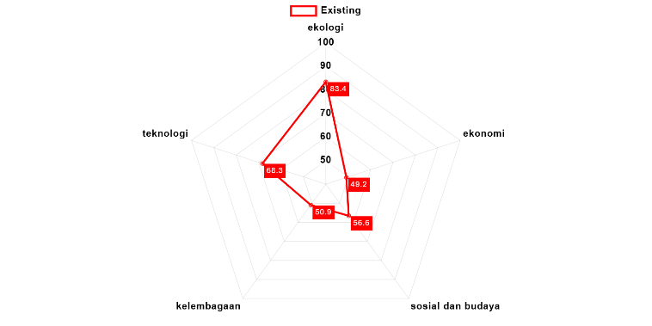
Figure 1. Kite Diagram of Cocoa Farming Sustainability in North Lombok Regency

Based on the analysis results, the ecological dimension has the highest score (83.4), indicating that environmental aspects strongly support the sustainability of cocoa farming. Furthermore, the technological dimension also shows a relatively good level of sustainability with a score of 68.3, reflecting that the application of agricultural technology has adequately supported the cocoa farming system in this region. However, the economic dimension has the lowest sustainability score (49.2), highlighting significant challenges in the economic aspect. Meanwhile, the institutional dimension also falls into the low category (50.9), indicating that the farmers' institutional system is not yet strong enough to sustain cocoa farming. The social and cultural dimension is at a moderate level (56.6), suggesting that while some social factors support sustainability, certain aspects still need improvement to enhance long-term sustainability.

3.3 Sensitive Attributes of Cocoa Farming Sustainability in North Lombok Regency
Ecological Dimension
The research results using MSA indicate a sustainability value of 83.4 in the ecological dimension, categorized as "highly sustainable." The attributes influencing this dimension include: 1. Land suitability for cocoa. 2. Land altitude for cocoa. 3. Soil microorganism diversity. 4. Soil fertilization. 5. Provision of shade plants. 6. Utilization of cocoa husk waste for fertilizer/livestock feed. 7. Disposal of cocoa husk waste. 8. Plantation land management. 9. Crop diversity. 10. Conservation measures taken in case of land degradation. The results of the leverage analysis for the ecological dimension are as follows:
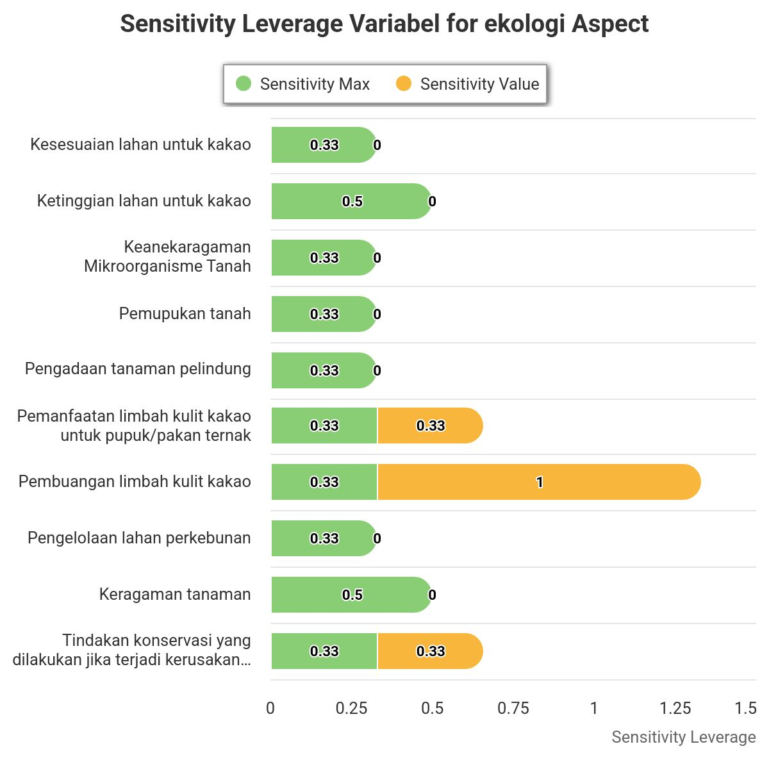
Figure 2. Attributes That Sensitively Influence the Sustainability of Cocoa Farming in the Ecological Dimension.

Based on Figure 2, there is one attribute that sensitively influences the sustainability of cocoa farming, namely the disposal of cocoa pod husk waste. Cocoa farmers in North Lombok Regency still dispose of waste without proper processing or simply discard it, which has the potential to cause negative environmental impacts, such as soil and water pollution, as well as an increased risk of pest and disease spread in crops. The improper disposal of waste without adequate processing can hinder the sustainability of cocoa farming.
According to research conducted by Mulyati et al. (2020), improperly managed cocoa pod husk waste can become a source of pest and disease spread and contaminate the surrounding environment. Additionally, indiscriminate waste disposal can degrade soil and water quality, disrupt ecosystem balance, and ultimately affect cocoa crop productivity.

Economic Dimension
The analysis using MSA resulted in a sustainability index score of 49.2 for the economic dimension, indicating that this dimension falls into the "low sustainability" category. The attributes that influence this dimension include: 1. Cocoa selling price. 2. Subsidy level. 3. Cocoa productivity. 4. Market reach. 5. Market access. 6. Product diversification. 7. Government support. 8. Access to credit. 9. Training and education. 10. Dependence on third parties. The results of the leverage analysis for each attribute are as follows:
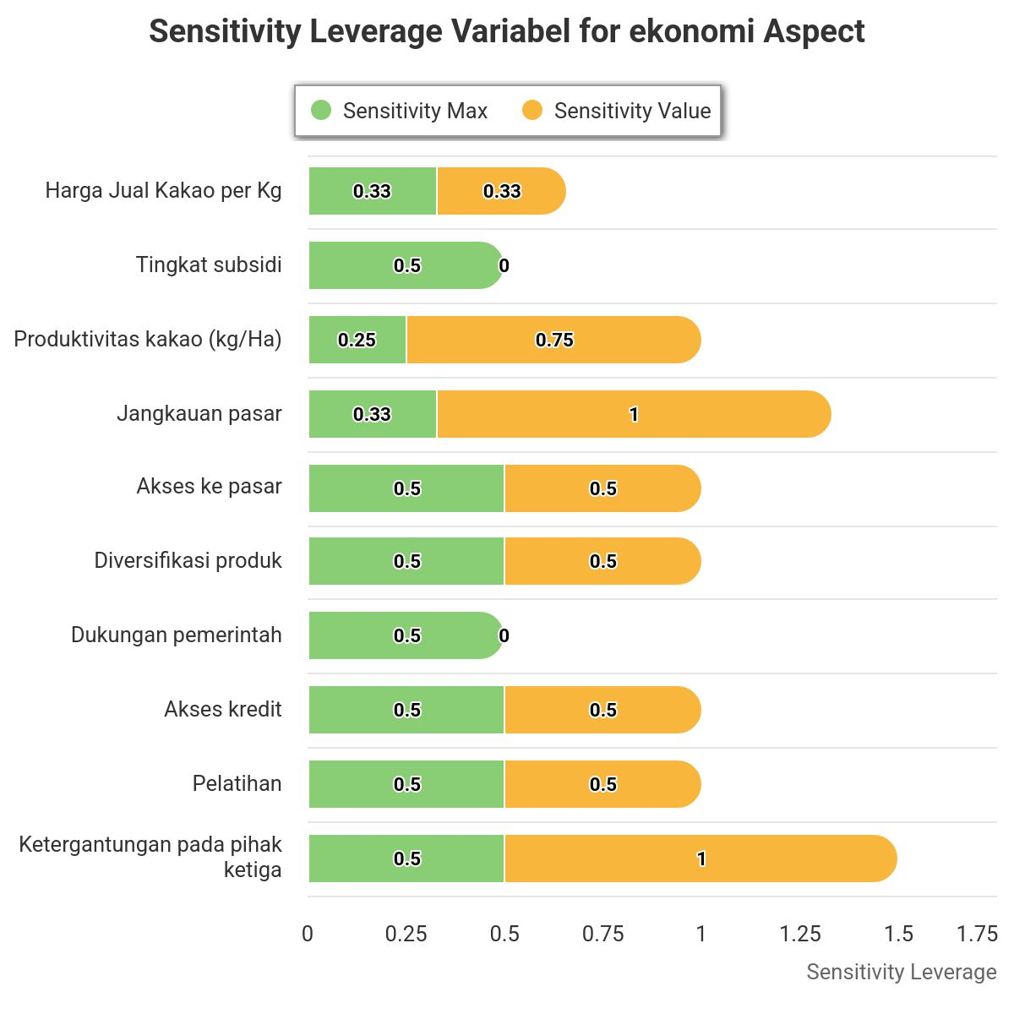
Figure 3. Attributes That Sensitively Influence the Sustainability of Cocoa Farming in the Economic Dimension

Based on Figure 3, there are two attributes that most sensitively influence the sustainability of cocoa farming: (1) dependence on third parties and (2) market reach. A high reliance on intermediaries for various operational functions, such as marketing, input procurement, and access to information, causes farmers to lose control over their farming operations. Cocoa farmers in North Lombok Regency sell their harvest only to middlemen or collectors at prices determined by these intermediaries, leaving them with little bargaining power and no direct access to more profitable markets. Additionally, farmers must purchase fertilizers, pesticides, and seedlings from specific distributors at high prices due to limited access to alternative suppliers, further worsening their economic conditions. According to Putra et al. (2021), farmers who rely solely on local markets and sell through intermediaries tend to have lower profits compared to those with direct access to wider markets.

Social and Cultural Dimension
The analysis using MSA resulted in a sustainability index score of 56.6 for the Social and Cultural dimension, indicating that this dimension falls into the “sustainable” category. The attributes influencing this dimension include: 1. Land ownership status. 2. Population size. 3. Women's involvement in cocoa farm management. 4. Education level of cocoa farmers. 5. Availability of transportation access for farmers. 6. Government service institutions. 7. Participation in extension services/training. 8. Sustainability of the younger generation in cocoa farming. 9. Social funds. 10. Age of workers employed in cocoa plantations. The results of the leverage analysis for each attribute are as follows:
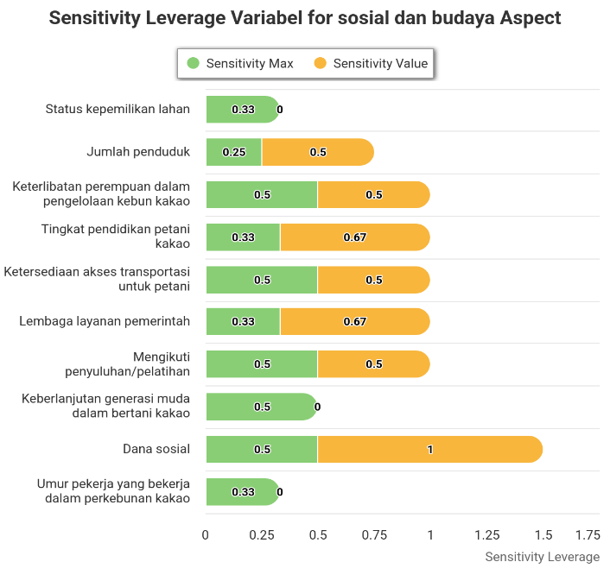
Figure 4. Sensitive Attributes Affecting the Sustainability of Cocoa Farming in the Social and Cultural Dimension.

Based on Figure 4, there is one highly sensitive attribute affecting the sustainability of cocoa farming: social funds. Social funds play a crucial role in supporting farmers' well-being, access to training, infrastructure, and economic resilience. However, in North Lombok Regency, social funds are not yet available, making it difficult for farmers to cope with risks such as crop failure, price fluctuations, and limited access to training and agricultural technology. According to Wulansari (2020), social funds can serve as financial reserves for farmers when facing crop failure due to pests, plant diseases, or extreme weather conditions. Without these funds, farmers often have to sell assets or take on high-interest loans to survive. As a result, they experience increasing financial pressure and struggle to afford essential production inputs such as seeds, fertilizers, and pesticides.

Institutional Dimension
The analysis using MSA resulted in a sustainability index score of 50.9 for the institutional dimension, indicating that this dimension falls into the "sustainable" category. The attributes influencing this dimension include: 1. Farmer groups. 2. Women's farmer groups. 3. Institutions or business/service entities in the input and output sectors. 4. Institutional influence in cocoa farming communities. 5. Functions and benefits of farmer group institutions. 6. Legal entity ownership of farmer groups. 7. Frequency of group meetings. 8. Group savings. 9. Institutional conflicts. 10. Marketing institutions. The results of the leverage analysis for each attribute are as follows:
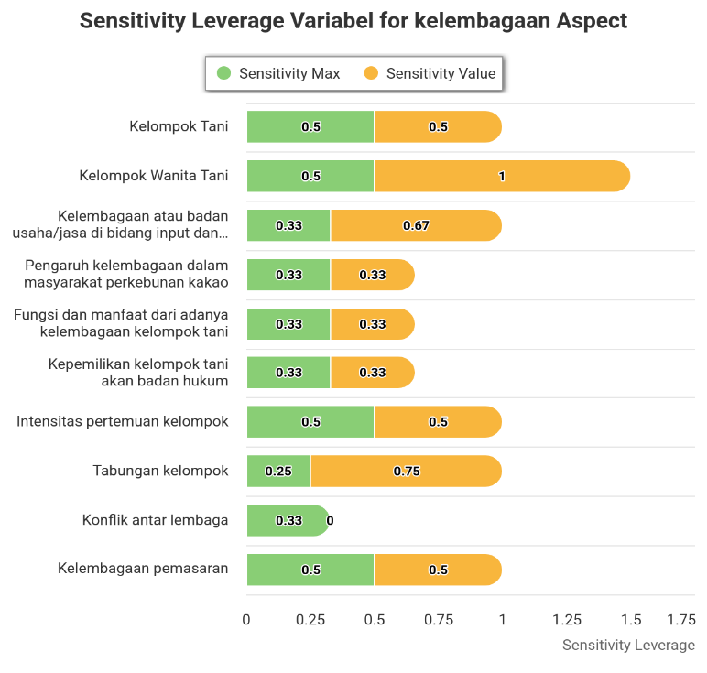
Figure 5. Sensitive Attributes Influencing the Sustainability of Cocoa Farming in the Institutional Dimension

Based on Figure 5, there is one attribute that is most sensitive in influencing the sustainability of cocoa farming, namely the Women's Farmer Group. The Women's Farmer Group (KWT) plays a role not only in land management but also in improving household economies through agricultural product processing. According to Fardhilah et al. (2022), the role of Women's Farmer Groups in enhancing family economies through agricultural product processing has been proven significant.
Over the past five years, the number of Women's Farmer Groups in North Lombok Regency has declined due to a lack of regeneration and participation from the younger generation. This is evident from the decreasing number of young women interested in continuing cocoa farming, driven by low economic incentives and a general lack of interest in the agricultural sector. If this condition persists, the sustainability of cocoa farming may be at risk.

Technology Dimension
The analysis using MSA resulted in a sustainability index score of 68.3 for the technology dimension, indicating that this dimension falls into the "sustainable" category. The attributes influencing this dimension include: 1. Use of cocoa plant seedlings. 2. Equipment for making planting holes. 3. Type of fertilizer used. 4. Cocoa drying methods. 5. Pest and disease control techniques for cocoa plants. 6. Harvested cocoa. 7. Cocoa pod cracking. 8. Cocoa bean fermentation. 9. Bean sorting. 10. Cocoa storage. The results of the leverage analysis for each attribute are as follows:
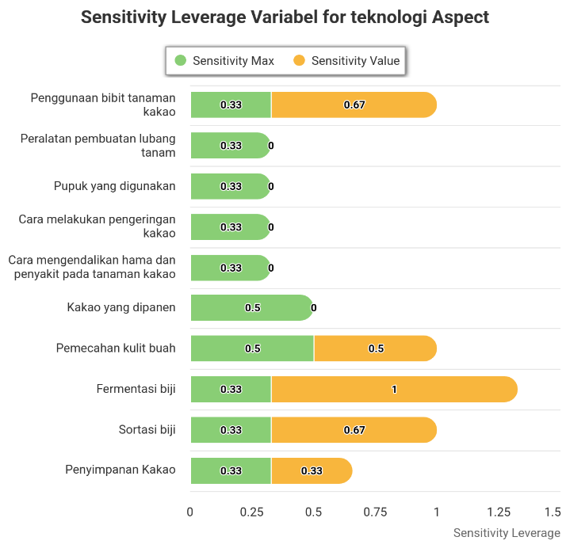
Figure 6. Sensitive Attributes Influencing the Sustainability of Cocoa Farming in the Technology Dimension

Based on Figure 6, there is one attribute that most sensitively influences the sustainability of cocoa farming: bean fermentation. Fermentation is a crucial process that determines the quality and market value of cocoa. However, the majority of cocoa farmers in North Lombok Regency have not yet adopted this process, leading to lower cocoa quality and selling prices in the international market. The low selling price results in insufficient income, making it difficult for farmers to sustain their farming activities. Consequently, cocoa farming in the region may be at risk of stagnation or discontinuation.

3.4 Actors in the Sustainability of Cocoa Farming in North Lombok Regency

Cocoa farming in North Lombok Regency is a complex ecosystem involving various actors with interconnected roles, including local farmers, local government, NGOs, academics, the private sector, and the media. Local farmers and the local government hold significant influence and interest in achieving the sustainability of cocoa farming, while Women's Farmer Groups contribute to the social and economic empowerment of farmers. Although the media and NGOs have a lower direct influence, they play a crucial role in disseminating information and advocating policies. Academics and researchers provide knowledge and technology to support the agricultural system, even though their impact is not always immediately visible. The private sector, despite having lower direct involvement compared to other actors, still plays a role in shaping policies through its influence on pricing, distribution, and the cocoa supply chain. Understanding these actor dynamics allows sustainability strategies to focus on close collaboration between the government, farmers, and other supporting sectors to enhance the productivity and competitiveness of cocoa farming in North Lombok Regency.
Figure 7. Competitiveness Among Actors in the Sustainability of Cocoa Farming in North Lombok Regency

The competitiveness histogram among actors shows relatively balanced values, indicating that all actors contribute significantly to supporting the sustainability of cocoa farming, although mass media has slightly lower competitiveness compared to other actors. Collaboration among all actors is essential to achieving more sustainable agricultural goals.

3.5 Factors Influencing the Sustainability of Cocoa Farming in North Lombok Regency

This analysis utilizes MICMAC to identify factors influencing the sustainability of cocoa farming in North Lombok Regency, based on the results of the Multi-Sustainability Analysis (MSA) by Eximpro. The MSA previously identified sensitive variables across various sustainability dimensions, such as Cocoa Pod Waste Management, Dependence on Third Parties, Market Reach, Social Funds, Women's Farmer Groups, and Bean Fermentation. MICMAC then categorizes these factors based on their level of influence and dependence to determine the key driving factors and the most vulnerable ones. This analysis produces Direct and Indirect Influence/Dependence maps that classify factors into four quadrants: key variables (Quadrant I), relay variables dependent on other factors (Quadrant II), dependent variables (Quadrant III), and variables with minimal significance in the system (Quadrant IV). The findings provide strategic insights to enhance economic, social, and ecological efficiency in the cocoa farming system, focusing on reducing external dependency and strengthening variables with a significant impact on sustainability.
Figure 8. Direct Influence Dependency Map

Figure 9. Indirect Influence Dependency Map

The MICMAC analysis indicates that the influence and dependence patterns of variables in the sustainability of cocoa farming in North Lombok Regency vary between direct and indirect influences. Quadrant I has no dominant variables, suggesting a balance of influence among factors. Quadrant II includes variables such as dependence on third parties, social funds, women farmer groups, and market reach, which have significant influence but still heavily rely on external factors. Quadrant III has no variables that are significantly dependent on others, while Quadrant IV includes cocoa husk waste disposal and bean fermentation, which have low influence and dependence within the cocoa farming system. By understanding this distribution, sustainability strategies can be more focused on the variables in Quadrant II to reduce external dependence, while the variables in Quadrant IV can be better managed to improve production efficiency.

3.6 Recommendations for the Sustainability of Cocoa Farming in the North Lombok Regency

To support the sustainability of cocoa farming in North Lombok Regency, strategic policies are needed that encompass market access improvement, institutional strengthening, technology adoption, waste management, and stakeholder collaboration. The local government must enhance distribution networks to reduce farmers' dependence on intermediaries while considering price subsidies to protect them from harmful price fluctuations. Local institutions, particularly farmer groups and Women Farmer Groups, should be strengthened through managerial training and the adoption of environmentally friendly technologies. Additionally, the implementation of modern agricultural technologies, such as superior cocoa varieties and improved cocoa bean fermentation, should be encouraged to enhance product quality and market value. Waste management, particularly cocoa pod husk waste, is also a key concern, requiring initiatives to promote its use as compost or animal feed. Achieving sustainable cocoa farming necessitates close cooperation among local governments, the private sector, academics, NGOs, and farmers to create a more competitive, productive, and environmentally friendly agricultural system.

4. Conclusion

Based on the research findings, the following conclusions can be drawn: (1). Cocoa farming in North Lombok Regency falls into the sustainable category, with an index score of 61.68. (2). The sensitive attributes in each dimension of cocoa farming sustainability in North Lombok Regency are as follows: a. Ecological dimension: waste disposal, b. Economic dimension: dependence on third parties and market size, c. Social and cultural dimension: social funds, d. Institutional dimension: women's farmer groups, and e. Technological dimension: cocoa bean fermentation. (3). Key actors in the sustainability of cocoa farming in North Lombok Regency involve various stakeholders, including cocoa farmers, local governments, the private sector, non-governmental organizations (NGOs), academics, and the media. Each actor plays a different role in supporting cocoa farming sustainability, ranging from policy formulation, technical assistance, and education to market access. Close collaboration among these actors is a determining factor in improving farmers' welfare and the sustainability of the cocoa sector. (4). The factors that influence and are influenced by the sustainability of cocoa farming include: Ecological dimension: suboptimal waste disposal. Economic dimension: dependence on third parties and limited market access. Social and cultural dimension: the role of social funds in farming communities. Institutional dimension: the existence and effectiveness of women's farmer groups in supporting cocoa farmers. Technological dimension: the limited adoption of cocoa bean fermentation technology. These factors interact with each other and determine the level of sustainability of cocoa farming in the region.

DISCLAIMER (ARTIFICIAL INTELLIGENCE)

Author(s) hereby declare that no generative Al technologies like large language models (ChatGPT, copilot, etc.) Moreover, text-to-image generators have been used during the writing or editing of this manuscript.

References

Alliance, R. (2021). Cocoa Production in Indonesia. Rainforest Alliance. Retrieved from https://www.rainforest-alliance.org/
Badan Meteorologi, Klimatologi, dan Geofisika (BMKG) NTB. (2021). Climate Change Report in NTB. Retrieved from https://bmkg.go.id
Badan Pusat Statistik NTB. (2021). Agricultural Statistics of NTB. Retrieved from https://ntb.bps.go.id
Dinas Pertanian dan Perkebunan NTB. (2022). Cocoa Conditions in North Lombok. Retrieved from https://distan.ntbprov.go.id
FAO. (2022). Sustainable Cocoa Supply Chains. Food and Agriculture Organization of the United Nations. Retrieved from https://www.fao.org/markets-andtrade/publications/detail/en/c/1664717/
Fardhilah, L., Darusman, Y., & Danial, A. (2022). Efforts of Women Farmer Groups in Increasing Family Income Through Utilization of Home Gardens. Lifelong Education Journal. Retrieved from https://journal.imadiklus.or.id/index.php/lej
Fikrunnisa, N., Kusnadi, N., & Pambudy, R. (2022). Sustainability of Cocoa Agribusiness at the Farming Level in Indonesia. Bogor Agricultural Institute. Retrieved from https://repository.ipb.ac.id/handle/123456789/113402
Ibrahim, S., Sapanli, K., & Tropical Marine Economics Study Group. (2024). Analysis of Sustainable Livelihood of Bajo Tribe Fishermen in Wuring Village. Journal of Tropical Marine Economics, 8(3), 275–287.
Mulyati, S., Sumardi, Y., & Kurniawan, R. (2020). Utilization of Cocoa Pod Waste as Animal Feed and Organic Fertilizer. Journal of Agricultural Technology, 22(3), 114-121.
Putra, M. D., Rahmawati, A., & Suryani, D. (2021). Market Access Analysis for Cocoa Farmers in West Sumatra. Journal of Agricultural Economics, 25(2), 154-162.
Putri, W. N., & Kurniawan, A. (2021). Development of Processed Cocoa Products for Local and Export Markets. Indonesian Journal of Agribusiness, 4(1), 21-34. Retrieved from https://doi.org/10.1234/ija.v4i1.21
Sri, H. (2011). Farming Experience in the Application of Agricultural Technology: A Case Study in Cilacap Regency. Journal of Sustainable Agriculture, 19(1), 50-60.
Susanti, D., Listiana, H. N., & Widayat, T. (2016). The Effect of Farmers' Age, Education Level, and Land Area on Sembung Plant Production. Journal of Agrotechnology, 12(2), 45-52.
Wessel, M., & Quist-Wessel, P. M. F. (2015). Cocoa Production in West Africa: A Review and Analysis of Recent Developments. NJAS - Wageningen Journal of Life Sciences, 74-75, 1-7. Retrieved from https://doi.org/10.1016/j.njas.2015.09.001
Wulansari, E. (2020). Interest-Bearing Social Funds in Community Economic Empowerment. Journal of Social Empowerment, 15(1), 72-80.

Awodumila, D. J., Ogunjobi, T. E., Orimogunje, A. O., Ogundeji, B. A., Agbebaku, E. E. O., Olorunmota, R. T., & Adewoye, G. A. (2020). Assessment of Awareness and Utilization of Cocoa Production Technologies among Farmers in Oyo State, Nigeria. Journal of Experimental Agriculture International, 42(10), 19–25.

Witjaksono, J., & ., M. (2016). Driving Sustainable Intensification System on Cocoa Farming Practices. Asian Research Journal of Agriculture, 2(3), 1–7.
Usman, A., Yusuf, M., & Nursan, M. (2023, October). Supply chain analysis of cocoa seeds in Narmada, West Lombok, Indonesia. In IOP Conference Series: Earth and Environmental Science (Vol. 1253, No. 1, p. 012076). IOP Publishing.

Fahmid, I. M., Harun, H., Fahmid, M. M., & Busthanul, N. (2018, May). Competitiveness, production, and productivity of cocoa in Indonesia. In IOP Conference Series: Earth and Environmental Science (Vol. 157, No. 1, p. 012067). IOP Publishing.

Fajriani, N., Mulyati, M., & Suwardji, S. (2024). Farmer Behavior in Cocoa Farming Activities in Gitak Demung Village, Gangga District, North Lombok Regency. Unram Journal of Community Service, 5(2), 83-86.

Andriani, D., & Tanjung, M. S. (2023, December). Key factors analysis in optimizing Indonesian cocoa exports. In Proceedings of International Conference on Finance Economics and Business (ICOFEB) (Vol. 1, pp. 0020-0020).

Nisa, D. P. J. I. N., & Antriyandarti, E. (2023). The Determinant of Indonesian Cocoa Export Growth to the Main Export Destination Countries. Jurnal Ilmiah Teknik Elektro Komputer dan Informatika (JITEKI), 9(4), 1035-1044.

Kongor, J. E., Owusu, M., & Oduro-Yeboah, C. (2024). Cocoa production in the 2020s: Challenges and solutions. CABI Agriculture and Bioscience, 5(1), 102.

Boateng, K. O., Dankyi, E., Amponsah, I. K., Awudzi, G. K., Amponsah, E., & Darko, G. (2023). Knowledge, perception, and pesticide application practices among smallholder cocoa farmers in four Ghanaian cocoa-growing regions. Toxicology Reports, 10, 46-55.

Nurjanah, N., & Oktarina, Y. (2025). Potential of the Agricultural Sector Based on Classification and Its Role in Sustainable Development in OKU Regency. AJARCDE (Asian Journal of Applied Research for Community Development and Empowerment), 9(1), 73-78.

