**Exploring Farmers' Awareness and Adoption of Soil Sampling Practices: A Survey in Fatehgarh Sahib District, Punjab, India**

**Abstract**

Soil sampling is a vital practice for assessing soil health, nutrient levels, and fertility, contributing to informed decisions on fertilizer application and sustainable land management. Despite widespread awareness of its importance in agriculture, the adoption of soil sampling techniques remains limited in rural areas of Punjab, India. This study, conducted in Fatehgarh Sahib district, aims to assess farmers' awareness, knowledge, and adoption of soil sampling practices. The survey was conducted in six villages, involving 60 farmers, with data collected through a structured questionnaire and a demonstration video on soil sampling techniques. The findings revealed that while 78.3% of farmers were aware of soil sampling, only 16.7% had actually implemented the practice on their farms. The study identified several barriers to adoption, including limited access to soil testing facilities, cost concerns, and lack of technical knowledge. However, after watching the educational video, 91.7% of farmers expressed their intention to adopt soil sampling in the future. The results suggest that awareness campaigns, subsidies, improved access to testing facilities, and hands-on training are crucial to increasing the adoption of soil sampling practices. This study highlights the importance of targeted education and support in fostering sustainable agricultural practices and improving soil health management in Punjab.

**Keywords:** Soil, physiochemical, sample, fertilizer

**Introduction**

The history and development of soil testing are considered in three approximate periods:1 845 to 1906, 1906 to 1925, and 1925 to 1952. Phosphorus and potassium are emphasized, but other elements are considered. Data of the second period provide background information for interpretation of soil tests. More recently many new methods have been developed, some for universal application and others for specific problems(1).Soil analysis is a valuable tool for farm as it determines the inputs required for efficient and economic production. A proper soil test will help to ensure the application of enough fertilizer to meet the requirements of the crop while taking advantage of the nutrients already present in the soil. It will also allow to determining lime requirements and can be used to diagnose problem of that area(2). To enhance farm profitability under different soil-climate conditions, it is necessary to have information on optimum doses for crops. Traditionally, to determine the optimum fertilizer doses of the most appropriate method is to apply the fertilizer on the basis of a soil test and crop response studies. During 1956-57 the semi-quantitative soil test calibrations were evolved and advocated for its use. Subsequently, in India, the quantitative refinements in the fertilizer recommendations based on the soil and plant analysis were made during 1967-68 through the All India Coordinated Research Project for Investigation on Soil test crop response correlation (STCRC)(3). Soils vary considerably in their characteristics and behaviour. The land resources of the nation represent its most invaluable and revered asset. They serve as the primary source to produce food, fiber, fuel, and numerous other essential goods necessary for fulfilling the needs of both humans and animals (4). In Punjab, soil is generally course textured, alkaline and contains a very little organic matter. Moreover, it has medium to high fertility level . The physicochemical properties of soils collected from various areas of Punjab were studied viz. soil pH, Electrical Conductivity, Organic Carbon, organic matter and Nitrogen percentage. Most of soils were little alkaline having pH ranged from 7.0-8.2. The value of Electrical Conductivity ranged between 0.21-0.31 mmhos/cm indicating the normal nature of soil. Moreover, the soils were enriched with Organic Carbon ranging between 0.31%-0.80 %(5). This study focuses on the **Fatehgarh Sahib district**, particularly the villages of *Khant, Kotli, Kajouli, Manpur, Bari*, and *Choti Rauni*. By surveying 60 farmers, the research seeks to assess their awareness and understanding of soil sampling techniques. The objective is to identify knowledge gaps, practical challenges, and possible solutions to promote better soil health management. The findings aim to support ongoing efforts to enhance agricultural sustainability in Punjab through improved soil care and scientific practices.

**Methodology**

**Study Area and sample selection**

The study was conducted in *Fatehgarh Sahib district, Punjab, an agriculturally significant region where farming is the primary livelihood. The district is characterized by intensive cultivation of wheat, rice, and other crops, making soil health management a crucial factor in sustaining agricultural productivity. The survey focused on six villages: \**Khant, Kotli, Kajouli, Manpur, Bari, and Choti Rauni*. These villages were selected due to their diverse farming practices and varying levels of awareness regarding soil sampling. A total of *60 farmers* were selected for the survey using a *random sampling method* to ensure a diverse representation of different farm sizes, cropping patterns, and agricultural experiences. The sample included *small, medium, and large-scale farmers* to assess variations in soil sampling awareness across different farming demographics.

**Data Collection**

A *structured questionnaire* was used to collect data on: Farmers’ awareness and knowledge of soil sampling techniques, Frequency and methods of soil testing, Challenges faced in adopting soil testing practices and In addition, the survey worked in 2 phases i.e. Before and after watching video. ThisVideo consist important point like sampling depth necessary equipment, sampling frequency, and typical errors to avoid were covered in the video.

**RESULTS AND DISCUSSION**

Soil sampling is an essential practice in modern agriculture, helping farmers make informed decisions about soil fertility, nutrient management, and crop productivity. Understanding farmers' awareness and knowledge of soil sampling is crucial for promoting sustainable farming practices.

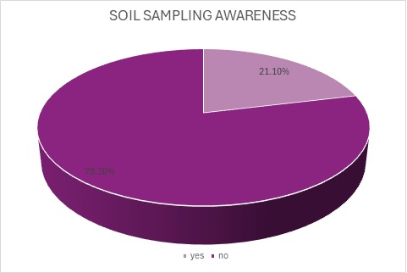

**Figure 1. This figure represents data collected from randomly selected farmers from 6 villages about soil sampling Awarness**

In a study conducted to assess farmers' awareness of soil sampling, it was found that 47 farmers had knowledge of soil sampling, while 13 farmers were unaware of this practice. This indicates that the majority (78.3%) of farmers understand the importance of soil sampling, while a smaller portion (21.7%) lack awareness. Farmers who are aware of soil sampling recognize its benefits, such as determining soil nutrient levels, optimizing fertilizer use, and improving crop yields. Their knowledge may come from agricultural extension services, training programs, or personal experience. However, the 13 farmers who are unaware of soil sampling may lack access to information, resources, or proper training. To bridge this knowledge gap, it is necessary to strengthen extension services, conduct training workshops, and provide accessible educational materials on soil sampling techniques. Increasing awareness among all farmers will contribute to better soil health management, reduced production costs, and enhanced agricultural sustainability.

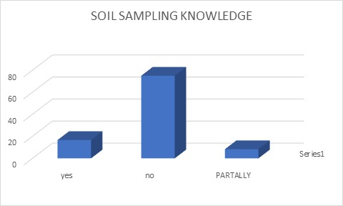

**Figure 2. Data of farmer who previously conducted soil sampling**

Despite the relatively high awareness level, only *10 farmers (16.7%)* have actually conducted soil sampling on their farms. This means that while many farmers know about soil sampling, only a small fraction has put it into practice. The remaining *50 farmers (83.3%)* have not yet performed soil testing, even though 47 of them are aware of it. (Singh et al., 2022) Out of 60 farmers surveyed:

* *47 farmers (78.3%)* were already aware of soil sampling.
* *13 farmers (21.7%)* had no prior knowledge of soil sampling.

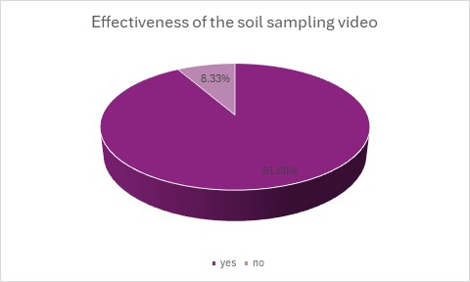

**Figure 3. farmer knowledge enhancement after watching the soil sampling educational video.**

This indicates that while the majority of farmers understand soil sampling, there was still a knowledge gap among a small percentage of them. Despite the high awareness level, only *10 farmers (16.7%)* had actually conducted soil sampling on their farms, while *50 farmers (83.3%)* had not yet taken this step. This suggests that while many farmers knew about soil sampling, barriers such as cost, accessibility, and lack of technical knowledge may have prevented them from adopting the practice.

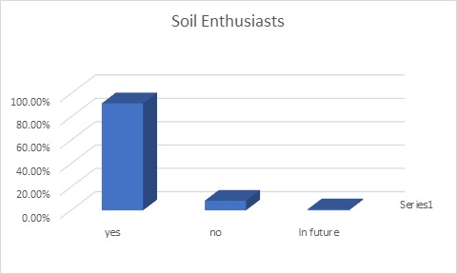

**Figure 4. Farmer interest in adoption of soil sampling practices.**

After watching an educational video on soil sampling, 55 out of 60 farmers (91.7%) expressed their intention to conduct soil sampling in the future. This significant shift in attitude highlights the power of awareness and education in influencing farmers’ decisions. The increase from 10 farmers who had previously conducted soil sampling to 55 intending to do so demonstrates the effectiveness of visual learning tools in bridging knowledge gaps and encouraging positive agricultural practices.

**Conclusion**

The study conducted in Fatehgarh Sahib district, Punjab, highlights the crucial role of soil sampling in promoting sustainable agricultural practices and improving soil health management. Despite a high level of awareness (78.3%) about soil sampling techniques among farmers, the adoption rate remains low, with only 16.7% of farmers actually implementing soil testing on their farms. This gap between awareness and practice can be attributed to several factors, including limited access to soil testing facilities, cost constraints, and a lack of technical knowledge.The educational intervention through a demonstration video on soil sampling proved to be highly effective in bridging knowledge gaps and fostering a positive attitude toward soil testing. After viewing the video, the intention to adopt soil sampling significantly increased, with 91.7% of farmers expressing an interest in conducting soil tests in the future. This indicates the potential of visual tools and targeted awareness programs in motivating farmers to embrace scientific farming practices. However, the study also revealed concerns regarding the cost, accessibility, and perceived benefits of soil testing, which continue to hinder widespread adoption. To address these barriers, it is essential to enhance awareness campaigns, provide subsidies or incentives for soil testing, improve access to local testing facilities, and offer hands-on training to empower farmers with the necessary skills to carry out soil sampling effectively. In conclusion, while there is a growing awareness of the importance of soil sampling, further efforts are needed to translate this awareness into action. Agricultural extension services, government support, and local initiatives play a key role in overcoming the challenges faced by farmers. By addressing these barriers and providing continuous support, Punjab’s farmers can be empowered to adopt soil sampling practices, leading to improved soil health, enhanced crop productivity, and long-term agricultural sustainability.

**Disclaimer (Artificial intelligence)**

Option 1:

Author(s) hereby declare that NO generative AI technologies such as Large Language Models (ChatGPT, COPILOT, etc.) and text-to-image generators have been used during the writing or editing of this manuscript.

Option 2:

Author(s) hereby declare that generative AI technologies such as Large Language Models, etc. have been used during the writing or editing of manuscripts. This explanation will include the name, version, model, and source of the generative AI technology and as well as all input prompts provided to the generative AI technology

Details of the AI usage are given below:

1.

2.

3.

References

1. Anderson, M. S. (1960). History and development of soil testing. *Journal of Agricultural and Food Chemistry*, *8*(2), 84-87.[10.1021/JF60108A001](https://doi.org/10.1021/JF60108A001)
2. Singh, H. P., Shaktawat, R. P. S., Singh, D., & Srivastava, S. C. (2013). Impact analysis of adoption of soil testing techniques for providing balance dose of fertilizers for kharif and rabi crops grown in Mandsaur district (MP). *International Journal of Scientific Research*, *2*(8), 12-14.
3. Tripathi, V., Srivastava, A., Gangwar, S. P., & Singh, R. K. (2018). Soil test crop response based fertilizer prescription for Urd Grown on Mollisol of Uttarakhand, India. *International J of Current Microbiology Applied Sci*, *7*(7), 90-101.
4. Jadhav, S., Kadao, S., Kusugal, S., & Baviskar, M. Soil Fertility Assessment and Management Strategies for Sustainable Agriculture in Chikkanayakanahalli Block of Karnataka, India.
5. Makkar, A., Chatli, A. S., Sharma, A., Kaur, P., Kaur, N., & Goswami, E. (2018). Analysis of Soil Samples from Various Areas of Punjab. *International Journal of Research in Engineering, Science and Management*, *1*, 496-498.