Socio-Economic Impact of Technological Interventions on Sheep Farming Productivity

ABSTRACT

Aims: The study aimed to assess the impact of technological interventions on sheep farming productivity and farmer livelihoods in Krishnagiri district, Tamil Nadu. The primary objectives should be improved production and profitability of sheep farming.

Methodology: A benchmark survey of 200 sheep farmers was conducted to identify production challenges. Fifty farmers were selected for targeted interventions, prioritizing women and marginalized groups. The interventions included introducing improved rams to reduce inbreeding, strategic supplementary feeding during flushing, pregnancy, and lactation, hydroponic fodder and Azolla supplementation, ethno-veterinary first aid training, and improved marketing strategies. Farmers underwent training, and the impact was assessed through productivity and economic indicators.

KEY FINDINGS AND DISCUSSION: The interventions significantly improved reproductive efficiency and lamb growth. Conception rates increased from 50–60% to over 80%, while prenatal nutritional support enhanced birth weight and weaning weight by over 20%. Lactation-phase supplementation led to a 15% increase in postnatal lamb growth. Farmers observed a reduction in lamb mortality and faster weight gain, enabling earlier market sales. The introduction of improved rams and better nutrition resulted in increased meat yield and profitability. Ethno-veterinary practices improved flock health, and training enhanced marketing efficiency. Farmers reported higher incomes, selling more animals per cycle and reducing rearing costs.

Conclusion: Strategic technological interventions significantly enhanced sheep farming productivity and farmer income. Improved breeding, nutrition, and health management practices resulted in better reproductive efficiency, lamb survival, and economic gains. The study highlights the importance of integrating scientific innovations into traditional sheep farming systems for long-term sustainability and rural development.

***Keywords:*** *Socio-economic analysis, Technological interventions, Sheep productivity, Rural livelihoods, Smallholder farmers.*

1.0 INTRODUCTION

Sheep have been an integral part of human society since ancient times, contributing significantly to agriculture and rural livelihoods. Even with modern technological advancements, sheep continue to hold an important place in global farming systems. Today, the global sheep population stands at approximately 1.2 billion. China leads the world in sheep numbers, with an estimated 175 million animals—a figure that continues to grow alongside the nation's expanding economy. This is more than double the sheep population of the next-ranking country.

Australia follows with around 75 million sheep, while India ranks third, maintaining an estimated 54 million sheep. These figures highlight the enduring importance of sheep farming in both developed and developing agricultural economies. Krishnagiri district in Tamil Nadu is home to approximately 2,30,527 sheep, with the highest population density (61-70 heads per sq. km) observed in Krishnagiri, Bargur, Vepanahalli, and Soolagiri blocks. Sheep farming in the region is predominantly managed by small and marginal farmers, who rely on extensive grazing systems to sustain their livestock. Despite the availability of 7,853 hectares of pasture and grazing land, these resources are insufficient to support grazing throughout the year, particularly during the lean season, when poor forage availability and low-quality grazing material significantly impact animal growth rates. This often results in distress sales, reducing the profitability of sheep farming (Chinnathambi et al., 2025a & b).

Traditional rearing methods, which include free-range grazing and minimal veterinary intervention, often contribute to low productivity levels due to challenges such as nutritional deficiencies, disease outbreaks, high lamb mortality, and suboptimal breeding practices (Kanakaraja et al., 2024). The lack of awareness and access to scientific sheep farming technologies further limits productivity and profitability in this sector (Ajafar et al, 2022).

Recognizing these constraints, the National Bank for Agriculture and Rural Development (NABARD) sponsored a project through the Veterinary University Training & Research Centre, Krishnagiri (Tamil Nadu Veterinary and Animal Sciences University - TANUVAS) to analyze and improve sheep farming practices in the region. The key objectives of this study were to:

1. Identify major constraints in extensive sheep farming under field conditions and evaluate how the adoption of scientific interventions can enhance sheep productivity and farmers' economic well-being.
2. Implement farmer-friendly technological interventions in extensive sheep farming to improve growth rate, reproductive efficiency, and disease resistance, thereby enhancing overall productivity.
3. Document the impact of these interventions on sheep productivity, health, and farmers' income levels, ensuring measurable improvements.
4. Disseminate knowledge by demonstrating successful interventions and their outcomes to other sheep farmers, promoting widespread adoption.
5. Assess the economic benefits of technological interventions on the livelihoods of sheep farmers, particularly small and marginal farmers, and recommend policy measures for sustainable growth.

Through this study, the project aimed to bridge the gap between traditional sheep farming practices and modern scientific approaches, thereby improving flock performance, reducing economic losses, and enhancing the socio-economic conditions of sheep farmers in Krishnagiri district.

2.0 METHODOLOGY

The study was conducted in Krishnagiri district of Tamil Nadu, a region with a substantial population engaged in sheep farming. The geographical location of the study area is shown in the map below. Although more than 1,000 farmers rear sheep in the district, a sample of 200 farmers was initially selected for the benchmark survey and data collection. A scoring system was developed to evaluate the farming practices and willingness of each participant. Based on these assessments, 50 farmers were finally selected for the technological intervention phase of the study, primarily due to funding limitations (Chinnathambi et al., 2025a).

The selection process considered several practical constraints. In rural settings, many farmers continue to follow traditional, non-scientific methods of sheep rearing, which pose challenges for implementing and monitoring modern interventions. Some farmers were also reluctant to participate consistently or adopt new practices. Moreover, the presence of mixed-breed flocks among many participants introduced variability, limiting the ability to draw consistent conclusions.

To ensure meaningful results and effective implementation, the 200 farmers included in the baseline study were those who showed willingness to cooperate under field conditions. The final 50 beneficiaries were selected from this group based on their engagement, flock suitability, and practical feasibility. The results and benefits of the interventions will be disseminated to the wider farming community through farmer workshops and outreach activities, with the aim of encouraging broader adoption of scientific sheep-rearing practices and improving the socio-economic well-being of rural households (Chinnathambi et al., 2025b).

|  |  |  |
| --- | --- | --- |
| 1,960 World Map India Highlighted Images, Stock Photos, 3D objects, &  Vectors | Shutterstock | India Map Tamil Nadu Photos and Images & Pictures | Shutterstock |  |
| Fig 1: location of study area |  |  |

The selection criteria included flock size, farming experience, and willingness to adopt new technologies. A mixed-methods approach was employed, integrating quantitative and qualitative research techniques. Data collection involved structured interviews to gather demographic and economic information, farm observations to assess existing management practices, and participatory rural appraisals to understand farmers' perceptions and challenges. Additionally, baseline and post-intervention assessments were conducted to measure the impact of technological interventions on productivity and economic gains.

3.0 RESULT AND DISCUSSION

3.1 Benchmark survey

We conducted a benchmark survey in the field, covering 200 sheep farmers, to assess their existing farming practices, constraints, and socio-economic conditions. The collected data were systematically analyzed, and the consolidated results are presented in the following table:

Table 1: Benchmark survey

|  |  |  |
| --- | --- | --- |
| S. No. | Study Components | Key observations |
|  | Number of sheep maintained | Ewes average = 28-35  Rams = 2 - 3 |
|  | Breed | Mecheri |
|  | Land Holding | Mostly landless |
|  | Housing of sheep | Folded in Patti |
|  | Night Folding done in Agricultural land | Its seasonal variation like during agricultural harvesting period. |
|  | Regular Feeding | Only Grazing |
|  | Duration of Grazing available in Year (Months) | 5 - 6 months |
|  | Where the Animals are Grazed | Village grazing land |
|  | Problems in Grazing (Rank) | Only few months |
|  | Any supplement Given after Grazing | No |
|  | Do you cultivate and feed green grass | No |
|  | Mating season (specify month) | Seasonal breeds |
|  | Any supplement before mating | No |
|  | No. of Breeding Rams in flock | Average 2 — 3 Rams |
|  | No. of Breedable Ewes in Flock | Average 15-3.8 |
|  | Age at sexual maturity in female | Not known |
|  | Body weight at the time of first mating | Not known |
|  | Tupping % | Not known |
|  | Percentage of twins in flock | Very less |
|  | Quantity milk consumed by lambs | Not known |
|  | Are your Rams used for Breeding born in your flock itself | Yes (Most of the farmers) |
|  | How long you use the same Ram for Breeding? | Years together |
|  | Where from you buy your Rams? | Own Farm |
|  | Grazing both your Rams and Ewes together | Yes (Most of the farmers) |
|  | Do you feed supplement in Pregnancy | No |
|  | Approximate birth weight of Lambs | Not known |
|  | Percentage of pre weaning lamb mortality | 18-20% |
|  | Do you feed supplement to lactating Ewes | No |
|  | Percentage of survival of lambs at weaning | No Record |
|  | App. Weight of lambs at weaning | 7.05 Kg. |
|  | Body weight of Ewes | Above 36 Months -28.39 Kg |
|  |  | 24 to 36 months-6 Teeth-28.65 Kg |
|  | 12 months — 19.32 kg |
|  | 9 Months — 14.29 kg |
|  | Do you know about Azolla and its feeding | No |
|  | No. of animals sold/ year | 5 — 7 Lambs |
|  | Place of selling animals | Shandy |
|  | Have you visited any Government/ private sheep farm in the last 5 years | No |
|  | Have you under gone any training | No |
|  | Approximate annual income | Not known |

The majority of farmers rear Mecheri sheep under an extensive system with minimal technological interventions. Flock sizes typically range from 28 to 35 ewes with 2 to 3 rams, and inbreeding is common due to the continuous use of farm-born rams without replacement. Grazing is the primary source of nutrition, but its availability is limited to about six months per year, leading to severe feed shortages during lean periods. No supplementary feeding is practiced, and farmers lack awareness of nutritional interventions such as green fodder cultivation and alternative feed resources like Azolla. Breeding management is unstructured, with no strategic supplementation before mating, resulting in low twin birth rates and reduced reproductive efficiency. High pre-weaning lamb mortality (18-20%) is observed, likely due to inadequate colostrum intake, disease prevalence, and poor nutrition. Housing facilities are temporary, and night folding is practiced on agricultural lands depending on seasonal availability. Marketing is primarily done through local shandies, with farmers selling around 5 to 7 lambs annually, but financial record-keeping is absent, making it difficult to assess profitability. Additionally, no farmers have attended training programs or exposure visits to improve their farming knowledge.

Fig 2: Sheep reared under an extensive grazing system in the study area and Benchmark survey being conducted at the field level among sheep farmers.

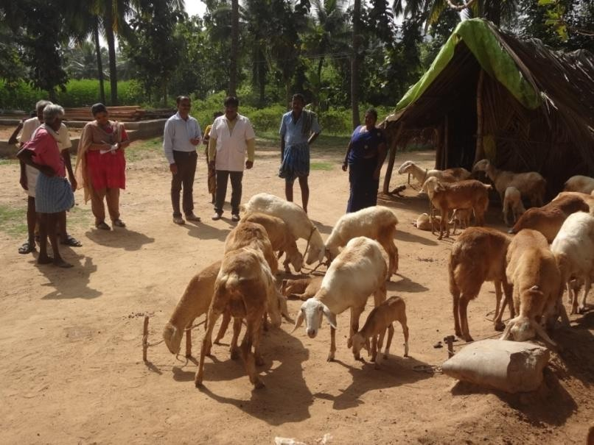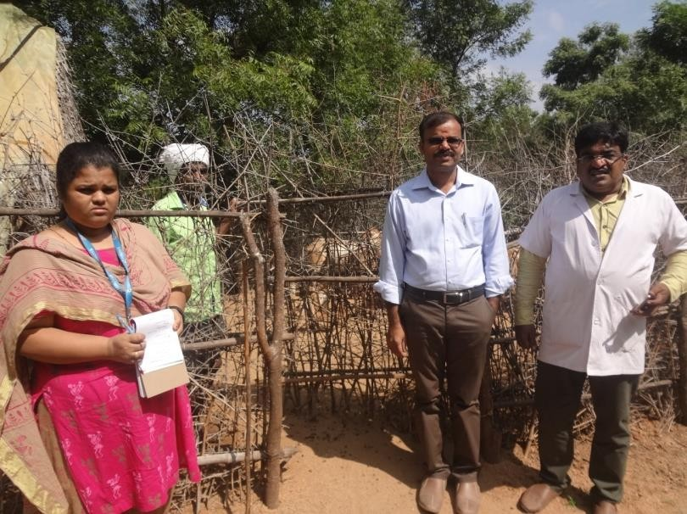

From the above findings, it is evident that immediate interventions are necessary. We have identified key technological interventions that can be implemented to improve sheep productivity and profitability, ultimately enhancing farmers' livelihoods by addressing the following issues:

3.2 Technological Interventions needs to implemented

3.2.1 Inbreeding:

Farmers commonly practiced breeding within the same flock due to limited access to quality breeding rams. This led to a decline in genetic diversity, resulting in reduced growth rates, lower fertility, and higher susceptibility to diseases.

3.2.2 Poor Nutrition During Critical Periods:

Sheep experienced nutritional deficiencies, particularly during the dry season when natural grazing resources were scarce. The lack of supplementary feeding during gestation and lactation phases further contributed to poor reproductive performance and weak lambs.

3.2.3 Low Birth Weight and Weaning Weight of Lambs:

Due to inadequate maternal nutrition and genetic limitations, lambs were born with lower birth weights. This significantly affected their survival and growth rates, ultimately impacting the overall productivity of the flock.

3.2.4 High Lamb Mortality:

The mortality rate among lambs was alarmingly high, primarily due to inadequate colostrum intake, disease prevalence, and poor housing conditions. Limited awareness of disease prevention and lack of vaccination further aggravated the issue.

3.2.5 Reduced Feed Efficiency in Male Lambs Grown for Meat Production:

Male lambs, reared for meat production, exhibited poor feed conversion efficiency due to substandard nutrition and genetic factors. This resulted in extended rearing periods and lower profitability for farmers.

3.2.6 Poor Marketing Ability Among Sheep Keepers:

Most farmers lacked access to organized markets and were dependent on local traders who offered lower prices for their animals. The absence of collective bargaining power and market intelligence further restricted their ability to obtain fair prices, limiting their income potential.

3.3 Technological Interventions

The following key technological interventions have been carried out to alleviate the above field constraints in sheep farming under rural conditions.

3.3.1 Beneficiaries

A total of 25 sheep keepers, each possessing a minimum of 20-25 sheep, were enrolled each year for two consecutive years. Priority was given to women, with 10 beneficiaries from SC/ST communities out of the total 50 selected participants.

3.3.2 Training Program

A two-day training program was conducted for the beneficiaries on the following transferable technologies:

* Introduction of improved rams (breedable males) for genetic improvement and to prevent inbreeding.
* Supplementary feeding during critical periods such as flushing, advanced pregnancy, and lactation in ewes.
* Production and feeding of hydroponic fodder to lambs and Azolla to growers as supplements.
* Stimulating the oesophageal groove in pre-weaned lambs for effective feeding.
* Defaunation of the rumen to increase feed efficiency.
* Feeding groundnut oil cake to weaned kids.
* Ethnoveterinary first-aid practices to reduce sheep mortality.

Fig 3: Training and Demonstration of Transferable Technologies

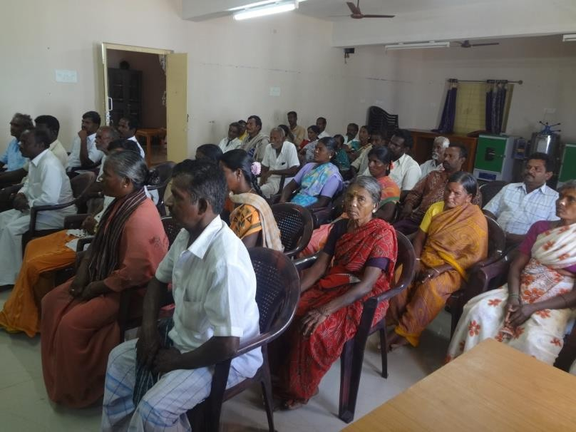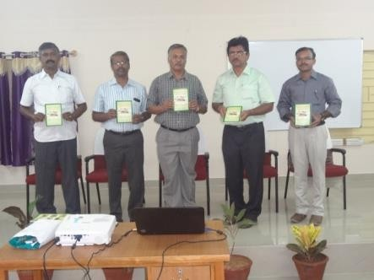

3.3.3 Introduction of Improved Rams for Genetic Enhancement

Each enrolled beneficiary received a high-quality breedable ram purchased from reputed sheep breeders. To prevent accidental mating, the existing rams with the beneficiaries were either castrated or sold to cover their contribution toward purchasing improved rams. Regular deworming of the entire flock was ensured.

Fig 4: Distribution of Improved Male Germplasm and Inputs to Beneficiaries

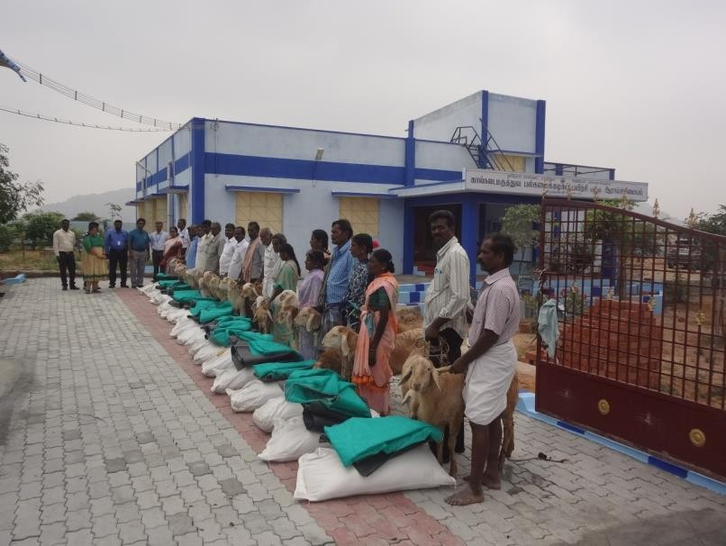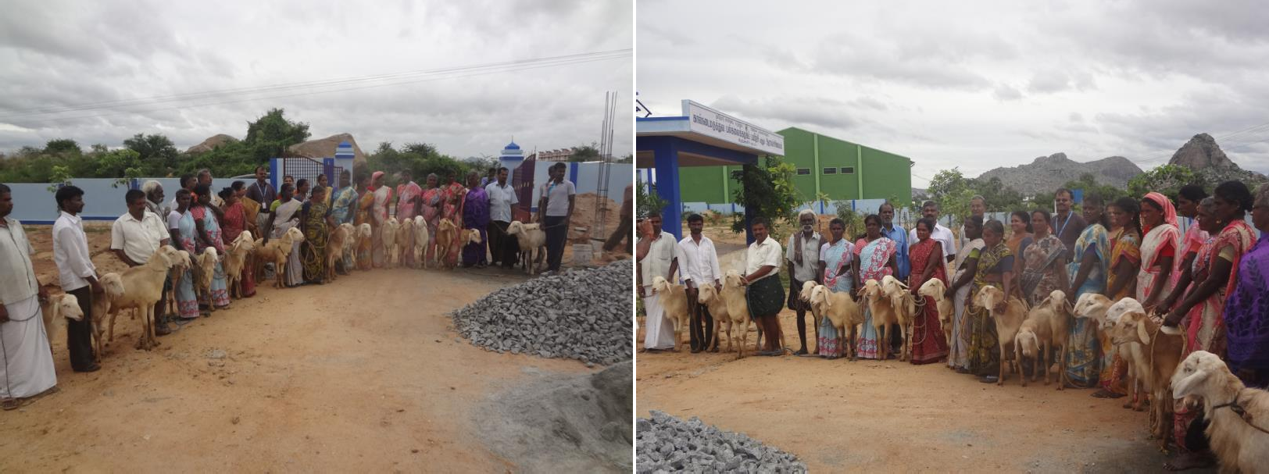

3.3.4 Concentrate Feed Supplementation During Flushing Period

Approximately 20 days before mating, ewes were supplemented with 100g of concentrate feed per day. The tupping rate and conception percentage were monitored and recorded.

3.3.5 Concentrate Feed Supplementation During Late Pregnancy

Pregnant ewes, during the last 60 days of gestation, were fed 100g of concentrate feed per day as a supplement. The birth weight of lambs was recorded to assess the impact.

3.3.6 Supplementation During Lactation

Lactating ewes were provided with 100g of concentrate feed per day during the first 60 days of lactation, especially during the lean season. The body weight of lambs was measured at 60 days to evaluate growth performance.

3.3.7 Production and Feeding of Azolla as a Supplement

Beneficiaries were provided with necessary inputs, including polythene sheets and Azolla seed material. Adult sheep were regularly supplemented with Azolla to improve nutrition and overall health.

Fig 5: Practical Demonstration and Capacity Enhancement on Azolla Use in Sheep Diets

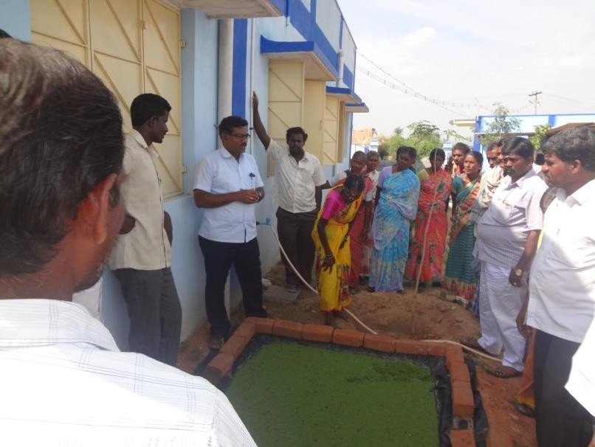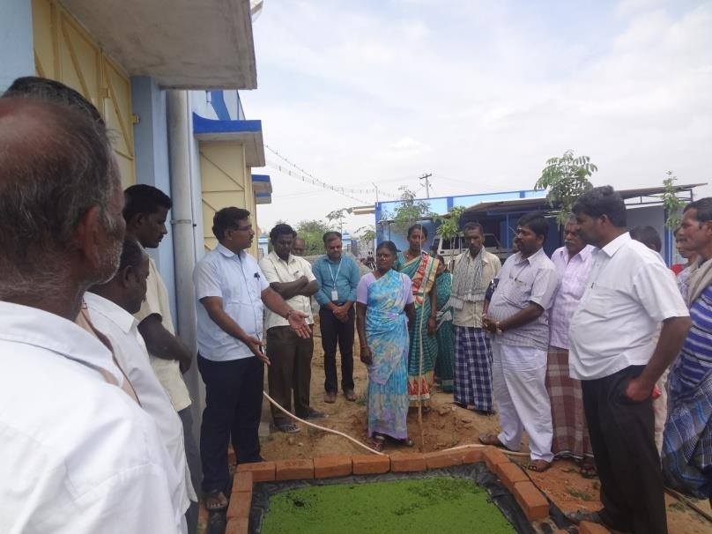

3.3.8 Ethno-Veterinary First Aid Practices

Under this intervention, NABARD beneficiaries were trained in the use of locally available plant sources for first-aid treatment in sheep management. The training focused on addressing common health issues such as diarrhea control, ectoparasite management, and indigestion problems.

3.3.9 Exposure Visit to Mecheri Sheep Research Station (MSRS), Pottaneri

The enrolled farmers were taken to the government-run Mecheri Sheep Research Station (MSRS) in Mecheri Taluk, Salem District. At the farm, scientists provided insights into various aspects of sheep management for profitable farming, emphasizing the role of novel technologies in improving productivity and doubling farmers' income. The sheep farmers actively participated in discussions and visited different sections of the farm, including various rearing systems, feeding patterns, breeding techniques, and herbal gardens (Karunanithi et al., 2005).

Fig 6: Exposure Visit to MSRS to Enhance Knowledge on Scientific Sheep Rearing

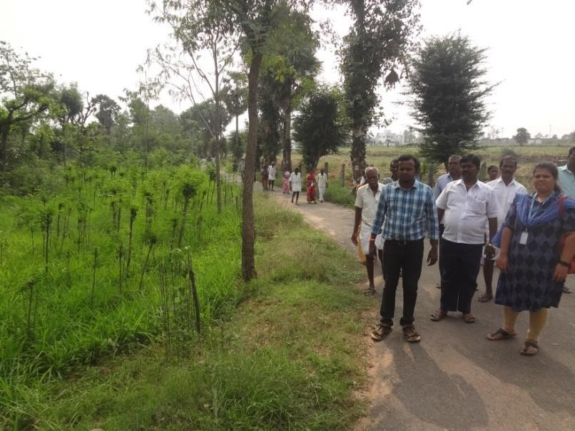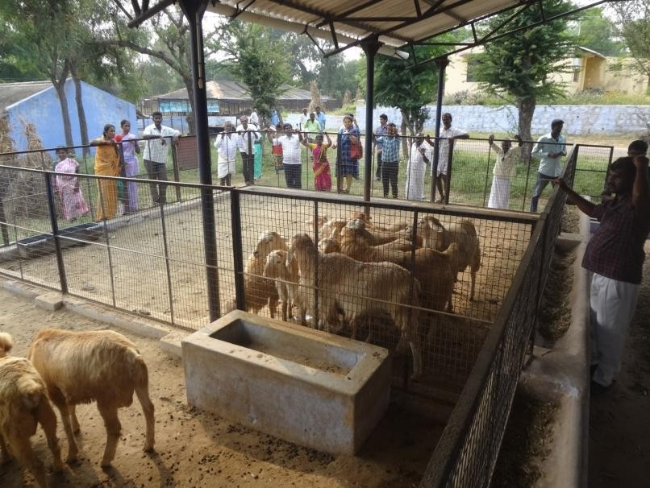

3.3.0 Rural Workshop for Knowledge Dissemination

Upon completion of the intervention program, a rural workshop was organized where first-year beneficiaries shared their experiences regarding technology adoption and its impact. They discussed the effectiveness of each intervention and recommended viable technologies for wider implementation. Over two years, a total of 100 sheep keepers from the district benefited from the program.

3.4 Impact of Technological Interventions on Sheep Farming

The implementation of these technological interventions brought significant benefits to sheep farmers in the following ways:

3.4.1 Reduction in Inbreeding – The introduction of improved male germplasm helped reduce the risk of inbreeding within sheep flocks. This genetic management strategy led to healthier, more productive animals and minimized the adverse effects of inbreeding depression—a concern in smallholder systems with limited breeding stock. Although direct studies on Indian sheep populations are limited, practices that ensure genetic diversity are vital for sustainable flock productivity (Ravimurugan et al., 2022; Ajafar et al., 2022; Chinnathambi et al., 2025b).

3.4.2 Enhanced Nutrition for Ewes – Balanced nutritional supplementation during flushing, late pregnancy, and lactation improved the health of ewes and the survivability of lambs. Better nutrition directly influenced lamb birth weight and weaning weight, aligning with findings from Indian livestock feeding strategies that emphasize stage-specific rationing (Tiwari et al., 2012; Chinnathambi and Chitrambigai, 2025).

3.4.3 Azolla Supplementation for Fodder Scarcity – During lean summer months, Azolla pinnata served as a crucial nutritional supplement (Roy et al., 2015). Azolla is rich in protein, minerals, and amino acids, making it a highly effective substitute for conventional fodder. Ahmed et al. (2016) demonstrated that Azolla could replace traditional feeds in sheep without negatively affecting growth performance. Additionally, Sankar et al. (2020) reported enhanced feed conversion efficiency and daily weight gain in sheep when Azolla meal was used as a dietary supplement. These findings underscore Azolla's utility in managing fodder scarcity and improving small ruminant productivity.

3.4.4 Reduced Early-Stage Lamb Mortality – Introducing feeding techniques such as oesophageal groove feeding significantly reduced early lamb mortality. Ensuring adequate milk or milk replacer consumption in the first weeks of life enhances survival—a fact well-supported by lamb-rearing practices across arid Indian regions (Kumar et al., 2017; Chinnathambi and Chitrambigai, 2025)

3.4.5 Improved Growth Rate in Weaned Lambs – Supplementation of groundnut oil cake improved early body weight gain in weaned lambs, directly increasing their market value. Oilseed cakes are widely used in India to enhance protein intake, and studies have shown that groundnut cake is especially effective in boosting growth performance in small ruminants (Kumar et al., 2021; Chinnathambi and Chitrambigai, 2025).

Fig 7: Effect of Technological Interventions on Sheep Productivity and Farmer Livelihoods

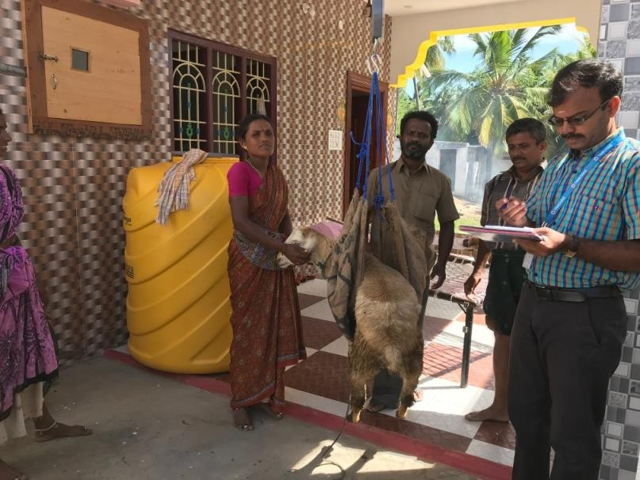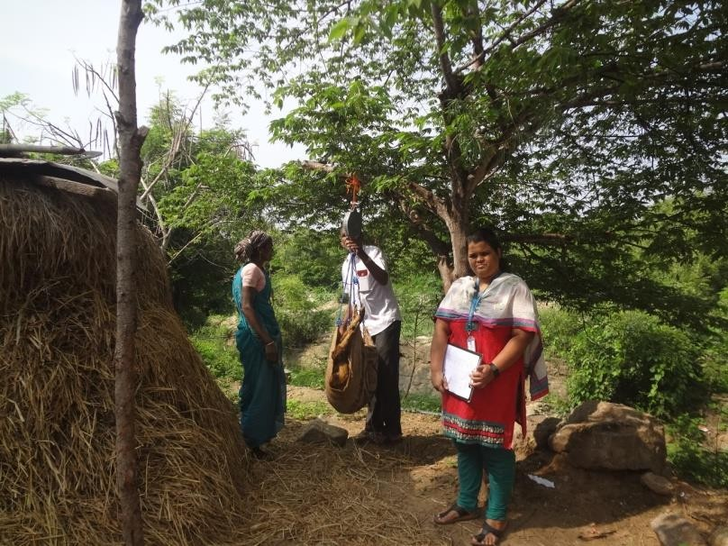

3.4.6 Ethno-Veterinary First Aid Practices – Workshop on ethno-veterinary medicine empowered farmers with locally adaptable, plant-based remedies. Meena et al. (2021) documented these practices among the Raika pastoralists of Rajasthan, highlighting their practical efficacy in addressing common ailments in sheep and goats. By integrating traditional knowledge with modern awareness, farmers were better equipped to provide timely and cost-effective first aid.

3.4.7 Improved Marketing Skills – Skill-building workshops on sheep marketing equipped farmers with the tools to better understand market dynamics, negotiate prices, and plan sale timing. Although detailed Indian studies on sheep marketing are still emerging, extension-driven marketing interventions have proven effective in similar livestock systems across India (Sasidhar et al., 2013).

3.5 Impact of Technological Interventions in Percentage Terms

The adoption of technological interventions led to measurable improvements in various aspects of sheep farming, as outlined below:

3.5.1 Reduction in Inbreeding – The introduction of new, genetically superior male sheep significantly reduced inbreeding, improving female acceptance and overall reproductive success.

3.5.2 Higher Reproductive Efficiency – Over 80% of ewes conceived, compared to the previous rate of 50–60%, indicating a substantial improvement in fertility.

3.5.3 Better Pregnancy and Delivery Rates – Prenatal growth rate of foetuses improved, leading to more than 90% confirmed pregnancies and successful deliveries, compared to 60–70% earlier.

3.5.4 Increased Birth and Weaning Weights – Lambs showed a more than 20% increase in birth weight and weaning weight, contributing to better survival rates and growth performance.

3.5.5 Improved Milk Secretion in Ewes – Supplemental feeding during lactation resulted in a 15% increase in postnatal growth of lambs, due to enhanced milk production in ewes.

3.5.6 Economic Benefits for Sheep Farmers – The socio-economic status of sheep farmers improved significantly, with higher revenues than in previous years. Farmers who earlier sold 5–6 male lambs at 9 months of age were now able to sell 7–8 male lambs every 6 months, thereby increasing their income and reducing the rearing period.

3.5.7 Overall Productivity Gains – The combined impact of improved conception rates, higher lambing rates, reduced lamb mortality, and increased weight gain resulted in a higher quantity of quality meat production, benefiting both farmers and consumers.

The consolidated impact of this project / intervention were tabulated as follows:

**Table 2: Summary of the consolidated impact of the project:**

|  |  |  |  |
| --- | --- | --- | --- |
| **Parameter** | **Before Intervention** | **After Intervention** | **Impact** |
| Lamb Birth Weight | 2.0 – 2.2 kg | 2.8 – 3.0 kg | Increased by 0.8 – 1.0 kg due to genetic improvement and better nutrition |
| Lamb Growth Rate | 15 kg at 9 months | 15 kg at 6 months | Faster growth rate, reducing rearing time by 3 months |
| Market Price of Sheep | Rs. 3,500 per animal | Rs. 4,500 – 5,000 per animal | Increased by 30% due to healthier and heavier lambs |
| Twin Births in Ewes | Rare or absent | 5 out of 9 ewes gave twins | Increased fertility due to improved feeding strategies |
| Feed Cost Reduction | Higher due to reliance on commercial feed | 15 – 25% lower | Adoption of Azolla and unconventional fodder reduced expenses |
| Use of Concentrate Feed | Minimal or absent | 100 – 150 gm per animal/day | Improved nutrition for pregnant and lactating ewes |
| Maturity and Breeding Efficiency | Longer time to reach mating weight | Reduced maturity period | Increased mating frequency and overall reproductive efficiency |
| Mortality Rate of Lambs | Higher due to poor nutrition | Reduced significantly | Better survival rate with enhanced maternal nutrition |
| Overall Income Increase | Baseline | 25 – 30% higher | Due to better flock management, growth rate, and market value |

This table systematically summarizes the key improvements observed through the NABARD intervention, demonstrating its success in improving sheep productivity and farmers’ livelihoods. Let me know if you need any modifications!

3.6 Cost-Benefit Ratio of Individual Farmers

The lamb growth rate significantly improved as their mothers were provided with concentrate feed for increased milk production for 60 days post-delivery at a rate of 100 grams per day (fully subsidized by NABARD). As a result, the lambs were healthier, had a noticeable glow, and exhibited better body weight compared to pre-intervention conditions.

Additionally, the weight gain of lambs accelerated, with farmers previously achieving a body weight of 15 kg only at around 9 months of age. Following the intervention, the same weight was attained within just 6 months, owing to the supplementary feeding of lactating ewes.

The sale of male lambs also generated higher revenue, with prices ranging from Rs. 250 to Rs. 300 per kg of live body weight (average market rate at the local level), due to their improved health and appearance. Since participating in the project, farmers have sold 20 sheep at Rs. 4,500 per animal, yielding significant profits while also saving three months' worth of rearing costs.

These interventions are expected to yield even better results over time. Farmers expressed high levels of satisfaction and have begun actively disseminating their success stories, sharing the benefits of the project with other sheep farmers in nearby villages.

4. Conclusion

The implementation of targeted technological interventions in sheep farming in Krishnagiri district has demonstrated significant improvements in reproductive efficiency, lamb growth rates, and the economic well-being of small and marginal farmers. The introduction of improved breedable males effectively reduced inbreeding, while strategic supplemental feeding during critical physiological stages enhanced birth weights and weaning weights. The adoption of Azolla supplementation addressed seasonal fodder shortages, improving overall nutrition and productivity. Additionally, training on ethno-veterinary practices and marketing strategies empowered farmers to manage health issues efficiently and optimize their revenue.

Quantifiable benefits include an over 80% conception rate (compared to 50–60% before), a more than 20% increase in lamb birth and weaning weights, and a 15% improvement in postnatal lamb growth due to enhanced milk production in ewes. Farmers also reported an increase in the number of male lambs sold per cycle, significantly boosting their income. The improved management practices led to a notable reduction in lamb mortality, increased feed efficiency, and a higher quality of meat production.

These findings emphasize the potential of scientific interventions to bridge the gap between traditional and modern sheep farming methods. Widespread adoption of such practices, supported by training and financial assistance, can lead to sustainable growth in the sector, ensuring better productivity, profitability, and livelihoods for sheep farmers in resource-limited regions.

5. Success stories

The implementation of the NABARD-sponsored scheme, Technical Interventions for Improving Productivity of Sheep, has significantly benefited sheep farmers in Krishnagiri district by enhancing their flock productivity and economic returns. Mr. C. Ramachandran of Kurinapalli village, who previously sold sheep at Rs. 3,500 per animal at nine months of age, adopted scientific feeding practices, including concentrate feed and quality ram introduction. As a result, lamb birth weights increased from 2 kg to 3 kg, and their growth rate improved, reaching 15 kg in six months instead of nine. His income rose by 30%, with improved market prices for his sheep. Similarly, Mrs. Rani of Chinnagudoor Village, struggling with poor weight gain in her flock due to arid conditions, benefited from concentrate feeding during flushing, resulting in a significant increase in twin births (from none to five out of nine ewes). The introduction of Azolla feeding helped her save Rs. 40 per day on feed costs, reducing expenses by 25%. Post-intervention, her flock size expanded to 24 ewes, 2 rams, and 14 growers, leading to a 30% increase in income.

Mr. Poongavanam of Melkottai village, starting with 12 ewes and 2 rams, acquired a genetically superior ram at a 60% subsidy. With 150 g of concentrate feed per ewe, lamb birth weights improved, and mortality rates declined. Technical training on feeding, summer management, and unconventional fodder helped reduce feed costs by 15% while boosting profits by 25%. Likewise, Mr. M. Rajini of Saklinatham village, who initially had 25 ewes, 1 ram, and 10 lambs, replaced his genetically poor ram with a superior one through the scheme. Training in breeding, nutrition, and management increased lamb birth weights from 2.0 kg to 2.8 kg and accelerated their growth, reducing the time to reach maturity. The use of Azolla reduced feed costs by 15%, while better breeding practices led to decreased inbreeding defects and higher reproductive efficiency. His overall profit increased by 15%.

Fig 8: Success stories highlight the tangible impact of scientific interventions in sheep farming

These success stories highlight the tangible impact of scientific interventions in sheep farming, demonstrating improved birth weights, faster growth rates, reduced feed costs, and increased incomes. Farmers, impressed by these results, are now actively sharing their experiences, encouraging wider adoption of best practices across their communities.

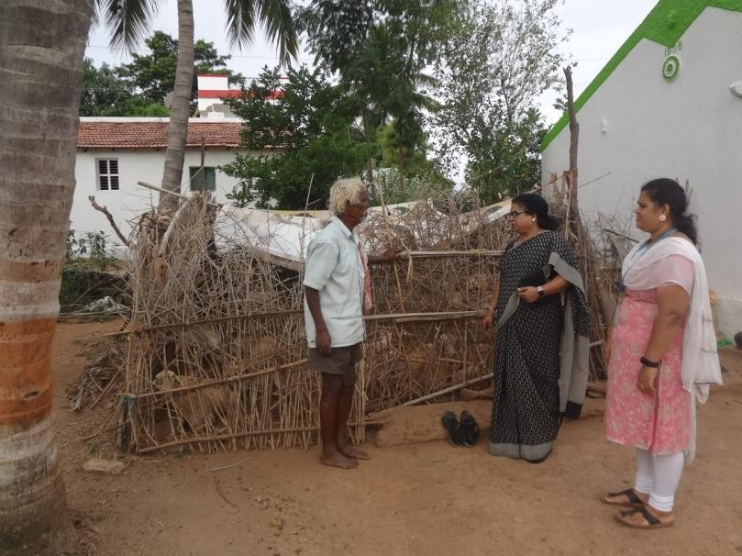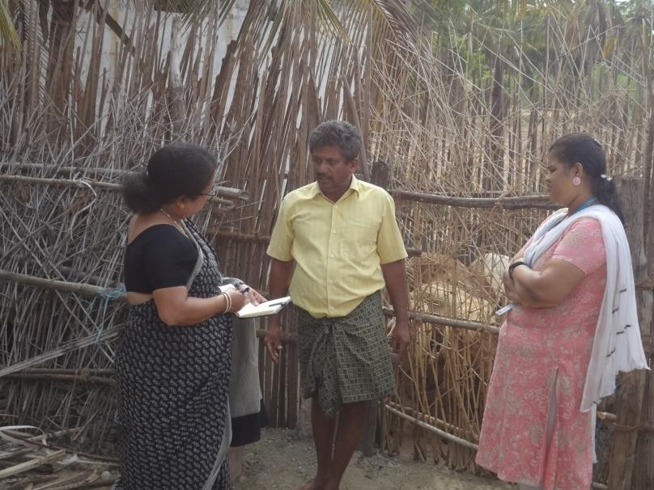

**DISCLAIMER (ARTIFICIAL INTELLIGENCE)**

Author(s) hereby declare that NO generative AI technologies such as Large Language Models (ChatGPT, COPILOT, etc.) and text-to-image generators have been used during the writing or editing of this manuscript.

References

Ahmed, H. A., Ganai, A. M., Beigh, Y. A., Sheikh, G. G., & Reshi, P. A. (2016). Performance of growing sheep on Azolla based diets. Indian Journal of Animal Research, 50(5), 721-724.

Ajafar, M. H., Kadhim, A. H., & AL-Thuwaini, T. M. (2022). The reproductive traits of sheep and their influencing factors. Reviews in Agricultural Science, 10, 82-89. <https://www.jstage.jst.go.jp/article/ras/10/0/10_82/_html/-char/en>

Chinnathambi, V., Meenalochani, V., Balachandran, P., & Murugan, M. (2025a). Addressing field constraints in sheep farming: Pathways to sustainability and economic growth. International Journal of Agriculture Extension and Social Development, 8(3), 295-302. <https://www.extensionjournal.com/article/view/1713/8-3-62>

Chinnathambi, V., Chitrambigai, K., & Enbavelan, P.A. (2025b) Optimizing sheep reproductive performance through technological interventions. International Journal of Veterinary Science and Animal Husbandry,10(4):27-31. <https://www.veterinarypaper.com/archives/2025/10/4/A/10-3-63>

Chinnathambi, V., & Chitrambigai K. (2025). “Optimizing Sheep Reproductive Performance through Nutritional Interventions”. Journal of Experimental Agriculture International 47 (4):113-21. <https://doi.org/10.9734/jeai/2025/v47i43361>.

Kanakaraja M. G., Sagar M., Juniwal C, Afnan SN, Reddy EN, Kartik. (2024). Collective Study on Housing Management Practices of Kenguri Sheep Farmers under Intensive and Extensive Rearing Systems in Yadgir District of Karnataka, India. Journal of Scientific Research and Reports, 30(5), 9–15. <https://journaljsrr.com/index.php/JSRR/article/view/1916>

Karunanithi, K., Rajendran, R., and Kandasamy, N. (2005). Breed characteristics of Mecheri sheep. Animal Genetic Resources Information (AGRI), 37, 53–62. DOI: [10.1017/S1014233900001966](http://dx.doi.org/10.1017/S1014233900001966)

Nagalakshmi, D., & Dhanalakshmi, K. (2015). Effect of feeding castor seed cake based diets on growth, nutrient utilization, immune response and carcass traits in lambs. Asian J Anim Sci, 9(6), 293-305.

Suresh, A., Gupta, D. C., & Mann, J. S. (2008). Farmers’ management practices and economics of sheep farming in eastern semi-arid region of Rajasthan. The Indian Journal of Small Ruminants, 14(2), 236-242.

Bamikole, M. A., & Ikhatua, U. J. (2009). Compilation and adoption of ethno-veterinary medicine, traditional and other management practices by small ruminant farmers in Edo State Nigeria. Tropical Animal Health and Production, 41, 1549-1561.

Chaudhari, A. B., Ramanujam, R., & Ragothaman, V. (2023). Effects of inbreeding on reproduction and fitness traits in a closed flock of Nilagiri sheep, an endangered Indian breed. Small Ruminant Research, 219, 106904.

Roy, A., Mandal, A. B., & Sharma, K. (2015). Feeding Azolla to Hariana heifers: A performance study. Indian Journal of Dairy Science, 68(5), 453–456. <https://ebook.icar.gov.in/index.php/IJDS/article/view/50583>

Sankar, P., Senthilkumar, P., Sribalaji, N., Nalini, P., Arun, L., & Muralidharan, J. (2020). Effect of feeding Azolla meal on growth performance of Mecheri sheep. International Journal of Current Microbiology and Applied Sciences, 9(5), 1945-1949. <https://doi.org/10.20546/ijcmas.2020.905.222>

Sasidhar, P. V. K., Chand, K., & Anitha, K. (2013). Training farmers on marketing strategies for livestock. Indian Journal of Small Ruminants, 33(1), 61–66. https://doi.org/10.5958/j.0976-0563.33.1.007

Tiwari, R., Dutta, N., & Chaturvedi, V. B. (2012). Nutritional management of ewes for better reproductive performance. Indian Journal of Small Ruminants, 32(1), 24–29. <https://doi.org/10.5958/j.0976-0563.32.1.004>