**Collaborative Prosperity-Partnership Caravan for Transformative Community Impacts towards Global Citizenship Education and Advocacy**

**Abstract:**

Towards the achievement of the Philippine commitments to the United Nation’s 17 Sustainable Development Goals, the University of Eastern Philippines pledged its commitment to contribute its share for this global policy and advocacy to fulfill its social and moral responsibility to its stakeholders, clients and partners in the development arena.

Generally, the extension research aimed to foster collaborative development partnership among stakeholders in the province of Northern Samar, specifically it 1.) explore how partnership drive community transformation, 2.) identified factors contributed to the successful collaboration for global citizenship and advocacy, and 3.) developed a model-framework for implementing prosperity-partnership caravan. It employs stakeholders’ consultation, partnership agreement signing, co-management, resource sharing commitments, pledging, volunteerism, and feedbacking.

There are 10 categories of stakeholders participated in the prosperity caravan namely; NGAs with 16 individual line agencies, 24 municipal LGUS, 1 academe, 12 CSOs, 13 private sectors, 220 schools, 84,000 families and 639,186 people in 569 Barangay LGUs were able to reach out. Facilitating factors that contributed to the success of the caravan were good planning, advance preparation and mobilization, monitoring and reporting, and documentation, resources sharing and complementation, and delivery of program, products and services offerings of development partners and stakeholders.

**Keywords:** Stakeholders**,** Co-management, service delivery, strategy, empowerment

1. **Introduction:**

Despite the global environmental and economic crisis that is affecting the local academic community, the University strives its efforts to cope with these crises. In order to help the local community to educate the people to become globally-aware citizens, the University has collaborated with various national government agencies, local government units, and private institutions for this causes for a greater impact to the target communities. Stakeholders’ participation plays a critical role in global citizen education. It provides the opportunity to share available yet limited resources at the same time learning from its success and failures [8-10]. Through collaboration and co-management of various program and projects, the impacts to the target population and communities radiates to various degree of effects on their lives, environment, society and their economy.

The University’s innovative solutions to contribute with this global agenda is manifested in the participation in the local action dubbed as Prosperity (KAUSWAGAN) Caravan which was initiated last 2022. This is a humble taking of local actions for the global concern of sustainable development goals. The Public-Private Partnership (PPP) Law (RA 11966) offers great opportunities of taking possibilities for changes in the near future for all concern agencies to actively participate in the execution and working for the progress of our local actions for this global agenda [11-14]. Recently, the provincial government of Northern Samar has concluded its 28th  of the series of KAUSWAGAN Caravan in the island municipality of Lao-ang where the presence of the University is always recognized for providing its program, products, and services to the people.

1. **Objectives:**

The extension research was intended to foster collaboration among development partners and stakeholders in the province of Northern Samar. Specifically, it focused to:

1. Explore how partnership drive the community transformations;
2. Identify factors contributed to the successful collaboration for global citizenship and advocacy;
3. Develop a model-framework for implementing prosperity-partnership caravan.
4. **Methodology:**

**Location of the Study**

The study covered the 24 municipalities in the province of Northern Samar geographically located in the Balicuatro area located on the left portion of the map with sample municipalities of Allen, San Vicente, and Capul, for the Central area are the municipalities of Lope de Vega, Catarman, San Jose, and Mondragon, and for Pacific area are the municipalities of Lao-ang, Catubig and Lapinig on the right (Figure1).

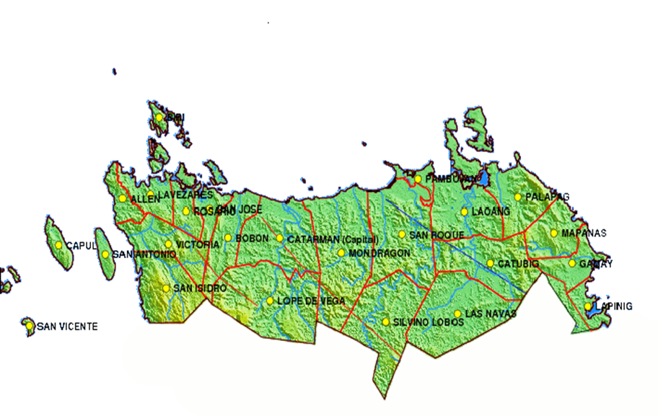

**Figure 1.** Map of the province of Northern Samar

Research Design

Qualitative approach was used to gather data and utilizing the participatory rural appraisal to document transformative impacts.

Data Collection Methods

A personal interviews with 30 respondents from partner-stakeholders in the province of Northern Samar. Field observations and participatory mapping exercises. Stakeholders’ consultation, partnership agreement signing, co-management, resource sharing commitments, pledging, volunteerism, and feedbacking was also employed.

Sampling

Selection of stakeholders/partnerships engaged in collaborative initiatives.

Key informants including community leaders, NGOs, local government, and advocacy groups.

Data Analysis

Thematic analysis for qualitative data and the basic statistical tools for quantitative data.

1. **Results and Discussions**

**Profile of the Respondents**

Majority of the respondents who respond the survey were female and may have the enthusiasm to provide sharing of experience in the partnership caravan. Intentionally, the target respondents were only 30 representing 10 representatives from each stakeholders’ category distributed from the 3 geographical locations of the province as presented in the tables below.

**Table 1.** Demographic Profile of the Respondent-Stakeholders

|  |  |  |
| --- | --- | --- |
| 1. **Sex** | **#** | **%** |
| **Male** | 12 | 40 |
| **Female** | 18 | 60 |
| **TOTAL** | **30** | **100** |

**Table 2.** Institutional Distribution of Respondent-Stakeholders

|  |  |  |
| --- | --- | --- |
| 1. **Agency/Affiliation** | **#** | **%** |
| **NGAs** | 10 | 33.33 |
| **LGUs** | 10 | 33.33 |
| **CSOs/Private Sector** | 10 | 33.33 |
| **TOTAL** | **30** | **100%** |

**Table 3.** Geographical Distribution of Respondent-Stakeholders

|  |  |  |
| --- | --- | --- |
| 1. **Area** | **#** | **%** |
| **Balicuatro** |  |  |
| **Allen**  **Capul**  **Lavezares** | 3  3  3 | 33.33  33.33  33.33 |
| **Central** |  |  |
| **Catarman**  **San Jose**  **Mondragon**  **Lope de Vega** | 3  3  3  3 | 25  25  25  25 |
| **Pacific** |  |  |
| **Lao-ang**  **Catubig**  **Lapinig** | 3  3  3 | 33.33  33.33  33.33 |
| **TOTAL** | **30** | **100%** |

**Partnership Caravan Stakeholders**

Since 2022, the stakeholders who are actively engaged in the prosperity-partnership caravan in the province are categorized into 10, these are the Local Government Units, the community-based leaders, the National Government Agencies, the Private Sectors, Civil Society Organizations, Schools, the Academe (UEP), and the individual citizens and the families who served as the partner-beneficiaries (Table 4). Their nature of participations and services offering varies according to their institutional mandates and functions as manifested in the programs and services provided to these communities.

**Table 4.** Distribution of Prosperity-Partnership Carvan Stakeholders in the province

|  |  |  |  |  |
| --- | --- | --- | --- | --- |
| **No** | **Nature/Category of Stakeholders** | **Number of Stakeholders** | **Nature of Participation** | **Program and Services Offerings** |
| 1 | Municipal LGUs | 24 | Service Providers | Products and Services |
| 2 | Barangay LGUs | 569 | Beneficiaries, Complementary service providers to the local populace | Community Services  Organizational assistance  Advocates |
| 3 | Community-based Stakeholders | 18,208 | Service Providers  Volunteers | Barangay officials, local leaders, and community organizations  Advocates |
| 4 | Local Citizens/Population/Families | 639, 186 | Partner-Beneficiaries availed | Community Volunteers  Advocates |
| 5 | Families | 84,000 | Partner-Beneficiaries served | Community Volunteers |
| 6 | NGAs | 16 | Service Providers | Products and Services |
| 7 | Private Sectors | 13 | Service Providers | technical assistance, microfinance institutions, business development services, and market linkages. |
| 8 | NGOs/CSOs | 17 | Service Providers | community development, livelihood training, health, and education. |
| 9 | Academe | 1 | Service Provider | Instruction, research, extension, advisory, consultancy services  Advocacy Proponent |
| 10 | TechVoc Schools | 220 | Service Provider | Community volunteers  Education/IEC  Services |

**Community Transformations**

Prosperity-partnership caravan is an ongoing initiative of the province that generally involves bringing government services and development programs/projects/activities directly delivered to underserved communities and marginalized sectors. This aims to foster community transformation by addressing pressing needs, promoting inclusive growth, and empowering communities to actively participate in their development.

The following are the key strategies employed by the stakeholders and development partners in ensuring community transformation towards global citizenship education and advocacy categorized with these themes:

1. Provide access to education and information

The prosperity caravan provides educational services and awareness campaigns, which can empower communities with knowledge on critical issues such as sustainability, climate change, human rights, peace and order, environmental managements, livelihood development and sustainability, and social protection program and services.

1. Empowerment and Skills Development

These caravans often include workshop and training sessions on livelihood skills, financial literacy, digital literacy, and organizational development. This empowers community members to improve their economic prospects and become more self-reliant, aligning with global citizenship’s goals of fostering responsible, active participation in local and global communities.

1. Promotion of Inclusive and Sustainable Development

Prosperity Caravans promote inclusive growth by bringing government services directly to the people, helping reduce inequality. This aligns with global citizenship education’s emphasis on social justice, equity, and respect for diversity to advocate for inclusive policies. All government and private agencies were able to bring their program and services to the communities.

1. Health and Well-being Advocacy

Concerned government and line agencies are providing healthcare services, vaccination drives, and health education as part of the caravan helps improves overall community health, promoting well-being as key component of global citizenship. Agencies with healthcare program and services such as Department of Health (DOH) has brought their services to the community. The University as well initiates the distribution of Nutri buns to the community every caravan. Holding students feeding program is also being implemented. Other private business establishments such Jollibee, McDonalds and other food products and service-related establishments were also provided food packs to the community. This aspect helps to foster a culture of care and shared responsibility for collective health.

1. Community Engagement and Advocacy

Through dialogues and consultations, prosperity caravans facilitated community engagement in local governance and advocacy, encouraging active citizenship. The university being a member of the Provincial development Council is always pro-active in promoting community engagement through its extension services provision to its clientele as one of its core functions. This participatory approach helps communities voice out their concerns and collaborate on solutions, a core aspect of global citizenship.

1. Building Resilience and Awareness

Caravan often addresses climate resilience and disaster preparedness, crucial for communities vulnerable to environmental challenges. This focus helps communities understand their roles in mitigating climate change and builds a sense of shared responsibility for the planet. The university research functions always provide research and extension services in conducting community risks assessments in the critical farming and fishing communities in the province. Results of these are presented to the local government and the community to understand their situations and help them prepare disaster risks reduction and management plans. Disaster Risk Reduction and Management is being mainstreamed or integrated in the curriculum of all academic program offerings of the university.

1. Strengthening Cultural Identity and Global Understanding

By celebrating local culture and heritage while introducing global concepts, these initiatives help communities appreciate their identity within global context. This promotes respects for cultural diversity, a key tenet of global citizenship.

The province has already on its 2nd year of the celebration of Ibabao Festival to promote tourism by showcasing its traditions, diverse culture, and local products. Different LGUs also having their annual celebrations of their own festivals and anniversaries.

1. Linking Local Actions to Global Goals

Prosperity Caravans align community actions with global goals, such as Sustainable Development Goals (SDGs). By connecting local efforts to broader global objectives, communities become active contributors to global challenges, reinforcing their role as global citizens.

The Green Initiatives of the university employs various activities such as the implementation of students and employee’s legacy by growing trees in the campus premises as a greening program. The promotion of walking and biking as a form of transportation among students and employees are also being implemented to reduce ecological and carbon footprints locally.

**Partnership exploration strategies**

Partnership plays a critical role in driving community transformations by leveraging the strengths and resources of multiple stakeholders to address social, economic, and environmental challenges. The study shows how the stakeholders explore partnership caravan to catalyze transformative changes within the community- beneficiaries by having the following themes presented in table 5. Majority was saying that with the resource complementation among the stakeholders, the partnership caravan became effective.

**Table 5.** Partnership exploration strategies

|  |  |  |
| --- | --- | --- |
| **Themes** | **#** | **%** |
| Pooling of resources and expertise | 7 | 23.33 |
| Technical Expertise | 6 | 20 |
| Capacity Building | 5 | 16.67 |
| Inclusive participation in the planning | 5 | 16.67 |
| Civic engagement and governance | 4 | 1.33 |
| Advocacy and networking | 3 | 10 |
| **TOTAL** | **30** | **100%** |

**Factors contributed to the successful collaboration for global citizenship and advocacy**

Global Citizenship Education (GCE) aims to empower learners to engage and assume active roles both locally and globally to face and resolve global challenges. It emphasizes values such as human rights, cultural diversity, sustainable development, and social justice. According to UNESCO (2015), GCE fosters critical thinking, empathy, and responsible decision-making, equipping individuals to become agents of change.

Partnership Building serves as one of the key factors that influence success. By identifying development partners and stakeholders, and establishing their roles, the set of programs and the outlined plan of activities are efficiently and effectively implemented.

The Philippine Learning and Livelihood Caravan (PLLC) was designed to address education and livelihood gaps in rural areas of the Philippines by providing mobile training, seminars, and workshops on entrepreneurship, environmental stewardship, and civic responsibility (Manalili, 2020).

Community Engagement is likewise significant to ensure the success of the caravans. Mobilizing local participation and co-creation of solutions to the problems and issues encountered were the good practices observed. The Advocacy and Global Citizenship program is being promoted by creating awareness, education, and advocacy at the local level. GCE can be effectively integrated into community-based service delivery models like prosperity caravans. These caravans provide a unique platform to reach marginalized populations who may lack access to traditional education systems (Reimers, 2017).

Studies have shown that community engagement initiatives can enhance awareness of global issues, including climate change, gender equality, and human rights (Andreotti, 2014). By bringing GCE to rural communities, caravans help bridge the educational divide and foster inclusivity in global dialogues.

Although the Monitoring and Evaluation Plan and activities are in place, there are still weakness on its implementation on the ground. Proper documentation among the local stakeholders should be strengthened. Measuring transformative impacts and sustainability must also be considered for succeeding consultative meetings.

**Problems and challenges encountered**

Despite the effective implementation of the partnership caravan, problems and challenges along its implementation were documented. The study shows there is a need to implement the strong monitoring and evaluation component of the initiative. Likewise, the strengthening of the logistical and coordination system among the stakeholders. There is also a need to improve the information dissemination of the partnership caravan activities at the community level.

**Table 6.** Problems and Challenges encountered

|  |  |  |
| --- | --- | --- |
| **Problems and Challenges** | **#** | **%** |
| Lack of Monitoring and Evaluation | 9 | 30 |
| Logistical and coordination issues | 8 | 26.6 |
| Communication barriers | 6 | 20 |
| Limited resources and funding | 4 | 13.33 |
| Political and bureaucratic barriers | 3 | 10 |
| **TOTAL** | **30** | **100** |

**Model-framework for implementing prosperity-partnership caravan**

The prosperity partnership caravan model being implemented in the province of Northern Samar brings positive responses form the community and the stakeholders. All government programs and services and other socio-economic initiatives are directly benefitting the marginalized and rural sectors of the community. It serves as vehicle for poverty alleviation and promoting inclusive development.

While the partnership caravan model generally perceived as a positive initiative for improving access to services, health, livelihood support, education, and fostering community engagement, its long-term effectiveness depends on the sustainability of the programs introduced and equitable service delivery across all Barangays in the province. Regular follow-up, capacity building initiatives, and depoliticization of the model are key to its continued success to become a resilient, progressive, cheerful province of Northern Samar.

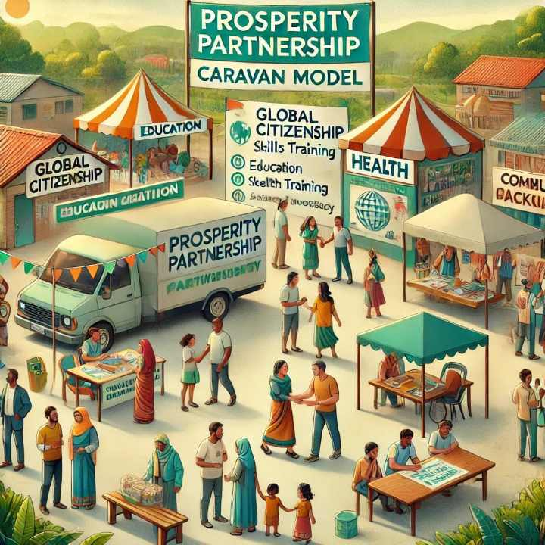

**Figure 2.** The Prosperity-Partnership Caravan Model Developed

1. **Conclusion and Recommendations**

The Prosperity-Partnership Caravan Model initiatives of the province of Northern Samar is a transformative approach that brings essential government services, education, and advocacy directly to the underserved and marginalized communities. By providing access to resources like healthcare, skills training, and educational programs, these caravans empower communities to actively participate in their own development and foster a sense of global citizenship. The model supports the principles of inclusivity, sustainability, and active engagement, aligning local community actions with global goals such as the Sustainable Development Goals (SDGs). Prosperity Caravans serve not just as a means of delivering services but as catalysts for community empowerment, enhancing resilience, promoting social justice, and advocating for inclusive development.

The Prosperity Partnership Caravan model provides a dynamic and inclusive approach to promoting Global Citizenship Education and advocacy in rural communities. By bringing together multiple sectors and directly engaging communities, these caravans bridge the gap between global and local knowledge, empower marginalized populations, and foster a sense of shared responsibility toward global challenges.

However, the success of these caravans relies heavily on effective partnerships, adequate resources, and sustained community engagement. They offer a powerful platform for integrating global citizenship education into local contexts, helping individuals understand their roles and responsibilities within the global community. The Prosperity-Partnership Caravan model exemplifies a holistic approach to community development, linking local initiatives ideals and contributing to a more equitable and connected world.

The following recommendations aims to enhance the impact of the Prosperity-Partnership Caravan model, positioning it as a key driver in promoting global citizenship education and advocacy. By empowering communities, building resilience, and fostering a culture of inclusivity, the caravans can significantly contribute to the development of active, informed, and globally-minded citizens.

1. Strengthen Multi-sectoral Partnerships by enhancing collaboration between government agencies, civil society organizations, private sectors, and local government units, and local communities to maximize resources and expertise. This can help expand the reach and impact of the caravans.
2. Incorporate Global Citizenship Education into Program Design by integrating the GCE principles into the curriculum of workshops and training sessions provided by the caravans. Emphasize topics such as human rights, environmental sustainability, social justice, and cultural diversity to foster global awareness.
3. Sustaining Funding and Resource Allocation by ensuring sustainable funding models by engaging local businesses and international donors. This can support the continuous operation of the caravans and prevent disruptions in service delivery.
4. Community-led Advocacy Initiatives by empowering communities to initiate their advocacy campaigns by providing training on leadership, public speaking, and policy engagement. Encourage community members to voice their needs and work collaboratively with local authorities.
5. Monitor and Evaluate Impacts by implementing robust M&E framework.
6. Conduct a comprehensive Impact Assessment to the community.

**Disclaimer (Artificial intelligence)**

Option 1:

Author(s) hereby declare that NO generative AI technologies such as Large Language Models (ChatGPT, COPILOT, etc.) and text-to-image generators have been used during the writing or editing of this manuscript.

Option 2:

Author(s) hereby declare that generative AI technologies such as Large Language Models, etc. have been used during the writing or editing of manuscripts. This explanation will include the name, version, model, and source of the generative AI technology and as well as all input prompts provided to the generative AI technology

Details of the AI usage are given below:

1.

2.

3.

1. **References**
2. **Amador, F., & Castillo, L. (2022).** Community Development through Government-Led Prosperity Caravans: A Case Study in the Philippines. Journal of Community and Social Development, 15 (2), 45-61.
3. **Banks, J. A., & Banks, C. A.M. (2019).** Global Citizenship Education: Critical Perspectives. Routledge.
4. **Delos Santos, R. P. (2021).** Reaching the Margins: The Role of Prosperity Caravans in Enhancing Community Resilience. Asian Journal of Public Administration, 38 (1), 23-37.
5. **Marshall, H., & Namazzi, S. (2020).** Education for Global Citizenship: Concepts, Practices, and Challenges. Cambridge University Press.
6. **Perez, M. & Buan, A. (2023).** Advocacy on Wheels: The Transformative Power of Prosperity Caravans in Promoting Global Citizenship. Philippine Journal of Governance, 12 (4), 78-95.
7. **Smith, R. & Torres, M. (2018).** Beyond Boarders: How Local Initiatives Shape Global Citizenship Education. International Review of Education, 64 (5), 607-623.
8. **United nations Educational Scientific and Cultural Organizations (UNESCO). (2015).** Global Citizenship Education: Topics and Learning Objectives. UNESCO Publishing.
9. Jenss A. Fantasies of Flows and Containment: The Technopolitics of Security Infrastructures in the Americas. Antipode. 2024 Mar;56(2):492-515.
10. Monaghan J, Walbsy K. Making up ‘Terror Identities’: security intelligence, Canada's Integrated Threat Assessment Centre and social movement suppression. Policing and Society. 2012 Jun 1;22(2):133-51.
11. Miller F, editor. Ecovillages around the world: 20 regenerative designs for sustainable communities. Simon and Schuster; 2018 Jul 10.
12. McGrath D, Spear MB. The academic crisis of the community college. State University of New York Press; 1991 Jul 3.
13. Paradeise C, Thoenig JC. Academic institutions in search of quality: Local orders and global standards. Organization studies. 2013 Feb;34(2):189-218.
14. Münch R. Academic capitalism: Universities in the global struggle for excellence. Routledge; 2014 Apr 16.
15. Altbach PG, Reisberg L, Rumbley LE. Trends in global higher education: Tracking an academic revolution. Brill; 2019 Apr 9.