Original Research Article

Adsorptive Removal of Oils from oil spillage: Kinetic and isotherm studies using raw and chemically modified Pentaclethra macrophylla seed pods

ABSTRACT

Oil spill remediation using agricultural wastes has become an attractive technique due to its simplicity, low cost and effectiveness. In this work, Pentaclethra macrophylla seed pods, which are readily available agricultural wastes were modified in order to increase their hydrophobicity. The effect of the modification was studied using FTIR analysis. Batch oil sorption tests were conducted using both the raw and modified pods. Results from the FTIR analysis of the raw pods showed peaks corresponding to O-H, C-H, C=O, C=C, and C-O stretching vibrations. The spectra of the modified PMSP showed increased intensity of the peaks owing to the acetylation effect. The spectra of the oil-treated pods show the appearance of intense and sharp peaks corresponding to CH₃, CH₂ and C-H bending of crude oil. Isotherm studies revealed conformation to the Freundlich model (R² > 0.85), suggesting multilayer adsorption on heterogeneous surfaces, and Langmuir model (R² > 0.99) for modified pods, confirming monolayer coverage on uniform active sites. Pseudo-first order kinetic model best described the oil sorption on the raw seed pods, suggesting physisorption mechanism, with equilibrium oil sorption capacity of 6281 mg/g. For the modified pods, pseudo-second order model best suited the sorption, suggesting chemisorption mechanism, with equilibrium oil sorption capacity of 14286 mg/g. The higher oil sorption capacity of the modified pods indicates their higher potential for application as an environmentally friendly alternative for oil spill remediation and treatment of industrial effluents before disposal.

Keywords: Oil removal, Pentaclethra macrophylla, kinetics, isotherm

1. INTRODUCTION

Oil spills can occur at any point during the extraction, shipping, refining, storage, and usage processes, causing environmental degradation. According to estimates, up to 100 million gallons of crude oil leak into marine habitats annually (Barros et al., 2014). In Nigeria, an estimate of 103,000 - 311,000 barrels of oil has been reported to have spilled into the Bodo Creek in the Niger Delta area (Nkeeh et al., 2025). This spill of oil has a negative impact on human life, aquatic life, local economy, tourism, and leisure activities (Machalowski et al., 2020). As a result, enormous efforts are being made to create an effective way of cleaning up oil spills. In aquatic environments, a variety of mechanical, biological, chemical, and adsorption techniques are employed to remove oil spills. Adsorption technology has been the method of choice due to its efficiency, affordability, and ease of use (Lv et al., 2018). Owing to their availability, renewability, and biodegradability, agricultural waste materials are becoming increasingly common as sorbents. Both the wastes themselves and how they are disposed of typically pose environmental risks. As a result, turning them into useful items will contribute to the development of pollution-reduction solutions. The main drawback of using agricultural materials in oil spill mop is that they are hydrophilic due to their high hydroxyl content (Omer et al., 2020). However, this can be remedied by modification techniques that give the materials hydrophobic qualities (Yusof et al., 2015). One of the most popular methods of modification is acetylation, which converts lignocellulosic materials from hydrophilic to hydrophobic by substituting hydrophobic acetyl group for hydrophilic hydroxyl group. In the acetylation reaction, the lignocellulosic material is heated together with acetic anhydride in the presence or absence of a catalyst (Nwadiogbu et al., 2014).
A variety of agricultural materials have undergone acetylation to increase their ability to absorb oil. These materials include corn silk (Asadpour et al., 2015), jute fibre (Teli and Valia, 2016), cocoa pods and oil palm fruit empty bunch (Onwuka et al., 2018), and Borassus aethopum coir (Arinze-Nwosu et al., 2019). Pentaclethra macrophylla (commonly called African oil bean) is a leguminous tree belonging to the Leguminosae family and Mimosoideae subfamily (Yusuf-Babatunde et al., 2020). Typically found in the wet lowlands of West and Central Africa, it is the sole member of the genus (Nwokocha et al., 2023). The tree usually grows on soils that have sufficient drainage and receive between 1500 and 2700 mm of rainfall annually (Iloabachie et al., 2022). This species exists in both wild and cultivated forms, with a maximum height of approximately 21 meters and a maximum circumference of roughly 6 meters.
Pentaclethra macrophylla is primarily grown for its edible seed, which can be processed to produce oil. The fruit is a green pod that grows darker with age, measuring up to 36–46 cm in length and 5–10 cm in breadth. At maturity, each pod has eight to ten seeds, which are released as the pod cracks open violently and the valves curl up. Usually used as a snack or culinary garnish, these seeds are roasted or fermented. The roots, stem bark, leaves, fruits and seeds of the tree have been reported to be major ingredients for herbal medicines in many countries (Onyenibe et al., 2022; Nnamani et al., 2020). The empty dry seed pods decompose slowly and usually pollute the surrounding area, though they are used in certain areas as cooking fuel. There have been reports on the application of the seed pods for the adsorption of heavy metals (Uchechukwu et al., 2015; Nsude et al., 2024) and the generation of activated carbon (Okey-Onyesolu et al., 2016; Chimi et al., 2023; Ogbeh et al., 2024). This work focuses on the application and modification of the seed pod for crude oil sorption.

2. methodology

2.1 Preparation and Characterization of Adsorbents
Pentaclethra macrophylla seed pods were obtained from the environment of Awka town in Anambra State, Nigeria. They were washed with tap water to remove dust and extraneous materials. Then they were washed with distilled water and sundried for 12 hours, after which they were oven dried to constant weight at 65⁰C. The dried samples were ground and then sieved with BS410/1986 laboratory sieves using a mechanical shaker to obtain particles of size 425 – 600 microns.
A portion of the ground samples were modified using acetic anhydride under moderate conditions according to the solvent-free acetylation process described by (Asadpour et al., 2015). The substrate was contacted with the modifier in a ratio of 1:20 (g dry PMSP/mL acetic anhydride) at 30ºC for 1 hour in the presence of 1% iodine as a catalyst. The modified sample was then dried to constant weight and cooled.
Using an attenuated total reflection (ATR) mode on a Nicolet iS5 spectrometer, Fourier-Transform Infrared (FTIR) spectra were obtained over the spectral range of 4000-400cm⁻¹.
2.2 Batch Adsorption Tests
In order to mimic an actual oil spill, the crude oil for the sorption experiments were exposed to air for 24 hours. A weighed portion (0.2 g) of the raw and modified PMSP were contacted with 100 g/L of the crude oil at room temperature following the method of (Onwuka et al., 2016). The sorbents were taken out using sifting nets after the allotted amount of time, dried for 30 minutes at 60 ºC, and then weighed again. Using equations 1 and 2, the oil sorption capacity and the amount of crude oil adsorbed per unit weight of adsorbent (q) were calculated.
Oil sorption capacity = $\frac{\text{W}\text{1 }\text{-} \text{W}\text{0}}{\text{W}\text{0}}$ (1)
q_{t} = $\frac{\text{(C}\text{o }\text{- C}\text{t}\text{)V}}{\text{m}}$ (2)

where: W₀ (g) – weight of adsorbent before oil sorption, W₁ (g) – weight of the oil-loaded sorbent, C_{o} (mg/L – initial crude oil concentration, C_{t} (mg/L) – crude oil concentration at time t, V (L) – volume of the solution, and m (g) – mass of the sorbent.

3. results and discussion

3.1 Infra-red spectroscopy
The Fourier-Transform Infrared (FTIR) spectra of raw PMSP (RPMSP) and modified PMSP (MPMSP), before and after crude oil sorption, are shown in Figs. 1 and 2, respectively.

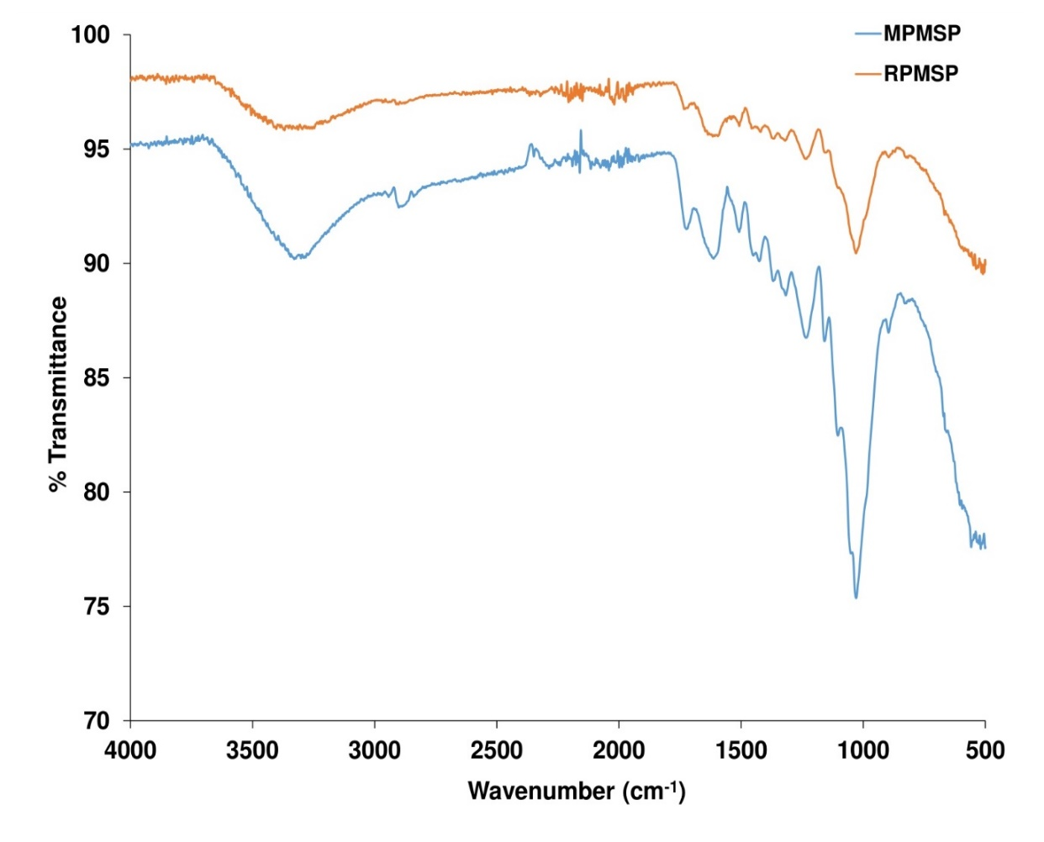
Fig. 1. FTIR spectra of raw and modified PMSP before crude oil sorption

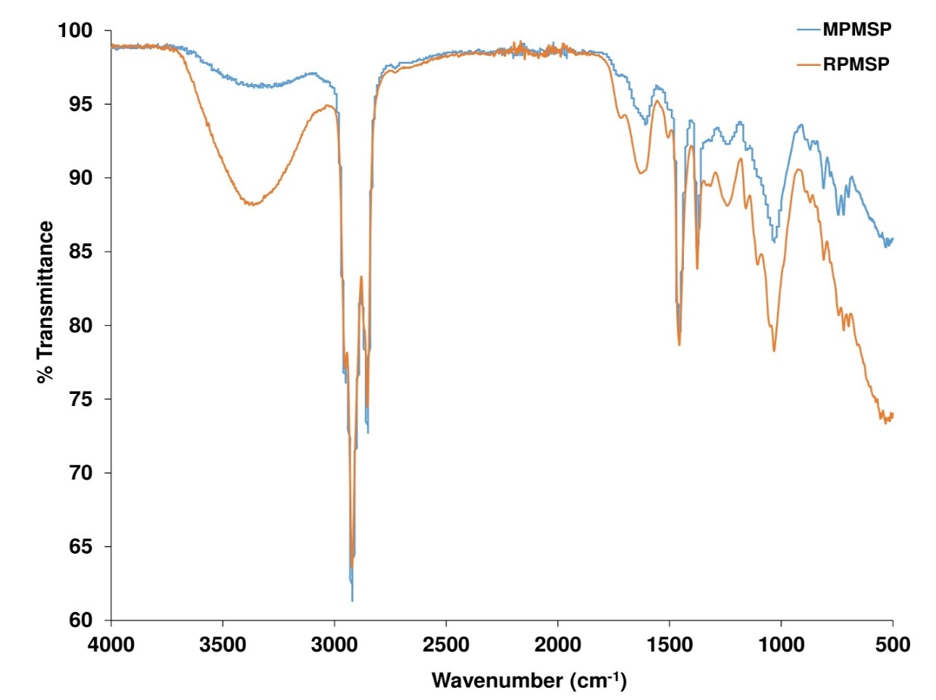
Fig. 2. FTIR spectra of raw and modified PMSP after crude oil sorption

“The absorption band at the region of 3300 – 3400 cm⁻¹ and the peak at 1610 cm⁻¹ are attributed to O-H stretching and bending vibrations, respectively” (Purwaningrum et al., 2021). “The peaks at 2910 cm⁻¹ and in the range of 1317 – 1426 cm⁻¹ correspond to the C-H stretching and bending vibrations, respectively, which constitute the basic structure of lignocellulosic materials” (El-Gheriany et al., 2020). “The peaks at 1724 cm⁻¹ and 1508 cm⁻¹ correspond to the C=O stretching vibration of acetyl group and C=C stretching of aromatic ring, respectively” (Roy et al., 2024). “The peaks in the region of 1029 – 1232 cm⁻¹ are attributed to C-O stretching vibration of acetyl group” (Abdullah et al., 2015). “The spectra of the modified PMSP showed increased intensity of the peaks owing to the acetylation effect. The FTIR spectra of the raw and modified PMSP are consistent with those of other cellulosic materials reported by other researchers” (Onwuka et al., 2018; Mahmoud, 2020).
“The spectra of the oil-treated RPMSP and MPMSP (Fig. 2) show the appearance of intense and sharp peaks at 2921cm⁻¹, 2852 cm⁻¹ and 1376.12 – 1456.40 cm⁻¹ which correspond to CH₃, CH₂ and C-H bending of crude oil. This provides evidence that crude oil actually adsorbed on the sorbents” (Kudaybergenov et al., 2013).

3.2 Effect of Initial Crude Oil Concentration and Isotherm Studies
The effect of initial crude oil concentration on the oil sorption capacity of RPMSP and MPMSP is shown in Fig. 3. The oil sorption capacity of the adsorbents increased with an increase in the initial crude oil concentration from 50 to 125 g/L. Further increase in the oil concentration resulted in lower oil sorption capacity. This finding is similar to that of Onwuka et al. (2018), who observed that “as initial crude oil concentration increased to 2.5 g/100 mL, the oil sorption capacity of unmodified cocoa pods (CP) and modified oil palm empty fruit bunch (OPEFB) increased. Sorption equilibrium was reached for both the modified CP and unmodified OPEFB at 1.25 and 3.75 g/100 mL, respectively. Subsequently, the oil sorption capacity declined as the initial crude oil concentration increased”.
“The oil sorption capacity increased with increase in initial oil concentration because the concentration gradient caused mass transfer of the oil from the bulk to the adsorbent's surface. However, there are only a finite number of active sites in each adsorbent, and these sites saturate at increasing oil concentrations, leaving a large amount of oil un-adsorbed” (Najaa-Syuhada et al., 2017). Furthermore, resistance to the mass transfer driving force for adsorption may result from the saturation of the adsorbent's surface, which could cause the adsorbed oil to desorb, resulting in lower oil sorption capacity (Basu et al., 2018). For the different initial crude oil concentrations considered, MPMSP had higher oil sorption capacity than RPMSP. This is likely due to the increased surface area and pore volume of MPMSP, as earlier observed, which provided more active area for sorption.
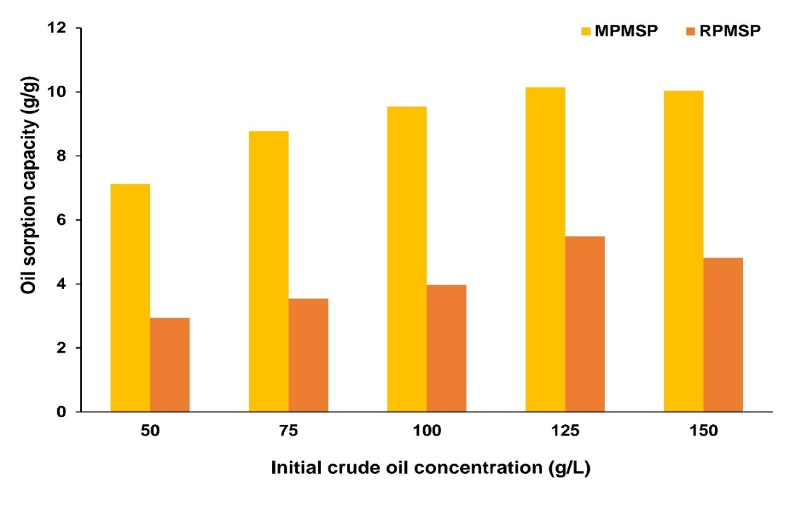
Fig. 3. Effect of initial oil concentration on the oil sorption capacity of raw and modified PMSP

The sorption equilibrium was further studied by applying various isotherm models to the experimental data. Adsorption isotherms can be used to establish the surface properties of a sorbent and its affinity for a sorbate (Amrutha et al., 2023). The isotherm models applied were the Freundlich, Langmuir, Temkin, and Dubinin-Radushkevich isotherm plots as expressed in equations (3) – (6), respectively (Santos et al., 2015; Shah et al., 2021).
$\frac{\text{C}\text{e}}{\text{q}\text{e }}\text{ = }\frac{\text{1}}{\text{K}\text{L}\text{.q}\text{m}}\text{ + }\frac{\text{C}\text{e}}{\text{q}\text{m}}$ (3)
ln q_{e} = ln K_{F} + $\frac{1}{n}$ ln C_{e} (4)
q_{e} = $B$ln K_{T} + $B$ ln C_{e} (5)
$\text{ln}{{\text{q}}_{\text{e}}}\text{= }\text{ln}{{\text{q}}_{\text{m}}}-\text{ β}{\text{ε}}^{\text{2}}$ (6)
$ε= RTln\left(1+ \frac{1}{C_{e}}\right)$ (7)
where: C_{e} – equilibrium concentration of the adsorbate, q_{m} and q_{e} – maximum monolayer and equilibrium adsorption capacity, respectively, K_{L} – Langmuir or equilibrium constant of adsorption, K_{F} – Freundlich constant, n – measure of the intensity of adsorption, K_{T} – equilibrium binding constant, B – Temkin constant, K_{D} – Dubinin-Radushkevich constant, and $\text{ε}$ – Polanyi potential.
The isotherm plots for the oil adsorption on raw and modified PMSP are shown in Fig. 4 and the isotherm parameters obtained from the plots are listed in Table 1. Fig. 4 shows that for adsorption on RPMSP, the Freundlich isotherm gave the highest R² value (0.8599), suggesting that it is the most suitable isotherm for describing crude oil sorption on RPMSP. This implies that the surface of RPMSP is heterogeneous in nature. The obtained value of n is 1.984 (Table 1). This value is greater than 1, suggesting that the oil sorption process was favorable (Samson et al., 2022). However, for adsorption on MPMSP, Fig. 4 shows that the Langmuir isotherm gave the highest R² value (0.9950), showing that it is the most suitable isotherm for describing crude oil sorption on MPMSP. Thus, the crude oil sorption on MPMSP took place by monolayer coverage. The maximum monolayer sorption capacity of MPMSP is 11.990 g/g. A dimensionless constant called the separation factor (R_{L}), which is expressed in equation 8 can be used to estimate the affinity between MPMSP and crude oil.
R_{L} = $\frac{\text{1}}{\text{1 + k}\text{L}\text{.C}\text{o}}$ (8)

where: C_{o} – initial oil concentration. The adsorption is favorable if 0<R_{L}<1, unfavorable if R_{L}>1, irreversible if R_{L}=0, and linear if R_{L}=1 (Santos et al., 2017). The R_{L} values obtained using various initial concentrations of crude oil for adsorption on MPMSP are between 0 and 1 (Table 1). This indicates the favorability of the oil sorption.
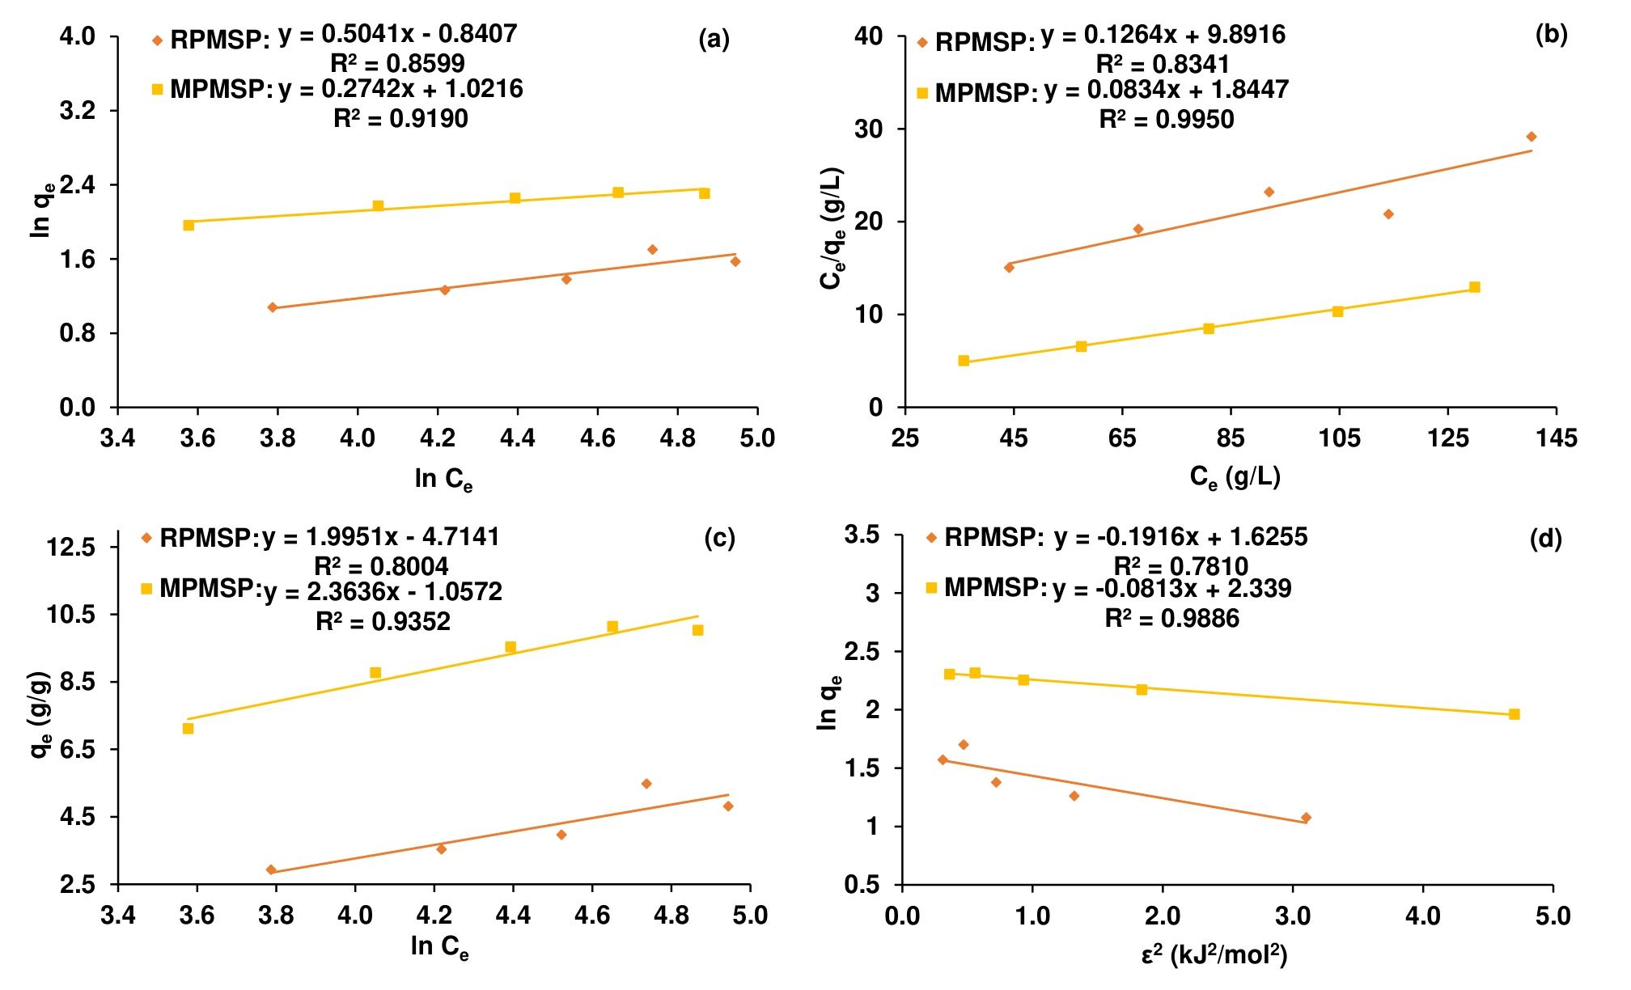
Fig. 4. a) Freundlich, b) Langmuir, c) Temkin, d) Dubinin-Radushkevich isotherms for oil sorption on raw and modified PMSP

Table 1. Isotherm parameters for oil sorption on raw and modified PMSP
Isotherm model | Parameter | MPMSP | RPMSP
Freundlich isotherm | K_{F} (g/g)(L/g)^{1/n} | 2.778 | 0.431
 | n | 3.647 | 1.984
Langmuir isotherm | q_{m} (g/g) | 11.990 | 7.911
 | b (L/g) | 4.52 x 10⁻² | 1.28 x 10⁻²
 | R_{L} | 0.307 – 0.129 | 0.610 – 0.342
Temkin isotherm | K_{T} (L/g) | 0.639 | 0.094
 | B | 1.9951 | 2.3636
Dubinin-Radushkevich isotherm | q_{m} (g/g) | 10.371 | 5.081
 | K_{D} (mol²/kJ²) | 0.081 | 0.192
3.3 Effect of Contact Time and Kinetic Studies
The effect of contact time on crude oil sorption capacity of the raw and modified PMSP is shown in Fig. 5.
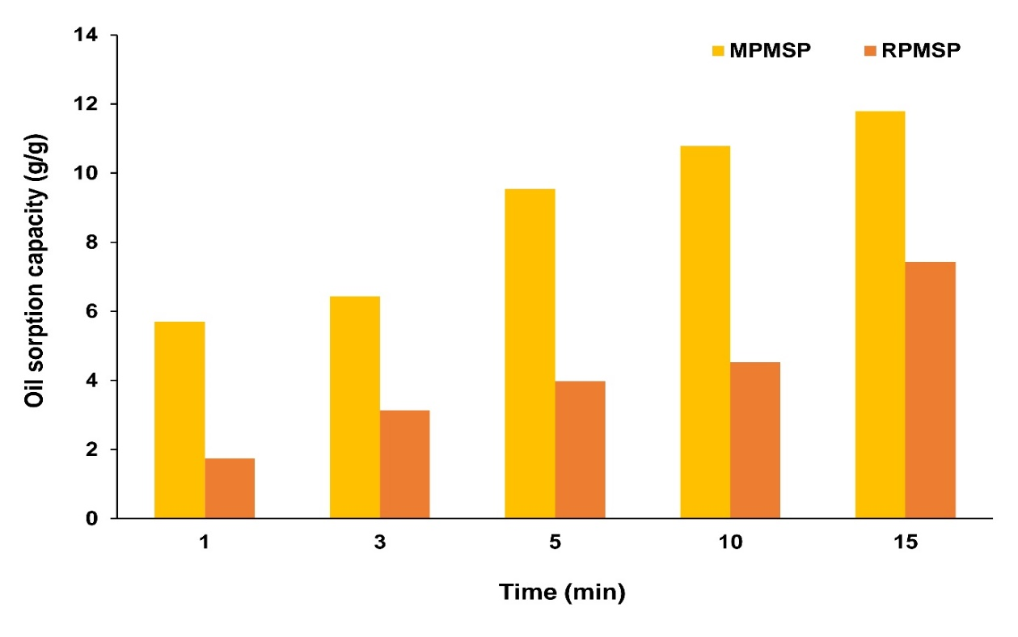
Fig. 5. Effect of contact time on the oil sorption capacity of raw and modified PMSP
“The oil sorption capacity of MPMSP and RPMSP increased with an increase in contact time. The sorption process was fast at first and then slowed down. This could be because of the high concentration gradient at the beginning which drove the diffusion of the oil from the bulk to the sorbent’s surface and pores. However, with time, the adsorbed oil began to clog the sorbent’s pores, making it challenging for oil to diffuse into the interiors of the sorbent” (Basu et al., 2018). “MPMSP exhibited a higher oil sorption capacity than RPMSP for the entire sorption duration. The sorption capacities of RPMSP and MPMSP were 7.43 and 11.80 g/g, respectively, after 15 minutes of contact. The higher oil sorption capacity of MPMSP is likely due to the increment of its surface area and hydrophobicity by the acetylation process. A similar trend was reported for crude oil adsorption on raw and acetylated Borassus aethopum coir” (Arinze-Nwosu et al., 2019) and Siamese senna seed pods (Obi et al., 2024).
“To understand the kinetics of the oil sorption on RPMSP and MPMSP, various kinetic models were applied to the sorption data. These models are the pseudo first order, pseudo second order, intra-particle diffusion, and film diffusion kinetic models as expressed in equations (9) – (12), respectively” (Nnaji et al., 2016; Oladimeji et al., 2019):
ln (q_{e} – q_{t}) = ln q_{e} – k₁t (9)
$\frac{\text{t}}{\text{ q}\text{t} }\text{ = }\frac{\text{1}}{\text{k}\text{2}\text{.q}\text{e}\text{2} }\text{ + }\frac{\text{t}}{\text{q}\text{e }}$ (10)
q_{t} = K_{id} t^{0.5} + C (11)
ln (1 – F) = $-K_{fd}$t (12)
where: q_{t} and q_{e} – amounts of oil adsorbed in mg/g at time t (min) and at equilibrium, respectively, k₁, k₂, K_{id}, and K_{fd} – pseudo first order, pseudo-second order, intraparticle diffusion, and film diffusion rate constants, respectively, C – an integration constant which gives information about sorption mechanism, and F $\left(=\frac{{\text{q}}_{\text{t}}}{{\text{q}}_{\text{e}}}\right)$– fractional equilibrium attainment.
The kinetic plots for crude oil adsorption on raw and modified PMSP are shown in Figure 6 and the kinetic parameters obtained from the plots are listed in Table 2.
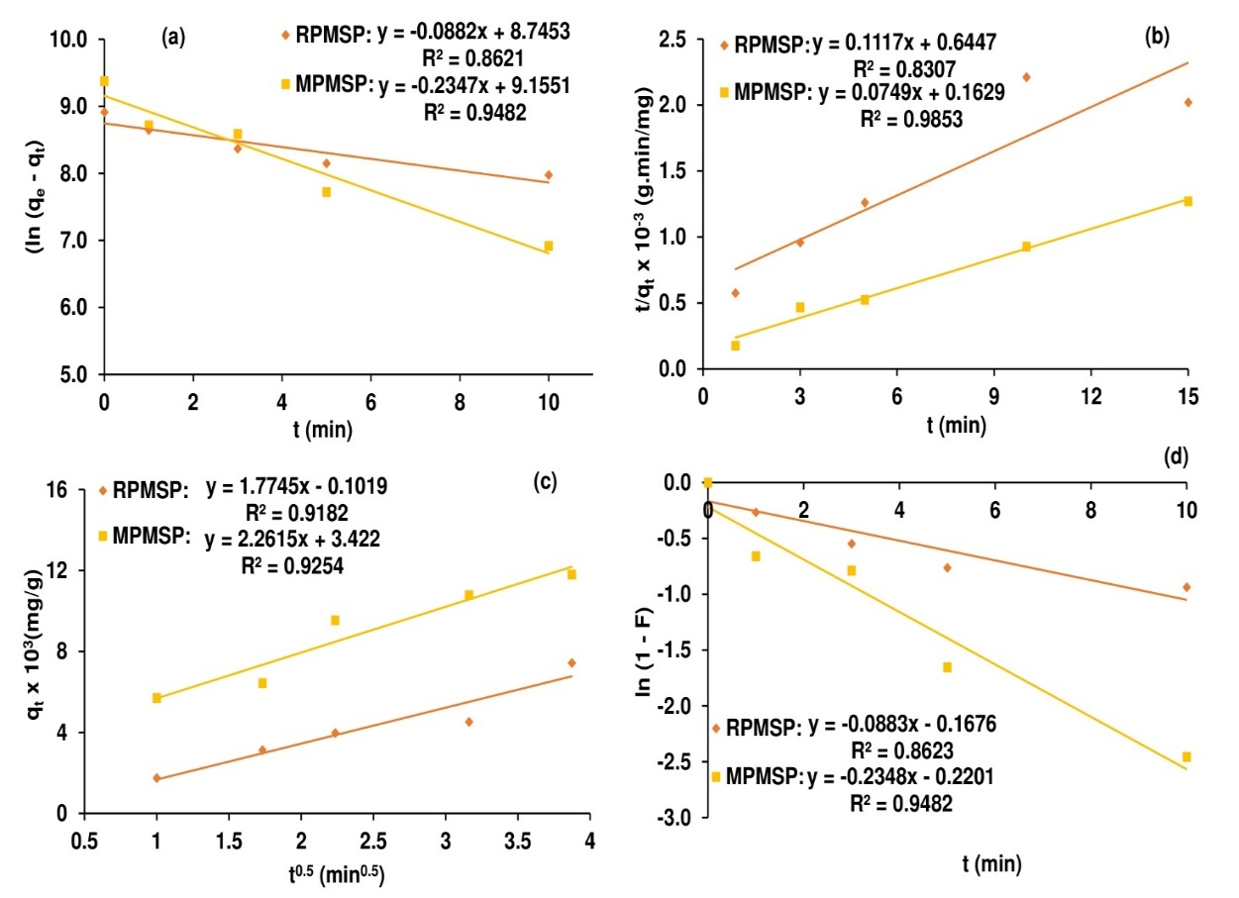

Fig. 6. a) Pseudo-first order, b) Pseudo-second order, c) Intra-particle diffusion, d) Film diffusion kinetic plots for oil sorption on raw and modified PMSP

Table 2. Kinetic parameters for oil sorption on raw and modified PMSP
Kinetic model | Parameter | MPMSP | RPMSP
 | q_{e}, exp (mg/g) | 11795 | 7430
Pseudo-first order model | q_{e} (mg/g) | 9463 | 6281
 | k₁ (min⁻¹) | 0.2347 | 0.0882
Pseudo-second order model | q_{e} (mg/g) | 14286 | 10000
 | k₂ (g/mg.min) | 2.45 x 10⁻⁵ | 1.67 x 10⁻⁵
Intra-particle diffusion model | k_{id} (mg/(g.min^{1/2})) | 2261.50 | 1774.50
 | C | 3422.00 | -101.93
Film diffusion model | K_{fd} (min⁻¹) | 0.2348 | 0.0883

Fig. 6 shows that for adsorption on RPMSP, the pseudo-first order model yielded higher R² value than the pseudo-second order model. This shows that the oil sorption on RPMSP obeyed the pseudo-first order model. The conformity to the pseudo-first order model suggests that the oil sorption process on RPMSP involved physisorption (Onwuka et al., 2016). The equilibrium sorption capacity and rate constant were 6281 mg/g and 0.0882 min⁻¹, respectively (Table 2). For adsorption on MPMSP, the pseudo-second order model gave higher R² value than the pseudo-first order model (Fig. 6). This shows that the oil sorption on MPMSP obeyed the pseudo-second order model. The conformity to the pseudo-second order model suggests that the oil sorption process on MPMSP was by chemisorption. The equilibrium sorption capacity and rate constant were 14286 mg/g and 2.45 x 10⁻⁵ g/mg.min, respectively (Table 2).
The intra-particle diffusion and film diffusion model plots (Fig. 6 c and d) were linear but did not pass through the origin. This shows that intra-particle diffusion took part in controlling the rate of oil sorption on both MPMSP and RPMSP, but it was not the sole mechanism (Shin and Kim, 2016). Low value of integration constant (-101.93) was obtained for the sorption on RPMSP whereas a high value (3422.00) was obtained for the sorption on MPMSP. The low and high values of integration constant point to the possibility of physisorption and chemisorption being involved in the sorption on RPMSP and MPMSP, respectively (Nnaji et al., 2016). This is in agreement with the observation that the sorption on RPMSP obeyed the pseudo-first order model whereas the sorption on MPMSP obeyed the pseudo-second order model. The K_{id} value for sorption onto MPMSP (2261.50 mg/g.min^{1/2}) was higher than that for RPMSP (1774.50 mg/g.min^{1/2}). Likewise, the K_{fd} value for sorption onto MPMSP (0.2348 min⁻¹) was higher than that for RPMSP (0.0883 min⁻¹). This shows that acetylation improved the adsorptive potential of PMSP since higher K values indicate an increase in the adsorption rate and a better adsorption mechanism.
3.3 Effect of Adsorbent Dose on Sorption Capacity
The effect of adsorbent dose on crude oil sorption capacity of the raw and modified PMSP is shown in Fig. 7.
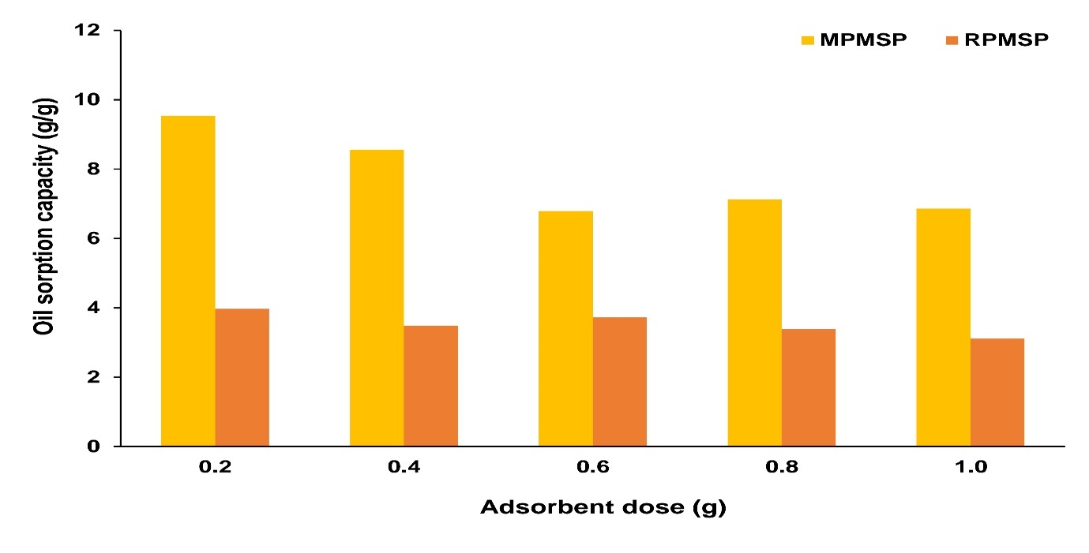
Fig. 7. Effect of adsorbent dose on the oil sorption capacity of raw and modified PMSP
“Increasing the adsorbent dose from 0.2 to 1.0 g resulted in reduction of the oil sorption capacity of RPMSP and MPMSP from 3.97 to 3.11 g/g and 9.54 to 6.86 g/g, respectively. This drop in oil sorption capacity could be the result of sorption sites aggregating and overlapping as sorbent dose increases, which lowers the total exposed surface area. As a consequence, there is a decrease in the amount of sorbate absorbed per unit mass of sorbent, which lowers the sorption capacity” (Nnaji et al., 2016; Basu et al., 2018). A comparable pattern was reported by Shittu et al. (2020), who discovered that “increasing the sorbent dosage from 1 g to 5 g caused the crude oil sorption capacity of alkaline treated sponge gourd to decline from 3528.6 mg/g to 834.3 mg/g”. Similarly, Obi et al. (2023) reported “a decrease in the crude oil sorption capacity of unmodified and modified Napier grass from 5.414 to 4.276 g/g and 6.825 to 5.268 g/g, respectively, on increasing the sorbent dose from 0.2 to 1.0 g”.

4. Conclusion

Pentaclethra macrophylla seed pod, a readily available agricultural waste, was discovered in this study to be an effective sorbent for removing crude oil from an aqueous solution. The sorption capacity of the pod increased significantly after modification by acetylation. Oil sorption on both the raw and modified pods were affected by changes in the initial oil concentration, contact time, and sorbent dosage. Adsorption on the raw pod was best described by the Freundlich isotherm, whereas for the modified pod, the Langmuir isotherm gave the best fit. Kinetic analysis revealed that the pseudo first order kinetic model best represented adsorption on the raw pod, while the pseudo second order model best suited adsorption on the modified pod. The sorption on both the raw and modified pods was partly controlled by intra-particle diffusion mechanism. Due to its high oil sorption capacity, availability, and biodegradability, modified PMSP can serve as a substitute sorbent for oil spill clean-up.

Competing interests

Authors have declared that no competing interests exist.

DISCLAIMER (ARTIFICIAL INTELLIGENCE)
Author(s) hereby declare that NO generative AI technologies such as Large Language Models (ChatGPT, COPILOT, etc.) and text-to-image generators have been used during the writing or editing of this manuscript.

References

Abdullah, M. A., Afzaal, M., Ismail, Z., Ahmad, A., Nazir, M. S. & Bhat, A. H. (2015). Comparative study on structural modification of Ceiba pentandra for oil sorption and palm oil mill effluent treatment. Desalination and Water Treatment, 54(11), 3044–3053. https://doi.org/10.1080/19443994.2014.906326
Amrutha, A., Jeppu, G., Girish, C. R., Prabhu, B., & Mayer K. (2023). Mayer, Multi-component adsorption isotherms: review and modeling studies. Environmental Processes, 10(38), 1–52. https://doi.org/10.1007/s40710-023-00631-0.
Arinze-Nwosu, U. L., Ajiwe, V. I. E., Okoye, P. A. C., & Nwadiogbu, J. O. (2019). Kinetics and equilibrium of crude oil sorption from aqueous solution using Borassus aeothopum coir. Chemistry and Materials Research Journal, 11(2), 12–19. https://doi.org/10.7176/CMR.
Asadpour, R., Sapari, N. B., Isa, M. H., Kakooei, S., & Orji, K. U. (2015). Acetylation of corn silk and its application for oil sorption. Fibers and Polymers, 16(9), 1830–1835. https://doi.org/10.1007/s12221-015-4745-8.
Barros, F. C. D. F., Vasconcellos, L. C. G., Carvalho, T. V., & Nascimento, R. F. D. (2014). Removal of petroleum spill in water by chitin and chitosan. Orbital: The Electronic Journal of Chemistry, 6(70), 70–74. https://doi.org/10.17807/orbital.v6i1.509.
Basu, S., Ghosh, G., & Saha, S. (2018). Adsorption characteristics of phosphoric acid induced activation of bio-carbon: equilibrium, kinetics, thermodynamics and batch absorber design. Process Safety and Environmental Protection, 117, 125–142. https://doi.org/10.1016/j.psep.2018.04.015.
Chimi, T., Lincold, N. M., Shikuku, V., Meva, F. E., Hanna, B. U., Jacques, M. B., et al. (2023). Preparation, characterization and application of H₃PO₄-activated carbon from Pentaclethra macrophylla pods for the removal of Cr(VI) in aqueous medium. Journal of the Iranian Chemical Society, 20, 399–413. https://doi.org/10.1007/s13738-022-02675-9.
El-Gheriany, I. A., Ahmad, E. F., Razek, A. A. & Hussein, M. (2020). Oil spill sorption capacity of raw and thermally modified orange peel waste. Alexandria Engineering Journal, 59, 925–932. https://doi.org/10.1016/j.aej.2020.03.024
Iloabachie, I. C. C., Atuanya, C. U., & Chime, C. E. (2022). Effect of heat treatment on the chemical composition of Pentaclethra macrophylla pod. Engineering and Technology Journal, 7(9), 1437–1443. https://doi.org/10.47191/etj/v7i9.01.
Kudaybergenov, K. K., Ongarbayev, E. K., & Mansurov, Z. A. (2013). Petroleum sorption by thermally treated rice husks derived from agricultural byproducts, The Eurasian Chemico-Technological Journal, 15, 57–66. https://doi.org/10.18321/ectj141.
Lv, N., Wang, X., Peng, S., Zhang, H., & Luo, L. (2018). Study of the kinetics and equilibrium of the adsorption of oils onto hydrophobic jute fiber modiﬁed via the sol-gel method. International Journal of Environmental Research and Public Health, 15(969), 1–14. https://doi.org/10.3390/ijerph15050969.
Machałowski, T., Wysokowski, M., Petrenko, I., Fursov, A., Rahimi-Nasrabadi, M., Amro, M. M., et al. (2020). Naturally pre-designed biomaterials: Spider molting cuticle as a functional crude oil sorbent. Journal of Environmental Management, 261(110218), 1–12. https://doi.org/10.1016/j.jenvman.2020.110218.
Mahmoud, M. A. (2020). Oil spill cleanup by waste flax fiber: modification effect, sorption isotherm, kinetics and thermodynamics, Arabian Journal of Chemistry, 13(6), 5553–5563. https://doi.org/10.1016/j.arabjc.2020.02.014.
Najaa-Syuhada, M. T., Rozidaini, M. G., & Norhisyam, I. (2017). Response surface methodology optimization of oil removal using banana peel as biosorbent. Malaysian Journal of Analytical Sciences, 21(5), 1101–1110. https://doi.org/10.17576/mjas-2017-2105-12
Nkeeh, D. K., Korfii, U., Uganda, U., & Vaah, B.D. (2025). Prospects of oil spill remediation in the Niger Delta, Nigeria: A case study of Bodo Creek. Asian Journal of Fisheries and Aquatic Research, 27(1), 39–56. https://doi.org/10.9734/ajfar/2025/v27i1862
Nnaji, N. J. N., Onuegbu, T. U., Edokwe, O., Ezeh, G. C., & Ngwu, A. P. (2016). An approach for the reuse of Dacryodes edulis leaf: characterization, acetylation and crude oil sorption studies, Journal of Environmental Chemical Engineering, 4(3), 3205–3216. https://doi.org/10.1016/j.jece.2016.06.010.
Nnamani, P. O., Kenechukwu, F. C., Asogwa, F. O., Momoh, M. A., Lehr, C., & Attama, A. A. (2020). Novel anti-ulcer phytosomal formulation of ethanol extract of Pentaclethra macrophylla stem-bark. Tropical Journal of Natural Product Research, 4(8), 385–391. https://doi.org/10.26538/tjnpr/v4i8.11.
Nsude, O. P., Osi, V., & Orie, K. J. (2024). Kinetic, isotherm, and thermodynamic modeling of Pb(II) removal from aqueous solutions using cellulose extracted from Pentaclethra macrophylla Benth pod. Chemistry Letters, 5(2), 84–89. https://doi.org/10.22034/JCHEMLETT.2024.431010.1152.
Nwadiogbu, J. O., Ajiwe, V. I. E. Okoye, P. A. C., & Nnaji, N. (2014). Hydrophobic treatment of corncob by acetylation: kinetics and thermodynamics studies. Journal of Environmental Chemical Engineering, 2(3), 1699–1704. https://doi.org/ 10.1016/j.jece.2014.06.003.
Nwokocha, B. C., Chatzifragkou, A., & Fagan, C. C. (2023). Impact of ultrasonication on African oil bean (Pentaclethra macrophylla Benth) protein extraction and properties. Foods, 12(1627), 1–15. https://doi.org/10.3390/foods12081627.
Obi, A. I., Ajiwe, A. C., Okoye, P. A. C., Umeh, C. T., & Amadi, E. G. (2024). Crude oil sorption performance of native and acetylated Siamese senna seed pods. Sustainable Chemistry for the Environment, 8(100173), 1- 13. https://doi.org/10.1016/j.scenv.2024.100173.
Obi, A. I., Ajiwe, V. I. E., & Okonkwo, C. P. (2023). Equilibrium and kinetic studies of crude oil sorption on unmodified and modified Napier grass, Makara Journal of Science, 27(2), 115–128. https://doi.org/org/10.7454/mss.v27i2.1458.
Ogbeh, G. O., Ogunlela, A. O., & Emaikwu, N. O. (2024). Statistical optimization of iodine adsorption for Pentaclethra macrophylla pods activated carbon production. Science World Journal, 18(4), 678–693. https://doi.org/10.4314/swj.v18i4.22.
Okey-Onyesolu, C. F., Onukwuli, O. D. Okoye, C. C., & Nwokedi, I. C. (2016). Removal of heavy metal Pb(II) ions from aqueous solution using Pentaclethra macrophylla and Tetracarpidium conophorum seed shells based activated carbons: equilibrium, kinetics and thermodynamics studies. British Journal of Applied Science and Technology, 16(6), 1–20. https://doi.org/10.9734/BJAST/2016/27255.
Omer, A. M., Khalifa, R. E., Tamer, T. M., Ali, A. A., Ammar, Y. A., & Eldina, M. S. M. (2020). Kinetic and thermodynamic studies for the sorptive removal of crude oil spills using a low-cost chitosan-poly (butyl acrylate) grafted copolymer. Desalination and Water Treatment, 192, 213–225. https://doi.org/10.5004/dwt.2020.25704.
Onwuka, J. C. Agbaji, E., Ajibola, V. O., & Okibe, F. J. (2016). Kinetic studies of surface modification of lignocellulosic Delonix regia pods as sorbent for crude oil spill in water, Journal of Applied Research and Technology, 14, 415–424. https://doi.org/ 10.1016/j.jart.2016.09.004.
Onwuka, J. C., Agbaji, E., Ajibola, V. O., & Okibe, F. (2018). Treatment of crude oil-contaminated water with chemically modified natural fiber. Applied Water Science, 8(86), 1–10. https://doi.org/10.1007/s13201-018-0727-5.
Onyenibe, S. N., Ifie, J., & Oriabure, E.A., (2022). Use of plant foods from West Africa in the management of metabolic syndrome. In R. B. Singh, S. Watanabe, & A. A. Isaza (Eds.), Functional foods and nutraceuticals in metabolic and non-communicable diseases (pp. 107-120). Massachusetts: Academic Press. https://doi.org/10.1016/B978-0-12-819815-5.00030-0.
Purwaningrum, W., Vilantina, V., Rizki, W. T., Desnelli, D., Hariani, P. L., & Said, M. (2021). Cr(III)-doped bentonite: synthesis, characterization and application for phenol removal, Makara Journal of Science, 25(2), 69–78. https://doi.org/10.7454/mss.v25i2.1171.
Oladimeji, A. S., Uzoamaka, I. E. M., & Chidi, O. (2019). Decontamination of Ni(II) and Co(II) ions from aqueous medium using the cola lepidota pericarp. Makara Journal of Science, 23(1), 51‒64. https://doi.org/10.7454/mss.v23i1.10865.
Roy, T. K., Mondal, A., & Mondal, N. K. (2024). Removal of congo red by waste fish scale: isotherms, kinetics, thermodynamics and optimization studies. Pollution, 10(1), 329–347. https://doi.org/10.22059/POLL.2023.361313.1963.
Samson Lall, A., Pandey, A. K., & Mani, J. V. (2022). Biosorption potential of Saraca asoca bark powder for removal of Cr (VI) ions from aqueous solution. Pollution, 8(1), 249–267. https://doi.org/10.22059/POLL.2021.329212.1164.
Santos, C. M., Dweck, J. Viotto, R. S., Rosa, A. H., & Morais, L.C. (2015). Application of orange peel waste in the production of biofuels and biosorbents. Bioresource Technology, 196, 469–479. https://doi.org/10.1016/j.biortech.2015.07.114.
Santos, O. S. H., Silva, M. C., Silva, V. R., Mussel, W. N., & Yoshida, M. I. (2017). Polyurethane foam impregnated with lignin as a filler for the removal of crude oil from contaminated water, Journal of Hazardous Materials, 324(B), 406–413. https://doi.org/10.1016/j.jhazmat.2016.11.004
Shah, A. J., Soni, B., & Karmee, S. K. (2021). Locally available agroresidues as potential sorbents: modelling, column studies and scale-up. Bioresources and Bioprocessing, 8(34), 1–14. https://doi.org/10.1186/s40643-021-00387-1
Shin, H. S., & Kim, J. (2016). Isotherm, kinetic and thermodynamic characteristics of adsorption of paclitaxel onto Diaion HP-20. Process Biochemistry, 51, 917–924. https://doi.org/10.1016/j.procbio.2016.03.013.
Shittu, T. D., Aransiola, E. F. & Alabi-Babalola, O. D. (2020). Adsorption performance of modified sponge gourd for crude oil removal, Journal of Environmental Protectection, 11, 65–81. https://doi.org/10.4236/jep.2020.112006.
Teli, M. D., & Valia, S. P. (2016). Effect of substrate geometry on oil sorption capacity of raw and chemically modified jute fibre. IRA-International Journal of Technology and Engineering, 3(3), 138–147. https://doi.org/10.21013/jte.v3.n3.p4.
Uchechukwu, O. F., Azubuike, O., & Eddy, N. O. (2015). Biosorption of Cd²⁺, Ni²⁺ and Pb²⁺ by the shell of Pentaclethra macrophylla: equilibrium isotherm studies. Journal of Science,Technology and Environment Informatics, 2(1), 26–35. https://doi.org/10.18801/jstei.020115.13.
Yusof, N. A., Mukhair, H., Malek, E. A., & Mohammad, F. (2015). Esterified coconut coir by fatty acid chloride as biosorbent in oil spill removal. BioResources, 10(4), 8025 – 8038. https://doi.org/10.15376/biores.10.4.8025-8038.
Yusuf-Babatunde, A. M., Kasim, L. S., & Osuntokun, O. T. (2020). Short term toxicological evaluation of the Pentaclethra macrophylla (Benth) essential oil (oil bean seed) on organs of normal male albino rats, Journal of Advances in Medical and Pharmaceutical Sciences, 22(3), 41–48. https://doi.org/10.9734/jamps/2020/v22i330163

