**EVALUATION of SECONDARY METABOLITES and FUNCTIONAL GROUPS in *Derris elliptica (Wall) Benth* AGAINST COCKROACH**

**ABSTRACT**

This study evaluated the pesticidal potential of Derris elliptica (Tubli) through phytochemical screening and Fourier Transform Infrared (FTIR) analysis, focusing on its secondary metabolites and functional groups. Leaf and root extracts were tested against cockroaches to assess insecticidal efficacy at varying concentrations (50% and 100%). Phytochemical analysis revealed the presence of flavonoids, steroids, and tannins in the leaves, while the roots also contained alkaloids and saponins—compounds with known insecticidal properties. FTIR analysis confirmed the presence of functional groups such as hydroxyl, carbonyl, and aliphatic chains in both leaf and root samples. Bioassays demonstrated 93.3% cockroach mortality with 100% root extract, compared to 0% mortality from leaf extract. Statistical analysis (ANOVA) showed significant differences between treatment groups, with root extract at full concentration exhibiting comparable efficacy to commercial pesticides. These findings suggest that the root of Derris elliptica—rich in alkaloids such as rotenone—holds promise as a natural, eco-friendly pesticide. The researcher recommends to the future researcher to conduct a study on the other plant species under Family of Fabaceae or Faboideae as potential insect pesticide.

**Keywords:** Rotenone, secondary metabolites, pesticide

**I. INTRODUCTION**

The *Derris elliptica (Wall) Benth* genus of vines is found in the Old World tropics, especially South East Asia. In the province of Pambujan, Northern Samar, *Derris elliptica* is commonly known as Tubli. It was often found in forest, along rivers and roadsides.

Pest control in the recent years has become a major problem in almost all agricultural countries. A number of pest control strategies have been developed to manage various pests under different situation. However, pesticides continue to be the single most widely used pest control due to their ease of application and rapidity of action (Ecobichon, 2001).

To overcome increasing problems encountered with the excessive use of pesticides, efforts was being made to turn to the use of alternative methods that was environmentally friendly and relatively lower cost compared to the chemical pesticides. A large number of plants have been reported to possess insecticidal properties (Bohmon, 2000).

Plant extracts provide a safe and viable alternative to synthetic pesticides and was compatible with the use of beneficial organism, pest- resistant plants and to preserving a healthy environment in an effort to decrease reliance on synthetic pesticides. (Erdogan, et al.,2012).

This study was conducted to evaluate the secondary metabolites and functional groups present in*Derris elliptica (Wall) Benth* leaf and root as an agent for being a natural pest control.

**II. METHODOLOGY**

**Locale of the Study**

The matured fresh leaves and roots of *Derris elliptica* (Tubli) were collected in Barangay Cababto-an, Pambujan, Northern Samar at 7:00 AM during summer season. The actual experiment was conducted at the Chemistry Laboratory Room at the College of Science, University of Eastern Philippines, Catarman, Northern Samar

**Research Design**

This study employed an experimental research design with six treatments and three replications to determine the pesticidal efficacy of the experimental sample and positive control.

**Research Methods and Procedures**

**Preliminary Activities**

The fresh leaves of Tubli were collected in Barangay Cababto-an, Pambujan, Northern Samar. The Tubli leaves were washed with water and dried. After that, the Tubli leaves were cut into smaller pieces with the use of scissors. The cut leaves were juiced using a manual juicer. The extracts of the plant sample were filtered using a funnel with filter paper to remove leaf particles and all other solid substances from the extract. The collected pure extracts of the plant sample were poured separately into a bottle, and was tightly capped and stored in a refrigerator until used in the test for determining the physical properties and secondary metabolites. On the other hand, fresh Tubli roots were collected in Barangay Cababto-an, Pambujan, Northern Samar. One kilogram (1kg) of roots were washed and air dried for one day. After drying, the roots were cut into smaller pieces and placed an oven for drying then it was pulverized using a grinder. Pulverized roots were kept in dry bottle, macerated, and soaked in 80% analytical grade ethanol for three (3) days. The resulting suspension was filtered and subjected to rotary evaporator for extraction at 70°C. After rotary extraction, the Tubli root extract was incubated at 60°C to 70°C to remove the remaining alcohol.

**Phytochemical Screening**

For secondary metabolites determination of Derris Elliptica (Tubli) Extracts, procedures were done in triplicate. The applied procedures are adopted in Guevara, et al. (2004)

**Detection of Alkaloids:**

Dragendorff’s reagent, and Mayer’s reagent were used to test the presence of alkaloid on the tubli leaf, and root extracts. By adding one (1) mL of Dragendorff’s reagent to two (2) mL of leaf, and root extracts in the separate test tubes, an orange red precipitate was formed, indicating the presence of alkaloids. While on Mayer’s test, few drops of Mayer’s reagent were added to one (1) mL of leaf,and root extracts. A yellowish or white precipitate was formed, indicating the presence of alkaloids.

**Detection of Flavonoids**

To detect the presence of flavonoids, a five(5) mL of the tubli leaf, and root extracts in the separate test tubes, was mixed with 0.1g of Metallic Zinc, and added eight (8)mL of concentrated sulfuric acid. The mixture was observed for red color as indicative of flavonoid.

**Detection of Saponins**

Saponin test used the standard Froth, and Foam tests to detect and confirm the presence of saponin in tubli leaf, and root extracts.

Froth Test: A 5mL of leaf and root extracts of

Tubli in a separate test tubes were added with

20 mL distilled water and shaken vigorously for5 minutes. It was allowed to stand for 10 minutes and observed for honeycomb froth, which

was indicative of the presence of saponins.

Foam Test: A five (5) mL of tubli leaf, and root extracts was shaken vigorously in the separate test tube for five (5) minutes. Development of stable foam suggested the presence of

saponin.

**Detection of Steroids**

Salkowski test was used to detect the presence of steroids. Placed one (1)mL of tubli leaf, and root extracts into the separate test tubes then added two (2)mL of chloroform and wait for a few seconds then added five (5) drops concentrated sulfuric acid, and if a green color was produced in the forms of ring, the presence of steroids was confirmed.

**Detection of Tannins**

Ferric chloride test was used to detect the presence of tannins.

A two (2)mL of tubli leaf, and root extracts in a

separate test tubes were added with three (3

mL of distilled water and then added three (3)

drops of 10% ferric chloride. It gave a blue-bla

ck color that indicated the presence of hydroly

zable tannins while a brownish-green color ind

icated the presence of condensed tannins.

**Preparation of the Tubli leaf , root extract and positive control at different concentration.**

The different concentration from the filtered leaves, and roots extract of tubli samples were prepared as follows.

1.50% concentration- 5 mL of pure tubli leaves extract was added with 5 mL distilled water.

2.100% concentration- the pure tubli leaves extract without adding water.

3.50% concentration- 5 mL of pure tubli root extract was added with 5 mL distilled water.

4.100% concentration- the ethanolic tubli root extract without adding water.

5. 50% concentration - 5 mL of commercial pesticide was added with 5 mL distilled water.

6.100% concentration - 10 mL of commercial

pesticide.

**Collection of Experimental Insects / Pest**

Cockroaches were collected from several locations, a total of 90 cockroaches were used in this study. Fishing was used in collecting the insects that were transferred to clear round disposable plastic containers.

**Administration of the Test Substances to the Cockroaches as Pest.**

In testing the efficacy of plant extracts as pesticides, five (5) cockroaches was placed in a cages covered with a clear net. Four (4) mL of each concentration (50%, and 100%) of the fresh leaves, roots extract and commercial pesticide were poured separately in a bottle spray, then sprayed on the cage containing the test insects. The number of dead cockroaches was recorded (the efficacy) after 15 minutes, 30 minutes, 45 minutes, and 60 minutes. This

was done thrice.

**Data Analysis Procedure**

Analysis of Variance (ANOVA) was used to determine the significant differences between the average of mortality of cockroaches in the different concentration based on different treatments such as 50% root extract, 100% root extract, 50% commercial pesticide, and 100 % commercial pesticide. The percentile was employed to compare the pesticidal efficacy between the extracts and commercial pesticide / positive control.

**III. RESULTS**

**Phytochemical Screening on Tubli Extracts**

The table below illustrates the results of secondary metabolites for Tubli leaf, and root extracts in terms of Alkaloids, Flavonoids, Saponins, Steroids and Tannins.

Phytochemical screening revealed that Tubli leaf extract contains flavonoids, steroids, and tannins, while the root extract contains alkaloids, flavonoids, saponins, steroids, and tannins. This indicates that the root extract possesses secondary metabolites with pesticidal properties, particularly due to the presence of alkaloids. Rotenone is an alkaloid, a key compound, exhibits toxicity symptoms that inhibit insect growth, ultimately leading to their death. (Int J Mol Sci. 2022).

**Table 1. Secondary metabolites of Tubli Extracts**

|  |  |  |
| --- | --- | --- |
| **Phytochemical Screening** | **Tubli leaf extract** | **Tubli root extract** |
| **Alkaloids** | Negative | Positive |
| **Flavonoids** | Positive | Positive |
| **Saponins** | Negative | Positive |
| **Steroids** | Positive | Positive |
| **Tannins** | Positive | Positive |

**FT-IR Analysis of Tubli Samples**

The FT-IR spectra for the Tubli leaf and root powder were analyzed using FTIR spectrometer. When infrared radiation passes through a material, intensity passes through without interacting with molecules, while the remainder interacts with molecules and is absorbed. This makes infrared spectroscopy useful several types of analysis. (Marichelvam et al., 2018). The result of the characterization of the Tubli leaves and root samples using FT-IR Analysis was presented.

**Table 2. FT-IR Characterization on Tubli Leaf**

|  |  |  |
| --- | --- | --- |
| **FT-IR Analysis Result on Tubli Leaf** | | |
| **Observed Peaks**  **(cm-¹)** | **IR Assignment** | |
| **Functional Group** | **Range (cm-¹)** |
| 1610.81 | -C=O (Carbonyl group) | 1730-1650 |
| 2917.79 | -C-H (Aliphatic) | 2850-2950 |
| 3287.15 | -O-H (Hydroxyl group) | 3570-3200 |

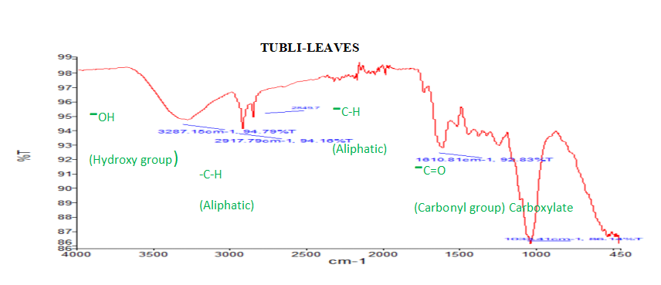

**Figure 1. FT-IR Analysis on Tubli Leaves**

**Table 3. FT- IR Characterization on Tubli Root**

|  |  |  |
| --- | --- | --- |
| **FT-IR Result on Tubli Root** | | |
| **Observed Peaks (cm-¹)** | **IR Assignment** | |
| **Functional Group** | **Range (cm-¹)** |
| 1606.95 | -C=O(Carbonyl group) | 1730-1650 |
| 1611.64 | -C=C-C (Aromatic ring) | 1600-1580 |
| 2922.7 | -C-H (Aliphatic) | 2850-2950 |
| 32888.16 | -O-H (Hydroxyl group) | 3570-3200 |

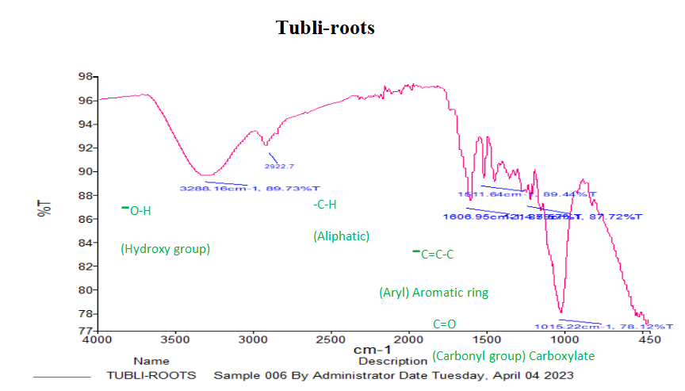

**Figure 2. FT-IR Analysis Result on Tubli Root**

Fourier Transform Infrared Spectroscopy (FTIR) analysis was conducted to identify the functional groups present in Tubli leaves and roots. The analysis revealed broad peaks in the range of 3287.15–3288.16 cm⁻¹, with additional peaks forming between 3200–3600 cm⁻¹, which are characteristic of the O-H (hydroxyl) functional group. These peaks can be attributed to the presence of glycerin, a polyol that contains multiple hydroxyl groups (Tahir et al., 2018). This suggests that Tubli contains compounds with hydroxyl-rich compounds like glycerin, which may contribute to its bioactivity. .

The column graph below presents data on the pesticidal efficacy of Tubli (Derris elliptica) leaf and root extracts against cockroaches, compared to a commercial insecticide (positive control). The results are shown for different concentrations (50% and 100%) of each extracts, with the number of dead cockroaches recorded.

No cockroach mortality (0%) was observed at both 50% and 100% concentrations of Tubli leaf extract. Only that the cockroaches became weak after 45 minutes and revive after 60 mins. This indicates that Tubli leaf extract has a slight pesticidal effect on the cockroach.

While at 50% concentration of Tubli root extract has a 66.67% efficacy wherein, 10 out of 15 cockroaches died. In addition, 100% concentration of Tubli root extract has a 93.33% efficacy wherein, 14 out of 15 cockroaches died. The root extract showed a significant pesticidal effect, with higher mortality at 100% concentration. This confirms that Tubli roots contain bioactive compounds, particularly rotenone, which is known for its high toxicity to insects.

As to compare at 50% concentration of commercial pesticide with 86.67% efficacy, wherein 13 out of 15 cockroaches died. In addition, a 100% concentration of positive control has a 100% efficacy wherein all 15 cockroaches died.

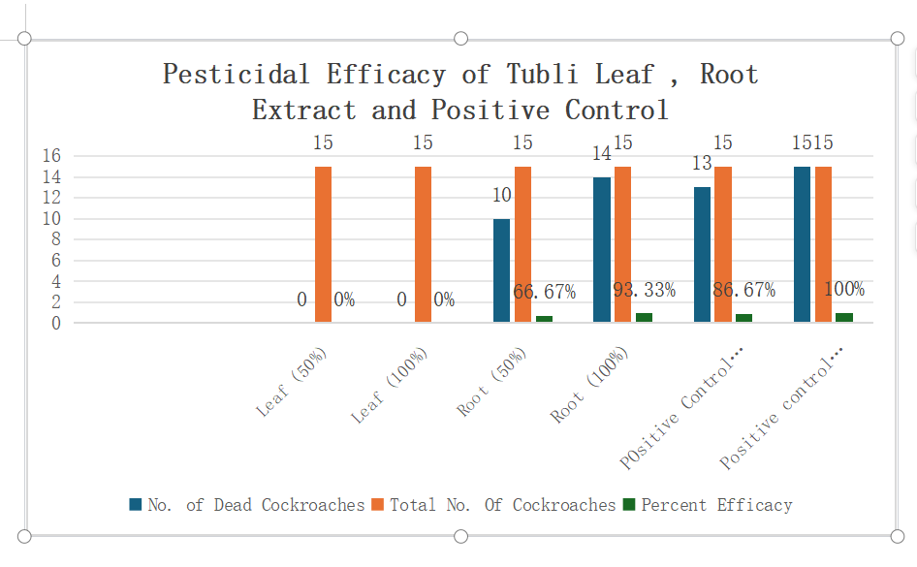

**Figure 3. Pesticidal Efficacy of Tubli Leaf, Root Extract and Positive Control**

**Analysis of Variance (ANOVA) for Pesticidal Efficacy of Tubli Extract**

The analysis of variance (ANOVA) examined the variability in cockroach mortality across the four treatment groups: **Tubli root 50%, Tubli root 100%, commercial pesticide 50%, and commercial pesticide 100%**.

Since the computed F-value **(3.90) is greater than the critical value (3.49)**, this means **at least one of the treatments has a significantly different effect** from the others, based on Table 4.

**Table 4. ANOVA data on Pesticidal Efficacy of Tubli root extract and Positive Control**

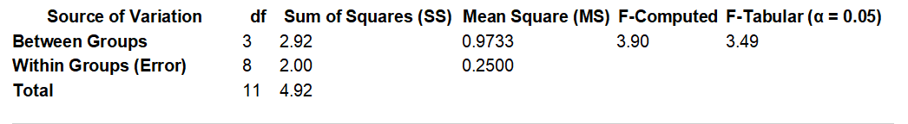

**Table 5. Comparative Analysis on Pesticidal Efficacy of Tubli root extract and Positive Control**

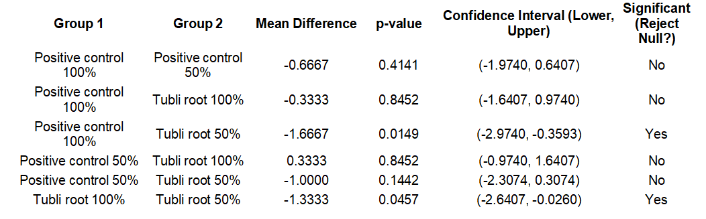

Table 5 indicated that the effectiveness of Derris elliptica (Tubli root) extract varies depending on concentration. The 100% concentration of Tubli root extract performs comparably to the positive control at both 100% and 50%, suggesting its potential as a natural pesticide. However, Tubli root extract at 50% concentration is significantly less effective than the positive control at 100%, indicating a reduction in pesticidal efficacy at lower concentrations. The significant difference between Tubli root 100% and Tubli root 50% suggests that higher concentrations are necessary for effective pesticidal action.

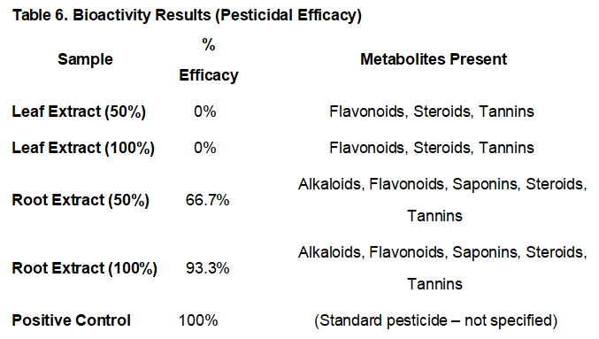

**Table 6. Root extracts** showed strong **pesticidal bioactivity**, especially at 100% concentration, suggesting the active metabolites (likely **alkaloids and saponins**) may contribute to this effect.

**Leaf extracts** showed **0% efficacy**, despite containing flavonoids, steroids, and tannins—suggesting these alone may not be sufficient for pesticidal action in this case.

Therefore, **alkaloids and saponins (present only in the root)** may be the key contributors to the observed insecticidal effect.

**IV. DISCUSSION**

This study was conducted to compare the pesticide efficacy of Derris elliptica (tubli) leaf and root extracts for the reason that these plant samples might contain active constituents that was effective as pesticidal agents. It also aimed to determine the secondary metabolites and functional group present in the leaves and roots of Derris elliptica (tubli).

Based on phytochemical screening, that Tubli root extract may be more effective as a bio-pesticide compared to the leaf extract due to the presence of alkaloids and saponins. Saponins have been reported to enhance permeability in insect cell membranes, which may facilitate the action of rotenone and other toxic compounds. Additionally, flavonoids and tannins may contribute to antioxidant and defensive mechanisms that further strengthen the plant’s insecticidal properties.

The FTIR spectra interactions between different components in the Tubli leaf and root samples. The leaf extracts caused weakening and reduced movement of the cockroaches after one hour, no significant mortality was observed. This suggests that Tubli leaves lack potent pesticidal properties, likely due to the absence of rotenone, the primary insecticidal compound found in the plant. Instead, the leaves are rich in flavonoids and tannins, which are known for their antioxidant and medicinal properties rather than insecticidal effects (Trease & Evans, 1983; Ayinde et al., 2007). Although these compounds may contribute to general plant defense mechanisms, they do not exhibit strong toxicity against insects.

In addition, the functional groups present in Tubli (Derris elliptica) extract that contribute to its pesticidal potential include primarily the hydroxyl (O-H) group, along with other bioactive groups such as rotenone, alkaloids, flavonoids, tannins, saponins, and terpenoids. Rotenone, a known potent insecticide found in Tubli roots, plays a major role in its pesticidal efficacy by disrupting cellular respiration in pests. Other phytochemicals such as alkaloids and flavonoids also contribute through neurotoxic and antifeedant effects, while tannins, saponins, and terpenoids add to the pest deterrent and toxic properties of the extract. These combined functional groups underlie the eco-friendly pesticidal potential of Tubli extract (Tahir et al., 2018; Usama Saleem et al., 2024).

More over, the ethanolic root extracts showed clear pesticidal activity, with mortality increasing over time. Treatment 4 recorded the highest number of dead cockroaches (14) after one hour, confirming the effectiveness of the root extract as an insecticide. The superior efficacy of Tubli roots can be attributed to rotenone, a well-documented natural insecticide that interferes with the mitochondrial electron transport chain, leading to energy depletion and eventual insect death (Binas, 2021). Additionally, Tubli roots contain lipid-based compounds, ceramides, and polyhydroxyl octadecenoic acid, which further enhance their pesticidal properties against a variety of insects, including aphids, flies, caterpillars, and ticks (Evans, 2002). Positive **c**ontrol confirming its high toxicity and rapid action. The commercial insecticide remains the most effective, killing all cockroaches at full concentration.

The ANOVA results indicate that there is a **statistically significant difference among the treatment groups** at the **0.05 significance level**. This means that at least one of the treatment groups differs significantly from the others in terms of efficacy. Further post-hoc analysis may be needed to determine **which specific groups** are significantly different from each other. This finding supports the hypothesis that Derris elliptica extracts may exhibit pesticidal activity at varying concentrations, and at least one concentration shows a distinct effect compared to others.

Based on **Tukey’s HSD test**, we observed that **Tubli root extract at 100% performs similarly to the positive control (synthetic pesticide) at 100%** but differs from Tubli root extract at 50%.

This supports the idea that **higher concentrations of Tubli root extract increase effectiveness**, making it a viable alternative to commercial insecticides at full strength.

Based on bioactivity result, the root extracts of Tubli demonstrated strong pesticidal bioactivity, particularly at 100% concentration, where 93.3% of cockroaches were eliminated. This high efficacy suggests that the active metabolites unique to the root—specifically **alkaloids** and **saponins**—may be the primary contributors to its insecticidal properties. Alkaloids are known for their neurotoxic effects on insects, often interfering with their nervous systems and leading to paralysis or death (Kumar & Warikoo, 2010), while saponins act as natural detergents that disrupt cell membranes and respiratory function in insects (Siddiqui et al., 2012). In contrast, the leaf extracts showed 0% efficacy at both tested concentrations, despite containing flavonoids, steroids, and tannins. These compounds, although bioactive in other ways, are generally weak or ineffective as standalone insecticides (Cowan, 1999; Ravi et al., 2017). This stark difference in bioactivity between the leaf and root extracts strongly supports the idea that **alkaloids and saponins**, present only in the root, are the key phytochemicals responsible for the observed pesticidal effect.

**V. CONCLUSION**

Based on the research findings from the series of laboratory tests on the evaluation of secondary metabolites and functional groups in *derris elliptica (wall) benth* for natural pest control the researchers derived the following conclusions:

1. This study successfully evaluated the **secondary metabolites and functional groups** present in Derris elliptica (Tubli) leaves and roots, determining their potential use as a **natural pest control agent**. The phytochemical screening confirmed the presence of **alkaloids, flavonoids, saponins, steroids, and tannins**, which are known for their pesticidal properties. Notably, the root extract exhibited **higher pesticidal efficacy** due to the presence of alkaloids, particularly rotenone, a compound known for its insecticidal activity.
2. The FTIR analysis highlights the presence of key functional groups in Derris elliptica (Tubli) that contribute to its pesticidal potential, particularly in the root extract. While the leaf extract showed minimal insecticidal activity—likely due to the absence of rotenone and the predominance of non-toxic compounds such as flavonoids and tannins—the root extract demonstrated the presence of potent bioactive compounds including rotenone, alkaloids, saponins, and terpenoids. These compounds work synergistically to disrupt insect physiology, confirming the superior pesticidal efficacy of Tubli roots and supporting their potential as an eco-friendly alternative to synthetic insecticides.
3. The **ANOVA results** revealed a **statistically significant difference** in the mortality rate of cockroaches treated with different extract concentrations, confirming the pesticidal potential of Tubli root extract, particularly at **100% concentration**.
4. Comparative analysis with a **commercial pesticide** indicated that **Tubli root extract at 100% concentration exhibited a comparable effect** on cockroach mortality, highlighting its potential as an alternative, eco-friendly, and cost-effective pesticide.
5. The study clearly demonstrates that the root extracts of Tubli possess significant pesticidal potential, primarily due to the presence of alkaloids and saponins, which are absent in the leaf extracts. The stark contrast in efficacy—93.3% mortality from root extracts versus 0% from leaf extracts—highlights the critical role of these specific metabolites in exerting insecticidal effects. These findings support the potential development of root-based botanical pesticides, emphasizing the importance of targeted phytochemical composition in determining bioactivity.

This research supports the **sustainable use of natural plant extracts** as an alternative to synthetic pesticides, contributing to safer and more environmentally friendly pest management solutions.

**Recommendations**

Based on the findings and conclusions obtained in this study the following recommendations was presented:

1. The future researcher to conduct study on the plant species under Family of Fabaceae or Faboideae as potential insect pesticide.

2. Similar study must be conducted but on the other test insects.

3. To perform further study on other chemical components, present in Tubli.

Disclaimer (Artificial intelligence)

Option 2:

Author(s) hereby declare that generative AI technologies such as Large Language Models, etc. have been used during the writing or editing of manuscripts. This explanation will include the name, version, model, and source of the generative AI technology and as well as all input prompts provided to the generative AI technology

Details of the AI usage are given below:

1.ChatGPT is used to enhance some statemenst, to generate Turkey’s HSD table based on data that I input.

2.Gemini is used to check some subject-verb agreement.

References

1. Alcera, Christian (2021). “EFFICACY of Derris elliptica (TUBLI), Annona Squamosa Linn. (ATIS) and Lantana Camara Linn. (KORONITAS) LEAVES EXTRACT AS TERMICIDAL AGENT,” University of Eastern Philippines. Unpublished.
2. Ayinde B.A.,E.K., Omogboi, F.C. Amaechina, (2007). Pharmacognosy And Hypertensive Evaluation Of Ficus Exasperate Vahl (Moraceae) Leaf. Pharmacological Article 64. Page 543-546.
3. Bala, A. Y., & Sule, H. (2012). Vectorial potential of cockroaches in transmitting parasites of medical importance in Arkilla, Sokoto, Nigeria. Nigerian Journal of Basic Applied Science, 20(2), 111–115.
4. Balico, E.C(2013). Anti-termicidal of Gliricidea sepium Steud. (Kakawate), Piper bettle Linn. (Buyo), and Jatropha curcas Linn. (Tubang Bakod) leaf extracts. University of Eastern Philippines.Unpublished.
5. Binas, Enrique, (2021). Tubli Plant Used as Organic Pesticide: Input toward Sustainable Agriculture. Jose Rizal Memorial State University.
6. Bohmon, B. (2000). Insecticidal properties of plants. Journal of Agricultural and Food Chemistry, 48(6), 2325-2330.
7. Broto, A.S. (2008). Statistics Made Simple. 2nd ed. Mandaluyong City: National Book Store, p.96.
8. Cowan, M. M. (1999). Plant products as antimicrobial agents. Clinical Microbiology Reviews, 12(4), 564-582.
9. Eiman, A. (2018). Diospyros blancoi(kamagong) leaf and Decayed Fruit Extracts as Pesticide for Termites. Unpublished Thesis. College of Science. University of Eastern Philippines.
10. Ecobichon, D. J. (2001). Pesticides and human health. CRC Press
11. Erdogan,P., A. Yildirim, B. Server, (2012). Investigation on the Effects of Five Different Plant Extracts on the Two-Spotted Mite Tetranychus urticae Koch (Arachnida: Tetranychidae). Journal of entomology. Volume (2012), Article ID 125284, 5 pages.

<https://onlinelibrary.wiley.com/doi/10.1155/2012/125284>

1. Evans, W.C. (2002). Trease and Evans Pharmacognosy, 15th Ed; W.B, Saunders: London, 2002; pp.510-511. Date access: June 202
2. Guevara, B. Q., Aparente, M. L. C., De Leon, R. M. O., & Bayan, L. G. (2004). A guidebook to plant screening: phytochemical and pharmacological. Research Center for Natural Sciences, University of Santo Tomas.
3. Jessa, O.E., R.B, Ikomi, and S.O. Asagba. (2015). The Effect of Dry Extract of Derris elliptica Stem on some Enzymatic changes in the Plasma of African Catfish Clarias gariepinus Jordan Journal of Biological Sciences volume 8, Number 2, June. (2015) ISSN 1995-6643 Pages 101-105.
4. Junaid S. and Mk P. (2020). Qualitative test for preliminary phytochemical screening: An overview. International Journal of chemical studies: 603-608

https://www.chemijournal.com/archives/2020/vol8issue2/PartI/8-2-34-147.

DOI:https://doi.org/10.22271/chemi.2020.v8.i2i.8834

1. Kumar S., Warikoo R, Wahab N.(2010). Larvicidal potential of ethanolic extracts of dried fruits of three species of peppercorns against different instars of an indian strain of dengue fever mosquito, Aedes aegypti L. (Diptera: Culicidae):National Library of Medicine:PubMed:. 2010 Sep;107(4):901-7. doi: 10.1007/s00436-010-1948-1.
2. Lu,H.Y., and J.Y. Liang (2009). Rotenoids from the Root of Derris elliptica (Roxb.) Benth. II. Chinese Journal of Natural Medicines Volume, 2009, 7, Issue 1, Pages 24-37.

DOI: [10.1016/S1875-5364(09)60041-8](http://dx.doi.org/10.1016/S1875-5364(09)60041-8" \t "https://www.researchgate.net/publication/_blank)

1. Marichelvam, M. K., Jawahar, S., Sureshkumar, S., & Sankar, S. (2018). Fourier Transform Infrared Spectroscopy (FTIR) analysis of some Indian seaweeds. Journal of Pharmacy and Biological Sciences, 13(2), 66-71.
2. Moges, F., Eshetie, S., Endris, M., Huruy, K., Muluye, D., Feleke, T., … Nagappan, R. (2016). Cockroaches as a source of high bacterial pathogens with multidrug resistant strains in Gondar Town, Ethiopia. BioMed Research International, Article ID 2825056. <https://doi.org/10.1155/2016/2825056.>
3. Nguyen, A, and Y. Phan. (2014). Preliminary Phytochemical analysis of different solvent extract of Derris elliptica (Roxb.) Benth leaves. International Journal of Innovative and

Applied Research Volume 2, 2014, Issue (12): 74-76.

<https://www.semanticscholar.org/paper/Preliminary-phytochemical-analysis-of-different-of-Nguyen-Phan/1ab9b6cd8982c30e8b8c2a190e05995a9b78f419>

Corpus ID: 96966787

1. Olufayo, M. (2009). Haematological Characteristics of Clarias gariepinus (Burchell 1822) Juveniles Exposed to Derris Elliptica “ROOT POWDER” Ajfand, volume 9 No.3 2009. Date access: July 10,2011.

DOI:[10.4314/AJFAND.V9I3.43115](https://doi.org/10.4314/AJFAND.V9I3.43115).

Corpus ID: 53506511

1. Orwa C., A. Mutual, R. Kindt, R. Jamnadass, S. Anthony. (2009). Derris elliptica. Agroforestry Database 4.0.
2. Premree, P. and N. Sukhapanth. (1990). Phytochemical toxicity of the crude extract from Derris elliptica Benth. On mosquito larvae. J. Sci. Soc. Thailand, 16, 133-139.

doi:[10.2306/scienceasia15131874.1990.16.133](http://dx.doi.org/10.2306/scienceasia1513-1874.1990.16.133)

1. Rattanapan, A. (2009). “Effect of rotenone from Derris crude extract on esterase enzyme mechanism in the beet armyworm, spodoptera exigua (Hubner). Research Support, Non-U.S. Gov’t, Journal Article, 2009, 74 (2): 437-444].

PMID: **20222603**

1. Ravi, L., Kathiresan, S., Rajasekaran, R., & Elumalai, K. (2017). Insecticidal activity of some medicinal plants against Helicoverpa armigera (Hubner). Journal of Entomology and Zoology Studies, 5(3), 205-208.
2. Starr, F., F. Starr, L. Loope. (2003) Derris elliptica. United States Geological Survey—Biological Resources Division Haleakala Field Station, Maui, Hawaii.
3. Siddiqui, B. S., Ali, S. T., Khan, S., & Ali, M. S. (2012). Insecticidal constituents from the seeds of Madhuca longifolia var. latifolia. Journal of Ethnopharmacology, 141(3), 934-937.
4. Tahir, H. E., Xiaobo, Z., Jiyong, S., Wijaya, E. R., Zhang, Z., & Ge, Y. (2018). Effect of different drying methods on the nutritional properties and antioxidant activities of Moringa
5. Trease G.E. and M.C. Evans. (1983).

Textbook of Pharmacognosy, 12th ed. Tindall,

London. Page: 343-383.

1. Tunaz, H., Er, M. K., & Isikber, A. A. (2009). Fumigant toxicity of essential oils and selected monoterpenoid components against German cockroach, Blattella germanica (L.)

Dictyoptera: Blattellidae). Turkish Journal of

Agriculture and Forestry, 33, 211–217.

DOI:10.3906/tar-0805-22

1. Saleem, U., Asrar, M., Jabeen, F., Hussain,
2. M., & Hussain, D. (2024). Determination of

insecticidal potential of selected plant extracts

against *Spodoptera frugiperda*.

*Published by Elsevier Ltd.

DOI: [10.1016/j.heliyon.2024.e39593](http://dx.doi.org/10.1016/j.heliyon.2024.e39593" \t "https://www.researchgate.net/publication/_blank)

oleifera leaves. Journal of Food Processing

and Preservation, 42(8), e13706.