**Effect of Alkaline Earth Metal Doping on Photocatalytic behaviour of Lanthanum Manganite Perovskite Nanoparticles for Degradation of Organic pollutants**

ABSTRACT

Lanthanum manganite doped with calcium,barium and strontium having perovskite structures (LCMO, LBMO and LSMO) have been prepared through sol-gel technique and characterized by XRD, FTIR, ICP-AES, SEM, EDX and UV-VIS spectroscopy. The XRD data showed the formation of single crystalline phases. SEM images showed that the micro sized structure with average diameter of 1-5 µm. The ICP-AES and EDX data confirmed the formation of required stoichiometric La1-xMxMnO3 Oxide. Metal doping resulted in reduction of band gap energy (Eg) of the Lanthanum Manganite whose catalytic performance towards photodegradation of Methylene Blue (MB) dye was evaluated using visible light of constant dose for several hours at pH value 4. The results showed highest photocatalytic efficiency 68.52 % in case of LCMO in 100 min illumination time. For LBMO and LSMOthe values were 47.92 and 54.87% respectively. But the pseudo first order rate constant ‘k’followed the reverse order with highest value in case of LBMO.The linear increase in rate of photodegradation was found to be a function of irradiation time. These findings showed convincingly that La0.7M0.3MnO3[M= Ca, Ba, Sr], possessed great promise for visible light driven photodegadation of MB dye. The reproducibility of the sample for degradation was also studied.

Key Words: Perovskite; Sol-Gel technique; Photocatalyst; Methylene Blue.

INTRODUCTION

Semiconductor photocatalytic processes have been widelyapplied to initiate photocatalytic reactions for the degradationof pollutants. Perovskites type oxides, ABO3, have been extensively investigated as catalysts for several processes including fuelcells [1], water dissociation [2], hydrogenation, hydrogenolysis [3] and ammonia oxidation [4]. Nanostructured rare earth manganites doped with alkaline earth metals show interesting electric properties [5]. Perovskites, especially LaMnO3, have been used in environmental applications e.g. the oxidation of hydrocarbons [6–8], chlorinated organic compounds [9] etc. To develop more efficientphotocatalyst, there is an urgent need for photocatalytic systems,which are able to operate effectively under visible light irradiation.The use of semiconductor photocatalyst under visible light has recentlydrawn much attention. Removal of organic dyes by photocatalyticdegradation is emerging as an effective treatment method. Thepartial substitution(doping) of a trivalent rare-earth by the divalent alkaline-earth cations produces a mixed valency of Mn3+(t2𝑔3 e𝑔1) and Mn4+(t2𝑔3 e𝑔0) ions. It is believed that the doubleexchange (DE) interaction between a pair of these Mn ions is responsible for the electrical and magnetic properties[22].

Nanostructured manganites such as La1−𝑥Ca𝑥MnO3, La1−𝑥Sr𝑥MnO3 and La1−𝑥Ba𝑥MnO3 have been extensively studied in the last decade owing to their notably affected magnetic and electric properties at the nanoscale. The Mn4+/Mn3+ ratio strongly depends on the substitution, therefore the classic method used to change the ratio is substituting La3+ by Sr2+ with different doping levels. When the doping amount of Sr2+ is around 0.33 , the ratio of Mn4+/Mn3+ is 1:2, which is the optimum ratio for the transport property of the system. Additionally, the number of manganese ions may also be changed by creating oxygen vacancies (oxygen deficiency), leading to the modification of the exchange interactions . The oxygen content is crucial in determining the magnetic and electrical properties of the manganites. Due to the generation of oxygen vacancies, the manganites have technological applications in many fields, such as in solid oxide fuel cells (SOFC), high-temperature electrolyzers, oxygen sensors, and catalyses [10]. As variation of A- site cationic radius using alkaline earth metal dopants plays a vital role in determining the various properties of the manganites. By varying the cation, a mismatch occurs between thecation already presented at the A-site (La in the present case) and the dopant cation (Ca, Sr or Ba). This mismatch is expressed in terms of variance might influence the electrical and magnetic properties of manganites.

Over the past decades, photocatalytic oxides or compounds have beenincreasingly utilized in water purification. Manganitesby nature is same as semiconductorshaving an empty conduction band (CB) and a full valence band (VB) in their electronic structure [11]. Thus this property; band gap energy, highlights the application of manganites in photocatalytic processes [12]. In the present work, the choice of three specific cations,Ca2+,Sr2+,Ba2+ is based on their similar atomic properties due to their position in the periodic table. In this letter an attempt is made to investigate the effect on the A-site cationic radius ⟨𝑟A⟩by varying the divalent alkaline earth dopants as Ca, Sr and Ba in LaMnO3.

Organic and toxic pollutants pollute water sources indifferent dyeing factories [13]. Common methods of treatment dyes with a complex aromatic structure can be very difficult to degrade since products resulting from different reactions, such as hydrolysis and oxidation in aqueous media, produce toxicity and carcinogenic substances. These products should be removed with appropriate treatment methods for publichealth and safety [14]. In recent years,enormous research and development have gained considerableimportance as an environmental remediation processin photocatalysis because it can fully remove organic andinorganic toxins from water pollutants by using nanosizedmetal oxides as catalysts (15-17]. Several metal oxidenanosized semiconductor nanoparticles have been used indifferent applications. The predominant researchin the field of photocatalysis for wastewater purification hasincluded semiconductors of wide bandgap and high surface-to-volume ratio material such as titanium dioxide (TiO2),zinc oxide (ZnO), tin oxide (SnO2), and zirconium oxide(ZrO2) [18]. These hole-doped compounds play a role in transferring theelectronic system to the Fermi level to ensure that conductivityand valence band behaviour is observed.

The coexistence of electrons and holes in manganites introduces them into optical systems as promising materials [19]. Doped alkaline rare earthtransition metal perovskite-like structure oxides reduce thebandgap energy values because this feature increases thecharge carrier separation (photogenerated electrons and holes) [20]. Intense studies were conducted onthe materials because their electrical and optical propertiescan be tuned, indicating control of the rational design structure in ABO3 perovskite by cationic substitutions . So, we can say that perovskite compounds are one of the promising structures that adapt the band gap values to collect the visible-light absorption and thecapacity of the band edge to meet the specific photocatalytic needs. The photodegradation of La0.7Sr0.3MnO3 has been achieved up to 99% compared to other samples with high degradation rate under UV lights of wavelength 254 nm. A La0.7Sr0.3MnO3 nanocomposite performs as a photocatalyst to enhance the efficiency of methylene blue photodegradation [21].The purpose of the present study is to get an optimal degradation value using appropriate doping with alkaline earth metals.

EXPERIMENTAL

**Synthesis of doped manganites**

La0.7Ca0.3MnO3 , La0.7Sr0.3MnO3 and La0.7Ba0.3MnO3(hereafter will be called LCMO, LSMO and LBMO respectively) was synthesized via wet chemical method by mixing Sigma Aldrich-USA, AR grade La(NO3)3.6H2O, Ca(NO3)2.4H2O, Sr(NO3)2, Ba(NO3)2 and Mn(NO3)2.4H2O as the raw chemicals in 0.7:0.3:1.0 molar ratios. Stiochiometric amounts of all the salts were taken and separate solutions for each composition were made in de-ionized water. Citric acid was added in 100 % of total amount of the chemicals mixture solution for auto combustion followed by addition of 5 ml ofethylene glycol as surfactant. The prepared mixture with pH adjusted to 8 was stirred vigorously for the next 30-45 min to get dark-brown gel. The viscous liquid so obtained was dried at 120 0C overnight. The final powdersLa0.7A0.3MnO3 , (A= Ca, Sr and Ba) were calcined at 800 0C for 6 hours in the Muffle furnace (Model No: AI-106) to obtain manganites of nano dimensions..

**Characterization method**

The structural, spectroscopic and optical properties of the synthesized powders were studied by X-Ray Diffraction (XRD), Inductively Coupled Plasma–Atomic Emission Spectroscopy (ICP–AES), Field Emission Scanning Electron Microscopy (FESEM), Fourier Transform Infrared Spectroscopy (FTIR) and UV–VIS absorption spectroscopy.

**Photocatalytic test**

The photocatalytic degradation of aqueous MB solution(5 ppm, pH = 4) was carried out at room temperature separately by using LCMO, LSMO and LBMO as the photocatalysts (0*.*07 g l−1),one 100 W fluorescent lamp as a visible-light source, 10 cm above the surface of MB solution at room temperature. At first, the mixture of water and prepared oxides were ultrasonicated for 15 minutes. The MB solution was added properly to each mixture with stirring at constant pH = 3.5, because the highest efficiency in the photocatalytic activity of the MB has been reported in acidic conditions [23,24]. The reaction mixtures were allowed to be magnetically stirred in dark for 30 minutes with an aim to attain adsorption-desorption equilibrium of MB on the surface of the catalyst. In appropriate intervals, 5 mL of each suspension was collected and centrifuged. The MB concentration was determined by using the UV–VIS spectrophotometer for both the samples in the dark and after light irradiation. The decreasing concentration of MB in the solution was used to investigate the activity of the LCMO, LSMO and LBMO particles.

**RESULTS AND DISCUSSION:**

**TG-DTA Analysis**

Thermogravimetric studies of the prepared samples at the heating rates of 5 0C min-1 from 30 0C to 1000 0C, were carried out using HITACHI STA7200 thermal analyser. The curve showed that weight loss occurred in several steps. The primary weight loss found between 250C to 150 0C was associated with loss of water.(Fig-1).

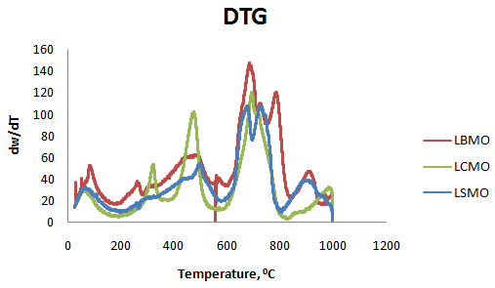

Fig.1: Derivative Thermogravimetric curves of the perovskite samples

A minor disintegration was observed between 250 0C to 380 0C in all the cases of samples, appeared as notches which might have occurred due to breaking of polymeric chain. The second step weight loss between 400 0C to 570 0C appeared due to decomposition of nitrates and citrates and implied initial formation of nano-perovskite. The final stage of mass degradation took place between 600 0C to 800 0C which was attributed to the formation of phase pure or crystalline nano-perovskite. Above 800 0C there was a very weak mass degradation which showed completion of perovskite oxide phase formation. The result of TGA analysis could be used to estimate the calcinations temperature.

**XRD Analysis:**

Powder XRD of the prepared La0.7Ca0.3MnO3(LCMO), La0.7Sr0.3MnO3(LSMO), La0.7Ba0.3MnO3(LBMO) samples (Fig-2) were carried out by X-ray diffractometer (PAN Analytical Empyrean Series 2) with Cu Kα (λ = 0.15406 nm) radiation in therange 2θ= 100-800 [Table-1], under current of 30 mA and 40 Kv.The synthesized samples have single-phase perovskite structures and it has been confirmed that there is no extra peak relating to the secondary phase. The most prominent peaks were obtained at 2θ value of 32.650, 32.710 and 32.400 for LCMO, LSMO and LBMO respectively along with other characteristic peaks confirming the crystal formations. There is a little variation in d-values in different samples which is attributed to distortion in crystal structures arising from change in bond lengths and bond angles. All strong peaks have small shift towards lower angle because of Ca,Sr and Ba due to incorporation of dopant ions into the lattice host material i.e. lanthanum manganite. The figure shows that the Ca,Ba,and Sr doped samples give characteristic broadened peaks which represent the smaller size of crystals in the compositions.The data were analyzed using a commercial X-pert package and FULLPROF program. The diffraction peaks matched with the X-pert high score PDF (code: 01-075-0440), indicating the formation of a cubic LaMnO3 perovskite phase.

It is observed that undoped LaMnO3 usually acquires an orthorhombic crystal structure. Thediffraction peaks in the Ca doped compositionare also indexed as an orthorhombic structure without any other secondary or impurity phase. However, the peaks in Sr and Ba doped compositions are indexed to the rhombohedral structure with the presence of minor impurity phases.

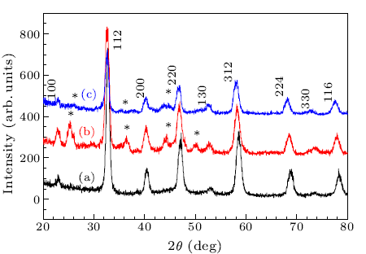

Fig-2:XRD pattern of the nano perovskite samples-(a):LCMO, (b):LSMO, (c):LBMO. The asterisks represent the SrCO3 and Ba(OH)2 impurities.

The broadening of peak is because of the finite size of the crystals and broadening of peaks decreases with metal doping due to increase in grain size. Further, the post annealing temperature (800 °C for 6 h) removes all the impurities and develops pure phase nano perovskites. The most intense peak (110) was used to calculate the crystallite size (D) by the equation D = 0.9λ/βcosθ, where λ = 1.5405 Å, the wavelength of incident X-ray, θ is the corresponding Bragg’s diffraction angle and β is full width at half maxima of the (110) peak. Any secondary phase was not detected in XRD spectra which ensure the phase purity of the final product. Crystalline structure forms at a high-temperature treatment. As it can be seen from the DTG curves (Fig.2), the process of formation of crystalline nanoparticles is one-stage; it begins at 600 °C and finishes at 800 °C.

Table-1: X- Ray Crystallographic data of nano-perovskite samples)

|  |  |  |  |  |  |  |  |  |
| --- | --- | --- | --- | --- | --- | --- | --- | --- |
| LCMO | | | LSMO | | | LBMO | | |
| Pos. [°2θ] | d-spacing [Å] | Rel. Int. [%] | Pos. [°2θ] | d-spacing [Å] | Rel. Int. [%] | Pos. [°2θ] | d-spacing [Å] | Rel. Int. [%] |
| 22.9058  32.6502  40.2325  46.8260  58.1931 | 3.88259  2.74270  2.24158  1.94017  1.58537 | 19.51  100.00  17.55  27.76  21.38 | 22.9243  32.7176  40.1473  46.7879  58.0691 | 3.8795  2.7372  2.2461  1.9417  1.58846 | 13.69  100  12.7  25.15  17.29 | 23.8733  22.8307  32.4006  39.9911  46.6222  57.9149 | 3.7274  3.8952  2.7632  2.25455  1.94817  1.5923 | 27.7  21.66  100  19.57  32.77  24.72 |

**SEM Analysis:**

Morphological studies of the prepared sample were carried out using HITACHI S-3400N scanning electron microscope. The SEM pictures [Fig-3] show that synthesized perovskite had spongy, irregular and rough surface with numerous cavities. The particles also had fluctuating sizes and shapes. This served to make sense of the great adsorptive characteristics.

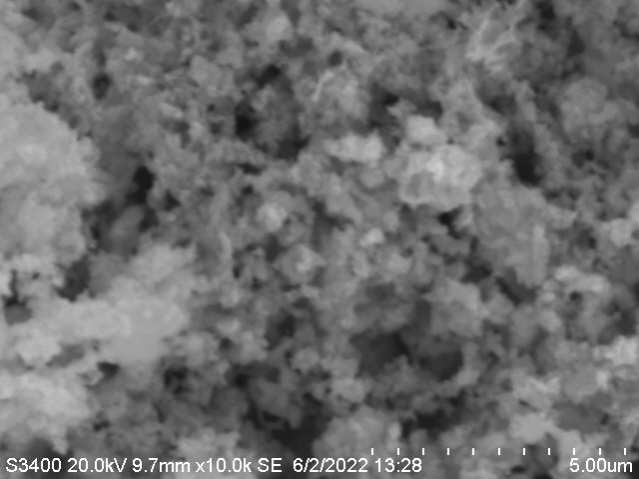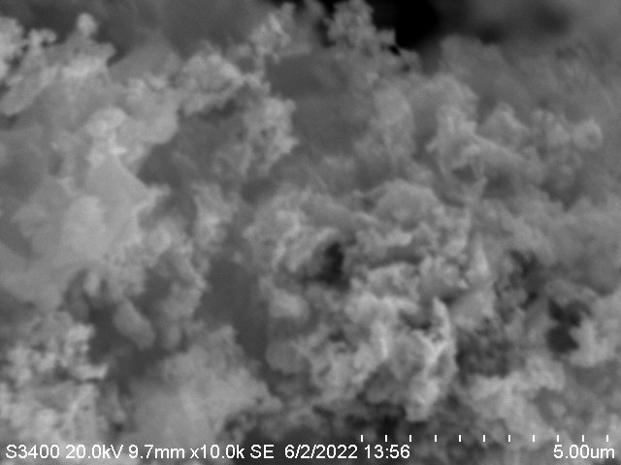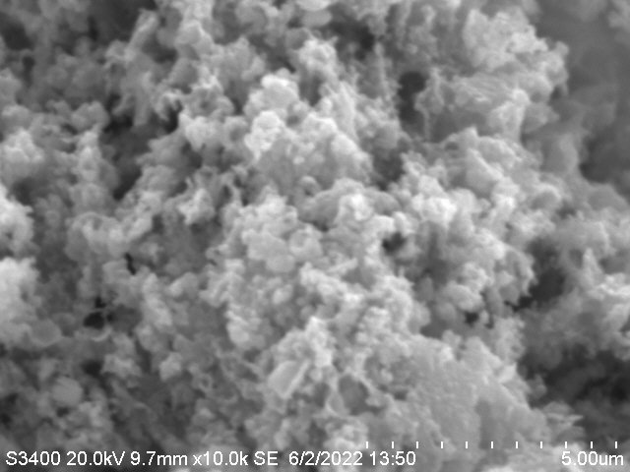

LBMO LSMO LCMO

Fig 3: Scanning Electron Microscopy photographs of the prepared samples.

FE-SEM images in Fig.3 clearly showed that most of the grain sizes were distributed from 5 to 100 µm, which was much larger than one estimated by the Scherrer formula. This implieed that our perovskite particles were polycrystalline. The presence of citric acid prevented agglomeration of the particles to a large extent [25]. It was expected that large amount of gases evolved during calcination at high temperatures when citric acid decomposed.It was observed that undoped LaMnO3 usually acquires an orthorhombic crystal structure.

**EDAX Analysis:**

The Energy Dispersive Analysis X-ray (EDAX) study provided quantitative essential investigations of the atoms present on the surface of prepared samples (Fig.4)**.**The related peaks in the spectrum are because of the presence of La, Ca, Sr, Ba, Mn and O atoms. No extra impurity peaks were seen which affirmed that the synthesized sample was pure in nature. Likewise, the Atomic weight ratios of (La, M) : Mn, (M= Ca,Ba,Sr)were found to be 1.07,1.02 0.99 indicate the stoichiometric nature of the prepared samples. [ Table-2]

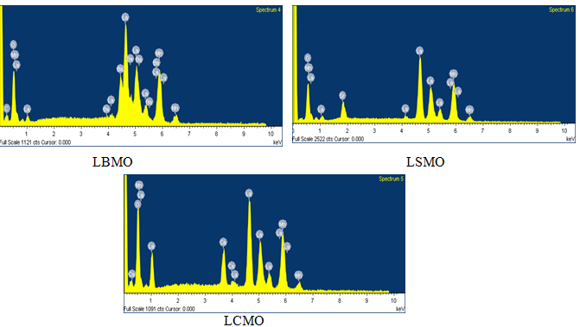

(Fig-4: EDAX Patterns of synthesized LCMO;spectrum-5,LSMO;spectrum-4,& LBMO;spectrum-6)

[Table-2: EDAX elemental composition of synthesized samples]

|  |  |  |  |  |  |  |  |  |
| --- | --- | --- | --- | --- | --- | --- | --- | --- |
| Element | Weight% | Atomic% | Element | Weight% | Atomic% | Element | Weight% | Atomic% |
| LCMO | | | LBMO | | | LSMO | | |
| O K | 13.73 | 50.57 | O K | 14.45 | 34.99 | O K | 14.66 | 44.67 |
| Ca K | 11.08 | 6.56 | Mn K | 25.42 | 27.89 | Mn K | 24.43 | 27.80 |
| Mn K | 23.77 | 22.85 | Ba L | 18.59 | 7.21 | Sr L | 12.69 | 6.95 |
| La L | 51.42 | 20.02 | La L | 40.11 | 21.43 | La L | 48.22 | 20.58 |
| Totals | 100.00 | 100.00 |  | 100.00 | 100.00 |  | 100.00 | 100.00 |

**FT-IR Analysis:**

There is a complete similarity in FT-IR spectral pattern(Fig.5) of all the prepared samples without much variation in absorption data.The doped perovskites were analysed by using PERKIN ELMER UATR 2, FT-IR spectrophotometer. The LCMO spectra showed peaks at 492.94 cm-1, 586.40 cm-1, 880.59 cm-1, 1060.90 cm-1, 1160.37 cm-1 and 3609.33 cm-1 etc. LBMO perovskite sample shows absorption at 497.26cm-1, 575.25cm-1, 879.82cm-1, 1145.16cm-1, 3609.30cm-1, etc. LSMO perovskite sample shows absorptions at 482.32cm-1, 571.21cm-1, 860.95cm-1, 1058.07cm-1, 1144.49cm-1, 3608.82cm-1 etc. The main absorption bands around 492.94 cm-1497.26 cm-1 and 482.32 cm-1 for LCMO,LBMO and LSMO respectively might have been due to the bending mode of Mn-O-Mn bond [Fig-5]. The absorption band at 586.40 cm-1, 575.25cm-1 and 571.21cm-1 arises from the stretching mode of Mn-O-Mn bond which involves motion of a change in Mn-O-Mn bond length. Thus the presence of both the peaks showed the strong metal-oxygen bond present in the sample. These two bands are related to the environment surrounding the MnO6 octahedron in the ABO3 perovskite and confirms the formation of perovskite structure, which is in agreement with the XRD results. The peak at 880.59 cm-1857.47cm-1 and 879.82cm-1 were due to the presence of atmospheric CO2 whereas peaks at 1033.42 cm-1 and 1060.90 cm-11145.16cm-1were due to the presence of little carbonates in the sample and these data are in conformity with other samples.. Besides, the peak around1450 cm-1 in case of all the samples are related to the asymmetric elongation of O-C-O vibration.

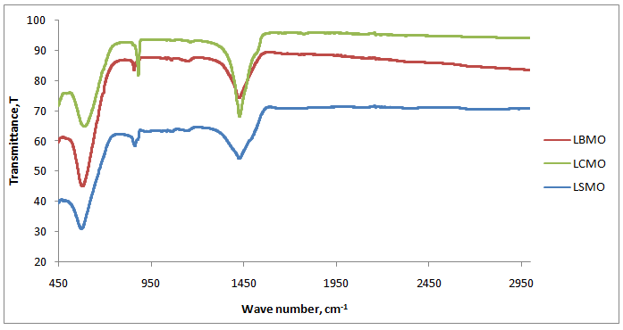

Fig.5: FT-IR spectral patterns of various prepared samples

**Optical properties:**

The band gap energies of the doped perovskites were evaluated from the UV–VIS spectra by using the earlier methods [23]. Considering the results of the band gap energy, the synthesized samples were found to be promising candidates for use in photocatalytic activities.The efficiency of photocatalytic degradation of the perovskite samples on MB dye was studied [26,27] with the help of eqn(1):

D % = (A0 – A) / A0 × 100 (1)

where A0 is the initial absorbance of MB solution and A shows the absorbance at time t.

The degradation efficiencies of the samples on organic dye(MB) over time intervals were represented in Table-3.

Table-3: Percentage of Degradation of MB

|  |  |  |  |
| --- | --- | --- | --- |
| Time, min | % Degradation in visible light | | |
| LCMO | LBMO | LSMO |
| 0 | 52.07 | 35.42 | 42.06 |
| 20 | 59.07 | 38.79 | 44.53 |
| 40 | 60.70 | 41.68 | 47.64 |
| 60 | 63.61 | 42.32 | 48.47 |
| 80 | 66.01 | 44.58 | 52.01 |
| 100 | 68.52 | 47.92 | 54.87 |

The photocatalytic absorbance of MB of the different catalysts (LCMO, LBMO, and LSMO) at room temperature in visible light is shown in Fig.6a–c, respectively.Forall the three samples, the maximum absorbance reveals at 675 nm wavelength and It was ascertained that the value decreases with increase in irradiation time in all the cases suggesting good photocatalytic activities of the prepared perovskites. Fig.6 shows photocatalytic absorbance of doped samples along with undoped one(LMO) after 100 min of irradiation.The figure indicated lowest absorbance in case of Ba doping and hence highest photocatalytic behaviours.The activity follow the order

LBMO > LSMO > LCMO > LMO.

Fig. 6: Photocatalytic absorbance of prepared samples after 100 mins of irradiation

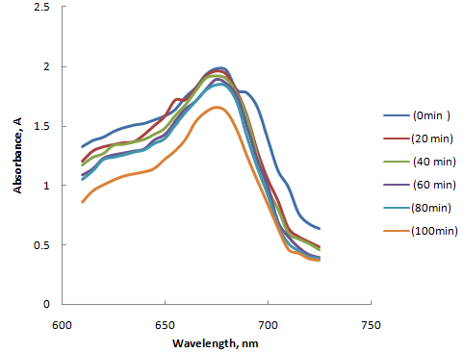

Fig. 6(a):Absorbance curves of MB at different time intervals using LCMO as catalyst

Fig. 6(b): Absorbance curves of MB at different time intervals using LBMO as catalyst

Fig. 6(c): Absorbance curves of MB at different time intervals using LSMO as catalyst

The absorbance of Dye(MB) solution decreased with increasing time of exposure to the light indicating the decrease in concentration and hence increase in degradation (Fig-7). The percentage of degradation increased with irradiation time. However it was observed thathighest rate of photodegradation was effected in 20 min of irradiation in case of ‘Ca’ whereasin case of ‘Sr’ and ‘Ba’the time was 40 min. Figure 7(a) shows the effect of irradiation time on photocatalytic degradation of methylene blue in all the cases. The decomposition steadily increased with time of irradiation up to 100 min and 68.52% of degradation was achieved in case of ‘Ca’ as dopant whereas for Sr and Ba the degradation percentage were 54.87% and 47.92% respectively. As the time of irradiation increased, the interaction of dye molecules increased with the surface of the photocatalyst thereby increasingthe photodegradation efficiency [28- 30]. A shorter time interval 100 min was chosen in order to achieve faster rate of degradation within a short period of time.

Fig-7: Degradation percentage of Methylene Blue in presence of synthesized photocatalysts under visible light irradiation)

Fig-7(a): Degradation percentage of Methylene Blue in presence of synthesized photocatalysts under visible light irradiation

**Kinetics of photodegradation:**

The kinetics and rate constants were analyzed with the help of Eq. 2[31,32].

ln (A∕A0) = −*kt*, .....................................................(2)

where A0 is the initial absorbance, A is absorbance after time t, and k is rate constant; the plot of ln(A/A0) against the time t is linear according to Eq. 2.

Fig.8: Variation of ln A/A0 with time ‘t’ for the degradation kinetics using different perovskites as photocatalysts.

Fig.8a: Variation of ln A/A0 with time ‘t’ for the degradation kinetics using perovskite, LMO with no doping as photocatalysts.

Thus, the values of ‘k’ were obtained directly from the slopes (Fig.8a) and was presented along with degradation efficiency after 100 mins of irradiation with visible light[fig.9].The ‘k’ values for the prepared perovskite samples were presented in Table-4.

Table-4: Rate constant and degradation percentage of samples exposed to visible light after 100 mins

|  |  |  |
| --- | --- | --- |
| Perovskite Samples | % Degradation | Rate constant k, min-1 |
| LMO | 42.63 | 0.001538 |
| LCMO | 68.52 | 0.001582 |
| LSMO | 54.87 | 0.003952 |
| LBMO | 47.92 | 0.006684 |

Since the concentration of MB solution is directly proportional to the absorbance, the pseudo first order rate constant, k was estimated from the slopes of the linear plots (Fig-8a). The linearity of the

plots for definite MB concentrations, proved the applicability of the Langmuir–Hinshelwood equation for the photocatalytic degradation of MB.

Fig.9: Rate constants of degradation of MB using both doped and undoped perovskite samples.

By substituting La with a divalent M2+cation, Mn4+ions can be introduced into LaMnO3[30]. Since the parent sample (LaMnO3*)* was Mn3+-rich, La1−*x*M*x*MnO3 (La3+1−*x*M2+*x*Mn3+1−*x*Mn4+*x*O3) with mixed-valence Mn3+and Mn4+played a major role inthe electronic structure of this sample. The catalytic activity of the investigated perovskites may be correlated with the presence of the active oxygen species (O 2‾, O2• ‾, O ‾ ) determined by the structural defects generated due to high Mn4+/Mn3+ ratio in the perovskite structure. Thus La1−*x*M*x*MnO3 compound is called hole-doped manganite perovskites and the hole doping plays a role of shifting down to the Fermi level so that the conduction and valence band behaviour occurs [32].Thus, the coexistence of electron and hole in manganites, introduce them as promising materials in optical devices.

As well known, OH• radicals degrade dye molecules into simpler compounds (CO2 and H2O). The impact of irradiation time on the percentage of dye degradation can be seen in Fig. 7a. Looking at the curves it is ascertained that the amount of degraded OH• radicals increases with increasing irradiation time [33]. The photo-degradation originated when the visible light irradiated the catalyst, so the photodegradation mechanism of dye solutions is based on the redox reactions for perovskite samples. The photon energy (*hυ*) absorbed is equal to/or greater than the perovskite energy gap. During the photoexcitation process, the valence band (VB) electron jumps to the conduction band (CB) and lets h+ on VB, which reacts with the adsorbed OH− ions or the H2O on the perovskite surface, producing OH•.

hν + Catalyst → e CB‾ + hVB+ [i]

H2O → H+ + OH‾ [ii]

OH- + hVB+ → OH• [iii]

e CB‾ + O2 → O2• ‾ [iv]

O2• ‾ +H+ → HO2• [v]

2 HO2• → 2H2O2 + O2 [vi]

H2O2 → 2 OH• [vii]

MB + OH• → degraded product + H2O + CO2 [viii]

Introduction on of Ca in to Lanthanum manganite has already been reported[34] which signified almost 68.52% of degradation after 100 mins of illumination with a pseudo first order rate constant of 1.582 x 10-3min-1. Introduction of largercations (Sr, Ba) stabilizes the metallic state with an increased metal-insulator transition temperature. The introduction of a smaller cation (Ca) leads to an insulating state with increased resistivity attributed to the fact that smaller cationic size decreases the Mn-O-Mn bond angle and which in response decreases the double exchange(DE) mechanism between Mn-Mn ions[22].

**Photocatalyst reusability**

The reusability of thesynthesized sampleswere investigated by recycling the solidsamples after the photocatalyticdegradation under visible-light irradiation. The photocatalystswere collected after each run and washed with 0.01 MH2SO4 solution and an excess amount of deionized water. In each run, the photocatalytic activity of thesolid sample was examined in the same condition as mentionedbefore up to 100 minutes and as shown in Fig-10. The results showed thatthis material could retain its photocatalytic activity for at leastfive reaction cycles.

(Fig. 10:Reusability of the LCMO sample)

**Conclusion**

In this study La0.7Ca0.3MnO3 ,La0.7Sr0.3MnO3 and La0.7Ba0.3MnO3  nano perovskite was synthesized by a simple Sol-Gel method followed by heat treatment at 800 0C. XRD showed that the obtained sample had perovskite structure. SEM showed micrometer sized randomly distributed crystal particles. Using Tauc’s equation band gap energy values were found out which were in the range of photocatalytic activitiywith visible light irradiation. The photocatalytic activities were investigated by degradation of MB in aqueous solution under visible light irradiation which revealed efficient photocalytic activities. The photodegradation efficiency for decolorising MB solution (5 ppm) by using doped lanthanum manganite(0.07 g l-1) after 100 min of illumination, was about 68.52 % , 54.87% and 47.92% respectively using Ca, Sr and Ba respectively. But reaction rate determination resulted in reverse trend with highest rate constant 6.684 x 10-3 min-1in case of Ba doping.. The result indicate that although Ba doping had best catalytic activity among the three, but with increase in time of irradiation Ca show highest degradability.

Disclaimer (Artificial intelligence)

Option 1:

Author(s) hereby declare that NO generative AI technologies such as Large Language Models (ChatGPT, COPILOT, etc.) and text-to-image generators have been used during the writing or editing of this manuscript.

Option 2:

Author(s) hereby declare that generative AI technologies such as Large Language Models, etc. have been used during the writing or editing of manuscripts. This explanation will include the name, version, model, and source of the generative AI technology and as well as all input prompts provided to the generative AI technology

Details of the AI usage are given below:

1.

2.

3.

**References**

[1] S. Tao, J.T.S. Irvine, J.A. Kilner, Adv. Mater.,17, (2005) 1734–1737.

[2] J. Kim, D.W. Hwang, H.G. Kim, S.W. Bae, J.S. Lee, W. Li, S.H. Oh, Top. Catal., 35, (2005) ,295–303.

[3] K. Ichimura, Y. Inoue, I. Yasumori, Catal. Rev. Sci. Eng.,34, (1992),301–320.

[4] L.A. Isupova, E.F. Sutormina, N.A. Kulikovskaya, L.M. Plyasova, N.A. Rudina, I.A.Ovsyannikova, I.A. Zolotarskii, V.A. Sadykov, Catal. Today ,105, (2005),429–435.

[5] Kuo J and Kai G S Chin. Phys., B 18,(2009),3035.

[6] N. Yi, Y. Cao, Y. Su, W.L. Dai, H.Y. He, K.N. Fan, J. Catal.,230, (2005), 249–253

[7] K. Stephan, M. Hackenberger, D. Kiessling, G. Wendt, Chem. Eng. Technol.,27, (2004),687–693.

[8] Y.N. Lee, R.M. Lago, J.L.G. Fierro, V. Cortes, F. Sapina, E. Martinez, Appl. Catal.,A207,(2001),17-24.

[9] R.M. Lago, F.C.C. Moura, M.H. Araujo, J.D. Ardisson, W.A. Macedo, A.S. Albu-querque, J. Braz. Chem. Soc.,18,(2007), 322–329.

## [10] Yu Zhou, Xinde Zhu, Shengli Li,Effect of heat treatment condition on magnetic, electrical transport and magnetoresistance properties of La0.67Sr0.33MnO3 manganite coatings; [Ceramics International](https://www.sciencedirect.com/journal/ceramics-international)[, 44](https://www.sciencedirect.com/journal/ceramics-international/vol/44/issue/13), (2018), 15010-15018

[11] R. D. Kumar, R. Thangappan, and R. Jayavel, "Enhanced visible light photocatalytic activity of

LaMnO 3 nanostructures for water purification," *Research on Chemical Intermediates,* ,44,(2018), 4323-4337,.

[12] B. Barrocas, S. Sério, A. Rovisco, Y. Nunes, and M. M. Jorge, "Removal of rhodamine 6G dye contaminant by visible light driven immobilized Ca1-xLnxMnO3 (Ln= Sm, Ho; 0.1< x<0.4) photocatalysts," Applied Surface Science,,360, (2016), 798-806,.

[13] Sakamoto M, Ahmed T, Begum S, Huq H Water pollution and the textile industry in Bangladesh: flawed corporate practices or restrictive opportunities. Sustainability,11,(2019), 1951

https:// doi. org/10. 3390/ su11071951

[14] Gowthami K, Suppuraj P, Thirunarayanan G, Krishnakumar B, Sobral AJFN, Swaminathan M, Muthuvel I Fe2V4O13 assisted hetero-fenton mineralization of methyl orange under UV-A light irradiation. Iran Chem Commun, , 6,(2018), 97–108

[15] Guillaume PLA, Chelaru AM, Visa M, Lassine O Titaniumn oxide-clay as adsorbent and photocatalysts for wastewater treatment.J Membr Sci Technol, 8,(2018),1000176.

https:// doi. org/ 10.4172/ 2155- 9589. 10001 76

[16] Kanakaraju D, Wong SP Photocatalytic efficiency of TiO2-biomass loaded mixture for wastewater treatment. J Chem ,2018, ID 4314969. https:// doi. org/ 10. 1155/ 2018/ 4314969

[17] A.Yerkinova, G.Balbayeva, V.J.Inglezakis, S.G. Poulopoulos,Photocatalytic treatment of a synthetic wastewater. IOP Conf Series: Mater Sci Eng ,301,( 2018), 12143–12148.

https:// doi. org/ 10. 1088/ 1757-899X/ 301/1/ 012143

[18] Anandan K, Rajesh K, Gayathri K, Vinoth Sharma S, Mohammed Hussain SG, Rajendran V Effects of rare earth, transition and post transition metal ions on structural and optical properties and photocatalytic activities of zirconia (ZrO2) nanoparticles synthesized via the facile precipitation process. Physica ,, E 124, (2020), 114342.

https:// doi. org/ 10. 1016/j. physe. 2020. 114342

[19] Esmaeili S, Ehsani MH, Fazli M Structural, optical and photocatalytic properties of La0.7Ba0.3MnO3 nanoparticles prepared by microwave method. Chem Phys, 529, (2019), 110576 https:// doi. org/ 10. 1016/j. chemphys. 2019.110576

[20] Ismail D, Bahnemann W, Robben L, Yarovyi V, Wark M Chem Mater, 22, (2010), 108–116

[21] Mohamed H. Ghozza , Ibrahim S. Yahia , Mai S. A. Hussien, Structure, magnetic, and photocatalysis of La0.7Sr0.3MnO3(M = Mn, Co,and Fe) perovskite nanoparticles: Novel photocatalytic materials. Environmental Science and Pollution Research,30, (2023), 61106-61122

<https://doi.org/10.1007/s11356-023-26411-9>

[22] Asma Khalid, Saadat Anwar Siddiqi, Affia Aslam, Synthesis and Characterization of Alkaline-Earth Metal (Ca, Sr, and Ba) Doped Nanodimensional LaMnO3 Rare-Earth Manganites, CHIN. PHYS. LETT. ,30(2013), 077501.

DOI: 10.1088/0256-307X/30/7/077501.

[23].F. R. Afje and M. Ehsani, "Size-dependent photocatalytic activity of La0.8Sr0.2MnO3 nanoparticles prepared by hydrothermal synthesis," Materials Research Express, 5,(2018), 45012. **DOI** 10.1088/2053-1591/aaba51

[24]. M. Behpour and V. Atouf, "Study of the photocatalytic activity of nanocrystalline S, N-codoped TiO2 thin films and powders under visible and sun light irradiation," Applied Surface Science, 258, (2012), 6595-6601

[25] M. Khazaei, A. Malekzadeh, F. Amini, Y. Mortazavi, A. Khodadadi, Effect of citric acid concentration as emulsifier on perovskite phase formation of nano-sized SrMnO3 and SrCoO3 samples, Cryst. Res. Technol. 45,(2010) ,1064–1068.

[26] A. Arabi, M. Fazli, and M. Ehsani, "Synthesis and characterization of calcium-doped lanthanum manganite nanowires as a photocatalyst for degradation of methylene blue solution under visible light irradiation," Bulletin of Materials Science, 41, (2018) ,77, .DOI[10.1007/s12034-018-1590-6](http://dx.doi.org/10.1007/s12034-018-1590-6)

[27] Hassan AE, Hussien MSA, Elsayed MH, Mohamed MG, S-W Kuo,H-H Chou, Yahia IS, Wang G, Wen Z , One-step construction of Y, C, and O tridoped g-C3N4 as a bifunctional photocatalyst for H2 evolution and organic pollutant degradation under visible light irradiation. Sustain Energy Fuels, 6(2022), 3858–3871

[28].H. Lachheb, E. Puzenat, A. Houas, M. Ksibi, E. Elaloui, C. Guillard, J.M. Herrmann, Photocatalytic degradation of various types of dyes (Alizarin S, Crocein Green G, Methyl Red, Congo Red, Methylene Blue) in water by UV-irradiated titania, Appl. Catal. B: Environ. 39,(2002) ,75–90.

[29]. W. Baran , A. Makowski, W. Wardas, The influence of FeCl3 on the photocatalytic degradation of dissolved azo dyes in aqueous TiO2 suspensions, Chemosphere, 53, (2003) ,87–95.

[30]. U.G. Akpan, B.H. Hameed, Parameters affecting the photocatalytic degradation of dyes using TiO2-based photocatalysts: A review, Journal of Hazardous Materials, 170,(2009) ,520–529

[31] Hussien MSA, Mohammed MI, Yahia IS, Flexible photocatalytic membrane based on CdS/PMMA polymeric nanocomposite films: multifunctional materials. Environ Sci Pollut Res. 27, (2020) ,45225-45237

https://doi. org/ 10. 1007/ s11356- 020- 10305-1

[32] Hussien M.S.A, Mohammed M.I, Yahia I.S Multifunctional applications of grapheme-doped PMMA nanocomposite membranes for environmental photocatalytic. J InorgOrganomet

Polym Mater. 30, (2020), 2708-2719. https:// doi. org/ 10. 1007/ s10904- 019- 01433-4

[33] Rahmayeni R, Oktavia Y, Stiadi Y, Arief S, Zulhadjri Z , Spinelferrite of MnFe2O4

synthesized in Piper betle Linn extract mediaand its application as photocatalysts and antibacterial. J DispersionSci Technol., 42(2020 , 1-10

https:// doi. org/ 10.1080/01932691.2020.1721011

[34] H.Nayak, B.Padhi: Degradation of methylene blue using Ca-doped LaMnO3 as a photocatalyst under visible light irradiation. Results in Chemistry,6,(2023), 101104. <https://doi.org/10.1016/j.rechem.2023.101104>