Measuring Spatial Vitality and Its Influencing Factors in Traditional Neighborhoods Using Multi-source Data: A Case Study of Zhengzhou Xidajie

.

ABSTRACT

|  |
| --- |
| With the progress of urban development, the spatial quality of urban streets has become one of the key concerns. In view of the actual new needs of urban micro-renewal, this study takes the street accessibility, regional accessibility and other aspects, takes Zhengzhou West Street Area as a case study, extracts the elements of street space based on the street view image data, combines the artificial intelligence technology with the sDNA spatial accessibility grid analysis technology, and synthesises the classification and scientific analysis of the cutting-edge urban data such as the urban street walkability index system, and based on this, proposes the street vitality optimisation strategy for historical blocks. Based on this, we propose the optimisation strategy of street vitality in historic districts, and provide technical support for urban micro-renewal in terms of analysis and theory. |

*Keywords: urban streets; multivariate data; sDNA; spatial accessibility*

1. INTRODUCTION

　　As China's urbanization enters a stage of high-quality development, the evaluation of urban street quality[1] has become an important topic to promote sustainable urban development. Streets, as one of the main carriers of urban residents' lives, play a key role in improving the quality of life, enhancing environmental quality, and driving economic development. However, there are evident issues in the current process of micro-renewal of old urban blocks[2], namely the chaotic street scales in old city areas and significant differences in the spatial vitality values of streets. Traditional urban streets, as important public spaces, carry the main communication and activities of residents and tourists, and are also a concentrated display of urban life and character. Therefore, there is a need to study urban streets that urgently need revitalization to determine the characteristic attributes of their street vitality. Moreover, analyzing which factors influence and limit the vitality values of streets[3] is of significant importance for revealing the essential connotations and patterns of the distribution of vitality in urban block streets. This provides theoretical support for optimizing the renewal of traditional urban blocks. However, past urban planning and design often lacked scientific evaluation methods and data support, making it difficult to comprehensively and objectively measure the quality of urban streets, and thus guide urban development and improvement. In recent years, with the rapid development of big data and new analytical technologies, new possibilities have emerged for the evaluation of urban street quality. Among these, the structural and spatial network analysis (sDNA) analysis technology has shown great potential in the field of urban planning and design. sDNA data analysis technology[4] can comprehensively consider multiple factors such as transportation networks, social networks, and spatial distribution, quantitatively assess the interconnectivity and accessibility of urban streets, and provide scientific decision-making support for urban planners and designers.

　　Against the current backdrop, China's urbanization has entered a stage of high-quality development, and urban design[5] faces urgent demands and transformational trends. Traditional urban planning methods can no longer meet the increasingly complex needs of urban development, making new evaluation methods and analytical tools imperative. This paper aims to explore the vitality assessment and measurement analysis of urban streets, and by integrating sDNA data analysis technology, to provide new directions for urban design. Taking the West Street area of Zhengzhou as an example, this paper details the research methods, including data collection and processing, the application process of sDNA data analysis and artificial intelligence data training. We will use empirical research and case analysis methods, combining specific urban data and contexts, to verify and explore the effectiveness and feasibility of new analytical technologies in the evaluation of urban street quality. The research in this paper will provide theoretical and practical guidance for the high-quality development of the urbanization process, making a positive contribution to improving the quality of life[6] for urban residents and promoting sustainable urban development.

1. Frontier technologies drive the measurement and design optimization of urban street vitality

2.1Urban Street Space Development under the New Era of Urban Development

2.1.1The Historical Evolution of Chinese Street Spaces

In the historical process of urban development in China, street spaces[7] play a crucial role. As an important carrier of urban transportation and social activities, streets not only connect various urban functional areas but also carry the heritage of urban culture, history, and social relations. The evolution and development of street spaces reflect the historical changes of urban development and embody the transformation of urban planning concepts and social needs from different periods. In ancient Chinese cities, street spaces typically exhibited orderly and well-arranged characteristics. Ancient urban planning focused on the layout and design of streets, pursuing overall harmony and balance. For instance, the traditional hutongs[8] and quadrangle courtyards in Beijing reflect a rigorous urban planning philosophy and social structure. The narrow and winding form of streets not only adapted to the transportation needs of the time but also could form spaces for social interaction and community sharing.

2.1.2New Developments in Street Space Guided by New Technology Analysis

As the modernization process advances, Chinese cities have undergone rapid urbanization and industrialization. In recent years, with the increased attention to urban environment and historical and cultural preservation, the streets of Chinese cities have begun to regain their historical value and significance. Urban planners and designers are increasingly focusing on the protection and renovation of street spaces to restore and rebuild the charm and vitality of traditional streets. Traditional evaluations of street vitality often rely on subjective and experiential judgments, lacking objective and scientific bases. However, new artificial intelligence data analysis technologies provide a fresh perspective and method for the evaluation of streets and street architecture. By collecting and analyzing large-scale urban data, artificial intelligence can reveal information about the usage of street spaces, pedestrian and vehicle traffic, traffic congestion, and more, providing objective data support for assessing street quality. The application of new artificial intelligence data analysis technologies not only enhances the objectivity and accuracy of street evaluations but also brings new directions for the design of contemporary architectural streets. Through in-depth analysis and data mining, urban planners and designers can better understand the characteristics and needs of street spaces, optimize design plans, and enhance the quality of life for urban residents and the overall image of the city. In some cities, by preserving and restoring historical buildings, improving pedestrian environments, and providing leisure facilities, street spaces are becoming important venues for urban residents' lives and the center of community activities.

2.1.3Multi-source Data and New Technology Support Urban Street Evaluation Method

2.1.3.1Big Data Analysis

Big data[9] plays a significant role in the analysis of urban street spaces. By collecting and analyzing large-scale urban data, such as traffic flow, population movement, and air quality, it is possible to gain a deep understanding of how streets are used and their characteristics. Big data analysis can reveal street congestion, hotspots, and peak times, thereby providing data support for improving traffic flow and optimizing road network layouts. Moreover, big data can help uncover information about urban residents' travel preferences[10] and consumption habits, offering reference for the layout and design of commercial streets and related facilities. By applying artificial intelligence algorithms, such as machine learning and deep learning, the automation of street space identification and classification can be achieved. Based on image recognition technology, analysis of architectural styles and historical and cultural features of streets can be conducted, providing a basis for the cultural preservation and historical revival of streets. Furthermore, by analyzing data on pedestrian and vehicle flows, the use efficiency and population distribution of streets can be predicted and optimized, offering guidance for improving the pedestrian environment and enhancing traffic safety.

2.1.3.2Analysis of Database and Neural Network Establishment and Analysis

Establish an analytical database and analytical models to discover hidden patterns and regularities from a vast amount of street data. By training neural network models, automatic identification and classification of street spaces can be achieved, evaluating their performance in terms of accessibility, convenience, and landscape value. Moreover, artificial intelligence data analysis can also integrate image recognition and semantic analysis techniques to deeply explore the style, function, and cultural connotations of street architecture, providing strong guidance and insights for the design of modern architectural streets.

3. Research methods and objects

3.1Research Background

As urban design gradually evolves into the fourth generation paradigm, computational design methods are maturing, bolstered by purpose-driven, machine learning, and algorithmic iteration techniques. Urban design has more innovative applications in focusing on large-scale urban areas as well as on the community, neighborhood, street, and square scales at the meso-micro level. Examples of large-scale computational urban design practices include the study of the height morphology of Nanjing's old town, the overall urban design of Guangzhou, and the Shenzhen digital urban design and control platform. Although these practices can cover data accuracy and scope at the meso-micro level, their primary goal is to connect urban-level planning and management policies, conducting agile analysis from a top-down perspective. In contrast, urban renewal at the meso-micro level is constrained by higher-level planning control conditions and is more directly related to the interests of the government, developers, and residents. However, traditional methods have many limitations. First, they overly rely on the subjective experience of designers, and obtaining population and economic data at the neighborhood scale is very difficult, which leads to the design team's inability to fully understand and assess problems in a large area within a short time, resulting in a "disconnection" between local projects and the overall system. Second, due to defects in data fitting, scenario simulation, and human-centric spatial perception accuracy in traditional techniques, it is difficult to scientifically and deeply develop strategies. Third, constrained by technological limitations, traditional methods are not effective in conducting post-construction project evaluations, leading to constant modifications of plans and resulting in resource waste. Therefore, based on computational analysis techniques, there is an urgent need to explore effective practical methods at the urban design level on the meso-micro scale.

3.2Research Methodology

3.2.1Conceptual Definition

Streets are public spaces[11] within cities, serving as significant venues for urban social vitality and facilitating communication and activities among people. Unlike traffic arteries where vehicles constantly pass through, streets focus on the activities people engage in on them. The vitality of a street is reflected in the level of participation and the diversity of activities. A vibrant street can meet the needs of different groups, offering a rich array of experiences and social opportunities. As urban public spaces, streets carry the vitality of urban society, promoting communication and activities among people, with their vitality expressed through the degree of participation, the frequency of activities, and the diversity of activity content. The core elements of street vitality are the intensity, frequency, and diversity of types of human activities.

3.2.2Research subject

The West Street area in Zhengzhou is located at the northwest corner of the Guancheng Hui Autonomous District in Zhengzhou, Henan Province. It is named after the site of the ancient Guan state capital during the Spring and Autumn period. Presently, the Guancheng Hui Autonomous District is situated in the southeast part of the main urban area of Zhengzhou. It borders Xinxing City to the south and is adjacent to the Jinshui District to the north. The terrain is generally higher in the southwest and lower in the northeast, with an incline of approximately 2%, and the elevation ranges between 100 to 150 meters. The site is close to the central area of Zhengzhou, with a square base, and is adjacent to the main urban artery, Zijing Mountain Road, on the east side. The site is dividedby East Street and West Street, and by South Street and Guancheng Street. The surrounding streets are under the jurisdiction of the Shangcheng Road, West Street, Beixia Street, and East Street administrative areas. Due to the influence of the old city protection policies, the texture of the Guancheng District and the appearance of the buildings along the streets have been well preserved.

3.2.3Research Methodology

This study constructs an evaluation index system for the vitality of streets in historical districts by combining survey data and open-source data. Through field research and analysis of street vitality indices, it distributes the characteristics of street vitality. Then, we will adopt a stepwise multiple linear regression method to reveal specific factors affecting street vitality and propose targeted strategies for optimizing the built environment based on the analysis results.

The research methodology includes current situation investigation, data collection, and modeling analysis. Through this process, a comprehensive understanding of the current vitality of historical district streets is achieved, and the potential for their development is deeply explored. By evaluating various indicators of street vitality, we will provide targeted strategies for optimizing the built environment to promote the enhancement of street vitality. Using methods such as "multi-source data," "big data," and "sDNA data analysis," we combine keywords related to street space such as "street scale," "resident behavior," and "spatial evaluation." Utilizing new technologies, this study is divided into three directions: —— data visualization analysis, geographic data analysis, and spatial evaluation analysis.

3.2.4Data source

The acquisition of basic data encompasses both field survey data and open-source data from the internet. Field surveys record data on human activities, street interface data, the quantity of street facilities, street view photos, and the distribution of historical resource points. Open-source data on the internet includes traffic flow information and traffic mobility information. Field survey data for streets includes street interface size data, which records the length, width, building alignment rate, height of buildings along the street, and the length of continuous street wall facades for major streets in the West Street area. By crawling open-source data, such as the road network grid images from Gaode Maps, basic street data is obtained. In ArcGIS, the collected map road network grid images are vectorized according to the actual connection situation, converting them into vector data for subsequent spatial syntax analysis. The sDNA is used as an improved spatial syntax program to analyze the street network. In this analysis, "closeness" is interpreted as the potential of a space to be a destination relative to other spaces for travel, while "throughness" is interpreted as the potential of a space to be a travel path relative to other spaces. Street accessibility is based on path analysis within the street network to assess the number and quality of destinations reachable within walking distance, using selected walking times (5 minutes, 10 minutes, and 15 minutes) as the radius for the sDNA analysis to calculate street accessibility. Through the above data acquisition and analysis methods, a comprehensive street vitality evaluation index system is constructed. Built environment optimization strategies: Using the research results, propose built environment optimization strategies based on actual data. For　planning, and improvement, to enhance street accessibility and vitality[12], and optimize people's travel methods and experiences.

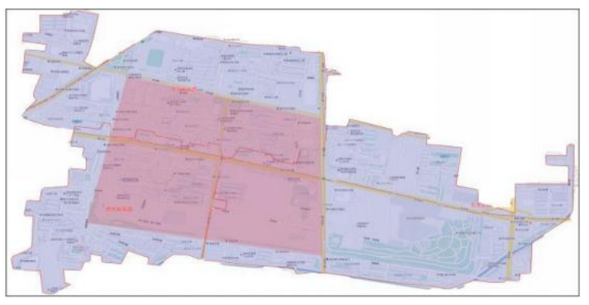

**Figure 1: Research Subject**

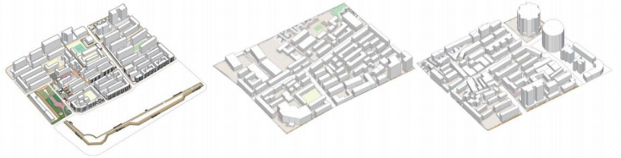

**Figure 2. Research Case Modeling**

4.Traditional Urban Street Vitality Measurement Analysis

4.1Data collection and analysis

4.1.1Regional Population Analysis

Danish architect Jan Gehl categorizes pedestrian activities into necessity activities, spontaneous activities, and social activities. These activity types reflect the atmosphere and environment of the street and whether it supports the occurrence of diverse activities.

In this study, a network big data platform such as the Gaode Map big data platform was utilized to depict the street population profile, in order to understand the needs of the population. By analyzing the data, the characteristics, interests, and needs of the population were comprehended, thereby evaluating whether the street environment meets these needs. Through querying land use functions and conducting passenger flow OD analysis, the initial understanding of the street's site characteristics and human movement dynamics was achieved. This aids in understanding the usage of the street and the distribution of human traffic, providing a foundation for subsequent facility analysis. Utilizing POI data from Gaode Map, Dianping, and others, the street's shops[13], human traffic, street facilities, and vehicle flow were analyzed. This can assess the supply level of different types of facilities and match them with the population's activity needs. Accompanied by field research and questionnaire surveys, more direct information about street vitality and population needs was obtained. During the field research, the street environment, population behavior, and types of activities were observed. Through the questionnaire survey, the residents' opinions, needs, and suggestions regarding the street environment and facilities were understood. According to the results of the questionnaire survey, the Xidajie area has a relatively large number of elderly people who engage in leisure activities in small parks, such as square dancing, chess, walking, and exercising. Additionally, the research revealed a lack of humanized places in the neighborhood, such as fewer public activity spaces[14], incomplete accessibility facilities, and obstructed fire and blind person pathways. These factors may lead to a loss of street vitality.

4.1.2Street Space Data Visualization

By utilizing street data from OpenStreetMap, including road networks, street names, and street attributes, analysis and research on street spaces can be conducted. Through the use of OSM data, researchers can obtain information such as the geometric shape, length, and connectivity of streets, which enables network analysis, traffic flow simulation, and road classification research. Importing street data into ArcGIS forms a visualization of multiple data sources, such as satellite imagery, spatial databases, and sensor data, to acquire street data. With ArcGIS's spatial analysis tools, operations such as visualization, attribute querying, and spatial association analysis can be performed to deeply study the characteristics and influencing factors of streets. Furthermore, drone aerial photography technology can capture more detailed street data, including building heights and road conditions. In addition, urban traffic management departments, local governments, and third-party data providers may also provide data on street traffic flow, road conditions, traffic accidents, and more, to establish a multi-source data collection for streets.

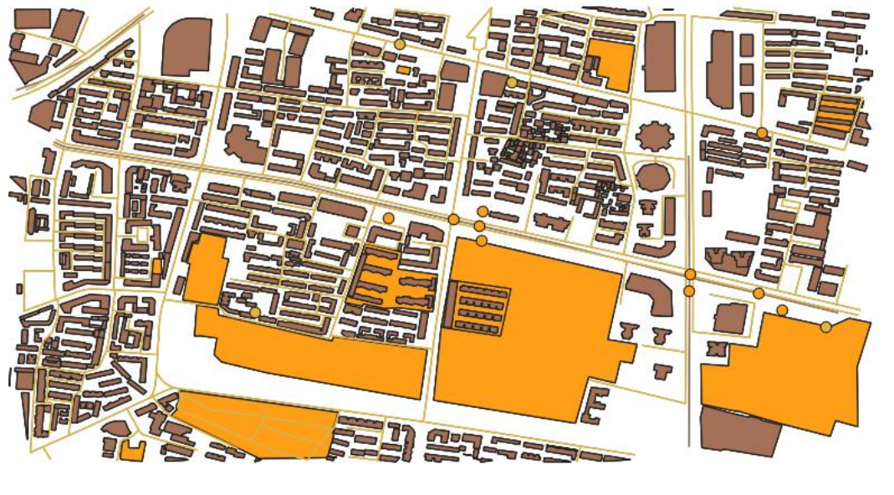

**Figure 3. Spatial GIS Visualization**

4.1.3Street Vitality Index

Street vitality is a rather subjective evaluation indicator, and it is difficult to determine the specific impact of various indicators on street vitality through objective weighting methods. In this study, statistical averaging was adopted, and software machine learning was used to assign values to street sections. During this process, multiple scoring results were obtained through calculation, and their arithmetic mean was used as the weight for the three indicators. To ensure the comparability of the data, mean normalization processing was performed on the indicator data. Weighted summation was performed on the normalized data to calculate the street vitality index. The specific calculation formula is as follows: Street Vitality Index = (0.5 * Normalized Population Density) + (0.3 * Normalized Number of Commercial Facilities) + (0.2 * Normalized Public Space Area)

**Table 1: Street Vitality Evaluation System**

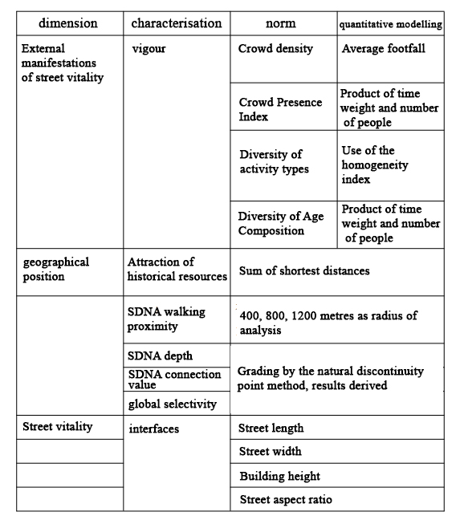

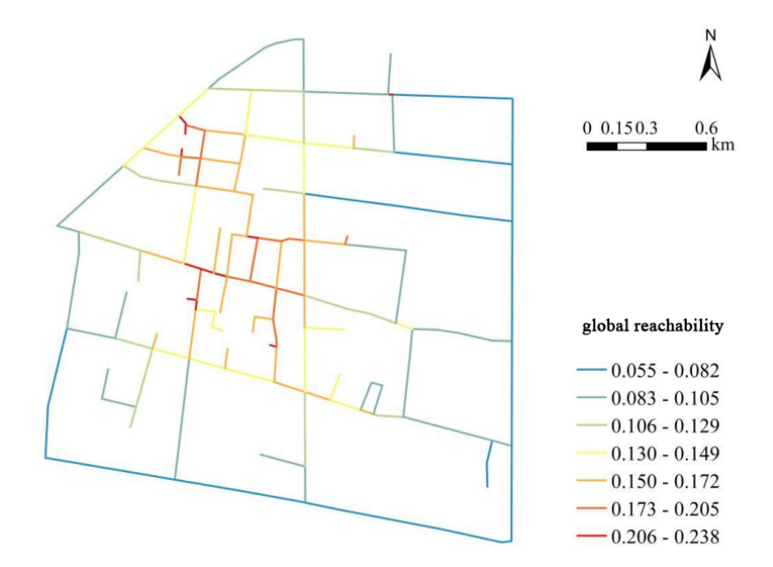

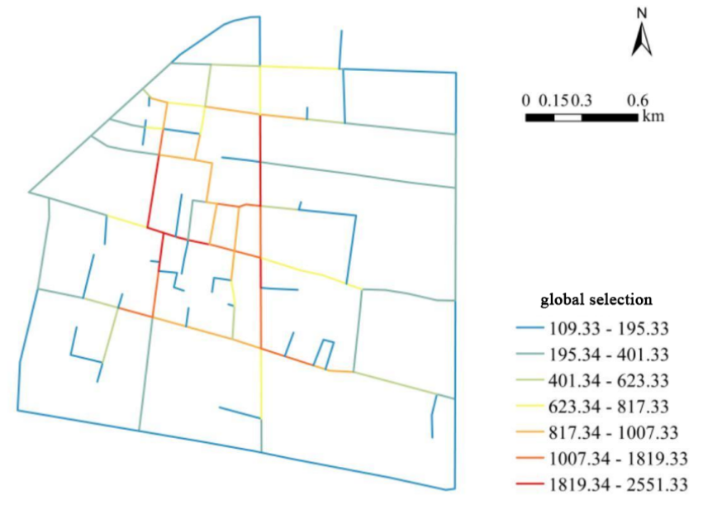

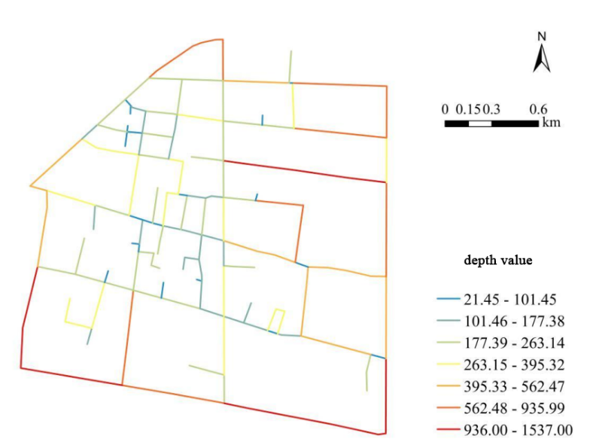

**Figure 4. SDA Analysis**

5. Conclusion

　　The research results show that the vitality of the West Street area exhibits a spatial distribution characteristic of high vitality in the southeast and low vitality in the northwest, with an obvious uneven distribution of vitality. This study takes the West Street area of Zhengzhou as an example, adopts multi-source data analysis technology to measure the spatial vitality of traditional blocks, and studies the factors affecting the vitality of the blocks. Through the analysis of indicators such as the accessibility of streets, functional density, and street scale, the spatial distribution characteristics and influencing factors of block vitality are revealed. By crawling map road network raster images and vectorizing them, spatial syntax analysis is performed using the sDNA software. This method quantifies and visualizes spatial morphological relationships, helping researchers understand the connection situation and vitality potential of streets. Regression analysis is performed on the acquired data to reveal the impact of various factors on block vitality. Combining planning and design theories and methods, this study proposes a series of optimization strategies from the perspective of architectural and urban design, such as improving street environments, enriching block businesses, and strengthening street space guidance. These strategies are based on the latest theories of urban planning and design, aiming to enhance the attractiveness and vitality of the blocks. Through these studies, urban historical block optimization strategies can be further implemented, such as improving pedestrian accessibility, encouraging the creation of public open spaces, and enriching business types. Thus, a spontaneous awareness of inheriting the essence of historical culture can be formed among the entire population and society, allowing urban blocks to not only undertake urban production and communication activities, inherit urban cultural values, but also create vibrant public space types, providing residents with a good living environment.

Disclaimer

Author(s) hereby declare that NO generative AI technologies such as Large Language Models (ChatGPT, COPILOT, etc.) and text-to-image generators have been used during the writing or editing of this manuscript.

References

1. Park, K.; Ergan, S. Quantification of the impact of street design features on restorative quality in urban settings. *Sustainable Cities and Society* **2025**, *121*, 106216, doi:<https://doi.org/10.1016/j.scs.2025.106216>.

2. Liang, Y.; Qian, Q.K.; Li, B.; An, Y.; Shi, L. A critical assessment on China’s old neighborhood renovation: Barriers analysis, solutions and future research prospects. *Energy and Buildings* **2025**, *332*, 115407, doi:<https://doi.org/10.1016/j.enbuild.2025.115407>.

3. Jiang, Y.; Han, Y.; Liu, M.; Ye, Y. Street vitality and built environment features: A data-informed approach from fourteen Chinese cities. *Sustainable Cities and Society* **2022**, *79*, 103724, doi:<https://doi.org/10.1016/j.scs.2022.103724>.

4. Cooper, C.H.V.; Chiaradia, A.J.F. sDNA: 3-d spatial network analysis for GIS, CAD, Command Line & Python. *SoftwareX* **2020**, *12*, 100525, doi:<https://doi.org/10.1016/j.softx.2020.100525>.

5. Xu, X.; Zhou, S.; Xu, H.; Wu, Z. Advancing urban hub planning: A bibliometric analysis of concepts, effects evaluation, and spatial design. *Land Use Policy* **2025**, *152*, 107507, doi:<https://doi.org/10.1016/j.landusepol.2025.107507>.

6. Huang, Q.; Lin, S.; Guo, Y. Can energy transition improve the quality of life for the population?–Empirical analysis of 30 provinces in China. *Energy* **2024**, *313*, 133938, doi:<https://doi.org/10.1016/j.energy.2024.133938>.

7. De Gruyter, C.; Davies, L.; Li, X.; Jafari, A.; Yacoubian, A.; Amati, M. Measuring use of the street space in central city areas. *Journal of Transport Geography* **2025**, *125*, 104197, doi:<https://doi.org/10.1016/j.jtrangeo.2025.104197>.

8. Wang, Y.; Crompton, A.; Agkathidis, A. The Hutong neighbourhood grammar: A procedural modelling approach to unravel the rationale of historical Beijing urban structure. *Frontiers of Architectural Research* **2023**, *12*, 458-476, doi:<https://doi.org/10.1016/j.foar.2022.12.004>.

9. Kong, Y.; Li, Y.; Wan, B. Big data development, accounting information quality, and corporate innovation. *Finance Research Letters* **2025**, *78*, 107257, doi:<https://doi.org/10.1016/j.frl.2025.107257>.

10. Deng, J.; Yang, Y.; Li, T.; Gao, L.; Bachmann, C.; Chen, X. Unveiling Route Choice Preferences and Classifying Travelers Based on Distinct Travel Patterns Using Trajectory Data. *Case Studies on Transport Policy* **2025**, *19*, 101399, doi:<https://doi.org/10.1016/j.cstp.2025.101399>.

11. Pujinda, P.; Sirikhan, K.; Sanit, P. A bibliometric exploration of geospatial disparities and research dynamics in public spaces and urban health. *Cities* **2025**, *161*, 105884, doi:<https://doi.org/10.1016/j.cities.2025.105884>.

12. Wu, Y.; Mashhoodi, B.; Patuano, A. Effective street tree and grass designs to cool European neighbourhoods. *Urban Climate* **2025**, *61*, 102376, doi:<https://doi.org/10.1016/j.uclim.2025.102376>.

13. Fujii, N.; Watanabe, R.; Kokuryo, D.; Kaihara, T.; Son, M.; Doi, M.; Yoshida, Y.; Suzuki, Y. A Study on Store Location Optimization in Underground Shopping Street Using Human Flow Data - Verification of Advertisement Effect. *Procedia CIRP* **2022**, *112*, 17-21, doi:<https://doi.org/10.1016/j.procir.2022.09.017>.

14. Askarizad, R.; He, J. The role of urban furniture in promoting gender equality and static social activities in public spaces. *Ain Shams Engineering Journal* **2025**, *16*, 103250, doi:<https://doi.org/10.1016/j.asej.2024.103250>.