In-Situ Precipitated Calcium Carbonate in the Presence of Wood Flour and High Refined Old Corrugated Containerboard – A Handsheet Study

.

ABSTRACT

The paper and board industry strives to become more environmentally friendly by utilizing new eco-friendly raw materials that can improve production processes at the same time.
One solution for the board producing paper product segment is the utilization of nano fibrillated fiber material, the utilization of wood flour, and the production of In-Situ precipitated calcium carbonate.
The presented research project investigates on a laboratory scale the possibility of producing In-Situ precipitated calcium carbonate in the presence of old corrugated container fibers, nano fibrillated old corrugated container fibers and wood flour as an alternate additive for paper production process.
The laboratory experiments produced successfully In-Situ precipitated calcium carbonate in the presence of old corrugated fiber, nano fibrillated old corrugated fiber and wood flour material. In-Situ precipitated calcium carbonate could be produced at a level of 6.94%, 13.88%, and 20.83% regardless of the fiber material used.
Time for the precipitation was shorter for the lower level of In-Situ precipitated calcium carbonate, while higher level of In-Situ precipitated calcium carbonate increased up to over 9-fold for the old corrugated fiber, nano fibrillated old corrugated fiber and wood flour.
Fine retention for the old corrugated fiber material with In-Situ precipitated calcium carbonate containing wood flour was slightly lower than for the old corrugated fiber material with in-situ precipitated calcium carbonate. Nano fibrillated old corrugated fiber material with in-situ precipitated calcium carbonate had a approximately 40% higher fine retention ability then the old corrugated fiber material and the wood flour material, allowing that more In-Situ precipitated calcium carbonate material can be incorporated into the paper during sheet forming.
These findings suggest that ISPCC can be effectively produced with different fiber sources and may serve as an efficient filler for paper products, leading to improved performance and environmental sustainability.

Keywords: Additive, Beating, Bio additive, Cellulose Nano fibrillated, Old corrugated container board, paper, papermaking, Precipitated calcium carbonate, refining, sustainability,

1. INTRODUCTION

New solutions for utilizing raw materials in a more sustainable way in the paper and board producing industry are needed. Today’s challenges are raising raw material, energy, water, and additive cost, newly imposed environmental regulation and an ever-growing demand of consumers for environmentally and eco-friendly products. Therefore, the paper industry has the challenge to find and utilize new raw materials, improve existing and future production processes, increase biodegradability, reduce overall energy consumption, and lower the CO₂ footprint of the manufacturing operation at the same time. [1,2,3,4].
One of the possible solutions is the use of In-Situ Precipitated Calcium Carbonate (ISPCC) in the paper manufacturing process. This will allow the replacement of more expensive fiber materials with less expensive raw material.
In the 1970’s European paper manufacturers started to shifted from acid to alkaline papermaking to allow the use of calcium carbonate as filler material. North America followed in the 1980’s [5,6]. Since then, Calcium Carbonate both in ground and precipitated form has become the preferred filler material for printing and writing grades in the paper industry sector [3]. At present time paper products require worldwide approximately over 8 million tons of filler material [7].
In North America Calcium carbonate is the largest filler category with nearly 83% market share with Precipitated Calcium Carbonate (PCC) at 70% and Ground Calcium Carbonate (GCC) at 13%. The second most common filler type, with a market share of 15%, is Kaolin, Titan dioxide’s estimated market share is about 2%. The use of Silica / Silicates accounts for 0.3% and Talc and Aluminum Trihydrate together account for approximately 0.1% [7].
However, the PCC filler level is limited to a maximum of 20 to 25% depending on the paper grade used, and is mainly driven by production cost issues, because paper fillers materials are less expensive than fiber, allowing reduced production costs, improved optical paper properties, dimensional stability, and better sheet formation and printability as well as increased machine speed on the paper machine and coating application side [8].
However, applying filler material causes a decrease of the paper's strength, increases use of sizing and wet end agents, can create dusting problems and can lower the paper sheets product quality. [7,8,9]. Another serious problem is the loss of bulk and an increasing density of the paper product if filler levels are increased in paper product, because paper is sold in rims and pounds, meaning customers would get less paper product for the same price.
Over the last decades and today paper manufacturers attempted to increase the calcium carbonate based (CaCO₃) filler in a sheet of paper because of lower materials costs (calcium carbonate has lower cost than virgin pulp), lower operation costs (less energy consumption in the dryer step), and the improvement of some quality properties (opacity, brightness and printability) [10]. Associated production cost savings can reach over $ 4.0 for each 1% increase in filler content [11].
In commercial paper making applications GCC and PCC is presently applied in slurry or powdered form to the papermaking suspension in the blend chest in wet-end section of the paper mill and at the fan pump shortly before the fiber suspension is entering the paper machine headbox after which the sheet forming process occurs [11]. During sheet formation filler particles are incorporated into the paper web. A common problem of both filler types is that a high portion of the colloidal solid filler particles is not retained in the fibrous web due to many factors affecting their retention [12]. It is known that filler particles incorporated into the paper sheet can cause damage to rotating parts of the paper machine, especially wires and felts and rolls. Filler particles draining through the wire can cause abrasion, plugging and wear, making wire and felt more vulnerable to structural and dynamic damage. However, an increase in filler level can increase the wear on rotating paper machine parts especially wires and felts. These problems in the paper manufacturing process can be particularly serious during production of relatively lightweight papers, as well as copy and printing papers and general papers with a high calcium carbonate filler level [13]. Wear tends to be higher using GCC rather than with PCC particles and is especially very high using any filler type that incorporates silica and or titan dioxide due to the hardness and abrasive character of the particles.
The use of fillers in the paper manufacturing process is driven mainly by the printing industry’s need for higher quality, brightness and improved printability as well as increased machine speed on the paper machine and coating application side. This development is tailoring of course the need for improved coating pigments suitable for increased quality, machine speed and production [13,14,15,16,17].
The production and consumption of board and packaging products has steadily increased in the past. During the pandemic years in 2020 and 2021 the demand for board and packaging products increased significantly, which required board and packaging producers to increase their production capacities [18] and increased use of recycled fiber materials that may contain PCC and GCC filler materials.
In board and packaging applications the filler material of the produced product is dependent on the recycled raw materials filler content, implemented processes at the paper manufacturing site and the product produced, and may vary greatly.
In order to provide additional fiber saving, production increase and energy savings for producing board products may require increasing the filler content of the produce board product, leading to a more favorable environmental footprint.
Another avenue to achieve an more favorable environmental footprint is the use of Nanocellulose (NC) which is a general term that includes natural cellulosic nanomaterials, both from NFC and Cellulose Nanocrystals (CNC). NFC are manufactured by a mechanical process called beating or refining, high pressure homogenization, enzymatic hydrolysis, ultrasonication and steam explosion, cryo-crushing, and hydrolyzation process [19].
The application of NC has a wide range of applications, including but not limited to thermal insulation applications, barrier coatings, optical applications in thin film applications, 3-D printing, application as a catalyst carrier for metals, biomedical applications, and a variety of paper applications as strength enhancing additive, including manufacturer of transparent paper and films [20,21].
However, despite the promising application potential of NC materials drawbacks compared to established plastic or chemical-based materials are economic and environmental challenges due to energy needed, chemicals used, and additional processes needed in a paper manufacturing operation. Costs of $7 to $12 per kilogram of NC produced are reported by Hashemzehi et. al. [20]. At present NC materials are produced on a pilot scale and the cost of small amounts are over 10 to 20-fold of the previous mentioned numbers based on the NC characteristics.
Today each paper manufacturing process has a beating/refining process installed to improve the fiber materials bonding and dewatering ability to produce a strong and smooth paper sheet with the desired properties during the paper sheet manufacturing process of forming, pressing and drying. [4,7,22,23].
Combining the ISPCC manufacturing with Old Corrugated Container (OCC) raw material, at a High Refined (HR) level as a Nano Fibrillated (NF) OCC pulp and or Wood Flour (WM) could serve as a new way of generating a new composite additive that is applicable to the paper and board manufacturing process and could improve optical and paper properties as well as positively influence the paper manufacturing process. using the generated ISPCC combined with NF OCC fiber materials an alternate additive for paper production [24,25].
Therefore, preparing NFC fiber material direct at the paper mill seems to be a logical choice, because paper manufacturing installation has these processes already installed and the mill personnel are familiar with the operational conditions.
The following research project investigates with a laboratory study the possibility of producing ISPCC in the presence of OCC, HR, or NF OCC pulp and WM as an alternate additive for paper production.

2. Materials AND METHODS

The following materials and methods were used for the production and evaluation of physical and mechanical paper properties of the laboratory hand sheets containing OCC, HR, or NF OCC pulp and WM with and without ISPCC.

2.1. Old Corrugated Container Fibers
OCC material was obtained from the stock preparation and wet end of a board paper mill in New York State.

2.2. Wood Flour
Spruce WM was obtained from J. Rettenmaier & Söhne, Rosenberg, Germany with a particle size distribution of 20 μm to 40 μm. Based on a manufacturer the WM has a beige color and the manufacturers screening analyses states that 10% of the WM particles were larger then 45 μm and 0.5% of the particles were larger then 100 μm. The color of the wood flour is beige. The WF pH is between 4.5 and 6.5. Oxide Ash content is 0.8% (850°C at 4h). The Alpha Cellulose content is at 39%, Hemicellulose content is at 26.5% , Lignin content at 25.7%, extracts at 1.6%, and loss of drying at 6.4%.and the bulk Density is between 180 to 2010 g/l with an average of 195 g/l. The water binding capacity is 4 g per g of cellulose and the oil binding capacity is 2.7 g per g cellulose.

2.3. Calcium Hydroxide
Calcium hydroxide (Ca(OH)₂) powder was obtained from Lhoist North America for precipitating Calcium Carbonate (CaCO₃) under laboratory conditions.

2.4. Carbon Dioxide
Industrial grade Carbon Dioxide (CO₂) gas was used with 99% purity, supplied in a pressurized container containing 50 lbs. (22.68 kg) of gas for precipitating Calcium Carbonate (CaCO₃) under laboratory conditions.

2.5. Testing Methods
For this research project the following testing methods of the Technical Association of the Pulp and Paper Industry (TAPPI) were used:
Beating of pulp (Valley beater method) in accordance with T 200 sp-06 “Laboratory beating of pulp (Valley beater method)” [26]. Physical testing of handsheets was performed in accordance with T 220 sp-06, “Physical testing of pulp handsheets” [27]. The ash content was measured after T 211 om-02, “Ash in wood, pulp, paper and paperboard: combustion at 525°C . Freeness of pulp was measured as Canadian Standard Freeness (CSF) according to T 227 om-09 “Freeness of pulp (Canadian standard method)” [29]. Consistency of a pulp suspension was measured with TAPPI T240 om-07 “Consistency (concentration) of pulp suspensions” [30]. Fines content was determined with a Britt Jar testing device according to TAPPI T261 cm-00, “Fines fraction by weight of paper stock by wet screening” [31]. Conditioning of the paper samples was done according to T 402 sp-08, “Standard conditioning and testing atmospheres for paper, board, pulp handsheets, and related products” [32]. Moisture content of pulp was determined by T412 om-06 “Moisture in pulp, paper and paperboard” [33].

2.6. Pulp Beating Procedure
Beating of the OCC pulp suspension for the production of the NFOCC was done using a laboratory Valley Beater shown in Fig. 1. according to TAPPI test method T200 sp-06 [10].
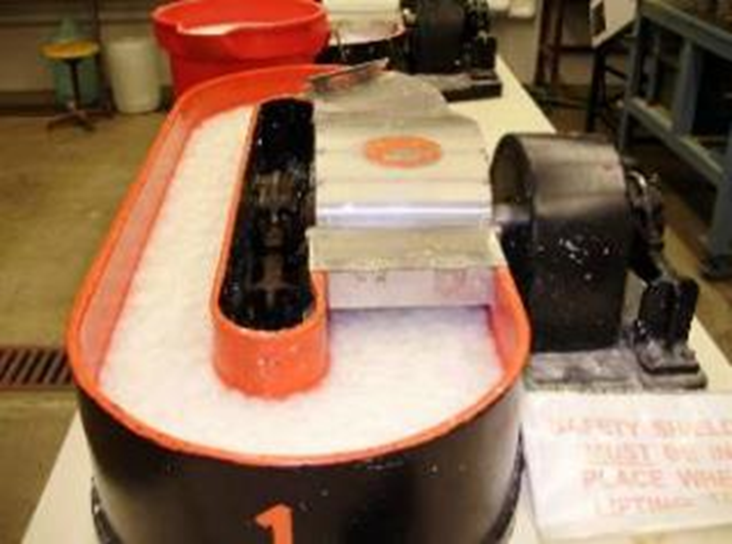
Fig 1. Valley Beater [21]

Refining occurs in the Valley Beater as interaction as described by Doelle & Bajrami [23] by pushing a stator bed plate having spaced bars, against a turning rotor containing spaced bars as well. The interaction between stator and rotor refines the fibers through a mechanical interaction, called a surface-to surface interaction, as the fibers move through the rotor and stator assembly.
Figure 2 represents the generated refining curve, showing the CSF value over the refining time.
For the production of NF fibers from OCC material three refining curves (Refining 1, 2 & 3) were done to determine the refining time needed to achieve a refining level close to 0 ml CSF. Refining Curve 1, 2, & 3 had the lowest refining level of 9 ml CSF at 80 min, 2 ml CSF at 105 min. and 20 ml CSF at 120 min refining time respectively. Difference in CSF value and reefing time can be explained with the inconsistency of the recycled OCC material.
Based on the three refining experiments it was decided to refine the OCC for 100 min to produce the NFOCC fiber material for the handsheet study. The NFC pulp for the handsheet study had a CSF value of 20 ml.
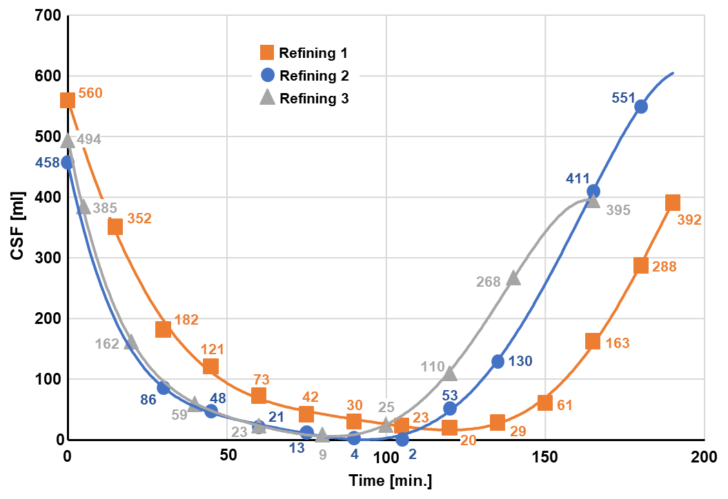
Regular OCC fibers were prepared by beating the fibers for 10 minutes, resulting in a CSF value of 400 ml.
Fig 2. Refining curve of OCC pulp.

2.6. Laboratory In-Situ Precipitation of Calcium Carbonate
To produce ISPCC a Laboratory Precipitation Set Up (LPSU) is used as shown in Figure 3. For producing the ISPCC the following preparations were done prior to the precipitation process: First, OCC pulp fibers are prepared having a CSF level of 400 ml in a 5-gal container at a solids content (consistency) of 3.0% and a temperature of 20°C and stirred continuously with a laboratory mixer until used.
Second, from the refined NFOCC pulp with a CSF level of 20 ml a NFOCC fiber-water solution is prepared with 3.0% consistence in a 5-gal container at a temperature of 20°C and stirred continuously with a laboratory mixer until used.
Third, from the WF powder a solution with water is prepared with 3.0% consistence at a temperature of 20°C and stirred continuously with a laboratory mixer until used.
The above prepared solutions are used to precipitate three individual ISPCC filler levels. Each ISPCC filler level is produced by adding 3 liters of the respective solution to a 5-liter plastic beaker (2), followed by adding separately, for each run, 150 g, 300 g, and 450 g Ca(OH)₂ powder.
Each prepared solution containing the WM, OCC fibers, and NFOCC fibers with the respective Ca(OH)₂ powder content is continuously mixed using a laboratory mixer (4) with a variable drive. The speed is adjusted, that good mixing occurs, and a small vortex is created.
After 2 minutes of mixing, the pressure regulator of the Carbon Dioxide (CO₂) storage tank (1) is opened and the CO₂ gas flow adjusted to approximately 2.0 l/min exiting the stone disperser (3) in the plastic mixing beaker (2). The LPSU is operated as described above and temperature, and pH values are monitored with probes (5) and (6) respectively.
The LSLP system operation in stopped when pH of the recirculated pulp fiber suspension reaches a value of 7.0. The pulp fiber suspension with the ISPCC is then transferred into a 5-gallon pail and stored in a cold room at a temperature of 41°F (5°C) until further processing.

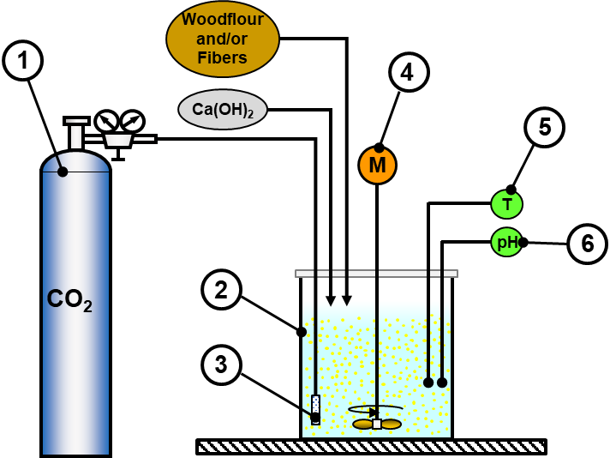

Fig 3. In-Situ Precipitated Calcium Carbonate Production

2.7. Fine Content Measurements
Fines fraction per weight was determined by wet screening with a Britt Jar testing device, shown in Figure 4, according to TAPPI T261 cm-00 [31]. Each test was performed 3 times and results were average. Prior to performing the measurement, the stirrer was set to 750 rpm and located about 1/8-inch (3.2 mm) above the metal screen with 75μm hole size. To start the measurement 500 ml of the to measure suspension is added to the holding vessel and the stirrer is started, followed by opening the drain valve, allowing the suspension drain through the metal screen plate into a beaker, while the stirrer keeps the particles of the suspension mixed. Once the liquid level reaches about 5 mm above the metal screen plate the drain valve is closed, and 500 ml of deionized water is added to the holding vessel. The drain valve is opened again, and the screened liquid is drained into another beaker. The washing cycle is repeated another 3 times or more till the filtrated liquid in the receiving beaker is clear as shown in Figure 5. After the washing cycle the remaining material in the holding vessel is screen with a 30 μm filter paper using a Büchner funnel.
Solids content and ash content of the original suspension and the remaining material on the filter paper are analyzed for solids and ash content using TAPPI T412 om-06 “Moisture in pulp, paper and paperboard” [33], TAPPI T240 om-07 “Consistency (concentration) of pulp suspensions” [30], and T 211 om-02, “Ash in wood, pulp, paper and paperboard: combustion at 525°C .

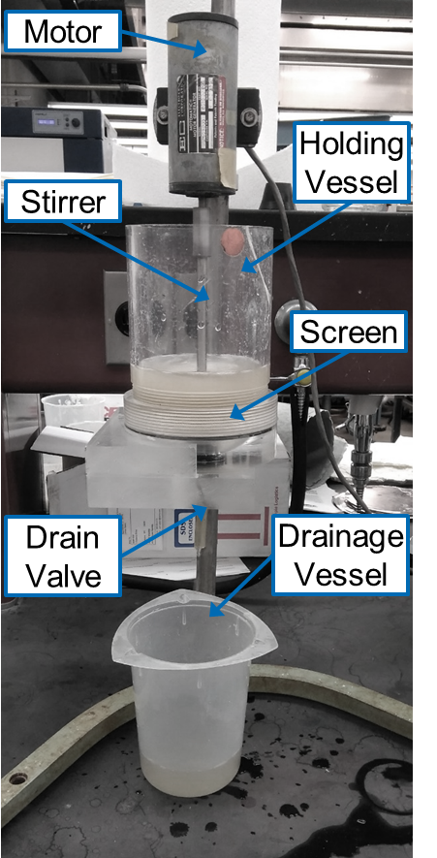
Fig 4. Britt Jar Testing Device [Doelle]

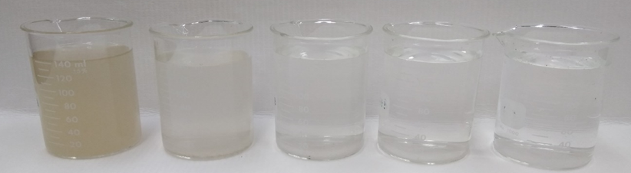
Fig 5. Five Washing Cycles Through Britt Jar Testing Device [Doelle]

3. results and discussion

The material for the LPSU operation to produce ISPCC was prepared as described in Section 2 with a targeted consistency having 3% of fiber material present in the solution.
A total of nine experiments were conducted including: OCC only, NFOCC pulp, and WM by adding to each raw material three different levels of Ca(OH)₂ powder, followed by precipitation of the ISPCC. Temperature and pH level were recorded till a target pH-value of 7.0 was reached.
Lab testing of the produced ISPCC fiber material solution was done according to TAPPI standards.

3.1 Precipitation of Calcium Carbonate
Results of the laboratory experiments producing ISPCC with OCC pulp are shown in Figure 6. Results show that a total ISPCC level of 6.94%, 13.88%, and 20.83% was achieved based on a 3000 ml solution with a precipitation time of 100 min, 120 min, and 422 min respectively. The initial and final pH for the 6.94% ISPCC was 12.57 and 7.59. The ISPCC level of 13.88% had an initial pH of 12.60 and 6.93, and the 20.83% ISPCC level had an initial and final pH of 12.63 and 6.98. All three experiments had a starting temperature of 18°C and the end temperature for the ISPCC level of 6.94%, 13.88%, and 20.83% was 25°C, 34.8°C, and 22.4°C respectively.

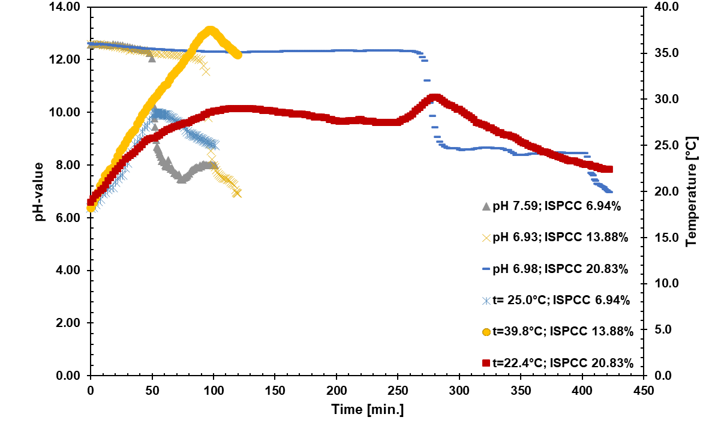
Fig 6. Precipitation of Calcium Carbonate in Suspension with Old Corrugated Container Board Fibers.

Results of the laboratory experiments producing ISPCC with high refined OCC pulp fibers (NFOCC) are shown in Figure 7. Results show that a total ISPCC level of 6.75%, 13.75%, and 20.27% was achieved based on a 3000 ml solution with a precipitation time of 25.1 min, 42.2 min, and 227.5 min respectively. The initial and final pH for the 6.75% ISPCC was 12.65 and 7.00. The ISPCC level of 13.75% had an initial pH of 12.65 and 7.00, and the 20.27% ISPCC level had an initial and final pH of 12.64 and 6.98. All three experiments had a starting temperature of 18.5°C and the end temperature for the ISPCC level of 6.94%, 13.88%, and 20.83% was 30.0°C, 36.7°C, and 29.4°C respectively.
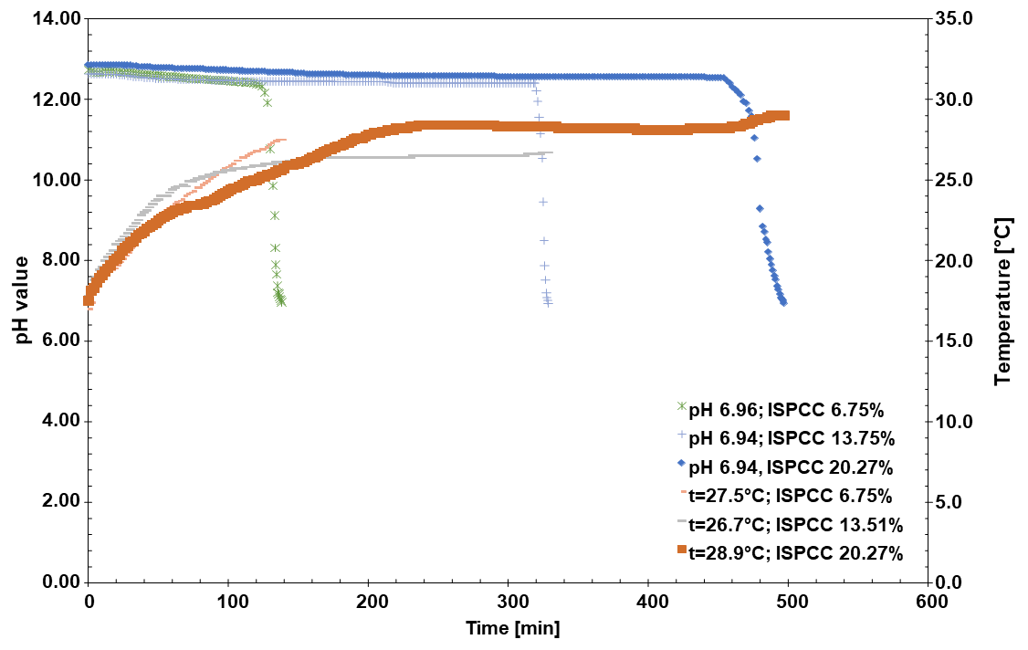
Fig 7. Precipitation of Calcium Carbonate in Suspension with High Refined Old Corrugated Container Board Fibers.

Results of the laboratory experiments producing ISPCC with wood are shown in Figure 8. Results show that a total ISPCC level of 6.94%, 13.83%, and 20.83% was achieved based on a 3000 ml solution with a precipitation time of 25.1 min, 42.2 min, and 227.5 min respectively. The initial and final pH for the 6.94% ISPCC was 12.65 and 7.00. The ISPCC level of 13.75% had an initial pH of 12.65 and 7.00, and the 20.27% ISPCC level had an initial and final pH of 12.60 and 6.98. All three experiments had a starting temperature of 18.5°C and the end temperature for the ISPCC level of 6.94%, 13.88%, and 20.83% was 30.0°C, 36.7°C, and 29.4°C respectively.
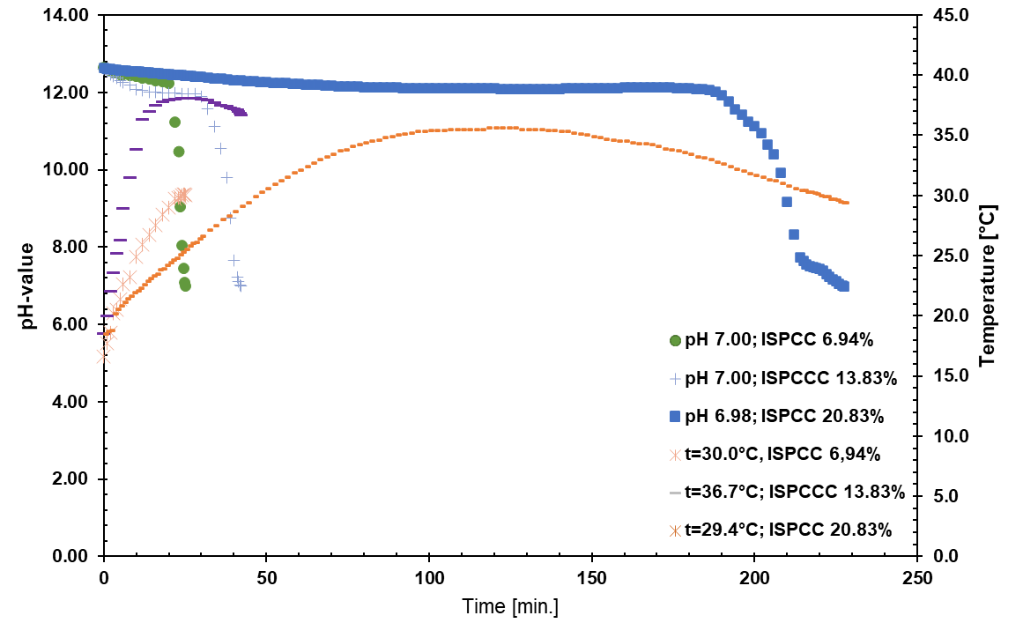
Fig 8. Precipitation of Calcium Carbonate in Suspension with Wood Flour.

The ISPCC precipitation experiments revealed consistent ISPCC production regardless of the used fiber material of OCC, NFOCC and WM.
Time for the precipitation was shorter for the lower precipitated ISPCC of 6.94%, 6.75%, and 6.94% for the OCC, NFOCC and WM respectively and increased by 20% for the for the 13.88% ISPCC using OCC fiber material, 59% for the NFOCC and WM fiber material yielding 13.75% and 13.83% ISPCC and 1100% for the WM fiber material. The significant higher precipitation time of 4.22 fold for the ISPCC level of 20.83% with OCC fiber material, 9.06-fold for the NFOCC fiber material and can be explained with the high degree of fibrillation of the high refined OCC material, as well as the fine particle size of the WM material that is preventing good mixing of the Ca(OH)₂ powder and CO₂ and as a result slowing down the chemical reaction of the ISPCC formation and reducing the final temperature of the ISPCC fiber slurry due to the prolonged precipitation.

3.2 Fines Content

A fines retention study was performed using a Britt Jar testing device according to TAPPI T261 cm-00 [14]. The Britt Jar study investigated fiber scurries containing WF material, OCC and NFOCC pulp fibers with and without precipitated ISPCC. Results of this study are presented I Figure 9.
The WF sample without ISPCC had an initial fines content of 96.82% whereas the commercial OCC pulp fiber sample without ISPCC had an initial fine content of 86.39%. The NFOCC fiber material had an 83.99% initial fines content.
WF material with a precipitated ISPCC content of 6.94%, 13.83% and 20.83% resulted in a fines content of 97.27%, 97.44%, and 98.45% respectively.
OCC pulp fibers with a precipitated ISPCC content of 6.94%, 13.885 and 20.83% showed a fine content of 91.51%, 95.01% and 96.04%.
NFOCC fiber material with a precipitated ISPCC content of 6.75%, 13.75%, and 20.27% showed a fines retention of 54.42%, 48.36% and 44.1%.
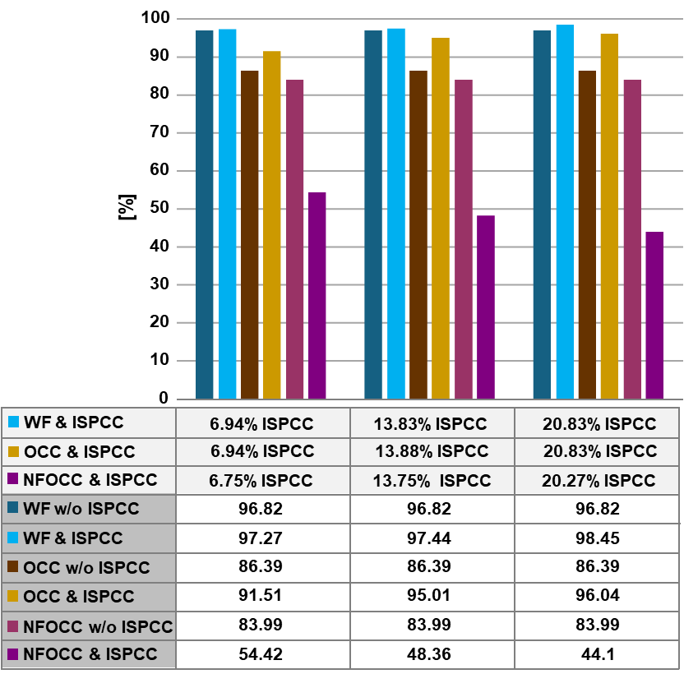
The above results show clearly that NFOCC has an approximately 40% higher potential in containing and collecting the precipitated ISPCC in the suspension, allowing that more ISPCC can be incorporated into the paper during sheet forming.
Fig 9. Fines Content of WF, OCC Fiber, NFOCC Fiber Materials based on Britt-Jar Test

4. Conclusion

The paper and board industry challenge for the future is finding solutions to raising, energy, water, material and additive cost and at the same time utilize new eco-friendly raw materials, improve existing and future production processes, increase biodegradability, reduce overall energy consumption by lowering the CO₂ footprint of the manufacturing operation.
One solution for the board producing paper product segment is the utilization of NFC fiber material from OCC produced direct at the paper mill site and the utilization of WF, both in combination with ISPCC.
The presented research project investigates with a laboratory study the possibility of producing ISPCC in the presence of OCC, HR, or NFOCC pulp and WM as an alternate additive for paper production.
The laboratory experiments produced successfully ISPCC with OCC and NFOCC pulp and WF with ISPCC level of 6.94%, 13.88%, and 20.83% regardless of the used lignocellulosic based fiber material.
Time for the precipitation was shorter for the lower precipitated ISPCC of 6.94%, 6.75%, and 6.94% for the OCC, NFOCC and WM respectively and increased by 20% for the for the 13.88% ISPCC using OCC fiber material, 59% for the NFOCC and WM fiber material yielding 13.75% and 13.83% ISPCC, and 1100% for the WM fiber material. The significant higher precipitation time of 4.22 fold for the ISPCC level of 20.83% with OCC fiber material, 9.06-fold for the NFOCC fiber material and can be explained with the high degree of fibrillation of the high refined OCC material, as well as the fine particle size of the WM material that is preventing good mixing of the Ca(OH)₂ powder and CO₂ and as a result slowing down the chemical reaction of the ISPCC formation and reducing the final temperature of the ISPCC fiber slurry due to the prolonged precipitation.
The above results show clearly that NFOCC has an approximately 40% higher potential in containing and collecting the precipitated ISPCC in the suspension, allowing that more ISPCC can be incorporated into the paper during sheet forming.
It is suggested that future research focuses on laboratory handsheet making and comparison of the mechanical and physical paper properties. After a successful handsheet study a small laboratory paper machine study should be conducted for a more in-depth evaluation.

7. DISCLAIMER (ARTIFICIAL IMTELLIGENCE)

The author hereby declares that NO generative AI technologies such as Large Language Models (ChatGPT, COPILOT, etc.) and text-to-image generators have been used during writing or editing of manuscripts.

8. COMPETING INTERESTS DISCLAIMER:

Author declares that no known competing financial interests OR non-financial interests OR personal relationships that could have appeared to influence the work reported in this paper.

Disclaimer (Artificial intelligence)
Option 1:
Author(s) hereby declare that NO generative AI technologies such as Large Language Models (ChatGPT, COPILOT, etc.) and text-to-image generators have been used during the writing or editing of this manuscript.
See above

9. References

- Dölle K. Copy Paper from Recycled Egg Cartons – A 12-inch Paper Machine Development Study. Journal of Engineering Research and Reports. 2022;23(3):39-49.
- Lyo, SW, Quesada-Pineda HJ, Crawford SD. Reducing electrical consumption in the forest products industry using lean thinking, BioResource. 2014;9(1):1373-1386.
- Doelle K, Amaya JJ, Application of calcium carbonate for uncoated digital printing paper from 100% eucalyptus pulp. TAPPI Journal. 2012;11(1):41-49.
- Klaus Dölle, Jacob Darius, Rodrigo Castillo Medina, Owen Henkler, Jonathan Day. A Study on Laboratory Type Paper Machine Using Nano Fibrillated Cellulose from Recycled Old Corrugated Containerboard as Bio Additive in Board Production. Journal of Engineering Research and Reports. 2022;24(5):46-55.
- Dölle K. Lime in Papermaking: A Historic Review. In: Thompson ML, Brisch JH, editors. Lime: Building on the 100-Year Legacy of The ASTM Committee C07; 2012.
- Dölle K. In-Situ Precipitated Calcium Carbonate Paper Filler Material: A Review. Journal of Engineering Research and Reports (JERR). 2022;21(11),38-58.
- Hubbe MA, Gill RA. (2016). Fillers for papermaking: A review of their properties, usage practices, and their mechanistic role. BioResource. 2016;11(1):2886-2963.
- Zhao Y, Hu Z, Ragauskas AJ, Deng Y. Improvement of Paper Properties Using Starch-Modified Precipitated Calcium Carbonate Filler. TAPPI Journal & Solutions. 2005; 4(2):3-7.
- Dölle K.Papermaking Using Willow (Salix dasiclados) as a Hardwood Source – A Handsheet and Pilot Paper Machine Study. Asian Journal of Chemical Sciences, (AJCS). 2019;5(2):1-16.
- Deng, Y., Zhao, Y., & Ono, H. (2005). Improvement of Paper Properties Using Starch-Modified Precipitated Calcium Carbonate Filler. TAPPI Journal & Solutions. Vol. 4(2)
- Morimanno LR, McLain LA.. Chapter 9 - Mineral Fillers: Application Strategies and Value. In: Hubbe MA, Rosencrance S, Editors. Advances in Papermaking Wet End Chemistry Application Technologies, TAPPI Press; 2018.
- Smook GA. Handbook for Pulp and Paper Technologists. Angus Wide Publications Inc., Vancouver, Bellingham. 2002.
- Ahonen, P. (1999). Challenges for digital printing papers. The America Pulp and Paper Journal, 4, 26-38.
- Beuleke E., Burri P. Streichpigmentkonzepte der Zukunft, Wochenblatt für Papierfabrikation. 199;22:1482-1487.
- Kowalczyk GE., Trksak RM. Image analysis of ink-jet quality for multi use office paper. TAPPI Journal, 1998;81(10):181-190.
- Maloney TC. (1999). The formation of pores in the cell wall. Journal of Pulp and Paper Science. 1999;25(12:430-436.
- Wurster K., Fechtmeister H. Erfahrungen mit dem Einsatz von PCC in Pressendruckpapieren, Wissenschaft und Technik. Das Papier. 1999;10A:V36-V43.
- Dölle K., et. al., Paper Bag and Plastic Bag – A Brief Review. Journal of Engineering Research and Reports (JERR). 2022;22(5):45-57.
- Dölle K., Zier S. Application of spruce wood flour as cellulosic-based wood additives for recycled paper applications—A pilot paper machine study. TAPPI JOURNAL. 2021;20(10):641-652.
- Hashemzehi M, Mesic B, Sjöstrand B, Naqvi M. A comprehensive review of nanocellulose modification and applications in papermaking and packaging: Challenges, technical solutions, and perspectives. BioResources. 2022;17(2), 3718-3780.
- Uetani K, Kitaoka T. Nanocellulose: Beyond the ordinary. BioResources. 2021, 16(1):1-4.
- Dölle K, Bajrami B. In-Situ Precipitated Calcium Carbonate in the Presence of Pulp Fibers – A Beating Study. Journal of Engineering Research and Reports. 2021;20(8),1-17.

Dölle K., Bajrami B. Beating of Eucalyptus Pulp Fibers under Neutral and Alkaline Conditions – A Valley Beater Study. Journal of Engineering Research and Reports. 2021;20(8):86-96.
- Dölle K., Zier S. Application of spruce wood flour as cellulosic-based wood additives for recycled paper applications—A pilot paper machine study. TAPPI JOURNAL. 2021;20(10),641-652.
- Dölle K., Bajrami B. In-Situ Precipitated Calcium Carbonate in the Presence of Pulp Fibers – A Beating Study. Journal of Engineering Research and Reports. 2021;20(8):1-17.
- TAPPI T200 sp-06 Laboratory beating of pulp (Valley beater method).
- TAPPI T220 sp10. Physical testing of pulp handsheets.
- TAPPI T211 om-02. Ash in wood, pulp, paper and paperboard: combustion at 525°C.
- TAPPI T227 om-09. Freeness of pulp (Canadian standard method).
- TAPPI T240 om-07. Consistency (concentration) of pulp suspensions.
- TAPPI T261 cm-00, Fines fraction by weight of paper stock by wet screening.
- TAPPI T402 sp-13. Standard conditioning and testing atmospheres for paper, board, pulp handsheets.
- TAPPI T412 om-06 (2006). Moisture in pulp, paper and paperboard.

