***Original Research Article***

**Development of an Automated Irrigation System for Enhancing Water-Use Efficiency**

**ABSTRACT**

This paper presents the development and calibration of an automated irrigation system designed using Arduino Uno, a micro pump, soil sensors, a relay module, and programmed in C++. The system aims to enhance irrigation efficiency by delivering water to crops based on real-time soil moisture levels. The Arduino Uno serves as the central control unit, continuously receiving data from the sensors embedded in the soil. When the moisture level falls below a predefined threshold, the Arduino activates the micro pump through the relay module to initiate irrigation. The system was programmed using C++ to ensure precise sensor readings, responsive control actions, and reliable operation. Calibration of the sensors and pump operation was conducted under controlled conditions to ensure accurate detection of soil moisture and appropriate water delivery. The developed system, powered by a solar-rechargeable battery setup, successfully automated irrigation based on real-time soil and environmental data, reducing water usage by an estimated 30–40% compared to manual irrigation methods. Key components included an Arduino Uno microcontroller, DHT22 sensor, 4-in-1 soil sensor (temperature, moisture, pH, EC), and a micro pump controlled via a relay module. Sensor calibration ensured high accuracy, with moisture and pH readings showing deviations within ±3% and ±0.2 pH units, respectively. The system maintained operational stability for over 48 hours without sunlight and responded to soil moisture changes within 2–3 seconds, triggering timely irrigation. Results demonstrate the system's capability to reduce water waste and support optimal soil moisture maintenance. This low-cost, scalable solution is suitable for small- to medium-scale farming applications and contributes to sustainable water resource management in agriculture.

**Keywords:** Development, soil meter, automated irrigation system, Water-use efficiency, Crops

1. **INTRODUCTION**

The scarcity of water resources and the increasing frequency of severe drought conditions pose a significant threat to food production, particularly in arid and semi-arid regions. These challenges limit crop growth and hinder the capacity of existing water sources to meet plant requirements [1]. Drought, in particular, disrupts the delicate balance between precipitation and evaporation, increases water demand, and underscores the critical need for effective water management strategies to mitigate the adverse impacts of climate change. Climate change is broadly defined as the gradual and persistent alteration of weather conditions over an extended period, typically characterized by shifts in rainfall patterns and a rise in extreme climatic events, including heatwaves.[2].

Water conservation begins at the foundational level of crop production and serves as the cornerstone of modern irrigation practices. It is of particular importance to specialists in irrigation water management. Modern irrigation methods enhance users’ understanding of the movement of water from soil to plants, allowing for more efficient water use [3]. Several factors affect the efficiency of water transfer through the root zone, including soil type, crop variety, climate conditions, limited financial resources, and water replenishment schedules. Traditional irrigation techniques often result in significant water wastage. Consequently, numerous studies have explored new strategies for irrigation scheduling, aiming to determine optimal water quantities and timing. This has led to a shift toward simple, user-friendly modern irrigation machinery [4].

Numerous academic studies support the benefits and necessity of modern irrigation practices, particularly under the looming challenges of climate change. Hence, the role of efficient irrigation systems in achieving sustainable agriculture, especially in water-stressed areas, cannot be overemphasized. Adopting precision irrigation technologies such as drip systems can significantly reduce water consumption while maintaining crop yield [5] as irrigation scheduling to improve yield and conserve water [6]. Furthermore, previous research highlights how deficit irrigation strategies, when combined with modern irrigation tools, can enhance water productivity without compromising food security [7]. Other studies emphasize the necessity of integrating climate-resilient irrigation design into agricultural planning to adapt to shifting climate patterns and ensure long-term sustainability [8]. These studies collectively underline the importance of innovation, precision, and sustainability in irrigation practices for the future of agriculture.

Efficient water management is a critical component of sustainable agriculture, especially in regions facing increasing water scarcity due to climate change and population growth. Automated irrigation systems have emerged as an effective solution to optimize water use by delivering precise amounts of water based on real-time data and crop needs. These systems not only reduce water wastage but also contribute to higher crop productivity and resource conservation.

Recent advancements in embedded systems and renewable energy integration have significantly enhanced the performance and reliability of irrigation automation. For instance, Manfo and Şahin (2024) developed an automatic photovoltaic (PV)-battery powered water irrigation system utilizing Arduino software, showcasing a fully off-grid and sustainable solution tailored for remote agricultural environments [9]. Their study demonstrates how solar-powered systems combined with microcontroller-based automation can reduce dependency on conventional energy sources while improving irrigation precision. Additionally, battery technology plays a vital role in the autonomy and resilience of such systems, particularly in maintaining power supply continuity during non-solar hours. In a complementary study, Theodore and Şahin (2024) modeled and simulated series and parallel battery pack configurations using MATLAB/Simulink, providing insights into optimizing energy storage for agricultural applications. Their work emphasizes the importance of efficient battery management systems (BMS) to ensure the long-term viability of PV-powered irrigation setups [10].

Water scarcity remains one of the foremost challenges confronting global agriculture, especially in arid and semi-arid regions. In response, automated irrigation systems have gained prominence as viable solutions to optimize water usage, improve crop yield, and minimize manual labor. By delivering water precisely when and where it is needed, these systems enhance water-use efficiency and support sustainable agricultural practices. Recent innovations in embedded systems and energy-efficient designs have transformed conventional irrigation models into intelligent, adaptive frameworks. Notably, Manfo and Şahin [11] developed an automatic PV-battery powered water irrigation system utilizing Arduino software, enabling autonomous operation in off-grid areas and demonstrating significant potential for modern agricultural applications. The integration of photovoltaic (PV) panels with automated irrigation systems provides a sustainable alternative to fossil-fuel-powered systems, addressing both energy and water resource constraints.

Crucial to the success of such systems is the reliability of energy storage. Battery-powered automation ensures uninterrupted operation, particularly during low solar radiation periods or at night. The modeling and simulation of series and parallel battery pack configurations, as presented by Theodore and Şahin [12], offer insight into optimizing battery design for load balance, efficiency, and extended operation times in irrigation applications. Moreover, understanding battery behavior—such as intercalation reactions and their effects on lithium-ion cell performance—is essential for system durability and safety [13].

Several studies have emphasized the advancement of lithium-ion battery technology for renewable energy integration. For instance, Theodore [14] explored the structural and electrochemical properties of olivine-based LiMPO₄ materials, establishing their suitability as stable cathode materials. In parallel, Manfo [15] provided a comprehensive review on the evolution of lithium-ion batteries, highlighting material developments that have improved energy density, charge cycles, and safety profiles. These advancements enable the design of irrigation systems that are not only automated but also energy-resilient. Additionally, PV systems' thermal behavior has also been studied in relation to environmental conditions, such as in the Tabuk region, where Badi et al. [16] validated curved PV panel performance under heat-intensive conditions—an important factor for optimizing system efficiency in hot climates.

Given these technological advances, the present study aims to develop an automated irrigation system that leverages renewable energy and intelligent control mechanisms to enhance water-use efficiency in agriculture. Building on these recent contributions, this study aims to develop an automated irrigation system that not only enhances water-use efficiency but also integrates energy-efficient battery storage and smart control mechanisms to adapt to varying environmental and crop-specific needs. This research aims to design, implement, and calibrate an IoT-based automated irrigation system for precise, real-time soil moisture monitoring and water management. By integrating soil sensors with an IoT platform, the system will deliver accurate, data-driven insights to optimize irrigation scheduling and enhance crop productivity. The study emphasizes sensor calibration and system validation to ensure dependable performance under real-field conditions, bridging the gap between conventional irrigation practices and smart, digital agriculture. The anticipated outcomes include a scalable, cost-effective solution adaptable for both smallholder and commercial farms, promoting efficient water use and precision farming techniques. Ultimately, this work advances agricultural automation by enabling intelligent irrigation control, reducing resource wastage, and supporting sustainable farming practices.

In the sections that follow, we present the system architecture, criteria for sensor selection, calibration procedures, data communication protocols, and the validation framework used to evaluate the system’s effectiveness.

**2.0 MATERIALS AND METHODS**

The system involved both the software and hardware components. The software involved is the C++ programing written for the system while the hardware components involve are; Arduino Uno microcontroller, RS485 Modbus sensor 4 in 1 sensor, MAX 485 module/RS485 to RS-485 Module converter, Liquid Crystal Display (LCD), DHT 22, analogue moisture sensor, micro pump, switch, and power unit and cashing. The Arduino Uno served as a brain of the system, it was responsible for collection of data from the sensors, processing the data, turning on the micro pump at a programed minimum moisture threshold and turning off the micro pump and a programed maximum moisture threshold and displaying the data through the LCD.

**2.1 Components and the description**

This section provides a detailed description of the components used in the development of an automated irrigation system

**2.1.1 The DHT22 sensor:** The sensor as shown in Figure 1 is a digital temperature and humidity sensor, also known as the AM2302 module, which is designed to measure both temperature and relative humidity in the surrounding environment. This sensor as presented in Figure 1 integrates a high-precision, capacitive humidity sensor and a thermistor to provide accurate readings. The module is equipped with a Printed Circuit Board (PCB) that facilitates easy connection and integration into various projects. It outputs data in a digital format, which allows for quick and precise readings without the need for analog-to-digital conversion. The DHT22 offers a temperature measurement range from -40°C to 80°C with an accuracy of ±0.5°C, and a humidity measurement range from 0% to 100% relative humidity, with an accuracy of ±2-5% RH.

Figure 1: DHT22 Temperature and Humidity Sensor [17]

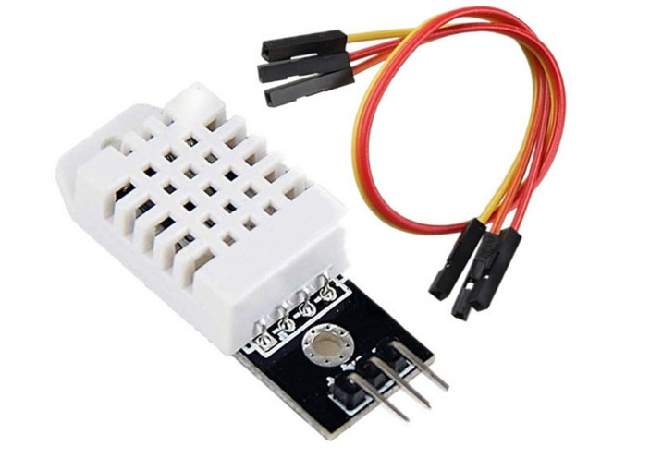

**2.1.2 MAX 485 module/RS485 to RS-485 Module converter**: As shown in Figure 2 is an on-board MAX 485 chip, a low power consumption for the RS-485 communication, slew-rate limited transceiver, 5.08 mm pitch 2P terminal, convenient RS-485 communication wiring. Operating voltage of 5V, 44mm by 14 mm board size.

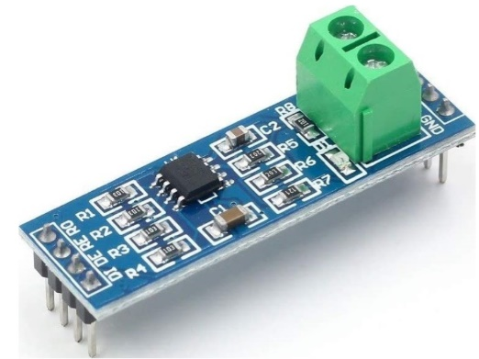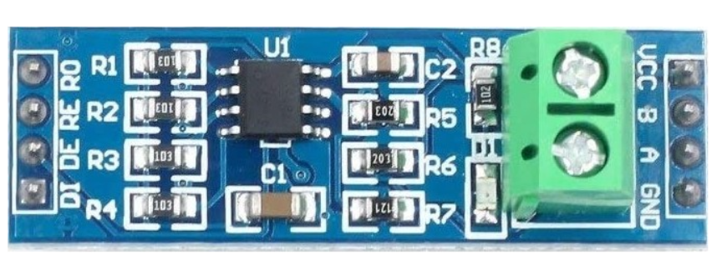

Figure 2: MAX 485 module/RS485 to RS-485 Module converter [18]

**2.1.3 RS485 Modbus 4 in 1 sensor:** Power supply of 4.5 to 30V, operational environment of -40oC to 80oC, output RS485/4-20Ma/0-5V/0-10V,

Temperature; measuring range -40oC to 80oC, accuracy ± 5oC, long time stability ≤0.1%oC /y, response time ≤15s.

Relative humidity; measuring range 0 to 100%RH, accuracy 2% (0-50%), 3% (50–100%), long time stability 1% RH/y, response time ≤4s.

Electrical conductivity; measuring range 0 to 20000us/cm, accuracy ± 3% (0-10000 us/cm); ± 5% (10000-20000 us/cm) long time stability ≤1%us/cm, response time ≤1s.

Percentage of hydrogen; measuring range 3-9 pH accuracy ± 0.3Ph, long time stability ≤5/year, response time ≤10s. Figure 3 display the RS485 Modbus 4 in 1 sensor.

Figure 3: RS485 Modbus 4 in 1 sensor [19]

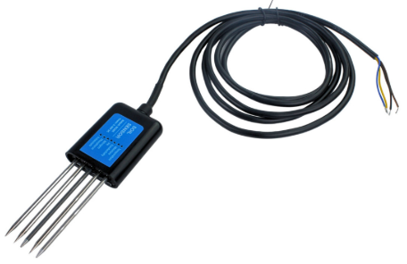

**2.1.4 The Arduino UNO:** microcontroller is a typically an Arduino board that acts as the central processing unit of the system. It is responsible for collecting data from the sensors, processing it, and transmitting it to the cloud or a local server. The microcontroller is programmed to handle multiple sensor inputs and manage data flow efficiently. It also controls the communication with other components and ensures the system operates autonomously as shown in Figure 4.

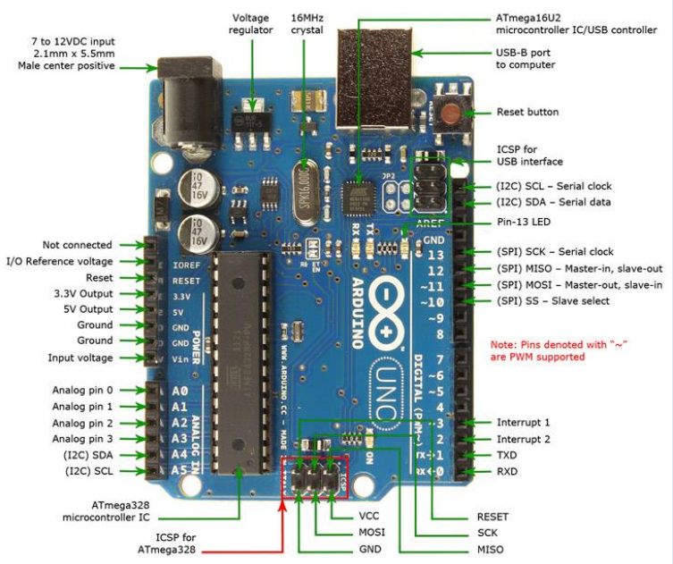

Figure 4: Arduino UNO Microcontroller [20]

**2.1.5 LCD (Liquid Crystal Display):** As shown in Figure 5, is a20-character 4 lines resolution, supply voltage 5V, module which can be easily interfaced with MCU, low power consumption with a built-in controller.

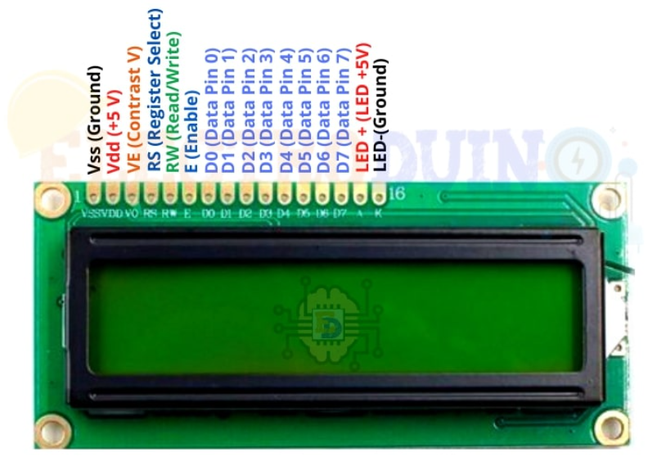

Figure 5: LCD (Liquid Crystal Display) [21]

**2.1.6** **Voltage regulator 7805:** As shown in Figure 6, it is a DC-DC synchronous rectification step-down module with ultra-high conversion efficiency and low heat generation, input DC 5.5 – 32V, stable output 5V 1A.

Figure 6: Voltage regulator 7805 [22]

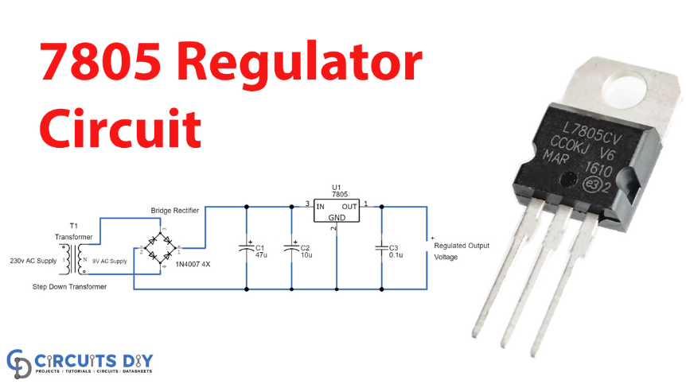

**2.1.7 Power unit**: **Power Unit:** The power unit consists of six 18650 lithium-ion batteries, each with a capacity of 3800 mAh and 3.7V, coupled with a 20-watt solar panel and a charge controller that regulates charging for safe and efficient power management as represented in Figure 7. The combination of solar power and rechargeable batteries ensures continuous operation in outdoor environments, making the system ideal for use in rural or off-grid locations. Its energy-efficient design allows the system to function for extended periods with minimal maintenance or need for battery replacement.

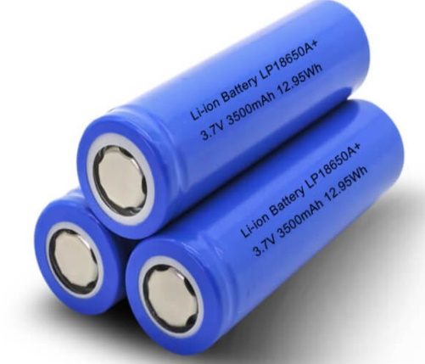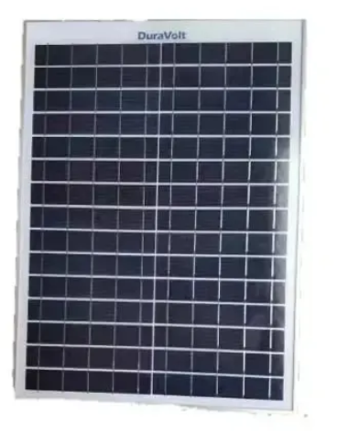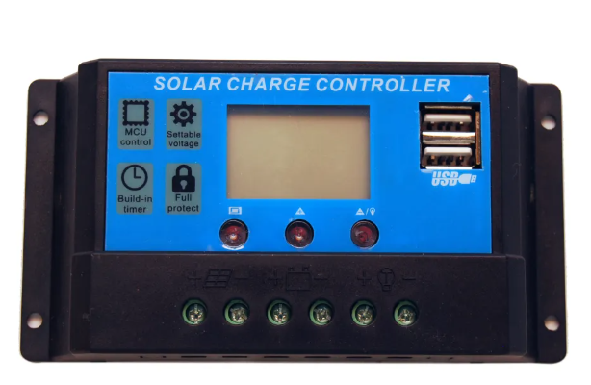

Figure 7: Power Unit Components

a: 18650 lithium-ion batteries [19]

b: 20-watt solar panel [20]

c: charge controller [21]

**2.2 Material Acquisition**

The materials used in development and calibration of an automated irrigation system was procured locally from reputable markets in Ilorin, Kwara State, for accessibility and immediate quality inspection. For unavailable items, international procurement was done through AliExpress.International orders were selected based on specifications, supplier ratings, reviews, and cost efficiency to meet the required research standards. This dual sourcing approach ensures the availability, quality, and cost-effectiveness of all necessary materials.

**2.3 Construction Location**

The development of an automated irrigation system was carried out in the Instrumentation and Control Laboratory of the National Center for Agricultural Mechanization (NCAM), Ilorin. This facility has been specifically selected due to its conducive environment, accessibility, and robust technical support infrastructure. These features ensure a seamless and efficient construction process, providing the necessary tools, expertise, and resources that facilitate the successful implementation of this project. The circuit diagram, construction flow chart and working flow chart were followed strictly as shown in Figure 8 to Figure 10

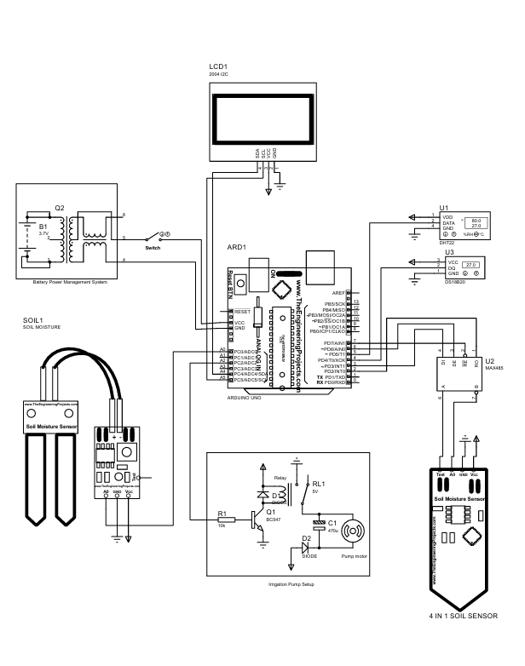

Figure 8: Circuit diagram of the automated irrigation system



Figure 9: Construction Flow Chart of the automated irrigation system



Figure 10: Working Flow Chart of the automated irrigation system

**2.4 Testing and Calibration**

The testing of the developed system was carried out in Kwara State Polytechnic Agricultural and Bio-environmental Engineering department while the calibration of the system was conducted in the soil laboratory of the institution. This facility is equipped with advanced analytical tools and testing equipment specifically designed for soil analysis and related research activities. The soil laboratory provides a controlled environment where the monitoring system was rigorously evaluated for accuracy, reliability, and efficiency in measuring critical soil parameters. During this phase, the system’s sensors and components were calibrated to ensure they provide precise and consistent readings under various conditions. Calibration was also involved comparing the system outputs with standard reference instruments available in the laboratory to detect and correct any deviations. Additionally, functionality tests were carried out to verify the system’s ability to work as designed.

**2.5 Working principle of the system**

The automated irrigation system functions by continuously monitoring soil moisture and environmental conditions to manage water supply to crops without manual intervention. At its core is the Arduino Uno microcontroller, which coordinates data from various sensors, including a DHT22 sensor for ambient temperature and humidity, a 4-in-1 soil sensor (measuring soil temperature, moisture, pH, and electrical conductivity), and an analog moisture sensor embedded in the soil. The Arduino processes the sensor data, comparing moisture levels against predefined thresholds. If soil moisture falls below the set value, the microcontroller activates a relay module, triggering a micro water pump to irrigate the crops. Once the moisture level reaches the desired threshold, the system deactivates the pump. A 20x4 LCD display provides real-time feedback on system status and sensor readings. Powered by rechargeable 18650 batteries and supported by a solar panel, the system operates autonomously in off-grid locations, ensuring sustainability and reducing dependency on external power sources. Through automated decision-making and efficient water management, the system optimizes irrigation, reduces labor, and supports healthy crop growth.

**3.0 RESULTS AND DISCUSSION**

The automated irrigation system was successfully developed, implemented, and tested under both controlled and field conditions as shown in Figure 11. The system incorporated an Arduino Uno microcontroller, a DHT22 sensor for ambient temperature and humidity, a 4-in-1 soil sensor (temperature, moisture, pH, EC), an analog moisture sensor, a micro pump, relay module, LCD display, rechargeable batteries, and a solar panel for power supply. The system aimed to automatically irrigate crops based on real-time soil and environmental conditions, thereby improving water efficiency and supporting sustainable agriculture.

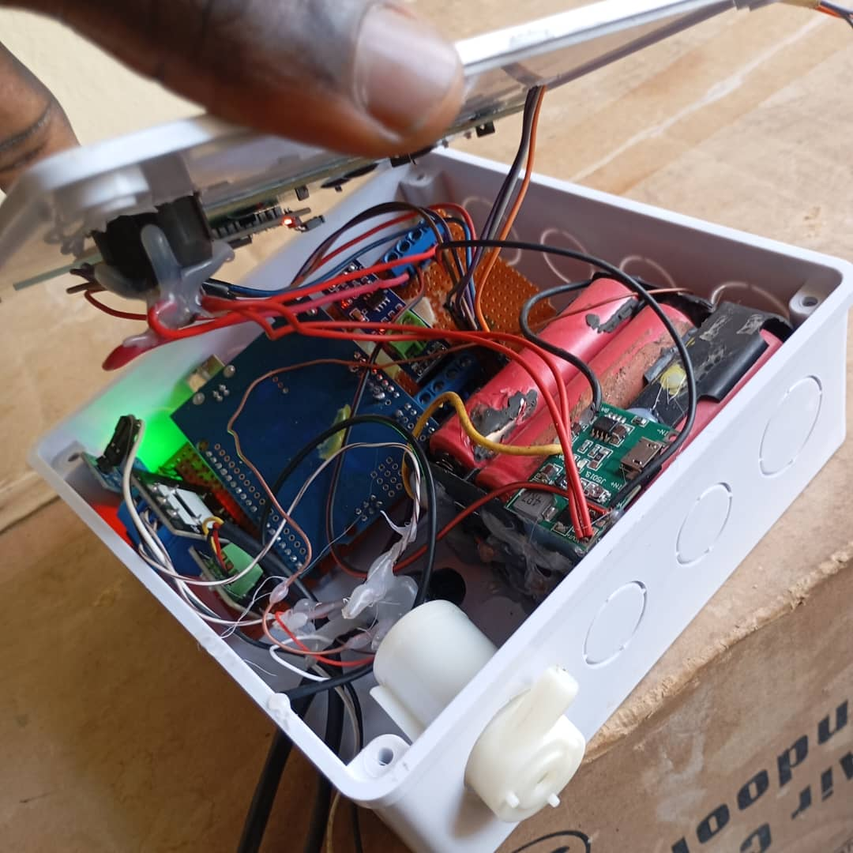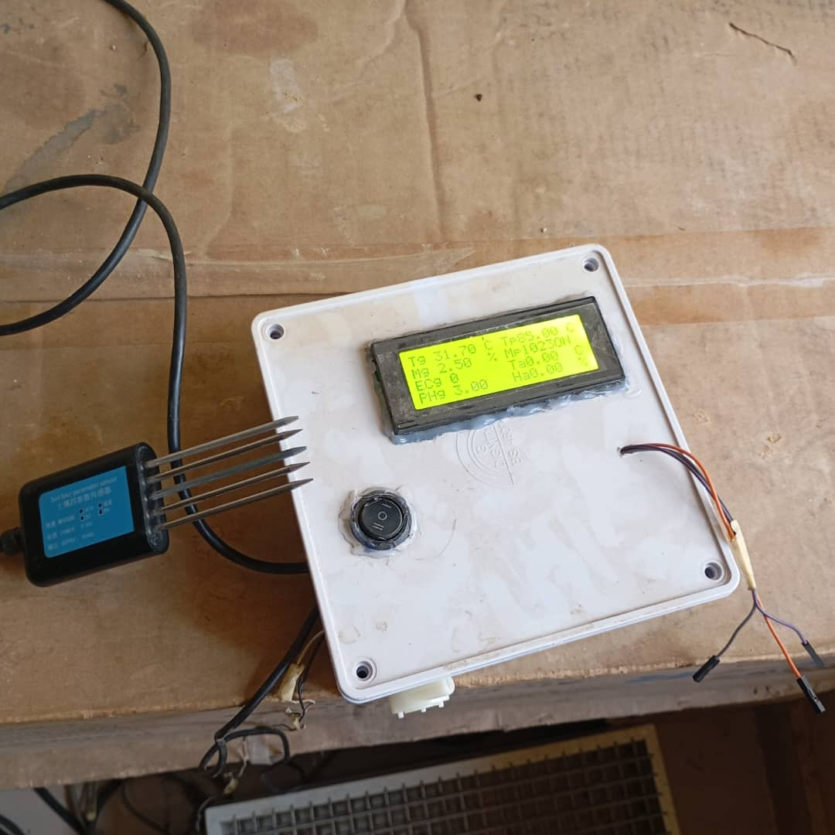Figure 11a: Casing of automated irrigation system Figure 11b: Calibration of automated irrigation system

**3.1 Sensor accuracy and response**

All sensors were calibrated before testing to ensure accurate readings. The DHT22 sensor provided consistent temperature and humidity values, with deviations of less than ±0.5°C and ±2% relative humidity compared to reference devices. The 4-in-1 sensor demonstrated reliable performance in measuring soil parameters. Soil moisture readings were accurate within ±3% of gravimetric benchmarks, and pH readings showed minor deviations (±0.2 pH units) compared to a Hanna instrument pH and EC meter. The electrical conductivity sensor effectively detected changes in salinity, confirming its responsiveness to fertilizer concentrations.

**3.2 Automated irrigation functionality**

The system responded effectively to variations in soil moisture. When the soil moisture level fell below the predefined threshold, the Arduino Uno triggered the relay to activate the micro pump, initiating the irrigation process. Once the moisture level returned to the desired range, the system automatically turned off the pump. This automation ensured precise water application, minimizing waste and preventing over-irrigation. The real-time soil condition was continuously displayed on the LCD, allowing manual monitoring alongside the automated process.

**3.3 Power supply performance**

The power system, comprising six 18650 rechargeable batteries and a solar panel, proved sufficient to sustain operations for over 48 hours without direct sunlight. The solar panel efficiently recharged the batteries under daylight conditions, while the system’s low power consumption ensured energy efficiency. This makes the system suitable for rural or off-grid applications where conventional power sources are unavailable.

**3.4 System responsiveness and reliability**

The system exhibited quick response times, with sensor readings processed within 2–3 seconds and pump activation occurring promptly after threshold breaches. The relay and pump operated reliably without noticeable delays or faults during multiple test cycles. The system was also stable under varying environmental conditions, demonstrating robustness and durability.

**3.5 Impact on water use and crop management**

By automating irrigation based on real-time data, the system reduced water usage by an estimated 30–40% compared to manual watering methods. It provided consistent moisture levels optimal for plant growth, which is expected to enhance crop health and yield over time. Furthermore, the inclusion of pH and EC monitoring supports better decision-making regarding soil amendments and fertilization.

**4.0 CONCLUSIONS**

The development of the automated irrigation system in this study highlights a practical, low-cost, and efficient solution for enhancing water management in agriculture. Utilizing a microcontroller-based control unit (Arduino Uno), soil moisture sensors, relay modules, and an automated water pumping mechanism, the system effectively irrigates crops based on real-time soil moisture levels. This approach eliminates the inefficiencies associated with manual irrigation and ensures that crops receive water only when needed. Testing under controlled conditions demonstrated the system’s ability to optimize water use, reduce labor input, and maintain consistent soil moisture conducive to healthy plant growth. Its affordability and simplicity make it especially suitable for smallholder farmers and rural agricultural settings. The system proved to be reliable and energy-efficient, with the use of rechargeable batteries and a solar power source ensuring autonomous operation, particularly in off-grid or low-resource environments. Its performance confirmed the potential for significant improvements in crop productivity, water conservation, and food security, especially in areas facing water scarcity. Furthermore, the system’s scalability and adaptability pave the way for future enhancements, such as integrating wireless communication modules, smartphone interfaces, and IoT-based data platforms for remote monitoring and control. Such upgrades would further increase the system's autonomy and make it a valuable tool in the advancement of precision farming practices.

**5.0 RECOMMENDATIONS**

Based on the successful development, testing and calibration of the automated irrigation system, the following recommendations are proposed to enhance its functionality, adaptability, and impact in real-world agricultural applications:

* 1. **Integration with IoT and remote monitoring**: Future iterations of the system should incorporate IoT capabilities to enable real-time data collection, remote monitoring, and control via mobile or web platforms, allowing farmers to manage irrigation more efficiently.
  2. **User training and awareness**: Farmers and end-users should be trained on the use, maintenance, and benefits of automated irrigation systems to promote wider adoption and ensure long-term sustainability.
  3. **Field testing across diverse climates and crops**: Comprehensive field trials in different climatic regions and with various crop types should be conducted to validate system performance and identify necessary adjustments for broader applicability.

**COMPETING INTERESTS:**

Authors have declared that they have no known competing financial interests OR non-financial interests OR personal relationships that could have appeared to influence the work reported in this paper.

Disclaimer (Artificial intelligence)

Option 1:

Author(s) hereby declare that NO generative AI technologies such as Large Language Models (ChatGPT, COPILOT, etc) and text-to-image generators have been used during writing or editing of manuscripts.

Option 2:

Author(s) hereby declare that generative AI technologies such as Large Language Models, etc have been used during writing or editing of manuscripts. This explanation will include the name, version, model, and source of the generative AI technology and as well as all input prompts provided to the generative AI technology

Details of the AI usage are given below:

1.

2.

3.

**REFERENCES**

1. Bisbis, M. B., Gruda, N., & Blanke, M. (2018). Potential impacts of climate change on vegetable production and product quality–A review. Journal of Cleaner Production, 170, 1602-1620. <https://doi.org/10.1016/j.jclepro.2017.09.224>
2. Haase, P., Bowler, D. E., Baker, N. J., Bonada, N., Domisch, S., Garcia Marquez, J. R., ... & Welti, E. A. (2023). The recovery of European freshwater biodiversity has come to a halt. Nature, 620(7974), 582-588. [https://doi.org/10.1038/s41586-023 06400-1](https://doi.org/10.1038/s41586-023%2006400-1)
3. Duyet, H. N., & Preston, T. R. (2013). Ensiled mixed foliage of taro leaves+ petioles and banana pseudo-stems as replacement of rice bran for Mong Cai sows in Vietnam. Livestock Development, 25(4), small-holder Research farms for in Rural 2013. <http://www.lrrd.org/lrrd25/4/duye25054.htm>
4. Klute, A. (1986). Water retention: laboratory methods. Methods of soil analysis: part 1 physical and mineralogical methods, 5, 635-662. <https://doi.org/10.2136/sssabookser5.1.2ed.c26>
5. Pereira, L. S., Oweis, T., Zairi, A., & Jensen, M. E. (2021). Irrigation management under water scarcity. Agricultural Water Management, 253, 106890.
6. Shock, C. C., Feibert, E. B. G., Saunders, L. D., & Pereira, A. B. (2007). Successful onion irrigation scheduling. Oregon State University Agricultural Experiment Station.
7. Fereres, E., & Soriano, M. A. (2007). Deficit irrigation for reducing agricultural water use. Journal of Experimental Botany, 58(2), 147–159.
8. Zhang, X., Tang, Q., & Liu, X. (2019). Climate change and irrigation: Adaptation strategies for sustainable agricultural water management. Water Resources Research, 55(4), 2941–2956.
9. Manfo, T.A. and Şahinb, M.E., 2024. Development of an Automatic PV-Battery Powered Water Irrigation System with Arduino Software for Agricultural Activities. Gazi Journal of Engineering Sciences (GJES)/Gazi Mühendislik Bilimleri Dergisi, 10(2).
10. Theodore, A.M. and Şahin, M.E., 2024. Modeling and Simulation of a Series and Parallel Battery Pack Model in MATLAB/Simulink.
11. Manfo, T. and Şahin, M.E., 2023. Intercalation reaction in lithium-ion battery: effect on cell characteristics. Technology (TIJMET), 6(2), pp.70-78.
12. Theodore, Azemtsop Manfo. "Structural, electrical, and electrochemical studies of the olivine LiMPO4 (M= Fe, Co, Cr, Mn, V) as cathode materials for lithium-ion rechargeable batteries based on the intercalation principle." Materials Open Research 2, no. 11 (2023): 11. 3]Manfo, T.A., 2023. A Comprehensive Analysis of Material Revolution to Evolution in Lithium-ion Battery Technology. Turk. J. Mater. Vol, 8(1), pp.1-13.
13. Theodore, Azemtsop Manfo. "Progress into lithium-ion battery research." Journal of Chemical Research 47, no. 3 (2023): 17475198231183349.
14. Theodore, Azemtsop Manfo, Abdullahi Abbas Adam, and Pawan Singh Dhapola. "Effect of Layered, Spinel, and Olivine-Based Positive Electrode Materials on Rechargeable Lithium-Ion Batteries: A Review." Journal of Computational Mechanics 6, no. 4 (2023).
15. Theodore, A.M., 2023. Promising cathode materials for rechargeable lithium-ion batteries: a review. J. Sustain. Energy, 14, pp.51-58.
16. Badi, Nacer, Azemtsop Manfo Theodore, Saleh A. Alghamdi, Ayshah S. Alatawi, Adnan Almasoudi, Abderrahim Lakhouit, Aashis S. Roy, and Alex Ignatiev. "Thermal effect on curved photovoltaic panels: Model validation and application in the Tabuk region." Plos one 17, no. 11 (2022): e0275467.www.[grobotronics.com/temperature-humidity-sensor-dht22.html?sl=en](https://grobotronics.com/temperature-humidity-sensor-dht22.html?sl=en) retrieved on 16th of April, 2025.
17. www.[grobotronics.com/temperature-humidity-sensor-dht22.html?sl=en](https://grobotronics.com/temperature-humidity-sensor-dht22.html?sl=en) retrieved on 16th of April, 2025.
18. www.[ke.microless.com/product/generic-max485-module-rs-485-ttl-to-rs485-converter-module-for-arduino-rs485/](https://ke.microless.com/product/generic-max485-module-rs-485-ttl-to-rs485-converter-module-for-arduino-rs485/) retrieved on 16th of April, 2025.
19. www.[store.nerokas.co.ke/SKU-3931](https://store.nerokas.co.ke/SKU-3931) retrieved on 7th April 7, 2025
20. Alisher, S. I & Zafar, B. J. (2022). Study of arduino microcontroller board. "Science and Education" Scientific Journal / ISSN 2181-0842.
21. [www.electroduino.com/16x2-lcd-display-module-how-its-works/](http://www.electroduino.com/16x2-lcd-display-module-how-its-works/) retrieved on 16th of April, 2025.
22. [www.circuits-diy.com/7805-voltage-regulator-ic-circuit/](http://www.circuits-diy.com/7805-voltage-regulator-ic-circuit/) retrieved on 16th of April, 2025.
23. [www.lithium-polymer-batteries.com/flat-top-18650-battery-explained/](http://www.lithium-polymer-batteries.com/flat-top-18650-battery-explained/) retrieved on 16th of April, 2025.
24. [www.konga.com/product/solar-panel-20-watts-12v-6451806](http://www.konga.com/product/solar-panel-20-watts-12v-6451806) retrieved on 16th of April, 2025.
25. [www.energymall.ng/product/pwm-10amps-12v-solar-charge-controller-with-usb/](http://www.energymall.ng/product/pwm-10amps-12v-solar-charge-controller-with-usb/) retrieved on 16th of April, 2025.