Estimation of evaporation using Long Short Term Memory and Gated Recurrent Unit based Neural Network

.

ABSTRACT

|  |
| --- |
| This study presents the comparison of conventional Artificial Neural Network (ANN) and advanced neural networks to predict weekly potential evaporation for Anand, Gujarat, India, which comes under the subtropical climatic zone. Recently, many advanced deep neural structures like Long Short Term Memory (LSTM) and Gated Recurrent Unit (GRU) have been introduced that have excellent prediction accuracy. Climate data such as bright sunshine hours, rainfall, wind speed, maximum and minimum temperature, and maximum and minimum relative humidity have been used to train and test the conventional and advanced neural network models. A comparison was made for the estimation of evaporation predicted by these models. The performance results show that deep neural network models with advanced structures like LSTM and GRU have performed better in terms of Root Mean Square Error and correlation coefficient and are able to learn the events very well in comparison to conventional neural network structures. |

*Keywords:* *Evaporation, Deep Neural Network, Long Short Term Memory, Gated Recurrent Unit*

1. INTRODUCTION

Evaporation is an important process in the water cycle that is responsible for the transfer of water from land and water bodies to the atmosphere. It plays an important role in different areas such as agriculture, meteorology, and water resource management. It is very essential to estimate evaporation in regions facing water scarcity for managing water balances, estimating crop water requirements, and managing water resources. Evaporation governs the amount of water in the soil, crop yields, and water requirements for irrigation. In hydrological models, evaporation is frequently used to calculate stream flow, groundwater recharge, and overall water availability. Changing weather conditions and temperature have a significant impact on regional evaporation rates; understanding evaporation patterns is critical for analyzing climate change implications.

Traditionally, an empirical method like the Penman-Monteith equation is widely used for estimation of evaporation using meteorological parameters like temperature, humidity, wind speed, and solar radiation (Allen et al. 1998). This method is widely used and has many benefits but has several limitations. This method needs a large number of meteorological observations, which can limit its applicability in regions with poor or missing meteorological observations. The covariance between methodological variables can cause bias across different climate zones, which can make this method less accurate (Hargreaves and Samani 1985, Samani 2000). Due to these limitations, many researchers have begun to focus on data-driven techniques that use machine learning techniques for more accurate estimation of evaporation. These techniques have the capability of learning complicated patterns and dependencies from large datasets. It also eliminates the requirement of manual feature engineering and provides more flexible models that are able to adapt to different environmental conditions. Many machine learning techniques, like Multiple Linear Regression, Support Vector Machine, Random Forest Regression, Feed Forward Neural Network, and Recurrent Neural Network have been used for the prediction of time series data. The Artificial Neural Network (ANN) has a nonlinear structure, which makes them able to capture the more complex characteristics of data, and have been successfully used to model the complex time series data (Galvão et al. 1999). The important benefit of ANNs in comparison to the classical technique is that ANNs do not need the detailed knowledge of the physical processes of the system that is to be modelled (Sudheer et al. 2003). A comparison between the performance of the artificial neural network approach and the discrimination analysis method for operational rainfall forecasting has been made, and it was found that the artificial neural network was superior to the conventional statistical strategy (Allen et al. 1994). An ANN model was developed for predicting daily solar radiation for the south-eastern U.S. using daily maximum and minimum air temperature, precipitation, clear sky radiation, and day length (Elizondo et al. 1994). An ANN-based alternative approach was proposed for evaporation estimation for Lake Eirdir using meteorological data, including daily observations of air and water temperature, sunshine hours, solar radiation, air pressure, relative humidity, and wind speed (Keskin et al. 2006). The results show that ANN has better estimation accuracy compared to other conventional models. A fuzzy rule-based model was developed for estimating the evaporation of the Raichur region (Megha et al. 2022). Among the various machine learning methods, Long Short Term Memory (LSTM) networks and Gated Recurrent Units have shown good results, particularly in time series forecasting tasks (Hochreiter et al. 1997), (Cho et al. 2014), (Fu et al. 2016). Two novel LSTM-based hybrid models, wavelet-based LSTM and convolution LSTM, were proposed for streamflow and rainfall (L. Ni et al. 2019). The authors presented a comparison of various conventional machine learning algorithms like Support Vector Machine, Random Forest, ANN models, and deep models like LSTM and bidirectional LSTM and GRU models for predicting rainfall for North-Western Himalayas region (Wani et al. 2024). These models do not require predefined assumptions and modelling of physical processes, and they are able to analyze time-series data and learn complex nonlinear relationships between input features and output targets.

This study investigates the potential of the LSTM and GRU models for estimation of evaporation. This work aims to enhance the estimation performance, generalizability, and robustness. Our goal is to overcome the constraints of traditional approaches and produce more reliable estimates for practical applications in water resource management and climate studies by using deep learning techniques that will allow us to overcome the limitations of conventional methods.

2. material and methods

### ****2.1. Data Collection:****

### **The average weekly weather dataset with observations of** bright sunshine hours, rainfall, wind speed, maximum and minimum temperature, and maximum and minimum relative humidity **for the years 1980 to 2022 was collected from the Meteorological Department, B.A.C.A., Anand Agricultural University, Anand, which falls under the** subtropical climatic zone. The 1980 to 2020 data are used for NN training and validation, and the years 2021 to 2022 were used for testing the performance of the trained model.

### ****2.1. Artificial Neural Network:****

An **ANN** is a mathematical version of the biological neural networks. Figure 1 shows the architecture diagram of ANN. It consists of layers of interconnected nodes (neurons) that process input data. The ANN receives the raw data as input from the input layer and passes this information to the hidden layer neurons. The hidden layer is placed between the input and output layers and processes the information received from the input layer through weights, biases, and nonlinear activation functions. Then this information goes to the output layer, which produces the final results or estimation. The layers are connected to each other by weights and biases and updated during the training period to minimize the error between the target and predicted value.

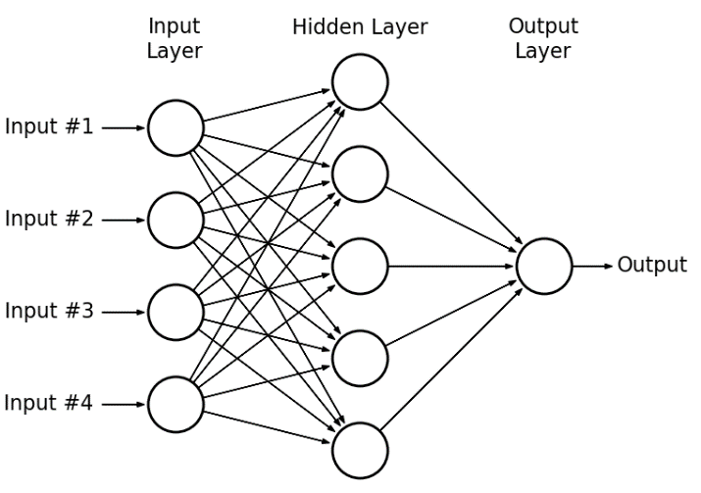

Figure. 1 Artificial Neural Network Architecture

**2.2 Long Short Term Memory (LSTM):**

**Long Short Term Memory is a special type of Recurrent Neural Network (RNN)** designed to address the vanishing gradient problem of conventional RNN. LSTM has good accuracy in terms of capturing long-term dependencies in sequential data. Figure 2 shows the architecture diagram of the LSTM. LSTMs have a special kind of structure that contains a gate mechanism that regulates the flow of information. It has a forget gate, an input gate, and an output gate, which calculate the output from previous information. Forget Gate decides which information from the past step to forget, and it is calculated by

ft = *σ* ( wf [xt , ht-1 ] + bf  ) (1)

In the calculation of forget gate, first input is multiplied with the input weight and previous state is multiplied with its weight and then both term will be added with the bias term. Then sigmoid activation function is applied to calculate output of the forget gate.

The input gate decides what new information to add to the cell state, and it is calculated by

it = *σ* ( wi [xt , ht-1 ] + bi  ) (2)

and output gate decides the information form cell state to output. It is calculated as

ot = *σ* (wo [xt , ht-1 ] + bo ) (3)

The hidden candidate function ht final candidate function is calculated by

ct = *tanh* ( ct-1* ft + *it ) and ht = ot * *tanh (*ct ) (4)

Where ht and ct are hidden state and cell state at time step t.

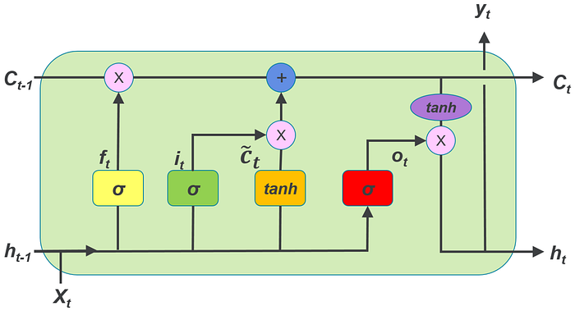 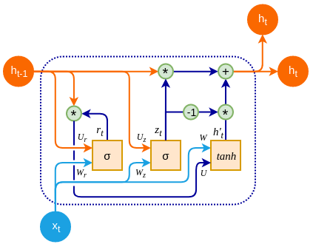

Figure. 2 LSTM and GRU Structure

The structure of LSTM allows remembering significant information over long sequences, making them a better choice for tasks like time series forecasting, natural language processing, and speech recognition.

**2.3. GRU (Gated Recurrent Unit)**:

The **Gated Recurrent Unit (GRU)** is another advanced type of Recurrent Neural Network (RNN) architecture to solve the **vanishing gradient problem** and **capture long-range dependencies** in sequential data. GRU has only two gates, which makes it less complex in architecture and more computationally efficient than LSTM. GRU has an update gate and a reset gate that can be calculated as

zt = *σ* (wz [xt  , ht-1 ]+ bz) (4)

rt = *σ* (wr [xt  , ht-1 ]+ br) (5)

$\tilde{h_{t}}=tanh⁡(w_{h}[r_{t}* h_{t-1} , x_{t}])$ (6)

$h_{t}=\left(1-z_{t}\right)*h_{t-1 }+z_{t}{\check{h}}_{t-1}$ (7)

GRU is faster to train and require fewer parameters than LSTMs; however, the performance is the same or better in many applications.

**2.4 Model Evaluations:**

A neural network model can be assessed using Root Mean Squared Error (RMSE) and R-squared (R2). It helps to evaluate how the model is performing and also provides various insights into the quality of the model and the accuracy of its estimation.

**2.4.1 RMSE:**

Root Mean Squared Error (RMSE) is a widely used statistical metric to evaluate the performance of regression models. It measures the average magnitude of the error between predicted values and actual (observed) values. RMSE provides a direct measure of the prediction accuracy, and it is expressed as

RMSE $= \sqrt{\frac{1}{n}{\sum_{i=1}^{n}{(y_{i}-\hat{y_{i}})}}^{2}}$ (8)

Where:

yi​ is the true value (target value) for the ith data point,

$\hat{y_{i}}$ is the predicted value for the ith data point,

n is the number of data points.

**2.4.2 R-SQUARE**

R-squared (R²) tells how well the model fits the data. It is a statistical measure that provides the proportion of the variance in the dependent variable that is predictable from the independent variables.

${ R}^{2}=1-\frac{\sum_{i=1}^{n}{{(y_{i}-\hat{y_{i}})}^{2}}}{\sum_{i=1}^{n}{{(y_{i}-\overline{y_{i}})}^{2}}}$ (9)

Where:

yi​ is the true value (target value) for the ith data point,

$\hat{y_{i}}$ is the predicted value for the ith data point,

$\overline{y_{i}}$ is the mean of the true values.

**Results and Discussion:**

Three types of neural networks were trained to estimate the **average weekly** evaporation using the climate data, such as bright sunshine hours, rainfall, wind speed, maximum and minimum temperature, and maximum and minimum relative humidity of the Anand district of Gujarat state. To make the meaningful and reasonable comparisons, we kept the same structure for all three neural networks. All structures have 4 inputs in the input layer, 64 neurons (simple neurons in ANN, LSTM neurons in LSTM-NN, and GRU neurons in GRU-NN) in the 1st hidden layer with a dropout ratio of 0.2, and the output layer has 1 neuron with a linear layer. We trained all these models for 30 epochs for data from 1980 to 2020 with 80% data for training and 20% data for validation purposes. We used 2021 and 2022 data for testing purposes. Table 1 shows the performance of neural network models during the training and testing phases.

**Table 1: Performance of Neural Network Models**

|  |  |  |  |  |  |
| --- | --- | --- | --- | --- | --- |
| **NN Model.** | **Training and Validation Loss** | **Training**  **RMSE** | **Testing RMSE** | **Training** **R²** | **Testing** **R²** |
| ANN | 0.0124  0.0085 | 0.0804 | 1.1390 | 0.82 | 0.72 |
| LSTM | 0.0036  0.0092 | 0.0655 | 1.0168 | 0.89 | 0.80 |
| GRU | 0.0039  0.0103 | 0.0681 | 1.0626 | 0.88 | 0.77 |

**Figure 3(a) shows the training and validation loss during the training of the conventional NN model. Figure 3(b) shows the Regression plot of actual EP and predicted EP by the model during the training phase.**

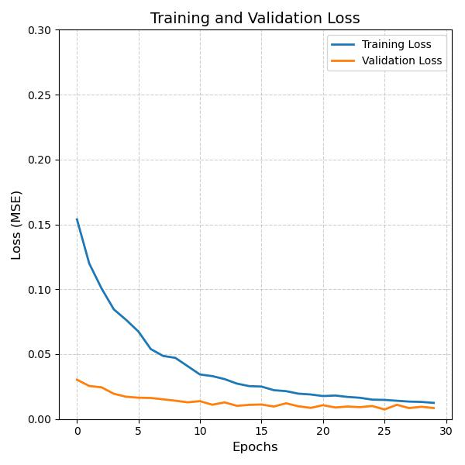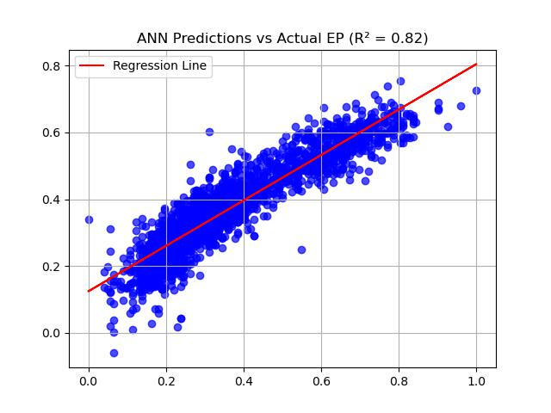

**Figure 3: (a) Training and Validation Loss (b) R_squared for Training Data**

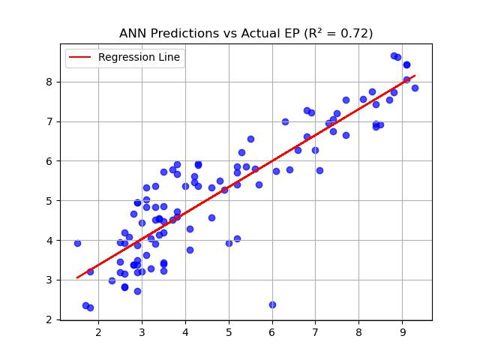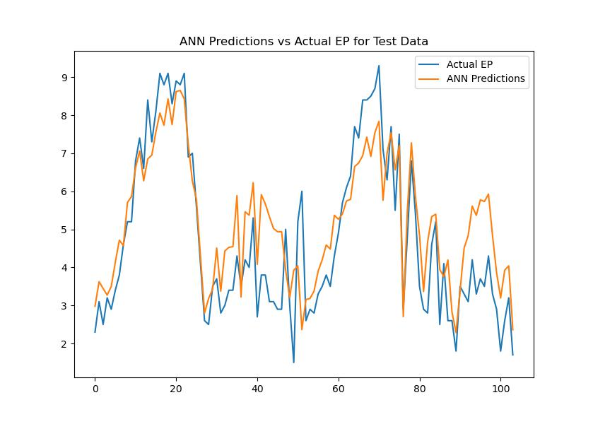

**Figure 4: (a) R_squared for Testing Data (b) Actual Vs Predicted EP using ANN**

**Figure 4 (a) shows the graph of the R2 for the test data and Figure 4(b) depicts the graph of actual EP and predicted EP by ANN model.**

**Figure 5(a) shows the training and validation loss during the training of the LSTM-based NN model. From the figure, it can be seen that training and validation loss are decreasing simultaneously. This characteristic shows that the model is neither overfitting nor underfitting during the training. After training of 30 epochs, training loss is 0.0036 and validation loss is 0.0092, which is the lowest among all three models. Figure 5(b) shows the Regression plot of actual EP and predicted EP by the model during the training phase, and this model achieved an R² of 0.89 during the training phase. Figure 6(a) shows the graph of the R² for the test data, and Figure 6(b) depicts the graph of actual EP and predicted EP by the LSTM based model.**

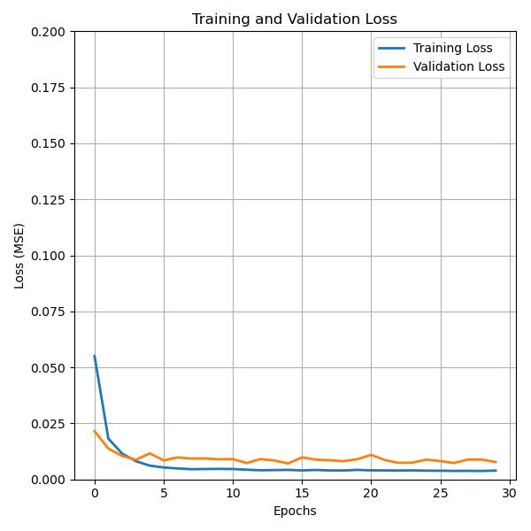 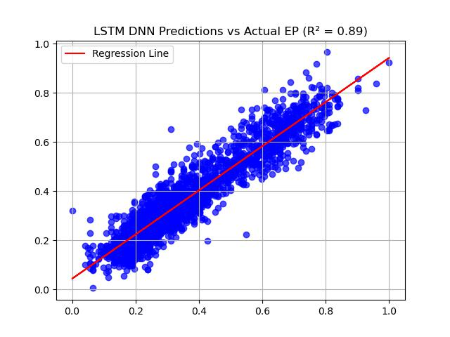

**Figure 5: (a) Training and Validation Loss (b) R_squared for Training Data**

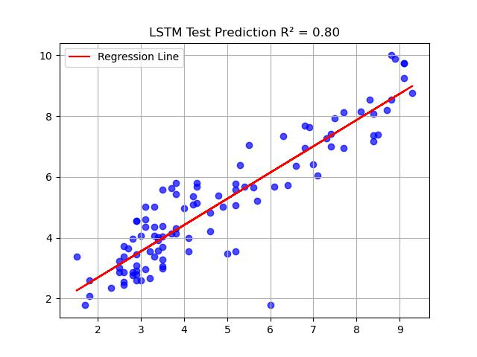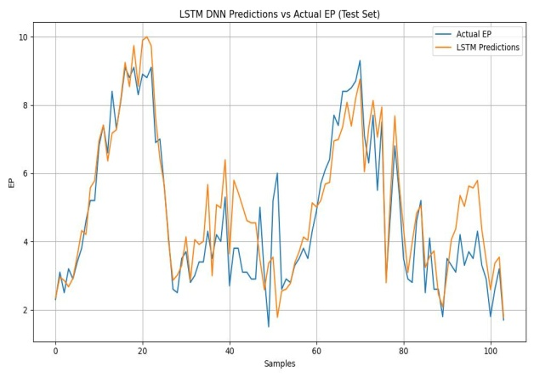 **Figure 6: (a) R_squared for TestingData (b) Actual Vs Predicted EP using LSTM**

**Figure 7(a) shows the training and validation loss during the training of the GRU-based NN model. From the figure, it can be seen that training and validation loss are decreasing simultaneously. After training of 30 epochs, training loss is 0.0039 and validation loss is 0.0103, which is the second lowest among all three models. Figure 7(b) shows the Regression plot of actual EP and predicted EP by the model during the training phase, and this model achieved an R² of 0.88 during the training phase. Figure 8(a) shows the graph of the R² for the test data, and Figure 8(b) depicts the graph of actual EP and predicted EP by the GRU-based NN model.**

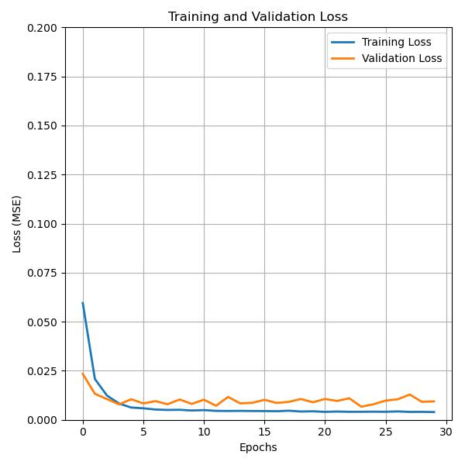 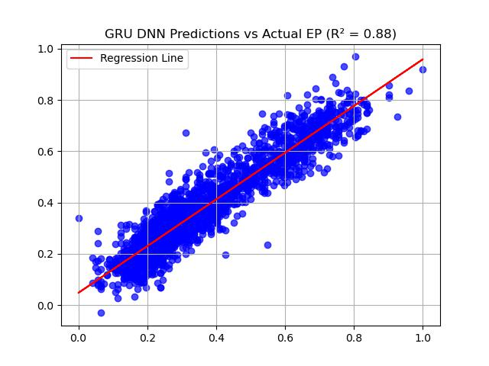

**Figure 7 (a) Training and Validation Loss (b) R_squared for Training Data**

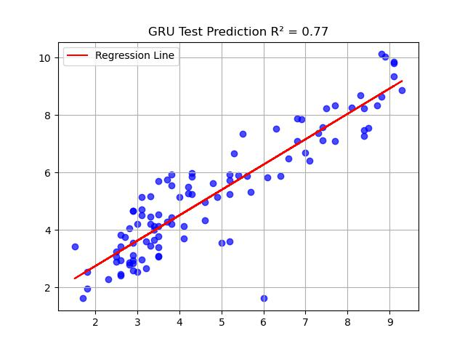 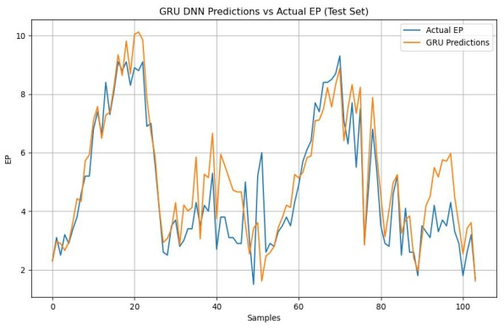

**Figure 8: (a) R_squared for Testing Data (b) Actual Vs Predicted EP using GRU**

**Conclusion: In this study, three different neural network models were trained and evaluated for estimation of average weekly evaporation using weather parameters. The LSTM-based NN presented high prediction accuracy, as shown by the lowest training and testing Root Mean Square Error of 0.0655 and 1.0168, respectively, and training and testing multiple coefficient of determination (R²) of 0.89 and 0.80, outperforming other NN models.**

Disclaimer (Artificial intelligence)

Option 1:

Author(s) hereby declare that NO generative AI technologies such as Large Language Models (ChatGPT, COPILOT, etc.) and text-to-image generators have been used during the writing or editing of this manuscript.

**References:**

1. Allen, R. G., Pereira, L. S., Raes, D., & Smith, M. (1998). Crop evapotranspiration: Guidelines for computing crop water requirements. FAO Irrigation and Drainage Paper 56. Food and Agriculture Organization of the United Nations, Rome.
2. Hargreaves, G. H., & Samani, Z. (1985). Reference crop evapotranspiration from ambient air temperature. American Society of Agricultural Engineers Meeting, Chicago, Paper 85–2517.
3. Samani, Z. (2000). Estimating solar radiation and evapotranspiration using minimum climatological data. Journal of Irrigation and Drainage Engineering, 126(4), 265–267.
4. Galvão, C. O., Valença, M. J. S., Vieira, V. P. P. B., Diniz, L. S., Lacerda, E. G. M., Carvalho, A. C. P. L. F., & Ludermir, T. B. (1999). Sistemas inteligentes: Aplicações a recursos hídricos e ciências ambientais. Universidade Federal do Rio Grande do Sul / Associação Brasileira de Recursos Hídricos, Porto Alegre, Brazil.
5. Sudheer, K. P., Gosain, A. K., & Ramasastri, K. S. (2003). Estimating actual evapotranspiration from limited climatic data using neural computing technique. Journal of Irrigation and Drainage Engineering, 129(3), 214–218.
6. Allen, G., & Le Marshall, J. F. (1994). An evaluation of neural networks and discrimination analysis methods for application in operational rain forecasting. Australian Meteorological Magazine, 43, 17–28.
7. Elizondo, D., Hoogenboom, G., & McClendon, R. W. (1994). Development of a neural network model to predict daily solar radiation. Agricultural and Forest Meteorology, 71(1–2), 115–132.
8. Keskin, M. E., & Terzi, Ö. (2006). Artificial neural network models of daily pan evaporation. Journal of Hydrologic Engineering, 11(1), 65–70.
9. Shirgure, P. S., Rajput, G. S., & Seth, N. K. (2011). Artificial neural network models for estimating daily pan evaporation. Abstract in 45th Annual Convention of ISAE and International Symposium on Water for Agriculture, Dr. PDKV, Nagpur, 17–19 January, pp. 81.
10. Sudheer, K. P., Gosain, A. K., Mohana, R. D., & Saheb, S. M. (2002). Modeling evaporation using an artificial neural network algorithm. Hydrological Processes, 16(16), 3189–3202.
11. Sudheer, K. P., Gosain, A. K., & Ramasastri, K. S. (2003). Estimating actual evapotranspiration from limited climatic data using neural computing technique. Journal of Irrigation and Drainage Engineering, 129(3), 214–218.
12. Mamdouh, A. A., Ibrahim, E., & Mohamed, N. A. (2006). Rainfall-runoff modeling using artificial neural networks technique: A Blue Nile catchment case study. Hydrological Processes, 20(5), 1201–1216.
13. Pachepsky, Y. A., Timlin, D. J., & Varallyay, G. (1996). Artificial neural networks to estimate soil water retention from easily measurable data. Soil Science Society of America Journal, 60, 727–733.
14. Murthy, S., & Gawande, S. (2006). Effect of meteorological parameters on evaporation in small reservoirs: 'Anand Sagar', Shegaon – a case study. Journal of Prudushan Nirmulan, 3(2), 52–56.
15. Megha ., Reddy GVS, Dashavant PB, Babu BM, Kumar GM (2022). Pan Evaporation Estimation Using Artificial Neural Network (ANN) and Fuzzy Logic Models for Raichur Region, Karnataka: A Case Study. *Int. J.Environ. Clim. Change.* 12(11):3725-3.
16. Hochreiter, S., & Schmidhuber, J. (1997). Long short-term memory. Neural Computation, 9(8), 1735–1780.
17. Cho, K., van Merriënboer, B., Gulcehre, C., Bahdanau, D., Bougares, F., Schwenk, H., & Bengio, Y. (2014). Learning phrase representations using RNN encoder-decoder for statistical machine translation. arXiv preprint, arXiv:1406.1078.
18. Fu, R., Zhang, Z., & Li, L. (2016). Using LSTM and GRU neural network methods for traffic flow prediction. In 2016 31st Youth Academic Annual Conference of Chinese Association of Automation (YAC) (pp. 324–328). IEEE. https://doi.org/10.1109/YAC.2016.7804912
19. Cahuantzi, R., Chen, X., & Güttel, S. (2023). A comparison of LSTM and GRU networks for learning symbolic sequences. In K. Arai (Ed.), Intelligent Computing. SAI 2023. Lecture Notes in Networks and Systems (Vol. 739, pp. 707–724). Springer, Cham. <https://doi.org/10.1007/978-3-031-37963-5_53>
20. Ni., Lingling, Wang Dong, Singh V. P., Wu J., Wang Y., Tao Y., Zhang J(2019), Stream flow and rainfall forecasting by two long short-term memory-based models*, Journal of Hydrology,* 583,124296,
21. Wani, O.A., Mahdi, S.S., Yeasin, M. (2024)*.* Predicting rainfall using machine learning, deep learning, and time series models across an altitudinal gradient in the North-Western Himalayas. *Sci Rep* **14,** 27876. <https://doi.org/10.1038/s41598-024-77687-x>
22. https://medium.com/@divyanshu132/lstm-and-its-equations
23. https://medium.com/@anishnama20/understanding-gated-recurrent-unit.