***Original Research Article***

**Isolation, identification and characterisation of coccidian protozoa in foods intended for direct consumption in two major markets in the city of Yaounde, Cameroon**

ABSTRACT

Direct-consumer foods are essential for a healthy diet, but they can also carry environmental forms of intestinal parasites. A survey was conducted in the city of Yaounde, Cameroon, from November 2021 to April 2022, samples of fruits, seeds, drinks and vegetables were collected from two markets in the city of Yaounde. The objective was to detect the presence of oocysts in foods for direct consumption that are sold in the markets of the city of Yaounde. An application of a simple sedimentation method and a modified Ziehl Neelsen staining technique of the forms of dissemination of coccidian protozoa made it possible to identify and count a total of 1280 oocysts/g with a predominance of *Cryptosporidium* spp. (64 %), followed by *Cyclospora* sp. (33 %). *Isospora belli* and *Sarcocystis* spp occupy the last place with 2 % and 1 % respectively. Lettuce (*Lactuca sativa*) had the highest contamination rate, reaching 196 oocysts/g, followed by Cabbage (*Brassica oleracea var. capitata*) with 182 oocysts/g, then Cola (*Cola acuminata*) with 161 oocysts/g, then carrots (*Daucus carota subsp. Sativus*) with 120, sprout water and water in sachets occupied last place with respectively 6 oocysts/g and 2 oocytes/g. Regarding the markets, the Mokolo market recorded a greater number of forms of parasite dissemination with 651 oocysts/g followed by the Mfoundi Markets with a total of 629 oocysts/g. The high content of parasitic elements was noted during the short rainy season (SRS) with a total of 838 oocysts/g and a low content of oocysts 442 oocysts/g during the long dry season (LDS). However, no significant association was found between the presence of oocysts and the type of food sold, sales markets, or season. This study highlights the importance of contamination by oocysts of vegetables sold in the markets of the city of Yaounde and health risk to customer if adequate precaution methods are not taken in to consideration.

Keywords: coccidian protozoa, direct consumption, market, short rainy season (SRS) , long dry season (LDS).

I-Introduction

Some foods intended for direct consumption, without the need to cook or subject them to any other treatment, such as fresh fruits and vegetables, are essential elements of a healthy and balanced diet (Barlaam *et al.,* 2021; Berger *et al.,* 2010; Nadabo *et al.,* 2022). However, these foods can be contaminated by biological, chemical and physical agents during production, transport, storage and handling, processes and transmit diseases to humans (Ajitha *et al.,* 2020; Berger *et al.,* 2010; Ishaq *et al.,* 2021). More than 200 recognized diseases are associated with biological agents (Riemann & Cliver, 2006). Fruits, vegetables and water are mostly associated with biological (bacteria, viruses and parasites) agent (Liu, 2019). In fact, approximately 70 species of protozoan and helminthic parasites are capable of infecting food and water (Omalu *et al.,* 2013). Protozoa are one of the most cosmopolitan and ubiquitous food parasites in the world. Many of them are members of the phylum Apicomplexa and produce environmentally resistant oocysts (Gajadhar *et al.,* 2015; Liu, 2019).

Oocysts produced by apicomplexan parasites that cause foodborne illness include *Cryptosporidium* spp. *Toxoplasma gondii*, *Cyclospora cayetanensis*, *Isospora belli* and *Sarcocystis* spp. and can be grouped under the name coccidian protozoa (Doyle, 2003; Gajadhar *et al.,* 2015; Ortega & Sterling, 2018). According to the Food and Agriculture Organization and World Health Organization, fresh produce such as fruits and vegetables are the main vectors of *Cyclospora cayetanensis* and *Cryptosporidium* spp. (FAO/WHO, 2014). The ingestion of infectious oocysts through contaminated food makes these endemic parasite in many parts of the globe, although the problem is more acute in developing countries (Bekele & Shumbej, 2019; Panisset *et al.,* 2003). In addition, the main sources of contamination often come from contaminated soil and wastewater (Atud *et al.,* 2021), human and animal waste, and the consumption of contaminated water (Mohamed *et al.,* 2016). Oocyst infections are generally mild and cause gastrointestinal symptoms, such as diarrhea, abdominal pain, nausea and vomiting (Almeria *et al.,* 2019; Didier & Weiss, 2008). However, they can be more serious for some people, including those who are immunocompromised, particularly those infected with *Cryptosporidium* spp., which can lead to serious complications and even death (Kudah *et al.,* 2018; Mansfield & Gajadhar, 2004).

The coccidian parasite *Cyclospora cayetanensis* has recently been recognized as a cause of prolonged diarrhea in children and immunocompromised patients in developing countries (Almeria *et al.,* 2019). The sale of foods intended for direct consumption, and their consumption directly after buying them, or indirectly after storing them at home has been strongly developed over the last thirty years in Africa in general and in Cameroon in particular (WHO, 2007; Joséphine et al., 2007). However, this situation does not go without posing health and hygiene problems, including the risk of being contaminated by coccidian protozoa (FOA, 2007). Hence the importance of understanding how coccidian protozoa contaminate the foods we directly consume, what types of foods are typically most affected, and what risks to human health result. This understanding is essential for developing effective prevention and control measures to reduce the incidence of these infections and improve the quality of life for millions of people around the world who depend on subsidiary feeding for livelihood. Unfortunately, there are poorly documented studies regarding the level of coccidian protozoa contamination of vegetables and fruits commonly sold in local markets in Yaounde. Therefore, this research was carried out with the aim of assessing the quality of fresh fruits, vegetables, drinks and seeds sold in the markets of developing countries, especially in the case of Yaounde in Cameroon.

II. Material and methods

2.1 Study site and sampling

Yaounde, the political capital of Cameroon, is located on the western edge of the southern Cameroonian plateau at 3°52' north latitude and 11°32' east longitude, and at an average altitude of approximately 750 m (Suchel, 1986). The relief is rugged and extends over several hills of altitude between 25 and 50 meters, the soils being generally of the ferrolaterite type (Kuété, 2000). The climate is equatorial, warm and humid Yaounde an type, characterized by moderate precipitation and variable temperature over time (Suchel, 1988). These characteristics make it possible to distinguish 4 seasons: the long dry season (LDS) from mid-November to mid-March, a short rainy season (SRS) from mid-March to the end of June, the short dry season (PSS) from July to mid -August and a long rainy season (GSP) from mid-August to mid-November (Suchel, 1986). The two rainy seasons and the two dry seasons are relatively unequal in importance (Pelletier, 1969) and vary in duration from one year to the next (Kuété, 1977). Yaounde is a city which is subdivided into seven distinct districts, namely Yaounde 1, Yaounde 2, Yaounde 3, Yaounde 4, Yaounde 5, Yaounde 6 and Yaounde 7. Each of these districts is home to several markets dedicated to the sale of agri-food products (Soudy, 2020). In total, there are 30 markets spread across the city's seven districts. It should be noted that among these markets, those of Mokolo, the central market and Etoudi are the most popular. Among the largest and most famous markets are Mokolo Market, Mfoundi Market and Central Market (Soudy, 2020).

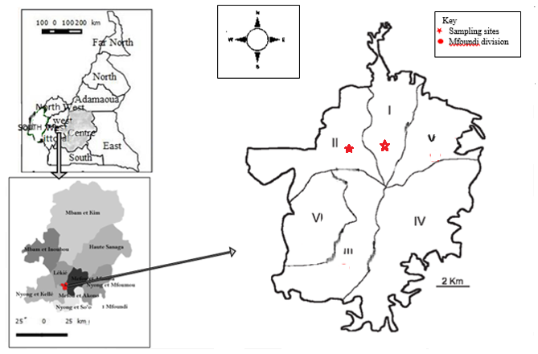**Figure 1: Location of study sites in the Mfoundi department, Center-Cameroon Region (source: National Institute of Cartography, 2023 modified)**

2.2. Sample collection, preparation and washing procedure

A cross-sectional study was conducted between November 2021 and April 2022. Samples of fruits, vegetables, drinks and seeds were collected from two markets (Mfoundi Markets, Mokolo) in the city of Yaounde. After obtaining institutional ethics approval and verbal consent from sellers, samples of fruits, vegetables, drinks and seeds were randomly collected from buyers and sellers. Each sample was placed in a separate, labelled sterile plastic bag. The beverage samples were collected in sterile 200mL bottles. The samples were transported to the hydrobiology and environment laboratory for parasitological analyses. In the laboratory, 500 g of each vegetable, fruit and seed were soaked (for fifteen minutes) then shaken vigorously in a solution of 200 mL of distilled water. Then this water was collected in a sterile 500 mL polyethylene bottle. The samples are left to stand at room temperature for 24 hours for sedimentation. Afterwards, the supernatant was poured out and the pellet volumes were collected, measured, the pellet was transferred to a centrifuge tube. The supernatant was decanted carefully. Finally, two methods were used for observations of the pellet: the simple sedimentation method and the modified Ziehl-Neelsen method.

2.3. Biological analysis methods

* Simple sedimentation method

After homogenization of the pellet, 5 mL of sample was taken using a graduated syringe and introduced into a test tube. To this, 1 mL of 10 % formalin was added to ensure the fixation of the organisms, 5 mL of distilled water and 2 drops of Lugol were successively added. The contents of these test tubes are then centrifuged at a force of 28 g for 5 minutes using a MINOR35 brand centrifuge to float the oocysts. Then, 1 to 2 drops of pellet were taken using a pipette and mounted between the slide and coverslip.

* Modified Ziehl–Neelsen method

This is a method which allows the detection of protozoan oocysts. It consists of coloring the slides. In bref, a 10 % zinc sulfate solution (allowing the oocysts to float) is added to the samples taken and distributed in the test tubes. The contents of these test tubes are then centrifuged at a force of 28 g for 5 minutes using a MINOR35 brand centrifuge to float the oocysts. The supernatant is collected using a micropipette and distributed onto slides which are subsequently air-dried to promote adhesion of the sample to the slides. The slides are fixed with methanol and stained with basic fuchsin respectively for 1 and 5 minutes, rinsed with distilled water and 2 % sulfuric acid (playing the role of decolorizing organisms other than our oocysts) for 2 minutes. The slides were rinsed again and counterstained with 5% methylene blue (which stains other structures or organisms with the exception of *C. cayetanensis* oocysts).

2.4. Identification and enumeration of oocysts

Oocysts were identified using WHO charts (1994, 2019). The measurements of the dimensions were made using the micrometer carried by one of the eyepieces of the microscope. A number (X) of parasitic oocysts was found in 1g of sample using the following formula (Ajeagah *et al.,* 2010; Ajeagah et al 2014):

$$X=\frac{y.Mi}{Mf}$$

With: Mi= Initial weight of the sample, Mf= Final weight of the sample used for observation, y= number of oocysts observed in Mf. As presented by Ajeagah *et al*, 2010

2.5. Statistical analysis

Data recording and plotting of graphs and tables were done using Excel. And SPSS 12.0 allowed us to carry out statistical analyses, the chi-square test was used to compare the level of contamination of oocysts and food types, between markets and seasons. *P*-value less than 0.05 is considered statistically significant.

III. Results and Discussion

Figure 2:Relative abundance of identified oocysts

The observations of the forms of protozoan dissemination made it possible to identify and count in total 1280 oocysts/g with a predominance of *Cryptosporidium* spp. with 64%, followed by *Cyclospora* sp. with 33 %. *Isosospora* belli and *Sarcocystis* spp occupying the latest place with 2 % and 1 % respectively (Figure 1).

The oocysts of C*ryptosporidium* spp. are very small (4 to 6 µm in diameter) and contain a visible or invisible vacuole, their wall is thick (Figure 3 a). The oocysts of *Isospora belli* have a size which oscillates between 17 and 36 µm long with a thin wall that is smooth and not very refractive (Figure 3 b). They contain finely granulated round egg cells. *Cyclospora cayetanensis* oocysts are circular with a smooth double wall. Inside these is a greenish mass called morula. Their size varies from 7 to 10 µm long (Figure 3 c). The sporocysts of *Sarcocystis hominis* are ovoid in shape and contain sporozoites. Their shell is thin and their size fluctuates between 10 and 25 µm long (Figure 3d).

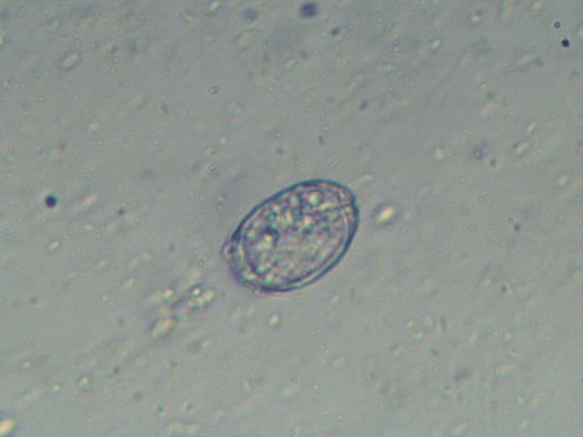

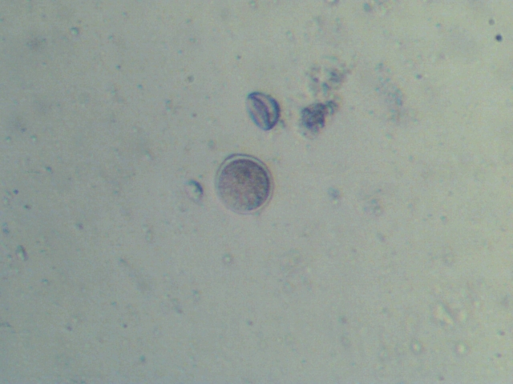

**b**

**a**

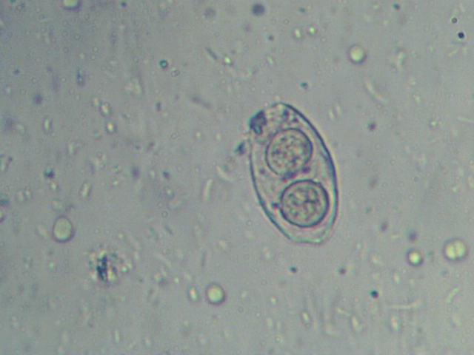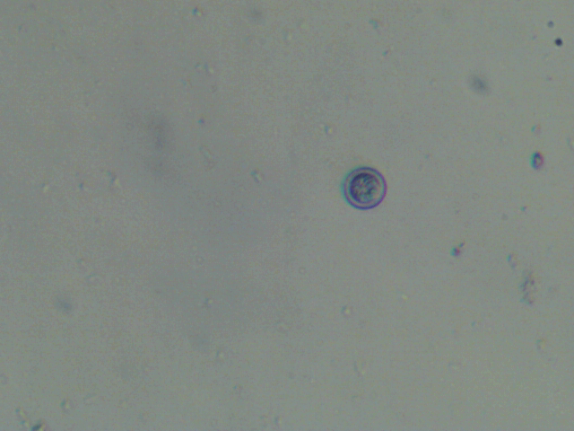

**d**

**c**

**Figure 3: Oocysts identified during the study (a) *Cryptosporidium* spp. (b) *Isospora* belli (c) C*yclospora* sp. and (d) Sarcocystis spp.**

A greater number of forms of parasite dissemination were recorded in lettuce (*Lactuca sativa*) (196) followed by cabbage (*Brassica oleracea var. capitata*) (182), cola (*Cola acuminata*) (161), carrots (*Daucus carota subsp. Sativus*) (120). Bucket water and sachet water occupied last place with (6) and (2) oocytes/g respectively. Statistical tests show no significant differences between foods (P=0.325).

**Figure 4: Relative abundance of protozoan oocysts identified at food level**

**Figure 5: Abundance of protozoan oocysts identified in the Markets**

Spatially, the market in which a greater number of forms of parasite dissemination were recorded is the Mokolo Market with 651 oocysts/g followed by the Mfoundi Markets with a total of 629 oocysts/g. Statistical tests show no significant difference between oocysts and markets (P=0.135)

**Table 1: Relative abundance of protozoan oocysts identified in the Markets**

|  |  |  |  |  |  |
| --- | --- | --- | --- | --- | --- |
| **Foods** | | **Protozoan oocysts** | Markets | | TOTAL  oocysts/g |
| MOKOLO, oocysts/g | MFOUNDI, oocysts/g |
| **FRUITS** | Tomato (*Solanum lycopersicum*) | *Cyclospora cayetanensis* | 22 | 18 | 40 |
| *Cryptosporidium* spp. | 46 | 46 | 92 |
| *Isospora belli* | 2 | 0 | 2 |
| *Sarcocystis* spp. | 0 | 0 | 0 |
| Guava (*Psidium guajava*) | *Cyclospora cayetanensis* | 14 | 4 | 18 |
| *Cryptosporidium* spp. | 22 | 34 | 56 |
| *Isospora belli* | 0 | 0 | 0 |
| *Sarcocystis* spp. | 0 | 0 | 0 |
| Mango (*Mangifera indica*) | *Cyclospora cayetanensis* | 14 | 14 | 28 |
| *Cryptosporidium* spp. | 28 | 46 | 74 |
| *Isospora belli* | 0 | 0 | 0 |
| *Sarcocystis* spp. | 0 | 0 | 0 |
| Apple (*Malus domestica*) | *Cyclospora cayetanensis* | 4 | 4 | 8 |
| *Cryptosporidium* spp. | 26 | 13 | 39 |
| *Isospora belli* | 0 | 0 | 0 |
| *Sarcocystis* spp. | 0 | 0 | 0 |
| **TOTAL** |  | 178 | 179 | 357 |
| **VEGETABLES** | Lettuce (*Lactuca sativa*) | *Cyclospora cayetanensis* | 46 | 24 | 70 |
| *Cryptosporidium* spp. | 46 | 60 | 106 |
| *Isospora belli* | 6 | 6 | 12 |
| *Sarcocystis* spp. | 2 | 4 | 6 |
| Cabbage (*Brassica oleracea var. capitata*) | *Cyclospora cayetanensis* | 30 | 30 | 60 |
| *Cryptosporidium* spp. | 60 | 58 | 118 |
| *Isospora belli* | 0 | 0 | 0 |
| *Sarcocystis* spp. | 0 | 0 | 0 |
| Eggplant (*Solanum melongena*) | *Cyclospora cayetanensis* | 22 | 18 | 40 |
| *Cryptosporidium* spp. | 28 | 40 | 68 |
| *Isospora belli* | 6 | 0 | 6 |
| *Sarcocystis* spp. | 0 | 0 | 0 |
| Carrot (*Daucus carota subsp. Sativus*) | *Cyclospora cayetanensis* | 12 | 30 | 42 |
| *Cryptosporidium* spp. | 30 | 52 | 82 |
| *Isospora belli* | 0 | 2 | 2 |
| *Sarcocystis* spp. | 0 | 2 | 2 |
| **TOTAL** |  | 288 | 326 | 614 |
| **SEEDS** | Date (*Phoenix dactylifera*) | *Cyclospora cayetanensis* | 20 | 0 | 20 |
| *Cryptosporidium* spp. | 22 | 16 | 38 |
| *Isospora belli* | 0 | 0 | 0 |
| *Sarcocystis* spp. | 0 | 0 | 0 |
| Cola (*cola acuminata*) | *Cyclospora cayetanensis* | 27 | 40 | 67 |
| *Cryptosporidium* spp. | 64 | 28 | 92 |
| *Isospora belli* | 0 | 0 | 0 |
| *Sarcocystis* spp. | 0 | 0 | 0 |
| Hazelnut (*Corylus avellana*) | *Cyclospora cayetanensis* | 6 | 0 | 6 |
| *Cryptosporidium* spp. | 0 | 8 | 8 |
| *Isospora belli* | 0 | 0 | 0 |
| *Sarcocystis* | 0 | 0 | 0 |
| Tiger Nut (*Cyperus esculentus*) | *Cyclospora cayetanensis* | 18 | 6 | 24 |
| *Cryptosporidium* spp. | 12 | 8 | 20 |
| *Isospora belli* | 0 | 0 | 0 |
| *Sarcocystis* spp. | 0 | 0 | 0 |
| **TOTAL** |  | 169 | 106 | 275 |
| **DRINKS** | Rotten milk | *Cyclospora cayetanensis* | 0 | 0 | 0 |
| *Cryptosporidium* spp. | 8 | 4 | 12 |
| *Isospora belli* | 0 | 0 | 0 |
| *Sarcocystis* spp. | 0 | 0 | 0 |
| Red hibiscus flowers juice (*Hibiscus sabdariffa*) | *Cyclospora cayetanensis* | 4 | 0 | 4 |
| *Cryptosporidium* spp. | 4 | 6 | 10 |
| *Isospora belli* | 0 | 0 | 0 |
| *Sarcocystis* spp. | 0 | 0 | 0 |
| Bucket water | *Cyclospora cayetanensis* | 0 | 2 | 2 |
| *Cryptosporidium* spp. | 0 | 4 | 4 |
| *Isospora belli* | 0 | 0 | 0 |
| *Sarcocystis* spp. | 0 | 0 | 0 |
| Sachet water | *Cyclospora cayetanensis* | 0 | 0 | 0 |
| *Cryptosporidium* spp. | 0 | 2 | 2 |
| *Isospora belli* | 0 | 0 | 0 |
| *Sarcocystis* spp. | 0 | 0 | 0 |
| **TOTAL** |  |  | 16 | 18 | 34 |

Seasonally, the high content of parasitic elements was noted during the SRS with a total of 838 oocysts/g and a low content of oocysts therefore 442 oocysts/g during the LDS. Statistical tests show no significant difference between oocysts and seasons (P=0.455).

**Figure 6: Abundance of protozoan oocysts identified during Season**

**Table 2: Relative abundance of protozoan oocysts identified at food level by season**

|  |  |  |  |  |  |
| --- | --- | --- | --- | --- | --- |
| **Foods** | | **Protozoan oocysts** | **Seasons in** oocysts/g | | **TOTAL** |
| LDS | SRS |
| **FRUITS** | Tomato (*Solanum lycopersicum*) | *Cyclospora cayetanensis* | 10 | 30 | 40 |
| *Cryptosporidium* spp. | 46 | 46 | 92 |
| *Isospora belli* | 0 | 2 | 2 |
| *Sarcocystis* spp. | 0 | 0 | 0 |
| Guava (*Psidium guajava*) | *Cyclospora cayetanensis* | 0 | 18 | 18 |
| *Cryptosporidium* spp. | 12 | 44 | 56 |
| *Isospora belli* | 0 | 0 | 0 |
| *Sarcocystis* spp. | 0 | 0 | 0 |
| Mango (*Mangifera indica*) | *Cyclospora cayetanensis* | 4 | 24 | 28 |
| *Cryptosporidium* spp. | 12 | 64 | 76 |
| *Isospora belli* | 0 | 0 | 0 |
| *Sarcocystis* spp. | 0 | 0 | 0 |
| Apple (*Malus domestica*) | *Cyclospora cayetanensis* | 0 | 8 | 8 |
| *Cryptosporidium* spp. | 18 | 19 | 37 |
| *Isospora belli* | 0 | 0 | 0 |
| *Sarcocystis* spp. | 0 | 0 | 0 |
| **TOTAL** |  | 102 | 255 | 357 |
| **VEGETABLES** | Lettuce (*Lactuca sativa*) | *Cyclospora cayetanensis* | 20 | 50 | 70 |
| *Cryptosporidium* spp. | 34 | 74 | 108 |
| *Isospora belli* | 0 | 12 | 12 |
| *Sarcocystis* spp. | 4 | 2 | 6 |
| Cabbage (*Brassica oleracea var. capitata*) | *Cyclospora cayetanensis* | 22 | 38 | 60 |
| *Cryptosporidium* spp. | 56 | 60 | 116 |
| *Isospora belli* | 2 | 4 | 6 |
| *Sarcocystis* spp. | 0 | 0 | 0 |
| Eggplant (*Solanum melongena*) | *Cyclospora cayetanensis* | 6 | 34 | 40 |
| *Cryptosporidium* spp. | 20 | 56 | 76 |
| *Isospora belli* | 0 | 0 | 0 |
| *Sarcocystis* spp. | 0 | 0 | 0 |
| Carrot (*Daucus carota subsp. Sativus*) | *Cyclospora cayetanensis* | 22 | 20 | 42 |
| *Cryptosporidium* spp. | 34 | 40 | 74 |
| *Isospora belli* | 2 | 0 | 2 |
| *Sarcocystis* spp. | 0 | 2 | 2 |
| **TOTAL** |  |  | 222 | 392 | 614 |
|  | Date (*Phoenix dactylifera*) | *Cyclospora cayetanensis* | 0 | 20 | 20 |
| **SEEDS** | *Cryptosporidium* spp. | 16 | 22 | 38 |
| *Isospora belli* | 0 | 0 | 0 |
| *Sarcocystis* spp. | 0 | 0 | 0 |
| Cola (*cola acuminata*) | *Cyclospora cayetanensis* | 24 | 43 | 67 |
| *Cryptosporidium* spp. | 38 | 56 | 94 |
| *Isospora belli* | 0 | 0 | 0 |
| *Sarcocystis* spp. | 0 | 0 | 0 |
| Hazelnut (*Corylus avellana*) | *Cyclospora cayetanensis* | 0 | 6 | 6 |
| *Cryptosporidium* spp. | 6 | 0 | 6 |
| *Isospora belli* | 0 | 0 | 0 |
| *Sarcocystis* spp. | 0 | 0 | 0 |
| Tiger Nut (*Cyperus esculentus*) | *Cyclospora cayetanensis* | 10 | 14 | 24 |
| *Cryptosporidium* spp. | 10 | 10 | 20 |
| *Isospora belli* | 0 | 0 | 0 |
| *Sarcocystis* spp. | 0 | 0 | 0 |
| **TOTAL** |  | 104 | 171 | 275 |
| **DRINKS** | Rotten milk | *Cyclospora cayetanensis* | 0 | 0 | 0 |
| *Cryptosporidium* spp. | 10 | 2 | 12 |
| *Isospora belli* | 0 | 0 | 0 |
| *Sarcocystis* spp. | 0 | 0 | 0 |
| Red hibiscus flowers juice (*Hibiscus sabdariffa*) | *Cyclospora cayetanensis* | 4 | 0 | 4 |
| *Cryptosporidium* spp. | 0 | 10 | 10 |
| *Isospora belli* | 0 | 0 | 0 |
| *Sarcocystis* spp. | 0 | 0 | 0 |
| Bucket water | *Cyclospora cayetanensis* | 0 | 2 | 2 |
| *Cryptosporidium* spp. | 0 | 4 | 4 |
| *Isospora belli* | 0 | 0 | 0 |
| *Sarcocystis* spp. | 0 | 0 | 0 |
| Sachet | *Cyclospora cayetanensis* | 0 | 0 | 0 |
| *Cryptosporidium* spp. | 0 | 2 | 2 |
| *Isospora belli* | 0 | 0 | 0 |
| *Sarcocystis* spp. | 0 | 0 | 0 |
| **TOTAL** |  |  | 14 | 20 | 34 |

High densities of *Cryptosporidium* spp. were found on the surface of fruits and vegetables and drinks sold in Yaounde markets, followed by *Cyclospora cayetanensis*, while low densities of *Isospora belli* and *Sarcocystis* sppwere found on these foods. This high density of *Cryptosporidium* spp. and *Cyclospora cayetanensis* has been reported on vegetables in Nigeria (Maikai *et al.,* 2013) and on vegetables and fruits in Ethiopia (Tefera *et al.,* 2014). However, the presence of Cryptosporidium spp., *Cyclospora cayetanensis* on vegetables and fruits was found to be low in China (Li *et al.,* 2020). However, low densities of *Isospora belli* have also been reported in Ghana (Duedu *et al.,* 2014). These results can be directly linked to the nature of the wall of each oocyst. In fact Cryptosporidium spp. is very abundant in nature and very resistant in the environment compared to its small size and its double wall, they have a thicker outer layer which protects them against harsh environmental conditions. This allows them to survive longer in the environment and easily been spread (Pierre *et al.,* 2020). On the other hand, *Sarcocystis* spp. having an ovoid shape and containing sporozoites. Their shells are thin and offer little protection against harsh environments.

At the seasonal level, the parasite load on fruits and vegetables was higher during the SRS period, totaling 838 oocysts/g, and lower during the LDS period, 442 oocysts/g (Sim *et al.,* 2017). This could be explained by the rains observed during the rainy season which moisten the soil, thus facilitating the spread of oocysts. Rain provides nutrients that promote the growth and maturation of oocysts, rain also creates a humid environment perfect for oocyst maturation (LeBari, 2022). Additionally, precipitation can spread oocysts into the environment, increasing the risk of contamination of fruits and vegetables. Finally, the humidity and heat of the rainy season can promote parasitic infestation and contamination of crops.

The parasitic load of oocysts on fruits and vegetables is higher at the Mokolo market than at the Mfoundi market. The attendance and the size and organization of the markets may explain this observation. In fact, the Mokolo market is larger and busier and poorly organized. The Mokolo markets are an all-rounder, in fact the particularity of this market is that we find all types of products, there is a wide variety of foods, including fresh fruit and vegetables, meat and fish and drinking water, as well as prepared foods. There are also animals that are killed and gutted on site, there are also non-food products, household items and clothing (Soudy, 2020). This can explain the high number of population in this market, making it easy for intestinal parasites to spread within said markets (Omalu *et al.,* 2013). The Mfoundi market, on the other hand, is smaller, less crowded and better organized. This reduces the risk of contamination by oocysts as presented by Li et al, 2020.

At the food level, variations in the number of oocysts have been noted. This variation in contamination rates of different foods may be partly due to differences in the shape and surface of vegetables and fruit grains. Green leafy vegetables like lettuce (*Lactuca sativa*) have irregular surfaces that make it easier for parasitic oocysts to adhere. In contrast, fruits with smooth surfaces, such as apples, have the lowest prevalence rates. Other studies have also demonstrated a higher contamination rate in leafy vegetables (Maikai *et al.,* 2013).

IV. Conclusion

According to the results obtained involving the collection and analysis of fruits, seeds, drinks, and vegetables, protozoan parasites like *Cryptosporidium* spp., *Cyclospora* sp., *Isospora belli* and *Sarcocystis* spp. are present. A total of 322 oocysts/g of *Cryptosporidium* spp. were identified, with *Cryptosporidium* spp. being the most prevalent. The findings revealed that lettuce and cabbage had the highest contamination rates, highlighting the potential health risks associated with these commonly consumed vegetables. The Mokolo market showed a slightly higher contamination rate compared to the Mfoundi market, and a higher number of oocysts was detected during the short rainy season. Despite these findings, no significant association was found between the presence of oocysts and the type of food, sales markets, or season. The presence of parasites in these foods and water is a potential source of disease. It is therefore crucial to take immediate measures to reduce contamination and ensure food safety for consumers.

Ethical Approval:

As per international standards or university standards written ethical approval has been collected and preserved by the author(s).

Consent

As per international standards or university standards, respondents’ written consent has been collected and preserved by the author(s).

**COMPETING INTERESTS DISCLAIMER:**

Authors have declared that they have no known competing financial interests OR non-financial interests OR personal relationships that could have appeared to influence the work reported in this paper.

Disclaimer (Artificial intelligence)

Option 1:

Author(s) hereby declare that NO generative AI technologies such as Large Language Models (ChatGPT, COPILOT, etc.) and text-to-image generators have been used during the writing or editing of this manuscript.

Option 2:

Author(s) hereby declare that generative AI technologies such as Large Language Models, etc. have been used during the writing or editing of manuscripts. This explanation will include the name, version, model, and source of the generative AI technology and as well as all input prompts provided to the generative AI technology

Details of the AI usage are given below:

1.

2.

3.

**Reference:**

**Ajeagah, G., Njine, T., Bilong B. C., Foto, M. S., Wouafo., N., Nola M., Di G. & Huw., S. (2010).**Seasonal distribution of Enteric Opportunistic Cryptosporidium spp. Oocysts and Giardia spp. Cysts in a tropical water basin, Cameroon. Water, 2: 44-57.

1. **Ajeagah G., Foto Menbohan S., Talom S., Ntwong M., Tombi J., Nola M. et Njine T. 2014.** Propriété Physico-chimique et dynamique d’abondance des formes de dissémination des helminthes intestinaux dans les eaux usées et de surface à Yaoundé (Cameroun). *European Journal of Sientific Research*, 120 p.
2. **Ajitha, S., Vazhavandal, G., Uma, A., & Prabhusaran, N. (2020).** Study on parasitic contamination of common edible fruits and vegetables sold in local markets of Tiruchirappalli, South India. *Indian Journal of Microbiology Research*, *7*(4), 362‑368. https://doi.org/10.18231/j.ijmr.2020.065
3. **Almeria, S., Cinar, H. N., & Dubey, J. P. (2019).** Cyclospora cayetanensis and Cyclosporiasis : An Update. *Microorganisms*, *7*(9), 317. https://doi.org/10.3390/microorganisms7090317
4. **Atud Q.A., Aghaindum G.A., Okoa A. T.N. (2021).** Dynamique d’abondance des charges oocystiques dans les eaux souterraines de Mbankomo, une zone périurbaine de Yaoundé : physicochimie et risque sanitaire. *Bulletin de la Société de Pathologie Exotique,* 288 113-278
5. **Barlaam, A., Temesgen, T. T., Tysnes, K. R., Rinaldi, L., Ferrari, N., Sannella, A. R., Normanno, G., Cacciò, S. M., Robertson, L. J., & Giangaspero, A. (2021).** Contamination of fresh produce sold on the Italian market with Cyclospora cayetanensis and Echinococcus multilocularis. *Food Microbiology*, *98*, 103792. https://doi.org/10.1016/j.fm.2021.103792
6. **Bekele, F., & Shumbej, T. (2019).** Fruit and vegetable contamination with medically important helminths and protozoans in Tarcha town, Dawuro zone, South West Ethiopia. *Research and Reports in Tropical Medicine*, *Volume 10*, 19‑23. https://doi.org/10.2147/RRTM.S205250
7. **Berger, C. N., Sodha, S. V., Shaw, R. K., Griffin, P. M., Pink, D., Hand, P., & Frankel, G.** (2010). Fresh fruit and vegetables as vehicles for the transmission of human pathogens : Fresh produce as vehicles for transmission of human pathogens. *Environmental Microbiology*, *12*(9), 2385‑2397. https://doi.org/10.1111/j.1462-2920.2010.02297.x
8. **Didier, E. S., & Weiss, L. M. (2008)**. *Overview of microsporidia and microsporidiosis*. 13p.
9. **Doyle, M. E. (2003)**. A Review of the Scientific Literature Review. *Foodborne Parasites*, 32p.
10. **Duedu, K. O., Yarnie, E. A., Tetteh-Quarcoo, P. B., Attah, S. K., Donkor, E. S., & Ayeh-Kumi, P. F. (2014).** A comparative survey of the prevalence of human parasites found in fresh vegetables sold in supermarkets and open-aired markets in Accra, Ghana. *BMC Research Notes*, *7*(1), 836. https://doi.org/10.1186/1756-0500-7-836
11. **FAO. (2007).** Les bonnes pratiques d’hygiène dans la préparation et la vente des aliments de rue en Afrique:04-188.
12. **FAO/WHO. (2014).** Multicriteria-Based Ranking for Risk Management of Food-Borne Parasites. Microbiological Risk Assessment Series (MRA) 23. 2014 (Consulté avril 2022; disponible:http://www.fao.org/publications/card/en/c/ee07c6ae-b86c-4d5f-915c-**94c93ded7d9e/.**
13. **Gajadhar, A. A., Lalonde, L. F., Al-Adhami, B., Singh, B. B., & Lobanov, V. (2015).** Foodborne apicomplexan protozoa : Coccidia. *Foodborne Parasites in the Food Supply Web*.
14. **Ishaq, A. R., Manzoor, M., Hussain, A., Altaf, J., Rehman, S. Javed, Z., Afzal, I., Noor, A., & Noor, F. (2021).** Prospect of microbial food borne diseases in Pakistan : A review. *Brazilian Journal of Biology*, *81*(4), 940‑953. https://doi.org/10.1590/1519-6984.232466
15. **Joséphine, M.A., Éric-Joël, N., Christian, G. N & Pauline, M. (2017).** Overview of Culinary Preparations Sold in the Major Markets of Yaoundé-Cameroon: *Journal of Culinary Science & Technology*: 1542-8052.
16. **Kudah, C., Sovoe, S., & Baiden, F. (2018).** Parasitic contamination of commonly consumed vegetables in two markets in Ghana. *Ghana Medical Journal*, *52*(2), 88. https://doi.org/10.4314/gmj.v52i2.5
17. **Kuete, M. (1977).** Etude géomorphologique du massif de Yaoundé. Thèse pour le Doctorat de 3ème Cycle, Université de Bordeaux, 278 p.
18. **Kuete, M. (2000).** Les aspects physiques de l’environnement d’une bordure de socle tropical au fond du Golfe de Guinée. *Presse Universitaire de Yaoundé,* 17 : 12-18.
19. **LeBari B. G. (2022).** Seasonal Parasitic Contamination of Vegetables Marketed in Bori Central Market, Khana Local Governemnt Area, Rivers State, Nigeria. European Journal of Biology and Biotechnology, 2(4). https://doi.org/ 10.24018/ejbio.2022.3.4.381
20. **Li, J., Wang, Z., Karim, M. R., & Zhang, L. (2020).** Detection of human intestinal protozoan parasites in vegetables and fruits : A review. *Parasites & Vectors*, *13*(1), 380. https://doi.org/10.1186/s13071-020-04255-3
21. **Liu, D. (Éd.). (2019)**. *Handbook of foodborne diseases*. CRC Press, Taylor & Francis Group.
22. **Maikai, B. V., Baba-Onoja, E. B. T., & Elisha, I. A. (2013).** Contamination of raw vegetables with Cryptosporidium oocysts in markets within Zaria metropolis, Kaduna State, Nigeria. Food Control, 31(1), 45‑48. https://doi.org/10.1016/j.foodcont.2012.09.032
23. **Mansfield, L. S., & Gajadhar, A. A.** (2004). Cyclospora cayetanensis, a food- and waterborne coccidian parasite. *Veterinary Parasitology*, *126*(1‑2), 73‑90. https://doi.org/10.1016/j.vetpar.2004.09.011
24. **Mohamed, M. A., Siddig, E. E., Elaagip, A. H., Edris, A. M. M., & Nasr, A. A. (2016).** Parasitic contamination of fresh vegetables sold at central markets in Khartoum state, Sudan. *Annals of Clinical Microbiology and Antimicrobials*, *15*(1), 17. https://doi.org/10.1186/s12941-016-0133-5
25. **Nadabo, C., Ramyil, S. C., Bello, C. S., Adeola, O. A., Ike, R., Ogundeko, T. O., Yusuf Omope, A., & Adu, P. (2022).** Parasitic Contamination of Commonly Consumed and Locally Cultivated Leafy Vegetables in Jos, North-Central Nigeria. *Journal of Human, Environment, and Health Promotion*, *8*(1), 1‑9. https://doi.org/10.52547/jhehp.8.1.1
26. **Omalu, I., Paul S., Adeniran, A., Hassan S., Pam V., Eke S and EZE G. (2013).** Assessment of the Level of Gastrointestinal Parasites Infection among Food Vendors in Minna, North Central Nigeria. Annual Review & Research in Biology: 3(4): 705-713.
27. **OMS. (2007).** Marchés-santé : guide pour le respect des conditions d’hygiène sur les marchés alimentaires.45P**.**
28. **Ortega, Y. R., & Sterling, C. R. (Éds.). (2018).** *Foodborne Parasites*. Springer International Publishing. https://doi.org/10.1007/978-3-319-67664-7
29. **Panisset, J.C., Dewailly, É., Doucet-Leduc, H. (2003).** Contamination alimentaire In : Environnement et santé publique - Fondements et pratiques. Paris : Edisem. pp. 369-395.
30. **Pelletier, J. (1969)**. Données générales sur la répartition des principaux types de sol de la région de Yaoundé. Document Orstom, 25 p.
31. **Pierre, N.T., Aghaindum, G.A., Arnold, K.F., Atud, Q.A., Nadège,O.A.T., &Mireille T.K.(2021).** Effets De L’extrait Aqueux Du Moringa Oleifera Sur L’abondance Des Oocystes De Protozoaires Intestinaux Des eaux Usées D’origine Hospitalière À Yaoundé-Cameroun*. European Scientific Journal,* ESJ, 17(43), 58. https://doi.org/10.19044/esj.2021.v17n43p58
32. **Riemann, H., & Cliver, D. O. (2006).** *Foodborne infections and intoxications* (3rd ed). Academic press.
33. **Sim, S., Won, J., Kim, J.-W., Kim, K., Park, W.-Y., & Yu, J.-R. (2017).** Simultaneous Molecular Detection of Cryptosporidium and Cyclospora from Raw Vegetables in Korea. *The Korean Journal of Parasitology*, *55*(2), 137‑142. https://doi.org/10.3347/kjp.2017.55.2.137
34. **Soudy, E. (2020). [PROJET]** Réorganisation des marchés de Yaoundé (Consulté septembre 2023; disponible: https://lab.gestiondeprojet.pm/projet-reorganisation-des-marches-de-yaounde/).
35. **Suchel J. B. (1988).** Les climats du Cameroun. Thèse de doctorat d’état, 1177 p.

1. **Suchel, J. (1986).** Les climats du Cameroun. Thèse de Doctorat d’état. Université Saint-Étienne, France, 1177 .46 p
2. **Tefera, T., Biruksew, A., Mekonnen, Z., & Eshetu, T. (2014).** Parasitic Contamination of Fruits and Vegetables Collected from Selected Local Markets of Jimma Town, Southwest Ethiopia. *International Scholarly Research Notices*, *2014*, 1‑7. https://doi.org/10.1155/2014/382715
3. Li J, Wang Z, Karim MR, Zhang L.2020. Detection of human intestinal protozoan parasites in vegetables and fruits: a review. Parasites & Vectors. 2020 Dec;13:1-9.