**CLOUD-BASED SOLUTIONS FOR SCALABLE NON-PROFIT PROJECT MANAGEMENT SYSTEMS**

**ABSTRACT**

|  |
| --- |
| **Objective:** This study explores the feasibility of applying cloud computing to develop scalable, low-cost project management systems for non-profit organizations. It explores cloud-based technology advantages, limitations, and probable uses in optimizing project coordination, resource allocation, and impact assessment.  **Study Design:** A comprehensive review of literature on cloud-based non-profit project management solutions, with specific focus on research work published between 2019 and 2024.  **Methodology:** The research is based on Google Scholar systematic literature review, as well as Scopus, IEEE Xplore, and ScienceDirect databases. The articles selected in the databases cover cloud computing within non-profit management, cost-effectiveness, security concerns, and digital transformation in enhancing operational effectiveness.  **Results:** The review identifies 14 studies that illustrate the application of cloud computing for managing non-profit projects. Results highlight that cloud systems improve collaboration, data security, cost-effectiveness, and accessibility. Conversely, risks to data privacy, dependency on internet access, and the lack of technical understanding are concerns to most non-profit organizations.  **Conclusions:** Cloud computing has emerged as a transformative solution for non-profits to accomplish efficient and scalable project management. Although the advantages of cloud systems are well recognized, future research needs to focus on creating measures to mitigate security concerns and enhance digital competence among non-profit staff to unlock the complete potential of these technologies. |

***Keywords:*** *Cloud Computing, Non-profit, Project Management, Digital transformation.*

**1. INTRODUCTION**

Non-profit organizations (NPOs) play a vital role in addressing social, economic, and environmental problems worldwide. They operate in diverse fields such as education, healthcare, poverty eradication, and humanitarian aid, typically with the assistance of donor money, volunteers, and limited resources to achieve their objectives [1]. Efficient project management is necessary for NPOs to ensure openness, accountability, and effective utilization of resources. However, traditional project management systems are typically expensive, inflexible, and require a large amount of IT infrastructure, and thus are difficult to scale for resource-constrained non-profits [2]. Cloud computing has also been a transformative solution to these issues. Due to its scalability, low-cost, and collaborative features, cloud-based project management systems provide NPOs the possibility of streamlining operations, improving stakeholder engagement, and maximizing impact assessment [3]. The agility of cloud technology offers organizations the ability to access project management software on a subscription or pay-as-you-go basis, reducing the burden of the cost of maintaining in-house IT infrastructure [4]. Cloud solutions also enable non-profits to become agile, facilitating remote work in various locations, automating business processes, and improving data availability.

Cloud computing solutions are of different advantages to NPOs, most significantly scalability, accessibility, and efficiency. Microsoft Azure, Google Workspace, and Salesforce for Nonprofits are some of the cloud platforms that provide end-to-end solutions for project management, tracking donations, and communication between donors/beneficiaries [5]. These solutions enable real-time collaborative working since teams can work on documents, plan tasks, and track progress from anywhere without taking geographical constraints into consideration [6]. Besides, cloud computing reinforces data-driven decision-making among non-profits. By leveraging data analysis and artificial intelligence (AI) capabilities, NPOs are able to assess project performance, predict funding needs, and monitor impact more effectively [2, 7]. Cloud platforms also enable the integration of various applications, including financial management software, customer relationship management (CRM) platforms, and donor engagement platforms, with a centralized hub for organizational activities [8]. One of the greatest benefits of cloud computing is its ability to facilitate cost-effective project management. Unlike traditional IT infrastructure, which constitutes high capital expenditures and maintenance charges, cloud-based platforms offer a subscription model that allows organizations to scale services according to their needs [9]. Not only is this cost-effective in terms of initial costs, but also operational overhead, allowing NPOs to allocate more funds towards their core mandate.

Despite all the advantages of cloud computing, there are several issues to be addressed while non-profits adopt cloud-based project management systems. Data security and confidentiality are among the key issues. The majority of non-profits handle sensitive donor information, beneficiary details, and financial data, which require stringent security measures to prevent breaches and misuse [10]. Compliance with data protection legislation such as the General Data Protection Regulation (GDPR) and the Health Insurance Portability and Accountability Act (HIPAA) is crucial in maintaining donor trust and organizational integrity [11]. Another issue is the digital divide because certain non-profits lack the technical competencies to effectively utilize and operate cloud-based systems. Lack of IT competencies among staff could delay the adoption of new technology and render cloud systems less effective [12]. Capacity development and training programs are needed to equip non-profit professionals with the necessary competencies to use cloud computing effectively. Furthermore, NPOs must address issues of vendor lock-in. Many cloud providers offer custom-based services, and hence, organizations would find it difficult to switch providers at minimal or no cost and technical overhead [13]. Having a single cloud provider could limit adaptability and introduce long-term financial consequences. To avoid such an issue, non-profits can adopt multi-cloud strategies or open-source solutions that allow greater data and infrastructure management [3].

As digital transformation reshapes the not-for-profit sector further, cloud computing will become even more indispensable to project management. Growing trends such as edge computing, blockchain, and AI-fueled analytics continue to reshape the functionality of cloud-based infrastructure [9]. Such developments are creating new possibilities for enhanced transparency, reduced administrative expenses, and improved allocation of resources for not-for-profit organizations. For instance, blockchain can be used to enhance financial transparency by providing irrevocable transaction records to mean that donor donations and fund distributions are tracked with zero opportunity for lying [3]. Artificial intelligence-powered chatbots and virtual assistants may assist in donor outreach and volunteer engagement, freeing up non-profit employees [14]. Furthermore, cloud-based geographic information systems (GIS) enable non-profits to track and show the success of their projects in real time, improving program effectiveness and decision-making [13]. While adoption of cloud computing in the non-profit sector is still unfolding, it's evident that these technologies have huge potential to enhance project management capabilities. By overcoming security, digital capability, and vendor dependence issues, non-profits can maximize the benefits of cloud technologies and become more effective overall.

Although there are benefits of cloud-based project management in non-profits recognized by the existing literature, there are still gaps in investigating long-term sustainability and sector adoption of such technology. In the majority of research, technical feasibility of cloud computing is given more importance than socio-economic challenges of adoption, particularly in environments of scarce resource availability [14]. Furthermore, empirical studies that evaluate the effects of cloud-based systems in various non-profit fields like healthcare, education, and humanitarian relief are also lacking. Future studies need to investigate how digital literacy can be improved among non-profit employees, how cost-efficient cloud solutions can be designed for resource-constrained environments, and how cybersecurity threats can be mitigated. Besides, studies must examine the ethical implications of cloud computing in data management in non-profit organizations so that digital transformation remains in sync with organizational values and stakeholder interests. Bridging the research divide will play a key role in making cloud-based project management systems sustainable, inclusive, and responsive to shifting needs in the non-profit sector.

**2. METHODOLOGY**

The research methodology employed in this study is a systematic literature peer-review framework to analyze the application of cloud computing in developing scalable and cost-effective project management systems for non-profits. With this approach, the analysis is derived only from quality, peer-reviewed, and relevant sources. Only those articles published in 2019 and onwards have been considered because this is required to incorporate the recent advancements of cloud computing as well as their usage in non-profit organizations. The literature was accessed via four academic databases, which include Google Scholar, Scopus, IEEE Xplore, and ScienceDirect. These were selected because they host a complete set of scholarly papers on cloud computing, information systems, and non-profit management.

Keywords and Boolean operators were utilized to access relevant studies. The keywords employed were "cloud computing in non-profits," "cloud-based project management for NGOs," "scalable IT solutions for non-profit organizations," and "digital transformation in non-profits." The keywords were combined with Boolean operators such as "AND" and "OR" to limit the search results and encompass studies particular to project management in non-profit organizations and not overall cloud computing solutions. By applying these search terms, an initial set of 260 articles was identified in the selected databases with 95 articles in Google Scholar, 70 in Scopus, 55 in IEEE Xplore, and 40 in ScienceDirect.

Following the process of identification, the replicates were removed, reducing the records to 190. The second one was title and abstract screening to remove studies that were not directly related to the topic of the study. Such studies were removed if they were describing cloud computing concepts in general terms without a specific application to non-profits or if they were studies on project management methodologies with no mention of cloud solutions. After screening, 150 articles were excluded, and 40 full-text articles were left for assessment.

The final process of the study selection involved a careful assessment of the remaining full-text articles to see if they provided helpful information on the use of cloud computing for non-profit project management. Those studies lacking a clear emphasis on cloud-based solutions for non-profits were excluded. Additionally, studies that stated corporate or government sectors but not how they were relevant to non-profits were excluded. Those that were not in English were also excluded in order to maintain consistency in interpreting the language. After this rigorous selection process, 14 studies formed the qualitative analysis and were the foundation for this review.

There are limitations to this method even with the rigorous selection process. One of the main limitations is reliance on four databases, which, although extensive, may not include all relevant research on the topic. Some important articles could be found in other databases or institutional repositories that were not searched. The exclusion of non-English publications also means that potentially valuable contributions from studies reported in non-English-speaking countries may have been omitted. A further limitation is the focus on peer-reviewed academic literature, which may not encompass industry reports that demonstrate actual-world applications of cloud-based project management within non-profits. Finally, while the research attempts to encapsulate recent developments from 2019 onwards, certain older core research that would still be applicable to understanding cloud computing's evolution within non-profits was not encompassed.

Generally, this methodology ensures a structured and rigorous approach to reviewing cloud-based project management literature for non-profits. The study selection process allows the in-depth consideration of relevant high-quality studies without neglecting limitations that may impact the completeness of the results. Avoiding these limitations in further research by adopting a broader selection of sources and languages can heighten the relevance and depth of the research.

**3. RESULTS AND DISCUSSION**

The systematic literature search identified 14 original studies from 2019 to 2024 that study the application of cloud-based solutions in non-profit project management. The studies verify collectively the transformative potential of cloud computing to enhance organizational efficiency, collaboration, and scalability for non-profits but also identify current challenges that must be addressed to achieve optimal benefits of these technologies.

**1. Enhanced Collaboration and Accessibility**

Cloud-based project management software has been widely recognized as improving collaboration for geographically dispersed teams. Uddin and Koo [15], opine that cloud platforms such as Microsoft Azure and Google Workspace improve sharing of information in real-time as well as communication, which is crucial for non-profits that operate across many regions. This is particularly helpful for organizations that are working on enormous projects with several stakeholders because it eliminates the need for physical infrastructure and reduces delays in decision-making [16]. Furthermore, cloud software like Trello and Asana also enhances the organization of tasks and accountability, hence the accomplishment of project timelines with ease [17].

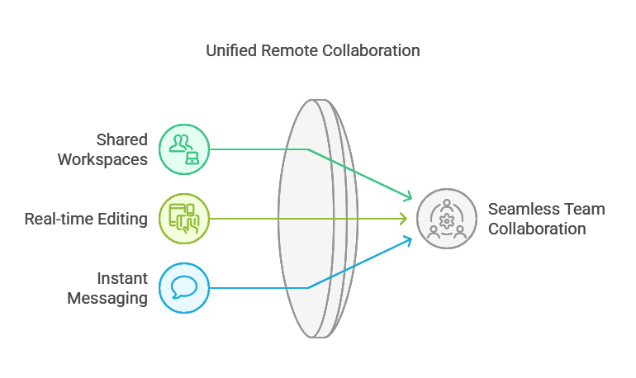

*Figure 1: Seamless Collaboration Using Cloud-based systems*

The fact that it is easy to access cloud-based systems is the other key advantage. Non-profits have limited resources, and cloud systems provide affordable access to high-level project management software that was previously only available to big organizations [18]. Such technology democratization allows smaller non-profits to compete on a level playing field so that they can grow operations without incurring massive capital expenses.

**2. Cost-Effectiveness, Scalability, and Impact Measurement**

The most prevalent among the benefits of cloud computing discussed in the reviewed studies is cost-effectiveness. Traditional project management software is usually characterized by enormous upfront costs in hardware and software, which may be beyond the reach of low-budget non-profits. Cloud computing, on the other hand, is subscription-based, where organizations only pay for the consumed utilities [19]. This pay-as-you-go system not only reduces initial costs but also provides scalability to increase or decrease based on project needs [20].

Scalability is also an important advantage of cloud systems. According to Azevedo [21], non-profits tend to experience episodes of shifting project scope and financing, thereby demanding flexible systems for adapting to demands. Cloud systems offer elastic resources that are capable of rapid reconfiguration, meaning that organizations can manage small projects as well as large, complex projects without suffering loss in performance.

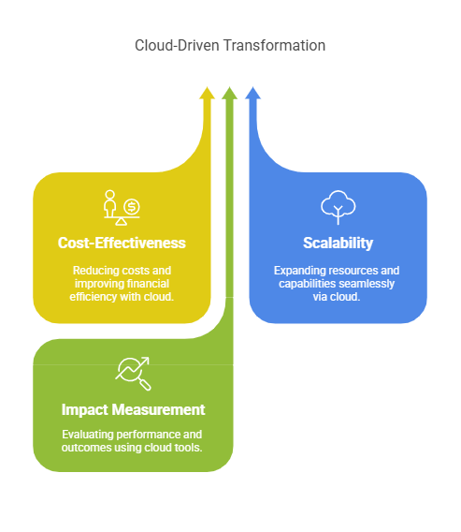

*Figure 2: Cloud Computing Transformative Solutions*

Furthermore, cloud-based solutions make it possible to measure impact in real-time, and organizations are able to track project progress, evaluate outcomes, and generate reports automatically. As Volk et al. [22] noted, cloud analytics software and cloud dashboards enable non-profits to monitor their key performance indicators (KPIs), track the impact of interventions, and generate transparent reports to stakeholders and donors. This ensures accountability as well as decision-making based on data, that resources are deployed effectively.

**3. Data Security and Privacy Concerns**

Albeit the many benefits, the reviewed research also presents compelling concerns in relation to data security and privacy. Non-profits tend to work with sensitive information, such as donor information, beneficiary information, and financial data, making them an appealing target for cyberattacks [7, 23]. Although cloud providers usually provide tight security measures, including encryption and multi-factor authentication, the duty of protecting data rests with the organization [24]. This can prove challenging to smaller non-profits with fewer technological resources since they may lack the ability to install and maintain effective security protocols.

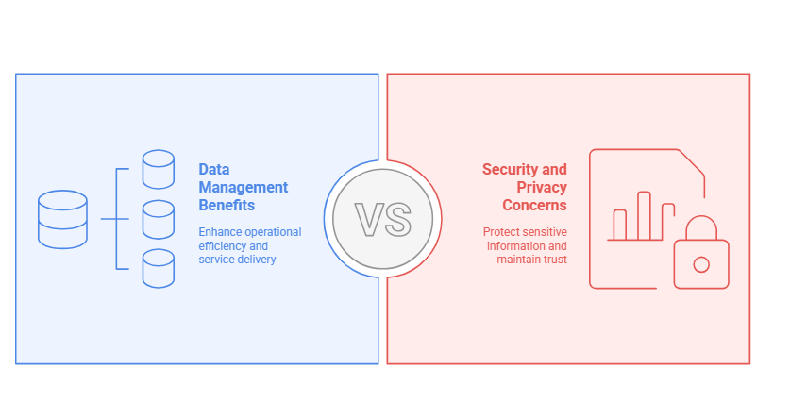

*Figure 3: Maintaining Balance between Data Management Benefits and Security and Privacy Concerns*

In addition, the use of third-party cloud providers has raised issues of data ownership and control. Reports indicate that the use of cloud systems by non-profits might be discouraged due to concerns of losing control over their data or being locked into proprietary systems [25]. These are the issues that highlight the importance of having well-drafted policies and agreements that outline data ownership and access rights in the use of cloud services [35.

**4. Dependency on Internet Connectivity**

Dependence on stable, high-speed internet connectivity is one of the key impediments to the adoption of cloud-based project management systems, particularly for non-profits that operate in remote or underserved areas. As Mershad et al. [26], and Maqueira et al. [27] observed, cloud platforms require constant internet connectivity to function optimally, which poses a challenge in regions that lack good infrastructure or have limited connectivity. This dependence, in addition to affecting the usability of cloud solutions, also exaggerates the chasm that previously existed, for organizations with minimal resources will certainly be at an unfair disadvantage while using these tools.

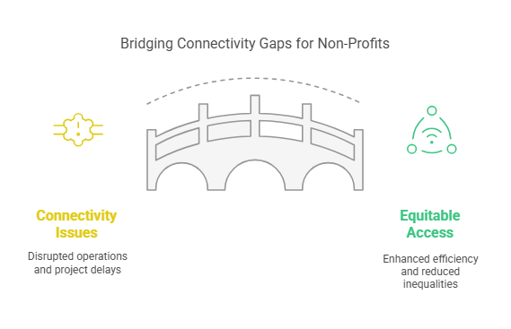

*Figure 4: Bridging Connectivity Gaps for Non-Profits*

For example, non-profits in rural or disaster-prone areas usually face connectivity issues that disrupt their ability to connect to cloud systems in real-time. This leads to project delays, communication breakdown, and resource wastages [25]. Moreover, the cost of accessing a stable internet connection can be prohibitive for small non-profits, which further restricts their ability to adopt cloud solutions.

**5. Limited Technical Expertise**

Effective operation of cloud-based project management tools often requires technical expertise that most non-profits do not have. As Gee et al. [28] noted, non-profits operate in small teams with tight budgets, and this can pose a challenge in offering the training and capacity development needed to build digital literacy among employees [12]. The technical skills deficit can deter adoption and optimization of cloud-based systems, which will undermine their benefits. For example, employees in non-profit organizations struggle to perform functions like establishing cloud platforms, managing user authorization, or troubleshooting technical issues. Through a lack of training, all these challenges translate to inefficient usage of cloud utilities or outright disregard of the systems [29, 30]. Moreover, limited availability of internal IT support services in most non-profits contributes to the woes, as staff may not receive the required guidelines for solving technical issues.

**6. Future Directions**

The findings of this review shows that although cloud computing offers great benefits for running non-profit projects, there are several areas to research and develop. To start with, more effective means of dealing with data security and privacy challenges are necessary. This could include the development of customized security models for non-profits and increased collaboration between non-profit organizations and cloud providers to ensure that the security solutions implemented are effective and affordable [29, 31,32].

Closing the digital skills gap among non-profit staff is another priority. Capacity development initiatives and training programs can bridge the technical skill gap, and organizations can leverage cloud services to their full potential [9, 29]. Furthermore, the creation of hybrid cloud platforms can address the issue of reliance on the internet. Offline-capable models in combination with cloud computing must be studied in the future. This can involve local data storage that synchronizes with cloud servers whenever an internet connection is available, enabling organizations in low-resource settings to carry on with digital tools without interruption [32,33,34].

**CONCLUSION**

The reviewed studies demonstrate that cloud-based solutions have the ability to revolutionize project management in non-profits by enhanced collaboration, reduced costs, and improved scalability. Adoption of these technologies, however, is dependent on the success in surmounting substantial data security, internet dependency, and technological challenges. By designing special measures to surmount these barriers, non-profits can achieve the best from cloud computing and gain maximum operational efficiency and effectiveness.

**COMPETING INTERESTS DISCLAIMER:**

Authors have declared that they have no known competing financial interests OR non-financial interests OR personal relationships that could have appeared to influence the work reported in this paper.

Disclaimer (Artificial intelligence)

Author(s) hereby declare that NO generative AI technologies such as Large Language Models (ChatGPT, COPILOT, etc.) and text-to-image generators have been used during the writing or editing of this manuscript.

**REFERENCES**

1. Becker A, Boenigk S, Willems J. In nonprofits we trust? A large-scale study on the public’s trust in nonprofit organizations. Journal of Nonprofit & Public Sector Marketing. 2020;32(2):189–216.

2. Atuluku AR, Osang F, Adebiyi S. Cloud computing adoption and use: A systematic review. Advances in Multidisciplinary and Scientific Research Journal Publication. 2022;13:29–64.

3. Martínez-Caro E, Cegarra-Navarro JG, Alfonso-Ruiz FJ. Digital technologies and firm performance: The role of digital organisational culture. Technological Forecasting and Social Change. 2020 May 1;154:119962.

4. Varghese B, Netto MA, Llorente IM, Buyya R. New generation cloud computing. Softw. Pract. Exp.. 2020;50(6):803-4.

5. Islam R, Ahmed S, Rahman M, Al Asheq A. Determinants of service quality and its effect on customer satisfaction and loyalty: an empirical study of private banking sector. The TQM Journal. 2020;33(6):1163-1182.

6. Wang H, Feng J, Zhang H, Li X. The effect of digital transformation strategy on performance: The moderating role of cognitive conflict. International Journal of Conflict Management. 2020;31(3):441-62.

7. Hamad DJ, Yalda KG, Tapus N, Okumus IT. A Survey on Security Issues in Cloud Systems. In2023 22nd RoEduNet Conference: Networking in Education and Research (RoEduNet) 2023 Sep 21 (pp. 1-8). IEEE.

8. Kalyani LK. The role of technology in education: Enhancing learning outcomes and 21st century skills. International journal of scientific research in modern science and technology. 2024;3(4):05-10.

9. Ogunlolu I, Rajanen D. Cloud computing adoption in organizations: A literature review and a unifying model. 2019.

10. Mohamad N, Saidin N, Zaidi M. Data security and privacy issues in cloud computing: Challenges and solutions review. 2023. doi:10.36227/techrxiv.170327865.59737799/v1.

11. Mahmood I, Sadeeq M, Zeebaree S, Shukur H, Jacksi K, Yasin H, et al. Task scheduling algorithms in cloud computing: A review. Turkish Journal of Computer and Mathematics Education (TURCOMAT). 2021;12:1041–53. doi:10.17762/turcomat.v12i4.612.

12. Abied O, Ibrahim O, Kamal SN, Alfadli IM, Binjumah WM, Ithnin N, Nasser M. Probing determinants affecting intention to adopt cloud technology in e-government systems. Sustainability. 2022;14(23):15590.

13. Sun PJ. Security and privacy protection in cloud computing: Discussions and challenges. Journal of Network and Computer Applications. 2020;160:102642.

14. Gonçalves C, Messias C, Soares J, Peixoto M. Adoption of cloud computing in organizations: A bibliometric analysis of this technology within a digital transformation context. Revista de Administração da UFSM. 2023;16:e1. doi:10.5902/1983465975326.

15. Uddin R, Koo I. Real-time remote patient monitoring: a review of biosensors integrated with multi-hop IoT systems via cloud connectivity. Applied Sciences. 2024 Feb 25;14(5):1876.

16. Buyya R, Broberg J, Goscinski A. Cloud computing: Principles and paradigms. John Wiley & Sons; 2021.

17. Teh R, Subramaniam A. A bibliometric analysis on cloud computing literature development. International Journal of Innovative Computing. 2023;13(2):49-57.

18. Taghipour M, Soofi ME, Mahboobi M, Abdi J. Application of cloud computing in system management in order to control the process. Management. 2020;3(3):34-55.

19. Chun SH. Cloud services and pricing strategies for sustainable business models: analytical and numerical approaches. Sustainability. 2019;12(1):49.

20. George AS. The Cloud Comedown: Understanding the Emerging Trend of Cloud Exit Strategies. Partners Universal International Innovation Journal. 2024 Oct 25;2(5):1-32.

21. Azevedo L. The impact of cloud management platforms on nonprofit business models. Journal of Technology in Human Services. 2021;39(4):405-425.

22. Volk M, Staegemann D, Turowski K. Providing Clarity on Big Data: Discussing Its Definition and the Most Relevant Data Characteristics. InKDIR 2022 (pp. 141-148).

23. Lalitha P, Yamaganti R, Rohita D. Investigation into security challenges and approaches in cloud computing. Journal of Engineering Sciences. 2023;14(08).

24. Abrera J. Data Privacy and Security in Cloud Computing: A Comprehensive Review. Journal of Computer Science and Information Technology. 2024;1(1):01-9.

25. Lawlor B. An overview of the 2023 NISO Plus Conference: Global conversations/global connections. Information Services and Use. 2023 Aug;43(3-4):211-242.

26. Mershad K, Dahrouj H, Sarieddeen H, Shihada B, Al-Naffouri T, Alouini MS. Cloud-enabled high-altitude platform systems: Challenges and opportunities. Frontiers in Communications and Networks. 2021;2:716265.

27. Maqueira Marín JM, Oliveira-Dias DD, Jafari Navimipour N, Gardas B, Unal M. Cloud computing and human resource management: systematic literature review and future research agenda. Kybernetes. 2022;51(6):2172-2191.

28. Gee IH, Nahm PI, Yu T, Cannella Jr AA. Not-for-profit organizations: A multi-disciplinary review and assessment from a strategic management perspective. Journal of Management. 2023;49(1):237-79.

29. Cipriano M, Za S. Non-profit organisations in the digital age: A research agenda for supporting the development of a digital transformation strategy. Journal of Information Technology. 2024;39(4):732-55.

30. Cordery CJ, Goncharenko G, Polzer T, McConville D, Belal A. NGOs’ performance, governance, and accountability in the era of digital transformation. The British Accounting Review. 2023;55(5):101239.

31. Okeke, K.; Omojola, S. Enhancing Cybersecurity Measures in Critical Infrastructure: Challenges and Innovations for Resilience. J. Sci. Res. Rep. 2025, 31, 474-484.

32. Tissir N, El Kafhali S, Aboutabit N. Cybersecurity management in cloud computing: semantic literature review and conceptual framework proposal. Journal of Reliable Intelligent Environments. 2021;7(2):69-84.

33. Runsewe O, Osundare OS. Challenges and solutions in monitoring and managing cloud infrastructure: A site reliability perspective. Information Management and Computer Science. 2024;7(1):47-55.

34. Okeke, K.; Omojola, S. Securing the Energy Sector: Advancing Cyber Resilience through Innovative Technologies and Best Practices. Curr. J. Appl. Sci. Technol. 2025, 44, 133-142.

35. Somanathan S. Leveraging Blockchain for Secure Cloud Transformation: Project Management and Governance Perspectives. International Journal of Applied Engineering and Technology. 2023;19(1):142–152.