Assessing the spatio-temporal pattern and analysis of obstacles to rural revitalization in China's Yangtze River Delta region

**Abstract:** It is crucial to objectively assess the development level of rural revitalization in China's Yangtze River Delta (YRD) region and its evolution pattern. This study uses the entropy method to measure the development level of rural revitalization in the YRD region from 2013 to 2022. We use the kernel density equation to analyze its evolution and spatial autocorrelation to analyze its spatial aggregation effect, and finally, The main factors affecting the development of rural revitalization were derived using the barrier model. It is found that the development level of rural revitalization in the Yangtze River Delta region is on an upward trend from 2013 to 2022, and spatially manifests itself in the form of “eastern coastal cities are larger than western regional cities”. Meanwhile, there is obvious spatial aggregation of rural revitalization development level among different cities in the Yangtze River Delta region. Finally, the analysis using the obstacle model concludes that the main first-level obstacle affecting the development level of rural revitalization is living a well-off life, while among the third-level indicators, the main obstacle is the incidence of rural poverty.To address the identified obstacles, policymakers should prioritize improving rural infrastructure and public services to enhance living standards. Specific measures include increasing investment in rural areas for better access to education, healthcare, and transportation. Additionally, targeted poverty alleviation programs and agricultural support initiatives can help reduce rural poverty rates. Promoting rural industries and agricultural innovation will also be crucial for sustainable rural development and achieving the goal of rural revitalization.

**Keywords:** Rural revitalization; spatial and temporal patterns; barrier factors; Yangtze River Delta region

1. **Introduction**

Rural revitalization is an important strategic plan for China to raise the income level of farmers and promote urban-rural integration (Kan, 2021; Zhao, 2024). As a large agricultural country, China faces problems such as insufficient rural infrastructure, a single industrial structure, brain drain and labor shortage, which constrain the development of agriculture and rural areas(Dzanku & Tsikata, 2022; Valentín-Sívico et al., 2022; Ma & Shi, 2023; Zhu et al., 2023; Deng et al., 2024). Therefore, our government proposed the implementation of the rural revitalization strategy in 2017, which prioritizes the development of industries in the agricultural sector while taking into account the goals of ecological livability, civilized rural customs, and the joint promotion of affluent living and effective governance (Peng et al., 2023; J. Du et al., 2024).

How high or low is the current development level of rural revitalization? In order to further understand the development differences of different regions in a comprehensive, systematic and scientific way, and to provide support for the government to formulate differentiated policies, we try to use economic models and correlation models to calculate the development level of rural revitalization and regional differentiation analysis in the study area.

Existing literature has actively explored the construction of the indicator system and the measurement of indicators for rural revitalization, Liu et al (2020) In order to study China's rural social problems, the most effective way to determine the development of rural revitalization from the perspective of urban-rural dynamics. Wang et al (2022) proposed a systematic analysis framework and a new evaluation index system for the effectiveness of rural revitalization at the county scale, and Zijun Song (2023) established a rural revitalization measurement system based on panel data from five provinces in Northwest China, and Du et al (2022) and Deng et al (2024) used entropy weighting to calculate the level of China's rural revitalization development. Liu et al (2023) explore the impact of digital financial inclusion on rural revitalization development from the unique perspective of counties. As for the analysis of the differentiation of the development level of rural revitalization, Xiong et al (2024) used the Dagum Gini coefficient and kernel density to explore the spatio-temporal differences and dynamic evolution characteristics of rural revitalization.

We take the Yangtze River Delta (YRD) region as an example to measure the level of rural revitalization development and analyze the regional differences, as the YRD region is at the forefront of China's economic development, and also one of the more unbalanced regions in terms of urban and rural development (Li et al., 2024; Guo et al., 2024). For example, in Jiangsu Province, which is located in the YRD region, the disposable income of urban residents in 2023 was RMB 52,674, while the disposable income of rural permanent residents was RMB 30,488. In Shanghai, which is also in the YRD region, the disposable income of urban residents in 2023 was RMB 89,477, while the disposable income of permanent residents in rural areas was only RMB 42,988.

The Yangtze River Delta region is experiencing rapid economic development, but at the same time there is a significant imbalance between urban and rural development. Therefore, we take the Yangtze River Delta region of China as the study area, and use the 2013-2022 panel data of 41 prefecture-level cities in its region to study the development of rural revitalization and regional differentiation, so as to provide an empirical reference for the development of rural revitalization in other regions. The marginal contributions in this study are: first, we review the existing literature on rural revitalization strategies, comprehensively measure the level of rural revitalization development in the 41 prefecture-level cities in the Yangtze River Delta region, and analyze their spatio-temporal evolutionary characteristics. Second, we analyze the spatial correlation of the development level of rural revitalization in different prefectures through spatial autocorrelation. Finally, based on the development level of rural revitalization in the Yangtze River Delta region, we use the obstacle degree model to calculate the first-level obstacle degree indicators and the third-level obstacle degree indicators in different years, to explore the main factors affecting the development level of rural revitalization in different years, and to provide theoretical references for the rural revitalization development in other regions.

1. **Materials and methods**
   1. **Research design**

In this study, in order to scientifically measure the development level of rural revitalization in the Yangtze River Delta region, we constructed an indicator system based on China's rural revitalization strategy from five aspects of the countryside: environment, governance, talent, affluence and countryside style, and used the panel data and entropy method from 2013-2021 to measure the comprehensive value of rural revitalization development level of the prefectures and cities within the study area, and the framework of the study is shown in (Fig.1).

To further analyze the spatio-temporal pattern of development, based on the results of measuring the development level of rural revitalization, we use the kernel density model and spatial autocorrelation to analyze the evolution in the temporal and spatial dimensions. Finally, to further explore the main obstacle elements affecting the spatio-temporal evolution pattern, we use the obstacle degree model to analyze the main obstacle factors from 2013 to 2021.



Fig.1. Research logical framework

* 1. **Rural Revitalisation Indicator System**

The scientific nature of the rural revitalization indicator system is the key to accurately measuring the development level of rural revitalization. Based on the policy text of China's rural revitalization, we have constructed an evaluation system for the development level of rural revitalization in five aspects: industrial prosperity, ecological livability, civilized countryside, effective governance, and affluent life.

(1) The foundation of rural revitalization is industrial revitalization. Rural industries can bring economic benefits to the countryside, thus enhancing farmers' income to promote rural revitalization.

(2) Ecological livability is an important component of rural revitalization, and the construction of ecologically livable and beautiful villages can help improve the quality of life of farmers and realize the unity of people's prosperity and ecological beauty.

(3) Civilization of rural customs is the soul of rural revitalization. Excellent rural customs can meet the spiritual needs of farmers and provide spiritual impetus for the development of rural revitalization.

(4) Effective governance is the guarantee of rural revitalization, and promoting the rural governance system and governance capacity is the road to rural revitalization.

(5) Wealthy living is the starting and ending point of rural revitalization, and rural revitalization allows farmers to lead a better life.

Therefore, in order to accurately evaluate the development level of urban rural revitalization in the Yangtze River Delta region, we followed the principles of science and accuracy, and constructed five first-level indicators such as “prosperous industry, ecological livability, civilized countryside, effective governance, and affluent life”, 12 second-level indicators such as “agricultural production capacity”, and 30 third-level indicators such as “per capita total power of agricultural machinery”, as shown in Table 1.

Table 1 Evaluation System for Rural Revitalisation in China's Yangtze River Delta Region

|  |  |  |  |  |  |
| --- | --- | --- | --- | --- | --- |
| **Primary index** | **Secondary index** | **ID** | **Three-level index** | **Stats** | **scale** |
| Prosperous industry | Agricultural production capacity | P1 | Total power of agricultural machinery per capita (kW) | + | 2.22% |
| P2 | Overall grain production capacity (10,000 tons) | + | 3.19% |
| Agricultural productivity | P3 | Agricultural labor productivity (Yuan/person) | + | 3.60% |
| Degree of industrial integration | P4 | Main business income of agricultural product processing enterprises above designated size (RMB 100 million) | + | 4.37% |
| Ecological habitability | Agricultural green development | E1 | Application amount of pesticides and fertilizers (10,000 tons) | — | 0.70% |
| E2 | Comprehensive utilization rate of livestock and poultry manure (%) | + | 3.40% |
| Rural environmental governance | E3 | The proportion of administrative villages that treated domestic sewage (%) | + | 3.64% |
| E4 | Proportion of administrative villages treating domestic waste (%) | + | 3.46% |
| E5 | Sanitary toilet penetration rate (%) | + | 3.35% |
| E6 | Rural greening rate (%) | + | 3.62% |
| E7 | Village road hardening rate (%) | + | 3.60% |
| Rural culture | The level of education of farmers | R1 | The proportion of expenditure on education, culture, and recreation of rural residents (%) | + | 3.42% |
| R2 | The proportion of full-time teachers in rural compulsory education schools with bachelor's degree or above (%) | + | 3.96% |
| R3 | Average years of schooling of rural residents (years) | + | 3.91% |
| Rural cultural construction | R4 | Cable TV coverage (%) | + | 3.28% |
| R5 | Proportion of administrative villages with Internet broadband service (%) | + | 3.41% |
| R6 | Number of rural cultural stations (units) | + | 4.05% |
| Effective Governance | Governance level | G1 | Access to safe drinking water (%) | + | 3.59% |
| G2 | Proportion of village director and secretary "shoulder to shoulder" (%) | + | 3.80% |
| Governance measures | G3 | Proportion of administrative villages with village plans prepared (%) | + | 4.21% |
| G4 | Proportion of administrative villages that have carried out village renovation (%) | + | 0.73% |
| Be well off | Farmer income level | B1 | Per capita net income of farmers (Yuan) | + | 1.00% |
| B2 | Farmers per capita income growth rate (%) | + | 3.14% |
| B3 | Urban-rural income ratio (%) | — | 3.44% |
| Farmers' living standard | B4 | Incidence of rural poverty (%) | — | 4.52% |
| B5 | Engel coefficient of rural residents (%) | — | 3.32% |
| B6 | Car ownership per 100 households (vehicles) | + | 4.08% |
| B7 | Per capita living area of rural residents (square meters) | + | 3.40% |
| Basic facilities and services | B8 | Per capita road area (m2) | + | 3.69% |
| B9 | Number of health technicians per 1000 people in rural areas | + | 3.89% |

* 1. **Data sources**

The YRD is one of the more economically developed city clusters in China, comprising 41 cities in three provinces and one municipality directly under the central government in eastern China, covering an area of 358,000 square kilometers. Currently, the YRD region has become a demonstration area for China's economic development, a model area for modernization, and one of the world's six largest urban agglomerations (Fig.2).

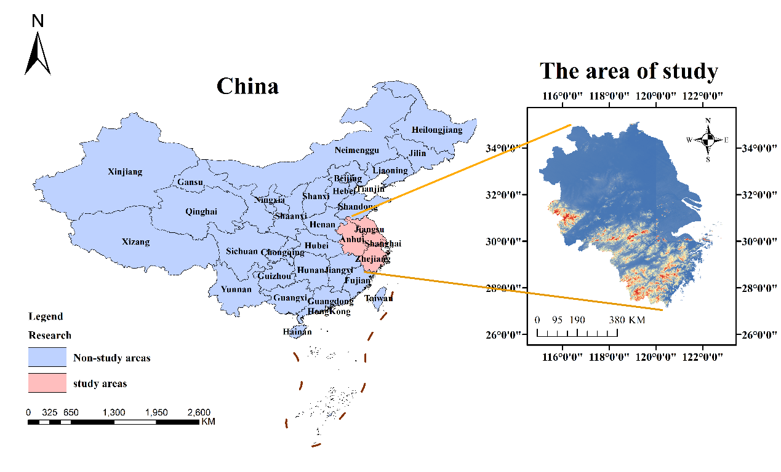Fig.2. Geographic location of the Yangtze River Delta region

We collected data for 41 prefecture-level cities in the YRD city cluster from 2013-2022. Among them, socio-economic data were mainly collected from the China Statistical Yearbook, statistical yearbooks of each city, and relevant websites. The basic geographic information data mainly comes from the National Centre for Basic Geographic Information and the National Geographic Information Public Service Platform. For the missing data in some years, we used the interpolation method to supplement and improve.

**2.4. Research Methods**

**2.4.1 Entropy value method**

The entropy value method is an objective empowerment evaluation method, the main principle is to give different weights to each indicator by judging the degree of dispersion of the indicator data, and its advantage is to avoid the influence of subjective judgment on the results, the specific calculation process refer to the scholars (Lu et al., 2022).

**2.4.2 Kernel density modeling**

The Kernel density model is very effective in dealing with non-equilibrium problems(Yan et al., 2018). A series of probability density curves are obtained by estimating the level of rural revitalization in each city of the Yangtze River Solution Belt in each year of the Kernel density. These curves are combined to form a continuous density curve, to examine the spatial and temporal evolution trend of regional rural revitalization in the Yangtze River Economic Belt.

Assuming that x1, x2,..., xn are n sample points of an independent homogeneous distribution F, the kernel density estimation function is:

$$F\left(x\right)=\frac{1}{nh}\sum_{i=1}^{n}{k(\frac{x_{i}-x}{h}})$$

$$K\left(x\right)=\frac{1}{\sqrt{2π}}exp⁡(-\frac{x^{2}}{2})$$

Where: h is the bandwidth, xi is the observation, x is the mean of all observations, and K(x) is the kernel density function.

**2.4.3 Spatial correlation analysis**

To detect the spatial correlation between places in the YRD region, we use the global Moran'I model with the following formula(Yang et al., 2023):

$$I=\frac{a\sum_{i=1}^{a}{\sum_{j=1}^{a}{w_{ij}\left(C_{i}-\overline{b}\right)\left(C_{j}-\overline{b}\right)}}}{\left(\sum_{i=1}^{a}{\sum_{j=1}^{a}{w_{ij}}}\right)\sum_{i=1}^{a}{{\left(C_{i}-\overline{b}\right)}^{2}}}$$

Where: I is the global spatial autocorrelation index, a is the number of spatial units, $\overline{b }$ is the mean value of the study sample, Ci and Cj are the attribute values of spatial units i and j, respectively, and wij is the neighborhood weights of spatial units i and j.

**2.4.4 Diagnostic Models of Barrier Factors**

To further explore the main obstacle factors affecting the development level of rural revitalization in different years in the Yangtze River Economic Belt region (Sivertsson & Tell, 2015), we use the obstacle degree model for evaluation, calculated as follows:

$$Z_{j}=\frac{A_{j}(1-D_{ij})}{\sum_{j=1}^{p}{A_{j}(1-D_{ij})}}×100\%$$

Where: Zj is the barrier degree of the jth indicator; Aj is the best projection direction of the jth indicator; Dij is the standardised value of the extreme deviation of the jth indicator for the ith city.

Dij is the standardised value of the extreme deviation of the jth indicator for the ith city.

1. **Results & Discussion :** 
   1. **Characterisation of the temporal evolution**

We used the entropy method to calculate the development level of rural revitalization in each prefecture-level city in the YRD region41 from 2013-2022 (shown in Fig.3). During the 10 years of the study period, the development level of rural revitalization in the YRD region has steadily increased, with Shanghai leading the way in terms of the spatial development of rural revitalization. Zhejiang Province and Jiangsu Province are in the second echelon of rural revitalization development, while Anhui Province is relatively weak in rural revitalization development.

The main reason for this spatial and temporal pattern is that Shanghai's favorable geographical location and economic development have led to a rapid increase in the level of rural development. Jiangsu Province and Zhejiang Province are both located in the coastal area and are in the leading position in terms of development strategy and scientific and technological innovation, and agricultural technology upgrading. Anhui Province, on the other hand, is constrained by factors such as unbalanced regional development and single industrial structure and lags in the development of rural revitalization.

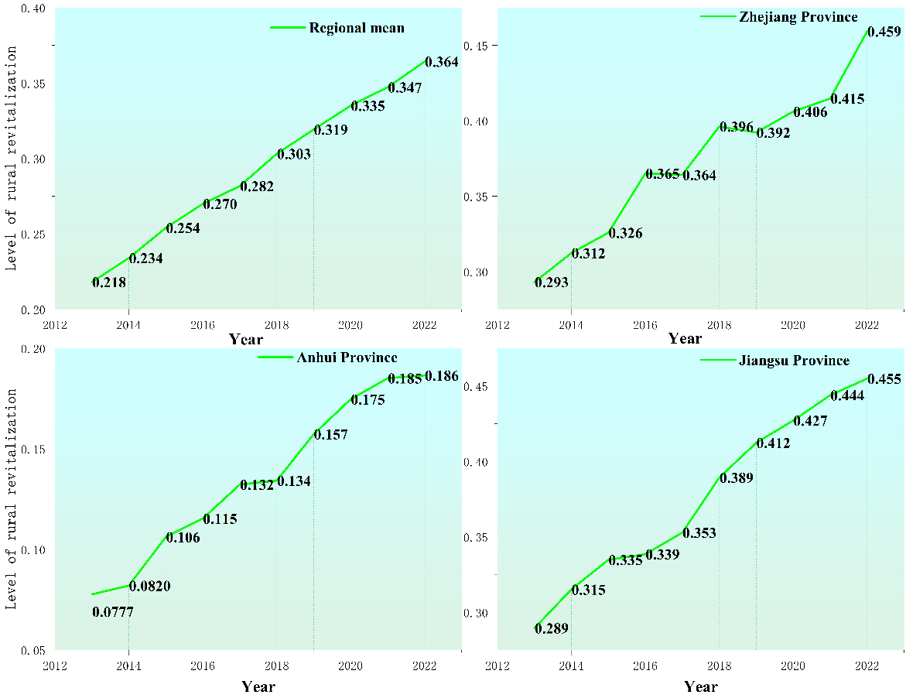Fig.3. Development Level of Rural Revitalisation in the Yangtze River Delta Region, 2013-2022

* 1. **Kernel density estimation analysis**

The kernel density of the development level of rural revitalization in the Yangtze River Delta region from 2013 to 2022 is shown in (Fig.4). It can be seen from the three-dimensional curves of the overall kernel density of the Yangtze River Delta region and the provinces in the study area that the overall kernel density curve shifted to the right of the main peak during the study period, and the peak heights showed the state of "rising-falling-rising", with no obvious change in the number

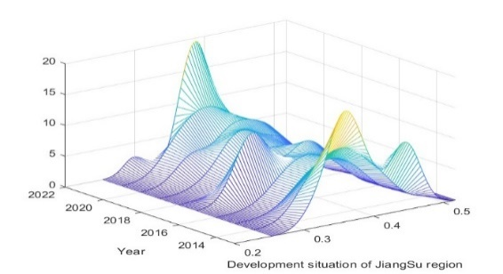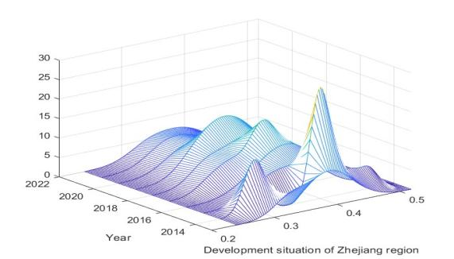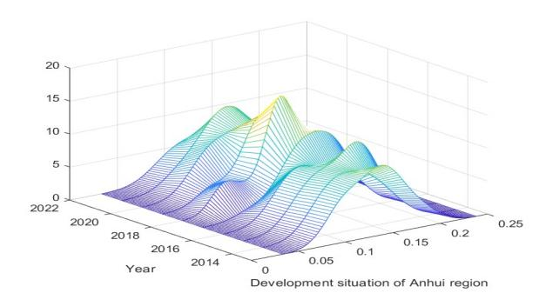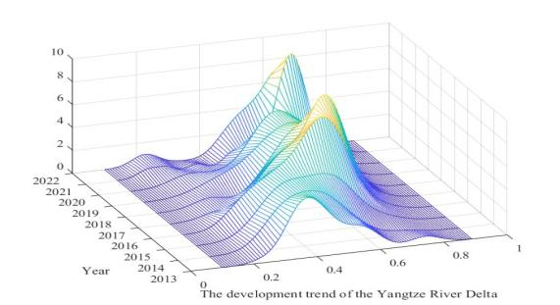

Fig.4. Kernel density map of the development level of rural revitalization in the Yangtze River Delta region, from 2013 to 2022.

of wave peaks. This indicates that the overall level of rural revitalisation development has been increasing, but the differences show a "rising-falling-rising" trend, indicating that the overall level of rural revitalisation development in the Yangtze River Delta region is not coordinated and has greater differences.

From the three-dimensional kernel density curve of Jiangsu Province, the main peak moves to the right, the height of the band decreases and then increases, and the number of peaks is less than that of the overall kernel density curve, which indicates that the level of rural revitalization and development in Jiangsu Province has been steadily increasing while there is a phenomenon of bipolarity. The bandwidth of the kernel density curve of Zhejiang Province is not much different from that of Jiangsu Province, with one main peak and the peak height decreasing year by year, which indicates that the development level of rural revitalization in Zhejiang Province is more focused on the coordinated development of the region within the province while improving. The peak height change and bandwidth of Anhui Province are significantly lower than those of other provinces, indicating that the development level of rural revitalization in Anhui Province is relatively backward and the regional development differences are small. Therefore, Anhui Province needs to strengthen the development of rural industry and rural scientific and technological innovation to help improve the development level of rural revitalization in Anhui Province.

* 1. **Analysis of spatial evolution**

Based on the measured mean value of the development level of rural revitalization in the YRD region from 2013-2022, the 41 prefecture-level cities in the studied region are divided into four levels (as shown in Fig 5). The development level of rural revitalisation in 2013-2022 shows a gradual increase in the number of high-level and high-quality development prefecture-level cities, and the development level of the eastern coastal cities in the Yangtze River Delta region is much higher than that of the western cities, showing an unbalanced development.

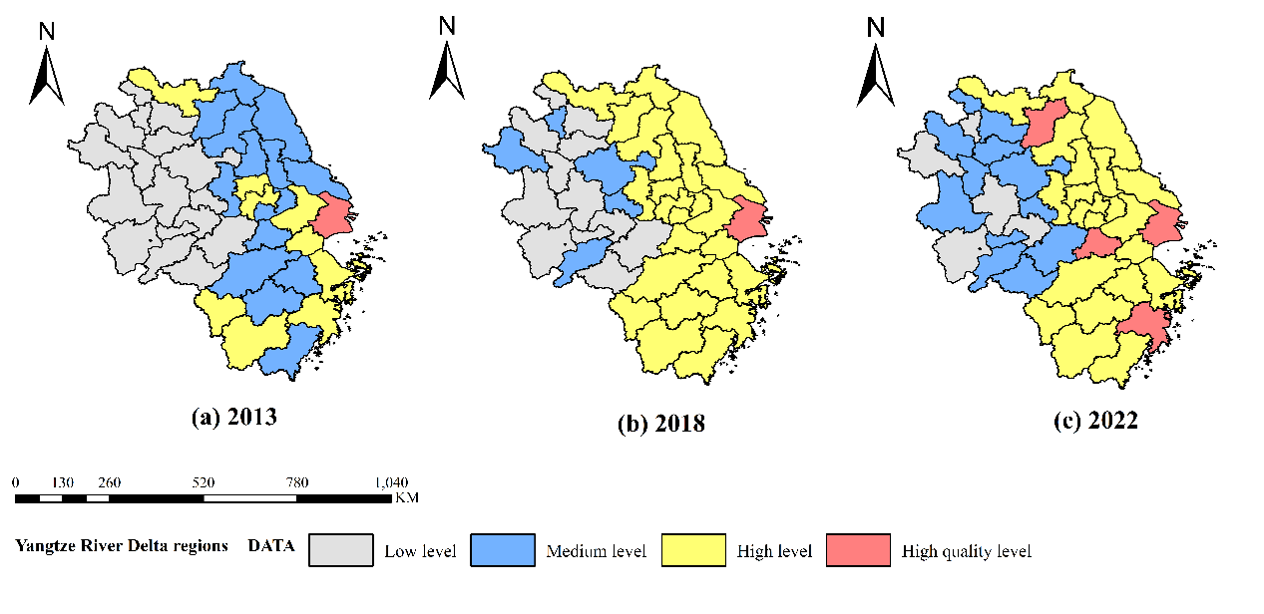

Fig 5 Spatial evolution of the level of development of rural revitalization, from 2013-2022

In terms of provinces and municipalities, Shanghai has been at the stage of high-quality development during the study period, Jiangsu and Zhejiang provinces have mainly changed from medium to high levels, and most cities in Anhui province are at the stage of changing from low to medium levels. Therefore, to improve the overall development level of rural revitalization in the Yangtze River Delta region, the coastal cities in the Yangtze River Delta should take the lead in driving the development level of rural revitalization in the cities in the western part of the Yangtze River Delta, and establish a coordinated development mechanism.

* 1. **Spatial correlation**

Global Moran calculations are carried out for the rural revitalization development level in the Yangtze River Delta region from 2013 to 2022, and global Moran aggregation maps are generated, such as the autocorrelation aggregation maps for 2013 and 2022 shown in Fig.6. The results show that there is a significant spatial correlation in the development level of rural revitalisation in the Yangtze River Delta region, which exhibits spatial aggregation characteristics.

Fig.6. LISA aggregation of rural revitalisation levels in the Yangtze River Delta region, 2013 and 2022

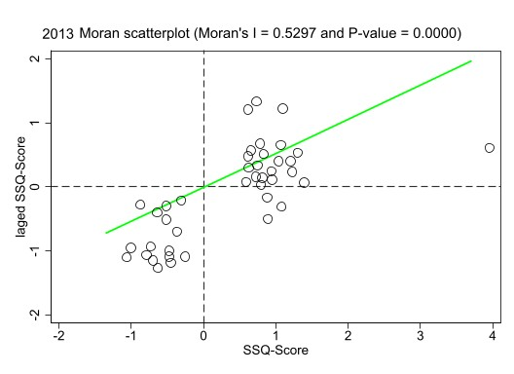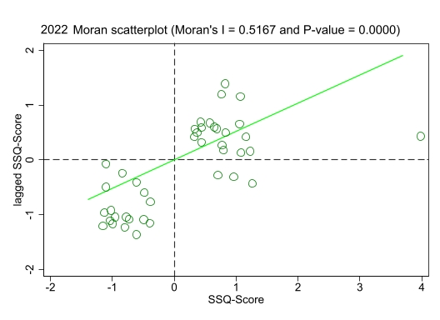

* 1. **Analysis of the main obstacle factors**
     1. **Tier 1 Indicator Barrier Recognition**

We can see from the above analysis that there are obvious spatial differentiation features in the development level of rural revitalization in the Yangtze River Delta region. Therefore, we apply the barrier degree model to diagnose the main influencing factors affecting the development of rural revitalization in the Yangtze River Delta region and further understand the main factors constraining rural revitalization in the Yangtze River Delta region.

Table 2 Obstacles to Rural Revitalisation Level 1 Indicators in the Yangtze River Delta Region, from 2013-2022

|  |  |  |  |  |  |  |  |  |  |  |
| --- | --- | --- | --- | --- | --- | --- | --- | --- | --- | --- |
| **Level 1 indicators** | **2013** | **2014** | **2015** | **2016** | **2017** | **2018** | **2019** | **2020** | **2021** | **2022** |
| Thriving industry | 14.52% | 13.85% | 14.10% | 14.01% | 13.77% | 13.58% | 13.86% | 13.83% | 13.70% | 13.70% |
| Ecologically livable | 22.32% | 21.89% | 21.57% | 21.55% | 21.34% | 21.32% | 21.30% | 20.88% | 21.24% | 21.05% |
| Civilized rural customs | 20.38% | 20.69% | 20.53% | 20.34% | 20.55% | 20.96% | 20.35% | 20.71% | 20.64% | 20.49% |
| Effective Governance | 11.15% | 11.74% | 11.41% | 11.85% | 11.42% | 11.44% | 11.46% | 11.48% | 11.49% | 11.41% |
| Prosperous life | 31.63% | 31.83% | 32.38% | 32.25% | 32.92% | 32.70% | 33.03% | 33.11% | 32.93% | 33.35% |

We calculated the proportion of the first-level obstacle degree of rural revitalization development in the Yangtze River Delta region from 2013-2022, as shown in (Table 2). From the perspective of time, the ranking of obstacles of each level of indicators from 2013-2022 are as follows: affluent life > ecological livability > civilized rural culture > prosperous industry > effective governance. The obstacle degree of living affluence is always at a high level during the study period, indicating that living affluence is an important factor constraining the development of rural revitalization in the cities of the Yangtze River Delta, which suggests that there is more room for improvement in living affluence.

* + 1. **Tier 3 Indicator Barrier Recognition**

Based on the first-level barrier degree indicators, we identified the barrier factors for the third-level indicators in the YRD region for 2013-2022, as shown in Table 3.

Table 3 Ranking of main obstacle factors and degree of obstacles for the three levels of indicators

|  |  |  |  |  |  |
| --- | --- | --- | --- | --- | --- |
| Year | First obstacle factor | Second barrier factor | Third barrier factor | Fourth barrier factor | Fifth barrier factor |
| 2013 | P1 0.043 | B4 0.041 | B6 0.040 | B9 0.038 | B5 0.038 |
| 2014 | B6 0.042 | B4 0.040 | E6 0.039 | B5 0.038 | B9 0.038 |
| 2015 | B4 0.045 | B9 0.042 | G3 0.039 | P4 0.039 | B6 0.038 |
| 2016 | B4 0.044 | B9 0.040 | B6 0.040 | G3 0.039 | R2 0.037 |
| 2017 | B4 0.046 | B6 0.043 | B9 0.041 | G3 0.041 | P4 0.039 |
| 2018 | B4 0.049 | B6 0.041 | G3 0.041 | B9 0.040 | P4 0.040 |
| 2019 | B4 0.048 | B6 0.042 | B9 0.042 | G3 0.041 | P4 0.040 |
| 2020 | B4 0.048 | B9 0.042 | B6 0.042 | G3 0.042 | P4 0.040 |
| 2021 | B4 0.048 | B6 0.043 | G3 0.042 | B9 0.041 | P4 0.040 |
| 2022 | B4 0.049 | B6 0.042 | B9 0.042 | G3 0.041 | P4 0.040 |

From the perspective of rural industries, the P1 and P4 indicators are the main obstacle factors, indicating that in agricultural mechanization and agricultural product processing, it is necessary to upgrade and increase inputs to improve the development of rural industries. Meanwhile, agricultural mechanization was the first obstacle to constraints in 2013, but by 2014-2022, it was no longer among the top five obstacles. This suggests that the Yangtze River Delta region has developed rapidly in agricultural mechanization during 2013-2022, but is still relatively weak in agricultural product processing.

1. **Conclusion**

Based on the connotation of rural revitalization and taking into account the development of the countryside, we construct a rural revitalization evaluation system from five aspects, use the entropy method to calculate the rural revitalization development index of the Yangtze River Delta region from 2013 to 2022 and use the kernel density model to analyze its time series and use the Moran index to analyze the spatial correlation of the development level of the rural revitalization of the cities of the Yangtze River Delta region. Finally, we use the obstacle degree model to explore the main obstacle factors affecting rural revitalization in cities in the Yangtze River Delta region. The conclusions drawn are as follows:

In general, the development level of the rural revitalization of cities in the Yangtze River Delta region shows an upward trend, and there are obvious regional differences, overall: eastern coastal region > western region cities. Secondly, we can conclude from the results of kernel density analysis that the development level of rural revitalization in the Yangtze River Delta region found that the development level of rural revitalization in Jiangsu Province and Zhejiang Province has been steadily increasing during the study period, but there is a problem of multilevel differentiation in regional development. While the level of rural revitalization development in Anhui Province is relatively slow, the regional development of rural revitalization is more balanced.

In terms of the spatial correlation of the development level of rural revitalization, we find that there is a significant clustering effect between the development levels of rural revitalization in 2013 and 2022, and it is mainly dominated by medium-level-high clustering.

By exploring the main influencing factors affecting the level of development of rural revitalisation in the Yangtze River Delta region, we arrive at the ranking of the first level indicators affecting the barriers as: Wealthy life > Ecological livability > Civilised rural culture > Prosperous industry > Effective governance. The top three barriers in the third-level indicators are: Incidence of rural poverty > Car ownership per 100 households > Number of health technicians per 1000 people in rural areas.

Based on the above conclusions, we believe that China's Yangtze River Delta region needs to further capitalize on the advantages of the east to drive the west, and to shorten the differences between different prefectural-level cities. Currently, the main constraint for the development of rural revitalization is the state of economic development in the countryside, so regions should take advantage of the local natural scenery and agricultural advantages to increase rural industries, so as to improve the income level of farmers and promote the coordinated development of the region.

In order to promote rural revitalization in the Yangtze River Delta region, the recommendations are as follows: first, increase investment in rural infrastructure and public services, improve education, medical care and transportation conditions, and enhance the quality of life of farmers; second, implement precise poverty alleviation policies, and reduce the rural poverty rate by means of industrial support and employment training; third, promote upgrading and innovation of the agricultural industry, and strengthen the level of agricultural product processing and mechanization, so as to promote the sustainable development of the rural economy. Third, promoting the upgrading and innovation of the agricultural industry, strengthening the level of agricultural product processing and mechanization, and promoting sustainable rural economic development. These initiatives will help to break through current obstacles, achieve the goals of the rural revitalization strategy and promote coordinated regional development.

Finally, this study also has certain limitations, and there may be the influence of disturbing factors on the results. There are more types of indicators for rural revitalization, and the development between different regions has its own characteristics, so there may be unconsidered factors that have an impact on them. Therefore, its limitations will be further explored in the future on the basis of existing work.

**COMPETING INTERESTS DISCLAIMER**:

Authors have declared that they have no known competing financial interests OR non-financial interests OR personal relationships that could have appeared to influence the work reported in this paper.

**Disclaimer (Artificial intelligence)**

Author(s) hereby declare that NO generative AI technologies such as Large Language Models (ChatGPT, COPILOT, etc.) and text-to-image generators have been used during the writing or editing of this manuscript.

**References**

1. Deng, X., Huang, M., & Peng, R. (2024). The impact of digital economy on rural revitalization: Evidence from Guangdong, China. *Heliyon*, *10*(7), e28216. https://doi.org/10.1016/j.heliyon.2024.e28216
2. Du, J., Zhao, B., & Feng, Y. (2024). Spatial distribution and influencing factors of rural tourism: A case study of Henan Province. *Heliyon*, *10*(7), e29039. https://doi.org/10.1016/j.heliyon.2024.e29039
3. Du, M., Huang, Y., Dong, H., Zhou, X., & Wang, Y. (2022). The measurement, sources of variation, and factors influencing the coupled and coordinated development of rural revitalization and digital economy in China. *PLOS ONE*, *17*(11), e0277910. https://doi.org/10.1371/journal.pone.0277910
4. Dzanku, F. M., & Tsikata, D. (2022). Implications of socioeconomic change for agrarian land and labour relations in rural Ghana. *Journal of Rural Studies*, *94*, 385–398. https://doi.org/10.1016/j.jrurstud.2022.07.010
5. Empirical Study on Digital Inclusive Finance to Promote Rural Revitalization—Taking Five Northwestern Provinces as an Example. (2023). *Academic Journal of Business & Management*, *5*(27). https://doi.org/10.25236/AJBM.2023.052718
6. Guo, Y., Jiang, X., Zhu, Y., & Zhang, H. (2024). Measurement and spatial correlation analysis of high-quality development Level: A case study of the Yangtze River Delta urban agglomeration in China. *Heliyon*, *10*(8), e29209. https://doi.org/10.1016/j.heliyon.2024.e29209
7. Kan, K. (2021). Creating land markets for rural revitalization: Land transfer, property rights and gentrification in China. *Journal of Rural Studies*, *81*, 68–77. https://doi.org/10.1016/j.jrurstud.2020.08.006
8. Li, R., Xu, Q., Yu, J., Chen, L., & Peng, Y. (2024). Multiscale assessment of the spatiotemporal coupling relationship between urbanization and ecosystem service value along an urban–rural gradient:A case study of the Yangtze River Delta urban agglomeration, China. *Ecological Indicators*, *160*, 111864. https://doi.org/10.1016/j.ecolind.2024.111864
9. Liu, Y., Wan, Q., & Chen, W. (2023). Digital Inclusive Finance as a Catalyst for Rural Revitalization: An Empirical Analysis from the County Development Perspective in Hubei Province. *Journal of the Knowledge Economy*. https://doi.org/10.1007/s13132-023-01493-5
10. Liu, Y., Zang, Y., & Yang, Y. (2020). China’s rural revitalization and development: Theory, technology and management. *Journal of Geographical Sciences*, *30*(12), 1923–1942. https://doi.org/10.1007/s11442-020-1819-3
11. Lu, C., Ji, W., Hou, M., Ma, T., & Mao, J. (2022). Evaluation of efficiency and resilience of agricultural water resources system in the Yellow River Basin, China. *Agricultural Water Management*, *266*, 107605. https://doi.org/10.1016/j.agwat.2022.107605
12. Ma, Q., & Shi, F. (2023). New urbanization and high-quality urban and rural development: Based on the interactive coupling analysis of industrial green transformation. *Ecological Indicators*, *156*, 111044. https://doi.org/10.1016/j.ecolind.2023.111044
13. Peng, J., Zhou, Y., Zhang, Z., Luo, Y., & Cheng, L. (2023). The development logic, scientific Connotation, and promotion path of rural eco-industries in China. *Heliyon*, *9*(7), e17780. https://doi.org/10.1016/j.heliyon.2023.e17780
14. Sivertsson, O., & Tell, J. (2015). Barriers to Business Model Innovation in Swedish Agriculture. *Sustainability*, *7*(2), 1957–1969. https://doi.org/10.3390/su7021957
15. Valentín-Sívico, J., Canfield, C., & Egbue, O. (2022). Push them forward: Challenges in intergovernmental organizations’ influence on rural broadband infrastructure expansion. *Government Information Quarterly*, *39*(4), 101752. https://doi.org/10.1016/j.giq.2022.101752
16. Wang, Y., Zhu, Y., & Yu, M. (2022). Measuring the implementation effects of rural revitalization in China’s Jiangsu Province: Under the analytical framework of “deconstruction, assessment and brainstorming”. *Growth and Change*, *53*(3), 1146–1169. https://doi.org/10.1111/grow.12569
17. Xiong, Z., Huang, Y., & Yang, L. (2024). Rural revitalization in China: Measurement indicators, regional differences and dynamic evolution. *Heliyon*, *10*(8), e29880. https://doi.org/10.1016/j.heliyon.2024.e29880
18. Yan, T., Qu, L., Li, Z., & Yuan, A. (2018). Conditional kernel density estimation for some incomplete data models. *Electronic Journal of Statistics*, *12*(1). https://doi.org/10.1214/18-EJS1423
19. Yang, Y., Gao, Y., Zhang, R., Xu, J., Yuan, H., & Wang, H. (2023). Agricultural Total Water Consumption Coefficient and Its Spatial Correlation Network in Yangtze River Economic Belt. *Water*, *15*(11), 2055. https://doi.org/10.3390/w15112055
20. Zhao, Q. (2024). Unpacking the effects of rural homestead development rights reform on rural revitalization in China. *Journal of Rural Studies*.
21. Zhu, M., Wang, Z., Cui, H., Yang, Y., & Qie, P. (2023). Situation and hotspot analysis on rural transport infrastructure from the perspective of bibliometric analysis. *Journal of Traffic and Transportation Engineering (English Edition)*, *10*(6), 1074–1098. https://doi.org/10.1016/j.jtte.2023.04.009