**Impact of Polyherbal Mixture on Reproductive Traits of Assam Hill Goat**

**ABSTRACT**

In this study, 36 Assam Hill goats were chosen and randomly divided into three groups of either sex for comparative analysis of reproductive traits. A mixture of herbal feed was supplemented to the treatment groups @ 1 and 2 grams per kilogram of body weight, starting from 4 months old until they were 12 months old. The mean average age (days) at first heat were 199.833 ± 3.842, 183.333 ± 2.985 and 183.167 ± 4.110 for goats in C0, T1 and T2, respectively. The highest mean semen volume (ml) was found in T2 group at 12th month 0.627 ± 0.008, Similarly, live sperm (%) 85.355 ± 0.895 was found in T2 group at 12th month. The overall semen qualities were found better in T2, followed by T1 and C0 . There was improvement in reproductive traits such as age at first heat, heat duration and age at sexual maturity in females as well as semen quality in males

*Keywords: Polyherbal, supplement, Reproductive traits, Assam Hill goat*

**1.Introduction**

Goat is the earliest known domesticated species, with evidence indicating domestication took place around 7000 years B.C. in Southeast Asia, near the current borders of Iraq and Iran (Mason, 1981). They are raised for multiple purposes of which milk and meat being the primary ones. The consumption of goat milk by human dates back to the initial stages of domesticating animals of economic significance (Dubeuf, 2005). “The global importance of goats as vital sources of meat and dairy nutrition has been explored and documented in many recent proceedings of national and international conferences” (Haenlein, 2001; Haenlein and Fahmy, 1999; Morand-Fehr and Boyazoglu, 1999; Rubino et al., 1999; Gruner and Chabert, 2000).

Medicinal plants are renewable natural resources. Traditionally some herbs or their mixtures are used to enhance animal performance through their flavouring and medicinal properties. Besides, they are less expensive and safer than the chemical additives as side effects are rarely observed. Careful selection of combination of herbal plant extracts may allow the manipulation of rumen microbial fermentation (Busquet et al., 2006). Certain herbs like fenugreek (*Tirigonella foenum-graecum*), and jivanti (*Leptadenia reticulata*), contain galactogogue which improve milk production if given in a suitable mixture for few days to lactating animals (Mudgal et al, 2003). Out of many herbal product Shatavari root, Fenugreek seed, Ajwain seed are known to have better production performances (Cullen et al., 2005). In animals, Shatavari extracts have mammogensis, lactogenesis, galactopoiesis role. Its usage reduces stress as it has antistress properties, maintains regular reproductive cyclicity due to estrogenic properties. According to the last two livestock census reports (19th and 20th livestock census, Department of Animal Husbandry & Dairying), the number of goats in Assam has dropped sharply by 30.05%, falling from 6.169 million to 4.315 million. It is now high time to undertake research and development program to check this decline and increase the population through improvement in their reproductive ability in a sustainable manner. Therefore, the current studyaimed to evaluate the effect ofpolyherbal feed supplementation consisting of Shatavari root (*Asparagus racemosus*), Fenugreek seed (*Trigonella foenum-graecum*) and Ajwain seed (*Trachyspernum ammi*) on reproductive parameters of Assam Hill Goat.

**2.MATERIALS AND METHODS**

A total of 36 healthy Assam Hill kids (18 males and 18 females) with similar body weight were selected from the farm flock of Goat Research Station, Assam Agricultural University, Burnihat. They were randomly divided into three groups of 12 animals (6 males and 6 females each): Group I (Control, C0), Group II (Treatment, T1), and Group III (Treatment, T2). All groups were fed with same basic diet under semi-intensive care, but T1 and T2 received a daily polyherbal supplement at 1 g/kg and 2 g/kg body weight, respectively. The supplement contained equal parts of Shatavari root (*Asparagus racemosus*), Fenugreek seed (*Trigonella foenum-graecum*) and Ajwain seed (*Trachyspernum ammi*) powder (Figure 1). The regular diet consisted of a mixture of roughage and concentrates in a ratio of 2:1 on dry matter basis to fulfil the nutrient requirement of kids, following ICAR (2013) guidelines. The roughage contained Para (*Bracharia mutica*) and Napier (*Pennisetum purpureum*) grasses mixed equally (50:50 DM basis).

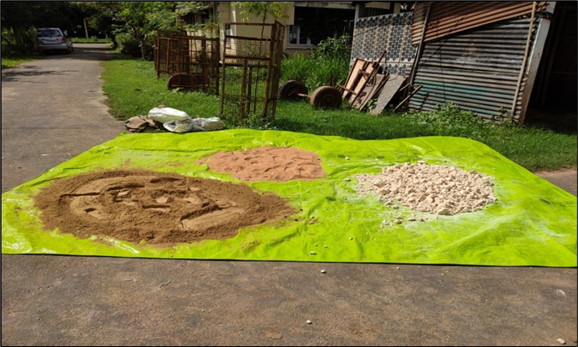

**Figure 1: SHATAVARI ROOT POWDER, FENUGREEK SEED POWDER AND AJWAIN SEED POWDER**

**2.1 Reproductive Parameters**

* + 1. **In female**

1. **Age at first heat (puberty):** The day on which first sign of heat in the females was recorded.
2. **Duration of the first heat:** The duration of time for which the female showed signs and symptoms of heat was recorded and expressed in hours.
3. **Age at sexual maturity:** The age at which animals attained 60-70% of their adult body weight and attained sexual maturity or deemed sexually fit were recorded.

**2.1.2 In male**

A routine semen examination was done for semen quality evaluation for the following traits. Semen was collected using an artificial vagina (Figure 2) (Evans and Maxwell, 1987).

1. **Volume:** The volume of fresh semen was recorded from the graduated mark of the semen collecting tube.
2. **Colour:** The colour of the semen was recorded in the collecting tube immediately after collection by the naked eye. The colour was scored on 5 point scale (Jainudeen, *et al.* 1993).

**Table 1 : Grade of semen based on consistency.**

|  |  |
| --- | --- |
| **Consistency** | **Grading** |
| Creamy-grainy | 5 |
| Creamy | 4 |
| Thin creamy | 3 |
| Milky white | 2 |
| Watery-cloudy | 1 |

**iii) Mass activity: A** drop (5-8 μl) of semen was placed on a pre-warmed (38° C) glass slide without a cover slip and examined under a light microscope at low magnification (100X). The mass activity was scored on 5 scales (Evans and Maxwell, 1987).

**Table 2: Grade of semen based on mass activity.**

|  |  |
| --- | --- |
| **Mass activity** | **Grading** |
| Dense, very rapidly moving waves and eddies | 5 |
| Vigorous movement with moderately rapid waves and eddies | 4 |
| Small, slow-moving waves | 3 |
| Weak motion without forming any waves | 2 |
| No perceptible motion | 1 |

**iv) Individual motility:** A drop (10 μl) of semen was placed on a clean pre-warmed (38 °C) glass slide and covered with a coverslip. The motility was determined by estimation the proportion of spermatozoa moving progressively straight forward at higher magnification (200X) (Evans and Maxwell, 1987).

**v) Live Sperm:** The percent of live sperms was determined using the standard Eosin Nigrosin staining technique (Blom, 1950).

**vi) Dead Sperm:** The percent of dead sperms was determined using the standard Eosin Nigrosin staining technique (Blom, 1950).

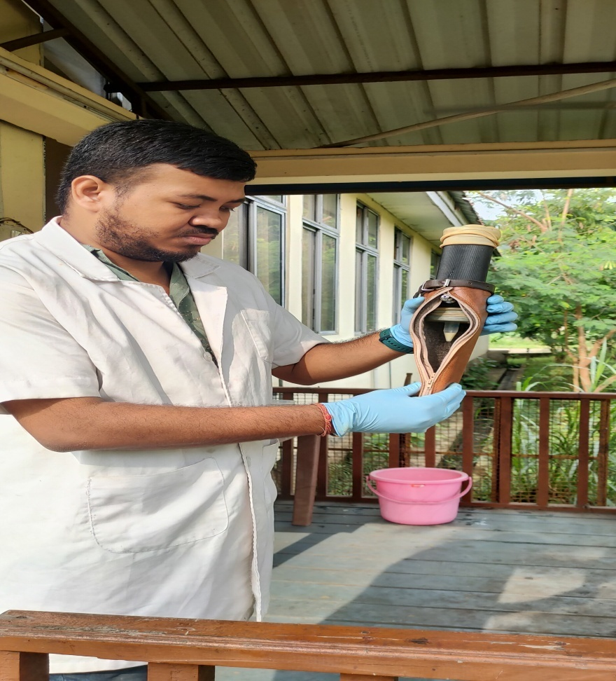

**Figure 2: EJACULATED SEMEN WITH ARTIFICIAL VAGINA**

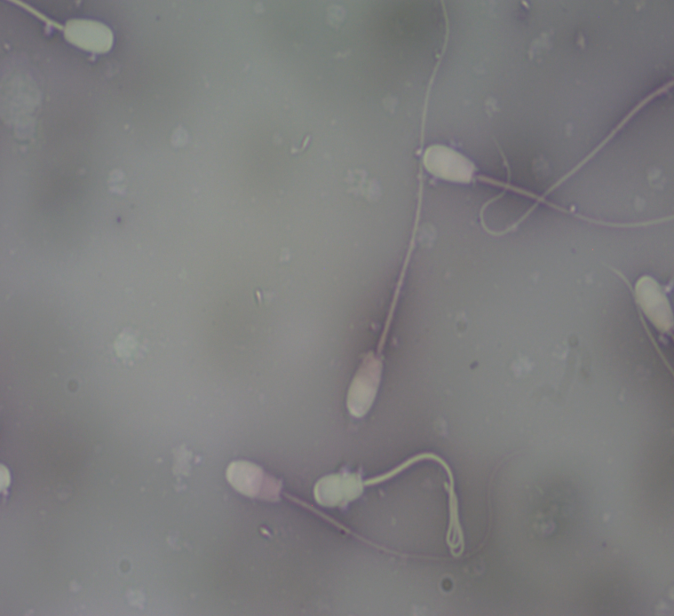

**Figure.3: SLIDE SHOWING LIVE AND DEAD SPERM,** **200X**

**3.RESULTS AND DISCUSSION**

**3.1 REPRODUCTIVE TRAITS**

**3.1.1 Age at first heat, fifth heat and duration of heat**

Reproductive traits included were age at first heat, fifth heat and duration of heats. The results observed during the experiment were shown in Table 3. The mean average age (days) at first heat were 199.833 ± 3.842, 183.333 ± 2.985 and 183.167 ± 4.110 for goats in C0, T1 and T2, respectively. And at fifth heat were 283.845 ± 3.842, 267.287 ± 2.982 and 267.062 ± 4.179, respectively. The goats in T2 and T1 came to heat earlier than control, Co group.The duration (hr) of first heat were 26.087 ± 0.582, 28.562 ± 0.970 and 28.627 ± 1.219 for goats in Co, T1 and T2, respectively. Similarly, for fifth heatduration (hr) were 26.955 ± 0.436, 32.317 ± 1.318 and 34.197 ± 1.010for goats in Co, T1 and T2, respectively. Goats in T2 had higher duration of heat followed by the goats in T1 and C0 and their analysis of variance were presented in Table 4. There were variations in the duration of heat, significantly high (*P*>0.01) in fifth heat but not significant in first heat duration. It was observed that the age at first heat were significantly lesser (*P*<0.01) in T2 followed by T1 compared to control (Co) group.

The results of the present study depicted that application of polyherbal supplementation in both the treatment T1 and T2 group had higher as well as better reproductive performance compared to control (Co) group.The results were in agreement with Kassem *et al.* (2006) findings. Similarly, with Berhane (2000), who reported that “highest reproductive performances (onset of estrus, pregnancy rate) were recorded in dairy cows supplemented with gur, linseed oil and fenugreek mixtures as compared to the control group which was without supplementation”. Rajkumar *et al.* (2008) studied “the effect of *Saraca asoca* stem bark and *Trigonella foenum*- graecum seeds on reproductive performance, serum progesterone and micro minerals profile in anoestrus cows and reported that the percentage of animals induced in oestrus and overall pregnancy rate using fenugreek seeds were higher (83.33 and 80.00 %) as compared to *Saraca asoca* (66.66 and 50.00 %) at doses of 50g and 100 g”.

The improvements in reproductive performance achieved by supplementing polyherbal combination @ 0.125 and 0.250 g/kg BW could be due to stimulation of the reproductive process by the steroidal and neurotransmitters effects of saponins contained in supplementation (Hussein and Badr, 2008). “Estrogenic property of shatavari, one of the polyherbal ingredient, stimulate the ovarian function, improves uterine tonicity thus helps in early uterine involution which consequently results into early initiation of estrus cycle” (Pandey *et al.*, 2005). Mitra *et al*., (1999) also reported that “shatavari based herbal formulation did not possess oxytocin like activity which might be useful in trating uterine hypermotility associated early abortion”.

The onset of puberty in goats typically occurs at 6–8 months of age in does and 4–6 months in bucks. The estrous cycle in goats is 21 days, on average but the age of onset can vary between breeds and is influenced by environmental factors, such as the season of birth, breed, geographic location (ie, latitude and climate), herd social structure, photoperiod and nutritional status. In temperate regions, spring-born animals will undergo puberty at younger age simply because physiologic maturity coincides with periods of decreased day length. Though some breeds, such as Pygmy goats, may reach puberty as early as 3 months of age, breeding should be delayed until the animal has reached at least 60% of its mature body weight to achieve higher conception rates and safer parturition, that is why in the present study fifth estrus was considered.

The mean duration of standing estrus has been reported to be 36 hours, although it can range from 24–48 hours depending on age, breed, season, and presence of a male. Breed-specific mean estrus duration has been reported for Mossi (20 hours), Angora (22 hours), Creole (27 hours), French Alpine (31 hours), Boer (37 hours), Nubian (42 hours) and Matou (58 hours) goats. In the present study, the average mean duration (Assam Hill goat) at fifth estrus was 31.156± 0.921. Estrus detection is based on behavioral signs, bleating, flagging of the tail, reddened vulva, vaginal discharge (which causes the tail hairs to stick together), and occasional “riding” by other does.

The results were in agreement with Jamra (2012) who observed “the average age at puberty of Sahiwal heifers in control and treatment group were 739.66±19.17 and 713.60±16.10, respectively”. The average age at puberty of Sahiwal heifers of treatment group was significant at 5% level of significance.

**TABLE 3 : AVERAGE (MEAN±SE) AGE AT HEATS AND DURATION OF HEAT OF ASSAM HILL GOAT OF DIFFERENT TREATMENT GROUPS**

|  |  |  |  |  |
| --- | --- | --- | --- | --- |
| **Female puberty** | **C0** | **T1** | **T2** | **Overall** |
| Age at first heat (Days) | 199.833 ± 3.842a | 183.333±2.985b | 183.167±4.110b | 188.778±3.646 |
| Duration of first heat (Hrs) | 26.087 ± 0.582 | 28.562±0.970 | 28.627±1.219 | 27.759±0.924 |
| Age at fifth heat (Days) | 283.845 ± 3.842a | 267.287±2.982b | 267.062±4.179b | 272.731±3.614 |
| Duration of fifth heat (Hrs) | 26.955 ± 0.436a | 32.317±1.318b | 34.197±1.010c | 31.156± 0.921 |

Means with similar superscript in a row or column do not differ significantly among themselves

**TABLE 4 : ANOVA FOR AVERAGE AGE AT HEATS AND DURATION OF HEAT OF ASSAM HILLGOAT OF DIFFERENT TREATMENT GROUPS**

|  |  |  |  |  |  |
| --- | --- | --- | --- | --- | --- |
| **Parameters** | **Source of Variation** | **df** | **SS** | **MS** | **F** |
| Age at first heat | Treatment | 2 | 1100.111 | 550.056 | 6.779** |
| Error | 15 | 1217 | 81.133 |  |
| Age at fifth heat | Treatment | 2 | 1179.111 | 589.556 | 7.808** |
| Error | 15 | 1132.667 | 75.511 |  |
| Duration of first heat | Treatment | 2 | 25.163 | 12.581 | 2.275 |
| Error | 15 | 82.961 | 5.531 |  |
| Duration of fifth heat | Treatment | 2 | 169.447 | 84.724 | 14.372** |
| Error | 15 | 88.427 | 5.895 |  |

**Highly significant (p<0.01)

**3.1. 2 Semen quality**

In the current study, routine examination of the semen samples were done to assess the semen quality comprises of mean volume (ml), Colour (1-5 scale), Mass activity (1-5 scale), Individual motility(%), Normal sperm (%), Live Sperm (%) and Dead Sperm (%) at 11th month and 12th month and were presented in Table 5 along with their analysis of variance were presented in Table 6, which showed significant differences (*P*<0.01) among the treatment groups. The highest volume (ml) was found in T2 group at 12th month 0.627 ± 0.008, Similarly, live sperm (%) 85.355 ± 0.895 was found in T2 group at 12th month. The overall semen qualities were found better in T2, followed by T1 and Co.In the treatment group, the buck could be used for mating or even for collection of semen from 11th month onwards instead of 12th months as level of testosterone hormone (ng/ml)was well within the optimum range and body condition score was found suitable. It was observed that the improvement of semen quality in the treatment groups T1 and T2 were due to the shatavari root powder, fenugreek seed powder and ajwain seed powder mixture supplementation and their synergistic effect.

The bucks are generally used for mating from 12th months of age, but the present study revealed it could be used from 11th months onward provided proper plane of management, feeding and nutritional status supplemented with herbs having property to improve testosterone hormone level resulted production of good quality semen. The other factors that can vary semen qualities were environmental factors, such as the season of birth, breed, geographic location, herd social structure and photoperiod.

Gangwar *et al.* (2018) observed in their study that “after first day of preservation, the experimental groups were having similar total sperm motility, whereas on the subsequent days, total sperm motility was significantly (*P*< 0.05) higher in Shatavari extract supplemented groups in comparison with the control group. However, significantly (*P* < 0.05) enhanced sperm motility was observed in group III containing 125 mg of Shatavari aqueous extract per 100 ml of diluter. Thus, it was confirmed the buck spermatozoa were more motile for longer duration in the group with shatavari extract. Hence, it was concluded that Shatavari helped in maintaining the sperm motility for longer duration. Similarly, after first day of preservation, all the experimental groups showed similar sperm viability, whereas on the subsequent days, sperm viability percentage was signicantly (P < 0.05) higher in Shatavari extract supplemented groups in comparison with the control group”. Hence, Shatavari was seen to help in maintaining the sperm viability for longer duration which was in agreement with the results of present study.

Semen volume also varies with season. The semen volume is high in spring and autumn (the reproductive season) and lower in summer and winter. The present research finding was consistent with that of Elsharif and Makawi (2004) and Gubartallah (2004). Also the results are comparable to those of bucks from different goats’ breeds (Wang *et al*., 2014). Earlier, studies reported that addition of antioxidants in semen diluter improved the semen quality (Gangwar *et al.,* 2014, Gangwar *et al* .,2015, Gangwar *et al.,* 2018). But now a days people are trying natural antioxidants in semen extenders (Wen *et al*., 2019) and extract from *Asparagus racemosus* (Shatavari) roots have been used in many investigations as antioxidants (Goyal *et al*., 2003). Similar to our findings, Wen *et al.* (2019) reported that “sperm motility, acrosomal integrity, mitochondrial membrane potential, plasma membrane integrity, total antioxidative activity in the 30 mg/L GSPE (Grape seed procyanidin extract) group was significantly enhanced, whereas Malondialdehyde (MDA) content was lower than as compared to the control group (*P* < 0.05). They also reported that AI results with GPSE supplemented semen showed higher litter size as compared to the control group (*P* < 0.05)”. Similarly, Zhao *et al*. (2009) reported “the significant correlation between Rhodiola sacra aqueous extract and concentrations of Glutathione (GSH) and MDA in frozen-thawed boar semen”.

**TABLE 5: AVERAGE (MEAN±SE) VOLUME, COLOUR, MASS ACTIVITY, INDIVIDUAL MOTILITY, NORMAL SPERM, LIVE SPERM, DEAD SPERM COUNT OF ASSAM HILL GOAT OF DIFFERENT TREATMENT GROUPS**

|  |  |  |  |  |  |
| --- | --- | --- | --- | --- | --- |
| **Semen evaluation** | **Age at**  **evaluation** | **C0** | **T1** | **T2** | **overall** |
| Volume (ml) | 11th month | 0.383 ±0.011a | 0.535 ±0.008b | 0.560 ±0.006b | 0.493± 0.008 |
| 12th month | 0.448 ±0.007a | 0.610 ±0.010b | 0.627 ±0.008b | 0.562± 0.008 |
| Colour  (1-5 scale) | 11th month | 3.333 ±0.067a | 4.133 ±0.061b | 4.217 ±0.031b | 3.894± 0.053 |
| 12th month | 4.033 ±0.080a | 4.483 ±0.040b | 4.483 ±0.031b | 4.333± 0.050 |
| Mass activity  (1-5 scale) | 11th month | 3.633± 0.076a | 4.033 ±0.021b | 4.217 ±0.031c | 3.961± 0.043 |
| 12th month | 4.117 ±0.040a | 4.300 ±0.026b | 4.417 ±0.048c | 4.278± 0.038 |
| Individual motility  (%) | 11th month | 75.948±0.349a | 80.158±0.187b | 81.792±0.391c | 79.299±0.309 |
| 12th month | 80.160±0.160a | 82.308±0.305b | 84.207±0.586c | 82.225±0.350 |
| Normal Sperm  (%) | 11th month | 93.622±0.417a | 93.700±0.380b | 94.128±0.441c | 93.817±0.413 |
| 12th month | 93.868±0.370a | 93.958±0.462b | 94.423±0.250c | 94.083±0.361 |
| Live Sperm  (%) | 11th month | 77.470±0.257a | 80.455±0.326b | 82.689±0.323c | 80.205±0.302 |
| 12th month | 80.269±0.153a | 82.842±0.373b | 85.355±0.895c | 82.822±0.474 |
| Dead Sperm  (%) | 11th month | 22.530±0.257a | 19.545±0.326b | 17.311±0.323c | 19.795±0.302 |
| 12th month | 19.731±0.153a | 17.158±0.373b | 14.645±0.895c | 17.178±0.474 |

Means with similar superscript in a row or column do not differ significantly among themselves

**TABLE 6: ANOVA FOR AVERAGE VOLUME, COLOUR, MASS ACTIVITY, INDIVIDUAL MOTILITY, NORMAL SPERM, LIVE SPERM, DEAD SPERM COUNT OF ASSAM HILL GOAT OF DIFFERENT TREATMENT GROUPS**

|  |  |  |  |  |  |
| --- | --- | --- | --- | --- | --- |
| **Parameters** | **Source of Variation** | **df** | **SS** | **MS** | **F** |
| Volume | Treatment | 2 | 0.23 | 0.11 | 383.33** |
| Month | 1 | 0.04 | 0.04 | 133.33** |
| Treatment x Month | 2 | 0.00 | 0.00 | 0.00NS |
| Error | 30 | 0.01 | 0.00 |  |
| Color | Treatment | 2 | 3.35 | 1.67 | 93.06** |
| Month | 1 | 1.73 | 1.73 | 96.11** |
| Treatment x Month | 2 | 0.32 | 0.16 | 8.89** |
| Error | 30 | 0.55 | 0.02 |  |
| Mass activity | Treatment | 2 | 1.21 | 0.61 | 50.42** |
| Month | 1 | 0.90 | 0.90 | 75.99** |
| Treatment x Month | 2 | 0.13 | 0.07 | 5.42** |
| Error | 30 | 0.35 | 0.01 |  |
| Individual motility | Treatment | 2 | 150.71 | 75.36 | 97.74** |
| Month | 1 | 77.03 | 77.03 | 99.91** |
| Treatment x Month | 2 | 7.55 | 3.77 | 4.89** |
| Error | 30 | 23.14 | 0.77 |  |
| Normal  Sperm | Source of Variation | df | SS | MS | F |
| Treatment | 2 | 1.957 | 0.978 | 0.979 |
| Month | 1 | 0.639 | 0.639 | 0.639 |
| Treatment x Month | 2 | 0.004 | 0.002 | 0.002 |
| Error | 30 | 27.749 | 0.925 |  |
| Live % | Treatment | 2 | 159.62 | 79.81 | 64.36** |
| Month | 1 | 61.65 | 61.65 | 49.72** |
| Treatment x Month | 2 | 0.27 | 0.13 | 0.11 |
| Error | 30 | 37.18 | 1.24 |  |
| Dead % | Treatment | 2 | 159.62 | 79.81 | 64.41** |
| Month | 1 | 61.65 | 61.65 | 49.76** |
| Treatment x Month | 2 | 0.27 | 0.13 | 0.11 |
| Error | 30 | 37.18 | 1.24 |  |

**Highly significant (*P*<0.01)

**4.CONCLUSION**

Adding a polyherbal supplement (Shatavari root, Fenugreek, and Ajwain seed powder) at 1 g/kg and 2 g/kg of body weight, along with routine basal diet from weaning period, enhanced reproductive traits such as age at first heat, heat duration and age at sexual maturity in females as well as semen quality in males. However, there is a need for exploration of combinations with other medicinal herbs for optimal reproductive performance of the animals.

**DISCLAIMER (ARTIFICIAL INTELLIGENCE)**

No AI technologies have been used during preparation of the manuscript.

**ACKNOWLEDGEMENT**

The authors extend sincere thankfulness to Assam Agricultural University, Jorhat for all kinds of financial and technical support.

**REFERENCES**

Berhane, M. (2000). Studies on feeding some indigenous galactpoietic feed supplement on performance of crossbred cows. M.Sc. Thesis, submitted to JNKVV, Jabalpur (MP).

Blom, E. (1950). Interpretation of spermatic cytology in bulls. *Fertility and Sterility*, *1*, 223-230.

Busquet, M.; Calsamiglia, S.; Ferret, A, and Kamel, C. (2006). Plant extracts affect in vitro rumen microbial fermentation. *J. Dairy Sci*.. **89**: 761-771.

Cullen, S.P.; Monahan, F.J.; Callan, J.J. and O’do.herty, J.V. (2005). The effect of dietary garlic and rosemary on grower-finisher pig performance and ensory characteristics of pork. *Irish Journal of Agricultural and Food Research*, **44**: 57-67.

Dubeuf, J.P. (2005). Structural, market and organizational conditions for developing goat dairy production systems. *Small Rumin. Res.,* 60: 6774

Elsharif, E.A. and Makawi, S.A. (2004). Effect of season on the freezability of semen in Nubian, Saanen and cross-bred bucks*. Sud. J. Vet. Sci. Anim. Husb.,* **43** (1&2): 72-73.

Evans, G. and Maxwell, W. C. (1987). *Salamons' artificial insemination of sheep and goats* (No. Ed. 2). Butterworths.

Gangwar, C.; Kharche, S.D.; Ranjan, R.; Kumar, S.; Goel, A.K. and Jindal, S.K. (2015). Effect of vitamin C supplementation on freezability of Barbari buck semen. Small Ruminant Research, 129: 104-107.

Gangwar, C.; Ranjan, R.; Satish, K.; Kharche, S. D.; Goel, A. K.; Ramachandran, N., and Jindal, S. K. (2014). Use of chelating agent for optimum post thaw quality of buck semen. Indian Journal of Animal Sciences, 84: 839-841.

Gangwar, C.; Saxena, A.; Patel, A.; Singh, S. P .; Yadav, S.; Kumar, R. and Singh, V . (2018). Effect of reduced glutathione supplementation on cryopreservation induced sperm cryoinjuries in Murrah bull semen. *Animal Reproduction Science,* 192: 171-178. <https://doi.org/10.1016/j.anireprosci.2018.03.005>.

Goyal, R. K.; Singh, J.; and Lal, H. (2003). Asparagus racemosus-an update. Indian *Journal of Medical Sciences*, **57**: 408-414.

Gruner, L and Chabert, Y. (Eds.) (2000) Proceedings of the Seventh International Conference on Goats, Vol. 2. Institute de l’Elevage, Tours, France, p. 1049.

Gubartallah, K.A.; Abdallah, M.A.; Amel, O.; Bakhiet and El Khider, O.A. (2004).Some observations on the reproductive performance of Sudanese Nubian bucks. Sud. *J. Vet. Sci. Anim. Husb*. Vol. **43** (1&2).

Haenlein, G. (2001). Past, present, and future perspectives of small ruminant dairy research. *J. Dairy Sci*., **84**(9): 2097-2115

Haenlein, G. F. W. and Fahmy, M. H. (1999). Role of small ruminants in the supply of animal products. In: Proceedings of the Special Symposium of IGA, HPI and WAAP at Eighth World Conference on Animal Production, Seoul, *South Korea. Small Ruminant Research*, **34**:175–308

Hussein, S. D. Abou and Badr, M. A (2008).Influence of antepartum administration of immune potentiators on reproductive efficacy of buffalo and viability of their calf. *Australian Journal of Basic and Applied Sciences,* **21**: 141-148.

Jainudeen, M. R.; Takahashi, Y.; Nihayah, M. and Kanagawa, H. (1993). In vitro maturation and fertilization of swamp buffalo (Bubalus bubalis) oocytes. *Animal Reproduction Science*, **31**(3-4): 205-212.

Kassem, A.; Al-Aghbari, A.; Molham, A. H. and Al-Mamary, M. (2006). Evaluation of the potential antifertility effect of fenugreek seeds in male and female rabbits. *Contraception*, **73**(3); 301-306.

M.S. Jamra Mittal, J.P. (1977). Comperative study on reproductive performance of barbari and jamunapari goats. *Animal Breeding Abst*., **50**:7303.

Mitra, S.K; Gopumadhavan, S.; Venkataranganna, M.V.; Sharma, D.N.K. and Anturlikar (1999). Uterine tonic activity of U-3107, a herbal preparation in rats. *Indian J. pharmacol*., **31**(3): 200-203.

Morand-Fehr, P. and Boyazoglu, J. (1999). Present state and future outlook of the small ruminant sector. *Small Ruminant Research*, 34(3): 175-188.

Mudgal, V.D.; Singhal, K.K. and Sharma, D.D. (2003). Advances in Dairy Animal Production. 2nd ed., International Book Distribution Co. India. Pp; 301- 330

Pandey, S.K.; Sahay, A.; Pandey, R.S. and Tripathi, Y.B. (2005). Effect of Asparagus racemosus rhizome (Shatavari) on mammary gland and genital organs of pregnant rat. *Phytother Res*.,**19**:721-4.

Rajkumar, R,; Srivastava, S.K.; Varshney, V.P. (2008) Mahmood S. Effect of medicinal plants Saracaasoca and Trigonella foenum- graecum in anoestrus cows. *Ind Vet J*., **85**: 1281-1283.

Rubino, R.; Morand-Fehr, P.; Renieri, C.; Peraza, C. and Sarti, F.M. (1999). Typical products of the small ruminant sector and the factors affecting their quality. *Small Ruminant Research*, **34**: 289– 302

Wang, W.;Luo,J.; Sun, S .; Xi, L.; Gao, Q.;Haile, AB.;Shi, H.;Zhang,W. and Shi, H. (2014). The Effect of Season on Spermatozoa Motility, Plasma Membrane and Acrosome Integrity in Fresh and Frozen–Thawed Semen from Xinong Saanen Bucks. *Reprod Dom Anim* doi: 10.1111/rda.12444.

Wen, F.; Li, Y.; Feng, T.; Du, Y.; Ren, F.; Zhang, L.; Han, N.; Ma, S.; Li, F.; Wang, P . and Hu, J. (2019). Grape seed procyanidin extract (GSPE) improves goat sperm quality when preserved at 4° C. Animals,9, <https://doi.org/10.3390/ani9100810>

Zhao, H. W.; Li, Q. W.; Ning, G. Z.; Han, Z. S.; Jiang, Z. L. and Duan, Y. F. (2009). R h o diola s a c r a aqueous extract (RSAE) improves biochemical and sperm characteristics in cryopreserved boar semen. *Theriogenology*, **71**: 849-857.

Mason, I. L. (1981). Classification and distribution of goat breeds. In: Maijala, K. (Ed.), Genetic Resources of Pig, Sheep and Goats. World Animal Science B8. *Elsevier*, *Amsterdam*, pp, 405–411.