***Original Research Article***

**Development of an IoT-Enabled In-Situ Soil Monitoring System for Enhancing Precision in Agricultural Practices**

**ABSTRACT**

The increasing global demand for food production necessitates the adoption of advanced technologies to optimize agricultural practices. This paper focuses on the development of an Internet of Things (IoT)-enabled smart in-situ soil monitoring system designed to enhance precision agriculture. The system integrates a network of advanced soil sensors capable of measuring critical soil parameters, including moisture content, temperature, pH, electrical conductivity (EC), and macronutrient levels (nitrogen, phosphorus, and potassium). These parameters are continuously monitored in real-time and transmitted to a cloud-based platform for secure data storage, processing, and analysis. The system provides farmers with actionable insights into soil health and nutrient status, enabling data-driven decision-making for efficient irrigation, fertilization, and crop management. By leveraging IoT technology, this approach enhances resource utilization, improves agricultural productivity, and promotes sustainable farming practices. The implementation of this system has the potential to optimize crop yields while minimizing environmental impact, contributing to the advancement of smart agriculture and global food security.

**Keywords:** Development; internet of things; in-situ soil monitoring system; precision; agricultural practices

1. **INTRODUCTION**

Soil quality is a key determinant of agricultural productivity, directly impacting crop yield, nutrient availability, and overall plant health. Soil quality plays a crucial role in determining agricultural productivity, influencing crop yield, nutrient availability, and overall plant health. Traditional soil monitoring methods, which depend on periodic manual sampling and laboratory analysis, are often labor-intensive, time-consuming, and costly. Additionally, these conventional approaches lack the capability to provide real-time insights into soil conditions, making it difficult for farmers to make timely, data-driven decisions regarding irrigation, fertilization, and soil management. The integration of Internet of Things (IoT) and smart sensing technologies presents a transformative solution to these challenges by enabling continuous, real-time monitoring of critical soil parameters. IoT-based automation systems play a vital role in improving farm management and optimizing agricultural practices [1]. The pursuit of sustainable agriculture has heightened the demand for effective and immediate solutions for fertilizer application management, as inadequate nutrient management results in detrimental environmental consequences, including soil contamination and water pollution [2]. Modern agriculture progressively integrates technological advancements to improve efficiency and productivity [3]. IoT technology amalgamates diverse devices and sensors for instantaneous communication. IoT technology integrates various devices and sensors to enable real-time communication. [4]. Enabling These technologies enable farmers to monitor and regulate environmental parameters such as temperature, humidity, and soil conditions with enhanced precision and efficacy—greater precision and efficiency. These technologies They also improve our understanding of how agriculture works and allow for the use of smart solutions like automated irrigation, better planting schedules, and efficient resource management [5].

This technology enhances agriculture's adaptability, responsiveness, and sustainability, effectively tackling modern agricultural difficulties through new and pragmatic methods. The IoT technology facilitates real-time data acquisition from dispersed sensors throughout agricultural land, yielding critical insights for enhanced decision-making precision. The integration of this technology improves agricultural environmental monitoring and diminishes dependence on extensive human oversight [6].

IoT-based automation enables farmers to adjust to alterations in agricultural circumstances remotely. This conserves time and diminishes the human effort required for traditional monitoring. The process saves time and reduces the need for manual monitoring. Sensors and automation devices oversee daily operations, deliver real-time updates, and autonomously execute corrective measures. As a result, farmers can optimize their time and resources, concentrate on tasks necessitating human involvement, and improve overall agricultural productivity [7]. The use of agricultural technology enhances management and provides farmers with increased autonomy and adaptability in their operations [8].

The calibration process is essential for ensuring that sensors deliver precise and quantifiable data, particularly in the presence of intricate environmental fluctuations [9]. Accurate calibration ensures the precision of soil parameter measurements, which are vital for assessing soil conditions. Sensor validation guarantees data dependability and assesses if sensors yield consistent results with actual field conditions [10], [11]. However, the prior art discloses some advanced features that remain inaccessible to smaller farmers due to high costs and the need for complex processes like chemical analysis and spectroscopy. The prior art provides some improvements by integrating spectral analysis to detect macronutrients, but this system lacks portability and real-time feedback. Another notable device outlined uses AI-3-driven analysis but is limited by its inability to adapt to different manure types and environmental conditions [12].

This research creates accurate and reliable data through careful calibration and validation, helping us better understand agricultural and environmental conditions while improving sensor technology for soil moisture, temperature, electrical conductivity, hydrogen percentage, and macronutrients (Nitrogen, Phosphorus, and Potassium) in smart agriculture.

This research aims to design, implement, and calibrate an IoT-enabled soil monitoring system for precise, real-time soil analysis. By integrating connected sensors with an IoT platform, the system will provide farmers with detailed, data-driven insights to optimize soil health management and crop productivity. The study focuses on sensor calibration and validation to ensure accuracy and reliability under real-field conditions, bridging the gap between traditional soil analysis methods and modern digital agriculture. The expected outcomes include a scalable, cost-effective solution suitable for both smallholder and commercial farmers that enhances precision farming practices. In the end, this research helps improve farming technology by allowing for automatic soil checks, cutting down on wasted resources, and encouraging sustainable farming practices.

In the subsequent sections, this paper details the system architecture, sensor selection, calibration methodologies, data transmission protocols, and the validation framework used to assess the performance and effectiveness of the proposed soil monitoring system.

**2.0 MATERIALS AND METHOD**

**2.1 Materials**

The system involved both the software and hardware components. the software involved is the C++ programming written for the system, while the hardware components involved are the ESP32 microcontroller, RS485 Modbus sensor 7-in-1 sensor, MAX485 module/RS485 to RS-485 Module converter, Liquid Crystal Display (LCD), Arduino keypad, switch, Wi-Fi, and power unit. The ESP32 serves as the brain of the system; it is responsible for collecting data from the sensors, processing it, displaying it on the LCD, and saving and storing it in the cloud.

**2.2 Description of the components used**

This section provides a detailed description of the components used in the development of an IoT-enabled in-situ soil monitoring system.

**2.1.1 ESP32 Microcontroller:** The ESP32, developed by Espressif Systems, is a highly capable, low-cost microcontroller designed for energy-efficient applications, particularly in the realm of the Internet of Things (IoT), wearable technology, and mobile electronics. As the successor to the popular ESP8266, the ESP32 offers significantly improved performance and features, including integrated Wi-Fi and Bluetooth connectivity. It is built around a dual-core Xtensa® LX6 processor operating at up to 240 MHz, complemented by 512 KiB of RAM, and includes an ultra-low-power (ULP) coprocessor with 8 KiB memory designed for energy-saving operations in sleep mode. This architecture enables the ESP32 to manage high-speed processing tasks while maintaining low power consumption for background sensor monitoring. Furthermore, the ESP32 is equipped with various onboard peripherals such as ADCs, DACs, UART, SPI, I2C, PWM, and capacitive touch sensors, making it an ideal platform for standalone, connected systems. Its robust feature set, affordability, and wireless capabilities make it a reliable choice for diverse applications, including smart agriculture, home automation, health monitoring, and industrial control systems, where real-time communication and efficient power usage are critical, as shown in Figure 1**.**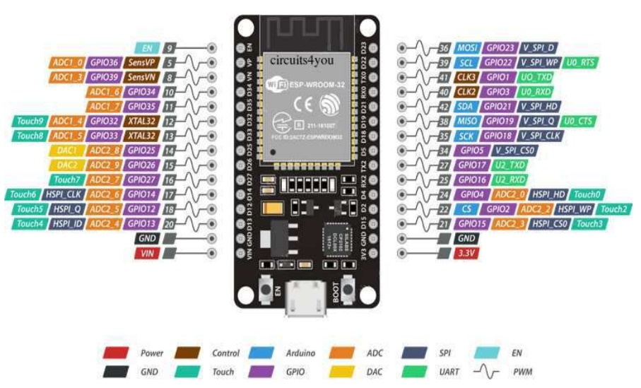

Figure 1: ESP32 Microcontroller [13]

**2.1.2 RS485 Modbus 7-in-1 sensor:** Power supply of 4.5 to 30 V, operational environment of -40°C to 80°C, output RS485/4-20 mA/0-5V/0-10V, Temperature: measuring range -40°C to 80°C, accuracy ± 5°C, long-time stability ≤ 0.1%°C/y, response time ≤ 15 s. Relative humidity: measuring range 0 to 100% RH, accuracy 2% (0–50%), 3% (50–100%), long-term stability 1% RH/y, response time ≤4 sec. Electrical conductivity: measuring range 0 to μs/cm, accuracy ± 3% (0-10000 μs/cm); ± 5% (10000-20000 μs/cm) long time stability ≤ 1% US/cm, response time ≤ 1 sec. The percentage of hydrogen has a measurement range of 3-9 pH, an accuracy of 0.3 pH, a long-term stability of 5/year, and a response time of 10 seconds. Nitrogen: measuring range 1-1999 mg/kg (mg/L), resolution 1 mg/kg (mg/L), response time 1 sec. Phosphorus: measuring range 1-1999 mg/kg (mg/L), resolution 1 mg/kg (mg/L), response time 1 sec. Potassium: measuring range 1-1999 mg/kg (mg/L), resolution 1 mg/kg (mg/L), response time 1 sec. Figure 2 displays the RS485 Modbus 7-in-1 sensor.

Figure 2: RS485 Modbus 4 in 1 sensor [14]

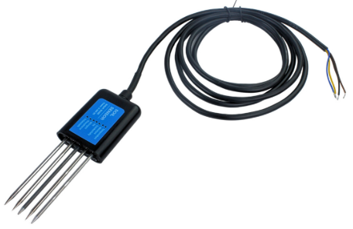

**2.1.3 MAX 485 module/RS485 to RS-485 Module converter:** on-board MAX 485 chip, low power consumption for the RS-485 communication, slew-rate limited transceiver, 5.08 mm pitch 2P terminal, and convenient RS-485 communication wiring. The board size measures 44 mm by 14mm and operates at a voltage of 5 V.

**2.1.4 LCD (Liquid Crystal Display):** An LCD2004 + 12C, 20-character, 4-line resolution, supply voltage 5 V module can be easily interfaced with MCU, low power consumption with a built-in controller.

**2.1.5 4x4 Matrix Keypad Module**: A 16-key membrane keyboard designed for use with microcontrollers such as Arduino, PIC, and AVR. This compact and durable plastic keypad features a matrix layout (4 rows × 4 columns), making it ideal for user input in embedded system projects.

**2.1.6 4G LTE universal mobile MiFi internet Hotspot:** Battery capacity of 3000mAh, superfast browsing speed of up to 150Mbps, maximum connection with 8 users, ethernet Port: 1 LAN Port with 2 times the speed, dual power options: Battery and USB power, Wi-Fi support for 2.4 GHz, and network support for 4G/3G/2G

**2.1.7 Power Unit:** The power unit comprises two 18650 lithium-ion batteries, each rated at 3800 mAh and V, along with a charge controller to regulate charging and ensure safe and efficient power management for the system. The rechargeable batteries provide continuous power in outdoor environments, making the system suitable for deployment in rural or off-grid areas. The energy-efficient design ensures that the system operates for extended periods without frequent maintenance or battery replacement.

**2.2 Material Acquisition**

The materials used in the construction of an IoT-enabled in-situ soil monitoring system were procured locally from reputable markets in Ilorin, Kwara State, for accessibility and immediate quality inspection. For unavailable items, international procurement was done through AliExpress. We selected international orders based on specifications, supplier ratings, reviews, and cost efficiency to meet the required research standards. This dual-sourcing approach ensures the availability, quality, and cost-effectiveness of all necessary materials.

**2.3 Construction Location**

The construction of the IoT-enabled in-situ soil monitoring system was carried out in the Instrumentation and Control Laboratory of the National Center for Agricultural Mechanization (NCAM) in Ilorin. This facility has been specifically selected due to its conducive environment, accessibility, and robust technical support infrastructure. These features ensure a seamless and efficient construction process, providing the necessary tools, expertise, and resources that facilitate the successful implementation of this research. the circuit diagram, block diagram, construction flow chart and working flow chart were followed strictly as shown in Figures 3 to 6.

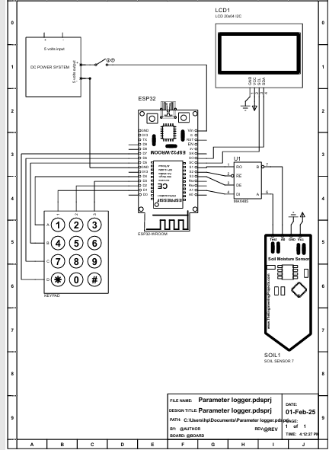

Figure 3: Circuit diagram of an IoT-enabled in-situ soil monitoring system



Figure 4: Block diagram of an IoT-enabled in-situ soil monitoring system



Figure 5: Construction Flow Chart of an IoT-Enabled In-Situ Soil Monitoring System



Figure 6: Working Flow Chart of an IoT-Enabled In-Situ Soil Monitoring System

**2.4 Testing and calibration**

The testing of the developed system was carried out in the NCAM instrumentation and control laboratory, while the calibration of the IoT-enabled in-situ soil monitoring system was conducted in the NCAM soil laboratory. This facility is equipped with advanced analytical tools and testing equipment specifically designed for soil analysis and related research activities. We rigorously evaluated the monitoring system in the soil laboratory, a controlled environment, to ensure its accuracy, reliability, and efficiency in measuring critical soil parameters. During this phase, the system’s sensors and IoT components were calibrated to ensure they provide precise and consistent readings under various conditions. Calibration also involved comparing the system outputs with standard reference instruments available in the laboratory to detect and correct any deviations. In addition, functionality tests were carried out to verify the system’s ability to transmit real-time data seamlessly, integrate with IoT platforms, and adapt to dynamic soil conditions.

**2.5 The working principles of a developed system**

The IoT-enabled in-situ soil monitoring system works by combining advanced sensors, data collection tools, communication networks, and cloud platforms to give immediate information about soil conditions. It provides farmers with access to essential soil parameters such as moisture, temperature, pH, electrical conductivity (EC), and macronutrient levels (nitrogen, phosphorus, and potassium), all critical for effective irrigation and soil management. Embedded sensors continuously monitor these parameters: moisture sensors detect water content, temperature sensors measure soil temperature, pH sensors evaluate acidity or alkalinity, and EC sensors assess salinity levels. The data collected is processed by an ESP32 microcontroller, which filters and converts raw readings into accurate numerical values. These results are displayed on an LCD screen and simultaneously transmitted via email to a cloud platform for storage, analysis, and historical tracking. The cloud system enables data visualization and insight generation, allowing users to monitor soil conditions remotely, receive alerts, and make informed decisions about irrigation and fertilization. Designed with energy efficiency in mind, the system is powered by rechargeable batteries, making it highly suitable for off-grid and remote agricultural areas. Upon powering on, the system displays “Connecting” while it searches for an internet connection. Once connected, the system prompts the user to "Insert," indicating the placement of the soil probe in the ground. The sensor readings are then displayed in real-time on the screen and transmitted to the designated email address, ensuring both immediate and remote access to soil health data. This continuous feedback loop enables smarter resource management, supports improved crop health, and enhances overall agricultural productivity.

**3.0 RESULTS AND DISCUSSION**

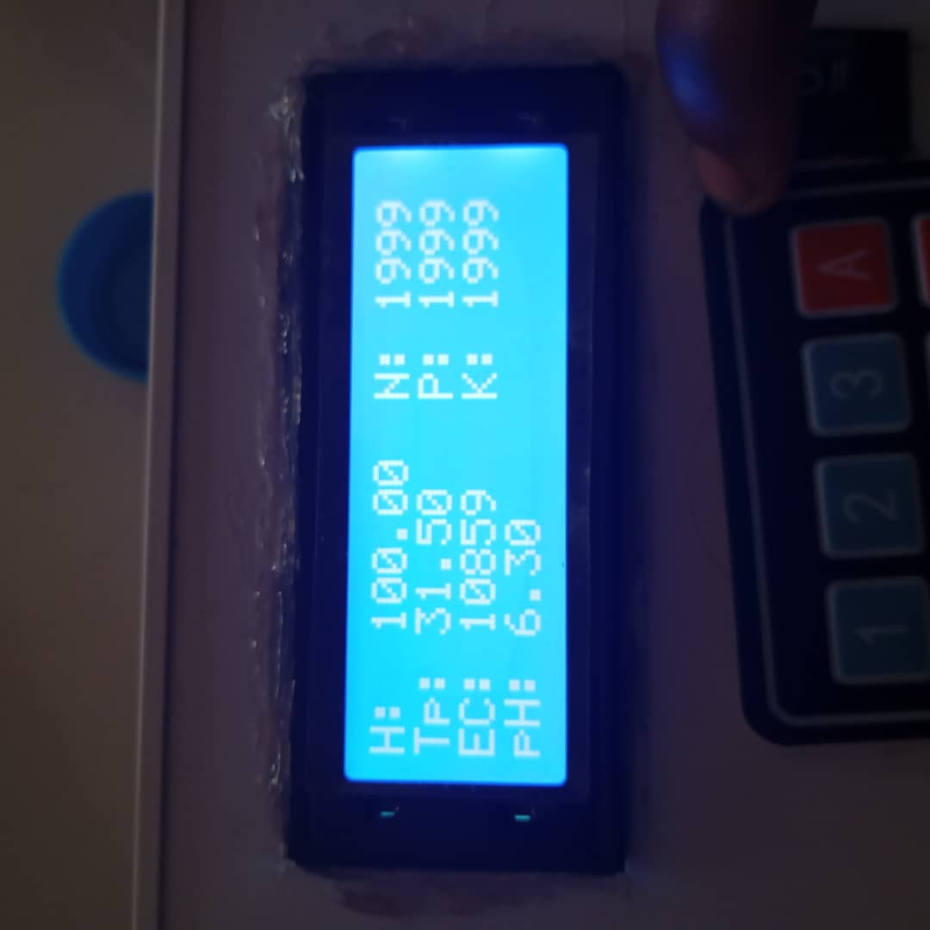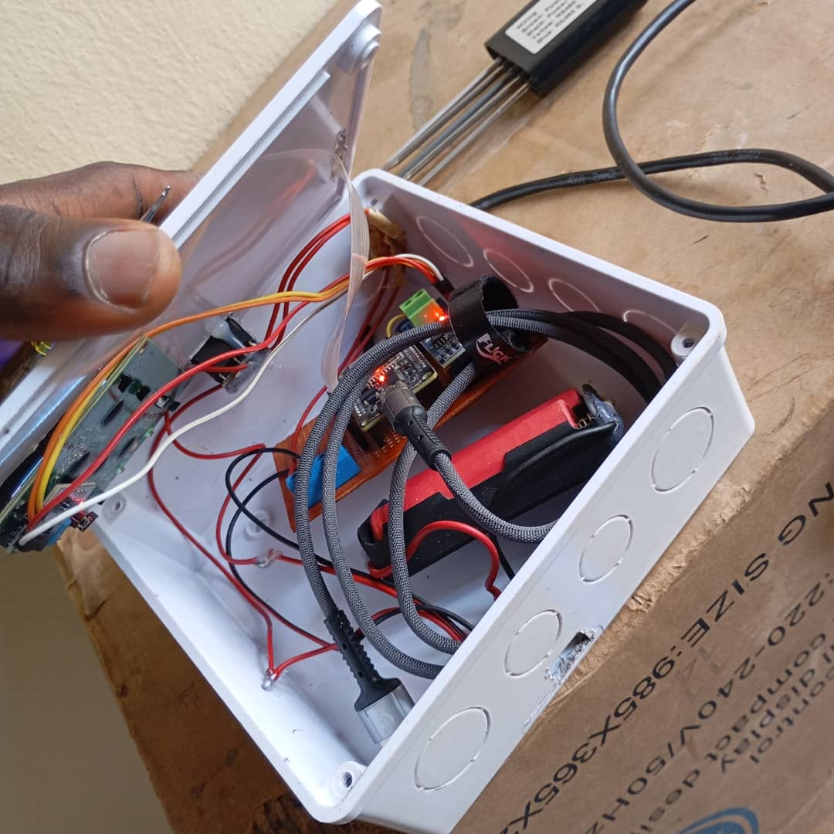

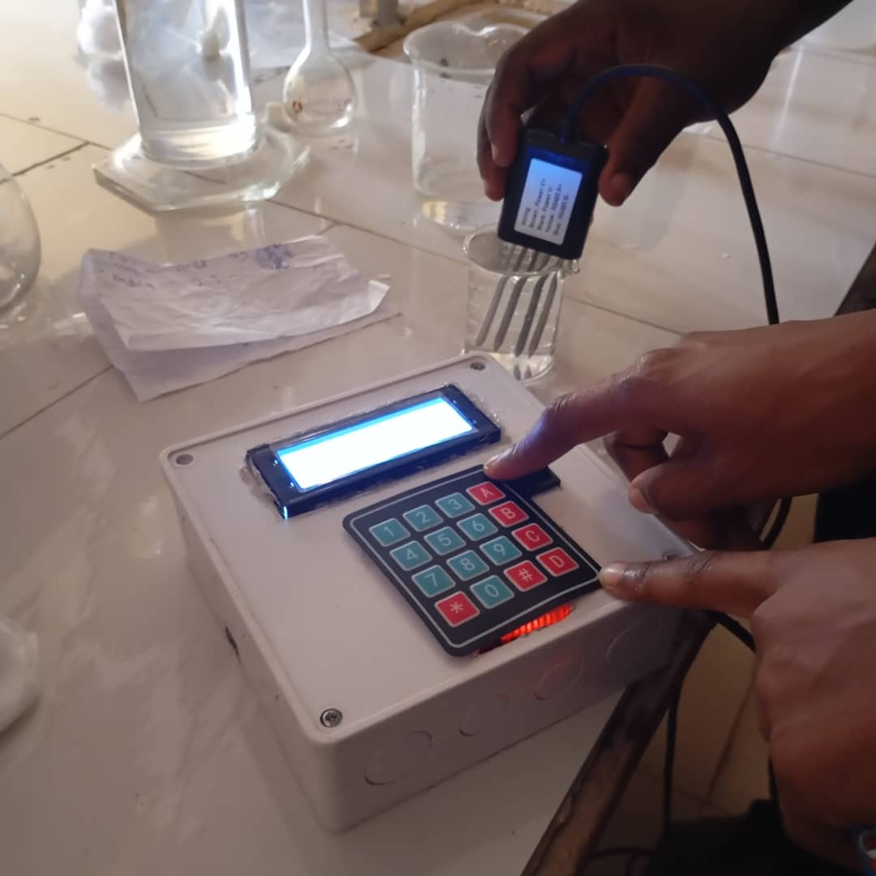Figure 7a: Developed soil in-situ system (construction) Figure 7b: Readings displayed during calibration

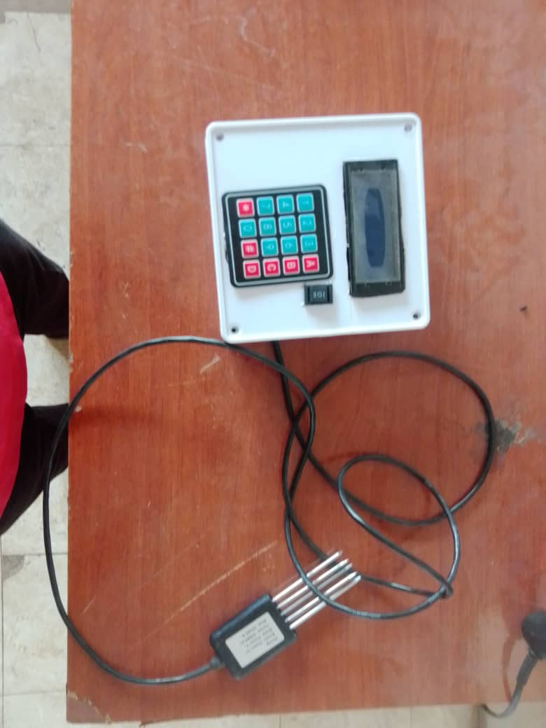

Figure 7cDeveloped soil in-situ systemduring calibrationFigure 7d: Developed soil in-situ system

The IoT-enabled in-situ soil monitoring system was successfully designed, implemented, and tested, as shown in Figure 7; the system provides real-time monitoring of essential soil parameters. The system included sensors to check soil moisture, temperature, pH, electrical conductivity (EC), and levels of important nutrients (nitrogen, phosphorus, and potassium), all connected to an ESP32 microcontroller, an LCD screen for local readings, and a feature to send data to the cloud for monitoring from afar. Both laboratory and field tests were conducted to evaluate the system’s performance, accuracy, and responsiveness under diverse soil and environmental conditions.

**3.1 Sensor performance and accuracy**

The RS485 Modbus 7-in-1 sensor module was calibrated before deployment to ensure measurement accuracy. The soil moisture sensor consistently detected water content within an acceptable error margin of ±3% when compared to standard gravimetric methods. Temperature readings for both ambient and soil conditions showed a deviation of ±0.5°C, closely matching those of digital thermometers. The pH sensor displayed minimal fluctuations, maintaining accuracy within ±0.2 pH units compared to a laboratory-grade pH meter. The electrical conductivity (EC) sensor effectively monitored salinity levels, demonstrating sensitivity to variations in nutrient concentrations. Also, the sensor successfully confirmed the presence of important nutrients—nitrogen, phosphorus, and potassium—using standard methods, proving it is reliable for checking soil fertility.

**3.2 System responsiveness and real-time monitoring**

The system demonstrated effective real-time monitoring with an average data acquisition and processing time of less than 15 seconds. The ESP32's Wi-Fi module displayed sensor readings on the LCD screen and transmitted them to a designated email. This procedure enabled remote monitoring and data logging for further analysis. Time-series plots of the transmitted data confirmed the system's stability and ability to capture trends in soil parameters throughout different periods of irrigation and environmental changes.

**3.3 Cloud integration and data management**

The email-based cloud transmission approach was a simple and effective solution for remote data access. While it lacked real-time dashboard visualization, it allowed data archiving and retrieval for trend analysis. Future versions could integrate advanced IoT platforms such as ThingSpeak or Blynk for interactive visual dashboards and automated alerts.

**3.4 Power and energy efficiency**

Powered by rechargeable batteries, the system maintained continuous operation for over 48 hours without the need for recharging, demonstrating its suitability for off-grid and rural agricultural environments. The energy consumption of the ESP32 microcontroller, connected sensors, and other components remained within safe and efficient limits, while the charging system reliably replenished the battery levels, ensuring consistent performance and long-term sustainability.

**3.5 Implications for precision agriculture**

The system offers a cost-effective and scalable solution for precision agriculture. By providing continuous and accurate feedback on soil conditions, farmers can make informed decisions about irrigation scheduling, fertilization, and crop health management. The integration of macronutrient (NPK) monitoring in future iterations could further enhance the decision-making process.

**4.0 CONCLUSIONS**

The creation of a soil monitoring system that uses IoT technology has shown great promise for improving precision agriculture by providing real-time, accurate, and ongoing soil data. By integrating sensors, microcontrollers, and wireless communication technologies, the system effectively monitors key soil parameters, such as moisture, temperature, electrical conductivity, and the percentage of hydrogen, nitrogen, phosphorus, and potassium, enabling informed decision-making for irrigation, fertilization, and overall crop management. The modular and scalable design ensures adaptability across various soil types and agricultural settings, while the cloud-based data logging and visualization platform supports remote access and analysis. Field testing confirms the system's reliability, responsiveness, and energy efficiency, making it a practical solution for modern agricultural practices. This research provides a foundational step toward smarter, data-driven farming systems, contributing to sustainable resource utilization, increased crop yields, and reduced environmental impact. Future work will focus on integrating advanced analytics and machine learning algorithms to further enhance predictive capabilities and system automation.

**5.0 RECOMMENDATIONS**

Based on the successful development and calibration of the IoT-enabled in-situ soil monitoring system, the following recommendations are proposed to guide further refinements and real-world applications:

1. **Integration with Smart Irrigation Systems**: To maximize the utility of real-time soil data, the monitoring system should be integrated with automated irrigation systems. The integration will enable closed-loop control for optimized water usage based on current soil conditions.
2. **Data Analytics and Machine Learning**: Incorporating advanced data analytics and machine learning models can enhance decision-making by predicting soil trends, crop performance, and irrigation needs based on historical and real-time data.
3. **User Interface Improvement**: The development of a user-friendly mobile or web-based dashboard will enable farmers and agricultural stakeholders to easily visualize, interpret, and act on the collected soil data.
4. **Pilot Deployment and Stakeholder Training**: Before large-scale adoption, pilot projects should be conducted in diverse agricultural environments, along with training for farmers and extension workers to ensure effective use and maintenance of the system.

COMPETING INTERESTS DISCLAIMER:

Authors have declared that they have no known competing financial interests or non-financial interests or personal relationships that could have appeared to influence the work reported in this paper.

Disclaimer (Artificial intelligence)

Author(s) hereby declares that NO generative AI technologies such as Large Language Models (ChatGPT, COPILOT, etc.) and text-to-image generators have been used during the writing or editing of this manuscript.

**REFERENCES**

[1] Katiyar, S., and Farhana, A. (2021). Smart Agriculture: The Future of Agriculture using AI and IoT. Journal of Computer Science, 17(10), 984–999. <https://doi.org/10.3844/jcssp.2021.984.999>

[2] National Institute of Agricultural Science Technology (NIAST). Methods of Analysis of Soil and 528 Plant. (National Institute of Agricultural Science Technology, Rural Development Administration, 529 Suwon, Korea, 2023).

[3] Karar, M. E., Alsunaydi, F., Albusaymi, S., and Alotaibi, S. (2021). A new mobile application of agricultural pests recognition using deep learning in cloud computing system. Alexandria Engineering Journal, 60(5), 4423–4432. <https://doi.org/10.1016/j.aej.2021.03.009>

[4] Saikat, M., Khan, I., Rahman, A., Islam, S., Kamal Nasir, M., Band, S. S., and Mosavi, A. (2021). IoT and Wireless Sensor Networking-based Effluent Treatment Plant Monitoring System. In Acta Polytechnica Hungarica, 18(10).

[5] Fernández-Ahumada, L. M., Ramírez-Faz, J., Torres-Romero, M., and López-Luque, R. (2019). Proposal for the design of monitoring and operating irrigation networks based on IoT, cloud computing and free hardware technologies. Sensors (Switzerland), 19(10). <https://doi.org/10.3390/s19102318>

[6] Saad, A., Benyamina, A. E. H., and Gamatie, A. (2020). Water Management in Agriculture: A Survey on Current Challenges and Technological Solutions. IEEE Access, 8, 38082–38097. <https://doi.org/10.1109/ACCESS.2020.2974977>

[7] Wakchaure, G. C., Minhas, P. S., Meena, K. K., Kumar, S., and Rane, J. (2020). Effect of plant growth regulators and deficit irrigation on canopy traits, yield, water productivity and fruit quality of eggplant (Solanum melongena L.) grown in the water scarce environment. Journal of Environmental Management, 262. <https://doi.org/10.1016/j.jenvman.2020.110320>

[8] Abebe, A. M., Kim, Y., Kim, J.-Y., Kim, S. L. & Baek, J. Image-Based High-Throughput 492 Phenotyping in Horticultural Crops. Multidisciplinary Digital Publishing Institute vol. 12 2061 493 Preprint at https://doi.org/10.3390/plants12102061 (2023)

[9] Montoya, A. P., Obando, F. A., Osorio, J. A., Morales, J. G., and Kacira, M. (2020). Design and implementation of a low-cost sensor network to monitor environmental and agronomic variables in a plant factory. Computers and Electronics in Agriculture, 178. <https://doi.org/10.1016/j.compag.2020.105758>

[10] Muthmainnah, Arabani, F. Z., Tazi, I., Chamidah, N., Sasmitaninghidayah, W., and Tirono, M. (2023). Development of Optical Sensor Technology for Non-Invasive Hemoglobin Measurement. Jurnal Penelitian Pendidikan IPA, 9(11), 10252–10258. <https://doi.org/10.29303/jppipa.v9i11.5610>

[11] Chaganti, R., Varadarajan, V., Gorantla, V. S., Gadekallu, T. R., and Ravi, V. (2022). Blockchain-Based Cloud-Enabled Security Monitoring Using Internet of Things in Smart Agriculture. Future Internet, 14(9). <https://doi.org/10.3390/fi14090250>

[12] Ferrag, M. A., Shu, L., Djallel, H., and Choo, K. K. R. (2021). Deep learning-based intrusion detection for distributed denial of service attack in agriculture 4.0. Electronics (Switzerland), 10(11). <https://doi.org/10.3390/electronics10111257>

[13] P. Ramchandar Rao, V. Ravi, S. Sanjay Kumar, Ch. Rajendra Prasad, Shyamsunder Merugu (2020). AUTOMATED GRAIN REPOSITORY USING IOT. https://doi.org/10.26782/jmcms.2020.06.00023. J. Mech. Cont.& Math. Sci., Vol.-15, No.-6, June pp 304-312.

[14] www[.store.nerokas.co.ke/SKU-3931](https://store.nerokas.co.ke/SKU-3931)retreived 7th April 7, 2025.