Comparing SeaDAS and ArcGIS extracted Aqua MODIS Sea Surface Temperature DN values at Bay of Bengal

ABSTRACT
This study compares Sea Surface Temperature (SST) DN values extracted from Aqua MODIS data using SeaDAS and ArcGIS of Visakhapatnam coastal waters, Bay of Bengal (BOB), India. SST data from January to December 2024 were analyzed across buffer zones of 50km ,75km,100km,125km,150km,200 km to assess their performance in zonal statistics. Both tools showed high consistency, with absolute errors ranging from 0.000007°C to 0.000163°C and APE from 0.000023 to 0.000563. Errors were negligible up to 150 km, but a one-pixel discrepancy observed at 200 km buffer, which slightly increase the error percentage. Seasonal pixel fluctuations, notably a 15-20% drop in July due to monsoon cloud cover, were observed. Both tools proved reliable for zone delineation, with negligible errors well below the ecological thresholds. SeaDAS excelled in precise SST processing, while ArcGIS offered superior geospatial visualization.

Key Words-Sea Surface Temperature, Buffer zone, Zonal Statistics, Aqua MODIS

- INTRODUCTION

Remote sensing plays a crucial role in monitoring and analysing Sea Surface Temperature (SST), as in-situ observations are often limited in frequency and spatial coverage. SST serves as a key indicator of climate system dynamics. Analysing SST distributions through remote sensing offers insights into ocean-atmosphere interactions and global climate patterns (Das, 2024). Remote sensing data facilitate the continuous monitoring of climate variables on regional and global scales, supporting assessments of climate change impacts and adaptation strategies (Gabriele et al., 2023). Remote sensing technologies, integrating both active and passive sensors across the electromagnetic spectrum, are pivotal in the comprehensive observation of oceanic parameters, with particular emphasis on SST dynamics (Devi et al., 2015). Various satellite sensors are employed to measure SST, including the Moderate Resolution Imaging Spectroradiometer (MODIS), Advanced Very High-Resolution Radiometer (AVHRR), and Sea-viewing Wide Field-of-view Sensor (SeaWiFS). Such data are essential for detecting temperature fluctuations, assessing climate change, and informing marine resource management strategies (Dunstan et al., 2018). Among the various methodologies for spatial SST analysis, Region of Interest (ROI) extraction plays a pivotal role in delineating specific zones, analysing coastal influences, and evaluating the impact of spatio-temporal variations on marine biodiversity. Multiple approaches exist for retrieving remote sensing data from satellite imagery. Madhavan et al. (2015) utilized beam software to extract monthly mean values by importing polygons from ArcGIS for their study. Similarly, Al-Hajri et al. (2020) and Pandey & Liou (2022) extracted mean values using ArcGIS. Additionally, AlHossainy et al. (2025) and Ginanjar et al. (2025) employed SeaDAS to extract DN values for their research. Scholars or Researchers who has no knowledge of coding on extraction of SST value, the tools SeaDAS and ArcGIS will give Zonal Statistics of study area. There are no such studies comparing both the tools SEADAS and ArcGIS for zonal statistics. This article helps scholars and researchers choose the best tool for extracting zonal statistics. SeaDAS is a free, open-source software designed for data processing, visualization, and geospatial analysis, particularly for oceanographic applications. In contrast, ArcGIS is a licensed software renowned for its capabilities in mapping, multilayer analysis, and advanced geospatial analysis. A comparative evaluation of these tools will provide insights into their effectiveness in extracting zonal statistics and analyzing SST variations.

2. MATERIALS AND METHODS
2.1 Study Area

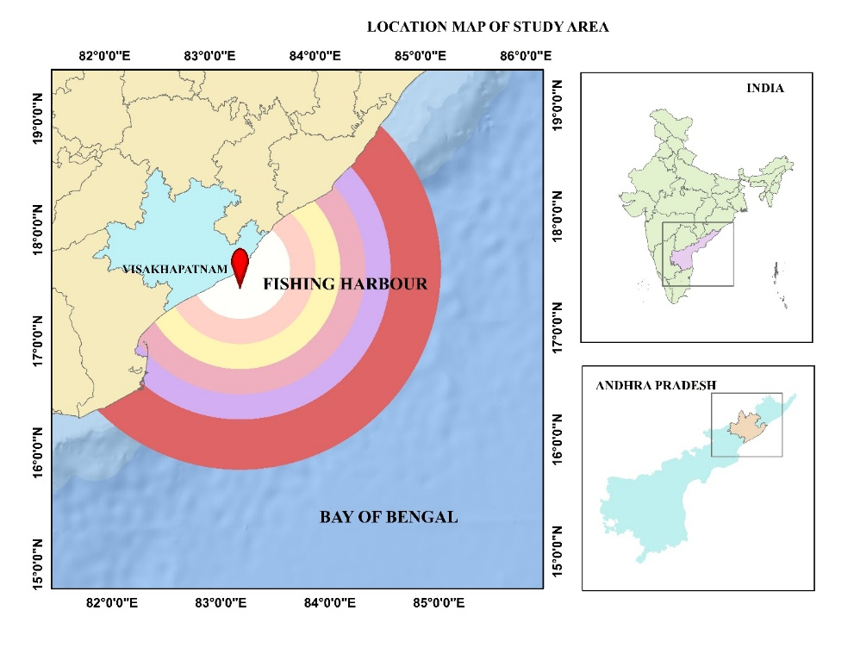
The study area includes the coastal waters of Visakhapatnam district in northern Andhra Pradesh, located in the Bay of Bengal at approximately 17.695° N latitude and 83.3025° E longitude. This study established multiple buffer zones extending from the Visakhapatnam fishing harbour with radii of 50 km, 75 km, 100 km, 125 km, 150 km, and 200 km. The Bay of Bengal is the largest bay in the world and is part of the Indian Ocean. It supports a diverse range of marine flora and fauna and is responsible for nearly 7% of the world's total fish catch (Transboundary Diagnostic Analysis, Vol. 2). Therefore, monitoring this region can be an effective strategy for delineating fishing zones and predicting fisheries yields. (Figure :1)
Figure 1:Study Area

2.2 SeaDAS (Sea, Earth and Atmosphere Data Analysis System)

SeaDAS, which is developed by NASA, is a special tool for the processing of ocean color data and thermal infrared satellite imagery. It offers advanced functions such as atmospheric correction, radiometric calibration, spectral analysis, and time-series studies, making it a preferred choice for researchers dealing with satellite-derived ocean parameters, particularly suitable for marine and coastal studies (Ginanjar et al., 2025). SeaDAS ensures high accuracy in SST retrieval through a combination of remote sensing algorithms. Its open-source nature and user-friendly interface help in the exploration of complex datasets, supporting interdisciplinary studies on climate change and marine ecosystems. (Ocean Biology Distributed Active Archive Center, 2017).

2.3 ArcGIS (Arc Geographic Information System)

ArcGIS, developed by Esri, is a software platform that helps users create, manage, analyse, and map data. It is a widely used Geographic Information System (GIS) that provides advanced geospatial analysis tools, including buffer creation, spatial interpolation, data integration, mapping, and statistical modelling (Setiawan et al., 2021). ArcGIS excels in spatial visualization, making it an excellent choice for buffer zones, integrating multiple environmental datasets, and conducting geostatistical and zonal statistical analyses (Raja & Kumar, 2023). The advantage of ArcGIS is to overlay different spatial layers and perform spatial queries, which enhances its applicability in marine studies, particularly in analysing SST gradients and their influence on coastal and offshore environments. GIS enables the analysis of long-term climate data, including trends in temperature, sea level rise, and changes in ice cover and vegetation.

2.4 Satellite-Derived Sea Surface Temperature

Monitoring SST is essential for understanding various scientific phenomena, including sea level rise, salinity, upwelling, Potential Fishing Zones (PFZ), eddies, and cyclone (Narayanan et al., 2013). One major advantage of using satellite remote sensing for SST is its ability to collect data across vast areas in near real-time (Kohtaro Hosoda et al., 2007). Satellite sensors such as MODIS, AVHRR and SeaWiFS can capture brightness values across different spectral bands. For this study, 12 monthly level 3 Aqua MODIS satellite images, each with a resolution of 4 × 4 km, have been downloaded from the NASA Ocean Color website (https://oceandata.sci.gsfc.nasa.gov/l3/) for the period from January to December 2024.The Aqua MODIS SST retrieval algorithm is given below.
SST=aij₀+aij₁BT_{11μm}+aij₂(BT_{11μm}−BT_{12μm}) T_{sfc}+aij₃(sec(θ−1) (BT1_{1μm}−BT_{12μm}) +aij₄(mirror)+aij₅(θ∗) +aij₆(θ²)

2.6 Methodology
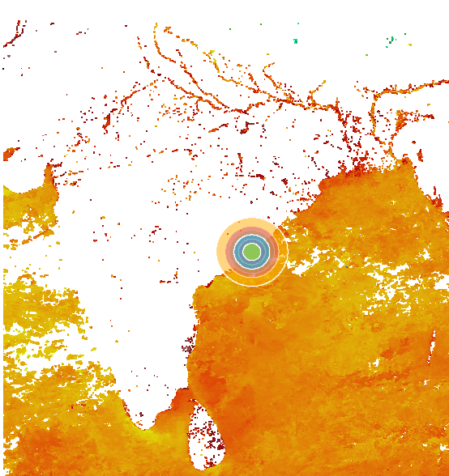
The methodology involves two types of DN value Extraction for summarizing statistics in a specific buffer zone or polygon from the downloaded image using SeaDAS and ArcGIS. Images downloaded from the NASA website are in NetCDF format. Initially a buffer zone was created in ArcGIS in the form of shapefile for the Region of Interest (ROI). In this study, the shapefile is created with six different radii of buffer having a distance of 50km, 75km, 100km, 125km,150km, 200 km from the Visakhapatnam fishing harbor as our ROI.

2.6.1 Extraction Of DN Value From Image Through SeaDAS

As an initial step, it is necessary to load the downloaded NetCDF file into SeaDAS. Then, access the file manager and open the file. Within this, there are various folders, and we need to open the "bands" folder and select the "sst" band, which corresponds to the SST satellite image. The SST image will then be displayed. Now we need to add land mask, which is present in the tool bar. Next, add the ROI shapefile by following these steps: Go to the vector menu in the toolbar, click on "Import," then choose "ESRI shapefile," and select the Multi buffer shapefile. This action overlays the vector shapefile on the Net CDF SST image, which can be seen in the following image (Figure2). Now, navigate to the analysis section in the toolbar and click on "Statistics" to obtain the summary statistics. In the dialog box, we can observe various headings, including "bands," "ROImask," and "Flagmask." Click on the "band" option, then select "sst". For the ROI-Mask, click on the Multi buffer shapefile, at the bottom, select "Individual" on “Mask grouping" and finally click on "Run." The statistics will be displayed on the screen. This outlines the methodology for extracting statistics for an ROI in SeaDAS providing a straightforward approach for oceanographic data analysis (Alaudin et al., 2024). The entire process is depicted in flow chart as figure: 3.
Figure 2: SST image of SeaDAS with Vector File
Create Region of Interest shape file using ArcGIS
Download L3 Aqua MODIS SST images
Load image into SeaDAS
Load vector File
(Shape File)
Open SST Band
Statistical Analysis
Load image into SeaDAS
Open SST Band
Export file as Geo Tiff
Load Geo Tiff into ArcGIS
Geo Processing
(Raster Calculator)
Zonal Statistics
IN SeaDAS
IN ArcGIS

2.6.2 Extraction Of Dn Value From Image Through ArcGIS

To extract SST data in ArcGIS, it is necessary to convert the image format from Net CDF to Geo TIFF, as Net CDF files are not supported in ArcGIS. For that in SeaDAS, load the SST Net CDF file, open the " sst" band, now apply the land mask present in the tool bar and proceed to the file menu in the toolbar, and export the file as a Geo TIFF file format. Next, open ArcGIS and load the TIFF file of SST into it. We then use various geoprocessing methods to remove negative values present in the data. Then to get the DN value of SST by opening the zonal statistics tool in the geoprocessing menu and select "Zonal Statistics as Table." For the input raster or feature zone data at the top, give input as ROI file. Next for the Zone Field, select the appropriate ID and for the Value Raster and give input as processed raster. It gives various statistical types such as mean, median, and standard deviation. In this study, the saved mean value from the ROI is used for comparison. This outlines the methodology used for extracting summary statistics is available in ArcGIS manual (Esri, n.d. 2025). The entire process is depicted in flow chart as figure: 3.
Figure 3: Flow Chart of Methodology

2.7 Methods Of Evaluation

The Absolute Percentage Error (APE) was utilized to quantify the difference between the mean values derived from SeaDAS and ArcGIS, enabling a comparative assessment of the two data extraction approaches. (Khair et al., 2017)

$$5APE= Abs \left( \frac{ArcGIS-SeaDAS}{ArcGIS}\right)×100$$

RESULTS AND DISCUSSION

The dataset examines SST in the coastal waters of Visakhapatnam in the Bay of Bengal, comparing ArcGIS and SeaDAS datasets across multiple buffer zones (50 km to 200 km). The analysis provides insights into seasonal variations, spatial patterns, and the accuracy of ArcGIS relative to SeaDAS. Further using metrics such as mean SST, error values, and APE. Below is a detailed discussion of the results.
The evaluation of monthly buffer analyses from Table 1 and Table 2 reveals a consistent pattern across the year. For the 50 to 150 km buffers, the number of valid pixels remains identical between SeaDAS and ArcGIS, and the mean values are so closely matched that any error is negligible, typically appearing only at the sixth decimal place. This consistency demonstrates a high level of accuracy and agreement between the SeaDAS and ArcGIS within these buffer ranges.
However, a consistent discrepancy emerges in the 200 km buffer for each month, where SeaDAS reports one pixel fewer than ArcGIS. While the difference of a single pixel might seem insignificant, it leads to a relatively higher error in this buffer zone compared to the others. The associated error values and Absolute Percentage Errors (APE) for the 200 km buffers, though still quite low (ranging approximately from 0.000007 to 0.000163 for error values and from 0.000023 to 0.000563 for APE), are notably higher than those in the 50–150 km buffers. This suggests that while both tools are largely in agreement, the slight deviation in pixel count at the 200 km range introduces a minor yet consistent error, possibly due to differences in how each software handles buffer boundaries or pixel inclusion at outer edges.
It is evident that there is minimal absolute error between the values obtained from the two methods(Table-3). The error values are found within the range 0.000007 to 0.000163. We can see differing of error values across the different months. The minimal error 0.000007 occurs in June and then in November at 0.000045. The highest error is observed in March at 0.000163, followed by August at 0.000137. The lowest APE is found in June at 0.000023, followed by November at 0.000157. The highest APE is recorded in March at 0.000563, followed by August at 0.000464.
The data indicates that the number of valid pixels fluctuates from month to month in SST readings (Figure-4). Notably, highest number of valid pixels is observed in October, November, and December. In contrast, there is a gradual decline in the number of valid pixels during the month of July across all buffers. Similar findings were reported by Redfern et al. (2023) in his study, who also noted missing pixels during July (2020). During the monsoon, there is a data gap of about 15-20%. However, Azmi et al. (2015) found that there is a 50-60% gap in data during the monsoon season at Mumbai coast in Arabian Sea in the year.
Figure 4: Pixel Number of ArcGIS at different Buffer Zones

CONCLUSION

This study assessed the performance of SeaDAS and ArcGIS in extracting zonal statistics for SST analysis in the coastal waters of Visakhapatnam, Bay of Bengal, using Aqua MODIS satellite imagery from January to December 2024 across buffer zones of 50–200 km. Both tools yielded highly consistent mean SST values, with absolute errors ranging from 0.000007 to 0.000163°C and absolute percentage errors (APE) from 0.000023 to 0.000563. Errors remained negligible up to 150 km, but a consistent one-pixel discrepancy at 200 km slightly elevated errors, peaking in March (0.000163°C) and minimizing in June (0.000007°C). SeaDAS is an open-source free software, offers superior precision for processing satellite-derived Net CDF data, making it ideal for researchers prioritizing SST accuracy in oceanographic studies. ArcGIS, despite requiring format conversion, excels in geospatial visualization and multilayer integration, enhancing its utility for comprehensive marine and climate analyses. For fishery zone delineation in the Bay of Bengal, both tools are reliable, as errors below 0.0002°C fall well below typical SST thresholds (0.5°C) for ecological impacts. The choice depends on user needs: SeaDAS for rapid, precise processing, and ArcGIS for advanced spatial presentation. Future research should address monsoon-related data gaps, which reduce pixel counts by 15-20% in July, to improve SST retrieval accuracy in tropical regions.

DISCLAIMER (ARTIFICIAL INTELLIGENCE)

Author(s) hereby declares that NO generative AI technologies such as Large Language Models (ChatGPT, COPILOT, etc) and text-to-image

ACKNOWLEDGEMENT

The support and co-operation received from the Department of Fisheries Engineering, College of Fishery Science at every stage of the study is warmly acknowledged.

REFERENCES

Alaudin, A., Zakiya, I., Burhanis, B., Munandar, R. A., & Kadhafi, M. (2024). The Use of Remote Sensing in Mapping the Distribution Of Chlorophyll In Belawan Waters. Zona Laut Jurnal Inovasi Sains Dan Teknologi Kelautan, 23-27.
Al-Hajri, S. M., Petropoulos, G. P., & Markogianni, V. (2021). Seasonal variation of key environmental parameters in the Sea of Oman using EO data and GIS. Environment, Development and Sustainability, 23, 6021-6046.
AlHossainy, R. H., Saber, A., Ghany, R. A. E., ElKafrawy, S. B., & Rabah, M. (2025). Inferring Bathymetry from Sentinel-2 Satellite Images Using Machine Learning Algorithms Based on Chlorophyll Concentration Data in the Absence of Ground Measurement. Arabian Journal for Science and Engineering, 1-18.
Azmi, S., Agarwadkar, Y., Bhattacharya, M., Apte, M., & Inamdar, A. B. (2015). Monitoring and trend mapping of sea surface temperature (SST) from MODIS data: A case study of Mumbai coast. Environmental Monitoring and Assessment, 187(3), Article 155.
Bay of Bengal Large Marine Ecosystem Project. (2012). Transboundary Diagnostic Analysis: Volume 2 – Background and Environmental Assessment.
Das, G. K. (2024). Analysing sea surface temperature and chlorophyll-a distribution along Visakhapatnam coast using MODIS data. Knowledge-Based Engineering and Sciences, 5(2), 19–30.
Devi, G. K., Ganasri, B. P., & Dwarakish, G. S. (2015). Applications of remote sensing in satellite oceanography: A review. Aquatic Procedia, 4, 579–584.
Dunstan, P. K., Foster, S. D., King, E., Risbey, J., O'Kane, T. J., Monselesan, D., Hobday, A. J., Hartog, J. R., & Thompson, P. A. (2018). Global patterns of change and variation in sea surface temperature and chlorophyll a. Scientific Reports, 8, Article 14624.
Esri. (n.d.). Zonal Statistics (Spatial Analyst). ArcGIS Pro Documentation. https://pro.arcgis.com/en/pro-app/latest/tool-reference/spatial-analyst/zonal-statistics.htm
Gabriele, M., Brumana, R., Previtali, M., & Cazzani, A. (2022). A combined GIS and remote sensing approach for monitoring climate change-related land degradation to support landscape preservation and planning tools: The Basilicata case study. Applied Geomatics, 14(2), 269–285. https://doi.org/10.1007/s12518-022-00437-z
Ginanjar, M. A., Wahyudi, A., & Alfaris, L. EXAMINING THE INTERRELATIONSHIP AMONG CHLOROPHYLL-A DISTRIBUTION, SEA SURFACE TEMPERATURE PATTERNS, AND FISHING GROUND IN SOUTHERN JAVA SEA.
Hosoda, K., Murakami, H., Sakaida, F., & Kawamura, H. (2007). Algorithm and validation of sea surface temperature observation using MODIS sensors aboard Terra and Aqua in the western North Pacific. Journal of Oceanography, 63(2), 267–280.
Khair, U., Fahmi, H., Al Hakim, S., & Rahim, R. (2017, December). Forecasting error calculation with mean absolute deviation and mean absolute percentage error. In journal of physics: conference series (Vol. 930, No. 1, p. 012002). IOP Publishing.
Madhavan, N., Vasan, D. T., Joseph, K. A., Madhavi, K. (2015). Neural network prediction on sardine landings using satellite derived ocean parameters Chlorophyll-a (SeaWiFS), SST and PAR. Indian J Nat Sci, 29(5), 5052-5063.
Narayanan, M., Vasan, D. T., Bharadwaj, A. K., Thanabalan, P., & Dhileeban, N. (2013). Comparison and validation of sea surface temperature (SST) using MODIS and AVHRR sensor data. International Journal of Remote Sensing & Geoscience, 2(3), 1–6.
Ocean Biology Distributed Active Archive Center (OB DAAC). (2017, May). SeaDAS introduction (Prepared for IOCS 2017). NASA Goddard Space Flight Center. https://www.seadas.gsfc.nasa.gov
Pandey, R. S., & Liou, Y. A. (2022). Sea surface temperature (SST) and SST anomaly (SSTA) datasets over the last four decades (1977–2016) during typhoon season (May to November) in the entire Global Ocean, North Pacific Ocean, Philippine Sea, South China sea, and Eastern China Sea. Data in Brief, 45, 108646.
Redfern, S., Optis, M., Xia, G., & Draxl, C. (2023). Offshore wind energy forecasting sensitivity to sea surface temperature input in the Mid-Atlantic. Wind Energy Science, 8(1), 1–23.
Setiawan, A., Agustriani, F., Ningsih, E. N., & Ulqodry, T. Z. (2022). Distribution pattern of potential fishing zones in the Bangka Strait waters: An application of the remote sensing technique. The Egyptian Journal of Remote Sensing and Space Science, 25(1), 257-265.

Vinston Raja, R., & Ashok Kumar, K. (2023). Financial derivative features based integrated potential fishing zone (IPFZ) Future forecast. Journal of Intelligent & Fuzzy Systems, 45(3), 3637-3649.
APPENDIX

Table 1:Monthly analysis From January to June
 |  | ArcGIS |  | SeaDAS
 | Buffer in km | Pixel | Mean | Pixel | Mean | Error | APE
January | 50 | 234 | 25.874762 | 234 | 25.874764 | 0.000002 | 0.000009
January | 75 | 519 | 26.001261 | 519 | 26.001261 | 0.000000 | 0.000001
January | 100 | 898 | 26.115992 | 898 | 26.115991 | 0.000001 | 0.000002
January | 125 | 1375 | 26.229845 | 1375 | 26.229847 | 0.000002 | 0.000007
January | 150 | 1951 | 26.351080 | 1951 | 26.351078 | 0.000002 | 0.000007
January | 200 | 3427 | 26.546511 | 3426 | 26.546393 | 0.000118 | 0.000443
Febuaruy | 50 | 234 | 27.279337 | 234 | 27.279337 | 0.000000 | 0.000000
Febuaruy | 75 | 516 | 27.358837 | 516 | 27.358837 | 0.000000 | 0.000000
Febuaruy | 100 | 895 | 27.404587 | 895 | 27.404586 | 0.000001 | 0.000003
Febuaruy | 125 | 1366 | 27.431904 | 1366 | 27.431903 | 0.000001 | 0.000003
Febuaruy | 150 | 1929 | 27.486904 | 1929 | 27.486904 | 0.000000 | 0.000001
Febuaruy | 200 | 3376 | 27.627579 | 3375 | 27.627473 | 0.000106 | 0.000383
March | 50 | 232 | 28.711809 | 232 | 28.711810 | 0.000001 | 0.000003
March | 75 | 511 | 28.773289 | 511 | 28.773287 | 0.000002 | 0.000006
March | 100 | 895 | 28.885658 | 895 | 28.885659 | 0.000001 | 0.000003
March | 125 | 1364 | 28.938021 | 1364 | 28.938020 | 0.000001 | 0.000002
March | 150 | 1914 | 28.955896 | 1914 | 28.955895 | 0.000001 | 0.000005
March | 200 | 3327 | 29.003969 | 3326 | 29.003806 | 0.000163 | 0.000563
April | 50 | 235 | 30.102489 | 235 | 30.102489 | 0.000000 | 0.000002
April | 75 | 514 | 30.138083 | 514 | 30.138083 | 0.000000 | 0.000002
April | 100 | 893 | 30.159155 | 893 | 30.159154 | 0.000001 | 0.000003
April | 125 | 1358 | 30.161255 | 1358 | 30.161255 | 0.000000 | 0.000000
April | 150 | 1916 | 30.203268 | 1916 | 30.203267 | 0.000001 | 0.000003
April | 200 | 3340 | 30.305183 | 3339 | 30.305252 | 0.000069 | 0.000226
May | 50 | 244 | 30.826332 | 244 | 30.826331 | 0.000001 | 0.000004
May | 75 | 530 | 30.947727 | 530 | 30.947726 | 0.000001 | 0.000004
May | 100 | 916 | 30.984192 | 916 | 30.984191 | 0.000001 | 0.000003
May | 125 | 1394 | 31.015451 | 1394 | 31.015451 | 0.000000 | 0.000001
May | 150 | 1988 | 31.145554 | 1988 | 31.145555 | 0.000001 | 0.000005
May | 200 | 3462 | 31.343615 | 3461 | 31.343521 | 0.000094 | 0.000299
June | 50 | 246 | 30.260061 | 246 | 30.260060 | 0.000001 | 0.000004
June | 75 | 535 | 30.269785 | 535 | 30.269784 | 0.000001 | 0.000003
June | 100 | 923 | 30.311268 | 923 | 30.311267 | 0.000001 | 0.000003
June | 125 | 1411 | 30.381163 | 1411 | 30.381165 | 0.000002 | 0.000008
June | 150 | 1987 | 30.410921 | 1987 | 30.410920 | 0.000001 | 0.000004
June | 200 | 3456 | 30.579834 | 3455 | 30.579827 | 0.000007 | 0.000023

Table 2: Monthly Analysis from July to December
 |  | ArcGIS |  | SeaDAS
 | Buffer In Km | Pixel | Mean | Pixel | Mean | Error | APE
July | 50 | 111 | 27.963554 | 111 | 27.963558 | 0.000004 | 0.000013
July | 75 | 340 | 28.130718 | 340 | 28.130720 | 0.000002 | 0.000006
July | 100 | 694 | 28.189150 | 694 | 28.189149 | 0.000001 | 0.000003
July | 125 | 1114 | 28.310106 | 1114 | 28.310107 | 0.000001 | 0.000003
July | 150 | 1596 | 28.364578 | 1596 | 28.364580 | 0.000002 | 0.000006
July | 200 | 2958 | 28.510481 | 2957 | 28.510366 | 0.000115 | 0.000403
August | 50 | 232 | 29.496292 | 232 | 29.496292 | 0.000000 | 0.000000
August | 75 | 509 | 29.370001 | 509 | 29.369999 | 0.000002 | 0.000006
August | 100 | 893 | 29.340469 | 893 | 29.340470 | 0.000001 | 0.000002
August | 125 | 1346 | 29.391842 | 1346 | 29.391842 | 0.000000 | 0.000000
August | 150 | 1932 | 29.396414 | 1932 | 29.396412 | 0.000002 | 0.000006
August | 200 | 3346 | 29.423143 | 3345 | 29.423280 | 0.000137 | 0.000464
September | 50 | 252 | 29.875872 | 252 | 29.875872 | 0.000000 | 0.000001
September | 75 | 540 | 29.866222 | 540 | 29.866222 | 0.000000 | 0.000001
September | 100 | 929 | 29.759581 | 929 | 29.759580 | 0.000001 | 0.000002
September | 125 | 1415 | 29.709610 | 1415 | 29.709611 | 0.000001 | 0.000003
September | 150 | 2025 | 29.745995 | 2025 | 29.745994 | 0.000001 | 0.000002
September | 200 | 3608 | 29.828123 | 3607 | 29.828210 | 0.000087 | 0.000291
October | 50 | 261 | 30.419653 | 261 | 30.419655 | 0.000002 | 0.000007
October | 75 | 567 | 30.447701 | 567 | 30.447698 | 0.000003 | 0.000008
October | 100 | 979 | 30.454050 | 979 | 30.454049 | 0.000001 | 0.000003
October | 125 | 1509 | 30.430580 | 1509 | 30.430579 | 0.000001 | 0.000004
October | 150 | 2194 | 30.451580 | 2194 | 30.451581 | 0.000001 | 0.000003
October | 200 | 3886 | 30.522985 | 3885 | 30.523055 | 0.000070 | 0.000228
November | 50 | 256 | 28.731289 | 256 | 28.731288 | 0.000001 | 0.000003
November | 75 | 562 | 28.736244 | 562 | 28.736245 | 0.000001 | 0.000003
November | 100 | 971 | 28.711998 | 971 | 28.711997 | 0.000001 | 0.000003
November | 125 | 1513 | 28.706659 | 1513 | 28.706662 | 0.000003 | 0.000009
November | 150 | 2197 | 28.733824 | 2197 | 28.733823 | 0.000001 | 0.000003
November | 200 | 3883 | 28.880903 | 3882 | 28.880858 | 0.000045 | 0.000157
December | 50 | 251 | 26.793924 | 251 | 26.793924 | 0.000000 | 0.000001
December | 75 | 557 | 26.988779 | 557 | 26.988779 | 0.000000 | 0.000000
December | 100 | 970 | 27.111784 | 970 | 27.111783 | 0.000001 | 0.000004
December | 125 | 1504 | 27.196808 | 1504 | 27.196808 | 0.000000 | 0.000001
December | 150 | 2174 | 27.301113 | 2174 | 27.301113 | 0.000000 | 0.000000
December | 200 | 3882 | 27.481401 | 3881 | 27.481333 | 0.000068 | 0.000249

Table 3: Annual 200Km Buffer Analysis

Month | ArcGIS Pixels | ArcGIS Mean | SeaDAS Pixel | SeaDAS Mean | Error | APE
January | 3427 | 26.546511 | 3426 | 26.546393 | 0.000118 | 0.000443
February | 3376 | 27.627579 | 3375 | 27.627473 | 0.000106 | 0.000383
March | 3327 | 29.003969 | 3326 | 29.003806 | 0.000163 | 0.000563
April | 3340 | 30.305183 | 3339 | 30.305252 | 0.000069 | 0.000226
May | 3462 | 31.343615 | 3461 | 31.343521 | 0.000094 | 0.000299
June | 3456 | 30.579834 | 3455 | 30.579827 | 0.000007 | 0.000023
July | 2958 | 28.510481 | 2957 | 28.510366 | 0.000115 | 0.000403
August | 3346 | 29.423143 | 3345 | 29.423280 | 0.000137 | 0.000464
September | 3608 | 29.828123 | 3607 | 29.828210 | 0.000087 | 0.000291
October | 3886 | 30.522985 | 3885 | 30.523055 | 0.000070 | 0.000228
November | 3883 | 28.880903 | 3882 | 28.880858 | 0.000045 | 0.000157
December | 3882 | 27.481401 | 3881 | 27.481333 | 0.000068 | 0.000249

