***Original Research Article***

**Comparative Anthropometric Circumferential Measurement of Yoruba and Igbo Ethnic Groups in Nigeria**

**Abstract**

**Background:** Circumferential measurements are important in various fields, including healthcare, sports, and industry. They are widely used to assess obesity levels, determine body fat distribution, and monitor changes in body composition over time.

**Aim:** This study compared the circumferential body measurements of Yoruba and Igbo individuals.

**Method:** Cross-sectional descriptive research was adopted in this study. 800 subjects (400 Yoruba and 400 Igbo) were recruited between 18 and 40 years. Data analysis was done using the statistical package for social sciences (version 23). Descriptive Statistics were presented, and an independent T-test was used to compare the mean among the ethnic groups. A probability less than 0.05 (p<0.005) was considered statistically significant, and 95% was the confidence level.

**Result:** The anthropometric circumferential differences between the both ethnic groups shows that neck circumference were (35.61±2.78cm, 31.69±2.37cm), mid-arm circumference were (27.87±3.28cm, 26.99±3.52cm), chest circumference were (85.64±5.74cm, 84.83±5.25cm), waist circumference were (75.99±7.49cm, 75.68±9.34cm), hip circumference were (89.86±5.25cm, 92.13±5.42cm), and mid-thigh were (49.05±5.58cm, 52.19±5.98cm) in Yoruba and Igbo respectively. It shows all parameters were statistically significant except chest and waist circumferences, which were not significant (p<0.005).

**Conclusion:** The Yoruba and Igbo ethnic groups show slight variations in body measurements. These findings highlight that while both ethnic groups have comparable body proportions, minor differences may arise due to genetic diversity, environmental influences, and individual lifestyle variations.

**Keywords:** Circumferential; Anthropometry, genetic diversity, lifestyle

**Introduction**

Anthropometry is the systematic measurement of the human body and is essential in many fields, including ergonomics, sports science, clothing design, and health assessment [1,2,3]. Among the various anthropometric parameters, circumferential body measurements offer important insights into body composition, shape, and size variations within particular populations [4,5].

Circumferential measurements are significant in various fields, including healthcare, sports, and industry. These measurements are commonly used to measure body fat distribution, evaluate obesity levels, and track changes in body composition over time [6,7]. In medical practice, they help diagnose and manage conditions such as cardiovascular diseases and metabolic disorders. In sports science, circumferential measurements assist in optimizing training programs by providing insights into muscle development and physical performance [8]. Additionally, industries such as fashion and ergonomics rely on these measurements to design well-fitting clothing and workplace equipment suited to specific body types [9]. By analyzing circumferential measurements, researchers and professionals can make informed decisions that enhance health, performance, and overall well-being.

In Nigeria, over 250 ethnic groups, the Yoruba and Igbo populations are among the largest and most studied due to their cultural, historical, and demographic significance [10]. The Yoruba ethnic group predominantly occupies the southwestern region of Nigeria, while the Igbo people mainly reside in the southeastern part of the country. Despite sharing geographical proximity and historical interactions, these two ethnic groups exhibit distinct physical and genetic traits influenced by environmental, genetic, and socio-cultural factors [11, 12]. Studies on anthropometric differences among ethnic groups are essential for applications in medical research, sports science, fashion design, and industrial ergonomics.

This study compares the circumferential body measurements of Yoruba and Igbo individuals. By analyzing parameters such as neck, mid-arm, chest, hip, waist and mid-thigh circumferences, this research seeks to provide valuable insights into the anthropometric characteristics of these two major Nigerian ethnic groups. The findings will contribute to the knowledge of human variability and have practical applications in various fields, including public health and nutrition.

**2.0 MATERIALS AND METHODS**

**2.1 Study Design**

The anthropometric value of Yoruba and Igbo ethnic groups in Nigeria was measured using a cross-sectional descriptive research method. Eight hundred subjects (400 Yoruba and 400 Igbo) between the ages of 18 and 40 made up the population. The subjects were selected using a multi-stage random proportionate sampling approach. Imo State University in Owerri, Imo State, was chosen as the research region to represent the Igbo people. Owerri is home to 983000 people, Adeline et al., [13].

Using the Taro Yamane formula, the sample size for the study will be determined using the Taro-Yamane formula, Okoh et al., [14].

$n=\frac{N}{1+N{\left(e\right)}^{2}}$

where n = minimum sample size,

N = total population and

e = margin of error = 0.05.

$$n=\frac{983000}{1+983000{\left(0.05\right)}^{2}}=399.83$$

For the study, the Igbo size was rounded up to 400 (200 males and 200 females)

For the Yoruba population, Lead City University in Ibadan was used as the study area, with 3,875,000beingthe total population in Ibadan, Ariyo et al., [14]

Applying the Taro Yamane formula

$$n=\frac{3875000}{1+3875000{\left(0.05\right)}^{2}}=399.95$$

For this study, the sample size of the Yoruba was rounded up to 400 (200 males and 200 females)

**2.2 Selection Criteria**

**Inclusion Criteria**

Only subjects whose parents and grandparents are from the Yoruba and Igbo were selected for the study. The study also recruited subjects whose ages ranged from 18-40 years.

**Exclusion Criteria**

Subjects who did not meet all these inclusion criteria were omitted from the study, and those who had damage or abnormalities on their hand morphology or stature were excluded.

**2.2.1 Anthropometric landmarks**

The study used some anthropometric variable measures (neck, mid-arm, chest, waist, hip, and mid-thigh), and these variables are defined as follows;

**Neck Circumference**

To measure neck circumference, wrap a flexible measuring tape around the neck at the level of the thyroid cartilage (just below the Adam's apple), ensuring the tape is horizontal and not too tight or loose.

**Mid-arm Circumference (Mid-Upper Arm Circumference):** The measuring tape is wrapped around the mid-upper arm at the point perpendicular to the long axis of the upper arm (at the medial part of the mid-arm). The subject stands with the elbow relaxed so that the right arm hangs freely to the side. This is the point between the olecranon process of the ulna and the acromion process of the scapula.

**Chest circumference:** The subjects maintain a standing posture while holding both hands out to the sides. The medial section of the chest is an area that corresponds to the nipples and the xiphoid process. Next, the measuring tape is positioned on the right side, traversed through the rear, and returned to the beginning point.

**Waist circumference:** The mid-axillary line of the body is indicated by crossing the line that corresponds to the superior iliac crest. The mid-axillary line of the body is shown by crossing the line when the measuring tape is positioned horizontally at the waist, which corresponds to the superior iliac crest. The measuring tape is placed at this level, which is marked on the right side of the trunk, in a horizontal plane around the trunk. To guarantee that the measuring tape is parallel and snug without squeezing the skin, it is then carried around the body.

**Hip circumference:** This area corresponds to the groin, the space between the abdomen and the thigh, and the inguinal region. The subject is standing upright, both feet together, and their weight evenly split between them. The area between the abdomen and the thigh, known as the inguinal region, is where the measuring tape is positioned. After that, the tape's sides are adjusted, and its front side is examined to the plane is horizontal. Next, the tape's zero end is held beneath the measurement value. While not tight, the tape is held in place. After that, a measurement is taken and recorded from the right side.

**Mid-thigh circumference:** The measurement tape is placed around the medial part of the mid-thigh, perpendicular to the long axis of the thigh, with the zero end of the tape held below the measuring value. The tape rests firmly on the skin without compressing the skin, and when the subject is standing with the right leg just in front of the left leg and the weight shifted back to the left leg, a table may be used to maintain the subject's balance.

**2.3 Method of Data Collection**

To gather sociodemographic data for both ethnic groups (Yoruba and Igbo) of Nigeria, a semi-structured descriptive questionnaire and a personal interview were used. This ensured that the subjects met the inclusion criteria and were fit to participate in the study. The neck, mid-arm, chest, waist, hip, and mid-thigh circumferences were measured using a measuring tape, adopting the appropriate anatomical landmarks. The authors recorded and preserved the data readings.

* 1. **Method of Data Analysis**

Data obtained were subjected to statistical analysis using the International Business Machine of the Statistical Package for Social Science (IBM version 23). The results obtained were presented in the table as mean ± standard deviation. The t-test was used as an inferential statistic to evaluate sexual.

**3.0 RESULT**

The study comprised eight hundred subjects (400 males and 400 females) of Yoruba and Igbo ethnic groups of Nigeria with an age interval of 18-36 years. The mean value of the Yoruba ethnic group shows that neck circumference was 33.67±3.17cm, mid-arm circumference was 27.44±3.43cm, chest circumference was 85.24±5.51cm, waist circumference was 75.84±8.45cm, hip circumference was 90.99±5.45cm, and mid-thigh circumference was 50.62±5.98cm (Table 1). Tables 2 and 4 show the sexual differences among the Yoruba and Igbo ethnic groups except in chest and waist circumferences. Table 3 shows the mean value of the Igbo ethnic group, where neck circumference was 33.88±3.11cm, mid-arm circumference was 28.32±3.37 cm, chest circumference was 87.55±5.58 cm, waist circumference was 76.54±7.55cm, hip circumference was 90.93±5.29cm, and mid-thigh circumference was 52.34±6.38 cm. The general mean value of both ethnic groups shows that neck circumference was 33.77±3.11cm, mid-arm circumference was 27.88±3.43cm, chest circumference was 86.39±5.67cm, waist circumference was 76.19±8.02cm, hip circumference was 90.97±5.37cm, and mid-thigh circumference was 51.48±6.24cm (Table 5). Table 6 displays Anthropometric Circumferential differences between the Yoruba and Igbo ethnic groups where chest circumference and waist circumference were not statistically significant.

**Table 1. Descriptive Statistics of the Yoruba Ethnic Group**

|  |  |  |  |  |  |
| --- | --- | --- | --- | --- | --- |
| Parameters | N | Minimum | Maximum | Mean | Std. Deviation |
| Neck Circumference | 400 | 23.00 | 46.20 | 33.6739 | 3.17500 |
| Mid-Arm Circumference | 400 | 20.50 | 39.00 | 27.4367 | 3.42604 |
| Chest circumference | 400 | 60.00 | 99.50 | 85.2395 | 5.51431 |
| Waist Circumference | 400 | 51.00 | 98.00 | 75.8350 | 8.45802 |
| Hip Circumference | 400 | 70.50 | 99.80 | 90.9980 | 5.45288 |
| Mid-Thigh Circumference | 400 | 36.00 | 69.30 | 50.6200 | 5.98573 |

**Table 2. Gender Based Differences of the Yoruba Subjects Based on Circumferential Measurement**

|  |  |  |  |  |  |
| --- | --- | --- | --- | --- | --- |
| Parameters | Male | Female | T-test | P-value | Inference |
| NC (cm) | 35.61±2.479 | 31.69±2.36 | 15.342 | 0.000 | S |
| MAC (cm) | 27.87±3.283 | 26.99±3.51 | 2.576 | 0.010 | S |
| CC (cm) | 85.64±5.746 | 84.83±5.254 | 1.480 | 0.140 | NS |
| WC (cm) | 75.98±7.498 | 75.68±9.336 | 0.358 | 0.723 | NS |
| HC (cm) | 89.86±5.247 | 92.13±5.429 | -4.263 | 0.000 | S |
| MTC (cm) | 49.04±5.581 | 52.19±5.976 | -5.44 | 0.000 | S |

*NC= Neck Circumference, MAC= Mid-Arm Circumference, CC= Chest Circumference, WC= Waist Circumference, HC= Hip Circumference, MTC= Mid-Thigh Circumference, S= Significant, NS= Not Significant*

**Table 3. Descriptive Statistics of the Igbo Ethnic Group**

|  |  |  |  |  |  |
| --- | --- | --- | --- | --- | --- |
| Parameters | N | Minimum | Maximum | Mean | Std. Deviation |
| Neck Circumference | 400 | 21.00 | 49.00 | 33.8890 | 3.11273 |
| Mid-Arm Circumference | 400 | 20.00 | 41.00 | 28.3228 | 3.37173 |
| Chest circumference | 400 | 73.00 | 99.80 | 87.5512 | 5.58720 |
| Waist Circumference | 400 | 56.50 | 98.00 | 76.5440 | 7.54685 |
| Hip Circumference | 400 | 67.10 | 99.80 | 90.9330 | 5.29307 |
| Mid-Thigh Circumference | 400 | 40.00 | 90.00 | 52.3395 | 6.38205 |

**Table 4. Gender Based Differences of the Igbo Ethnic Group**

|  |  |  |  |  |  |
| --- | --- | --- | --- | --- | --- |
| Parameters | Male | Female | T-test | P-value | Inference |
| NC (cm) | 36.04±2.48 | 31.74±1.95 | 19.067 | 0.000 | S |
| MAC (cm) | 28.79±3.09 | 27.85±3.58 | 2.77 | 0.006 | S |
| CC (cm) | 87.69±5.37 | 87.40±5.80 | 0.516 | 0.606 | NS |
| WC (cm) | 77.36±6.79 | 75.72±8.16 | 2.182 | 0.030 | S |
| HC (cm) | 89.75±5.54 | 92.12±4.76 | -4.587 | 0.000 | S |
| MTC (cm) | 50.76±5.76 | 53.92±6.59 | -5.096 | 0.000 | S |

*NC= Neck Circumference, MAC= Mid-Arm Circumference, CC= Chest Circumference, WC= Waist Circumference, HC= Hip Circumference, MTC= Mid-Thigh Circumference, S= Significant, NS= Not Significant*

**Table 5. Descriptive Statistics of Both Ethnic Groups**

|  |  |  |  |  |  |
| --- | --- | --- | --- | --- | --- |
| Parameters | N | Minimum | Maximum | Mean | Std. Deviation |
| Neck Circumference | 800 | 21.00 | 49.00 | 33.7690 | 3.11420 |
| Mid-Arm Circumference | 800 | 20.00 | 41.00 | 27.8797 | 3.42567 |
| Chest circumference | 800 | 60.00 | 99.80 | 86.3953 | 5.66668 |
| Waist Circumference | 800 | 51.00 | 98.00 | 76.1895 | 8.01822 |
| Hip Circumference | 800 | 67.10 | 99.80 | 90.9655 | 5.37030 |
| Mid-Thigh Circumference | 800 | 36.00 | 90.00 | 51.4798 | 6.24275 |

**Table 6.** **Anthropometric Circumferential Differences between the Yoruba and Igbo Ethnic Groups**

|  |  |  |  |  |  |
| --- | --- | --- | --- | --- | --- |
| Parameters | Yoruba | Igbo | T-test | P-value | Inference |
| NC (cm) | 35.61±2.78 | 31.69±2.37 | 16.159 | 0.000 | S |
| MAC (cm) | 27.87±3.28 | 26.99±3.52 | 2.576 | 0.010 | S |
| CC (cm) | 85.64±5.74 | 84.83±5.25 | 1.480 | 0.140 | NS |
| WC (cm) | 75.99±7.49 | 75.68±9.34 | .354 | 0.072 | NS |
| HC (cm) | 89.86±5.25 | 92.13±5.42 | -4.26 | 0.000 | S |
| MTC (cm) | 49.05±5.58 | 52.19±5.98 | -5.41 | 0.000 | S |

*NC= Neck Circumference, MAC= Mid-Arm Circumference, CC= Chest Circumference, WC= Waist Circumference, HC= Hip Circumference, MTC= Mid-Thigh Circumference, S= Significant, NS= Not Significant*

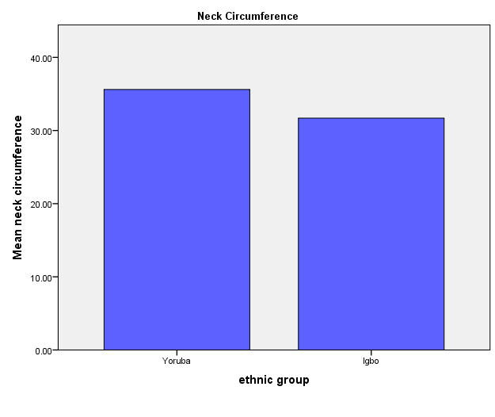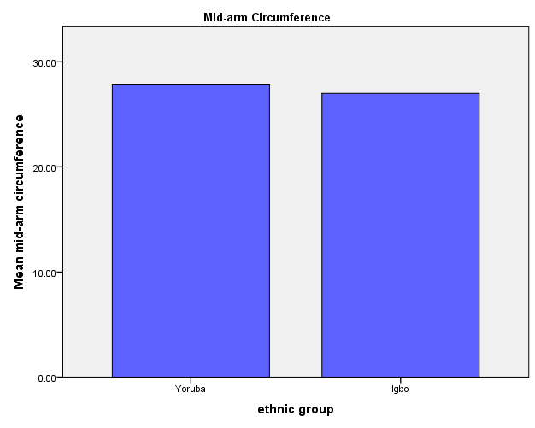

Fig 1. Showing the graph of anthropometric parameters of the neck and mid-arm circumferences of Yoruba and Igbo ethnic groups.

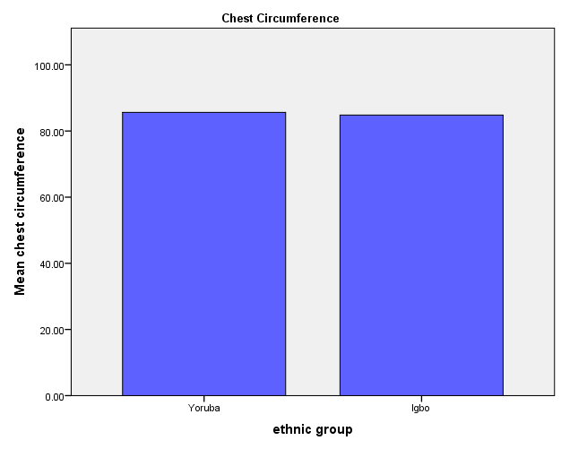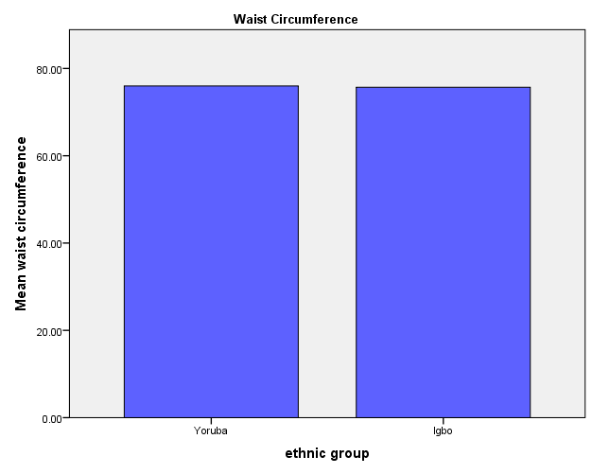

Fig 2. Showing the graph of anthropometric parameters of the chest and waist circumferences of Yoruba and Igbo ethnic groups.

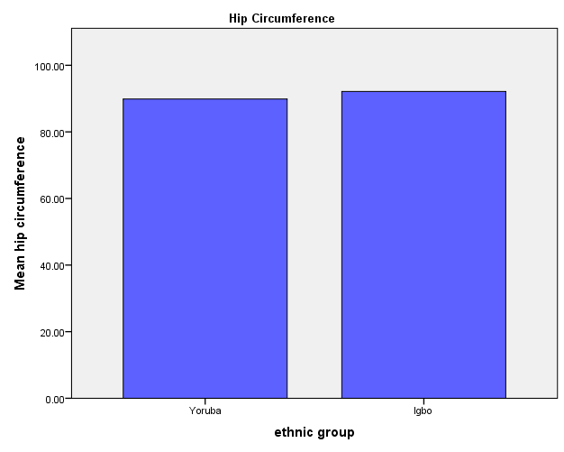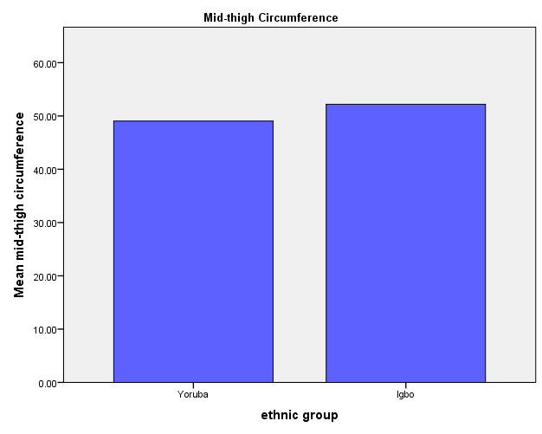

Fig 3. Showing the graph of anthropometric parameters of the hip and mid-thigh circumferences of Yoruba and Igbo ethnic groups.

**4. Discussion**

The study evaluated comparative anthropometric circumferential measurement of Yoruba and Igbo ethnic groups in Nigeria by analyzing the neck, mid-arm, chest, waist, hip, and mid-thigh circumferences. The mean anthropometric values of the Yoruba and Igbo ethnic groups reveal slight variations in body measurements, which can be attributed to genetic, dietary, and lifestyle factors. The neck circumference of the Yoruba group was 33.67±3.17 cm, and that of the Igbo group was slightly higher at 33.88±3.11 cm, suggesting minimal differences in neck structure, which is in line with a study done by Hingorjo et al., [15] among dental students, where the mean value of neck circumference was 35.56±2.77cm.

Mid-arm circumference showed a notable differences, with the Yoruba at 27.44±3.43 cm and the Igbo at 28.32±3.37 cm, which agreed with previous study of Okoh and Fawehinmi, [16] on Ijaws of Southern, Nigeria where the mean value of mid-arm circumference was 27.24±2.26 and Omotayo et al., [17] om medical students at the university of Lagos, Nigeria where the mean value of mid-arm circumference was 26.47±1.92 which could be possibly reflecting slight variations in muscle mass or body composition due to differences in diet and physical activity, according to Hughes et al.,[18].

The chest circumference was 85.24±5.51 cm for the Yoruba and 87.55±5.58 cm for the Igbo, which concur with Omotayo et al., [17], where the mean value of chest circumference was 84.31±3.71cm, but it shows a bit higher in a study done by Okoh and Fawehinmi, [16] (94.79±8.78cm). Therefore, suggesting that the Igbo group may have a slightly broader chest, which could be influenced by lung capacity, ribcage structure, or overall body frame, according to Rabbany et al.,[19] on the biomechanics of the respiratory.

Waist circumference values were quite close, with the Yoruba at 75.84±8.45 cm and the Igbo at 76.54±7.55 cm, indicating similar abdominal fat distribution, which is in line with the studies of Irozulike et al., [20], Omotayo et al., [17], and Asiwe et al., [21] but disagreed with Okoh and Fawehinmi, []. Hip circumference showed almost no difference, with the Yoruba at 90.99±5.45 cm and the Igbo at 90.93±5.29 cm, suggesting a shared genetic predisposition in lower-body structure, which is in line with Irozulike et al., [20], and Asiwe et al., [21] but contradicts Omotayo et al., [17].

However, mid-thigh circumference was larger in the Igbo group (52.34±6.38 cm) compared to the Yoruba (50.62±5.98 cm), and this agreed with Okoh and Fawehinmi [16], which may reflect differences in lower-body muscle mass or fat distribution. These slight variations in anthropometric measurements suggest that while both ethnic groups share many similarities in body composition, factors such as genetics, nutrition, and lifestyle contribute to the observed differences.

Sexual differences were observed between the ethnic groups, except in chest and waist circumferences in Yoruba and chest circumference in Igbo, receptively. Anthropometric circumferential differences between the Yoruba and Igbo ethnic groups have shown that all parameters were statistically significant except chest and waist circumferences. This can be attributed to lifestyle, dietary habits, and physical activity. Additionally, genetic factors may play a role in determining body proportions, with certain traits being more conserved across ethnic groups despite overall morphological differences. Furthermore, cultural practices related to clothing, body image, and nutrition, such as in the Yoruba diet like amala, ewedu, and gbegiri and in Igbo diet like akpu, ede, and ofe onugbu might contribute to the observed similarities in chest and waist circumferences, as both groups share some common socio-cultural influences. Therefore, while anthropometric measurements highlight ethnic variations, some parameters remain consistent, likely due to genetic, environmental, and lifestyle factors.

**5. CONCLUSION**

In conclusion, comparing the mean anthropometric values between the Yoruba and Igbo ethnic groups reveals slight variations in body measurements, though overall, both groups exhibit similar physical characteristics. These findings highlight that while both ethnic groups have comparable body proportions, minor differences may arise due to genetic diversity, environmental influences, and individual lifestyle variations.

**CONSENT AND ETHICAL APPROVAL**

Ethical approval was obtained from the Research Ethics Committee of the University of Port Harcourt, Port Harcourt, Nigeria (UPHCEREMAD/REC/MM/91/046). All subjects were adequately informed about the study procedure. They gave their consent in writing.

**COMPETING INTERESTS**

Authors have declared that no competing interests exist.

Disclaimer (Artificial intelligence)

Option 1:

Author(s) hereby declare that NO generative AI technologies such as Large Language Models (ChatGPT, COPILOT, etc.) and text-to-image generators have been used during the writing or editing of this manuscript.

**REFERENCES**

1. Irozulike FC, Uchechukwu CG, Nwofor PN, Filima PL, Selekekeme TB. Assessment of Earlobe Patterns and Ear Shapes in Hausa Ethnic Group of Nigeria: Implications for Forensic and Clinical Applications. Asian Journal of Medical Principles and Clinical Practice. 2024 Dec 12:502-508.
2. Fawehinmi HB, Okoh PD, Oghenemavwe LE, Ebieto CE, Irozulike FC, Stature and Sex Estimation Using Anthropometric Parameters in the Yoruba Ethnic Group of Nigeria: Implications for Forensic and Clinical Applications. Asian Journal of Medical Principles and Clinical Practice. 2025 Feb. 2:47-57.
3. Fawehinmi HB, Oghenemavwe LE, Okoh PD, Ebieto CE, Irozulike FC, Asiwe N. Stature and Sex Estimation Using Some Linear Anthropometric Parameters: A Cross-Sectional Study of the Igbo Ethnic Group of Nigeria: Implications for Forensic and Clinical Applications. Asian Journal of Medical Principles and Clinical Practice. 2024 Nov. 2:482-489.
4. Borga M, West J, Bell JD, Harvey NC, Romu T, Heymsfield SB, Dahlqvist Leinhard O. Advanced body composition assessment: from body mass index to body composition profiling. Journal of Investigative Medicine. 2018 Jun;66(5):1-9.
5. Ogbu IS, Obeagu EI. Anthropometric Parameters in Health and Diseases: A Review. Elite Journal of Public Health. 2024;2(1):62-70.
6. Andreoli A, Garaci F, Cafarelli FP, Guglielmi G. Body composition in clinical practice. European journal of radiology. 2016 Aug 1;85(8):1461-8.
7. Naimo MA, Varanoske AN, Hughes JM, Pasiakos SM. Skeletal muscle quality: a biomarker for assessing physical performance capabilities in young populations. Frontiers in Physiology. 2021 Aug 5;12:706699.
8. Pawlak A, Ręka G, Olszewska A, Warchulińska J, Piecewicz-Szczęsna H. Methods of assessing body composition and anthropometric measurements–a review of the literature. Journal of Education, Health and Sport. 2021 Apr 8;11(4):18-27.
9. Sutton L, Stewart A. Body composition in sport, exercise and health. Abingdon: Routledge. 2012.
10. Okoro CF. Democracy and Good Governance in a multi-ethnic society: Nigeria as a Case Study. A grassroot study of Igbo, Yoruba, and Hausa-Fulani in Nigeria 1999-2011.
11. Capocasa M, Volpi L. The ethics of investigating cultural and genetic diversity of minority groups. Homo. 2019 Nov 11;70(3):233-44.
12. Reed HE, Mberu BU. Ethnicity, religion, and demographic behavior in Nigeria. The international handbook of the demography of race and ethnicity. 2015:419-54.
13. Adeline NU, Ugboma EJ, Williams EE. Public Perception of Radio Programmes on Parental Sexual Abuse of Children: A Study of Residents of Owerri Metropolis. *Asian Journal of Advanced Research and Reports.*2024 Augst 7; 18(8) 191-202.
14. Okoh PD, David LK, Fawehinmi HB, Ebieto CE, Amadi MA and Irozulike FC. Discriminant and Multivariate Regression Analysis for Estimating Sex and Stature Model Using Upper Limb Anthropometric Measurements among the Yoruba Ethnic Group of Nigeria. Asian Journal of Advanced Research and Reports. 2025 Mar.26,19(4):41-48
15. Hingorjo MR, Qureshi MA, Mehdi A. Neck circumference as a useful marker of obesity: a comparison with body mass index and waist circumference. JPMA-Journal of the Pakistan Medical Association. 2012 Jan 1;62(1):36.
16. Okoh PD, Fawehinmi HB. Body Circumferential Anthropometric Features of Ijaws of Southern Nigeria. Journal of Advances in Medicine and Medical Research. 2020 March 28;32(4): 66-71
17. Omotayo HA, Agbara JO, Nafiu T, Omotayo MT, Ibeabuchi NM. The anthropometric indices of physical development in medical students at the University of Lagos, Nigeria. Journal of Experimental and Clinical Anatomy. 2024 Dec 31;21(2):373-6.
18. Hughes VA, Frontera WR, Wood M, Evans WJ, Dallal GE, Roubenoff R, Singh MA. Longitudinal muscle strength changes in older adults: influence of muscle mass, physical activity, and health. The Journals of Gerontology Series A: Biological Sciences and Medical Sciences. 2001 May 1;56(5):B209-17.
19. Rabbany SY, Rooney DM, Merna N. Biomechanics of the Respiratory System. In Fundamentals of Biomechanics: From Cells to Organ Systems 2024 Dec 21 (pp. 225-243). Cham: Springer Nature Switzerland.
20. Irozulike CF, Ekezie J, Godson KP, Akudu LS, Emeka-Obi OR, and Filima PLAnthropometric Health Assessment of the Igbo Ethnic Group in Nigeria: A Study of BMI and Waist to Hip Ratio. Asian Journal of Medical Principles and Clinical Practice. 2025 Feb 24 ;8(1):77-83.
21. Asiwe, N., Irozulike, F. C., Wariboko, L. I., & Adheke, O. M. (2023). Health assessment of the Ikwerres and Okrikas ethnic group of Rivers State, Nigeria: Using body mass index and waist-to-hip ratio. *Journal of Complementary and Alternative Medical Research, 23*(2), 27-35.