Expanding Distribution, Taxonomy and Morphological Descriptions of the collected fish species Halieutaea indica Annandale & Jenkins, 1910 (Indian Handfish) from the Jafrabad fish landing center, Arabian Sea, Northwest coast of India

Abstract
This study documents the taxonomy and morphology of Halieutaea indica specimens collected from the Gujarat coast, of India. Two specimens (total lengths: 7.6 cm and 10.3 cm) were obtained from a trawler operating from the Jafrabad Fish Landing Center and identified using original species descriptions. A distinguishing feature of seven inverted rostral spines protecting the mouth was observed. Fresh specimens exhibited yellow pectoral fins with a white band near the tip, further corroborating diagnostic characters. Morphometric parameters, including body proportions, fin lengths, and meristic counts, were measured and compared with existing data from earlier studies. The results align with prior morphological descriptions of H. indica, reinforcing its identification and confirming its presence in Gujarat’s coastal waters. This study contributes to baseline data on the species distribution in the Arabian Sea and supports regional biodiversity documentation in understudied fisheries ecosystems.
Keywords: Anglerfish, Indian Handfish, Ogcocephalidae, biodiversity, meristic counts

Introduction
India hosts an extensive variety of fish species, with 2,822 documented so far. Gujarat plays a notable role in this richness, supporting approximately 306 marine fish species, 23 of which are classified as vulnerable in the IUCN Red List. Additionally, the Zoological Survey of India has reported around 120 freshwater fish species in the state. In total, Gujarat's fish diversity stands at 422 species, representing 14.95% of the country's overall fish population. (Parmar et al., 2024).
Fishes of the order Lophiiformes, commonly known as anglerfishes, exhibit a wide range of body morphologies and adaptations, with species distributed globally across various environments, including shallow and deep waters. This order encompasses 21 families and includes diverse species with unique physical characteristics. One such family, Ogcocephalidae, contains about 75 species across 10 genera. In Indian waters, however, only 11 species from six genera are found: Coelophrys (1 species), Dibranchus (1 species), Halicmetus (1 species), Halieutaea (5 species), Halieutopsis (1 species), and Malthopsis (2 species). The distinctive feature of anglerfishes is their modified first dorsal fin spine, known as the illicium, which extends out from the tip of the snout and serves as a lure to attract prey. These species show remarkable morphological diversity, ranging from globose and spherical to elongated, laterally compressed, or dorso-ventrally depressed shapes (Pietsch, 2009).
The order Lophiiformes exhibits remarkable variation in bathymetric distribution across its constituent families. Among the 21 families analyzed, depth ranges span from shallow coastal waters to abyssal zones, reflecting diverse ecological adaptations. Families such as Brachionichthyidae and Rhycheridae are stenobathic, restricted to shallow waters (0–60 m), while Antennariidae, Histiophrynidae, Tathicarpidae, and Tetrabrachiidae inhabit slightly deeper neritic zones (0–300 m). In contrast, several families demonstrate eurybathic distributions, with Ceratiidae (0–3085 m), Ogcocephalidae (0–3000 m), and Thaumatichthyidae (0–4000 m) occupying expansive vertical ranges spanning mesopelagic to bathypelagic depths. Notably, Melanocetidae exhibits the broadest recorded range (100–6370 m), encompassing both upper bathyal and hadal zones. Families like Gigantactinidae (1000–2300 m) and Oneirodidae (750–2500 m) are predominantly bathypelagic specialists, whereas Chaunacidae (200–2000 m) and Diceratiidae (300–2306 m) occupy intermediate meso-bathyal habitats. The depth range of Lophichthyidae remains undocumented, highlighting a critical knowledge gap. This stratification underscores the ecological plasticity of Lophiiformes, with select families like Himantolophidae (0–1830 m) and Linophrynidae (0–2000 m) bridging multiple depth strata, suggesting adaptive versatility in exploiting niche habitats across the water column (Froese & Pauly, 2025).
Family Ogcocephalidae comprises benthic marine fish species distributed across tropical and subtropical regions. These fishes are primarily found on soft substrates along the continental slope, with most species inhabiting depths ranging from 200 to 1000 meters, while some occur in shallower waters among rocky areas or reefs (Bradbury, 2003). Their diet includes small snails, clams, scallops, worms, crustaceans, and occasionally small fishes. The early life stages, including eggs, larvae, and post-larvae, are pelagic. The post-larvae exhibit a transparent, globular form, sometimes reaching 25 to 30 mm lengths, before undergoing metamorphosis and settling on the seabed (Bradbury, 2003).
Halieutaea indica was originally described by Nelson Annandale and James Travis Jenkins (1910), based on 9 syntypes from the Bay of Bengal, off the Orissa coast, India, northeastern Indian Ocean. The objective of the current study is to identify and describe H. indica from Jafrabad fish landing center, Saurashtra coast of Gujarat.
Materials and Methods
The samples were collected in December 2024 from a trawler boat operating from the Jafrabad fish landing center. The samples were brought to the College of Fisheries Science, Navsari, where they were washed in water to clear the debris. Photographs were taken using a smartphone camera and a Cilika BTP-dualhead microscope, and morphometric parameters were recorded. The specimen was identified using the original descriptions of the species by Annandale and Jenkins (1910). The samples were preserved in 10% formalin and stored in the Aquatic Biodiversity Museum, College of Fisheries Science, Kamdhenu University, Navsari (Accession No: A 22.1.1.1).
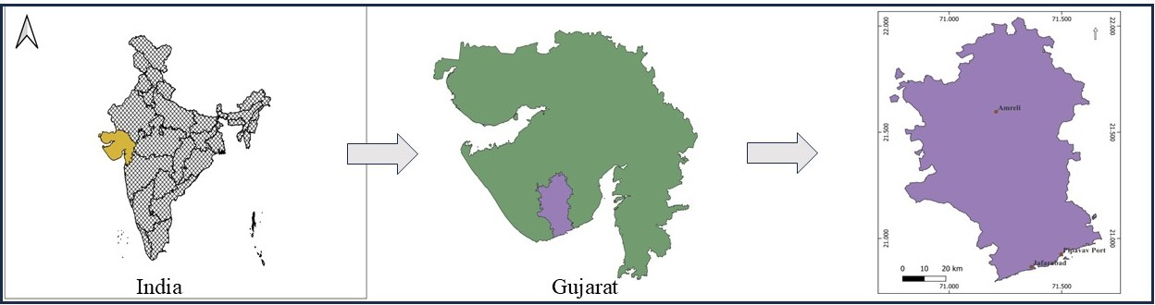
Figure 1: Location of Jafrabad fish landing center (QGIS 3.32.0)
Result and Discussion
Two specimens of H. indica were collected from the Jafrabad fish landing center and their parameters were taken. Table 1 shows the recorded morphometric parameters.
Table 1: Morphometric Parameters of H. indica
Sr. No. | Character | Specimen 1 (cm) | % TL | Specimen 2 (cm) | % TL
 | Total length (TL) | 7.60 | 100.00 | 10.3 | 100.00
 | Standard length | 6.00 | 78.95 | 8.0 | 77.67
 | Dorsal fin length | 0.90 | 11.84 | 0.90 | 8.74
 | Pectoral fin length | 1.70 | 22.37 | 2.60 | 25.24
 | Pelvic fin length | 0.90 | 11.84 | 1.20 | 11.65
 | Anal fin length | 0.90 | 11.84 | 1.10 | 10.68
 | Caudal fin length | 1.60 | 21.05 | 1.20 | 11.65
 | Interorbital space | 1.00 | 13.16 | 0.70 | 6.80
 | Eye diameter | 0.60 | 7.89 | 0.90 | 8.74
 | Disc length | 4.30 | 56.58 | 5.50 | 53.40
 | Disc width | 4.60 | 60.53 | 6.40 | 62.14
 | Tail length | 1.70 | 22.37 | 2.60 | 25.24
 | Mouth length | 1.70 | 22.37 | 2.20 | 21.36
 | Pectoral fin base | 0.50 | 6.58 | 0.80 | 7.77
 | Pelvic fin base | 0.30 | 3.95 | 0.50 | 4.85
 | Anal fin base | 0.70 | 9.21 | 0.90 | 8.74
 | Postorbital length | 6.30 | 82.89 | 8.80 | 85.44
 | Pre-orbital length | 4.50 | 59.21 | 5.10 | 49.51
 | Pre-anal length | 4.70 | 61.84 | 6.20 | 60.19
 | Pre-caudal length | 5.90 | 77.63 | 7.80 | 75.73
Species description: The mouth is horizontal, often arched, with immovable jaws and blunt teeth in the jaws. The mouth is protected with 7 rostral spines hanging upside down above the mouth. The teeth are palatine in a single patch on each side, separated by a wide gap. Teeth on the tip of the tongue are also present (Figure 3). An illicium is housed in a cave-like structure on the tip of the head (Figure 3). The eyes are of moderate size, visible from the dorsal view, and directed antero-dorsally. The width of the eye is about equal to the interorbital space, which equals or slightly exceeds the diameter of the eye. The length and width of the disk are nearly equal. The dorsal surface is covered with numerous strong, sub-equal spines, many of which are bifid, and at the edge, many are trifid. Most of the spines have four roots, projecting freely at the edge of the disk and accompanied by delicate cuticular processes. The anterior extremity of the roof of the tentacular cavity reaches or slightly advances beyond the anterior extremity of the disk, with the cavity’s aperture being vertical and concealed from above. The strong spine on each side of the cavity projects beyond the margin of the disk. Additionally, the superciliary ridge is equipped with strong spines, and the ventral surface is covered with minute, scattered spines.
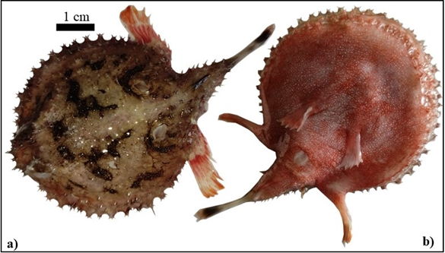
Figure 2: a) Dorsal side b) Ventral side of H. indica

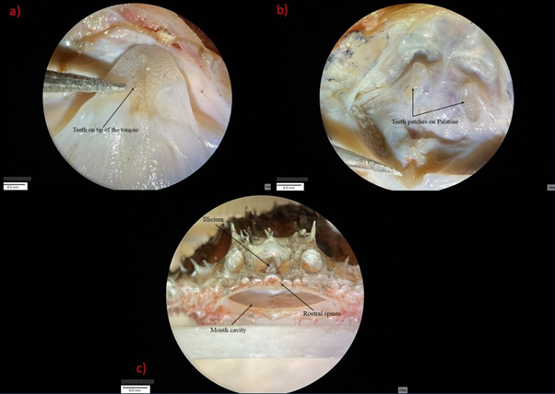
Figure 3: a) Tongue teeth b) Palatine teeth c) Front view of the mouth
Coloration: The dorsal surface is uniform brown with dark brown patches in irregular patterns. The ventral side is pink, and densely covered with numerous minute white spots uniformly distributed across the surface. These spots are significantly smaller and more densely packed than the rosettes observed in leopards (Panthera pardus). The pectoral fins are yellow in fresh specimens, with a white band running across towards the tip of the fin.
Discussion
The species was first described from the Gopalpur, East Coast, India, by Annandale and Jenkins (1910). In following years, it has been reported from various locations, including the Visakhapatnam coast (Krishnan et al., 1993), the Odisha coast (Barman et al., 2007; Mishra et al., 1999), the Gulf of Mannar (Murugan et al., 2011), off the Gujarat coast (Dash et al., 2013), the Kerala coast (Brijesh Kumar, 2015), and the Chennai coast (Silambarasan, 2016). However, apart from the study conducted by Dash et al. (2013), there are no other mentions or records of this species from Gujarat. A comparison of morphometric parameters of this species from various studies, including the present study, is provided in Table 2.
Table 2: Comparison of Morphometric parameters with previous studies
Sr. No. | Parameter | Present study 1 | Present study 2 | Das et al 2013 | Silambarsan et al 2016 | Mahapatro et al 2018 specimen 1 | Mahapatro et al 2018 specimen 2
1 | Total length (T.L.) | 100.00 | 100.00 | 100.00 | 100.00 | 100.00 | 100.00
2 | Dorsal fin length | 8.74 | 11.84 | 9.64 | 11.11 | 9.64 | 6.67
3 | Pectoral fin length | 25.24 | 22.37 | 19.28 | 23.61 | 31.33 | 25.33
4 | Pelvic fin length | 11.65 | 11.84 | 18.07 | 18.06 | 15.66 | 10.67
5 | Anal fin length | 10.68 | 11.84 | 14.46 | 11.11 | 16.87 | 12.00
6 | Caudal fin length | 11.65 | 21.05 | 24.10 | 9.72 | 22.89 | 14.67
7 | Inter orbital space | 6.80 | 13.16 | 6.02 | 12.50 | 8.43 | 5.33
8 | Eye diameter | 8.74 | 5.26 | 6.02 | 6.94 | 8.43 | 6.67
9 | Disc length | 53.40 | 56.58 | 50.60 | 77.78 | 54.22 | 54.67
10 | Disc width | 62.14 | 60.53 | 66.27 | 81.94 | 66.27 | 66.67
11 | Tail length | 25.24 | 22.37 | 49.40 | 29.17 | 49.40 | 45.33
12 | Mouth cavity width | 21.36 | 22.37 | 27.71 | 29.17 | 26.51 | 18.67
Conclusion:
The present study reports the occurrence of Halieutaea indica from the Jafrabad fish landing Center on the Saurashtra coast, further confirming its distribution along the Gujarat coast. Previously, the species was recorded from Okha Fishing Harbour, Gulf of Kachchh northwest coast of Gujarat, and this record strengthens existing knowledge of its presence in the Gujarat region, and provides detailed morphological descriptions of H. indica. This finding contributes to a better understanding of its distribution in Indian waters, emphasizing the need for further studies on its population status, habitat preferences, and fishery significance along Gujarat’s coastline.

Disclaimer (Artificial intelligence)
Option 1:
Author(s) hereby declare that NO generative AI technologies such as Large Language Models (ChatGPT, COPILOT, etc.) and text-to-image generators have been used during the writing or editing of this manuscript.

References
Annandale, N., & Jenkins, J. T. (1910). Memoirs of the Indian Museum (Vol. 3). Manager of Publications, Govt. of India Press.
Barman, R. P., Mishra, S. S., Kar, S., Mukherjee, P., & Saren, S. C. (2007). Marine and estuarine fish fauna of Orissa. Records of the Zoological Survey of India, Occasional Paper No. 260.
Bijukumar, A., & Raghavan, R. (2015). A checklist of fishes of Kerala, India. Journal of Threatened Taxa, 7(13), 8036–8080. https://doi.org/10.11609/jott.2004.7.13.8036-8080
Bradbury, M. G. (2003). Family Ogcocephalidae Jordan 1895—Batfishes. California Academy of Sciences Annotated Checklists of Fishes, 17, 1–17.
Dash, S. S., Dash, G., Koya, M. K., Sreenath, K. R., Pradeep, P., & Kamaliya Kiran, R. (2013). First record of Indian hand fish Halieutaea indica Annandale & Jenkins, 1910 from Gujarat. Marine Fisheries Information Service T&E Series, 216, 15.
Froese, R., & Pauly, D. (Eds.). (2024). Halieutaea indica. In FishBase. Retrieved October 1, 2024, from https://fishbase.mnhn.fr/summary/10332
Krishnan, S., & Mishra, S. S. (1993). On a collection of fish from Kakinada-Gopalpur sector of the east coast of India. Records of the Zoological Survey of India, 93(1–2), 201–240.
Mahapatro, D., Panigrahy, R. C., Panda, S., Karna, S. K., Mishra, R. K., Mishra, S. S., & Mohanty, S. K. (2018). New distributional record of Halieutaea indica (Lophiiformes: Ogcocephalidae) from Chilika lagoon, India. Indian Journal of Geo-marine sciences 47(08):1594-1600.
Mishra, S., Gouda, R., Nayak, L., & Panigrahy, R. C. (1999). A checklist of the marine and estuarine fishes of south Orissa, East Coast of India. Records of the Zoological Survey of India, 97(3), 81–90.
Murugan, A., Dhanya, S., Sarcar, A. B., Naganathan, V., Rajagopal, S., & Balasubramanian, T. (2011). Fishery biology, demography of three spotted seahorse, Hippocampus trimaculatus inhabiting Gulf of Mannar region, Southeast coast of India. Indian Journal of Geo Marine Sciences, 40(3), 411–423.
Parmar, J. N., Borichangar, R. V., Kardani, H. K., Vyas, U. D., & Kotadiya, D. P. (2024). First record of a rare species Atlantic triple tail, Lobotes surinamensis (Bloch, 1790) from the northwest coast of India. Biological Forum – An International Journal, 16(3), 237–242.
Pietsch, T. W. (2009). Oceanic anglerfishes: Extraordinary diversity in the deep sea. University of California Press.
Silambarasan, K., Sujatha, K., Sundaramanickam, A., Rajalakshmi, E., & Senthilkumaar, P. (2016). First record of Indian hand fish Halieutaea indica Annandale & Jenkins, 1910 from Chennai Coast, Tamil Nadu, India. Indian Journal of Geo Marine Sciences, 45(7), 882–884.

