*Original Research Article*

Entrepreneurial Potential of Urban and Peri-Urban Agri Enterprises: A Multidimensional Analysis

.

ABSTRACT

|  |
| --- |
| Urban and peri-urban agriculture is rising as one of the major sectors in India, spurred by increasing urbanization, food security concerns, and entrepreneurial prospects. The study was conducted in this backdrop to assess the entrepreneurial potential of urban and peri-urban agri enterprises in the Central region of Kerala in terms of the multidimensions such as scaling readiness, profitability, product diversification strategy, marketing competence, employment generation, capacity utilization and ecological sustainability. Using Principal Component Analysis, the study identified two major components: strategic growth orientation (driven by marketing competence, employment generation, scaling readiness and product diversification strategy) and green innovation (highlighting ecological sustainability) as the pillars of entrepreneurship development in the urban and peri-urban scenarios. The study also highlighted that marketing competence as the most significant dimension while ecological sustainability had the least impact on the entrepreneurial potential. The Entrepreneurial Potential Index (EPI) analysis revealed that a majority of urban and peri-urban agri enterprises (66%) had a medium level of entrepreneurial potential. Also, significant differences in the entrepreneurial potential were observed among the three major categories of enterprises; with value-addition firms having the highest mean EPI, followed by mushroom enterprises and aquaponics with the lowest mean EPI, underscoring the prospects for development in these sectors. The study highlights the need for adopting strategies to enhance marketing competence of agri enterprises by focusing on branding, labelling, and packaging. Use of skilled employees, innovation readiness and multiple product development would also help to achieve a resilient and competitive urban agripreneurial ecosystem in the State. |

*Keywords: [Urban and peri-urban agriculture, agripreneurship, entrepreneurial potential, entrepreneurial ecosystem, Principal Component Analysis]*

1. INTRODUCTION

Due to rapidly evolving society and economic liberalization, the agricultural sector in India has been experiencing substantial change with growing recognition among farmers, researchers, and policy makers on the necessity for entrepreneurship development in agriculture to boost production, adapt to market fluctuations, and adhere to environmental standards (McElwee, 2008 and Pyysianinen et al., 2006). Entrepreneurship development could be considered as growth engine and driving factors for economic prosperity and employment generation, resulting in poverty reduction through advancements in the nutrition, health, and food security standards of the country (Uplaonkar and Biradar, 2015).

Urban agriculture, is an industrialised, market-oriented agriculture, which has access to developed markets, information and transportation networks of international cities (Agarwal et al., 2021). Agripreneurship through encouraging innovativeness and productivity, it contributes to the national economy such as lowered food prices with higher profitability for farmers and advanced food security standards (Sah et al., 2009).

The COVID-19 pandemic had made a positive impact on the agriculture’s potential in terms of employment and increased number of agribusiness start-ups. Agribusiness has grown significantly in Kerala in particular, with government assistance being essential. Following the pandemic, a number of agribusinesses have formed that concentrate on processing, retailing of agricultural products, mechanization and agricultural input supply.

At present, almost 56.9 per cent of the eight billion world population is living in urban areas and by 2050, it will reach up to nearly 70 per cent. While in India, 35.87 per cent of total population currently lives in urban areas and it may project up to 675 million people by 2035, contributing to 43.2 per cent of the total Indian population. Almost 180 million of rural population are living near to the 70 largest urban centres in India, which may increase up to 210 million by 2030 (UN HABITAT-2022).

With the increasing urban population, people face constraints such as no clean and quality food, lack of greenery and fresh air, fresh water scarcity, improper waste management etc. Thus, country needs to tackle this issue as early as possible to overcome the challenge of meeting the needs of nutritional security and achieving sustainable urban development,

The urban population in Kerala has been increased to nearly half of the total population, while the population was only 16 per cent in 1971. Kerala has experienced a significant withdrawal of labourers from the agricultural sector because of the rapid urbanization process, resulting in a fall in the sector’s proportion of overall workforce participation to 22.56 per cent in 2020-21. Kerala lacks a distinct rural-urban demarcation, making urban agriculture and related enterprises feasible. The Government of Kerala had declared 2022-2023 as the “Year of Enterprises” in an attempt to promote and support the development of entrepreneurship throughout the State (GOK, 2023).

Urban agriculture in Kerala is in an emerging state, which includes agri enterprises such as value-addition, mushroom farming and aquaponics have become more popular in the State. Due to the more consuming nature of urban population than rural, limited land availability and high demand for premium agricultural products, entrepreneurs have the chance to create revolutionary agribusiness concepts. This indicates the increasing potential for urban and peri-urban agricultural enterprises.

With this backdrop, the present study was undertaken to assess the multidimensional analysis of the entrepreneurial potential of the urban and peri-urban agri enterprises in Kerala, with special reference to the central part of the State. Entrepreneurial potential is operationalized in the study as the perceived desirability, feasibility and propensity of the enterprises in the urban and peri-urban areas to evolve as a sustainable business. The entrepreneurial potential of urban and peri-urban agri enterprises were assessed based on social, economic and ecological dimensions.

2. RESEARCH methodologY

The study was conducted during 2023-24 in the Ernakulam and Thrissur districts of Central Kerala, which were purposively selected based on the criteria that these districts have maximum urban and peri-urban populations. Samples were collected from Kochi and Thrissur corporations and nearby municipalities. Based on the data on agri enterprises that were established within the last three to ten years, 50 enterprises were selected from each district among the three major categories of agri enterprises such as value addition (20 units), mushroom enterprises (15 units) and aquaponics (15 units) to constitute a total sample size of 100. The primary data were collected through personal interviews using a well- structured interview schedule.

The entrepreneurial potential of urban and peri-urban agri enterprises were assessed under multidimensions such as scaling readiness, profitability, product diversification strategy, marketing competence, employment generation, capacity utilization and ecological sustainability.

The study operationalised scaling readiness in view of the robustness of the team, technology infrastructure and financial ability to evaluate the readiness for implementation of effective innovation in future. Scaling readiness was determined as the product of innovation readiness and innovation use (Sartas et al., 2020). The scaling readiness of innovations in the study was assessed using the scale developed by Sartas et al. (2020) with suitable modifications.

Profitability is defined as the capacity of an enterprise to generate profit concerning its costs, capital, and expenses. It reflects the effectiveness and efficiency of an enterprise in using its resources to generate revenue that exceeds its expenditures (Filatov, 2022). Profitability was analysed using the discounted Benefit Cost Ratio.

Product diversification strategy refers to an approach that entails deliberate diversification of its product portfolio to include new and unique offerings, to reduce dependency on a single product or market segment and take advantage of growth prospects. Thus, it might indicate the profitability and sustainability of the enterprises (Manrai et al., 2014). It was assessed based on the summated measure of product diversification strategy statements, range of products and number of products marketed.

The marketing competence of an enterprise is operationally defined in the study as the strategic development and implementation of branding strategies to create a unique brand identity; choosing and utilizing suitable packaging materials and technologies to improve the product's efficiency and appeal; developing and implementing compliant and informative labelling; debuting product promotion centred initiatives; acquiring and displaying relevant certifications to establish credibility and trust; and strategically positioning products in the market to gain a competitive advantage. Olazo (2023) reported that marketing competence had a significant impact on sustainable competitive advantage which could be gained through marketing innovation.

Employment generation is operationally defined as the total number of man-days that an enterprise will provide to the different types of workforce, assessed based on the type of employees, type of employment (nature of work and nature of skill) and the number of man-days generated by an enterprise. Veeranjaneyulu et al*.,* (2017) reported that agripreneurship had the potential to promote economic development and income generation through creating employment generation opportunities and resulting in poverty reduction.

Capacity utilization is operationally defined as the extent to which an enterprise effectively utilises its potential resources to achieve sustained production efficiency. Capacity utilization acts as one of the indicators of the performance potential in a particular industry (Ray, 2013).

Capacity utilization of the enterprises was assessed based on the scale adopted by Vinayakam (1998) with suitable modifications.

Ecological sustainability is operationally defined as how an enterprise uses natural resources, recycles, and reduces waste during the manufacturing and sales process. The ecological sustainability of an enterprise was measured using a schedule that was developed based on the standard indicators of the ecological sustainability index developed by Ponnusamy (2006) with suitable modifications. The ecological sustainability of urban and peri-urban agri enterprises was assessed in terms of meeting quality standards, waste management, Good Manufacturing Practices, labelling standards, eco-friendly packaging, use of renewable energy, internal inputs utilization, by-product utilization and green innovations. Ivashkiv et al. (2020) in their research on sustainability of agri enterprises pointed out that incorporating environmental responsibility into agricultural businesses could improve their financial performance.

In the study, Principal Component Analysis was used to identify the major components that significantly contributed to the entrepreneurial potential of urban and peri-urban agri enterprises and also to assess the Entrepreneurial Potential Index (EPI).(DELETE)

**2.1 Principal Component Analysis (PCA)**

In the study, Principal Component Analysis was used to identify the major components that significantly contributed to the entrepreneurial potential of urban and peri-urban agri enterprises and also to assess the Entrepreneurial Potential Index (EPI).

**2.1.1 Computation of Entrepreneurial Potential Index**

An overall entrepreneurial potential index has been obtained for each enterprise by assigning suitable weights and relevant equations. Data on the dimensions were collected and normalisation of the variables was done according to the correlation with the objective of grouping using the following formula.

Formula for normalization = $\frac{Actual Value-Minimum Value}{Maximum Value-Minimum Value}$

**2.1.2 Weightage for entrepreneurial potential dimensions**

For assigning weights, principal components having eigenvalue greater than one were selected where eigenvalues represent the variations in the principal components. Through the analysis of data using PCA, weightage has been computed for all the dimensions of entrepreneurial potential as the sum product of eigenvalue with its respective absolute value of factor loadings using the following formula.

$W_{i }$**=Σ│ $L_{ij}$ │ $E_{j}$**

where,

$W_{i}$ is the weight of $i^{th}$ indicator

$E_{j}$ is the eigenvalue of the $j^{th}$ factor or Principal Components

$L_{ij}$ is the loading value of the $i^{th}$ unit of grouping on $j^{th}$ factor

i = 1,2,3,…..n indicators

j = 1,2,... n Factors or Principal Components (PCs)

Finally, a composite index is computed for each enterprise and is calculated by dividing the sum product of normalized scores and their respective assigned weights with the sum of all weightages as shown in the following formula.

**Entrepreneurial Potential Index = $\frac{\sum{X_{i}W_{i}}}{\sum{W_{i}}}$**

Where,

$X_{i}$ is the normalized value of the $i^{th}$ indicator

$X_{i}W_{i}$ = sum of normalized scores multiplied by weightage of the components

The Entrepreneurial Potential Index(EPI)was calculated for all enterprises using the given formula. The entrepreneurial potential of enterprises was categorised into Low, Medium and High based on mean and standard deviation.

The non -parametric Kruskal-Wallis H test was used to compare the entrepreneurial potential of different categories of urban and peri-urban agri enterprises and also to determine whether there is any statistical difference between various entrepreneurial potential dimensions within in an enterprise.

3. results and discussion

**3.1 Major Components of Entrepreneurial Potential**

Principal Component Analysis was carried out to identify the major components that contributed to the entrepreneurial potential of urban and peri-urban agri enterprises and the results were depicted in Table 1. Out of the seven components, the analysis had identified two major components that accounted for 76.37 per cent of total variance, which emphasized their significant role in determining the entrepreneurial potential. The scree plot graph in Fig. 1 showed a flattening trend after the second component, which suggested concentrating on the first two components as the contributions were negligible beyond these two. The identified major components were then accounted for further analysis, and the rotated component matrix is presented in Table 2.

Results from Table 2 revealed that the first component that explained 61.7 per cent variance, could be named “Strategic growth orientation” as it emphasises entrepreneurial orientation driven by proficiency in marketing, employment generation, scalability, and product diversification approaches. Similarly, Component 2, which contributed to 14.67 per cent of the variance, could be named “Green innovation” as it emphasises environmental stewardship and innovative approaches that support long-term sustainability.

**Table 1. Components of entrepreneurial potential**

|  |  |  |  |
| --- | --- | --- | --- |
| **Components** | **Eigenvalue** | **Variance (%)** | **Cumulative variance(%)** |
| 1  2  3  4  5 | 4.32  1.03  0.69  0.42  0.27 | 61.7  14.67  9.8  5.98  3.78 | 61.7  76.37  86.17  92.15  95.93 |

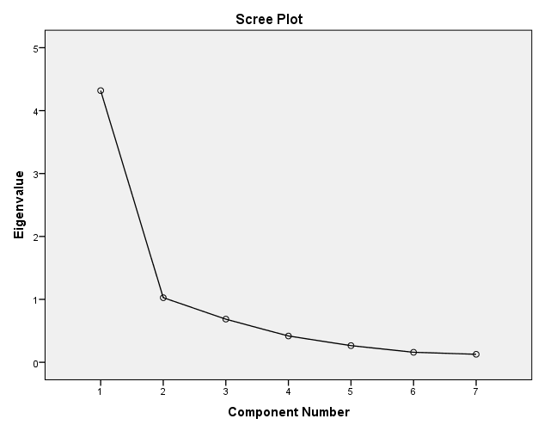

**Fig. 1 Scree plot graph on components of entrepreneurial potential**

**Table 2. Rotated component (varimax) matrix of dimensions of entrepreneurial potential**

|  |  |  |
| --- | --- | --- |
| **Entrepreneurial potential dimensions** | **Component 1** | **Component 2** |
| Scaling readiness  Profitability  Product Diversification strategy  Marketing competence  Employment generation  Capacity utilization  Ecological sustainability | 0.88  0.67  0.87  0.93  0.92  0.59  0.04 | 0.2  0.28  0.19  0.09  0.01  0.56  0.94 |

The weightage of dimensions of entrepreneurial potential of urban and peri-urban agri enterprises have been computed and the results are presented as Fig. 2. The results revealed that marketing competence (4.11) had the highest weightage, which underscored the significance of proficient marketing tactics in influencing the entire entrepreneurial potential of these enterprises. Thus, the results were in line with the observations of Olazo (2023) that emphasized marketing competency had a substantial impact on sustained competitive advantage as a driving factor of business development, product diversification and development of a unique brand identity.

Scaling readiness (3.98), employment generation (3.97), and product diversification strategy (3.93) also had significant weightages, suggesting that enterprises that concentrate on the upscaling based on innovation readiness and innovation use, workforce development, and a variety of product lines are more likely to succeed. Thus, the results were in conformity with the reports of Caputo et al. (2020) and Benedek (2021).

The moderate weightage of profitability (3.17) suggested that despite being an indicator of economic efficiency of enterprises, entrepreneurial success is not solely dependent on immediate financial gains. Similarly, the moderate weightage of capacity utilization (3.11) indicated that although production capacity is optimally used, it might not be the main factor influencing the overall entrepreneurial potential.

While, ecological sustainability had received the lowest weightage (1.14), indicating that although environmental issues are recognized, they are not currently a major dimension in determining the overall entrepreneurial potential of urban and peri-urban agri enterprises in Kerala. This might be because the majority of these enterprises are still in the early phases of incorporating ecological sustainability practices such as GMP, green innovations etc. into their business, as reported by Ivashkiv et al. (2020). However, studies report that adoption of ecologically sustainable practices and green innovations have the potential in accruing not only the environmental benefits like minimising carbon emission, pollution control, and waste reduction; but also the economic benefits due to cost reduction, image building, reputation and legitimacy of the firm, creating new markets, better performance, and profitability (da Silva et al,2023). Hence, these aspects might become more significant in the future due to the growing focus on green entrepreneurship.

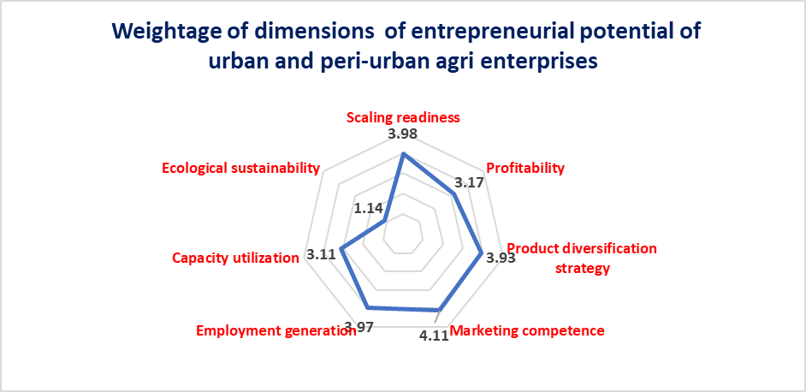

**Fig. 2. Weightage of dimensions of entrepreneurial potential of urban and peri-urban agri enterprises**

**3.2 Entrepreneurial Potential Index (EPI) Analysis**

The distribution of urban and peri-urban agri enterprises based on the entrepreneurial potential index is depicted in Table 3. It is evident from the results that the majority of these enterprises (66%) had a medium level of entrepreneurial potential. This might point to a well-balanced entrepreneurial ecosystem with a variety of steady and promising enterprises. The enterprises with a high level of entrepreneurial potential index (19%) might operate as role models for profitable company strategies and tactics that other companies could take inspiration from. The enterprises with a low level of entrepreneurial potential index (15%) might reflect areas in which specific assistance and actions are required to improve these businesses' viability and sustainability.

**Table 3. Distribution of urban and peri-urban agri enterprises based on entrepreneurial potential index (n=100)**

|  |  |  |  |
| --- | --- | --- | --- |
| **Sl.No** | **Entrepreneurial potential index** | **Frequency** | **Percentage** |
| 1  2  3 | Low (<15.93)  Medium (15.93-56.96)  High (>56.96)  Mean =36.44, SD = 20.52 | 15  66  19 | 15  66  19 |

The results from Fig.3 depicted the mean entrepreneurial potential index of different categories of urban and peri-urban agri enterprises. The mean EPI for value-addition enterprises was the highest (53.45), indicating that these enterprises were found to have the most sustainable and financial prospects. This might be due to increased customer demand for processed and ready-to-eat foods, urban market integration, and comparatively higher profit margins that contribute to its scalability in urban settings.

The moderate level of mean EPI for mushroom enterprises (32.95) reflected both their potential and the difficulties they encountered, including input costs, market volatility, and perishability. Despite these obstacles, the growing market for environmentally friendly, high-protein sources indicates that the potential of mushroom enterprises could be improved if effective logistics and storage solutions are provided.

The lowest mean EPI (17.27) was found in aquaponics enterprises, highlighting their lower level of market adoption and penetration. This might be due to constraints like high initial investment and operational costs and insufficient market awareness. However, if appropriate financial and technical support mechanisms are implemented, its sustainability features, like efficient water usage, waste reduction, and integrated plant and fish farming could offer growth prospects. The entrepreneurial potential of aquaponics enterprises might be improved through facilitating training on social media marketing and e-commerce platforms, advanced technologies, organic certification programs, skill development programs, etc. Also, providing financial incentives and encouraging the production of high-value crops and fishes, promoting cooperatives and local partnerships for input supply, promoting farm-to-table partnerships and diversifying the product lines like value-addition and customising the outputs from the aquaponics could also assist in improving the entrepreneurial potential.

The moderate level of mean EPI of urban and peri-urban agri enterprises(36.44) suggested that for the feasibility and sustainability of these enterprises, urban agriculture must be reinforced through infrastructural development, skill enhancement and financial incentives.

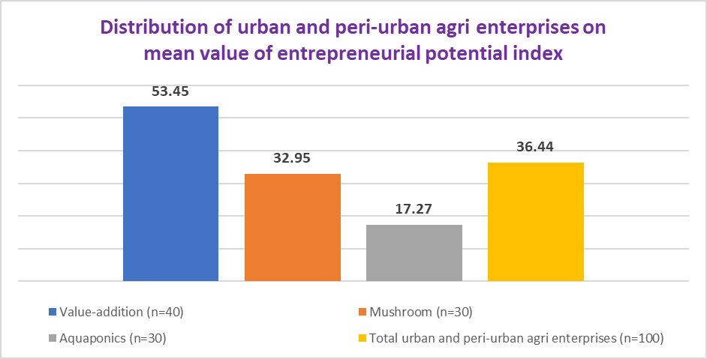

**Fig. 3. Distribution of urban and peri-urban agri enterprises on mean value of entrepreneurial potential index**

**3.3 Comparison of Entrepreneurial Potential of Different Categories of Urban and Peri-Urban Agri Enterprises**

The Kruskal Wallis test statistics results depicted in Table 4, indicated that there was statistically significant differences in the entrepreneurial potential among the different categories of urban and peri-urban agri enterprises which implied that entrepreneurial potential of urban and peri-urban agri enterprises was influenced by the various kinds of activities they engaged in. The mean rank analysis shown in Table 5 indicated that value-addition enterprises had received the highest rank (74.73), followed by mushroom enterprises (46.83) and aquaponics enterprises (21.87). This validates the assertion that aquaponics enterprises need strategic interventions to increase their competitiveness, while value-addition enterprises are more commercially feasible in urban and peri-urban markets.

**Table 4. Kruskal-Wallis test statistics for entrepreneurial potential index**

|  |  |
| --- | --- |
| **Test statistics** | **Values** |
| Chi-square  Df  p value | 57.592  2  0.000 |

**Table 5. Mean ranks of different categories of urban and peri-urban agri enterprises on entrepreneurial potential index**

|  |  |  |  |
| --- | --- | --- | --- |
| **Sl. No** | **Enterprise category** | **Sample size** | **Mean rank** |
| 1  2  3 | Value-addition  Mushroom  Aquaponics | 40  30  30 | 74.73  46.83  21.87 |

4. Conclusion

The results offer insightful information to stakeholders in urban and peri-urban agriculture, including agripreneurs and policymakers. Marketing competence was found to be the major determinant that contributes to the entrepreneurial potential followed by scaling readiness of innovation, employment generation and product diversification strategy of urban and peri-urban agri enterprises, which underscore the necessity of market competitiveness, strong infrastructure, training initiatives, product diversification portfolios and regulations that facilitate the entrepreneurial potential. The ecological sustainability had the least impact on entrepreneurial potential. Thus, sustainable methods should be promoted to prepare urban agriculture for the future.

The provision of capital, business development services, and technology adoption programs should be the primary emphasis of policymakers to assist urban and peri-urban agripreneurs in enhancing the entrepreneurial potential of their enterprises. Financial and entrepreneurial literacy could be improved through promoting training programs in branding, digital marketing and organics certification programs, particularly for mushroom and aquaponics enterprises, that enable them to improve their marketing competence. Additionally, encouraging partnerships among governmental organizations, commercial businesses, and academic institutions could spur innovation and guarantee the long-term viability of urban agriculture.

The study's overall findings highlight the significance of a multifaceted strategy to entrepreneurial development that strikes a balance between sustainability considerations and business growth strategy. The results implied that for better resilience and long-term success, urban and peri-urban agri-enterprises should solve sector-specific difficulties while concentrating on high-impact dimensions like marketing competency and scalability.

**5. Limitations of the study and potential areas for future research**

The study is limited to a particular region in the State of Kerala and only three categories of urban and peri-urban agri enterprises, viz., value- addition, mushroom and aquaponics units were taken under survey. Hence, the findings of the study might not be a precise portrayal of the scenario of urban and peri-urban agri enterprises of the entire Kerala or other states and need to be substantiated with other studies.

Similar studies with the same objectives can be replicated in other areas for drawing valid conclusions. A comparative study of the entrepreneurial potential of various categories of urban and peri-urban agri enterprises apart from value-addition, mushroom and aquaponics could be undertaken. To have an in-depth analysis, case studies of successful agri enterprises might be taken up to understand various factors contributing to their growth.

**DISCLAIMER (ARTIFICIAL INTELLIGENCE)**

Author(s) hereby declare that NO generative AI technologies such as Large Language Models (ChatGPT, COPILOT, etc.) and text-to-image generators have been used during the writing or editing of this manuscript.

References

McElwee, G. (2008). A taxonomy of entrepreneurial farmers. *International Journal of Entrepreneurship and Small Business.* 6(3),465-478. https://doi.org/10.1504/IJESB.2008.019139

Pyysiainen, J., Anderson, A., McElwee, G., and Vesala, K. (2006). Developing the entrepreneurial skills of farmers: some myths explored. [*International Journal of Entrepreneurial Behavior and Research*](https://www.emerald.com/insight/publication/issn/1355-2554)*.* 12 (1),21-39. <https://doi.org/10.1108/13552550610644463>

Uplaonkar, S.S., and Biradar, S.S. (2015). Development of agriculture in India through agripreneurs. *International Journal of Applied Research.* 1(9),1063-1066.

Agarwal, H., Das, D., and Bardhan, S. (2021).Urban agriculture as an entrepreneurial opportunity: case studies from various Indian cities In: Prasad, H. and Gupta, S. (eds), *Entrepreneurship during challenging times: strategies for success and sustenance*. Proceedings of Entrepreneurship Development Cell, Mohanlal Sukhadia University, Udaipur, India. National Press Associates, New Delhi, pp.45-54.

Sah, P., Sujan, D.K., and Kashyap, S.K. (2009). Role of agripreneurship in the development of rural area, Paper presentation in ICARD at Banaras Hindu University, Varanasi.

UN-HABITAT [United Nations-Habitat]. (2022). *World Cities Report 2022*. Envisaging the future of cities. United Nations. 422p. <https://unhabitat.org/sites/default/files/2022/06/wcr_2022.pdf>

GOK [Government of Kerala]. (2023). Economic Review 2022: Vol 2. Kerala State Planning Board, Thiruvananthapuram, 594p.

Sartas, M., Schut, M., Proietti, C., Thiele, G., and Leeuwis, C. (2020). Scaling readiness: Science and practice of an approach to enhance impact of research for development. *Agricultural Systems.* 183(32), 102874-102878. <https://doi.org/10.1016/j.agsy.2020.102874>

Sartas, M., Schut, M., Schagen, V. B., Velasco, C., Thiele, G., Proietti, C., and Leeuwis, C. (2020). Scaling readiness: concepts, practices, and implementation. http//www.scalingreadiness.org/cigar/218.pdf.

Filatov, E. (2021). Analysis of profitability of production of enterprises in the field of transportation and storage of the Irkutsk region. *Transportation Research Procedia. 63*, 518-524. <https://doi.org/10.1016/j.trpro.2022.06.043>

Manrai, R., Rameshwar, R., and Nangia, V. (2014). Interactive effect of diversification strategy on capital structure and corporate performance: an analytical evaluation. *Global Journal of Management and Business Research.* 14(4),75-92.

Olazo, D.B. 2023. Marketing competency, marketing innovation and sustainable competitive advantage of small and medium enterprises (SMEs): a mixed-method analysis. *Asia Pacific Journal of Marketing and Logistics.* 35(4), 890-907.

Veeranjaneyulu, K., BalazziiNaaiik, R.V.T., RavinderNaik, V., and Shankar, M. (2017). Development of agripreneurship as a tool of poverty reduction. *Agricultural Update*. 12(9), 2622-2626.

Ray, S. (2013). A close look into research studies on capacity utilization in India and abroad. *International Journal of Economics, Business and Management.* 2(1), 52-59.https://www.ejournalofbusiness.org/archive/vol2no1/vol2no1_1.pdf

Vinayakam, S.(1998). Entrepreneurial behaviour of agribusiness operators in Kerala. Ph.D thesis, Kerala Agricultural University, Thrissur, 155p.

Ponnusamy, K. (2006). Multidimensional analysis of integrated farming system in the coastal agro ecosystem of Tamil Nadu. Ph.D. thesis, National Dairy Research Institute, Karnal, 221p.

Ivashkiv, I., Kupalova, H., Goncharenko, N., Andrusiv, U., Streimikis, J., Lyashenko, O., Yakubiv, V., Lyzun, M., Lishchynskyi, I., and Saukh, I. (2020). Environmental responsibility as a prerequisite for sustainable development of agricultural enterprises. *Management of Science Letters.* 10(13),2973-2984.https://www.academia.edu/download/63616315/msl_2020_16420200613-84083-1q5tpz4.pdf

da Silva, A.R., Cirani, C.B.S.,Serra, F.A.R., Pigola, A., da Costa, P.R., Scafuto, I.C., Ruas, R.L., and Mazieri, M.R. (2023). Determining factors on green innovation adoption: An empirical study in Brazilian agribusiness firms. *Sustainability*. 15, 6266. <https://doi.org/10.3390/su15076266>

Caputo, P., Zagarella, F., Cusenza, M.A., Mistretta, M., and Cellura, M. (2020). Energy-environmental assessment of the UIA-OpenAgri case study as urban regeneration project through agriculture. *The* *Science of The Total Environment.* 729,138819. doi:10.1016/j.scitotenv.2020.138819

Benedek, Z., Ferto, I., Marreiros, C.G., Aguiar, P.M.D., Pocol, C.B., Cechura, L., Poder, A., Paaso, P., and Bacuks, Z. (2021). Farm diversification as a potential success factor for small-scale farmers constrained by COVID-related lockdown. Contributions from a survey conducted in four European countries during the first wave of COVID-19. *PLoS ONE*. 16(5), e0251715. <https://doi.org/10.1371/journal.pone.0251715>