The effects of dexamethasone on periodontitis and the influence of this disease in development and survival of mice ovarian follicles

ABSTRACT

Aims: To investigate the effects of periodontitis, alone or in combination with dexamethasone treatment, on the growth, viability, and cyclicity of ovarian follicles in mice.
Study design: The animals were divided into four different groups, kept in polyethylene boxes, with eight animals per box.
Place and Duration of Study: It was performed in the Federal University of Ceara, between January 2021 and December 2021.
Methodology: Swiss mice (N=32) were divided into four groups: naive, treatment with dexamethasone, with periodontitis and with periodontitis and treatment with dexamethasone. To induce periodontal disease, 4.0 cotton threads was placed around the lower first molars, over two months, from January to February 2021. Dexamethasone (0.5 mg/kg) was administered intramuscularly, every three days, over two months. After this period, from March to April 2021, the mandibles were decalcified with EDTA and the analysis was carried out in the subsequent months. At the end of treatment, alveolar bone and periodontal attachment losses were evaluated. Furthermore, ovarian follicles were classified as normal or degenerated, as well as primordial, primary, secondary or tertiary follicles.
Results: The ligature on the lower first molar significantly increased (P < 0.0001) the alveolar bone loss in mice that received only saline compared to those in which periodontitis was not induced. Treatment with dexamethasone did not promote significant (P > 0.05) changes in animals in which periodontitis was not induced. Animals with induced periodontitis and those with periodontitis and treated with dexamethasone showed a significant increase in estrous cycle irregularity. Periodontitis, or periodontitis associated with dexamethasone treatment significantly reduced the percentages of normal secondary and tertiary follicles.
Conclusion: Periodontitis significantly increases the degeneration of secondary and tertiary ovarian follicles, while dexamethasone does not influence follicular morphology but contributes to estrous cycle dysregulation.

Keywords: dexamethasone, follicles, ovary, periodontitis

1. INTRODUCTION

Periodontitis is a multifactorial chronic inflammatory disease characterized by progressive destruction of the of the gingiva, periodontal ligament, and supporting alveolar bone (Kwon, Lamster and Levin, 2021). It is a disease with site-specific characteristics which involves a cyclical positive feedback mechanism between the pathogenic microbiota of the biofilm and the host inflammatory response (Pan, Wang and Chen, 2019; Hajishengallis and Chavakis, 2021). The host response to periodontal disease involves the production of cytokines, such as prostaglandins, tumor necrosis factor alpha (TNF-α) and interleukins (IL) (Krejci and Bissada, 2002). Activation of the immune system by increasing levels of circulating pro-inflammatory cytokines (e.g., IL-1 and IL-6) stimulates the secretion of adrenocorticotropic hormone (ACTH) by the pituitary and glucocorticoids (cortisol) by the adrenal gland (Ayub et al., 2010). Synthetic glucocorticoids, such as dexamethasone, are widely used for the treatment of inflammatory diseases (Reichardt et al., 2021). The dexamethasone inhibits the production of some inflammatory cytokines activated by lipopolysaccharides, decreasing macrophage activation and inflammation (Waage and Bakke, 1988; Sasson et al., 2002). However, dexamethasone increased alveolar bone loss in ligature-induced periodontitis in rats (Cavagni et al., 2005). Furthermore, other studies have demonstrated the wide range of side effects induced by prolonged use of dexamethasone, including electrolyte, muscular, metabolic and endocrine disturbances (Freitas e Souza, 2007), apoptosis of immune cells (Torres, Insuela e Carvalho, 2012), and death of ovarian follicles (Sasson et al., 2002; Yuan et al., 2014). Additionally, estrogen and progesterone receptors have already been identified in the gingival tissue and, consequently, these hormones can influence the growth of colonizing microorganisms that are present in periodontal disease (Aufdemorte and Sheridan, 1981; Nakagawa et al., 1994).
Luo et al., (2016) showed that increased levels of endogenous glucocorticoids or its exogenous administration cause a reduction in the production of various hormones, like gonadotropin-releasing hormone (GnRH), follicle-stimulating hormone (FSH) and luteinizing hormone (LH), which negatively affect gametogenesis and female estrous cycle. Recent studies have demonstrated that dexamethasone negatively influences oogenesis during fetal development in humans (Poulain et al., 2012; Hulas-Stasiak, Dobrowolski and Tomaszewska, 2016). It has also been reported that dexamethasone regulates the apoptosis process in granulosa cells of pre-ovulatory follicles and reduces the production of estradiol (Maciel et al., 2001; Yuan et al., 2014). The growth or death of ovarian follicles can be regulated by several intra- and extra-ovarian factors (Andersen et al., 2019), as well as by cytokines arising from inflammatory processes, such as periodontitis (Fortune, 2003). The production of cytokines in the ovary, their detection in the follicular fluid and consequences on development of follicles indicate that these substances can act locally to regulate ovarian activities (Richards and Pangas, 2010; Qiao and Feng, 2011). Among the cytokines, we can highlight TNF-alpha, which is recognized as one of the main regulators of programmed cell death of rat ovarian cells (Kaipia and Hsueh, 1997), and granulosa cells cultured in vitro (Quirk et al., 1998; Matsubara et al., 2000). Thus, this study is based on the hypothesis that cytokines produced in response to periodontitis cause the degeneration of ovarian follicles in female mice. Furthermore, it is believed that treatment with dexamethasone negatively influences the mice estrous cycle, regulates the inflammatory process and increases the resorption of alveolar bone in mice with induced-periodontitis.
According to the World Health Organization, severe periodontal diseases are estimated to affect more than 1 billion cases worldwide (World Health Organization, 2024). A systematic review investigating the association between infertility and periodontal disease found a higher prevalence of periodontal disease in infertility patients compared to controls (Márquez-Arrico et al., 2024) and in another systematic review, it was concluded that patients with Polycystic Ovary Syndrome (PCOS) appear to be more susceptible to developing periodontal diseases than women without the pathology (Márquez-Arrico et al., 2020). These studies highlighted the social importance of periodontal diseases, such as periodontitis, and their potential effects on the female reproductive system, of which the ovarian follicle is a fundamental part. Despite the potential importance of this theme, to our knowledge, there are no studiesinvestigating the relationship between the ovarian follicle activity, periodontal disease and dexamethasone in mice.
To elucidate the existence of a relationship between periodontal disease and ovarian function, the present study aims to investigate the effects of periodontitis alone or associated with dexamethasone treatment on the growth and viability of ovarian follicles in female mice. Furthermore, it aims to investigate whether dexamethasone influences the process of periodontal attachment loss and alveolar bone loss related to periodontitis, and whether it has adverse effects on estrous cycle and on the development and viability of ovarian follicles.
2. material and methods
Animals
The number of animals (n=32) and the experimental protocols were performed in accordance with the guidelines and normative resolutions of the National Council for Control in Animal Experimentation (CONCEA). The experiments were started only after approval by the Ethics Committee on the Use of Animals (CEUA) of the Federal University of Ceara (Approval number: 12/20). The animals were divided into four different groups, kept in polyethylene boxes, with eight animals per box, lined with wood shavings, with free access to filtered water and food. The animals were maintained at an average temperature of 22.0°C, following a 12-hour light-dark cycle.
Assessment of the estrous cycle
All female mice (18 g weight and/or 2 months of age) had their estrous cycle evaluated once a day, during a period of 15 days, between 8 am and 9 am as established by (Marcondes, Bianchi e Tanno, 2002). Vaginal swab slides were stained as described by (Shorr, 1941). According to the cells observed, the stage of estrous cycle was classified as proestrus, estrus, metestrus or diestrus. Only females with a regular cycle, lasting 4 to 5 days, were used to carry out the experiments during a period of 60 days. During this experimental period, mice estrus cycle was evaluated in periods between day 0 and 10, as well as between days 50 and 60. The mice body weight were evaluated at days 0 and 60 in the different treatments study.
Experimental model for inducing periodontitis
Periodontitis-induction was performed, under anesthesia (90 mg/kg ketamine and 10 mg/kg xylazine intraperitoneally administered), by placing ligated with polyester braided cotton thread 4.0 with the knot around the lower first molars (Tavares et al., 2024), over two months, from January to February 2021. In this periodontitis-induced model, the accumulation of microorganisms around the ligature implies the participation of different antigens or pathogen-associated molecular patterns, such as toxins and products of microbial metabolism. The ligatures were checked periodically and repositioned when necessary.

Pharmacological modulation
To investigate pharmacological modulation, the mice were divided into four groups, each with a number of eight animals. In the naïve group (A), health mice were treated with saline solution, while in group B, they were treated intramuscularly with 0.5 mg/kg dexamethasone (CAS number 50-02-2, Sigma). In group C, mice with induced-periodontitis were treated with saline solution, and in group D, mice had periodontal disease associated with dexamethasone treatment. The dose was selected on the basis of a previous study (Cavagni et al., 2005) which showed that a dose of 0.5 mg/kg dexamethasone in Wistar rats had an effect on bone resorption associated with experimental periodontitis. The dexamethasone was diluted with sterile saline solution (0.85% NaCl). The animals were treated at the same time, every three days, for two months. After 60 days, the animals were euthanized with an overdose of ketamine/xylazine. After euthanasia, the ovaries and mandibles were removed for morphometric and histological analysis.

Measurement of alveolar bone loss
After the 60-day experimental period, the animals were euthanized, the mandibles were removed and divided in half, of which the right one was used for morphometric analysis. The hemi mandibles were fixed in buffered formalin (10%) for 24 h. Then, they were kept in 70% alcohol for 4 hours, dissected and stained with 1% aqueous methylene blue to differentiate bone from teeth. To quantify bone resorption, the pieces were photographed and the images were then evaluated using the Image J computer program (Image J 1.44p, National Institute of Health; USA). Bone level was measured between the enamel-cementum junction and the alveolar bone crest. This measure was considered in the present study as the alveolar bone loss in animals in which periodontitis was induced. This area was compared to another previously known area (5 x 5 mm²) (Kurh et al., 2004).

Histopathological analysis of the mandibles
The left hemi mandibles previously fixed in buffered formalin (10%) were demineralized using EDTA solution for 60 days. After this process, they were dehydrated in increasing concentrations of ethanol, cleared with xylene and included in paraffin. Serial sections (7 µm thickness) were stained with hematoxylin and eosin as described (Santos et al., 2021). For quantitative analysis, the Image J software was used on the mesial portion of the second molar to measure the attachment levels from the enamel-cementum junction to the base of the gingival sulcus or periodontal pocket (Sima et al., 2016), to assess attachment loss.

Histological analysis of the ovaries
After the end of the experimental period, the ovaries were collected, fixed in paraformaldehyde, dehydrated in a graded series of ethanol, clarified with xylene and embedded in paraffin wax. For each ovary, 7-μm sections were mounted on slides and stained by the Periodic acid-Schiff (PAS) and hematoxylin method. The slides were examined using a microscope (Nikon) at 100X and 400X magnification. To evaluate the effects of treatments on follicular development, ovarian follicles were classified as primordial (oocyte surrounded by a layer of squamous-shaped granulosa cells), primary (oocyte surrounded by a layer of cubic-shaped granulosa cells), secondary (oocyte surrounded by several layers of cubic-shaped granulosa cells) and tertiary (oocyte surrounded by several layers of cumulus cells and the presence of a well-developed antral cavity). Furthermore, follicles were individually classified as morphologically normal, when an intact oocyte was surrounded by granulosa cells well organized in one or more layers, and which did not have pyknotic nuclei. Degenerated follicles were defined as those with a retracted oocyte, with a pyknotic nucleus and/or surrounded by disorganized granulosa cells, detached from the basement membrane. In total, approximately 200 follicles were evaluated for each treatment. The percentages of normal or degenerated follicles, as well as those of primordial and developing follicles were calculated before and after the experimental protocol. Additionally, the number of corpora lutea present in the ovaries was counted. During the analyses, the researchers did not know which groups were being analyzed. Therefore, a blind evaluation was carried out for the assessment of the estrous cycle, the measurement of alveolar bone loss, the histopathological analysis of the mandibles and the histological analysis of the ovaries.

Statistical analysis
Data on the percentage of normal and degenerated follicles, as well as those of primordial, primary, secondary and tertiary follicles were evaluated by chi-square test (GraphPad Prism 9.0). Data on the percentage of animals in each stage of estrous cycle were also compared by chi-square test. Data of bone loss were assessed for normality of distribution (Kolmogorov-Smirnov test) and compared by analysis of variance (ANOVA) and Tukey test. Data of corpora lutea were compared by analysis of variance (ANOVA) and Kruskall-Wallis test. The results were expressed as mean ± S.E.M and the differences were considered significant when P < 0.05.

3. results

Analysis of mice estrous cycle
The data showed that in both after 10 or 60 days of experiment, health mice and those with induced-periodontitis had the highest percentages of deregulated estrus cycle, but significant differences were seen only after 60 days of treatment between mice with only periodontitis and those with periodontal disease associated with dexamethasone treatment. Only the periodontal disease did not influence estrus cycle (Table 1).

Mice body weight at the beginning and end of the experiments
Mice body in all groups gradually increased between days 0 and 60 (Table 2). Although animals with periodontitis alone or with periodontitis associated with dexamethasone treatment showed a smaller weight gain, no significant differences were observed when compared to the Naïve group.

Table 1. Estrous cycle in the periods between days 0 to 10 and days 50 to 60 in mice from the naive group, treated with dexamethasone and without periodontitis (Dexa), with periodontitis (Perio), or with periodontitis and treated with dexamethasone (Perio + Dexa).
Estrous cycle | Naive (A) | Dexa (B) | Perio (C) | Perio + Dexa (D)
Day 0 to day 10
Normal | 75.0% (6/8)ª | 25.0% (2/8)ª | 71.42% (5/7)ª | 25.0% (2/8)ª
Deregulated | 25.0% (2/8)ª | 75.0% (6/8)ª | 28.58% (2/7)ª | 75.0% (6/8)ª
Day 50 to day 60
Normal  Deregulated | 62.5% (5/8)^{ab}  37.5% (3/8)^{ab} | 28.58% (2/7)^{ab} 71.42% (5/7)^{ab} | 85.71% (6/7)^{b}  14.29% (1/7)^{b} | 12.5% (1/8)^{ac}  87.5% (7/8)^{ac}
Data on the percentage of animals in each stage of estrous cycle were also compared by chi-square test (N = 8 mice per treatment). a, b, c: different letters indicate statistically significant differences (P < 0.05).

Table 2. Body weight (grams) in mice from the naive group, treated with dexamethasone and without periodontitis (Dexa), with periodontitis (Perio), or with periodontitis and treated with dexamethasone (Perio + Dexa) on days 0 and 60.
Body weight | Naive (A) | Dexa (B) | Perio (C) | Perio + Dexa (D)
Day 0 | 20.75 $±$ 1.16 | 22.37 $±$ 2.44 | 21.37 $±$ 1.84 | 21.75 $±$ 1.16
Day 60  Gaining weight | 23.65 $±$ 1.18  2.87 $±$ 0.64 | 25.25 $±$ 3.37  2.87 $±$ 2.031 | 23.00 $±$ 2.00  1.57 $±$ 1.27 | 23.37$±$ 1.50  1.75 $±$ 1.03

Alveolar bone loss
Mice with induced periodontitis alone or associated with dexamethasone treatment had a significant increase in alveolar bone loss when compared with those from Naïve group or with those treated with dexamethasone (P < 0.0001) (Figure 1). The dexamethasone treatment only did not influence alveolar bone loss in healthy mice (P > 0.05). The mandibles of animals in which periodontitis was not induced had preserved alveolar bone, while those with induced periodontitis had significant alveolar bone loss, root exposure and furcation lesion (Figure 2).
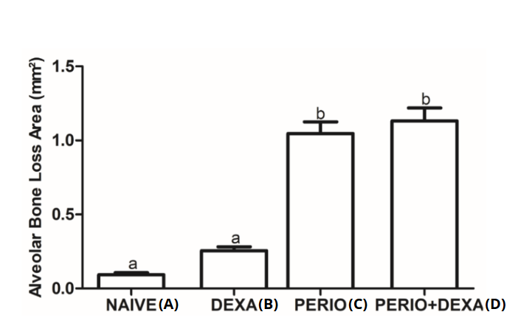
Figure 1. Resorption in mm² of alveolar bone in animals from the naïve group, with periodontitis, treated with dexamethasone, or with periodontitis and treated with dexamethasone. Indicated the alveolar bone resorption evaluated on the area limited between the cement-enamel junction and alveolar bone crest on the buccal face of hemimaxillae. Data are presented as mean ± SEM and were analyzed by ANOVA Tukey test (N = 8 mice per treatment). a, b: different letters indicate statistically significant differences (P < 0.05)

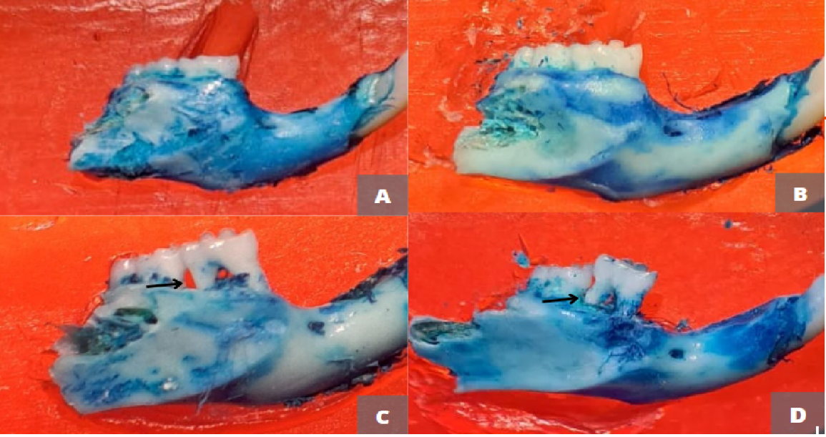
Figure 2. Level of mandibular bone resorption in animals from the naive group (A), treated with dexamethasone and without periodontitis (B), with periodontitis (C), or with periodontitis and treated with dexamethasone (D). Arrow indicating area of bone resorption.

Histopathology of the mandibles
Mice with periodontitis only or associated with dexamethasone treatment had a significant increase in the levels of insertion of the first molars when compared with those treated with saline solution (Naïve) or with dexamethasone (P < 0.0001) (Figures 3 and 4). Healthy mice treated with dexamethasone had no significant changes in insertion levels (P > 0.05). Mice with induced periodontitis that received dexamethasone treatment had reduced insertion levels when compared to those with periodontitis, but not treated with dexamethasone (P < 0.0001).

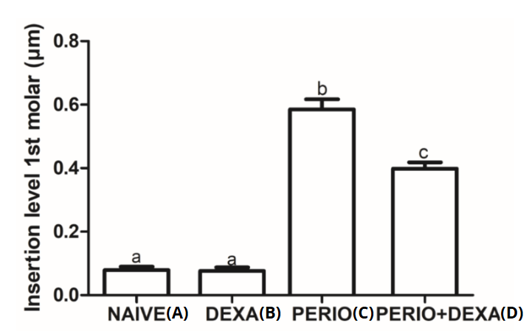
Figure 3. Loss of attachment of the 1st molars in animals from the naïve group, with periodontitis (Perio), treated with dexamethasone and without periodontitis (Dexa), or with periodontitis and treated with dexamethasone (Perio + Dexa). Data are presented as mean ± SEM and were analyzed by ANOVA Tukey test (N = 8 mice per treatment). a, b, c: different letters indicate statistically significant differences (P < 0.05)

Effects of periodontitis dexamethasone on ovarian follicles morphology
The dexamethasone treatment, periodontitis, or periodontitis associated with dexamethasone treatment did not influence the percentages of normal primordial and primary follicles (Table 3). On the other hand, periodontitis, or periodontitis associated with dexamethasone treatment significantly reduced the percentages of morphologically normal secondary and tertiary follicles. A concomitant increase in the percentage of degenerated secondary and tertiary follicles was observed in ovaries of these mice (Table 3). On the other hand, mice with periodontitis and treated with dexamethasone had increase number of corpora lutea when compared with those from naïve groups or with periodontal disease only (Table 4). The histological characteristics and the presence of corpora lutea in ovaries of mice from different groups are shown in Figure 5. Figure 6 shows the morphology of normal follicles at different stages of development.

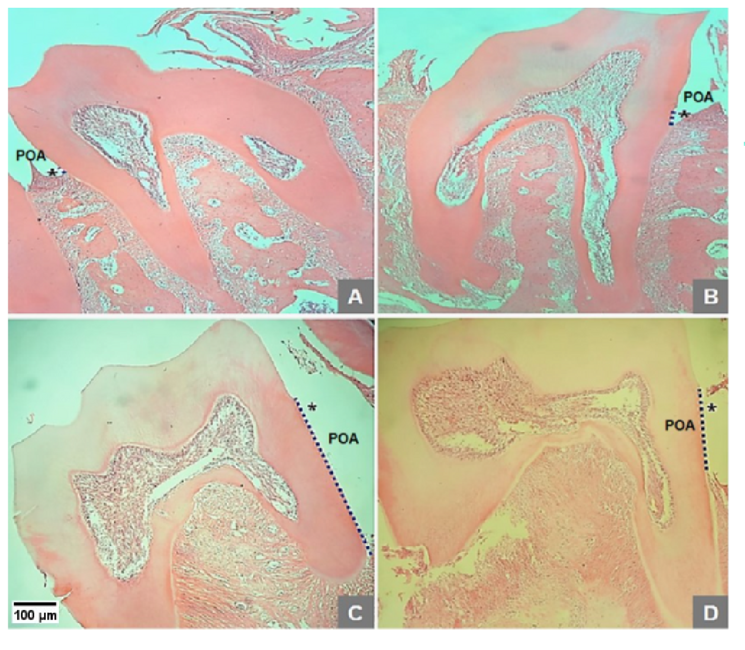
Figure 4. Histological sections illustrating alveolar bone loss (POA) in the 1st molars of mice from naïve group (A), treated with dexamethasone and without periodontitis (B), with periodontitis (C), or with periodontitis and treated with dexamethasone (D). Scale bar = 100μm (40x)

Table 3. Percentage of normal and degenerated primordial, primary, secondary and tertiary follicles in ovaries of mice from the naive group, treated with dexamethasone and without periodontitis (dexa), with periodontitis (Perio), or with periodontitis and treated with dexamethasone (Perio + Dexa) on day 60.
Percentage  (day 60) | Naive (A) | Dexa (B) | Perio (C) | Perio + Dexa (D)
Primordial follicles
Normal | 98.5% (65/66)ª | 100.0% (45/45)ª | 100.0% (44/44)ª | 97.6% (41/42)ª
Degenerated | 1.5% (1/66)ª | 0.0% (0/66)ª | 0.0% (0/44)ª | 2.4% (1/42)ª
Primary follicles
Normal  Degenerated | 97.0% (65/67)ª  3,0% (2/67)ª | 97.0% (66/68)ª  3,0% (2/68)ª | 92.3% (48/52)ª  7.7% (4/52)ª | 94.7% (72/76)ª  5.3% (4/76)ª
Secondary follicles
Normal | 93.9% (138/147)ª | 89.0% (101/113)ª | 69.5% (66/95)^{b} | 68.8% (86/125)^{b}
Degenerated | 6.1% (9/147)ª | 10.0% (12/113)ª | 30.5% (29/95)^{b} | 31.2% (39/125)^{b}
Tertiary follicles
Normal | 98.7% (77/78)ª | 97.3% (71/73)^{ac} | 87.0% (60/69)^{b} | 77.6% (59/76)^{bc}
Degenerated | 1.3% (1/78)ª | 2.7% (2/73)^{ac} | 13.0% (9/69)^{b} | 22.4% (17/76)^{bc}
Data on the percentage of normal and degenerated follicles, as well as those of primordial, primary, secondary and tertiary follicles were evaluated by chi-square test. a, b e c: different letters indicate statistically significant differences (P < 0.05)

Table 4. Number of corpora lutea (mean + S.D.) in ovaries of mice from the naive group, treated with dexamethasone and without periodontitis (Dexa), with periodontitis (Perio), or with periodontitis and treated with dexamethasone (Perio + Dexa) on day 60.
Day 60 | Naive (A) | Dexa (B) | Perio (C) | Perio + Dexa (D)
Corpora lutea | 7.37$±$ 2.87ª | 9.87$±$ 2.41^{ab} | 8.71$±$ 1.60ª | 12.50$±$ 4.92^{b}
Data of corpora lutea were compared by analysis of variance (ANOVA) and Kruskall-Wallis test. a, b: different letters indicate statistically significant differences (P < 0.05)

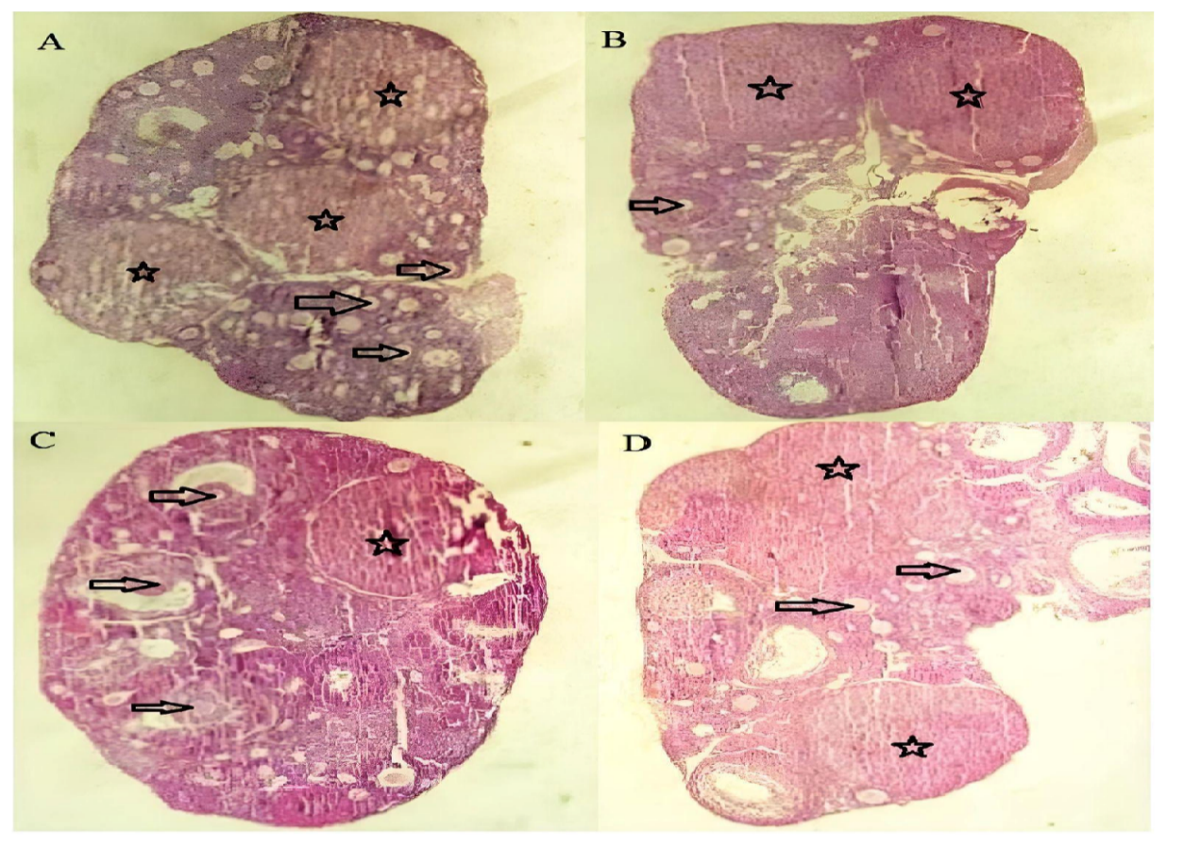
Figure 5. Characteristics of ovaries of mice from the naïve group (A), treated with dexamethasone and without periodontitis (B), with periodontitis (C), or with periodontitis and treated with dexamethasone (D) groups. Star indicates corpus luteum and arrow indicates follicles at different stages of development.

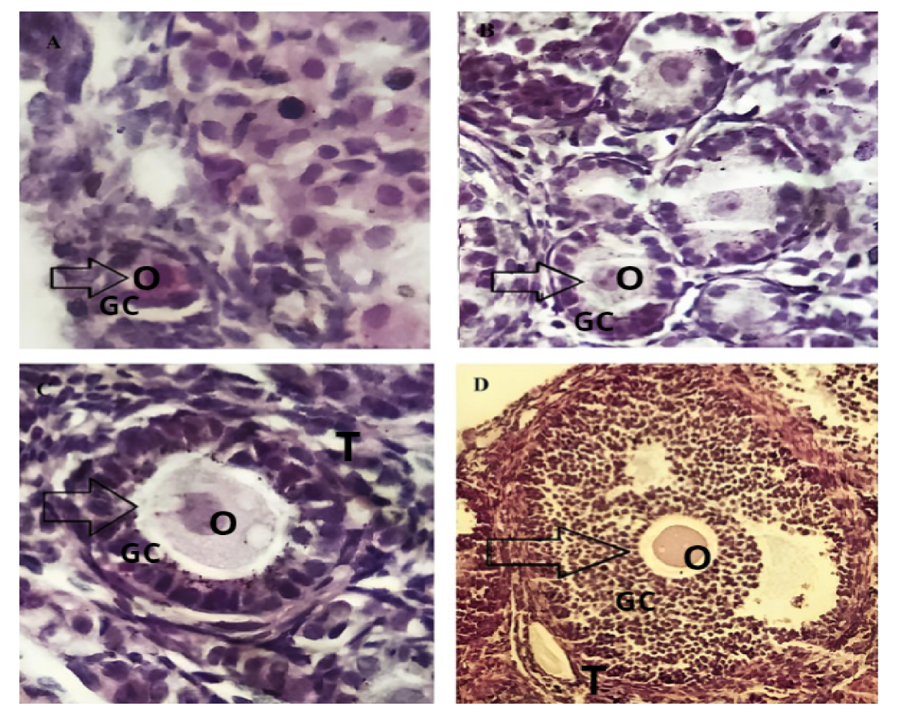
Figure 6: Ovarian sections showing follicles at different stages of development (arrows). (A) Primordial follicle with oocyte surrounded by a layer of squamous-shaped granulosa cells, (B) primary follicles with oocytes surrounded by a layer of cubic-shaped granulosa cells, (C) secondary follicle with oocyte surrounded by several layers of cells cubic-shaped granulosa and (D) tertiary follicle with oocyte surrounded by several layers of cumulus cells and the presence of a well-developed antral cavity (D). O; oocyte, GC: granulosa cells, T: theca cells.

4. discussion

This study shows for the first time that periodontitis associated or not with dexamethasone treatment causes degeneration of secondary and tertiary follicles, but does not influence primordial and primary follicles. Secondary and tertiary follicles have a large number of granulosa and theca cells and are surrounded by blood vessels that directly supply nutrients and hormones (Fraser and Duncan, 2005; Fraser, 2006). Probably, cytokines arising from the periodontitis process, as well as hormonal changes, are involved in the death of ovarian follicles from the secondary follicle stage onwards. On the other hand, primordial and primary follicles are located in poorly vascularized regions and receive nutrients through diffusion through the extracellular matrix (Fraser, 2006). Varley et al., (1991) demonstrated that high plasma concentrations of cortisol in the period preceding ovulation reduce LH levels. Complete follicular development and ovulation depend on the stimulation of the ovary by FSH and LH from the pituitary gland. It is important to highlight that tertiary follicles produce estradiol and that, after ovulation, the follicular cells of the dominant follicle remain in the ovary and undergo transformation into the corpus luteum. This structure is responsible for the production of progesterone, which creates suitable uterine conditions for pregnancy, such as the maturation of the endometrium for the secretory phase. Therefore, changes in survival of secondary and tertiary follicles can deregulate production of estradiol and progesterone and have negative consequences on estrous cycle. Previously, it was reported that dexamethasone influenced the growth, viability and antrum formation of secondary and tertiary follicles in mice, but had no impact on primary follicles (Ristić et al., 2008).
The periodontitis did not negatively influence mice estrous cycle, however, dexamethasone did. This data can be explained when it is taken into account that the application of corticosterone in mice interrupts the ovarian cycle, in part, by interrupting the positive feedback mechanism in both the hypothalamus and pituitary gland, which is necessary to generate the pre-ovulatory LH surge (Luo et al., 2016). Thus, it is understood that dexamethasone affects the production of gonadotropins and also estradiol, which plays a fundamental role in regulating the reproductive cycle (Maciel et al., 2001). Dexamethasone causes cyclical change through affecting hypothalamus and pituitary gland, in addition to change ovarian physiology by regulating the function of granulosa cells, oocytes, cumulus and luteal cells (Luo et al., 2016). This hormone also causes apoptosis of granulosa cells (Sasson et al., 2002; Yuan et al., 2014).
The dexamethasone treatment did not influence bone resorption in mice in which periodontitis was not induced. Furthermore, administration of dexamethasone to mice undergoing periodontitis did not prevent the increase in alveolar bone loss caused by periodontitis. In a previous study, dexamethasone aggravated periodontitis and induced spontaneous alveolar bone loss in healthy periodontium (Cavagni et al., 2005). Periodontitis is a complex multifactorial disease characterized by dysregulated host immune response against the dysbiotic polymicrobial community that colonizes the periodontal environment. Alveolar bone resorption is a direct consequence of the chronic inflammatory process and one of the main characteristics of disease progression (Alvarez et al., 2020). Within the progression of periodontitis, the role of cytokines is extremely important. Cytokines are key modulators of homeostasis and inflammatory processes that act in the first wave of responses against pathogens (Pan, Wang and Chen, 2019). In a previous study, it was demonstrated that dexamethasone reduced the production of cytokines induced by bacterial lipopolysaccharides in the cells of the periodontal ligament (Nilsson 2020). Therefore, periodontitis can contribute to increased systemic inflammation and potentially cause damage to other organs, including the reproductive system (Jaglan et al., 2024).
Periodontitis can cause an increase in oxidative stress in Wistar rats with experimental periodontitis (Mester et al., 2018), the reactive oxygen species, related to this oxidative stress, can increase the production of cytokines (Higashi, 2022). Wang et al. (2023) demonstrated that injections of tumor necrosis factor alpha (TNF-α) and interleukin 1beta (IL-1β) into the gums of mice caused both increased local periodontal destruction and increased gene expression of IL-1 and TNF-α in the hippocampus of these animals, suggesting that periodontitis could have systemic implications through this pathway of inflammation. Similarly, the production of these cytokines by the host with periodontitis (Krejci and Bissada, 2002) may mean an increase in follicular effects linked to TNF-α and IL-1β, such as apoptosis in granulosa cells (Sasson et al., 2002) as well as effects in the nuclear and/or cytoplasmic oocyte maturation process (Silva et al., 2020).
The pharmacology of dexamethasone is given by its anti-inflammatory action that results from the inhibition of phospholipase A2, which inhibits the arachidonic acid cascade, preventing the formation of prostaglandin, leukotrienes and thromboxane. Furthermore, it has an effect on reducing leukocyte migration and adhesion, reducing inflammation (Williams, 2018). However, dexamethasone is a glucocorticoid, as cortisol, which is related to the control and regulation of inflammatory and lymphocyte responses, but when e cortisol levels remain elevated for a certain period of time (Ayub et al., 2010), immunosuppression is observed, as glucocorticoids lose their ability to inhibit the inflammatory response, thus causing periodontal disease to develop without adequate control. In this context, it would be expected that animals with periodontitis and treated with dexamethasone would have greater bone resorption (Varley, 1991). Paradoxically, when taking into account the data measured in the histopathological analysis, there was a significant difference between the groups of animals with periodontitis and those with periodontitis treated with dexamethasone, indicating that dexamethasone caused protection in the periodontal tissue, reducing the loss of clinical insertion. When comparing the result with that of other studies, it is suggested that dexamethasone impairs wound healing and decreases bone mineralization (Cavagni et al., 2005). However, our results of this study showed that dexamethasone was not a factor in the progression of periodontitis. There are some relevant factors that can corroborate with this result, including the period of treatment, the amount of drug administered and the methodology of the experiment.
The degeneration observed in ovarian follicles may provide a physiological explanation for the clinical correlation between patients with periodontitis and other diseases, such as PCOS (Machado et al., 2020; Márquez-Arrico et al., 2020). This study establishes a basis for future studies that address the more precise analysis of inflammation markers with an emphasis on ovarian follicles analysis in models of experimental periodontitis. This study provides new perspectives on the interactions between inflammatory diseases, immunosuppressive drugs and reproductive health. It opens doors to a deeper understanding of the mechanisms of ovarian function and fertility, as well as guidance on the clinical management of patients with inflammatory conditions such as periodontitis. In future studies, other markers of inflammatory cytokines such as IL-6, IL-1, IL-11, TNFα and TGFβ can be evaluated. Additionally, different period of dexamethasone administration can be analyzed, since the dosage and time of use directly influence the side effects of this drug.

4. Conclusion

Periodontitis is associated with increased rates of degeneration of secondary and tertiary follicles in mice. Dexamethasone does not influence the progression of periodontal disease and also does not influence the morphology and development of ovarian follicles, but it deregulates mice estrous cycle.

Highlights: - Periodontitis increases the rate of degeneration in secondary and tertiary follicles.
- Dexamethasone does not influence the progression of periodontal disease in mice.
- Dexamethasone disrupts the estrous cycle of mice.
Ethical Approval
The experiments were started only after approval by the Ethics Committee on the Use of Animals (CEUA) of the Federal University of Ceara (Approval number: 12/20).
COMPETING INTERESTS DISCLAIMER:
Authors have declared that they have no known competing financial interests or non-financial interests or personal relationships that could have appeared to influence the work reported in this paper.
AI DISCLAIMER
The Authors hereby declare that NO generative AI technologies such as Large Language Models (ChatGPT, COPILOT, etc.) and text-to-image generators have been used during the writing or editing of this manuscript.

References

- Alvarez, C., Suliman, S., Almarhoumi, R., Vega, M. E., Rojas, C., Monasterio, G., et al. (2020). Regulatory T cell phenotype and anti-osteoclastogenic function in experimental periodontitis. Scientific Reports, 10(1), 19018. https://doi.org/10.1038/s41598-020-76038-w
- Andersen, C. L., Liu, M., Wang, Z., Ye, X., & Xiao, S. (2019). Chemotherapeutic agent doxorubicin alters uterine gene expression in response to estrogen in ovariectomized CD-1 adult mice. Biology of reproduction, 100(4), 869-871. https://doi.org/10.1093/biolre/ioy259
- Aufdemorte, T. B., & Sheridan, P. J. (1981). Nuclear uptake of sex steroids in gingiva of the baboon. Journal of periodontology, 52(8), 430-434. https://doi.org/10.1902/jop.1981.52.8.430
- Ayub, L. G., Novaes Júnior, A. B., Grisi, M. F. D. M., Souza, S. L. S. D., Palioto, D. B., Leite-Panissi, C. R. A., et al. (2010). Estresse como possível fator de risco para a doença periodontal: revisão da literatura. Periodontia, 28-36.
- Cavagni, J., Soletti, A. C., Gaio, E. J., & Rösing, C. K. (2005). The effect of dexamethasone in the pathogenesis of ligature-induced periodontal disease in Wistar rats. Brazilian oral research, 19, 290-294. https://doi.org/10.1590/S1806-83242005000400010
- Fortune, J. E. (2003). The early stages of follicular development: activation of primordial follicles and growth of preantral follicles. Animal reproduction science, 78(3-4), 135-163. https://doi.org/10.1016/S0378-4320(03)00088-5
- Fraser, H. M. (2006). Regulation of the ovarian follicular vasculature. Reproductive Biology and Endocrinology, 4, 1-9. https://doi.org/10.1186/1477-7827-4-18
- Fraser, H. M., & Duncan, W. C. (2005). Vascular morphogenesis in the primate ovary. Angiogenesis, 8, 101-116. https://doi.org/10.1007/s10456-005-9004-y
- Freitas, T. H. P. D., & Souza, D. A. F. D. (2007). Corticosteróides sistêmicos na prática dermatológica. Parte I: Principais efeitos adversos. Anais Brasileiros de Dermatologia, 82, 63-70. https://doi.org/10.1590/S0365-05962007000100009
- Hajishengallis, G., & Chavakis, T. (2021). Local and systemic mechanisms linking periodontal disease and inflammatory comorbidities. Nature Reviews Immunology, 21(7), 426-440. https://doi.org/10.1038/s41577-020-00488-6
- Higashi, Y. (2022). Roles of oxidative stress and inflammation in vascular endothelial dysfunction-related disease. Antioxidants, 11(10), 1958. doi: 10.3390/antiox11101958..
- Hułas-Stasiak, M., Dobrowolski, P., & Tomaszewska, E. (2016). Prenatally administered dexamethasone impairs folliculogenesis in spiny mouse offspring. Reproduction, Fertility and Development, 28(7), 1038-1048. https://doi.org/10.1071/RD14224
- Jaglan, S., Tewari, S., Singhal, S. R., & Sharma, R. K. (2024). Impact of Polycystic Ovary Syndrome on Periodontal Status of Women of Adolescent and Adult Age Groups: A Cross-Sectional Study. Medical Principles and Practice: International Journal of the Kuwait University, Health Science Centre, 33(2), 148-156. https://doi.org/10.1159/000536223
- Kaipia, A., & Hsueh, A. J. (1997). Regulation of ovarian follicle atresia. Annual review of physiology, 59(1), 349-363. https://doi.org/10.1146/annurev.physiol.59.1.349
- Krejci, C. B., & Bissada, N. F. (2002). Women's health issues and their relationship to periodontitis. The Journal of the American Dental Association, 133(3), 323-329. https://doi.org/10.14219/jada.archive.2002.0171
- Kuhr, A., Popa‐Wagner, A., Schmoll, H., Schwahn, C., & Kocher, T. (2004). Observations on experimental marginal periodontitis in rats. Journal of periodontal research, 39(2), 101-106. https://doi.org/10.1111/j.1600-0765.2004.00710.x
- Kwon, T., Lamster, I. B., & Levin, L. (2021). Current concepts in the management of periodontitis. International dental journal, 71(6), 462-476. https://doi.org/10.1111/idj.12630
- Luo, E., Stephens, S. B., Chaing, S., Munaganuru, N., Kauffman, A. S., & Breen, K. M. (2016). Corticosterone blocks ovarian cyclicity and the LH surge via decreased kisspeptin neuron activation in female mice. Endocrinology, 157(3), 1187-1199. https://doi.org/10.1210/en.2015-1711
- Machado, V., Escalda, C., Proença, L., Mendes, J. J., & Botelho, J. (2020). Is there a bidirectional association between polycystic ovarian syndrome and periodontitis? A systematic review and meta-analysis. Journal of clinical medicine, 9(6), 1961. doi: 10.3390/jcm9061961.
- Maciel, S. M., Chamberlain, C. S., Wettemann, R. P., & Spicer, L. J. (2001). Dexamethasone influences endocrine and ovarian function in dairy cattle. Journal of dairy science, 84(9), 1998-2009. https://doi.org/10.3168/jds.S0022-0302(01)74643-7
- Marcondes, F. K., Bianchi, F. J., & Tanno, A. P. (2002). Determinação das fases do ciclo estral em ratas: considerações úteis. Brazilian Journal of Biology, 62, 609-614. https://doi.org/10.1590/S1519-69842002000400008
- Márquez-Arrico, C. F., Silvestre, F. J., Fernández-Reyes, M., Silvestre-Rangil, J., & Rocha, M. (2024). Is there an association between periodontal disease and infertility? A systematic review. Medicina Oral, Patología Oral y Cirugía Bucal, 29(6), e866. doi: 10.4317/medoral.26831.
- Márquez-Arrico, C. F., Silvestre-Rangil, J., Gutiérrez-Castillo, L., Martinez-Herrera, M., Silvestre, F. J., & Rocha, M. (2020). Association between periodontal diseases and polycystic ovary syndrome: a systematic review. Journal of clinical medicine, 9(5), 1586. doi: 10.3390/jcm9051586.
- Matsubara, H., Ikuta, K., Ozaki, Y., Suzuki, Y., Suzuki, N., Sato, T., et al. (2000). Gonadotropins and cytokines affect luteal function through control of apoptosis in human luteinized granulosa cells. The Journal of Clinical Endocrinology & Metabolism, 85(4), 1620-1626. https://doi.org/10.1210/jcem.85.4.6509
- Mester, A., Ciobanu, L., Taulescu, M., Apostu, D., Lucaciu, O., Filip, G. A., ... & Campian, R. S. (2019). Periodontal disease may induce liver fibrosis in an experimental study on Wistar rats. Journal of Periodontology, 90(8), 911-919. doi: 10.1002/JPER.18-0585.
- Nakagawa, S., Fujii, H., Machida, Y., & Okuda, K. (1994). A longitudinal study from prepuberty to puberty of gingivitis: correlation between the occurrence of Prevotella intermedia and sex hormones. Journal of clinical periodontology, 21(10), 658-665. https://doi.org/10.1111/j.1600-051X.1994.tb00783.x
- Nilsson, B. O. (2021). Mechanisms involved in regulation of periodontal ligament cell production of pro‐inflammatory cytokines: Implications in periodontitis. Journal of periodontal research, 56(2), 249-255. https://doi.org/10.1111/jre.12823
- Pan, W., Wang, Q., & Chen, Q. (2019). The cytokine network involved in the host immune response to periodontitis. International journal of oral science, 11(3), 30. https://doi.org/10.1038/s41368-019-0064-z
- Poulain, M., Frydman, N., Duquenne, C., N′ Tumba-Byn, T., Benachi, A., Habert, R., et al. (2012). Dexamethasone induces germ cell apoptosis in the human fetal ovary. The Journal of Clinical Endocrinology & Metabolism, 97(10), E1890-E1897. https://doi.org/10.1210/jc.2012-1681
- Qiao, J., & Feng, H. L. (2011). Extra-and intra-ovarian factors in polycystic ovary syndrome: impact on oocyte maturation and embryo developmental competence. Human reproduction update, 17(1), 17-33. https://doi.org/10.1093/humupd/dmq032
- Quirk, S. M., Porter, D. A., Huber, S. C., & Cowan, R. G. (1998). Potentiation of Fas-mediated apoptosis of murine granulosa cells by interferon-γ, tumor necrosis factor-α, and cycloheximide. Endocrinology, 139(12), 4860-4869. https://doi.org/10.1210/endo.139.12.6353
- Reichardt, S. D., Amouret, A., Muzzi, C., Vettorazzi, S., Tuckermann, J. P., Lühder, F., et al. (2021). The role of glucocorticoids in inflammatory diseases. Cells, 10(11), 2921. https://doi.org/10.3390/cells10112921
- Richards, J. S., & Pangas, S. A. (2010). The ovary: basic biology and clinical implications. The Journal of clinical investigation, 120(4), 963-972. https://doi.org/10.1172/JCI41350
- Ristić, N., Nestorović, N., Manojlović‐Stojanoski, M., Filipović, B., Šošić‐Jurjević, B., Milošević, V., et al. (2008). Maternal dexamethasone treatment reduces ovarian follicle number in neonatal rat offspring. Journal of microscopy, 232(3), 549-557. https://doi.org/10.1111/j.1365-2818.2008.02117.x
- Santos K. R. P. D., et al. (2021). Manual de técnica histológica de rotina e de colorações. Universidade Federal de Pernambuco.
- Sasson, R., Winder, N., Kees, S., & Amsterdam, A. (2002). Induction of apoptosis in granulosa cells by TNFα and its attenuation by glucocorticoids involve modulation of Bcl-2. Biochemical and biophysical research communications, 294(1), 51-59. https://doi.org/10.1016/S0006-291X(02)00431-X
- Shorr, E. (1941). A new technic for staining vaginal smears: III, a single differential stain. Science, 94(2449), 545-546. https://doi.org/10.1126/science.94.2449.545.
- Silva, J. R., Lima, F. E., Souza, A. L., & Silva, A. W. (2020). Interleukin-1β and TNF-α systems in ovarian follicles and their roles during follicular development, oocyte maturation and ovulation. Zygote, 28(4), 270-277. https://doi.org/10.1017/s0967199420000222.
- Sima, C., Aboodi, G. M., Lakschevitz, F. S., Sun, C., Goldberg, M. B., & Glogauer, M. (2016). Nuclear factor erythroid 2-related factor 2 down-regulation in oral neutrophils is associated with periodontal oxidative damage and severe chronic periodontitis. The American journal of pathology, 186(6), 1417-1426. https://doi.org/10.1016/j.ajpath.2016.01.013
- Tavares, S. J. S., Pereira, C. R., Fortes, R. A. M., Alves, B. E. S., Fonteles, C. S. R., Wong, D. V. T., et al. (2024). Umbelliferone reduces inflammation and ligature‐induced osteoclastic alveolar bone resorption in mice. Journal of Periodontal Research, 59, 982-992. https://doi.org/10.1111/jre.13277
- Torres, R. C., Insuela, D. B. R., & Carvalho, V. D. F. (2012). Mecanismos celulares e moleculares da ação antiinflamatória dos glicocorticoides. Corpus et Scientia, 8(2), 36-51.
- Varley M. Stress and reproduction (1991). Pig News and Information (United Kingdom), 2(4), 567-571.
- Waage, A., & Bakke, O. (1988). Glucocorticoids suppress the production of tumour necrosis factor by lipopolysaccharide-stimulated human monocytes. Immunology, 63(2), 299-302.
- Wang, R. P. H., Huang, J., Chan, K. W. Y., Leung, W. K., Goto, T., Ho, Y. S., & Chang, R. C. C. (2023). IL-1β and TNF-α play an important role in modulating the risk of periodontitis and Alzheimer’s disease. Journal of neuroinflammation, 20(1), 71. https://doi.org/10.1186/s12974-023-02747-4.
- Williams, D. M. (2018). Clinical pharmacology of corticosteroids. Respiratory care, 63(6), 655-670. https://doi.org/10.4187/respcare.06314
- World Health Organization. (2024, November 6). Oral health. World Health Organization. https://www.who.int/news-room/fact-sheets/detail/oral-health. Accessed: March 24, 2025.
- Yuan, X. H., Yang, B. Q., Hu, Y., Fan, Y. Y., Zhang, L. X., Zhou, J. C., et al. (2014). Dexamethasone altered steroidogenesis and changed redox status of granulosa cells. Endocrine, 47, 639-647. https://doi.org/10.1007/s12020-014-0250-x

