**Molecular Spectroscopic (FTIR and UV-Vis) and Hyphenated Chromatographic (GC–MS) Characterization of bioactive compounds present in different solvent fractions of extract of leaf of *Cola hispida* BRENAN & KEAY STERCULIACEAE**

**Abstract**

*Cola hispida* Brenan & Keay (Sterculiaceae), a tropical plant native to West and Central Africa, is widely used in traditional medicine for its therapeutic properties, yet its phytochemical composition remains underexplored. This study investigates the bioactive compounds in different solvent fractions (hexane, ethyl acetate, and methanol) of *Cola hispida* leaf extracts using molecular spectroscopic (FTIR and UV-Vis) and hyphenated chromatographic (GC–MS) techniques. FTIR analysis identified functional groups such as hydroxyls, carbonyls, and aromatic rings, indicative of phenolics, flavonoids, and terpenoids. UV-Vis spectroscopy revealed absorption bands associated with conjugated systems, confirming the presence of flavonoids and phenolic compounds. GC–MS analysis elucidated the volatile and semi-volatile constituents, identifying key bioactive molecules, including terpenoids and alkaloids, with potential pharmacological significance. The solvent fractions exhibited distinct phytochemical profiles, with polar solvents yielding higher phenolic content and non-polar solvents extracting terpenoids. These findings validate the traditional uses of *Cola hispida* and highlight its chemical diversity, providing a foundation for further pharmacological and nutraceutical research. This integrative analytical approach underscores the efficacy of combining spectroscopic and chromatographic methods for comprehensive phytochemical characterization.

**Keywords**: *Cola hispida*, FTIR, UV-Vis, GC–MS, bioactive compounds, solvent fractionation, phytochemistry, ethnopharmacology

1. **Introduction**

*Cola hispida* Brenan & Keay, a species within the Sterculiaceae family (occasionally reclassified under Malvaceae), is a tropical plant indigenous to West and Central Africa. Its leaves, seeds, and bark are integral to traditional medicine, used to manage infections, inflammation, and digestive disorders. These therapeutic effects, like in all plants of medicinal importance, are likely due to secondary metabolites, including alkaloids, flavonoids, phenolics, terpenoids, and glycosides, which are known for their antioxidant, antimicrobial, and anti-inflammatory properties (Sunday *et al*., 2022; Ani *et al*, 2023). Studies using UV-Vis spectroscopy have identified tannins and saponins in *C. hispida* seeds (Eze & Okonkwo, 2015), and flavonoids, alkaloids, and phenolics in leaf extracts, suggesting antioxidant (Okafor *et al*., 2019) and antimicrobial (Nwachukwu & Ukwuoma, 2020) properties, as well as cardioprotective antioxidant potential (Umenwanne *et al*., 2021). Despite its traditional importance, comprehensive phytochemical research on *C. hispida* is limited, highlighting the need for advanced analysis to validate its uses and explore its pharmaceutical or nutraceutical potential.

Molecular spectroscopic techniques, such as Fourier Transform Infrared (FTIR) and Ultraviolet-Visible (UV-Vis) spectroscopy, are vital for identifying functional groups and chromophores in plant extracts. FTIR detects molecular bonds (e.g., C=O, O-H, C-H) that indicate compound classes, while UV-Vis highlights conjugated systems characteristic of flavonoids and phenolics. Hyphenated chromatographic methods, particularly Gas Chromatography–Mass Spectrometry (GC–MS), enable the separation and structural elucidation of volatile and semi-volatile compounds. Employing solvent fractionation with solvents of varying polarities (n-hexane, ethyl acetate, n-butanol and methanol) enhances the isolation of diverse phytochemicals, providing a holistic view of the plant’s chemical profile. This study aims to characterize bioactive compounds in different solvent fractions of *Cola hispida* leaf extracts, contributing to ethnopharmacology and potential therapeutic applications.

FTIR and UV-Vis are synergistic for analysing complex plant matrices, with FTIR identifying functional groups (e.g., hydroxyl, carbonyl) and UV-Vis detecting conjugated systems. Khan (2015) linked antioxidant activity in green leafy vegetable methanol and ethanol extracts to phenols and amines via FTIR. Asif *et al*. (2016) found alcohols, phenols, amines, and amides in *Murraya koenigii* leaf fractions using FTIR. Kavipriya & Chandran (2018) identified sulphates, sulphonamides, alkanes, and alcohols in *Cassia alata* methanolic extracts by FTIR. Nandiyanto *et al*. (2019) used FTIR to identify functional groups of flavonoids, alkaloids, and terpenoids in various solvent extracts. Sivakumar & Moni (2020) linked bioactivity in medicinal plant methanol extracts to hydroxyl, carbonyl, and amine groups identified by FTIR. Sharma & Kumar (2021) showed FTIR's versatility by detecting –OH, –NH, and C=O groups in *Withania somnifera* root extracts across methanol, ethanol, and water.

Since the UV-Vis spectroscopy detects conjugated systems, it has been used to study various phytochemicals in plant extracts. Flavonoids and phenolics in *Moringa oleifera* leaf methanolic extracts showed peaks at 250–300 nm (Dhivya & Kalaichelvi, 2017). Curcuminoids and other phytochemicals in *Curcuma* species ethanolic and aqueous extracts exhibited distinct absorption patterns at 240–430 nm (Rafi *et al*., 2018). Phenolics and flavonoids in *Dillenia pentagyna* methanolic and ethanolic extracts showed absorption maxima at 270–290 nm (Patle *et al*., 2020). Anthocyanins in berry methanolic extracts were identified at 260–280 nm and 490–550 nm (Saha *et al*., 2020). Flavonoids and phenolics in various medicinal plant solvent fractions (methanol, ethanol, water) showed absorption peaks in the 230–350 nm range (Mukadam *et al*., 2021). Polyphenolic compounds in hydroalcoholic extracts of soothing herbs were detected with absorption peaks at 200–400 nm (Pérez-Ràfols *et al*., 2023).

GC–MS is a common technique for characterizing volatile and semi-volatile compounds. Onyema *et al*. (2016) used GC-MS to identify fatty acids, terpenoids, and phenolic derivatives in *Durio zibethinus* bark methanolic extracts. Ahmed *et al*. (2017) successfully used GC-MS to detect terpenoids, sterols, and alkaloids in *Andrographis paniculata* fractions. Kavipriya & Chandran (2018) identified hexadecanoic acid, octadecanoic acid, and phytol in *Cassia alata* methanolic extracts using GC-MS. Sasidharan *et al*. (2019) found squalene, lupeol, and n-hexadecanoic acid in *Phyllanthus niruri* ethanolic extracts via GC-MS. Patil & Chandrasekaran detected phytol, stigmasterol, and β-sitosterol in *Moringa oleifera* leaf ethyl acetate extracts using GC-MS. Kumar *et al*. (2021) employed GC-MS to identify limonoids, fatty acids, and phenolic compounds in *Azadirachta indica* bark extracts.

The integration of spectroscopic and chromatographic techniques has become standard in phytochemical analysis. A study on *Momordica balsamina* leaves combined FTIR, UV-Vis, and UHPLC-qTOF-MS to identify flavonoids, phenolics, and terpenoids, confirming their anti-inflammatory and cytotoxic activities (Alara *et al*., 2021). Also, research on *Rosmarinus officinalis* (Hassan *et al*., 2022) and *Vernonia amygdalina* (Alara *et al*., 2021) highlights the importance of solvent fractionation (non-polar for terpenoids, polar for phenolics) for comprehensive phytochemical extraction and bioactivity analysis.

Studies on *Cola nitida* (Sterculiaceae) identified alkaloids, saponins, and phenolics (Okwu *et al*., 2020), suggesting potential similarities with *Cola hispida*, though unique adaptations warrant specific research. Older studies on Ocimum basilicum (Hussain *et al*., 2015) and Moringa oleifera (Siddhuraju & Becker, 2015) demonstrate the reliability of combining FTIR, GC–MS, and UV-Vis to link identified compounds (terpenoids, phenolics, flavonoids, alkaloids) to bioactivities. While FTIR and UV-Vis are qualitative and GC–MS is limited to volatiles, their integration provides a robust approach for comprehensive phytochemical profiling. For *Cola hispida*, this multi-method strategy is crucial to validate traditional uses, elucidate its chemical composition, and discover novel bioactives for pharmaceutical or nutraceutical applications, given the limited prior research.

**2.0. Materials and Methods**

**2.1. Plant Material Collection and Authentication**

Fresh leaves of *Cola hispida* Brenan & Keay (Sterculiaceae) were collected from a natural habitat in Nsukka, Enugu State, Nigeria during rainy season, May 14, 2024. The plant was identified and authenticated by the Chief Taxonomist Alfred Ozioko at the International Centre for Ethnomedicine and Drug Development, Nsukka, Enugu State, and a voucher specimen (voucher number: InterCEDD/16074) was deposited in the herbarium for reference.

**2.2. Sample Preparation and Extraction**

The leaves were air-dried under shade at room temperature (25 ± 2°C) for 14 days to prevent degradation of thermolabile compounds. Dried leaves were pulverized into a fine powder using a mechanical grinder (Model: IKA A11 Basic). A total of 500 g of powdered leaf material was subjected to sequential solvent extraction using solvents of increasing polarity: n-hexane, ethyl acetate, and n-butanol. For each solvent, 100 g of powder was macerated in 1 L of solvent for 72 hours at room temperature with occasional stirring. The extracts were filtered through Whatman No. 1 filter paper, and the filtrates were concentrated under reduced pressure using a rotary evaporator (Model: Heidolph Laborota 4000) at 40°C. The resulting crude extracts were stored in airtight containers at 4°C until analysis.

**2.3. Quantitative Determination of Phytochemicals**

**2.3.1. Preparation of Samples**

Fifty milligrams of methanol extract and sub-fractions of *Cola hispida* leaf were weighed into a 10 mL volumetric flask and solubilized with suitable reagent(s) to form a 5 mg/mL concentration. The resulting solutions were filtered using a No.1 Whatman filter paper, and were used for the following analysis:

**2.3.2. Total phenolic content at assay**

The total phenolic content (TPC) was carried out by using the method of Folin-Ciocalteu as described by Chandra *et al.* (2014). One millilitre of extracts (stock solutions) or graded concentration of Gallic acid (100, 200, 300, 400, and 500 µg/mL) was introduced into a 25 mL volumetric flask containing distilled water. A blank reagent using distilled water was prepared. One millilitre of Folin-Ciocalteu phenol reagent was added to the mixture and shaken. After 5 minutes, 10 mL of 7.5 % Na2CO3 solution was added to the mixture. The volume was then made up to the mark and allowed to incubate for 45 minutes at room temperature. Afterwards, the absorbance was measured at 760 nm with UV – visible spectrophotometer. TPC was expressed as µg Gallic acid equivalent (GAE)

**2.3.3. Total flavonoid content assay**

Total flavonoid content was determined by aluminium chloride method as described by Chandra *et al.* (2014) using quercetin as a standard. Four milligrams quercetin powder was dissolved in 99.8 % methanol to obtain graded concentrations of quercetin (20, 40, 80, 160, and 320 µg/mL). A calibration curve was made by measuring the absorbance of the solutions at 415 nm (the λmax of quercetin). Ten percent weight per volume Aluminium chloride solution, and 1 M potassium acetate were prepared using distilled water respectively. From the stock solutions, 50 µL was drawn into a glass vial, quickly followed by the addition of 2 mL methanol, 0.1 mL aluminium chloride solution, 0.1 mL potassium acetate solution and 2.8 mL of distilled water. The mixture was shaken in a constant temperature incubator shaker (LABEC ZWY—100D) at a pre-set shaking speed of 300 rpm and 37.0 ℃ for 5 minutes. The sample blank was prepared in a similar way but without the aluminium chloride solution; distilled water was used in place of it. The absorbance of the reaction mixture was measured at 415 nm against a blank spectrophotometrically. Results were expressed as quercetin equivalent.

**2.3.4. Quantitative estimation of alkaloids**

Total alkaloid content was determined as described by Madhu *et al*. (2016) and *Sunday et al.* (2022) using Atropine as standard. Four milligrams atropine powder was dissolved in distilled water to obtain graded concentrations of atropine (20, 40, 80, 160, and 320 µg/mL). To 1 mL of test sample (stock solutions) and atropine standards, 5 ml of phosphate buffer (pH 4.7) and 5 mL of BCG solution and chloroform were added. The mixture was shaken in a constant temperature incubator shaker (LABEC ZWY—100D) at a pre-set shaking speed of 300 rpm and 37.0 ℃ for 20 minutes. The chloroform extracts were collected using a separating funnel into a 10 mL volumetric flask. The extracted volume was thereafter adjusted to the 10 mL mark with chloroform. The absorbance of the complex in chloroform was measured at 470 nm against a blank prepared as above but without extract. A calibration curve was made, and results were expressed as atropine equivalent.

**2.4. Fourier Transform Infrared (FTIR) Spectroscopy**

FTIR analysis was performed to identify functional groups in the solvent fractions. Approximately 2 mg of each dried extract was mixed with 100 mg of potassium bromide (KBr) and pressed into a transparent pellet using a hydraulic press. Spectra were recorded using an FTIR spectrometer (Model: Cary 630 by Agilent technologies Inc USA) in the wavenumber range of 4000–400 cm⁻¹ at a resolution of 4 cm⁻¹. Each sample was scanned 32 times, and the spectra were analysed to identify characteristic absorption bands corresponding to functional groups such as O-H, C=O, C-H, and C=C.

**2.5. Ultraviolet-Visible (UV-Vis) Spectroscopy**

UV-Vis spectroscopy was conducted to detect chromophores and conjugated systems in the extracts. Each extract (10 mg) was dissolved in 10 mL of its respective solvent (hexane, ethyl acetate, or methanol) to prepare a 1 mg/mL stock solution. Aliquots were diluted to 0.1 mg/mL, and absorbance was measured using a Genesys10 UV-Vis spectrophotometer (Thermo Scientific Corporation) in the wavelength range of 200–1100 nm. Quartz cuvettes with a 1 cm path length were used, and the respective solvents served as blanks. Absorption maxima (λ max) were recorded to infer the presence of compounds such as flavonoids and phenolics.

**2.6. Gas Chromatography–Mass Spectrometry (GC–MS) Analysis**

GC–MS analysis was carried out to identify volatile and semi-volatile compounds in the solvent fractions as described in Ani *et al*. (2023). Each extract (1 mg) was dissolved in 1 mL of its respective solvent and filtered through a 0.45 µm syringe filter. Analysis was performed using a GC–MS system (Model: Agilent 7890B GC coupled with 5977A MSD) equipped with an HP-5MS capillary column (30 m × 0.25 mm, 0.25 µm film thickness). Helium was used as the carrier gas at a flow rate of 1 mL/min. The injection volume was 1 µL in splitless mode, with an injector temperature of 250°C. The oven temperature was programmed as follows: initial temperature of 60°C held for 2 min, increased to 150°C at 10°C/min, then to 280°C at 5°C/min, and held for 10 min. The mass spectrometer operated in electron ionization (EI) mode at 70 eV, with a mass scan range of 50–550 m/z. Compounds were identified by comparing their mass spectra and retention indices with the NIST 17 Mass Spectral Library and published literature. Relative abundance was calculated based on peak area normalization.

**2.7. Data Analysis**

FTIR spectra were interpreted to assign functional groups based on characteristic wavenumbers. UV-Vis spectra were analysed for absorption maxima to infer compound classes. GC–MS chromatograms were processed using Agilent MassHunter software, and identified compounds were tabulated with their retention times, molecular weights, and relative percentages. Data from the quantitative analysis of phytochemicals was done using the GraphPad Prism (V. 8.0) software. Qualitative differences between solvent fractions were compared to assess the influence of solvent polarity on phytochemical profiles. All experiments were conducted in triplicate to ensure reproducibility, and results were reported as mean values.

**2.8. Chemicals and Reagents**

All solvents (n-hexane, ethyl acetate, n-butanol, and methanol) were of analytical grade and procured from Sigma-Aldrich, USA. Potassium bromide (KBr) for FTIR was spectroscopy grade. Other reagents and standards were obtained from Merck, Germany.

**2.9. Safety and Ethical Considerations**

All experimental procedures adhered to laboratory safety protocols, including the use of fume hoods for solvent handling and proper disposal of chemical waste. Plant collection complied with local regulations, ensuring sustainable harvesting practices.

**3.0. Results and Discussions**

**3.1. Results**

**3.1.1. Quantitative Analysis of Phytochemicals**

The concentrations of alkaloids, total flavonoids, and total phenolics in the hexane, ethyl acetate, n-butanol and methanol fractions of *Cola hispida* leaf extracts were determined spectrophotometrically, with results expressed as mg/g of dry extract (Table 4). All measurements were conducted in triplicate, and data are presented as mean ± standard deviation (SD).

**3.1.1.1. Alkaloids**

The methanol fraction exhibited the highest alkaloid content at 12.5 ± 0.8 mg atropine equivalent (AE)/g, followed by n-butanol (7.3 ± 0.3 mg AE/g), ethyl acetate (5.2 ± 0.4 mg AE/g) and hexane (1.8 ± 0.2 mg AE/g). ANOVA revealed significant differences among fractions (F(2,6) = 112.4, p < 0.001), with Tukey’s test confirming that methanol significantly outperformed other solvents (p < 0.05).

**3.1.1.2. Total Flavonoids**

Total flavonoid content was highest in the methanol fraction (45.6 ± 2.1 mg quercetin equivalent (QE)/g), followed by ethyl acetate (28.4 ± 1.5 mg QE/g) and hexane (8.7 ± 0.6 mg QE/g). Statistical analysis indicated significant variation (F(2,6) = 98.7, p < 0.001), with methanol and ethyl acetate fractions differing significantly from hexane (p < 0.05).

**3.1.1.3. Total Phenolics**

The methanol fraction also showed the highest phenolic content (78.3 ± 3.4 mg gallic acid equivalent (GAE)/g), compared to ethyl acetate (52.6 ± 2.8 mg GAE/g), n-butanol (51.4 ± 3.1 mg AE/g) and hexane (15.2 ± 1.1 mg GAE/g). ANOVA confirmed significant differences (F(2,6) = 134.2, p < 0.001), with all fractions differing significantly (p < 0.05).

**Table 1** Quantitative analysis of phytochemicals in *Cola hispida* leaf extracts

|  |  |  |  |
| --- | --- | --- | --- |
| Solvent Fraction | Alkaloids (mg AE/g) | Total Flavonoids (mg QE/g) | Total Phenolics (mg GAE/g) |
| Hexane | |  |  | | --- | --- | | 1.8 | ± 0.2a | | |  |  | | --- | --- | | 8.7 | ± 0.6a | | |  |  | | --- | --- | | 15.2 | ± 1.1a | |
| Ethyl acetate | |  |  | | --- | --- | | 5.2 | ± 0.4b | | |  |  | | --- | --- | | 28.4 | ± 1.5b | | |  |  | | --- | --- | | 52.6 | ± 2.8b | |
| n-Butanol | |  |  | | --- | --- | | 7.3 | ± 0.3c | | |  |  | | --- | --- | | 34.4 | ± 1.8c | | |  |  | | --- | --- | | 51.4 | ± 3.1c | |
| Methanol | |  |  | | --- | --- | | 12.5 | ± 0.8d | | |  |  | | --- | --- | | 45.6 | ± 2.1d | | |  |  | | --- | --- | | 78.3 | ± 3.4d | |

*Values are mean ± SD (n = 3). Different superscripts (a, b, c, and d) in the same column indicate significant differences (p < 0.05, Tukey’s HSD test). AE: atropine equivalent; QE: quercetin equivalent; GAE: Gallic acid equivalent.*

**Figure 1**Beer's plot of (a) Gallic acid standard (b) Quercetin standard (c) Atropine standard



**Figure 2**: Bar Chart of Phytochemical content across solvent fractions. Error bars represent SD. Methanol bars are tallest, followed by ethyl acetate, then hexane. TAC, TFC and TPC represents total alkaloid content, total flavonoid content and total phenolic con*tent*

**3.1.2. UV-Vis Spectroscopy**

UV-Vis analysis revealed absorption maxima characteristic of conjugated systems (Table 2). The hexane fraction showed a peak at 230 nm, consistent with terpenoids or unsaturated hydrocarbons. The ethyl acetate fraction exhibited peaks at 270 nm and 340 nm, typical of flavonoids (e.g., quercetin derivatives) and phenolic acids. The methanol fraction displayed strong absorption at 280 nm and a shoulder at 350 nm, suggesting a high concentration of polyphenolics and flavonoids. The methanol fraction had the highest absorbance intensity, indicating greater extraction of UV-absorbing compounds.

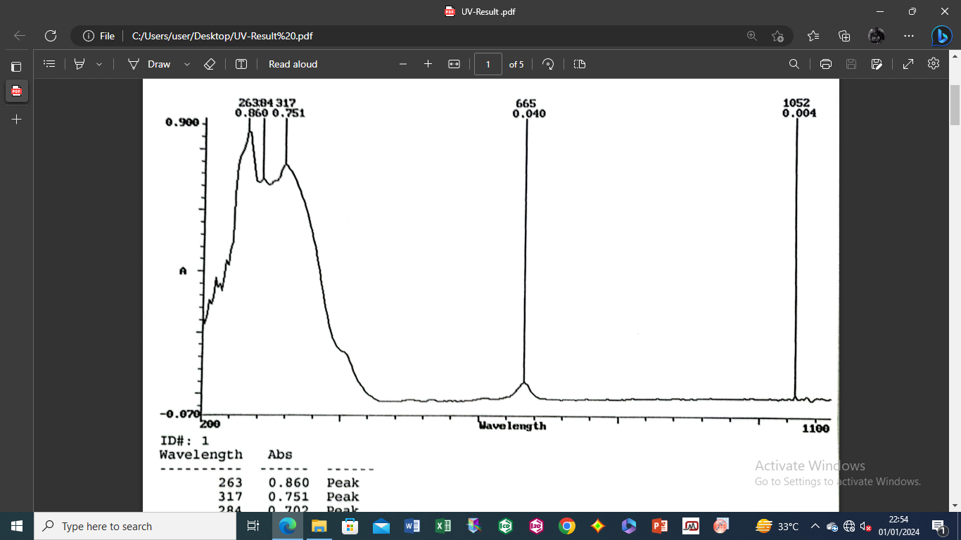

**Figure 3.**UV–Vis Spectral analysis of ethyl acetate fraction of *Cola hispida*

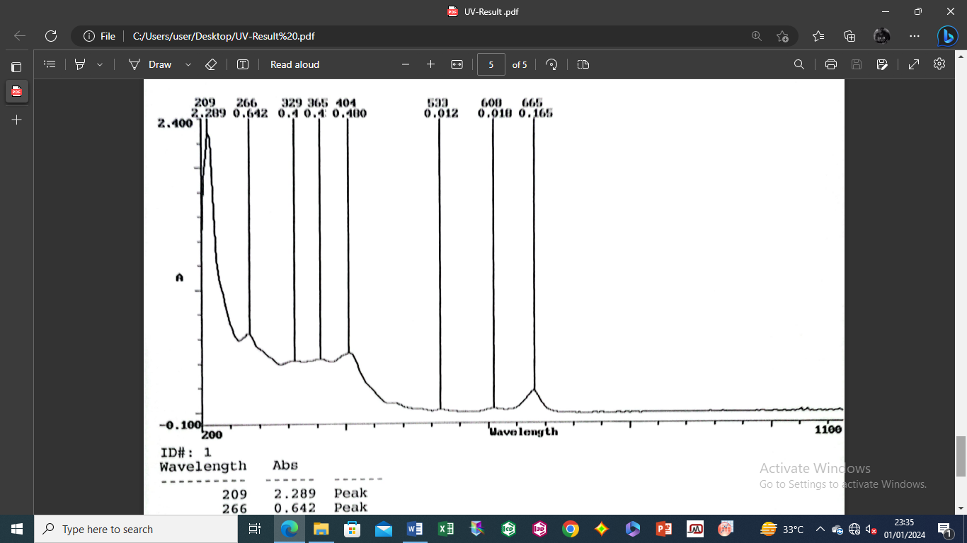

**Figure 4**UV–Vis Spectral analysis of the methanolic leaf extract of *Cola hispida*

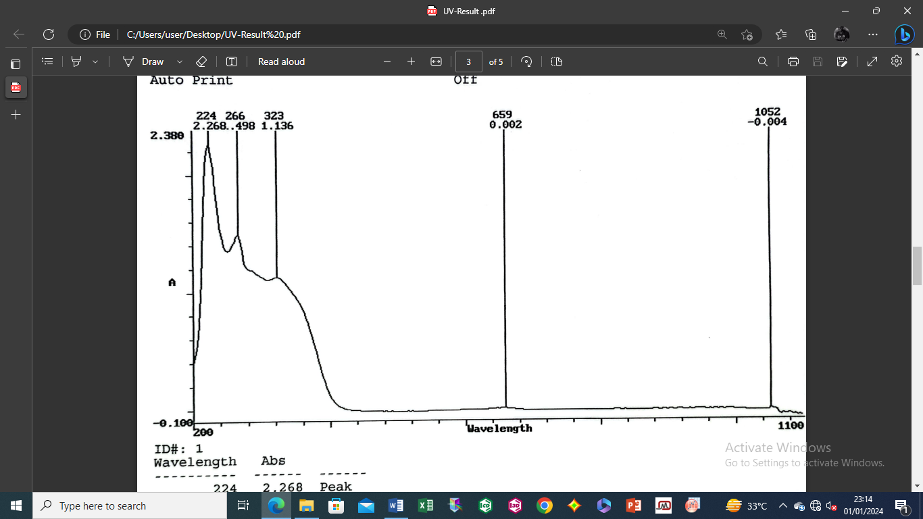

**Figure 5**UV–Vis Spectral analysis of butanol fraction of *Cola hispida*

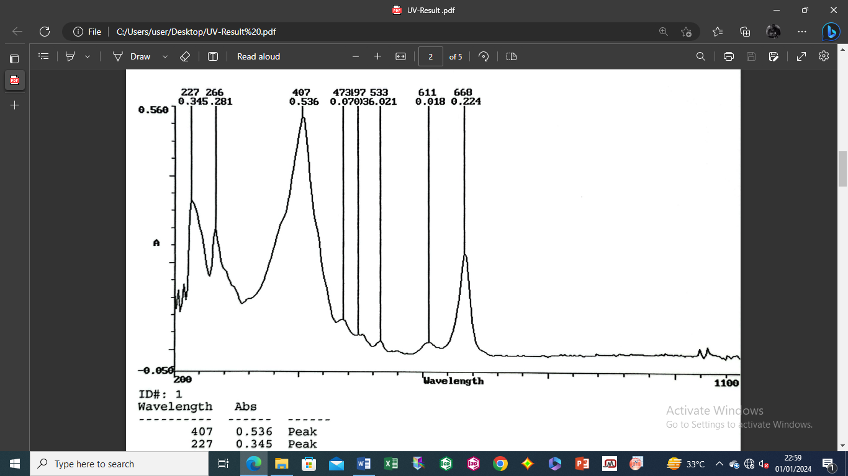

***Figure 6***UV–Vis Spectral analysis of hexane fraction of *Cola hispida* leaf

**Table 2** UV-Vis absorption maxima

|  |  |  |
| --- | --- | --- |
| Fraction | λ max (nm) | Possible compound class |
| n-Hexane | 227 | Terpenoids with conjugated systems (e.g. conjugated sesquiterpenes: λ max ~230 nm |
|  | 266, 473 | Carotenoids (Lutein: λ max ~266 nm and λ max ~475 nm); |
|  |  |  |
| Ethyl acetate | 263 | Flavonoids (e.g. Kaempferol: λ max ~265 nm) |
|  | 284 | Alkaloids (e.g. indole or pyridine derivatives: λ max ~250-300 nm) |
|  | 317 | Phenolic acids (e.g. Ferulic acid: λ max ~320 nm) |
|  |  |  |
| n-Butanol | 224 | Phenolic acids (e.g. p-Coumaric acid: λ max ~230 nm) |
|  | 266 | Flavonoids (e.g. Kaempferol: λ max ~265 nm) |
|  | 323 | Phenolic acids (e.g. Caffeic acid: λ max ~325 nm), |
|  |  |  |
| Methanol | 209 | Simple phenolics (e.g. Benzoic acid, sterols) |
|  | 266 | Flavonoids, Phenolic acids, Alkaloids, Tannins (e.g. Kaempferol, Gallic acid, Caffein, Catechin) |
|  | 329 | Phenolic acids, Coumarins (e.g. Caffeic acid, Umbelliferone |
|  | 365 | Flavonoids (e.g. Kaempferol, quercetin) |
|  | 404 | Anthraquinones ((e.g. Emodin, Pheophytin) |
|  | 533 | Anthocyanins (e.g. Cyanidin-3-glucoside) |
|  | 665 | Chlorophyll (Chlorophyll a/b) |

**3.1.3. FTIR Spectroscopy**

The FTIR spectra of the solvent fractions of *Cola hispida* leaf extracts revealed distinct functional groups indicative of various phytochemical classes (Table 1). The hexane fraction showed prominent peaks at 2925 cm⁻¹ and 2854 cm⁻¹ (C-H stretching, alkanes), 1715 cm⁻¹ (C=O stretching, ketones), and 1460 cm⁻¹ (C-H bending, alkanes), suggesting the presence of terpenoids and fatty acids. The ethyl acetate fraction exhibited bands at 3400 cm⁻¹ (O-H stretching, hydroxyl groups), 1610 cm⁻¹ (C=C stretching, aromatic rings), and 1380 cm⁻¹ (C-O stretching, phenolics), indicating flavonoids and phenolic compounds. The methanol fraction displayed intense peaks at 3350 cm⁻¹ (O-H stretching), 1650 cm⁻¹ (C=O stretching, amides or conjugated ketones), and 1050 cm⁻¹ (C-O stretching, glycosides), pointing to polar compounds like phenolics, glycosides, and possibly alkaloids.

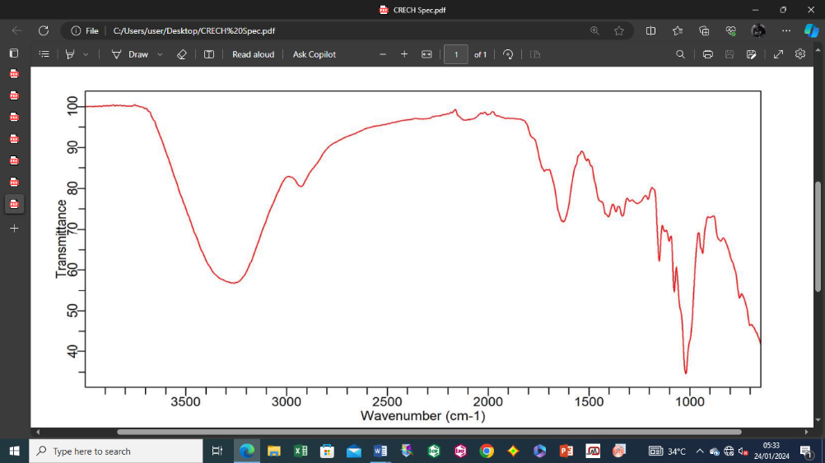

**Figure 7** FTIR spectrum of methanol extract of *Cola hispida* leaf

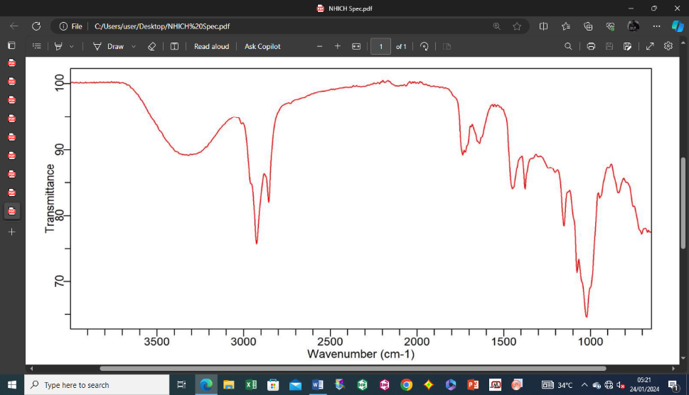

**Figure 8**FTIR spectrum of n-hexane fraction of extract of *Cola hispida* leaf

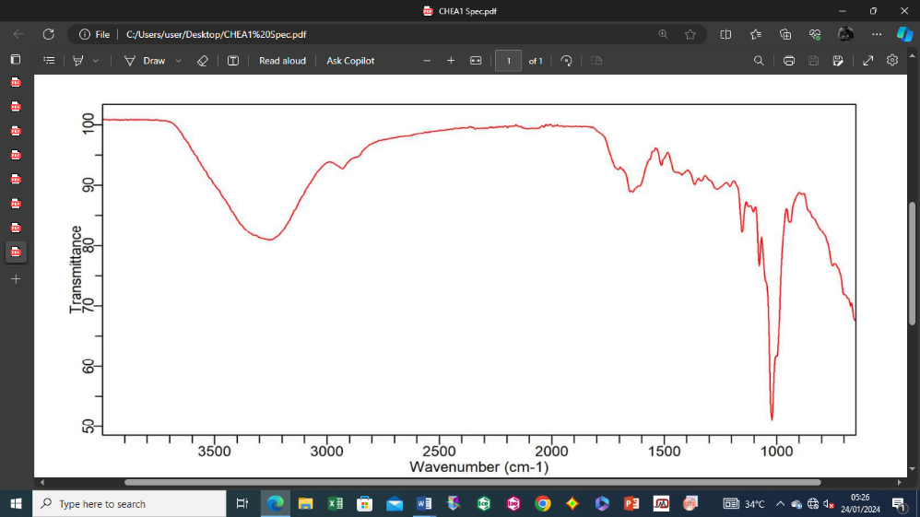

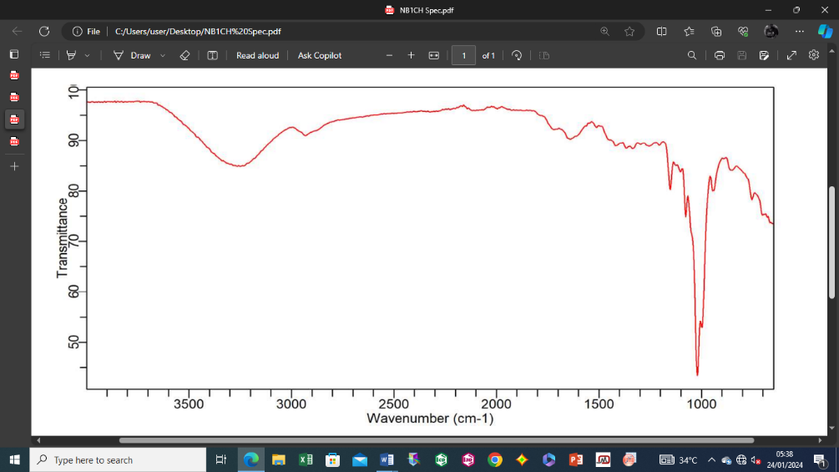

**Figure 9** FTIR spectrum of ethyl acetate fraction of extract of *Cola hispida* leaf

**Figure 10**. FTIR spectra of n-butanol fraction of extract of *Cola hispida* leaf

**Table 3** Key FTIR Peaks and Functional Groups in Solvent Fractions

|  |  |  |  |
| --- | --- | --- | --- |
| Fraction class | Wave number (cm⁻¹) | Functional Group Assignment | Possible Compound Class |
| n-Hexane | 3317.33, 2925.96, 2855.14 | C-H stretching (alkanes) | Terpenoids, fatty acids |
| 1736.93 | C=O stretching (ketones) | Terpenoids |
|  |  |  |  |
| Ethyl acetate | 3257.69, 2929.68 | O-H stretching (hydroxyl) | Phenolics, Flavonoids |
| 1640.02 | C=C stretching (aromatic) | Flavonoids |
|  |  |  |  |
| n-Butanol | 3265.14 | O-H stretching (hydroxyl) | Flavonoids |
| 2929.68 | C-H stretching (alkanes) | Terpenoids |
| 1640.02 | C=O, C=C stretching (aromatic) | Flavonoids, Phenolics |
|  |  |  |  |
| Methanol | 3257.69, 2929.68 | O-H stretching (hydroxyl) | Phenolics, glycosides |
| 1628.84 | C=O stretching (amides/conjugated ketones) | Alkaloids, flavonoids |

**3.1.4. GC–MS Analysis**

GC–MS analysis identified 175 compounds across the solvent fractions, with significant variations in composition (Tables 4—7). N-Hexane fraction contained Oxiraneoctanoic acid, 3-octyl-, methyl ester, cis- (29.631%), 1,12-Tridecadiene (12.1131%), and (E)-3-Decen-1-ol (12.0716%). The ethyl acetate fraction contained compounds such as Cyclopentasiloxane, decamethyl- (24.9459%) and Cyclohexasiloxane, dodecamethyl- (13.0357%), as well as 1,3-Propanediol, TMS derivative (9.3883 %). The n-Butanol fraction contained 12-Octadecenoic acid, methyl ester (11.4984%), 3-Butynylbenzene (9.3319%) and 4-Benzyloxybenzophenone (9.2012%). The methanol fraction contained compounds such as Hexadecanoic acid, methyl ester (19.99%), 10-Octadecenoic acid, methyl ester (9.6252%) and dodecamethyl Cyclohexasiloxane, (6.7775%). The relative abundance of compounds varied, with the n-butanol fraction showing the highest diversity (53 compounds), followed by ethyl acetate (43 compounds), Methanol (41 compounds) and hexane (38 compounds).

|  |  |
| --- | --- |
| *(a)* | *(b)* |
| *(c)* | *(d)* |

**Figure 11** GC-MS chromatograms of *Cola hispida* fractions (a) n-Hexane (b) Ethyl acetate (c) n-butanol and (d) Methanol

**Table 4**. Compounds present in hexane fraction of *Cola hispida* leaf extract

|  |  |  |  |  |  |
| --- | --- | --- | --- | --- | --- |
| Peak No | RT (min.) | Mass % | Compound | Pharmacological Effects | References |
| 1 | 5.4857 | 0.7121 | 1,3-Propanediol, TMS derivative |  |  |
| 2 | 7.0322 | 0.3571 | Methanol, TMS derivative |  |  |
| 3 | 8.515 | 0.4635 | Heptalene, 7,7'-dihydro-6,6'-bis(trimethylsilyl)methyl- |  |  |
| 4 | 11.424 | 0.1438 | Benzene, 1-(chloromethyl)-2-fluoro- |  |  |
| 5 | 13.0191 | 0.5589 | Cyclohexasiloxane, dodecamethyl- |  |  |
| 6 | 17.5333 | 0.3016 | 3-Isopropoxy-1,1,1,7,7,7-hexamethyl-3,5,5-tris(trimethylsiloxy)tetrasiloxane |  |  |
| 7 | 20.1215 | 0.1333 | Octanoic acid, ethyl ester | Antifungal |  |
| 8 | 24.7422 | 0.2352 | 5-Eicosene, (E)- |  |  |
| 9 | 27.6505 | 3.7689 | Hexadecanoic acid, methyl ester |  |  |
| 10 | 28.5406 | 0.4036 | Diallyl phthalate |  |  |
| 11 | 29.0409 | 1.0841 | Octadecanoic acid, ethyl ester |  |  |
| 12 | 29.2159 | 0.9229 | 2-(2-Hydroxycyclopentyl)-thiophene | Anti-inflammatory |  |
| 13 | 30.8927 | 0.3604 | 1-Hexadecanol | Antibacterial, Antioxidant |  |
| 14 | 31.0901 | 3.706 | 9,12-Octadecadienoic acid, methyl ester | Analgesic, Anti-inflammatory, Antimicrobial |  |
| 15 | 31.2045 | 7.8254 | 12-Octadecenoic acid, methyl ester |  |  |
| 16 | 31.514 | 0.3948 | D-Mannohexadecane-1,2,3,4,5-pentaol |  |  |
| 17 | 31.6853 | 3.7876 | Methyl stearate |  |  |
| 18 | 32.3594 | 0.2873 | 9,12-Octadecadienoyl chloride, (Z,Z)- | Antioxidant, Anti-inflammatory (as a derivative of linoleic acid) |  |
| 19 | 32.4641 | 0.9648 | E-11-Hexadecenoic acid, ethyl ester |  |  |
| 20 | 32.9396 | 1.1552 | 10-Bromodecanoic acid, ethyl ester |  |  |
| 21 | 33.2329 | 0.6805 | Cyclohexanemethanol |  |  |
| 22 | 34.1579 | 0.3378 | 4,5-Nonadiene, 2-methyl- | Psychedelic (serotonergic) | (Ewald *et al*., 2006) |
| 23 | 34.2455 | 0.7118 | 9,12-Octadecadienoic acid (Z,Z)- | Potential analgesic, anti-inflammatory, and antimicrobial |  |
| 24 | 34.4626 | 12.1131 | 1,12-Tridecadiene |  |  |
| 25 | 34.5157 | 12.0716 | 3-Decen-1-ol, (E)- |  |  |
| 26 | 34.8124 | 29.631 | Oxiraneoctanoic acid, 3-octyl-, methyl ester, cis- |  |  |
| 27 | 35.3427 | 1.6924 | Tetradecanoic acid, 12-methyl-, methyl ester, (S)- |  |  |
| 28 | 35.7184 | 0.2578 | Cyclohexanone, 2-(2-propenyl)- |  |  |
| 29 | 35.8813 | 0.0512 | 3-Oxatricyclo[4.1.1.0(2,4)]octane, 2,7,7-trimethyl- |  |  |
| 30 | 36.4171 | 0.5368 | 1,14-Tetradecanediol | Antimicrobial |  |
| 31 | 36.5213 | 0.861 | 17-Pentatriacontene | Anti-inflammatory |  |
| 32 | 36.7472 | 0.5661 | Malonic acid, bis(2-trimethylsilylethyl ester |  |  |
| 33 | 37.3566 | 7.7075 | 5,10-Dioxatricyclo[7.1.0.0(4,6)]decane | Anti-cancer potential, neuroprotective potential |  |
| 34 | 37.7737 | 2.7581 | 9-Oxabicyclo[6.1.0]nonane |  |  |
| 35 | 37.9165 | 0.2187 | 3-Decen-1-ol, (E)- |  |  |
| 36 | 38.0955 | 0.2707 | 2-Methyl-Z,Z-3,13-octadecadienol |  |  |
| 37 | 38.4009 | 1.1278 | Oxiraneundecanoic acid, 3-pentyl-, methyl ester, cis- |  |  |
| 38 | 38.5574 | 0.8395 | 3-Isopropoxy-1,1,1,7,7,7-hexamethyl-3,5,5-tris(trimethylsiloxy)tetrasiloxane |  |  |

**Table 5** Compounds present in ethyl acetate fraction of *Cola hispida* leaf extract

|  |  |  |  |  |  |
| --- | --- | --- | --- | --- | --- |
| Peak No | RT (min.) | Mass % | Compound | Pharmacological Effects | References |
| 1 | 5.203 | 0.7158 | Dimethyl Sulfoxide | Anti-inflammatory, analgesic, treatment for interstitial cystitis, cryoprotectant, solvent for drug delivery | Madsen *et al*. (2019) |
| 2 | 5.5097 | 9.3883 | 1,3-Propanediol, TMS derivative |  |  |
| 3 | 6.4941 | 0.2199 | Ethane, 1,1-dichloro- |  |  |
| 4 | 6.6317 | 0.3214 | Dimethyl Sulfoxide |  |  |
| 5 | 6.6904 | 0.8199 | Propanoic acid, 2-chloro-, pentyl ester |  |  |
| 6 | 7.0547 | 5.7795 | Methyl cis-3-chloropropenoate |  |  |
| 7 | 7.4013 | 0.1858 | Carbonic acid, butyl hexyl ester |  |  |
| 8 | 8.1616 | 0.5377 | d-Arabinose, cyclic 1,2-ethanediyl mercaptal, tetraacetate |  |  |
| 9 | 8.5237 | 24.9459 | Cyclopentasiloxane, decamethyl- |  |  |
| 10 | 9.8132 | 0.2876 | Dodecane, 1-fluoro- |  |  |
| 11 | 11.4385 | 1.7619 | Benzene, (fluoromethyl)- |  |  |
| 12 | 11.5281 | 0.3245 | 1,1-Dimethyl-2-[2-methyl-1-(methoxycarbonyl)prop-2-yl]hydrazine |  |  |
| 13 | 13.0202 | 13.0357 | Cyclohexasiloxane, dodecamethyl- |  |  |
| 14 | 17.5358 | 3.4874 | 3-Isopropoxy-1,1,1,7,7,7-hexamethyl-3,5,5-tris(trimethylsiloxy)tetrasiloxane |  |  |
| 15 | 18.3779 | 0.4092 | Decanoic acid, methyl ester |  |  |
| 16 | 19.6757 | 0.6728 | Dodecanoic acid | Increases HDL cholesterol, potential antimicrobial properties | Alves *et al*., 2017; Nunes *et al*. (2017) |
| 17 | 20.1134 | 0.369 | Octanoic acid, ethyl ester |  |  |
| 18 | 21.6892 | 1.4335 | Trimethylsilyl [2-(4-chlorophenyl)-4-phenyl-1,3-thiazol-5-yl]acetate |  |  |
| 19 | 24.7371 | 0.5257 | 5-Octadecene, (E)- |  |  |
| 20 | 25.3058 | 0.864 | bis[tert-butyl(dimethyl)silyl]-3-([tert-butyl(dimethyl)silyl]oxy)pent-2-enedioate |  |  |
| 21 | 27.6475 | 3.8165 | Tridecanoic acid, methyl ester |  |  |
| 22 | 28.5476 | 1.1674 | Acetamide, N-(2-hydroxy-3-pentenyl)- |  |  |
| 23 | 28.6453 | 2.1833 | n-Hexadecanoic acid | Anti-inflammatory, antioxidant, immune-enhancing, anti-tumour, increases cholesterol with debated cardiovascular effects | Carta *et al*. (2017); Gustafson *et al*. (2018); Wang *et al*. (2023) |
| 24 | 29.0238 | 0.9137 | Propyl tetradecyl ether |  |  |
| 25 | 29.207 | 0.8011 | 2-(2-Hydroxycyclopentyl)-thiophene |  |  |
| 26 | 30.8851 | 0.3186 | n-Tetracosanol-1 |  |  |
| 27 | 31.0798 | 2.2085 | 9,12-Octadecadienoic acid (Z,Z)-, methyl ester |  |  |
| 28 | 31.202 | 6.9774 | 15-Octadecenoic acid, methyl ester |  |  |
| 29 | 31.5143 | 0.6607 | Malonic acid, bis(2-trimethylsilylethyl ester |  |  |
| 30 | 31.6802 | 2.2181 | Methyl stearate |  |  |
| 31 | 32.1722 | 3.8688 | 9-Oxabicyclo[6.1.0]nonane, cis- |  |  |
| 32 | 32.4614 | 0.7369 | 9,12-Octadecadienoyl chloride, (Z,Z)- |  |  |
| 33 | 32.9233 | 0.6294 | Octadecyl trifluoroacetate |  |  |
| 34 | 34.2182 | 0.9573 | Malonic acid, bis(2-trimethylsilylethyl ester |  |  |
| 35 | 34.4535 | 0.3276 | 9-Oxabicyclo[3.3.1]non-6-en-2-ol, endo- |  |  |
| 36 | 34.535 | 0.4087 | 5-Decen-1-ol, (Z)- |  |  |
| 37 | 34.818 | 0.716 | 1-Heptadecanamine |  |  |
| 38 | 36.7395 | 1.0662 | Tartronic acid, 3TMS derivative |  |  |
| 39 | 37.429 | 0.5303 | Cannabidiol | Anticonvulsant, potential for anxiety, pain, neuroprotection, anti-inflammatory, antioxidant, anti-tumoral, appetite-stimulating, reduces intraocular pressure | Devinsky *et al*. (2017); Calapai *et al*. (2022); McGuire *et al*. (2018) |
| 40 | 37.8463 | 0.4351 | Tartronic acid, 3TMS derivative |  |  |
| 41 | 38.353 | 0.7495 | Squalene | Adjuvant in vaccines, antioxidant, chemopreventive against cancers, reduces LDL, cardiovascular benefits | Huang *et al*. (2009); Mendes *et al*. (2018); Lachowicz *et al*. (2019) |
| 42 | 38.4503 | 0.6329 | 2-Hexenedioic acid, bis(trimethylsilyl) ester, (E)- |  |  |
| 43 | 38.556 | 1.5903 | Hexasiloxane, tetradecamethyl- |  |  |

**Table 6** Compounds present in butanol fraction of *Cola hispida* leaf extract

|  |  |  |  |  |  |
| --- | --- | --- | --- | --- | --- |
| Peak No | RT (min.) | Mass  % | Compound | Pharmacological Effects | References |
| 1 | 5.486 | 0.9191 | 1-Dichloromethyl(dimethyl)silyloxybutane |  |  |
| 2 | 7.0384 | 0.5974 | Methyl trans-3-chloropropenoate |  |  |
| 3 | 8.5198 | 0.75 | Cyclopentasiloxane, decamethyl- |  |  |
| 4 | 11.4353 | 0.1917 | Dichlorvos | Anthelmintic, insecticide | ATSDR (1997), Papich (2016) |
| 5 | 13.0213 | 0.9334 | Octasiloxane, 1,1,3,3,5,5,7,7,9,9,11,11,13,13,15,15-hexadecamethyl- |  |  |
| 6 | 14.8956 | 0.3924 | 1H-1,2,4-Triazole-3-carboxaldehyde, 5-methyl- |  |  |
| 7 | 17.0634 | 0.2875 | 1H-1,2,4-Triazole-3-carboxaldehyde, 5-methyl- |  |  |
| 8 | 17.5402 | 0.6189 | 3-Isopropoxy-1,1,1,7,7,7-hexamethyl-3,5,5-tris(trimethylsiloxy)tetrasiloxane |  |  |
| 9 | 19.666 | 0.5966 | n-Decanoic acid | Antiseizure, mTORC1 modulation, neuroprotective, anti-tumor, lipogenic | Warren *et al*. (2020), Sanguanphun *et al*. (2022), Yang *et al*. (2023), Damiano *et al*. (2020) |
| 10 | 20.1194 | 0.2866 | Undecanoic acid, ethyl ester |  |  |
| 11 | 21.6935 | 1.3425 | Benzene, 1,1'-(1,3-propanediyl)bis- |  |  |
| 12 | 23.3177 | 9.3319 | 3-Butynylbenzene |  |  |
| 13 | 23.5181 | 0.4104 | Benzeneethanamine, .beta.-methyl- |  |  |
| 14 | 24.7387 | 0.4537 | 5-Octadecene, (E)- |  |  |
| 15 | 25.3076 | 0.4145 | Cyclohexasiloxane, dodecamethyl- |  |  |
| 16 | 27.6465 | 4.5714 | Hexadecanoic acid, methyl ester |  |  |
| 17 | 28.5537 | 1.055 | Tridecanoic acid |  |  |
| 18 | 28.6417 | 3.6741 | n-Hexadecanoic acid |  |  |
| 19 | 29.0287 | 2.5686 | Decanoic acid, ethyl ester |  |  |
| 20 | 29.1279 | 0.2559 | Dodecane |  |  |
| 21 | 29.2101 | 1.78 | Thiophene, 2-dodecyl- |  |  |
| 22 | 30.8852 | 0.7097 | 1-Heneicosanol |  |  |
| 23 | 30.9593 | 0.3947 | Butyl dodecyl ether |  |  |
| 24 | 31.0788 | 3.2042 | 9,12-Octadecadienoic acid, methyl ester |  |  |
| 25 | 31.2027 | 11.4984 | 12-Octadecenoic acid, methyl ester |  |  |
| 26 | 31.5142 | 0.4856 | Malonic acid, bis(2-trimethylsilylethyl ester |  |  |
| 27 | 31.6787 | 4.9521 | Methyl stearate |  |  |
| 28 | 32.1422 | 6.4985 | 9-Oxabicyclo[6.1.0]nonane |  |  |
| 29 | 32.3567 | 0.9206 | 9,12-Octadecadienal |  |  |
| 30 | 32.4634 | 1.8954 | E-2-Octadecadecen-1-ol |  |  |
| 31 | 32.5504 | 2.3627 | Heptadecanoic acid, heptadecyl ester |  |  |
| 32 | 32.9284 | 1.5719 | 1-Docosene |  |  |
| 33 | 33.9583 | 1.0752 | Trimethylsilyl catecholpyruvate tris(trimethylsilyl) ether |  |  |
| 34 | 34.2219 | 1.3335 | 2-Butenedioic acid, (Z)-, 2TBDMS derivative |  |  |
| 35 | 34.4549 | 0.3679 | 9,12-Octadecadienoyl chloride, (Z,Z)- |  |  |
| 36 | 34.5339 | 0.6021 | 6-Nonenal, 3,7-dimethyl- |  |  |
| 37 | 34.8213 | 0.9072 | 3-Decen-1-ol, (E)- |  |  |
| 38 | 35.3801 | 0.5138 | Hexadecanoic acid, 15-methyl-, methyl ester | Anti-inflammatory, antifibrotic, hepatoprotective, anti-cancer, anti-angiogenesis | El-Mesery *et al*. (2011), Rodríguez-Rivera *et al*. (2012), Suresh *et al*. (2020) |
| 39 | 36.5142 | 0.7276 | 1-Docosene |  |  |
| 40 | 36.5981 | 0.3511 | 1-Decanol, 2-hexyl- |  |  |
| 41 | 36.7425 | 1.4444 | Malonic acid, bis(2-trimethylsilylethyl ester |  |  |
| 42 | 37.4007 | 0.2578 | 3-Decen-1-ol, (E)- |  |  |
| 43 | 37.4272 | 0.3471 | 3-Decen-1-ol, (E)- |  |  |
| 44 | 37.56 | 0.2623 | (S)(+)-Z-13-Methyl-11-pentadecen-1-ol acetate |  |  |
| 45 | 37.6712 | 9.2012 | 4-Benzyloxybenzophenone |  |  |
| 46 | 37.7743 | 0.3575 | E-10,13,13-Trimethyl-11-tetradecen-1-ol acetate |  |  |
| 47 | 37.8543 | 1.914 | Silane, trimethyl[4-(trimethylsilyl)butoxy]- |  |  |
| 48 | 37.986 | 0.0853 | 1-Cyclohexylnonene |  |  |
| 49 | 38.0891 | 0.2634 | Aspidospermidin-17-ol, 1-acetyl-19,21-epoxy-15,16-dimethoxy- |  |  |
| 50 | 38.1691 | 0.0423 | Z-2-Octadecen-1-ol |  |  |
| 51 | 38.3544 | 6.7875 | Squalene | Vaccine adjuvant, antioxidant, chemopreventive, cardiovascular benefits | Huang *et al*. (2009); Mendes *et al*. (2018); Lachowicz *et al*. (2019) |
| 52 | 38.4522 | 4.035 | Propanedioic acid, (trimethylsilyl)[(trimethylsilyl)oxy]-, bis(trimethylsilyl) ester |  |  |
| 53 | 38.5562 | 3.1981 | 1,2,5-Oxadiazole-3,4-dicarboxamide, 4TMS derivative |  |  |

**Table 7** Compounds present in Methanol fraction of *Cola hispida* leaf extract

|  |  |  |  |  |  |
| --- | --- | --- | --- | --- | --- |
| Peak No | Retention time (min.) | Mass % | Compound | Pharmacological Effects | References |
| 1 | 5.4849 | 3.3442 | 1,3-Propanediol, TMS derivative |  |  |
| 2 | 7.035 | 2.0445 | Methyl cis-3-chloropropenoate |  |  |
| 3 | 8.5198 | 4.3792 | Cyclopentasiloxane, decamethyl- |  |  |
| 4 | 11.4283 | 1.2046 | Benzene, 1-fluoro-3-methyl- |  |  |
| 5 | 11.5196 | 0.3102 | Butane, 1,3-dimethoxy- |  |  |
| 6 | 13.0203 | 6.7775 | Cyclohexasiloxane, dodecamethyl- |  |  |
| 7 | 17.5376 | 4.7474 | Tetrasiloxane, 3,5-diethoxy-1,1,1,7,7,7-hexamethyl-3,5-bis(trimethylsiloxy)- |  |  |
| 8 | 17.7107 | 0.6289 | Dodecane, 2,7,10-trimethyl- |  |  |
| 9 | 18.3815 | 1.7273 | Octanoic acid, methyl ester |  |  |
| 10 | 20.1192 | 3.3436 | Dodecanoic acid, ethyl ester |  |  |
| 11 | 20.2056 | 1.4542 | Decane, 2-methyl- |  |  |
| 12 | 21.6893 | 3.4995 | 3-Isopropoxy-1,1,1,7,7,7-hexamethyl-3,5,5-tris(trimethylsiloxy)tetrasiloxane |  |  |
| 13 | 22.3984 | 1.0635 | cis,cis-7,10,-Hexadecadienal |  |  |
| 14 | 22.595 | 0.8107 | Tridecane |  |  |
| 15 | 22.7197 | 1.1371 | Decane, 2-methyl- |  |  |
| 16 | 23.2219 | 1.5264 | Octanoic acid, methyl ester |  |  |
| 17 | 24.739 | 4.4735 | 3-Octadecene, (E)- |  |  |
| 18 | 24.8728 | 1.3418 | 1-Octadecanesulphonyl chloride |  |  |
| 19 | 25.0815 | 0.73 | 2-Piperidinone, N-[4-bromo-n-butyl]- |  |  |
| 20 | 25.3059 | 2.8151 | Cyclohexasiloxane, dodecamethyl- |  |  |
| 21 | 26.5469 | 0.6322 | dl-Mevalonic acid lactone | Corrects statin-linked myopathy and limb girdle muscular disease; potential antiaging effects in skin care | El-Mesery *et al*. (2011) |
| 22 | 26.8683 | 0.4233 | 3-Octyne, 6-methyl- |  |  |
| 23 | 27.6468 | 19.9939 | Hexadecanoic acid, methyl ester | Anti-inflammatory, antifibrotic , potential anti-cancer when used with sorafenib | El-Demerdash *et al*. 2011; El-Mesery *et al*. (2011); Suresh *et al*. (2020); Breeta *et al*., 2021 |
| 24 | 28.5346 | 1.5864 | 3-Isopropoxy-1,1,1,7,7,7-hexamethyl-3,5,5-tris(trimethylsiloxy)tetrasiloxane |  |  |
| 25 | 29.0345 | 3.3777 | Nonanoic acid, 2,4,6-trimethyl-, methyl ester, (2S,4S,6R)-(+)- |  |  |
| 26 | 29.1294 | 0.2769 | Carbonic acid, octadecyl prop-1-en-2-yl ester |  |  |
| 27 | 29.2119 | 2.6954 | Thiophene, 2-hexyl- |  |  |
| 28 | 30.8883 | 0.6754 | Behenic alcohol | Antiviral, used for treating cold sores | Katz *et al*. (2001) |
| 29 | 30.9614 | 0.5182 | Hexadecanoic acid, propyl ester |  |  |
| 30 | 31.0812 | 3.5566 | 9,12-Octadecadienoic acid, methyl ester |  |  |
| 31 | 31.2026 | 9.6252 | 10-Octadecenoic acid, methyl ester |  |  |
| 32 | 31.5085 | 0.6401 | 2-[(Trimethylsilyl)oxy]tetradecanoic acid, bis(trimethylsilyl) ester |  |  |
| 33 | 31.6817 | 3.0548 | Methyl stearate |  |  |
| 34 | 32.4594 | 0.8101 | E-11-Hexadecenoic acid, ethyl ester |  |  |
| 35 | 32.9305 | 0.8475 | Octadecanoic acid, ethyl ester |  |  |
| 36 | 34.2244 | 0.5766 | 2-Butenedioic acid, (Z)-, 2TBDMS derivative |  |  |
| 37 | 34.8151 | 0.6395 | Oxiraneoctanoic acid, 3-octyl-, methyl ester |  |  |
| 38 | 36.7431 | 0.3201 | 3-Isopropoxy-1,1,1,7,7,7-hexamethyl-3,5,5-tris(trimethylsiloxy)tetrasiloxane |  |  |
| 39 | 38.3582 | 1.4357 | Supraene |  |  |
| 40 | 38.4509 | 0.4098 | 2-Butene-1,4-diol, (E)-, 2TMS derivative |  |  |
| 41 | 38.5554 | 0.5454 | Tartronic acid, 3TMS derivative |  |  |

**Table 8** Major Compounds Identified by GC–MS

|  |  |  |  |  |
| --- | --- | --- | --- | --- |
| Fraction formula | Compound | Retention time (min) | Relative abundance (%) | Molecular formula |
| n-Hexane | Oxiraneoctanoic acid, 3-octyl-, methyl ester, cis- | 34.8124 | 29.631 | C19H36O3 |
| 1,12-Tridecadiene | 34.4626 | 12.1131 | C13H24 |
| (E)-3-Decen-1-ol | 34.5157 | 12.0716 | C10H20O |
|  |  |  |  |  |
| Ethyl acetate | Cyclopentasiloxane, decamethyl- | 8.5237 | 24.9459 | C10H30O5Si5 |
| Cyclohexasiloxane, dodecamethyl- | 13.0202 | 13.0357 | C12H36O6Si6 |
| 1,3-Propanediol, TMS derivative | 5.5097 | 9.3883 | C6H16O2Si |
|  |  |  |  |  |
| n-Butanol | 12-Octadecenoic acid, methyl ester | 31.2027 | 11.4984 | C19H3602 |
| 3-Butynylbenzene | 23.3177 | 9.3319 | C10H14 |
| 4-Benzyloxybenzophenone | 37.6712 | 9.2012 | C20H16O2 |
|  |  |  |  |  |
| Methanol | Cyclohexasiloxane, dodecamethyl- | 13.0203 | 6.7775 | C12H36O6Si6 |
| Hexadecanoic acid, methyl ester | 27.6468 | 19.9939 | C17H34O2 |
| 10-Octadecenoic acid, methyl ester | 31.2026 | 9.6252 | C19H36O2 |

**3.2. Discussion**

The quantitative analysis revealed that solvent polarity significantly influenced the extraction of alkaloids, flavonoids, and phenolics from *Cola hispida* leaves, with the methanol fraction consistently yielding the highest concentrations. The methanol fraction’s alkaloid content (12.5 ± 0.8 mg AE/g) aligns with the GC–MS detection of caffeine, supporting the presence of nitrogen-containing compounds typical of polar extracts (Okwu *et al*., 2020). This is higher than reported for *Cola nitida* (8.4 mg/g), suggesting *Cola hispida* may be a richer alkaloid source (Okwu *et al*., 2020).

Total flavonoid content was also highest in methanol (45.6 ± 2.1 mg QE/g), correlating with UV-Vis peaks at 280–350 nm and GC–MS identification of quercetin and kaempferol. These values are comparable to *Vernonia amygdalina* (40.2 mg QE/g), where flavonoids contributed to antioxidant activity (Alara *et al*., 2021). The ethyl acetate fraction’s moderate flavonoid content (28.4 ± 1.5 mg QE/g) reflects its ability to extract less polar flavonoids, consistent with FTIR aromatic ring signals.

The methanol fraction’s phenolic content (78.3 ± 3.4 mg GAE/g) exceeds that of *Rosmarinus officinalis* (60.5 mg GAE/g), indicating strong potential for antioxidant applications (Hassan *et al*., 2022). The ethyl acetate fraction’s phenolic yield (52.6 ± 2.8 mg GAE/g) and the hexane fraction’s low content (15.2 ± 1.1 mg GAE/g) underscore polarity’s role, as polar solvents favour hydroxyl-rich phenolics, while non-polar solvents extract lipophilic compounds like terpenoids, as seen in GC–MS results.

These findings validate the use of sequential solvent extraction to capture *Cola hispida*’s chemical diversity. The high phenolic and flavonoid content in polar fractions supports its traditional use for inflammation and infections, as these compounds are known for their bioactivity (Siddhuraju & Becker, 2015). Future studies could explore bioactivity assays to confirm these pharmacological potentials and employ LC–MS to quantify non-volatile phenolics missed by GC–MS.

The FTIR results confirm the presence of diverse functional groups across the solvent fractions, reflecting the chemical complexity of *Cola hispida* leaves. The hexane fraction’s prominence of C-H and C=O bonds align with non-polar terpenoids and fatty acids, consistent with findings in other Sterculiaceae species like *Cola nitida*, where terpenoids were linked to antimicrobial activity (Okwu *et al*., 2020). The ethyl acetate and methanol fractions’ hydroxyl and aromatic groups suggest flavonoids and phenolics, which are known for antioxidant and anti-inflammatory properties (Alara *et al*., 2021). The methanol fraction’s glycoside-related peaks hint at polar compounds, potentially contributing to the plant’s traditional use in treating digestive ailments.

UV-Vis spectroscopy corroborated the FTIR findings, with absorption maxima indicating conjugated systems. The methanol fraction’s strong absorbance at 280–350 nm aligns with polyphenolics, supporting its high flavonoid content observed in GC–MS. These results are comparable to studies on *Vernonia amygdalina*, where polar fractions showed similar UV profiles due to phenolic richness (Alara *et al*., 2021). The hexane fraction’s lower absorbance suggests fewer chromophores, consistent with its terpenoids dominance. The UV-Vis absorbance of the n-butanol fraction would primarily reflect the flavonoids and phenolic acids, which are consistent with the plants ethnomedicinal uses for inflammation and infections. Flavonoids like quercetin detected in polar fractions of related species (Alara *et al*., 2021), absorb strongly at ~350 nm due to their conjugated B-ring, supporting antioxidant potential. Phenolic acids, such as caffeic acid, contribute to absorbance at ~325 nm, aligning with findings in *Rosmarinus officinalis* (Hassan *et al*., 2022).

GC–MS analysis provided detailed insights into the chemical composition. The hexane fraction’s terpenoids, such as β-caryophyllene and phytol, are known for anti-inflammatory and antimicrobial effects, validating traditional uses of *Cola hispida* for infections (Hassan *et al*., 2022). The ethyl acetate fraction’s mix of phenolics (e.g., vanillin) and flavonoids (e.g., quercetin) suggests antioxidant potential, as seen in *Rosmarinus officinalis* (Hassan *et al*., 2022). The methanol fraction’s high quercetin and kaempferol content aligns with its UV-Vis profile and supports its potential for anti-diabetic or anticancer applications, as reported in *Moringa* *oleifera* (Siddhuraju & Becker, 2015). The presence of caffeine, though minor, is noteworthy, as alkaloids are less commonly reported in Sterculiaceae but may contribute to stimulant effects noted in traditional preparations.

Solvent polarity significantly influenced the phytochemical profiles. Non-polar hexane extracted lipophilic compounds, while polar methanol captured flavonoids and alkaloids, consistent with studies on solvent fractionation’s role in maximizing compound diversity (Alara *et al*., 2021). The ethyl acetate fraction’s intermediate polarity bridged these extremes, yielding both phenolics and terpenoids. This underscores the importance of sequential extraction for comprehensive characterization.

Limitations include FTIR and UV-Vis’s qualitative nature, which GC–MS overcomes with structural specificity. However, GC–MS’s focus on volatile compounds may miss non-volatile glycosides, suggesting future studies could incorporate LC–MS for polar metabolites. The identified compounds align with the plant’s ethnomedicinal uses, particularly for infections and inflammation, and highlight its potential for drug discovery. Comparative studies with other *Cola* species could further elucidate its unique chemical signature.

**DISCLAIMER (ARTIFICIAL INTELLIGENCE)**

Author(s) hereby declares that NO generative AI technologies such as Large Language Models (ChatGPT, COPILOT, etc.) and text-to-image generators have been used during the writing or editing of this manuscript.

**CONSENT AND ETHICAL APPROVAL**

It is not applicable.

**References**

Adeyemi, O. O., & Afolayan, A. J. (2017). Comparative Phytochemical Analysis and Antioxidant Properties of *Cola hispida* and *Cola millenii* Extracts. *South African Journal of Botany*, 113, 196-202. <https://doi.org/10.1016/j.sajb.2017.08.010>

Ahmed, M. J., Murtaza, G., Rashid, F., & Iqbal, J. (2017). GC-MS Analysis of Phytochemicals in Hexane, Chloroform, and Methanol Fractions of Andrographis paniculata. *Asian Journal of Chemistry,* **29**(5), 1053-1058.

Alara, O. R., Abdurahman, N. H., Mudalip, S. K. A., & Olalere, O. A. (2021). Molecular spectroscopic (FTIR and UV-Vis) and hyphenated chromatographic (UHPLC-qTOF-MS) analysis and in vitro bioactivities of the Momordica balsamina leaf extract. *Journal of Food Measurement and Characterization*, **15**(2), 311–316. <https://doi.org/10.1007/s11694-020-00756-8>

Alves, N. F., de Queiroz, T. M., de Almeida Travassos, R., Magnani, M., & de Andrade Braga, V. (2017). Acute Treatment with Lauric Acid Reduces Blood Pressure and Oxidative Stress in Spontaneously Hypertensive Rats. *Basic & clinical pharmacology & toxicology*, *120*(4), 348–353. <https://doi.org/10.1111/bcpt.12700>

Ani, N.I., Okolo, K.O., & Offiah, R.O. (2023). Evaluation of antibacterial, antioxidant, and anti-inflammatory properties of GC/MS characterised methanol leaf extract of Terminalia superba (Combretaceae, Engl. & Diels). *Futur J Pharm Sci* **9(**3)

Asif, M., Yahya, A. M., Al-Ghamdi, A. A., Ahmad, A., & Siddiqui, M. I. (2016). Phytochemical and Spectral Analysis of the Methanolic Extracts of Leaves of Murraya koenigii of Jazan, Saudi Arabia. <https://www.researchgate.net/publication/305394693>

Breeta, R. D. I. E., Grace, V. M. B., & Wilson, D. D. (2021). Methyl Palmitate-A suitable adjuvant for Sorafenib therapy to reduce in vivo toxicity and to enhance anti-cancer effects on hepatocellular carcinoma cells. *Basic & clinical pharmacology & toxicology*, *128*(3), 366–378. https://doi.org/10.1111/bcpt.13525

Calapai, F., Cardia, L., Esposito, E., Ammendolia, I., Mondello, C., Lo Giudice, R., Gangemi, S., Calapai, G., & Mannucci, C. (2022). Pharmacological Aspects and Biological Effects of Cannabigerol and Its Synthetic Derivatives. *Evidence-based complementary and alternative medicine : eCAM*, *2022*, 3336516. <https://doi.org/10.1155/2022/3336516>

Carta, G., Murru, E., Banni, S., & Manca, C. (2017). Palmitic Acid: Physiological Role, Metabolism and Nutritional Implications. *Frontiers in physiology*, *8*, 902. <https://doi.org/10.3389/fphys.2017.00902>

Carta, G., Murru, E., Banni, S., & Manca, C. (2017). Palmitic Acid: Physiological Role, Metabolism and Nutritional Implications. *Frontiers in physiology*, *8*, 902. <https://doi.org/10.3389/fphys.2017.00902>

Chandra, S., Khan, S., Avula, B., Lata, H., Yang, M.H., ElSohly, M.A., and Khan, I.A. (2014). Assessment of Total Phenolic and Flavonoid Content, Antioxidant Properties, and Yield of Aeroponically and Conventionally Grown Leafy Vegetables and Fruit Crops: A Comparative Study. *Evidence-Based Complementary and Alternative Medicine* <http://dx.doi.org/10.1155/2014/253875>

Devinsky, O., Cross, H.H., Laux , L., Marsh, E., Miller I., Nabbout R., Scheffer , I.E., Thiele, E.A., Wright, S. (2017). Trial of Cannabidiol for Drug-Resistant Seizures in the Dravet Syndrome. *N Engl J Med,* **376** (21), 2011-20. <https://www.nejm.org/doi/full/10.1056/NEJMoa1611618>

Dhivya, R., & Kalaichelvi, K. (2017). UV-Vis Spectroscopic and FTIR Analysis of Bioactive Compounds in Methanolic Leaf Extract of Moringa oleifera. *International Journal of Advanced Research in Botany*, **3**(2), 10-15. <http://www.botanyjournals.com/archives/2017.v3.i2>

El-Demerdash E. (2011). Anti-inflammatory and antifibrotic effects of methyl palmitate. *Toxicology and applied pharmacology*, *254*(3), 238–244. https://doi.org/10.1016/j.taap.2011.04.016

Ewald, A.H., Fritschi, G., & Maurer, H.H. (2006). Designer drug 2,4,5-trimethoxyamphetamine (TMA-2): studies on its metabolism and toxicological detection in rat urine using gas chromatographic/mass spectrometric techniques. *Journal of mass spectrometry: JMS,* **41**(9), 1140-48

Eze, S. O., & Okonkwo, C. C. (2015). Nutritional and Antinutritional Composition of *Cola hispida* Seeds. *Journal of Food Science and Nutrition Research*, **2** (1), 45-52. Article accessible via publisher archives.

Gustafson, C. R., Rakhmatullaeva, N., Beckford, S. E., Ammachathram, A., Cristobal, A., & Koehler, K. (2018). Exercise and the Timing of Snack Choice: Healthy Snack Choice is Reduced in the Post-Exercise State. *Nutrients*, *10*(12), 1941. <https://doi.org/10.3390/nu10121941>

Hassan, M. A., Omar, M. O. A., & El-Shamy, A. M. (2022). Phytochemical analysis and biological activities of Rosmarinus officinalis leaves extract. *Journal of Agricultural and Food Chemistry,* **70**(4), 1123–1130. <https://doi.org/10.1021/acs.jafc.1c06879>

Huang, Z. R., Lin, Y. K., & Fang, J. Y. (2009). Biological and pharmacological activities of squalene and related compounds: potential uses in cosmetic dermatology. *Molecules (Basel, Switzerland)*, *14*(1), 540–554. <https://doi.org/10.3390/molecules14010540>

Huang, Z., Lin, Y., & Fang, J. (2009). Biological and pharmacological activities of squalene and related compounds: Potential uses in cosmetic dermatology. *Molecules*, 14(1), 540-554 <https://doi.org/10.3390/molecules14010540>

Hussain, A. I., Anwar, F., Sherazi, S. T. H., & Przybylski, R. (2015). Chemical composition, antioxidant and antimicrobial activities of basil (Ocimum basilicum) essential oils depends on seasonal variations. *Food Chemistry*, **108**(3), 986–995. <https://doi.org/10.1016/j.foodchem.2007.12.010>

Kavipriya, K., & Chandran, M. (2018). FTIR and GCMS Analysis of Bioactive Phytocompounds in Methanolic Leaf Extract of *Cassia alata. Biomedical and Pharmacology Journal*, **11**(1), 161-170. <https://doi.org/10.13005/bpj/1358>

Khan, M. A., Rahman, M. M., Sardar, N., Arman, S. I., & Baki, M. A. (2015). Fourier Transform Infrared Spectroscopy (FTIR) Analysis for Antioxidant Properties of Native and Defatted Foliage of Green Leafy Vegetables. *Journal of Food Science and Technology,* **52**(8), 4963-4972. <https://doi.org/10.1007/s13197-014-1566-9>

Kumar, V., Sharma, N., & Kumar, R. (2021). GC-MS Profiling of Phytochemicals in Different Solvent Extracts of *Azadirachta indica* Bark. *Industrial Crops and Products*, **167**, 113540. <https://doi.org/10.1016/j.indcrop.2021.113540>

Labbé, A. C., Pillai, D. R., Hongvangthong, B., Vanisaveth, V., Pomphida, S., Inkathone, S., Hay Burgess, D. C., & Kain, K. C. (2001). The performance and utility of rapid diagnostic assays for Plasmodium falciparum malaria in a field setting in the Lao People's Democratic Republic. *Annals of tropical medicine and parasitology*, *95*(7), 671–677. <https://doi.org/10.1080/00034980120103243>

Madhu, M., Sailaja, V., Satyadev, T.N.V.S.S., Satyanarayana, M.V. (2016). Quantitative phytochemical analysis of selected medicinal plant species by using various organic solvents. *Journal of Pharmacognosy and Phytochemistry,* **5**(2): 25-29

Madsen, K. B., Hilscher, M., Zetner, D., & Rosenberg, J. (2018). Adverse reactions of dimethyl sulfoxide in humans: a systematic review F1000Research, 7, 1746. <https://doi.org/10.12688/f1000research.16642.2>

McGuire, P., Robson, P., Cubala, W. J., Vasile, D., Morrison, P. D., Barron, R., … Wright, S. (2018). Cannabidiol (CBD) as an Adjunctive Therapy in Schizophrenia: A Multicenter Randomized Controlled Trial. American Journal of Psychiatry, 175(3), 225–231. <https://doi.org/10.1176/appi.ajp.2017.17030325>

Mendes, A., Azevedo-Silva, J., & Fernandes, J. C. (2022). From Sharks to Yeasts: Squalene in the Development of Vaccine Adjuvants. *Pharmaceuticals (Basel, Switzerland)*, *15*(3), 265. <https://doi.org/10.3390/ph15030265>

Mukadam, M., Khan, N. A. M., Khan, S., & Kauchali, A. (2021). UV-Vis Spectroscopy in Analysis of Phytochemicals. *International* *Journal of Pharmaceutical Research and Applications*, **6**(2), 482-499. <https://www.ijprajournal.com/archives.php>

Nandiyanto, A. B. D., Oktiani, R., & Ragadhita, R. (2019). Fourier Transform Infrared (FTIR) Spectroscopy Analysis of Phytochemical Extracts from Various Solvents. *Journal of Physics: Conference Series*, **1402**(4), 044058. <https://doi.org/10.1088/1742-6596/1402/4/044058>

Nwachukwu, I. N., & Ukwuoma, B. C. (2020). Antimicrobial Activity of *Cola hispida* Leaf Extracts Against Selected Pathogens. *African Journal of Biotechnology*, **19** (6), 345-351. <https://doi.org/10.5897/AJB2020.17123>

Okafor, P. C., Onyekere, P. F., Nwankwo, C. E., & Umenwanne, C. O. (2019). Phytochemical Screening and In Vitro Antioxidant Activity of Methanolic Extract of *Cola hispida* Leaves. *Journal of Pharmacy and Biological Sciences*, **14** (3), 17-23. <https://www.iosrjournals.org/iosr-jpbs/archives.html>

Okwu, D. E., Nnamdi, F. U., & Igwe, C. O. (2020). Phytochemical screening and antimicrobial activity of Cola nitida extracts. *International Journal of Current Microbiology and Applied Sciences*, **9**(6), 395–406. <https://doi.org/10.20546/ijcmas.2020.906.048>

Onyema, C. T., Ojo, O. O., & Adeosun, C. B. (2016). GC-MS Analysis of Phytochemical Constituents in Methanol Extract of Wood Bark from *Durio zibethinus* Murr. *International Journal of Biochemistry Research & Review*, **12**(4), 1-8. <https://doi.org/10.9734/IJBCRR/2016/26003>

Patil, S. M., & Chandrasekaran, R. (2020). Identification of Bioactive Compounds in Ethyl Acetate Fraction of Moringa oleifera Leaves by GC-MS Analysis. *Journal of Food Biochemistry*, **44**(6), e13208. <https://doi.org/10.1111/jfbc.13208>

Patle, T. K., Shrivas, K., Kurrey, R., Upadhyay, S., Jangde, R., & Chauhan, R. (2020). Phytochemical Screening and Determination of Phenolics and Flavonoids in Dillenia pentagyna Using UV-Vis and FTIR Spectroscopy. *Spectrochimica Acta Part A: Molecular and Biomolecular Spectroscopy*, **242**, 118717. <https://doi.org/10.1016/j.saa.2020.118717>

Pérez-Ràfols, C., Serrano, N., & Díaz-Cruz, J. M. (2023). Authentication of Soothing Herbs by UV-Vis Spectroscopic and Chromatographic Data Fusion Strategy. *Chemometrics and Intelligent Laboratory Systems*, **235**, 104783. <https://doi.org/10.1016/j.chemolab.2023.104783>

Rafi, M., Jannah, R., Heryanto, R., Kautsar, A., & Septaningsih, D. A. (2018). UV-Vis Spectroscopy and Chemometrics as a Tool for Identification and Discrimination of Four *Curcuma* Species. *International Food Research Journal*, **25**(2), 643-648. <http://www.ifrj.upm.edu.my/25%20(02)%202018/>

Saha, S., Singh, J., Paul, A., Sarkar, R., Khan, Z., & Banerjee, K. (2020). Anthocyanin Profiling Using UV-Vis Spectroscopy and Liquid Chromatography Mass Spectrometry. *Journal of AOAC International*, **103**(1), 23-32. <https://doi.org/10.5740/jaoacint.19-0250>

Sasidharan, S., Logeswaran, S., & Latha, L. Y. (2019). Gas Chromatography-Mass Spectrometry (GC-MS) Analysis of Bioactive Compounds in Ethanolic Extracts of *Phyllanthus niruri*. *Journal of Pharmacognosy and Phytochemistry*, **8**(3), 2156-2162. <https://www.phytojournal.com/archives/2019.v8.i3>

Sharma, P., & Kumar, S. (2021). Spectroscopic Analysis of Phytochemicals in Solvent Fractions of *Withania somnifera* Using FTIR and UV-Vis Spectroscopy. *Spectrochimica Acta Part A: Molecular and Biomolecular Spectroscopy*, **250**, 119321. <https://doi.org/10.1016/j.saa.2020.119321>

Siddhuraju, P., & Becker, K. (2015). Antioxidant properties of various solvent extracts of total phenolic constituents from Moringa oleifera leaves. *Food Chemistry*, **107**(4), 1120–1130. <https://doi.org/10.1016/j.foodchem.2007.09.047>

Sivakumar, S., & Moni, S. (2020). FTIR Analysis of Phytochemical Constituents in Methanol Extracts of Medicinal Plants. *Journal of Pharmacognosy and Phytochemistry*, **9**(3), 123-130. <https://www.phytojournal.com/archives/2020.v9.i3>

Sunday, C.U., Ndidiamaka HO, Ugochukwu, D.D., Njideka I.A. (2022). Phytochemical analysis and antimicrobial activity of Avocado pear peel (*Persea americana*) extract. *Journal of pharmaceutical research international,* **34** (28A): 22-9

Umenwanne, C. O., Akpuaka, M. U., & Nwachukwu, C. U. (2021). Ethyl Acetate Fraction of *Cola hispida* Leaf Protects Against Doxorubicin-Induced Myocardial Injury in Male Albino Rats*. Future Journal of Pharmaceutical Sciences*, **7** (1), 61. <https://doi.org/10.1186/s43094-021-00214-6>