*Original Research Article*

Pharmacological assessment of the *Ormosia robusta* methanol leaf extract against free radicals, cytotoxicity and inflammation: An *in vitro* and *in silico* investigation

.

ABSTRACT

|  |
| --- |
| **Aims:** *Ormosia robusta* (*O. robusta*) grown mainly in East Asia is known for its popular traditional uses. The objective of this research is to examine the phytochemical makeup of methanol extract of *O. robusta* leaves (MEORL) and assess its *in vitro* antioxidant, cytotoxic, and anti-inflammatory properties.  **Methodology:** DPPH free radical scavenging assay was utilized to assess its antioxidant activity. The brine shrimp lethality bioassay was used to check cytotoxicity. Additionally, *in vitro* anti-inflammatory potential of this plant was evaluated by utilizing the protein denaturation test. Moreover, molecular docking was performed to assess the binding affinity of phytoconstituents, and drug-like properties were evaluated by ADME/T analysis.  **Results:** MEORL showed an IC50 of 63.81 μg/ml compared to the standard 12.90 μg/ml in the DPPH free radical scavenging assay. MEORL showed concentration-dependent cytotoxic activity with a LC50 value of 167.19 μg/ml was found. On the other hand, diclofenac-Na was used as a standard for evaluating *in vitro* anti-inflammatory activity and showed 84.76% suppression of protein denaturation compared to the sample with a maximum of 93.29%. All the selected phytochemicals showed good binding affinity with each target protein in the molecular docking study and were pharmacologically safe based on the ADME/T analysis.  **Conclusion:** This investigation suggested the *in vitro* antioxidant, cytotoxic, and anti-inflammatory potential of MEORL and ensured the validity of this plant as a promising source of medication. |

*Keywords: O. robusta, antioxidant, cytotoxicity, inflammation, molecular docking*

1. INTRODUCTION

Medicines produced from plants remain a valuable resource in the battle against deadly illness in underdeveloped regions particularly (Najmi et al., 2022). Approximately 60 to 80 percent of the global population continues to depend on plant-derived remedies and medicines to treat a wide range of illnesses. Oxidation is an essential mechanism in humans that facilitates the conversion of nutrients like protein, fat, as well as carbohydrates into energy. In the course of this common metabolic process, reactive oxygen species (ROS) are generated as a secondary outcome. These ROS consist of hydroxyl radicals (OH*), superoxide anion radicals (O2−), and various other non-free radical entities (Karim et al., 2020). Food spoilage and the pathophysiology of different human illnesses and age-related ailments have both been linked to ROS (Abdullah et al., 2012). Although ROS have crucial roles in the body's normal functioning at low concentrations (operating as secondary messengers), at higher levels they may have deleterious effects and can be partially liable for a wide range of disorders such as diabetes mellitus, cardiovascular disease, neurodegenerative disease, and many other pathologies (Hayes et al., 2020). Oxidative stress is the overproduction of ROS relative to the antioxidant defense system in the body (Liguori et al., 2018)(Elsayed Azab et al., 2019). Endogenous antioxidants produced by the body are vital in maintaining peak cellular function by scavenging free radicals in low quantities. However, in the presence of oxidative stress, it has been shown that these endogenous antioxidants are not enough to safeguard the organism against the deleterious effects of ROS. Exogenous antioxidants obtained from food or nutritional supplements may be necessary for proper cellular function (Hossen et al., 2022). The incidence of cancer continues to rise, and it is now the second leading reason of mortality in the world, behind only cardiovascular disease (Tariq et al., 2017). Approximately 60% of all anticancer medicines are derived from plants, making them an essential part of the drug development process (Twilley et al., 2020). Several anticancer medicines produced from plants are now in use namely etoposide, teniposide,  docetaxel (taxotere), paclitaxel (taxol), camptothecin, homoharringtonine, elliptinium, vincristine and vinblastine (Joshi et al., 2020). In its natural state, inflammation protects the body against a wide range of pathogens and traumas by limiting tissue damage (Xie et al., 2019). Cancer, dermatitis, rheumatoid arthritis, osteoarthritis,  inflammatory bowel disease, systemic lupus erythematosus, and cardiovascular diseases are all linked to immune cell dysregulation caused by chronic inflammation (Nkadimeng et al., 2020). Macrophages are kinds of immune cells that impart a major contribution to how the body responds to inflammation. Lipopolysaccharide (LPS), an endotoxin, causes macrophages to release inflammatory (Ji et al., 2019). Several inflammatory mediators have been linked to both the inception and progression of inflammation. These include inducible nitric oxide (iNO), prostaglandin E2, and cyclooxygenase-2 (COX-2) (Nguyen et al., 2020). It is believed that the use of anti-inflammatory and antioxidant medicines may help mitigate the role that chronic inflammation plays in the occurrence of degenerative disorders (Dinarello, 2010). To overcome these obstacles, safer and more efficient drugs for treating acute and chronic inflammatory illnesses need to be created. Due to the deleterious effects of non-steroidal anti-inflammatory drugs (NSAIDs), researchers are looking into plant extracts and essential oils are being explored as a novel framework for anti-inflammatory drugs, potentially inhibiting the release of inflammatory mediators as well as free radicals while simultaneously increasing antioxidant defenses (Oboh, 2005). *Ormosia robusta* baker (*O. robusta*) is a member of the family Fabaceae, which is also known as the legume family: Leguminosae. The Garo tribes call this plant Sanchi or Sanchi-blog (K. T. Ahmed et al., 2013). It grows on tropical semi-evergreen forest hills. It is found across East Asia, including Meghalaya, Arunachal Pradesh, Assam, Mizoram, Myanmar, and Thailand. Sylhet, Maheskhali, Hathazari, and Sitakunda are its habitats in Bangladesh (Sinha et al., 2014). The *O. robusta* tree may grow up to 12 meters tall and produces beautiful orange-colored fruit. Leaves are imparipinnate; blooms are creamy white; seeds contain one to two yellowish-green seeds; seeds may be cylindrical or slightly compressed. Timber-based goods and fuel are its primary uses. The Garo tribes treat jaundice using an extract of bark (soaked in water overnight). However, this plant has not been explored much (Numanovich & Abbosxonovich, 2020). Therefore, we analyzed the phytochemical composition of *Ormosia robusta* methanol leaf extract (MEORL) and evaluated its *in-vitro* antioxidant, anthelmintic, cytotoxic, anti-arthritic, anti-inflammatory, and thrombolytic activities. In addition, *in silico* molecular docking as well as ADME/T investigation were carried out to get insights into the previously identified compounds from this plant for the investigated pharmacological attributes.

2. methodOLOGY

**2.1 Solvents and Chemicals**

Analytical and laboratory grade (e.g., SIGMA, E. Merck, or BDH) solvents and chemicals were employed throughout. Pure methanol was bought from Merck (Darmstadt, Germany), Whitman No. 1 was obtained from Sargent-Welch (New York, USA), and vincristine sulfate was acquired from Beacon Pharmaceuticals Ltd. (Mymensingh, Bangladesh). All chemicals, including DPPH, phosphate buffer saline, diclofenac sodium, and others, were acquired from a local supplier and were of analytical quality.

**2.2 Sample collection and plant identification**

The leaves of the *O. robusta* specimen were collected in July of 2023 from a hillside near Chittagong. Dr. Shaikh Bokhtear Uddin, Professor and taxonomist from the Department of Botany, Faculty of Biological Sciences, University of Chittagong identified the specimen after it was obtained.

**2.3 Extract preparation**

The representative samples of the suggested plant's leaves were cleaned, whacked, and allowed to dry for several days. Dried specimens were ground using a high-speed grinder. The items that were grounded were then placed in an airtight container for safekeeping. The process began by placing 300 grams of ground plant material into a consecrated, 5-liter round-bottom flask. Subsequently, 2 liters of pure methanol were added to the flask. The entire setup, including the container and its contents, was covered with aluminum foil and kept concealed for a minimum duration of 2-3 weeks. After this soaking period, the mixture underwent filtration through a fresh cotton plug, followed by a second purification and filtration step using Whitman No.1 filter paper. To eliminate the solvent volume in the filtrate, the Buchi Rota Evaporator (Cole-Parmer, UK) was employed under extremely low temperatures and pressure. The result was a semisolid methanol extract with a greenish-black color, yielding 27 grams when the solvent was evaporated. This yield index was expressed as a percentage, calculated through a straightforward mathematical method (Islam et al., 2019).

**2.4 Phytochemical analysis**

The methanolic extract underwent qualitative phytochemical tests according to the protocols described by Sofowara, Trease and Evans, and Harborne, allowing for the identification of alkaloids, saponins, volatile oil, phytosterols, glycosides, proteins & amino acids, fixed oils & fats, lipids, flavonoids, terpenes, gum & mucilage, carbohydrates, phenols, and tannins (Bolanle et al., 2014)(Ugbaja et al., 2017).

**2.5 DPPH (1, 1-diphenyl-2-picryl-hydrazyl) free radical-scavenging activity**

The Brand-Williams assay was used to measure the ability of a sample to scavenge the free radical 2,2-diphenyl-1-picryl hydrazyl (DPPH) (Brand-Williams et al., 1995). MEORL extract was diluted with methanol at various concentrations (500, 250, 125, 62.5, 31.25, and 15.625 μg/ml). Then, 3 ml of DPPH-containing methanol solution (0.004% w/v) was added to each test tube. The percentage inhibitory activity was determined by measuring the absorbance at 517 nm after 30 minutes, comparing it to a blank, and employing the following equation:

% of inhibition=[(A0-A1)/A0] × 100…………………………. (1)

Where, A0 represents the reference absorbance and A1 represents the sample absorbance.

Ascorbic acid was dissolved using methanol to create the stock solution with the identical concentration. This was done so that it could be used as a reference standard. The test sample and the control sample both have the same volume, but the control sample does not include any extract or reference medication. Methanol was used as a control substance. After preparing the inhibition curves and using linear regression analysis, the values for the half maximum inhibitory concentration (IC50) were determined.

**2.6 Brine Shrimp lethality bioassay**

The brine shrimp lethality assay was used to determine the extract's cytotoxicity (Meyer et al., 1982). Filtering a solution of 38 g of NaCl (3.8% concentration) dissolved in 1000 ml of distilled water yielded transparent artificial sea water. Dry brine shrimp cysts were submerged in oxygenated artificial sea water for 48 hours to facilitate hatching. Concentrations of 31.25,62.5,125, 250, 500, and 1000 μg/ml were achieved in 5 ml artificial sea water with 10 nauplii in each test tube after dissolving methanol extract in sea water with DMSO (<0.01%). Vincristine sulphate (VCS), a reference medication, was utilized at 10, 5, 2.5, 1.25, 0.625, and 0.312 μg/ml concentrations as a positive control. In each pre-designated petri dish marked beforehand, 100 μl of DMSO was introduced, along with 5 ml of simulated sea water and 10 shrimp nauplii, serving as control groups. A magnifying lens was used to count the number of live nauplii after a 24-hour incubation period at 25–30°C. The following formula was used to get the mortality percentage (%):

%Mortality= (Nt/N0) ×100……………………. (2)

Where, Nt = Number of nauplii that failed to survive incubation for 24 hours, and N0 = Total number of nauplii transferred (n=10). After that, we calculated the LC50 or the median lethal concentration.

**2.7 Inhibition of protein denaturation**

The anti-inflammatory effectiveness of MEORL was assessed using a methodology akin to a previously described one, with minor adjustments.(Tareq et al., 2020). 0.05 mL of test samples and 0.45 mL of a 5% w/v aqueous albumin solution made up the 0.5 mL test solution. For the test, the 0.5 mL control solution was made up of 0.45 mL of albumin solution (5% w/v aqueous solution) and 0.05 mL of distilled water. 100 mL of distilled water were used to dissolve 5 gm of albumin, yielding a 5% albumin solution. Both MEORL and diclofenac-Na were acquired at various concentrations through serial dilution (31.25, 62.5, 125, 250, 500, and 1000 µg/ml). Every solution was brought to a pH of 6.3 using 1N HCl. The samples underwent a 20-minute incubation period at 37°C, followed by an additional 30 minutes at 57°C. Following the incubations, 2.5 ml of phosphate buffer was added to the solutions that had been allowed to cool. The absorbance was measured with a UV spectrophotometer using a wavelength of 416 nm. Except for the extract, all of the reagents were present in the solution that served as the blank.

As shown in Equation 5, we were able to determine what percentage of protein denaturation inhibition we achieved.

(%) Inhibition of protein denaturation = [(Ac - As) / Ac] × 100…………………… (3)

Where, Ac= absorbance of control and As =absorbance of sample.

**2.8 Molecular docking study**

**2.8.1 Ligand preparation**

Based on a literature search, we pick to conduct molecular docking research 4 different biological components found namely Betulinic acid (PubChem CID: 64971), Lupeol (PubChem CID: 259846), Warangalone (PubChem CID: 5379679) and Euchrenone b8 (PubChem CID: 14704591) in *O. robusta* leaf extract based on the literature review (K. T. Ahmed et al., 2013). The chemical structure of all of them is shown in Fig. 1. The PubChem database was utilized for the collection of these compounds in *.sdf* format. The next step in the process was to prepare the ligands by reducing the amount of energy they contained and changing the format of their *.sdf* files to a *.pdbqt* file using the OpenBabel module of PyRx 0.8 software.



**Fig. 1. Phytochemicals isolated from *O. robusta* leaves**

**2.8.2 Protein preparation**

Antioxidant, cytotoxic, and anti-inflammatory target proteins such as glutathione reductase (PDB ID: 1XAN) (Mazumder et al., 2019), human cytochrome P450 CYP2C9 (PDB ID: 1OG5) (Hossen et al., 2021), and Phosphodiesterase-4 inhibitor (PDE4) receptor (PDB ID: 4WCU) (Eze et al., 2019), respectively, have been retrieved from the protein data bank (PDB) (Saur et al., 2021). After collecting from PDB, we removed water molecules and heteroatoms from these proteins by using Discovery Studio (DS) 2021. Using Swiss-PDB Viewer, we were able to reduce the amount of energy that was associated with each protein that was retrieved (Guex & Peitsch, 1997). Following that, the structures were ultimately preserved in the DS in the .*pdb* file format.

**2.8.3 Molecular docking**

The protein-ligand complexes of interest have been docked using PyRx AutoDock Vina (Herowati & Widodo, 2014). The docking analysis has made use of a semiflexible docking method. This investigation preserved both the protein's rigidness and the ligand's flexibility. The grid box was constructed around an active site. Additionally, we used BIOVIA DS Visualizer 2021 to locate optimal docking sites (Corporate, 2008).

**2.9 ADME/T analysis**

To further evaluate the results of the molecular docking simulation, an attempt was made to predict the ADME/T profile of docked molecules. To determine which compounds have desirable drug-like properties, Lipinski's rule of five was applied (Lipinski et al., 2012). This rule stipulates that a compound's molecular weight should not exceed 500, that the number of H-bond donors should not exceed 5, that the number of H-bond acceptors should not exceed 10, that its lipophilicity should not exceed 5, and that its molar refractivity should fall between 40 and 130. Analyzing the ADME profile of the compounds was accomplished with the help of the SwissADME server, which predicts the pharmacokinetic features of molecules (Daina et al., 2017).In addition, the web application called admetSAR was used to research the toxicological characteristics of each of the compounds (Cheng et al., 2012).

**2.10 Statistical analysis**

The data was reported in the form of mean ± SEM. In addition to other statistical analyses, the analysis of variance (one-way ANOVA) was carried out with the assistance of GraphPad Prism (version 8.0.1). For statistical significance, the following degrees of significance are considered: \**p< 0.05*, \*\**p<0.01*, and \*\*\**p<0.001*.

3. results and ~~discussion~~

**3.1** **Phytochemical screening**

Phytochemical analysis of the leaf extract revealed the presence of glycosides, saponins, terpenoids, tannins, flavonoids, and resins (Table 1).

**Table 1. The findings from different group tests of *O. robusta* leaves**

|  |  |
| --- | --- |
| **Phytochemicals** | **Leaves Extract** |
| Alkaloids | - |
| Reducing sugars | - |
| Glycosides | + |
| Cardiac glycosides | - |
| Flavonoids | + |
| Phenolic Compounds | - |
| Tannins | + |
| Phlobatannins | - |
| Saponins | + |
| Phytosterols | - |
| Terpenoids | + |
| Quinones | - |
| Anthraquinones | - |
| Carboxylic acid | - |
| Resins | + |
| Fixed oils and Fats | - |

*‘+’ represents presence and ‘–’ represents absence

**3.2 DPPH free radical-scavenging activity**

In the DPPH experiment, MEORL demonstrated a level of radical scavenging activity that was moderate. The value of the minimum inhibitory concentration (IC50) for MEORL was determined to be 63.81 μg/ml, and the regression equation was y = 0.1097x + 43.00, with R2= 0.8204. The IC50 value for the standard ascorbic acid was determined to be 12.90 μg/ml, and the regression equation was y = 0.1069x + 48.62, with R2= 0.8313. When compared to that of ascorbic acid, the antioxidant DPPH scavenging activity of MEORL was shown to be considerably similar. There were six different concentrations of MEORL. The one with the most scavenging activity was 1000 μg/ml (91.26%, *P < 0.001*), while the same amount of ascorbic acid had 95.12% scavenging activity (Fig. 2).



**Fig. 2. (A) DPPH scavenging potential of MEORL and (B) ascorbic acid**

**3.3 Brine Shrimp lethality bioassay**

At each of the randomly selected concentrations of MEORL (31.25,62.5,125, 250, 500, and 1000 μg/ml), distinct death rates were observed. It was found that an increase in the MEORL concentration led to an increase in the death rate of brine shrimp nauplii. The LC50 values for MEORL were found to be 167.19 μg/ml, with an R2 value of 0.8828, whereas the LC50 values for vincristine sulfate were found to be 1.84 μg/ml, with an R2 value of 0.8612. The findings are depicted in Fig. 3.



**Fig. 3. (A) The % of brine shrimp that died when exposed to varying amounts of MEORL and (B) Vincristine sulphate (VCS)**

**3.4 Inhibition of protein denaturation**

At dosages of 31.25, 62.5, 125, 250, 500, and 1000 μg/ml, MEORL demonstrated considerable protective efficacy against the denaturation of egg albumin. Based on the results obtained in the present investigation, the crude extract and diclofenac-Na each had a considerable effect on the suppression of protein denaturation (93.29% and 84.76%, respectively), as can be shown in Fig. 4.



**Fig. 4. Anti-inflammatory potential of MEORL and Standard diclofenac-Na at different concentrations. The results were presented as mean ± SEM. By using one-way ANOVA (Dunnett's test), statistical significance was determined at the *p < 0.05, **p < 0.01, and ***p < 0.001 levels**

**3.5 In silico molecular docking study**

The selected compounds interacted with the target proteins and the interactions of all the compounds are represented in Table 2, Fig. 5, and Supplementary Figures S1-S3.

For antioxidant activity, molecular docking simulation was conducted against glutathione reductase (PDB ID: 1XAN), and euchrenone b8 demonstrated the highest docking interaction (-11.8 kcal/mol) whereas the native co-crystalized ligand showed a docking score of -13.1 kcal/mol (Table 2). Euchrenone b8 showed comparatively good interaction with the target protein as it interacted with Gly128, Gly158, Ala130, and Ser51 via four conventional H-bonds (Fig. 5,B) displaying the stability of the interaction. For cytotoxic activity, molecular docking simulation was conducted against human cytochrome P450 CYP2C9 (PDB ID: 1OG5), and lupeol demonstrated the highest docking interaction (-10.5 kcal/mol) whereas the native co-crystalized ligand showed a docking score of -9.9 kcal/mol (Table 2). Lupeol showed comparatively good interaction with the target protein as it interacted with Ile99, Ile205, Leu208, Leu366, Val113, Arg97, Ala103, Pro367 via alkyl bonds (Fig. 5,D) displaying the stability of the interaction. For anti-inflammatory activity, molecular docking simulation was conducted against phosphodiesterase-4 inhibitor (PDE4) receptor (PDB ID: 4WCU), and euchrenone b8 demonstrated the highest docking interaction (-10.0 kcal/mol) whereas the native co-crystalized ligand showed a docking score of -8.7 kcal/mol (Table 2). Euchrenone b8, showed comparatively good interaction with the target protein as it interacted with His160 via conventional H-bonds (Fig. 5) displaying the stability of the interaction.

**Table 2.  The selected phytoconstituents binding description with their respective target proteins**

|  |  |  |  |
| --- | --- | --- | --- |
| **Compounds** | **Docking score (kcal/mol)** | | |
| **1XAN** | **1OG5** | **4WCU** | |
| Betulinic acid | -6.4 | -9.7 | -8.3 | |
| Lupeol | -6.9 | **-10.5** | -8.3 | |
| Warangalone | -8.7 | -9.8 | -9.3 | |
| Euchrenone b8 | **-11.8** | -9.7 | **-10.0** | |
| Known inhibitor (co-crystalized ligand) | **-13.1** | **-9.9** | **-8.7** | |

* Bold indicates best docking score



**Fig. 5. Presentation of best binding mode A) 3D interaction of euchrenone b8 and glutathione reductase (PDB ID: 1XAN), B) 2D interaction of euchrenone b8 and glutathione reductase (PDB ID: 1XAN), C) 3D interaction of lupeol and human cytochrome P450 CYP2C9 (PDB ID: 1OG5), D) 2D interaction of lupeol and human cytochrome P450 CYP2C9 (PDB ID: 1OG5), E) 3D interaction of euchrenone b8 and phosphodiesterase-4 inhibitor (PDE4) receptor (PDB ID: 4WCU), F) 2D interaction of euchrenone b8 and phosphodiesterase-4 inhibitor (PDE4) receptor (PDB ID: 4WCU)**

**3.6. ADME/T analysis**

According to Lipinski's rules as well as the degree of human intestinal absorption, AMES mutagenesis, and carcinogenesis in humans have all been shown to be within the limit. Importantly, betulinic acid, lupeol, warangalone, and euchrenone b8 fulfill the criteria of Lipinski's rule of five (Table 3).

**Table 3. Properties of the compounds in terms of their absorption, distribution, metabolism, excretion, and toxicology, abbreviated as ADME/T**

|  |  |  |  |  |  |  |  |  |  |
| --- | --- | --- | --- | --- | --- | --- | --- | --- | --- |
| **Compounds** | **PID** | **MW**  **(g/mol)** | **HBA** | **HBD** | **MlogP** | **HIA** | **AM** | **CAR (binary)** | **No. of Lipinski violations** |
| Betulinic acid | **64971** | **456.70** | **3** | **2** | **5.82** | **0.9952** | **0.8867** | **0.9363** | **1** |
| Lupeol | **259846** | **426.72** | **1** | **1** | **6.92** | **0.9974** | **0.9420** | **0.9188** | **1** |
| Warangalone | **5379679** | **404.46** | **5** | **2** | **2.64** | **0.9950** | **0.7229** | **0.8939** | **0** |
| Euchrenone b8 | **14704591** | **420.45** | **6** | **3** | **1.83** | **0.9880** | **0.7035** | **0.8917** | **0** |

*\**PID = PubChem ID, MW = Molecular Weight (acceptance range: <500), HBA = Hydrogen Bond Acceptor (acceptance range: ≤ 10), HBD = [Hydrogen Bond](https://www.sciencedirect.com/topics/pharmacology-toxicology-and-pharmaceutical-science/hydrogen-bond) Donor (acceptance range: ≤ 5), MLogP = High [Lipophilicity](https://www.sciencedirect.com/topics/pharmacology-toxicology-and-pharmaceutical-science/lipophilicity" \o "Learn more about Lipophilicity from ScienceDirect's AI-generated Topic Pages) (acceptance range: < 5), HIA = Human Intestinal Absorption, AM = AMES [Mutagenesis](https://www.sciencedirect.com/topics/pharmacology-toxicology-and-pharmaceutical-science/mutagenesis), CAR = Carcinogens, Lipinski’s rule of five violations less than or equal 1.

4. discussion

People in underdeveloped countries still widely rely on medicinal plants due to their cost-effectiveness. Even without any scientific proof, native people are using medicinal plants in a wide variety of dosage forms. This makes researchers curious about uncovering the potentiality of medicinal plants using efficient experimental methods. Recently, interest in medicinal plants has increased significantly because of the undesirable side effects of synthetic drugs. To investigate the pharmacological activities of a medicinal plant extract, methanol is highly preferred. The polarity index of methanol is comparatively high, which makes it the best choice for the extraction of medicinal plants (Boeing et al., 2014). Methanol is used as a solvent in this investigation. Medicinal plants contain a wide variety of phytoconstituents, and these are accountable for various pharmacological potentialities. In this investigation, the antioxidant activity of MEORL was evaluated to reduce undesirable side effects of conventional antioxidants and find better alternatives (Salehi et al., 2018). In this assay, ascorbic acid was used as a standard, which neutralizes free radicals by donating hydrogen. Flavonoids are the key components that destroy free radicals because they can donate hydrogen (Saeed et al., 2012). And the plant we investigated also contains flavonoids, which make it a potential source of antioxidants. *O. robusta* showed dose-dependent antioxidant activity by suppressing DPPH free radicals with a result of 63.81 μg/ml compared to 12.90 μg/ml for standard ascorbic acid. In the present investigation, the DPPH free radical scavenging assay makes it evident that *O. robusta* possesses antioxidant activity.

As an efficient, simple, and cheap way to test for cytotoxic effects, the brine shrimp lethality bioassay has been frequently used (Meyer et al., 1982), (Shifah et al., 2020). The brine shrimp lethality test has been discovered to have a strong association with solid human tumors in terms of cytotoxic and pesticidal action. This correlation is beneficial for the discovery of effective anticancer drugs as well as natural pesticides (S. Ahmed et al., 2019). In general, the LC50 should be smaller if the toxicity should be higher, and vice versa. The value of LC50 that is greater than 1000 µg/ml is regarded to be non-toxic, while a range from 500 to 1000 µg/ml is considered to be just weakly toxic, moderately toxic for 100 to 500 µg/ml, and highly toxic for less than 100 µg/ml (Douer, 2016). Using VCS as a standard, we assessed the cytotoxic activity of MEORL in this study. Neurotoxicity and a narrow therapeutic index are two of VCS's well-documented drawbacks (Silverman & Deitcher, 2013). Taking the drawbacks into consideration, researchers have been trying to find new solutions. The VCS is responsible for suppressing the production of microtubules in the mitotic spindle, which in turn halts the progression of cell division during the metaphase stage. Abnormal microtubule synthesis hinders cell replication and ultimately leads to cell death. Terpenoids are known to have cytotoxic activity (Ramos et al., 2014). The presence of terpenoids in our investigated plant makes it evident that it's a potential source of cytotoxic agents. *O. robusta* showed dose-dependent cytotoxic activity with a result of 167.19 μg/ml (moderately toxic) compared to 1.84 μg/ml (extremely toxic) for standard VCS.

It is well-known that inflammation is a complicated process that is connected to the response of cells in the body to irritants, infections, or other ailments (Yesmin et al., 2020). Other consequences, including arthritis, asthma, diabetes, cancer, and neurological illnesses, are also linked to inflammation (Zhang et al., 2019). Conventional remedies for inflammatory diseases, such as the use of steroidal and nonsteroidal anti-inflammatory drugs, have substantial drawbacks (Truong et al., 2019). In recent years, researchers have been exploring new anti-inflammatory medications that are derived from natural sources. Medications that are obtained from natural sources are often regarded to be safer and more easily accepted than conventional treatments that are used to treat inflammation (Elgorashi & McGaw, 2019). In this assay, diclofenac-Na was used as a standard due to its widespread use worldwide. Flavonoids and terpenoids are considered to be responsible for anti-inflammatory activity (Ghuman et al., 2019). MEORL also contains these phytochemicals, which makes it evident that it can be a promising anti-inflammatory agent. *O. robusta* showed concentration-dependent activity, and a maximum 93.29% blockade of protein denaturation was noted down at 1000 μg/ml compared to 84.76% shown by standard diclofenac sodium.

A well-known, effective way to learn more about the intended use of phytochemicals found in plant extract is by in-silico molecular docking (Moazzem Hossen et al., 2021). The prediction of ligand-protein interactions is crucial to supporting phytochemicals' biological activity. Phytochemicals contained in plant extracts have biological activity based on how well they interact with target proteins (Khan et al., 2019). Molecular docking is frequently used to forecast how substances will interact with a target protein's binding pocket. Gaining further insight into binding mechanisms can help us understand the biological activities of phytochemicals (Muhammad et al., 2019). In this method, we selected one well-known protein for each activity to observe the interactions and binding energy. From the extensive literature review, we found four compounds of *O. robusta*. These are subjected to docking against glutathione reductase (PDB ID: 1XAN), human cytochrome P450 CYP2C9 (PDB ID: 1OG5), and phosphodiesterase-4 inhibitor (PDE4) receptor (PDB ID: 4WCU) for antioxidant, cytotoxic, and anti-inflammatory activity, respectively. In this computational method, the prediction of activity is based on the docking score generated by the interaction between ligand and protein. The lower the docking score, the higher the stability of the complex (Shoichet et al., 2002). All of our findings are supported by the docking score. Euchrenone b8 showed the strongest docking score against 2 different proteins, namely 1XAN, and 4WCU, which predicts its antioxidant, and anti-inflammatory activity. Importantly, lupeol showed stronger affinity compared to known inhibitor against 1OG5, which helps to predict the cytotoxic activity. Docking scores as well as interactions with key amino acids of the target proteins are important to confirm the biological activity of phytochemicals (Rampogu et al., 2018). All the compounds with a stronger docking score also interacted with key residues of their respective targets. Predictions of ADME/T were also quite reliable for compounds with high docking scores and interactions with key residues. Based on the docking score, how it interacts with important residues, and the ADME/T analysis, it is clear that euchrenone b8 could be a lead molecule with antioxidant, and anti-inflammatory properties. Although this research investigation has demonstrated the potential of *O. robusta* for treating several human diseases, some of its limitations should be duly noted. Firstly, the extract of this plant was only tested on *in vitro* models. Secondly, phytochemicals with higher binding affinity were not isolated from the plant and retested to establish their efficacy against this model. Thirdly, only one specific protein is chosen for each particular activity. Despite these shortcomings, this study can be a valuable addition to the scientific literature, paving the way for further research to develop novel therapeutic investigations for treating diseases more effectively.

5. Conclusion

In this investigation, we assessed the *in-vitro* antioxidant, cytotoxic, as well as anti-inflammatory activities of MEORL, and molecular docking was performed to evaluate the phytoconstituents found in leaves to validate these activities. The explanation of the data from this experimental work demonstrates that the leaves of *O. robusta* can be a promising source of antioxidant, cytotoxic, and anti-inflammatory agents. Additionally, computational work supports these findings. Selected proteins for each activity were mostly bound with euchrenone b8, warangalone, lupeol, and betulinic acid. ADME/T analysis made it evident that these compounds have drug-like properties. However, to corroborate the present findings, research on animal models needs to be conducted to unravel the mechanisms of action of responsible bioactive phytoconstituents.

Consent

Not applicable.

Ethical approval

Not applicable.

References

Abdullah, N., Ismail, S. M., Aminudin, N., Shuib, A. S., & Lau, B. F. (2012). Evaluation of selected culinary-medicinal mushrooms for antioxidant and ACE inhibitory activities. *Evidence-Based Complementary and Alternative Medicine*, *2012*. https://doi.org/10.1155/2012/464238

Ahmed, K. T., Haque, M. R., & Ahsan, M. (2013). Isoflavones from the Bark of Ormosia robusta ( Fabaceae ) baker . *American Journal of Pharmtech Research*, *3*(November 2012), 1–8.

Ahmed, S., Rakib, A., Islam, M. A., Khanam, B. H., Faiz, F. B., Paul, A., Chy, M. N. U., Bhuiya, N. M. M. A., Uddin, M. M. N., Ullah, S. M. A., Rahman, M. A., & Emran, T. Bin. (2019). In vivo and in vitro pharmacological activities of Tacca integrifolia rhizome and investigation of possible lead compounds against breast cancer through in silico approaches. *Clinical Phytoscience*, *5*(1). https://doi.org/10.1186/s40816-019-0127-x

Boeing, J. S., Barizão, É. O., e Silva, B. C., Montanher, P. F., de Cinque Almeida, V., & Visentainer, J. V. (2014). Evaluation of solvent effect on the extraction of phenolic compounds and antioxidant capacities from the berries: Application of principal component analysis. *Chemistry Central Journal*, *8*(1), 1–9. https://doi.org/10.1186/s13065-014-0048-1

Bolanle, A. O., Funmilola, A. S., & Adedayo, A. (2014). Proximate analysis, mineral contents, amino acid composition, anti-nutrients and phytochemical screening of Brachystegia eurycoma harms and Pipper guineense schum and Thonn. *Am. J. Food Nutr.*, *2*(1), 11–17. https://doi.org/10.12691/ajfn-2-1-3

Brand-Williams, W., Cuvelier, M. E., & Berset, C. (1995). Use of a free radical method to evaluate antioxidant activity. *LWT - Food Science and Technology*, *28*(1), 25–30. https://doi.org/10.1016/S0023-6438(95)80008-5

Cheng, F., Li, W., Zhou, Y., Shen, J., Wu, Z., Liu, G., Lee, P. W., & Tang, Y. (2012). AdmetSAR: A comprehensive source and free tool for assessment of chemical ADMET properties. *Journal of Chemical Information and Modeling*, *52*(11), 3099–3105. https://doi.org/10.1021/ci300367a

Corporate, A. (2008). Discovery Studio Life Science Modeling and Simulations. *Researchgate.Net‏*, 1–8.

Daina, A., Michielin, O., & Zoete, V. (2017). SwissADME: A free web tool to evaluate pharmacokinetics, drug-likeness and medicinal chemistry friendliness of small molecules. *Scientific Reports*, *7*(January), 1–13. https://doi.org/10.1038/srep42717

Dinarello, C. A. (2010). Anti-inflammatory Agents: Present and Future. *Cell*, *140*(6), 935–950. https://doi.org/10.1016/j.cell.2010.02.043

Douer, D. (2016). Efficacy and Safety of Vincristine Sulfate Liposome Injection in the Treatment of Adult Acute Lymphocytic Leukemia. *The Oncologist*, *21*(7), 840–847. https://doi.org/10.1634/theoncologist.2015-0391

Elgorashi, E. E., & McGaw, L. J. (2019). African plants with in vitro anti-inflammatory activities: A review. *South African Journal of Botany*, *126*, 142–169. https://doi.org/10.1016/j.sajb.2019.06.034

Elsayed Azab, A., A Adwas,  Almokhtar, Ibrahim Elsayed, A. S., A Adwas, A., Ibrahim Elsayed,  Ata Sedik, & Quwaydir, F. A. (2019). Oxidative stress and antioxidant mechanisms in human body. *Journal of Applied Biotechnology & Bioengineering*, *6*(1), 43–47. https://doi.org/10.15406/jabb.2019.06.00173

Eze, F. U., Okoro, U. C., Ugwu, D. I., & Okafor, S. N. (2019). Biological Activity Evaluation of Some New Benzenesulphonamide Derivatives. *Frontiers in Chemistry*, *7*(September), 1–12. https://doi.org/10.3389/fchem.2019.00634

Ghuman, S., Ncube, B., Finnie, J. F., McGaw, L. J., Mfotie Njoya, E., Coopoosamy, R. M., & Van Staden, J. (2019). Antioxidant, anti-inflammatory and wound healing properties of medicinal plant extracts used to treat wounds and dermatological disorders. *South African Journal of Botany*, *126*, 232–240. https://doi.org/10.1016/j.sajb.2019.07.013

Guex, N., & Peitsch, M. C. (1997). SWISS-MODEL and the Swiss-PdbViewer: An environment for comparative protein modeling. *Electrophoresis*, *18*(15), 2714–2723. https://doi.org/10.1002/elps.1150181505

Hayes, J. D., Dinkova-Kostova, A. T., & Tew, K. D. (2020). Oxidative Stress in Cancer. *Cancer Cell*, *38*(2), 167–197. https://doi.org/10.1016/j.ccell.2020.06.001

Herowati, R., & Widodo, G. P. (2014). Molecular Docking Studies of Chemical Constituents of Tinospora cordifolia on Glycogen Phosphorylase. *Procedia Chemistry*, *13*, 63–68. https://doi.org/10.1016/j.proche.2014.12.007

Hossen, S. M. M., Hossain, M. S., Akbar, S., Tahmida, U., Mawa, J., & Emon, N. U. (2021). Wild mushrooms showed analgesic and cytotoxic properties along with phytoconstituent’s binding affinity to COX-1, COX-2 and cytochrome P450 2C9. *Heliyon*, *7*(9), e07997. https://doi.org/10.1016/j.heliyon.2021.e07997

Hossen, S. M. M., Hossain, M. S., Yusuf, A. T. M., Chaudhary, P., Emon, N. U., & Janmeda, P. (2022). Profiling of phytochemical and antioxidant activity of wild mushrooms: Evidence from the in vitro study and phytoconstituent’s binding affinity to the human erythrocyte catalase and human glutathione reductase. *Food Science and Nutrition*, *10*(1), 88–102. https://doi.org/10.1002/fsn3.2650

Islam, M. R., Naima, J., Proma, N. M., Hussain, M. S., Uddin, S. M. N., & Hossain, M. K. (2019). In-vivo and in-vitro evaluation of pharmacological activities of Ardisia solanacea leaf extract. *Clinical Phytoscience*, *5*(1). https://doi.org/10.1186/s40816-019-0128-9

Ji, K. Y., Kim, K. M., Kim, Y. H., Im, A. R., Lee, J. Y., Park, B., Na, M. K., & Chae, S. (2019). The enhancing immune response and anti-inflammatory effects of Anemarrhena asphodeloides extract in RAW 264.7 cells. *Phytomedicine*, *59*. https://doi.org/10.1016/j.phymed.2018.12.012

Joshi, P. R., Paudel, M. R., Chand, M. B., Pradhan, S., Pant, K. K., Joshi, G. P., Bohara, M., Wagner, S. H., Pant, B., & Pant, B. (2020). Cytotoxic effect of selected wild orchids on two different human cancer cell lines. *Heliyon*, *6*(5), e03991. https://doi.org/10.1016/j.heliyon.2020.e03991

Karim, M. A., Islam, M. A., Islam, M. M., Rahman, M. S., Sultana, S., Biswas, S., Hosen, M. J., Mazumder, K., Rahman, M. M., & Hasan, M. N. (2020). Evaluation of antioxidant, anti-hemolytic, cytotoxic effects and anti-bacterial activity of selected mangrove plants (Bruguiera gymnorrhiza and Heritiera littoralis) in Bangladesh. *Clinical Phytoscience*, *6*(1). https://doi.org/10.1186/s40816-020-0152-9

Khan, S., Nazir, M., Raiz, N., Saleem, M., Zengin, G., Fazal, G., Saleem, H., Mukhtar, M., Tousif, M. I., Tareen, R. B., Abdallah, H. H., & Mahomoodally, F. M. (2019). Phytochemical profiling, in vitro biological properties and in silico studies on Caragana ambigua stocks (Fabaceae): A comprehensive approach. *Industrial Crops and Products*, *131*(January), 117–124. https://doi.org/10.1016/j.indcrop.2019.01.044

Liguori, I., Russo, G., Curcio, F., Bulli, G., Aran, L., Della-Morte, D., Gargiulo, G., Testa, G., Cacciatore, F., Bonaduce, D., & Abete, P. (2018). Oxidative stress, aging, and diseases. *Clinical Interventions in Aging*, *13*, 757–772. https://doi.org/10.2147/CIA.S158513

Lipinski, C. A., Lombardo, F., Dominy, B. W., & Feeney, P. J. (2012). Experimental and computational approaches to estimate solubility and permeability in drug discovery and development settings. *Advanced Drug Delivery Reviews*, *64*(SUPPL.), 4–17. https://doi.org/10.1016/j.addr.2012.09.019

Mazumder, M. K., Choudhury, S., & Borah, A. (2019). An in silico investigation on the inhibitory potential of the constituents of Pomegranate juice on antioxidant defense mechanism: Relevance to neurodegenerative diseases. *IBRO Reports*, *6*(May), 153–159. https://doi.org/10.1016/j.ibror.2019.05.003

Meyer, B. N., Ferrigni, N. R., Putnam, J. E., Jacobsen, L. B., Nichols, D. E., & McLaughlin, J. L. (1982). Brine shrimp: A convenient general bioassay for active plant constituents. *Planta Medica*, *45*(1), 31–34. https://doi.org/10.1055/s-2007-971236

Moazzem Hossen, S. M., Akramul Hoque Tanim, M., Shahadat Hossain, M., Ahmed Sami, S., & Uddin Emon, N. (2021). Deciphering the CNS anti-depressant, antioxidant and cytotoxic profiling of methanol and aqueous extracts of Trametes versicolor and molecular interactions of its phenolic compounds. *Saudi Journal of Biological Sciences*, *28*(11), 6375–6383. https://doi.org/10.1016/j.sjbs.2021.07.016

Muhammad, A., Khan, B., Iqbal, Z., Khan, A. Z., Khan, I., Khan, K., Alamzeb, M., Ahmad, N., Khan, K., Lal Badshah, S., Ullah, A., Muhammad, S., Jan, M. T., Nadeem, S., & Kabir, N. (2019). Viscosine as a Potent and Safe Antipyretic Agent Evaluated by Yeast-Induced Pyrexia Model and Molecular Docking Studies. *ACS Omega*, *4*(10), 14188–14192. https://doi.org/10.1021/acsomega.9b01041

Najmi, A., Javed, S. A., Al Bratty, M., & Alhazmi, H. A. (2022). Modern Approaches in the Discovery and Development of Plant-Based Natural Products and Their Analogues as Potential Therapeutic Agents. *Molecules*, *27*(2). https://doi.org/10.3390/molecules27020349

Nguyen, T. Q. C., Binh, T. D., Pham, T. L. A., Nguyen, Y. D. H., Trang, D. T. X., Nguyen, T. T., Kanaori, K., & Kamei, K. (2020). Anti-inflammatory effects of lasia spinosa leaf extract in lipopolysaccharide-induced raw 264.7 macrophages. *International Journal of Molecular Sciences*, *21*(10). https://doi.org/10.3390/ijms21103439

Nkadimeng, S. M., Nabatanzi, A., Steinmann, C. M. L., & Eloff, J. N. (2020). Phytochemical, cytotoxicity, antioxidant and anti-inflammatory effects of psilocybe natalensis magic mushroom. *Plants*, *9*(9), 1–13. https://doi.org/10.3390/plants9091127

Numanovich, A. I., & Abbosxonovich, M. A. (2020). THE ANALYSIS OF LANDS IN SECURITY ZONES OF HIGH-VOLTAGE POWER LINES (POWER LINE) ON THE EXAMPLE OF THE FERGANA REGION PhD of Fergana polytechnic institute, Uzbekistan PhD applicant of Fergana polytechnic institute, Uzbekistan. *EPRA International Journal of Multidisciplinary Research (IJMR)-Peer Reviewed Journal*, *2*, 198–210. https://doi.org/10.36713/epra2013

Oboh, G. (2005). Effect of blanching on the antioxidant properties of some tropical green leafy vegetables. *Lwt*, *38*(5), 513–517. https://doi.org/10.1016/j.lwt.2004.07.007

Ramos, E. H. S., Moraes, M. M., Nerys, L. L. D. A., Nascimento, S. C., Militão, G. C. G., De Figueiredo, R. C. B. Q., Da Câmara, C. A. G., & Silva, T. G. (2014). Chemical composition, leishmanicidal and cytotoxic activities of the essential oils from Mangifera indica L. Var. Rosa and Espada. *BioMed Research International*, *2014*. https://doi.org/10.1155/2014/734946

Rampogu, S., Baek, A., Gajula, R. G., Zeb, A., Bavi, R. S., Kumar, R., Kim, Y., Kwon, Y. J., & Lee, K. W. (2018). Ginger (Zingiber officinale) phytochemicals-gingerenone-A and shogaol inhibit SaHPPK: Molecular docking, molecular dynamics simulations and in vitro approaches. *Annals of Clinical Microbiology and Antimicrobials*, *17*(1), 1–15. https://doi.org/10.1186/s12941-018-0266-9

Saeed, N., Khan, M. R., & Shabbir, M. (2012). Antioxidant activity, total phenolic and total flavonoid contents of whole plant extracts Torilis leptophylla L. *BMC Complementary and Alternative Medicine*, *12*. https://doi.org/10.1186/1472-6882-12-221

Salehi, B., Martorell, M., Arbiser, J. L., Sureda, A., Martins, N., Maurya, P. K., Sharifi-Rad, M., Kumar, P., & Sharifi-Rad, J. (2018). Antioxidants: Positive or negative actors? *Biomolecules*, *8*(4), 1–11. https://doi.org/10.3390/biom8040124

Saur, I. M. L., Panstruga, R., & Schulze-Lefert, P. (2021). NOD-like receptor-mediated plant immunity: from structure to cell death. *Nature Reviews Immunology*, *21*(5), 305–318. https://doi.org/10.1038/s41577-020-00473-z

Shifah, F., Tareq, A. M., Sayeed, M. A., Islam, M. N., Emran, T. Bin, Ullah, M. A., Mukit, M. A., & Ullah, A. (2020). Antidiarrheal, cytotoxic and thrombolytic activities of methanolic extract of hedychium coccineum leaves. *Journal of Advanced Biotechnology and Experimental Therapeutics*, *3*(1), 77–83. https://doi.org/10.5455/jabet.2020.d110

Shoichet, B. K., McGovern, S. L., Wei, B., & Irwin, J. J. (2002). Lead discovery using molecular docking. *Current Opinion in Chemical Biology*, *6*(4), 439–446. https://doi.org/10.1016/S1367-5931(02)00339-3

Silverman, J. A., & Deitcher, S. R. (2013). Marqibo® (vincristine sulfate liposome injection) improves the pharmacokinetics and pharmacodynamics of vincristine. *Cancer Chemotherapy and Pharmacology*, *71*(3), 555–564. https://doi.org/10.1007/s00280-012-2042-4

Sinha, B. K., Talukdar, A. Das, Roy, D. K., Verma, D., & Choudhury, M. D. (2014). On the identity and occurrence of Ormosia robusta (Fabaceae sophorea) in India. *Indian Jounrnal of Plant Sciences*, *3*(4), 53–57.

Tareq, A. M., Farhad, S., Neshar Uddin, A. B. M., Hoque, M., Nasrin, M. S., Uddin, M. M. R., Hasan, M., Sultana, A., Munira, M. S., Lyzu, C., Moazzem Hossen, S. M., Ali Reza, A. S. M., & Emran, T. Bin. (2020). Chemical profiles, pharmacological properties, and in silico studies provide new insights on Cycas pectinata. *Heliyon*, *6*(6), e04061. https://doi.org/10.1016/j.heliyon.2020.e04061

Tariq, A., Sadia, S., Pan, K., Ullah, I., Mussarat, S., Sun, F., Abiodun, O. O., Batbaatar, A., Li, Z., Song, D., Xiong, Q., Ullah, R., Khan, S., Basnet, B. B., Kumar, B., Islam, R., & Adnan, M. (2017). A systematic review on ethnomedicines of anti-cancer plants. *Phytotherapy Research*, *31*(2), 202–264. https://doi.org/10.1002/ptr.5751

Truong, D. H., Nguyen, D. H., Ta, N. T. A., Bui, A. V., Do, T. H., & Nguyen, H. C. (2019). Evaluation of the use of different solvents for phytochemical constituents, antioxidants, and in vitro anti-inflammatory activities of severinia buxifolia. *Journal of Food Quality*, *2019*. https://doi.org/10.1155/2019/8178294

Twilley, D., Rademan, S., & Lall, N. (2020). A review on traditionally used South African medicinal plants, their secondary metabolites and their potential development into anticancer agents. *Journal of Ethnopharmacology*, *261*, 113101. https://doi.org/10.1016/j.jep.2020.113101

Ugbaja, C. C., Fawibe, O. O., Oyelakin, A. S., Fadimu, I. O., Ajiboye, A. A., & Agboola, D. A. (2017). Comparative Phytochemical and Nutritional Composition of &lt;i&gt;Trichosanthes cucumerina&lt;/i&gt; (L.) and Some&lt;i&gt; Solanum lycopersicum &lt;/i&gt;(L.) Cultivars in Nigeria. *American Journal of Plant Sciences*, *08*(02), 297–309. https://doi.org/10.4236/ajps.2017.82021

Xie, Z., Wang, Y., Huang, J., Qian, N., Shen, G., & Chen, L. (2019). Anti-inflammatory activity of polysaccharides from Phellinus linteus by regulating the NF-κB translocation in LPS-stimulated RAW264.7 macrophages. *International Journal of Biological Macromolecules*, *129*, 61–67. https://doi.org/10.1016/j.ijbiomac.2019.02.023

Yesmin, S., Paul, A., Naz, T., Rahman, A. B. M. A., Akhter, S. F., Wahed, M. I. I., Emran, T. Bin, & Siddiqui, S. A. (2020). Membrane stabilization as a mechanism of the anti-inflammatory activity of ethanolic root extract of Choi (Piper chaba). *Clinical Phytoscience*, *6*(1). https://doi.org/10.1186/s40816-020-00207-7

Zhang, L., Virgous, C., & Si, H. (2019). Synergistic anti-inflammatory effects and mechanisms of combined phytochemicals. *Journal of Nutritional Biochemistry*, *69*, 19–30. https://doi.org/10.1016/j.jnutbio.2019.03.009

Definitions, Acronyms, Abbreviations

MEORL:Methanol Extract of *Ormosia Robusta* Leaves

ROS: Reactive Oxygen Species

DPPH: 1, 1-Diphenyl-2-Picryl-Hydrazyl

VCS: Vincristine Sulphate

PDB: Protein Data Bank

DS: Discovery Studio

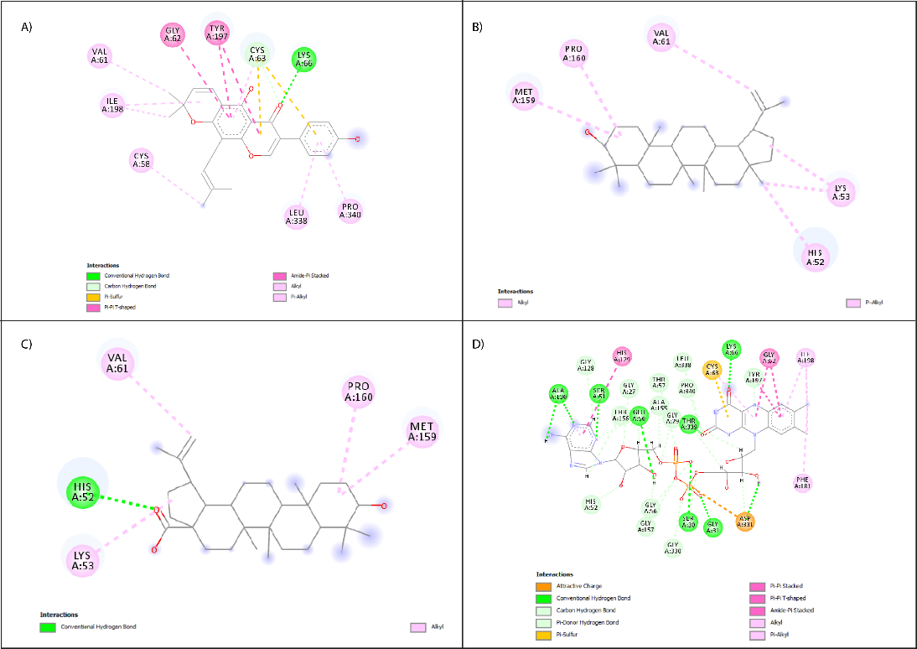

**Supplementary Fig. S1: 2D interaction of A) Warangalone B) Lupeol C) Betulinic acid D) co-crystalized ligand with glutathione reductase (PDB ID: 1XAN)**

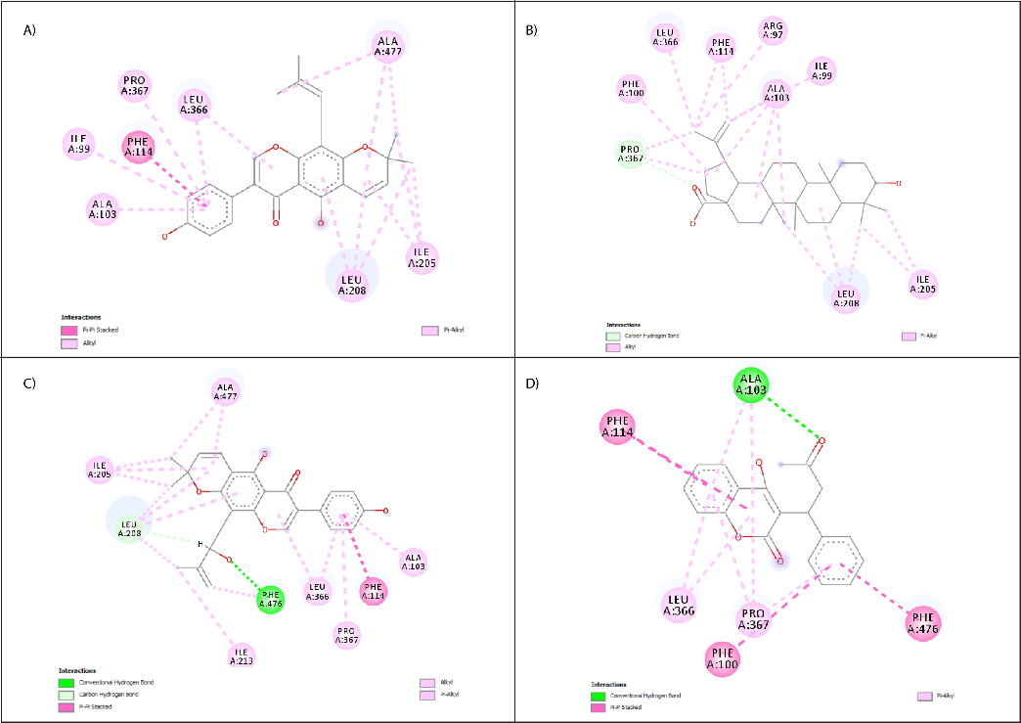

**Supplementary Fig. S2: 2D interaction of A) warangalone B) Betulinic acid C) Euchrenone b8 D) co-crystalized ligand with human cytochrome P450 CYP2C9 (PDB ID: 1OG5)**

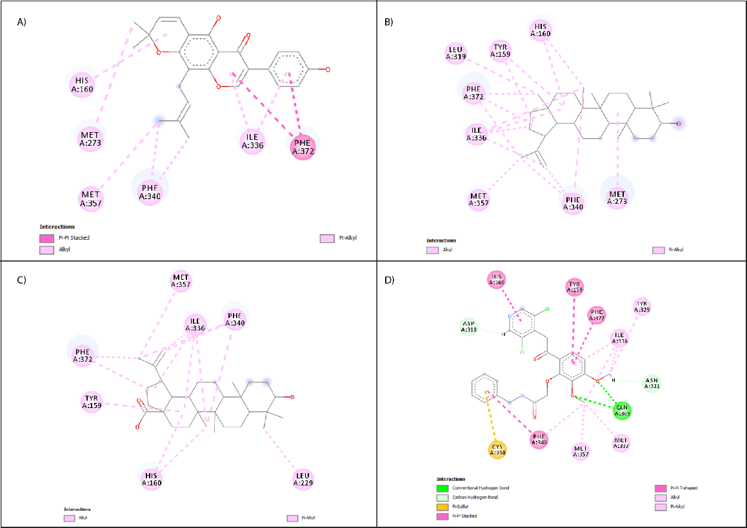

**Supplementary Fig. S3: 2D interaction of A) Warangalone B) Lupeol C) Betulinic acid D) co-crystalized ligand with phosphodiesterase-4 inhibitor (PDE4) receptor (PDB ID: 4WCU)**