**Phenotypic Screening of Gerbera Varieties for Field Tolerance Against Sucking Pests Under In-Situ and Ex-Situ Conditions**

**Abstract**

Gerbera is an important ornamental flower crop grown worldwide, significantly contributing to the national economy. In India, it serves as a major source of livelihood for both rural and urban flower industries. However, the yield of Gerbera is severely affected by sucking pests, which attack the crop at all growth stages. To identify tolerant varieties, present study was conducted in 2019-20 at the College of Agriculture, Vellayani, Thiruvananthapuram, to evaluate the field tolerance of Gerbera varieties against sucking pests under in-situ and ex-situ conditions. The experiment followed a Completely Randomized Block Design with five varieties viz.,Cappablanca, Aquamelone, Beaudine, Esmara and Sona replicated four times. These varieties were naturally exposed to thrips (*Scirtothrips dorsalis*), mites, aphids, scales, and mealybugs (*Planococcus citri*) under polyhouse conditions. Among the screened varieties, Beaudine (26.85) and Esmara (30.79) recorded the lowest thrips infestation, while Cappablanca (58.52) was the most susceptible. Beaudine also had the lowest mealybug infestation (31.25), whereas Sona recorded the highest (97.81). Overall, Beaudine demonstrated the highest tolerance to sucking pests, making it a promising variety for pest management in Gerbera cultivation, while Sona was the most susceptible.

**Key words:** Aphids, Gerbera, Mites, Mealybugs, Scales, Sucking Pest and Thrips

**Introduction**

Gerbera (*Gerbera jamesonii Bolus*), a member of the Asteraceae family, is one of the most widely cultivated ornamental flowers globally. While the genus includes 40 species, *G. jamesonii* is the most commercially important. It is a major source of income in floriculture, valued not only as a cut flower but also in cosmetics, medicine, and ornamental landscaping (Kaur *et al*., 2021). However, Gerbera is highly sensitive to pests, diseases, and environmental stresses. Recent studies indicate that sucking pest infestations significantly reduce its yield and quality, leading to economic losses (Abraham *et al*., 2012).

Gerbera is susceptible to several major pests, including whitefly (*Bemisia tabaci, Trialeurodes vaporariorum*), onion thrips (*Thrips tabaci*), western flower thrips (*Frankliniella occidentalis*), aphid (*Myzus persicae*), serpentine leaf miner (*Liriomyza trifolii*), two-spotted spider mite (*Tetranychus urticae*), yellow mite (*Polyphagotarsonemus latus*), and armyworm (*Spodoptera litura*) (Rani & Mohan, 1997; Hole *et al*., 2007). Additionally, *Helicoverpa armigera* and *S. litura* are highly destructive pests (Shah, 2014). Their infestation significantly impacts Gerbera yield and quality.

Prabhatchandra (2015) screened eight Gerbera varieties for aphid resistance, identifying ‘Latara’ (0.67) and ‘Alcatraz’ (0.76) as resistant, while ‘Dakota’ (1.01) was moderately resistant. ‘Terrajuba’ (3.18) was highly susceptible, and ‘Faith’ (3.00) and ‘Basic’ (2.81) were moderately susceptible. Reddy and Janakiram (2004) evaluated 52 chrysanthemum varieties under polyhouse conditions, finding 10 resistant, 21 moderately resistant, 16 susceptible, and 5 highly susceptible (>25 aphids/shoot, >50% affected leaves). These findings aid in selecting resistant varieties for cultivation.

Munib and Abass (2015) screened rose cultivars for aphid (*Macrosiphum rosae*) resistance, reporting the highest infestation in ‘Grand Gala’ (1.33) and ‘Nobless’ (1.10), while ‘Konifittii’ had the lowest (0.55). Hole and Salunkhe (2005) found ‘Rajhans’ least susceptible to Tetranychus urticae (16.08 mites/leaf), whereas ‘Arjun’ was highly susceptible (40.01 mites/leaf). Sudhirkumar (2008) identified ‘First Red’ as highly susceptible under polyhouse conditions. Toke (2010) reported ‘Sakira’ (8.17 mites/leaf) as least susceptible, while ‘First Red’ (12.87 mites/leaf) was the most susceptible. These findings aid in selecting resistant rose cultivars for pest management. By keeping all these in view the present experiment was carried with the objective of evaluation of gerbera varieties for field tolerance against sucking pests in controlled and natural environments.

**Materials and methods**

The study was conducted at the College of Agriculture, Vellayani, Thiruvananthapuram, from June 2019 to February 2020 to evaluate the field tolerance of Gerbera varieties to sucking pests under polyhouse conditions. Five varieties—Cappablanca, Aquamelone, Beaudine, Esmara, and Sona—were cultivated in polybags using a Completely Randomized Design with four replications. Thrips (*Scirtothrips dorsalis, Haplothrips sp.*) and mealybugs (*Planococcus citri*) were observed during the study. Pest populations were recorded from three randomly selected leaves (top, middle, and bottom) per plant. Infestation percentages on leaves, flower buds, and flowers were documented. Data were statistically analyzed using WASP software (Panse & Sukhatme, 1967), applying appropriate transformations for significance testing.

**Results and discussion**

**Population and extent of infestation of thrips, *S. dorsalis* in different varieties of gerbera**

The population and infestation of thrips (*Scirtothrips dorsalis*) on Gerbera leaves varied significantly across varieties (Fig.1). The lowest thrips population was recorded in Beaudine (26.85), which was statistically on par with Esmara (30.79) and Aquamelone (31.12). In contrast, Cappablanca (58.52) had the highest infestation, followed by Sona (50.62), both of which were comparable. However, no significant differences were observed among varieties in terms of the percentage of infested leaves, which ranged from 23.55% to 34.24% (Fig. 2 to 7).

The findings of the present study align with the reports of Rani and Mohan (1997) and Hole *et al*. (2007), who also observed that thrips and other sucking pests significantly impact gerbera yield. Similarly, Prabhatchandra (2015) screened gerbera varieties for resistance against sucking pests and identified a few genotypes with tolerance. Our results support these findings, as one variety, Beaudine, exhibited lower infestation levels, indicating its potential resistance to sucking pests. This suggests that selecting resistant varieties can be an effective strategy for managing pest infestations and minimizing yield losses in gerbera cultivation.

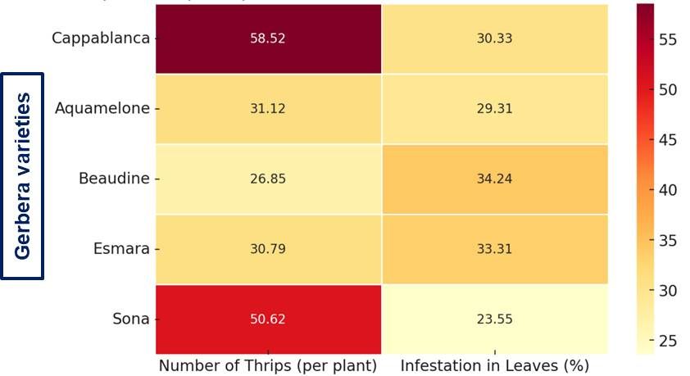

**Fig. 1. Population and infestation of thrips gerbera under polyhouse condition (red color indicates higher values; light yellow color indicates lower values)**

**Infestation of *Haplothrips sp.* in gerbera Varieties**

The extent of infestation of *Haplothrips sp.* in flower buds and flowers of various gerbera varieties is presented in Fig .2. The results indicate no significant variation among the varieties regarding the percentage of infested flower buds (ranging from 20.20% to 41.14%) and flowers (51.04% to 75.51%).

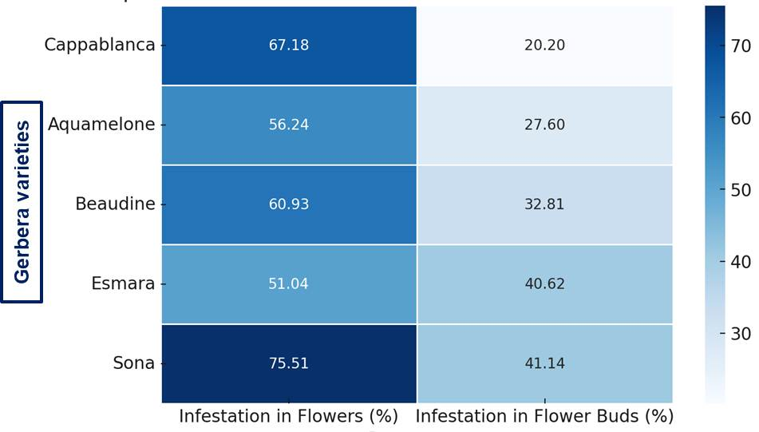

**Fig. 2. Infestation of thrips, *Haplothrips sp*.in gerbera under polyhouse condition (dark blue color indicates higher values; light blue color indicates lower values)**

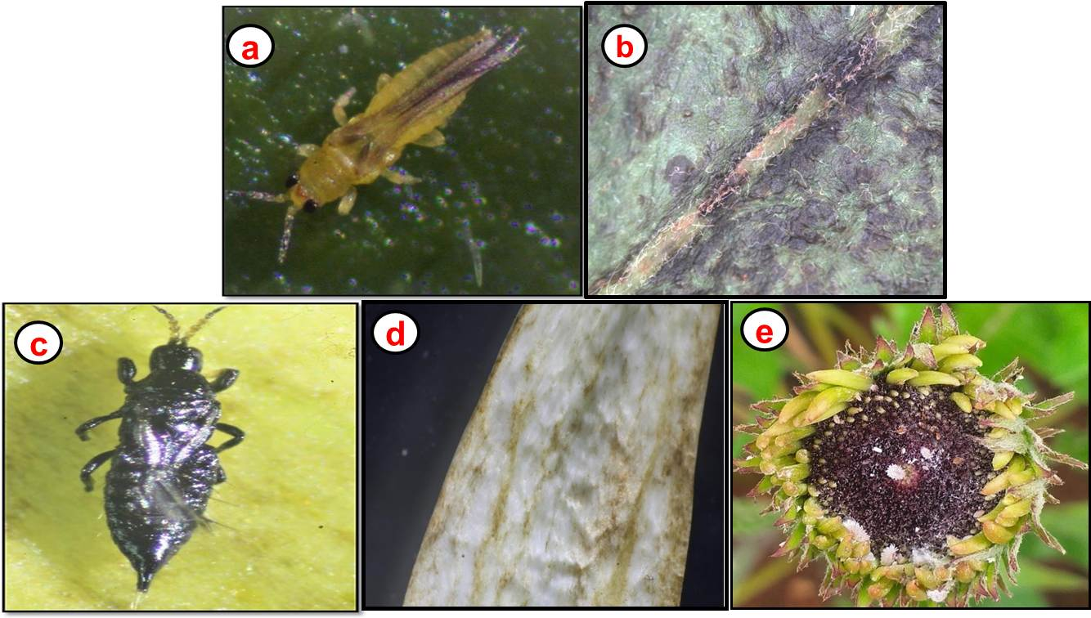

**Fig. 3: Documentation of sucking pest infestation in gerbera—(a, b) Thrips and associated leaf damage, (c, d, e) flower and leaf damage caused by *Haplothrips sp*.**

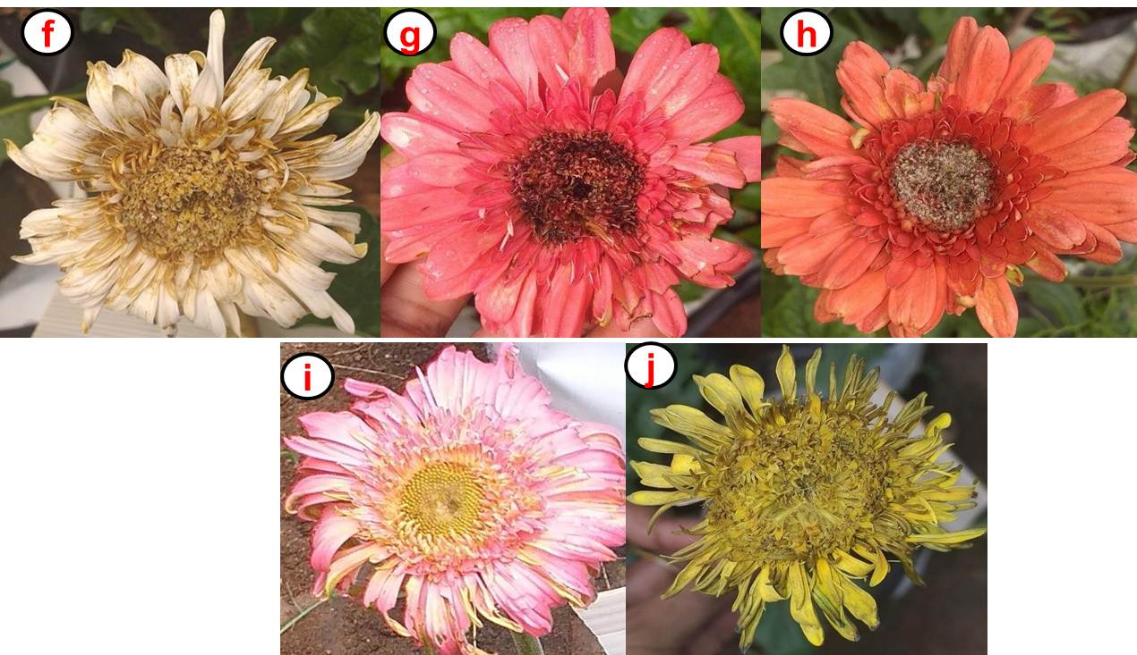

**Fig. 4: Documentation of sucking pest infestation in different Gerbera varieties—(f) Haplothrips sp. damage in Cappablanca, (g) Aquamelone, (h) Beaudine, (i) Esmara, and (j) Sona.)**

**Population and Infestation Levels of *Planococcus citri* in Different Gerbera Varieties**

The population and infestation levels of mealybugs on different gerbera varieties are presented in Table 1. Among the varieties, Beaudine recorded the lowest mealybug population (31.25), followed by Cappablanca (41.62), Esmara (42.62), and Aquamelone (48.50), all of which were statistically on par. Sona exhibited the highest mealybug population (97.81), significantly differing from the other varieties. Leaf infestation was lowest in Beaudine (30.03%), followed by Cappablanca (30.59%), Esmara (32.56%), and Aquamelone (35.49%), with no significant differences among them. However, Sona showed the highest infestation (51.86%), which was significantly different from the rest. No significant variation was observed in mealybug infestation on flowers across varieties (39.58% to 52.08%). However, flower bud infestation was significantly lower in Esmara (28.12%), which was on par with Beaudine (32.81%) and Sona (38.53%). In contrast, Cappablanca exhibited the highest flower bud damage (62.50%), followed by Aquamelone (49.99%), with both showing statistical similarity. Limited studies exist on the field tolerance of gerbera varieties to sucking pests. Prabhatchandra (2015) screened eight gerbera varieties for aphid resistance and found that Latara had the lowest aphid index (0.67), on par with Alcatraz (0.76) and Dakota (1.01). The highest aphid index was recorded in Terrajuba (3.18), followed by Faith (3.00) and Basic (2.81). The present findings align with previous studies by Rani & Mohan (1997), Hole et al. (2007), and Shah (2014), who screened various flower crop varieties for resistance to sucking pests. Their studies reported that several susceptible varieties suffered severe economic losses due to pest infestations. In the current experiment, Beaudine exhibited resistance to sucking pests, indicating its potential as a donor variety for developing pest-resistant gerbera cultivars. These results highlight the importance of selecting resistant varieties to minimize yield losses and enhance sustainable flower production.

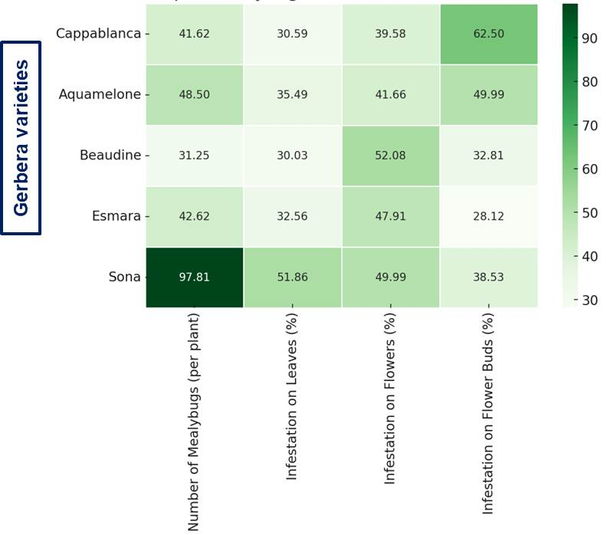

**Fig. 5. Population and infestation of mealybugs in gerbera under polyhouse condition (red color indicates higher values, light yellow color indicates lower values)**

**Conclusion**

This study assessed the field tolerance of five gerbera varieties to major sucking pests under polyhouse conditions. Beaudine showed the highest resistance, with the lowest infestation of thrips (26.85) and mealybugs (31.25), while Sona was the most susceptible (97.81). No significant differences were observed in flower bud and flower infestation among varieties. These findings suggest that Beaudine could be a potential donor for breeding pest-resistant gerbera cultivars. Selecting tolerant varieties can aid in integrated pest management (IPM), reducing pesticide dependence and promoting sustainable cultivation. Further molecular and biochemical studies are needed to understand resistance mechanisms.

**References**

Abraham, C. M. 2012. Developing integrated pest management strategies for greenhouse gerbera daisies. M. Sc. (Ag) thesis, University of Georgia, Athens, 187p.

Hole, U. B. 2007. Management of pests infesting rose under polyhouse condition. M.Sc. (Ag) thesis, Mahatma Phule Krishi Vidyapeeth, Rahuri, 179p.

Hole, U. B. and Salunkhe, G. N. 2005. Studies on the relative resistance of rose cultivars to two spotted spider mite (*Tetranychus urticae* Koch). *J. Maharashtra Agric. Univ.* 30(3): 316- 317.

Kaur, S., Singh, J., Singh, B., & Singh, G. (2021). Introduction and Scope of Gerbera. Just Agriculture. 2(3): 1-4.

Munib, M. and Abass, M. A. A. 2015. Survey and screening of different rose cultivars against rose aphid (*Macrosiphum rosae*). *J. Eco-friendly Agric.* 10(2): 175-179.

Panse, V. G. and Sukhatme, P. V. 1967. Statistical method for Agricultural workers. Second edition. Indian Council of Agricultural Research. New Delhi, 381p.

Prabhatchandra, P. P. 2015. Seasonal abundance, screening of genotypes and chemical control of gerbera aphid. M. Sc. (Ag.) thesis, Navsari Agricultural University, Navsari, 46p**.**

Rani, B. J. and Mohan, N. J. 1997. Pest management in ornamental crops. Progressive Floriculture 169 – 181.

Reddy, P. V. and Janakiram, T. 2004. Germplasm evaluation of chrysanthemum for resistance to aphid, *Macrosiphoniella sanbornii* (Gillette). *J. Ornamental Hortic.* 7(4): 27-31.

Shah, D. R. 2014. Studies on mite (Tetranychus urticae Koch) infesting gerbera (*Gerbera jamesonii*) under polyhouse condition. M. Sc. (Ag) thesis, Navsari Agricultural University, Navsari, 182p.

Sudhirkumar, S. 2008. Bioefficacy of newer miticides against two spotted spider mite (*Tetranychus urticae* Koch) on rose under polyhouse condition. M. Sc. (Ag) thesis, Mahatma Phule Krishi Vidyapeeth, Rahuri, 97p.

Toke, N. 2010. Biology, population dyanmics, varietal screening and chemical control of rose mite (*Tetranychus urticae* Koch) M. Sc. (Ag) thesis, Navsari Agricultural University, Navsari, 153p.