Journal Name: | Journal of Scientific Research and Reports
Manuscript Number: | Ms_JSRR_130172
Title of the Manuscript: | Impact of Biostimulant Soil Application on Improving Soil Properties and Nutrient Availability in Sweet Potato Fields
Type of the Article

PART 1: Comments

 | Reviewer’s comment | Author’s Feedback (Please correct the manuscript and highlight that part in the manuscript. It is mandatory that authors should write his/her feedback here)
Please write a few sentences regarding the importance of this manuscript for the scientific community. A minimum of 3-4 sentences may be required for this part. | Biostimulants influence the efficiency of plant nutrient use, develop tolerance to biotic and abiotic stress, improve the quality and increase the availability of nutrients in the rhizosphere.  The approach is particularly valuable in terms of reducing the consumption of mineral fertilizers
Is the title of the article suitable?  (If not please suggest an alternative title) | yes

Is the abstract of the article comprehensive? Do you suggest the addition (or deletion) of some points in this section? Please write your suggestions here.

Is the manuscript scientifically, correct? Please write here. | yes
Are the references sufficient and recent? If you have suggestions of additional references, please mention them in the review form. | yes
Optional/General comments Is the language/English quality of the article suitable for scholarly communications? | yes
My suggestion is to transform the tables into graphs. The statistically assured differences between the variants (a, b, c ...significance) are obvious.

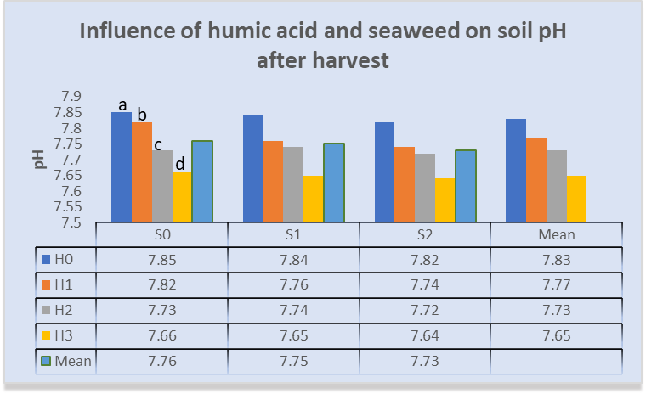

Table 2. Effect of humic acid and seaweed on soil pH after harvest.
Seaweed  Humic acid | S₀ | S₁ | S₂ | Mean
H₀ | 7.85 | 7.84 | 7.82 | 7.83
H₁ | 7.82 | 7.76 | 7.74 | 7.77
H₂ | 7.73 | 7.74 | 7.72 | 7.73
H₃ | 7.66 | 7.65 | 7.64 | 7.65
Mean | 7.76 | 7.75 | 7.73

PART 2:

 | Reviewer’s comment | Author’s comment (if agreed with reviewer, correct the manuscript and highlight that part in the manuscript. It is mandatory that authors should write his/her feedback here)
Are there ethical issues in this manuscript? | (If yes, Kindly please write down the ethical issues here in details)

Reviewer Details:

Name: | Nicola Claudia
Department, University & Country | National Institute for Research and Development of Biotechnologies in Horticulture Stefanesti, Romania

