**A Pharmacological Investigation of *Boerhaavia diffusa*:** **Anticancer, Antidiabetic, Analgesic, and Neuropharmacological Properties**

**Abstract**

*Boerhaavia diffusa*, commonly known as Punarnava, is a medicinal plant widely used in traditional medicine due to its rich phytochemical composition, including flavonoids, alkaloids, glycosides, and phenolic compounds. This study investigates the anticancer, antidiabetic, neuropharmacological, and analgesic properties of the methanolic extract of *Boerhaavia diffusa* (MEBD) using *in vitro* and *in vivo* models. The anticancer activity was evaluated using HeLa cell lines, where MEBD demonstrated significant inhibition of cell viability, with the highest inhibition (29.16%) observed at 1000 µm/mL. Morphological changes in cancer cells further supported its anticancer potential. For antidiabetic activity, MEBD was tested on streptozotocin-induced diabetic rats, showing a dose-dependent reduction in blood glucose levels, with the most significant effect at 400 mg/kg. Neuropharmacological effects were assessed through thiopental sodium-induced sleep and forced swimming tests. MEBD at 400 mg/kg significantly prolonged sleep duration and increased immobility time, indicating potential anxiolytic and antidepressant properties. Analgesic effects were evaluated using hot plate and formalin-induced nociception tests. MEBD at 500 mg/kg showed the highest latency in the hot plate test and significantly reduced nociceptive behavior in the formalin test, suggesting strong analgesic and anti-inflammatory properties. The results highlight the therapeutic potential of MEBD, with higher doses (400-500 mg/kg) demonstrating more pronounced effects across all tested activities. The study concludes that *Boerhaavia diffusa* possesses significant pharmacological properties, making it a promising candidate for developing novel treatments for cancer, diabetes, neurological disorders, and pain. Further research is needed to identify the specific bioactive compounds and their mechanisms of action.

**Keywords:** *Boerhaavia diffusa*, Anticancer, Antidiabetic, Analgesic, Neuropharmacological.

**1. INTRODUCTION**

Medicinal plants have long been used for centuries across the world to cure several health conditions (Jamshidi-Kia et al., 2017). They contain various bioactive compounds which is very effective for treating different kinds of ailments (Mgbeahuruike et al., 2017). According to a study, most of the people living in developing countries still use medicinal plants as their primary remedy due to cheap cost and its diverse therapeutic capabilities (Salmerón et al., 2020). For example, in Indian subcontinent, medicinal herbs have been used in the form of Ayurveda, as well as Unani, Siddha and folk medicine since the ancient times (Rupani et al., 2018). However, despite their rich historical significance and widespread use, the necessity for medicinal plants remains still significant today.

Among the many herbs used in traditional medicine, *Boerhaavia diffusa*—also known as Punarnava—stands out because of its great variety of therapeutic effects. This plant is rich in various bioactive compounds including alkaloids, flavonoids, glycosides, tannins, steroids, terpenoids, and phenolic compounds (Kaur et al., 2019). These compounds are believed to contribute to its medicinal efficacy, demonstrating properties such as anti-inflammatory, antioxidant, diuretic, and others (Nayak et al., 2016).

Although *B. diffusa* is widely used in folk medicine, its full therapeutic potential still remains unexplored in the scientific community. In other words, very few scientific studies have been conducted about its medicinal properties, especially in terms of its anticancer, antidiabetic, analgesic, and neuropharmacological effects. Anticancer properties involve the ability to inhibit the growth of cancer cells (Greenwell et al., 2015). This is done by targeting the key molecular pathways that regulate cell proliferation and also by preventing uncontrolled cell division (Vallianou et al., 2015). The anticancer agents can also induce apostasies (programmed cell death) in tumour cells which effectively reduces tumour size (Sa’adatu et al., 2022). In this paper, we are going to examine the anticancer properties of *B. diffusa* thoroughly. Likewise, the analgesic effects of this plant has not been explored fully. Analgesic properties refer to the ability of alleviating pain. Analgesic agents often reduces inflammation or even sometimes can block the pain signalling pathways and thus offering relief from conditions such as arthritis, neuropathy, or acute injuries (Lende et al., 2011). The antidiabetic and neuropharmacological aspect of this plant also lacks proper attention and research. By either boosting insulin production, improving glucose absorption, or preventing carbohydrate breakdown, the antidiabetic characteristics help control blood glucose (Mamun et al., 2014). Additionally, the neuropharmacological properties influence neurotransmitter activity, neuronal signaling, and neuroprotection, aiding in conditions like anxiety, epilepsy, and neurodegeneration (Roohbakhsh et al., 2014). In this paper, we are going to explore these medicinal aspects of *B. diffusa* to understand its therapeutic potential.

This study aims to address these critical literature gaps by examining the anticancer, antidiabetic, analgesic, and neuropharmacological effects of *Boerhaavia diffusa* using *in vitro* experimental models. Examining these properties will not only contribute to the current scientific understanding of its bioactive compounds but will also be used to treat conditions such as microbial infections, cancer, and thrombolytic diseases. The results of this work may inspire the development of novel medications based on *Boerhaavia diffusa*, thus extending its role in modern medicine.’

**2. MATERIAL and METHOD**

**2.1 Plant Merial**

The fresh specimens were gathered from Dhaka, Bangladesh in September 2024 and subsequently identified by the taxonomist at the Bangladesh National Herbarium, located in Mirpur, Dhaka. An accession number was assigned, and a voucher specimen (DACB: 41278) has been deposited in the herbarium for future reference. The dried and powdered plant material (100g) was immersed in 300ml of methanol for a duration of 10 days. Subsequently, the extract underwent filtration through a cotton plug, followed by Whatman filter paper number 1. The resulting solution was then concentrated utilizing a rotary evaporator at a low temperature range of 40-50°C and under reduced pressure (Shomudro, Aboni, et al., 2023).

**2.2 Anticancer Test**

**2.2.1 Cell viability assay**

Cells were maintained in their designated media within 96-well plates until they achieved an approximate confluence of 70%. Following this, the cells were subjected to different concentrations of the extract, alongside a control comprising the vehicle/DMSO, for a duration of approximately 24 hours. Subsequently, the media was eliminated to facilitate the cleansing of the cells utilizing phosphate buffer saline (PBS). A 0.5 mg/ml solution of MTT was introduced to each well, followed by incubation of the plate at 37 °C for a duration of 4 hours, ensuring the absence of light during this period. Following the incubation period, the MTT solution was substituted with 200 μl of DMSO. The plate underwent agitation at a rate of 150 rpm for a duration of 5 minutes, after which the optical density was assessed at 490 nm utilizing a plate reader (ELx 800; Biotek, Winooski, VT, USA). The experiment was performed repeatedly to assure precise data for graphical representation (Ritu et al., 2024).

**2.2.2 Morphology study**

Cells were seeded in 24-well plates and treated with DMSO or extract at the IC50 concentration for a duration of 24 hours. Subsequent to the administration of the treatment, the image was obtained utilizing phase contrast microscopy.

**3. *In Vivo* test**

**3.1 Experimental Animals**

For this entire investigation, young, healthy *Swiss albino* mice with a weight range of 22-25 g and *Rattus norvegicus* rats weighing between 110-122 g were utilized. The mice and rats were obtained from the Saver facility at Jahangirnagar University in Dhaka, Bangladesh. A temperature of 77°F, a relative humidity ranging from 55 to 65%, and a diurnal cycle of light and dark exemplify standard atmospheric variations. Following the collection, the conditions persist without alteration for a duration of eight days. To assist the mice in recovering from the water and food scarcity experienced during transit and to facilitate their acclimatization to the laboratory environment, a diet comprising adequate nutrition and clean water was administered, adhering to the protocols established by Jahangirnagar University. The mice underwent a recovery period of ten days prior to the initiation of the experiment.

**3.2 Antidiabetic test**

**3.2.1 Diabetes Induction**

Streptozotocin was administered to rats with a single intravenous injection after a 16-hour fasting interval. The pharmaceutical compound was solubilized in a citrate buffer at a pH of 4.5. Animals demonstrating post-prandial glycemia levels beyond 250 mg/kg, five days post-streptozotocin treatment, were categorized as diabetic. Non-diabetic control mice received an injection of citrate buffer (Akter, Nazim, et al., 2024).

**3.2.2 Oral Glucose Tolerance Test (OGTT)**

The OGTT was performed on overnight-fasted animals, including normal, diabetic control, and diabetic subjects administered with 200 and 400 mg/kg of extract. This was conducted after a 7-day regimen with the extract. All animals received a dosage of 2.5 g of glucose per kilogram of body mass. Plasma glucose concentrations were evaluated in blood samples collected from the tail tip at several time intervals: before to glucose injection (t = 0), and at 30, 60, 120, and 180 minutes post-delivery.

**3.4 Neuropharmacological Test**

**3.4.1 Evaluation of Sleep Duration Induced by Thiopental Sodium**

The subjects were stratified into five cohorts, each comprising five mice, utilizing a randomized selection methodology. Each cohort of mice was administered distinct treatments and subsequently housed in circular enclosures. After a duration of 30 minutes, thiopental sodium was administered to each mouse at a dosage of 40 mg/kg through the intraperitoneal route to facilitate the induction of sleep. Data were collected concerning the interval between thiopental administrations and the onset of the loss of the righting response, in addition to the duration from the loss to the subsequent recovery of the righting reflex (Bravo-Hernández et al., 2012).

**3.4.2 Forced Swimming Test**

The approach employed in prior studies. Following the implementation of specific modifications, we executed the forced swimming test by categorizing the mice into five distinct groups, with each group comprising five individuals. Each group received a control, Imipramine hydrochloride, along with three distinct doses of the extract. A cylindrical glass vessel with a height of 45 cm and a diameter of 20 cm was employed for the experimental procedure. The container was filled with water maintained at a temperature of 25±1ºC, reaching a depth of 17 cm. A mouse is classified as immobile when it remains suspended in water, exhibiting minimal motion to maintain its head above the surface. The experiment was performed from 1 P.M. to 3 P.M. for a duration of 5 minutes (Rahman et al., 2019).

**3.5. Analgesic Test**

**3.5.1 Hot plate test**

Employing the established protocol from prior studies, the analgesic efficacy was assessed utilizing the hot-plate test (Eddy's hot plate). A thermostat was calibrated to maintain the temperature at 51°±1° C. Mice of both sexes were divided into four groups, each consisting of five individual mice. Each cohort of mice was placed in a beaker positioned on a hot plate to assess their response to stimuli induced by electrical heat pain. Behaviors such as paw licking were documented as indicators of the animal's response to the painful heat. The response time (in seconds) of each mouse was quantified by recording the duration it took for them to either lick their paws or escape from the beaker. The response time was assessed prior to the administration of any therapeutic intervention. The mean initial response time prior to treatment for each group of mice was calculated based on this assessment. Subsequently, each test mouse received an oral administration of either distilled water (DW), Diclofenac sodium at a dosage of 10 mg/kg body weight, or MEBD at dosages of 200 and 400 mg/kg body weight, respectively. Reaction times were assessed five times at one-hour intervals, commencing 30 minutes post-administration of therapy in each cohort of mice (Chowdhury et al., 2023).

Percent Analgesic Score = $\frac{Ta-Tb}{Ta}$ X100.

Time (in seconds) to react (before medication administration): Tb; Time (in seconds) to react (after drug administration): Ta.

**3.5.2 Formalin induced antinociception test**

The formalin test is a reliable and accurate model of nociception because it results in two different phases of increased licking activity that are linked to different nociceptive pathways. There are two stages of licking after the formalin injection: the early stage lasts for the first five minutes, and the late stage happens 15 to 45 minutes later. As previously stated, a subcutaneous injection of formalin (20μL of a 2.5% solution) was administered to the dorsal surface of the right hind paw. A 45-degree angled mirror was then employed, and the animals were placed on a glass surface under a glass funnel [16]. The nociceptors directly caused the first phase of the pain response time (licking time), which lasted 0 to 5 minutes, and the second phase, which lasted 15 to 45 minutes and was brought on by the release of inflammatory mediators and resulted in inflammatory pain. They were divided into five groups (n = 5) of animals at random. The animals in the negative control group received 0.5 mL of ordinary saline. Morphine (10 mg/kg, Temad Co., Iran) was administered to the animals in the positive control group. The other groups received MEBD at different doses (250 and 500 mg/kg). The injections were all given intraperitoneally half an hour before to the test (Ritu et al., 2024).

**4. Statistical Analysis**

The experimental data was replicated three times, and the mean and standard deviation were used to represent the results. Excel is commonly utilized for conducting statistical analyses.

**5. Results**

**5.1 Anticancer activity**

The alcoholic extract (MEBD) of the plant materials underwent standardization through established methodologies, and its efficacy as an anticancer agent was assessed using HeLa cell lines. The methanolic extract derived from the *Boerhaavia diffusa* plant exhibited noteworthy outcomes, as presented in Table 1.

**Table 1. Anticancer activity of MEBD**

|  |  |  |
| --- | --- | --- |
| **Concentration (µm/mL)** | **Survival of the cell (%)** | **% of Inhibition** |
| 125 | 85.69 | 14.31 |
| 250 | 76.94 | 23.06 |
| 500 | 69.63 | 30.37 |
| 1000 | 60.84 | 39.16 |

The data presented in Table 1 illustrates the anticancer activity of MEBD, showing a concentration-dependent increase in the percentage of cell inhibition. Figure 1a further visualizes this trend.

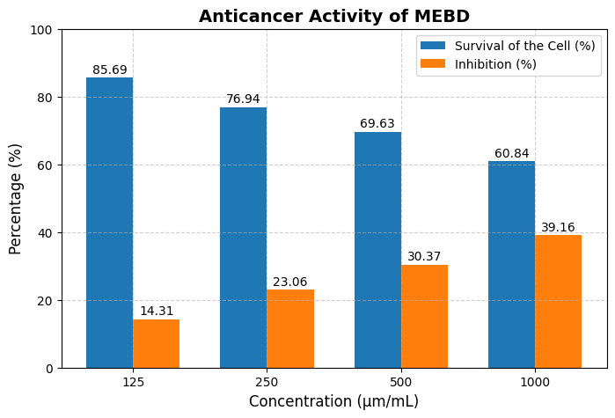

**Fig. 1a:** Anticancer activity of MEBD at varying concentrations, showing cell survival and inhibition percentages.

**Figure 1** illustrates the anticancer activity of MEBD, showing the percentage of inhibition at varying concentrations. The results indicate a concentration-dependent increase in inhibition, with the highest suppression observed at 1000 µm/mL.

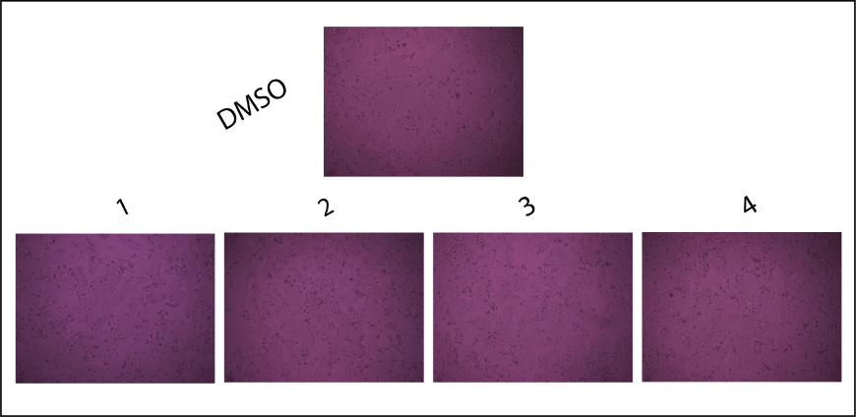

Figure.1b. Morphological changes at MEBD concentrations (125–1000 μm/mL).

Figure 1b presents a phase contrast image that illustrates significant and clear morphological changes. The serial numbers 1, 2, 3, and 4 denote the concentrations of MEBD, which vary from 125 to 1000 μm/mL, as outlined in Table 1.

**5.2 Antidiabetic Test**

The study presents strong findings indicating that MEBD, especially at dosages of 150 mg/kg and 300 mg/kg, markedly reduces blood glucose concentrations in diabetic murine models. The data presented in Table 2 indicate strong evidence that MEBD may function as a viable therapeutic agent for the management of diabetes. A higher dosage of MEBD appears to exert a more significant impact on the condition.

**Table 2. Effect of MEBD on Rats Blood Glucose for Antidiabetic Activity**

|  |  |  |  |  |  |  |  |  |  |
| --- | --- | --- | --- | --- | --- | --- | --- | --- | --- |
| **Test Samples** | | **Blood Glucose Levels at Varying Times (mmoles/L)** | | | | | | | |
| **½ hour** | | **1 hour** | | **2 hours** | | **3 hours** | |
| Control | | 5.21±0.05 | | 5.31±0.11 | | 5.33±0.03 | | 5.28±0.07 | |
| MEBD  (200 mg/kg) | | 11.55±0.20 | | 9.11±0.02 | | 7.46±0.31 | | 6.04±0.33 | |
| MEBD (400/mg/kg) | | 12.17±0.29 | | 7.31±0.16 | | 5.31±1.31 | | 4.21±0.17 | |
| Standard  Glibenclamide | 17.43±1.30 | | 8.51±0.07 | | 6.21±0.42 | | 4.96±0.11 | |

The data from Table 2 is visually represented in Figure 2, highlighting the reduction in blood glucose levels over time with different treatments.

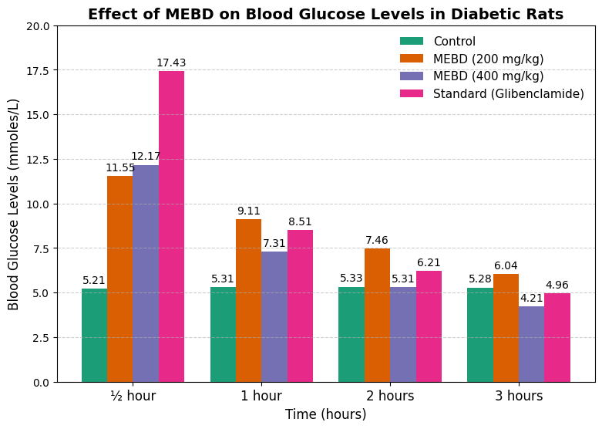

**Fig. 2:** Blood glucose levels in diabetic rats treated with MEBD, control, and glibenclamide over time

Figure 2 illustrates the effect of MEBD on blood glucose levels in diabetic rats over time. The data reveal a significant reduction in glucose levels, with higher MEBD dosages (400 mg/kg) showing a comparable effect to the standard drug, glibenclamide.

**5.3 Neuropharmacological Activity**

**5.3.1 Thiopental sodium induced sleeping time test**

The MEBD administered at dosages of 200 and 400 mg/kg exhibited a notable effect on sleep as assessed by the thiopental sodium-induced hypnosis test. Furthermore, the extract demonstrated a dose-dependent influence on the duration of sleep induced by thiopental sodium at dosages of 200 and 400 mg/kg. Furthermore, a comparison with the control group indicated that both administered doses led to an enhancement in the duration of sleep observed in the test subjects, as illustrated in Table 3.

**Table 3. Effect of MEBD on Thiopental Sodium Induced Sleeping Time Test**

|  |  |  |  |
| --- | --- | --- | --- |
| **Treatment** | **Dose** | **Thiopental Sodium induced sleeping time** | |
| **Onset of action (min)** | **Duration in total (min)** |
| Control | 0.1mL/mice | 5.65±1.06 | 59.0±1.67 |
| Diazepam | 1 | 2.77±0.24 | 133.70±1.35 |
| MEBD | 200 | 4.91±0.49 | 115.2±15.21 |
| MEBD | 400 | 3.36±0.31 | 132.2±6.02 |

The data presented in Table 3 is graphically illustrated in Figure 3, demonstrating the effect of MEBD on thiopental sodium-induced sleeping time.

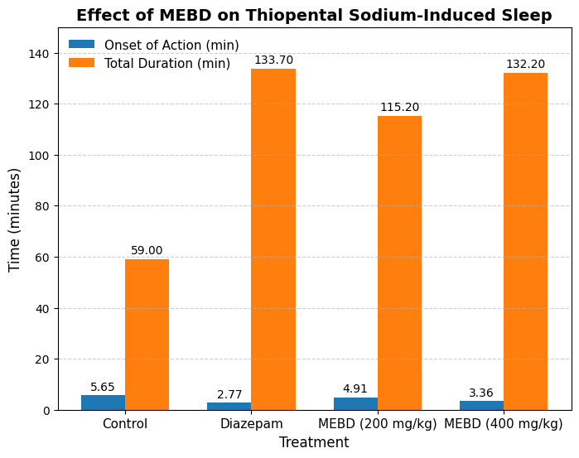

**Fig. 3:** Effect of MEBD on thiopental sodium-induced sleep onset and duration in mice.

Figure 3 illustrates the effect of MEBD on thiopental sodium-induced sleep in mice. The extract significantly reduced the onset time and increased the total sleep duration in a dose-dependent manner, comparable to the standard drug, diazepam.

**5.3.2 Forced swimming test**

The administration of MEBD at doses of 200 and 400 mg/kg resulted in a significant prolongation of immobility time when compared to the control group. In the murine model, administration of the standard pharmacological agent diazepam (1 mg/kg, i.p.) significantly enhanced the duration of immobility observed. The most pronounced depressive effect of *Boerhaavia diffusa* was noted at a dosage of 200 mg/kg (Table 4).

**Table 4. Effect of MEBD on Forced Swimming Test**

|  |  |  |
| --- | --- | --- |
| Treatment | Dose (mg/kg) | mobility time (s) |
| Control | 0.1mL/mice | 25.60±1.23 |
| Diazepam | 1 | 92.63±1.11 |
| MEBD | 200 | 61.00±1.01 |
| MEBD | 400 | 76.46±0.5 |

The findings from Table 4 are visually represented in Figure 4, illustrating the impact of MEBD on mobility time in the forced swimming test.

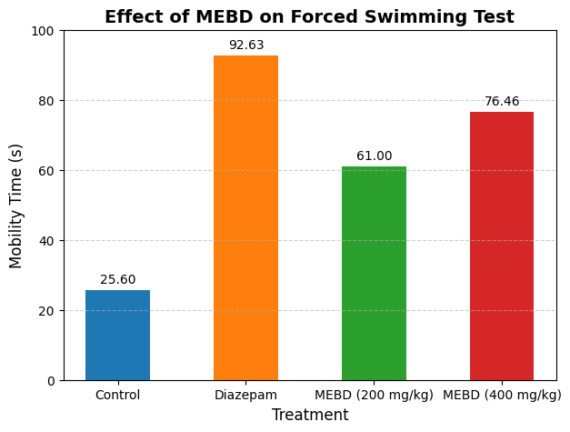

**Fig. 4:** Effect of MEBD on immobility time in the forced swimming test.

Figure 4 illustrates the effect of MEBD on mobility time in the forced swimming test. The extract significantly reduced mobility time in a dose-dependent manner, indicating potential depressant-like activity.

**6. Antinociceptive Activity**

**6.1 Hot plate test**

The outcomes of the experiments performed using the hot plate are presented in Table 5. When compared to the control group, the latency time (measured in seconds) exhibited a significant increase following the oral administration of MEBD at dosages of 250 and 500 mg/kg. A dose-dependent extension of the delay period was observed in both study cohorts. The administration of morphine at a dosage of 10 mg/kg resulted in the most significant prolongation of latency time. At the 90 and 120-minute marks, the extracts exhibited their maximum efficacy regarding their effects.

**Table 5.** **Primary data table for hot plate test for plant extract of MEBD**

|  |  |  |  |  |  |
| --- | --- | --- | --- | --- | --- |
| **Reaction time at different time intervals (in sec)** | | | | | |
| **Group** | **Average wt. of mice (g)** | **30 min** | **60 min** | **90 min** | **120 min** |
| Control | 22 to 27 | 6.4 | 7.0 | 6.0 | 5.9 |
| Morphine  (5mg/kg) | 8.6 | 9.4 | 11.0 | 16.6 |
| MEBD (250mg/kg) | 9.1 | 9.3 | 11.5 | 11.8 |
| MEBD (500mg/kg) | 8.3 | 8.4 | 9.0 | 14.7 |
|  |  |  |  |  |  |

The findings from Table 5 are visualized in figure 5 through a bar chart.

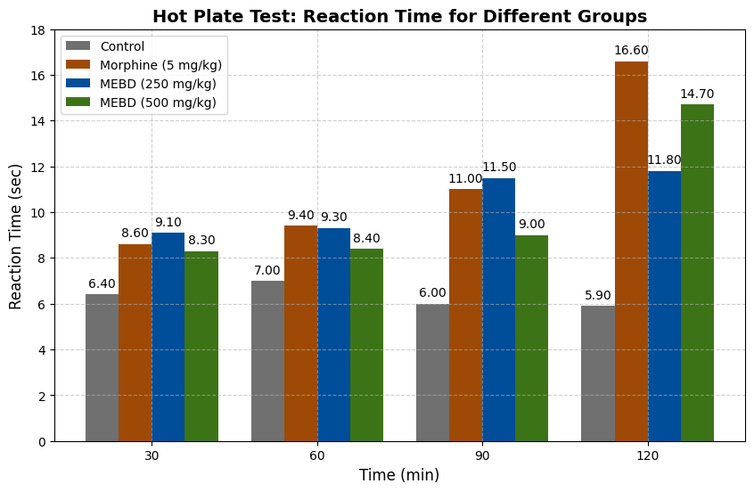

Fig. 5: Dose-dependent reaction time in the Hot Plate Test for MEBD, control, and morphine.

Figure 5 illustrates the **reaction time** for different groups in the **Hot Plate Test** across various time intervals. It highlights the dose-dependent increase in latency time for **MEBD** at 250 and 500 mg/kg, compared to the **control** and **morphine** groups.

**6.2 Formalin Induced Nociceptive activity**

The findings illustrated in Table 5 indicate that in the nociceptive phase (early phase), the administration of MEBD (250 mg/kg) led to a notable enhancement in nociceptive response when contrasted with the control group. In the late phase (phase II), MEBD at dosages of 250 and 500 mg/kg exhibited a significant antinociceptive effect.

|  |  |  |  |  |  |
| --- | --- | --- | --- | --- | --- |
| **Treatment** | **Dose (mg/kg)** | **Licking of the hind paw** | | | |
| **Early Phase** | **% of inhibition early phase** | **Late Phase** | **% of inhibition late phase** |
| Control  Diclofenac sodium  MEBD  MEBD | 0.1 mL/mice  10  250  500 | 24.50  10.30  22.0  13.50 | 0  64.398  17.785  45.675 | 14.70  4.80  10.10  7.35 | 0  75.683  69.56  80.15 |

**Table 6. Effect of MEBD on Formalin-Induced Nociceptive Activity in Mice.**

The findings from Table 6 are visually represented in Figure 6, illustrating the impact of MEBD on formalin-induced nociceptive activity in mice.

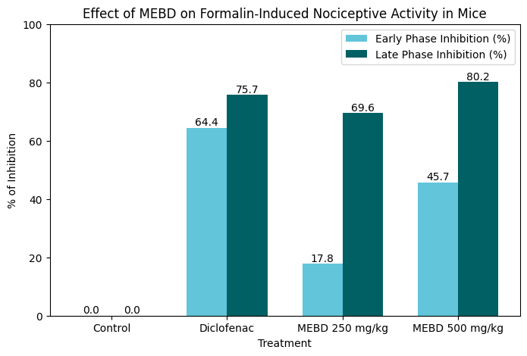

Fig. 6: Effect of MEBD on Formalin-Induced Nociceptive Activity in Mice

The bar graph shows that MEBD (250 mg/kg) increased nociceptive response in the early phase, while MEBD (250 and 500 mg/kg) significantly reduced nociceptive activity in the late phase. Higher doses of MEBD exhibited greater inhibition of nociceptive behaviour.

**7. DISCUSSION**

*Boerhaavia diffusa* (Punarnava) has rich phytochemical composition including alkaloids, flavonoids, glycosides, tannins, steroids, terpenoids, and phenolic compounds, which mostly explains its pharmacological features (Sharma & Singh, 2021). The many medicinal properties of the plant are attributed to these bioactive compounds: anticancer, antidiabetic, analgesic, and neuropharmacological actions. The function of these phytochemicals in mediating the noted pharmacological effects is discussed below. *B. diffusa's* flavonoids, alkaloids, and phenolic chemicals most certainly help to explain its anticancer actions. By altering important biochemical pathways involved in cell proliferation and survival, flavonoids like quercetin and kaempferol are well-known for causing programmed cell death—that is, death in cancer cells (Shomudro et al., 2023). With a dose-dependent lowering in cell survival, the methanolic extract of *B. diffusa* (MEBD) showed significant suppression of HeLa cell viability (Table 1). Flavonoids and phenolic compounds, which have been demonstrated to induce oxidative stress and DNA damage and so stop cancer cell growth, help to explain this effect (Akter et al., 2024). Furthermore, supporting the lethal properties of these phytochemicals are the morphological alterations seen in cancer cells treated with MEBD (Figure 2). *B. diffusa's* flavonoids, glycosides, and alkaloids—shown to increase insulin secretion, improve glucose absorption, and block carbohydrate-digesting enzymes—probably have antidiabetic actions (Pari & Amarnath Satheesh, 2004). In this work, especially at higher dosages, MEBD greatly lowered blood glucose levels in diabetic rats (Table 3). Important in the etiology of diabetes, oxidative stress and insulin sensitivity may be improved by the flavonoids in *B. diffusa* (Takey et al., 2024). Moreover, the glycosides in the plant might block alpha-amylase and alpha-glucosidase enzymes, thereby lowering post-prandial glucose levels (Akter et al., 2024). *B. diffusa's* alkaloids and flavonoids most certainly mediate its neuropharmacological actions; they have been demonstrated to alter neurotransmitter activity and provide neuroprotection (Mahesh et al., 2012). MEBD enhanced immobility time in the forced swimming test (Tables 4 and 5) and extended the length of sleep caused by thiopental sodium. These findings imply that *B. diffusa* may have anxiolytic and antidepressant qualities, maybe owing to its capacity to increase GABAergic neuromission, which is known to induce relaxation and lower anxiety (Bhuiyan et al., 2023). Reducing oxidative stress and inflammation in the brain, which are linked with neurodegenerative illnesses, the flavonoids in *B. diffusa* may also have neuroprotective benefits (Kumari et al., 2023). *B. diffusa's* alkaloids, flavonoids, and phenolic compounds most certainly contribute to its analgesic effects as they have been found to block lipoxygenase (LOX) and cyclooxygenase (COX), hence lowering the synthesis of pro-inflammatory mediators (Shomudro et al., 2023). In the formalin-induced pain model (Tables 4 and 5), MEBD dramatically shortened nociceptive behavior and greatly raised the latency time in the hot plate test. The anti-inflammatory and pain-relieving qualities of the plant's phytochemicals help to explain these benefits; they could inhibit pain signaling pathways and thus lower inflammation (Shaira et al., 2023). The flavonoids and phenolic chemicals in *B. diffusa* may also scavenge free radicals, therefore lowering oxidative stress and inflammation, which are major contributors to pain (Wang et al., 2019).

**8. Conclusion**

The complex phytochemical the composition of *Boerhaavia diffusa*—which includes flavonoids, alkaloids, glycosides, tannins, and phenolic compounds—mostly controls its pharmacological effects. These bioactive compounds assist the plant to have anticancer, antidiabetic, neuropharmacological, and analgesic properties by changing significant biochemical pathways, reducing oxidative stress, and thus decreasing inflammatory mediators. The findings of this investigation highlight the possibility of B. diffusa as a source of novel medicinal chemicals for the treatment of numerous diseases, including cancer, diabetes, neurological diseases, and pain. Greater research is needed to properly identify and characterize the specific phytochemicals generating these effects as well as to probe their mechanisms of action in greater depth.

**10 ETHICAL APPROVALS**

The authors confirm that all experiments were conducted in accordance with ethical guidelines and were reviewed by an appropriate ethics committee.

**11. COMPETING INTERESTS**

Authors have declared that no competing interests exist.

**REFERENCES**

1. Akter, J., Nazim, N. B., Uddin, M. S., & Shomudro, H. K. (2024). Phytochemical Characterization and Investigation of Anthelminthic, Antidiabetic, and Toxicological Effects of Polyscias scutellaria. *Journal of Applied Life Sciences International*, *27*(6), 1–9. https://doi.org/10.9734/jalsi/2024/v27i6660
2. Akter, J., Shomudro, H. K., & Chowdhury, S. A. (2024). Anti-Arthritic, Anti-Inflammatory, Thrombolytic, Membrane Stabilizing, Antifungal and Cytotoxic Activity of Polyscias scutellaria Leaf Extract: An In-vitro Analysis. *Asian Journal of Research in Biochemistry*, *14*(1), 19–29. https://doi.org/10.9734/ajrb/2024/v14i1274
3. Akter, J., Shomudro, H. K., & Chowdhury, S. A. (2024). Anti-Arthritic, Anti-Inflammatory, Thrombolytic, Membrane Stabilizing, Antifungal and Cytotoxic Activity of Polyscias scutellaria Leaf Extract: An In-vitro Analysis. Asian Journal of Research in Biochemistry, 14(1), 19-29. https://doi.org/10.9734/AJRB/2024/v14i1274
4. Bhuiyan, M. A., Shomudro, H. K., & Chowdhury, S. A. (2023). In-vitro Pharmacological Investigation of Ludwigia adscendens. *Asian Plant Research Journal*, *11*(6), 44–55. https://doi.org/10.9734/aprj/2023/v11i6229
5. Bravo-Hernández, M., Cervantes-Durán, C., Pineda-Farias, J. B., Barragán-Iglesias, P., López-Sánchez, P., & Granados-Soto, V. (2012). Role of peripheral and spinal 5-HT 3 receptors in development and maintenance of formalin-induced long-term secondary allodynia and hyperalgesia. *Pharmacology Biochemistry and Behavior*, *101*(2), 246–257. https://doi.org/10.1016/j.pbb.2012.01.013
6. Chowdhury, M., Sultana, L. A., Joya, A. C., & Shomudro, H. K. (2023). Pharmacological Investigation of In-vitro Anti-inflammatory, Antimicrobial, Thrombolytic, Cytotoxic and In vivo Analgesic Activities of Ethanolic Leaf Extract of Diospyros malabarica. *Journal of Advances in Medical and Pharmaceutical Sciences*, *25*(8), 1–11. https://doi.org/10.9734/jamps/2023/v25i8630
7. Greenwell, M., & Rahman, P. K. S. M. (2015). Medicinal plants: their use in anticancer treatment. *International journal of pharmaceutical sciences and research*, *6*(10), 4103.

<https://doi.org/10.13040/IJPSR.0975-8232.6> (10).4103-12

1. Jamshidi-Kia, F., Lorigooini, Z., & Amini-Khoei, H. (2017). Medicinal plants: Past history and future perspective. *Journal of herbmed pharmacology*, *7*(1), 1-7. https://doi.org/10.15171/jhp.2018.01
2. Kaur, H. (2019). *Boerhaavia diffusa*: bioactive compounds and pharmacological activities. *Biomedical and Pharmacology Journal*, *12*(4), 1675-1682. https://dx.doi.org/10.13005/bpj/1797
3. Kumari, M., Sharma, P., & Sharma, N. (2023). Evaluation of anti-anxiety effects of the hydromethanolic extract of *Boerhaavia diffusa* L. roots in mice exposed to unpredictable chronic mild stress. *Indian Journal of Natural Products and Resources*, *14*(2), 249–254. https://doi.org/10.56042/ijnpr.v14i2.4209
4. Lende, A. B., Kshirsagar, A. D., Deshpande, A. D., Muley, M. M., Patil, R. R., Bafna, P. A., & Naik, S. R. (2011). Anti-inflammatory and analgesic activity of protocatechuic acid in rats and mice. *Inflammopharmacology*, *19*(5), 255-263. https://doi.org/10.1007/s10787-011-0086-4
5. Mahesh, A., Kumar, H., Mk, R., & Devkar, R. A. (2012). Detail Study on *Boerhaavia diffusa* Plant for its Medicinal Importance-A Review. *Research Journal of Pharmaceutical Sciences. Res. J. Pharmaceutical Sci*, *1*(1), 28–36.
6. Mamun-or-Rashid, A. N. M., Hossain, M. S., Hassan, N., Dash, B. K., Sapon, M. A., & Sen, M. K. (2014). A review on medicinal plants with antidiabetic activity. *Journal of Pharmacognosy and Phytochemistry*, *3*(4), 149-159.
7. Mgbeahuruike, E. E., Yrjönen, T., Vuorela, H., & Holm, Y. (2017). Bioactive compounds from medicinal plants: Focus on Piper species. *South African Journal of Botany*, *112*, 54-69. https://doi.org/10.1016/j.sajb.2017.05.007
8. Nayak, P., & Thirunavoukkarasu, M. (2016). A review of the plant *Boerhaavia diffusa*: its chemistry, pharmacology and therapeutical potential. *J. Phytopharmacol*, *5*(2), 83-92. https://doi.org/10.31254/phyto.2016.5208
9. Pari, L., & Amarnath Satheesh, M. (2004). Antidiabetic effect of *Boerhavia diffusa*: Effect on serum and tissue lipids in experimental diabetes. *Journal of Medicinal Food*, *7*(4), 472–476. https://doi.org/10.1089/jmf.2004.7.472
10. Rahman, S. M. M., Rana, S., Islam, M. N., Kumer, A., Hassan, M. M., Biswas, T. K., & Atikullah, M. (2019). Evaluation of Anxiolytic and Sedative-Like Activities of Methanolic Extract of &lt;i&gt;Euphorbia hirta&lt;/i&gt; Leaves in Mice. *Pharmacology &amp; Pharmacy*, *10*(06), 283–297. https://doi.org/10.4236/pp.2019.106023
11. Ritu, T. J., Shomudro, H. K., Noor, S., Tahsin, H., & Uddin, M. S. (2024). Evaluation of Anticancer, Anthelminthic, Anti-Nociceptive, Antidiabetic and Toxicological Investigation of Ludwigia adscendens. *Journal of Advances in Biology & Biotechnology*, *27*(7), 140–155. https://doi.org/10.9734/jabb/2024/v27i7974
12. Roohbakhsh, A., Parhiz, H., Soltani, F., Rezaee, R., & Iranshahi, M. (2014). Neuropharmacological properties and pharmacokinetics of the citrus flavonoids hesperidin and hesperetin—A mini-review. *Life sciences*, *113*(1-2), 1-6. https://doi.org/10.1016/j.lfs.2014.07.029
13. Rupani, R., & Chavez, A. (2018). Medicinal plants with traditional use: Ethnobotany in the Indian subcontinent. *Clinics in dermatology*, *36*(3), 306-309. https://doi.org/10.1016/j.clindermatol.2018.03.005
14. Sa’adatu, M. I., Ali, M., Aminu, F., & Mu’azu, L. (2022). Potential Phytochemicals for Cancer Treatment: A Review. *Journal of Oncology Research*, *4*(1), 9-15. https://doi.org/10.30564/jor.v4i1.3656
15. Salmerón-Manzano, E., Garrido-Cardenas, J. A., & Manzano-Agugliaro, F. (2020). Worldwide research trends on medicinal plants. *International journal of environmental research and public health*, *17*(10), 3376. https://doi.org/10.3390/ijerph17103376
16. Shaira, H. A., Shomudro, H. K., & Chowdhury, S. A. (2023). In-vitro and In-vivo Pharmacological Evaluation of Persicaria lapathifolia Available in Bangladesh. *Journal of Scientific Research and Reports*, *29*(3), 12–26. https://doi.org/10.9734/jsrr/2023/v29i31733
17. Sharma, R. K., & Singh, V. I. (2021). Identification of Phytoconstituents using GC-MS and Determination of Antimicrobial and Antimycobacterial Activity of *Boerhaavia diffusa* L. Leaves. *Journal of Pharmaceutical Research International*, *33*, 71–86. https://doi.org/10.9734/jpri/2021/v33i36a31928
18. Shomudro, H. K., Aboni, A. M., Jasmeen, T., & Sanam, S. (2023). In-Vitro Antioxidant, Anti-Arthritis, Anti-inflammatory, Thrombolysis, Anti-bacterial, and in-Vivo Neuropharmacological Activities of Bioactive Metabolites of Solanum americanum Mill. *Journal of Pharmaceutical Research International*, *35*(7), 29–39. https://doi.org/10.9734/jpri/2023/v35i77338
19. Shomudro, H. K., Akter, U., Moni, F., & Bonna, K. A. (2023). Biological Investigation of In-vitro Anti-Inflammatory, Antifungal, Anti-Arthritic, Thrombolytic, Membrane Stabilizing an In-vivo Acute Toxicological Activity of Launaea asplenifolia. South Asian Research Journal of Natural Products, 6(3), 271-282.
20. Shomudro, H. K., Shaira, H. A., & Afreen, S. (2023). *Evaluation of in vitro antioxidant , anti-bacterial , cytotoxic and in vivo analgesic and neuro- pharmacological investigation of alysicarpus vaginalis available in Bangladesh*. *12*(1), 316–323.
21. Takey, I. I., Shomudro, H. K., & Chowdhury, S. A. (2024). Evaluation of In-vitro Anti-Inflammatory, Anti-Fungal, Thrombolytic, Membrane Stabilizing and Cytotoxic Properties of (Camellia chrysantha Hu Tuyama). *Asian Journal of Medicine and Health*, *22*(7), 36–44. https://doi.org/10.9734/ajmah/2024/v22i71043
22. Vallianou, N. G., Evangelopoulos, A., Schizas, N., & Kazazis, C. (2015). Potential anticancer properties and mechanisms of action of curcumin. *Anticancer research*, *35*(2), 645-651.
23. Wang, J. wen, Chen, S. shan, Zhang, Y. meng, Guan, J., Su, G. Y., Ding, M., Li, W., & Zhao, Y. Q. (2019). Anti-inflammatory and analgesic activity based on polymorphism of cedrol in mice. *Environmental Toxicology and Pharmacology*, *68*(September 2018), 13–18. <https://doi.org/10.1016/j.etap.2019.02.005>