Original Research Article
Investigation of Melt Quality Using by Bifilm and Density Indexes

ABSTRACT
This study evaluates the influence of refining processes on the liquid metal quality of 6060 aluminum alloy castings, comparing two batches (Cast-1 and Cast-2) with varying degassing durations and filtration conditions. Liquid metal quality was assessed using the Reduced Pressure Test (RPT), measuring density index (D_{I}), bifilm index (B_{I}), hydrogen level, and microstructural properties. Cast-1 exhibited ineffective refining, with B_{I} increasing from 127 mm to 155 mm post-fluxing, a high D_{I} (6.9–9.75%), and a coarse microstructure (120 µm grain size, 76% homogeneity) with abundant defects. In contrast, Cast-2 demonstrated higher quality, with B_{I} decreasing from 119 mm to 10.4 mm, D_{I} dropping to 2.32%, and a refined microstructure (111 µm grain size, 80% homogeneity) due to optimized refining and smaller-pored filtration. The results highlight bifilms as key porosity initiators and underscore the importance of tailored refining strategies for enhancing casting quality, offering practical insights for industrial applications.
Keywords: Aluminum Alloy, Porosity, Melt Quality, Bifilm Index, Refining Process
1. Introduction
Aluminum alloys are widely utilized across various industries due to their low density, high specific strength, and exceptional corrosion resistance. These properties make them indispensable in applications ranging from automotive and aerospace to construction and packaging [1]. However, the presence of impurities such as oxide inclusions and hydrogen entrapment during the melting and casting processes poses significant challenges to achieving high-quality liquid metal. These contaminants can lead to porosity and inclusions in the microstructure, ultimately compromising the mechanical performance of the final product [2]. To address these issues, refining techniques have been developed to enhance the purity of molten aluminum and improve casting outcomes. Methods such as gas injection and the application of chemical fluxes have proven effective in removing oxides and other unwanted compounds from the melt [3]. This study aims to explore the fundamental principles of refining processes in aluminum alloy production and their impact on enhancing liquid metal quality. By providing a theoretical framework, this work seeks to contribute to a deeper understanding of these techniques while offering practical insights for industrial applications.
Dispinar and colleagues investigated hydrogen, degassing, and porosity in A356 alloy. Using 75 kg of alloy, they adjusted hydrogen levels (0.1, 0.2, 0.4 mL/100 g Al). The bifilm index increased regardless of hydrogen level, attributed to surface dross entrainment during degassing. Mechanical tests showed that castings with lower bifilm index had better, more consistent properties. While hydrogen had limited impact, reducing the bifilm index improved mechanical performance [4].

Tigli and colleagues examined the liquid metal quality of A206 aluminum alloy using the K-mold technique, alongside density index and bifilm index, under varying casting temperatures (725°C, 750°C, 775°C) and hydrogen levels (degassed, as-cast, up-gassed). They melted 8 kg of alloy and assessed cleanliness via K-values, which increased with temperature and were lowest in degassed samples (0.8-1.4) and highest in up-gassed ones (3.6-4.8). Degassing reduced inclusions by ~70%, while up-gassing increased K-values by up to 25%. SEM analysis revealed oxides and porosity, with degassed samples showing the least defects. The study found that optimal cleanliness occurs when K-value is below 1 and bifilm index is under 10 mm, suggesting K-mold as a practical alternative when RPT is unavailable [5].

Tunca and colleagues explored refining techniques to enhance liquid metal quality in 6060 aluminum alloy castings. They examined four castings samples, varying flux amounts (1.42–2.15 kg/ton), refining durations (12–18 min), and nitrogen pressure (2 bar) to remove oxide compounds. Liquid metal quality was assessed using the Reduced Pressure Test (RPT), measuring density index (D_{I}%), bifilm index (B_{I}), and hydrogen levels. Microstructural analysis included grain size and homogeneity. Cast-3 (1.42 kg/ton flux, 12 min) showed the best results: D_{I}% dropped from 9.85% to 4.06%, B_{I} decreased by ~50% (125.33 mm to 62.43 mm), hydrogen reduced from 0.324 to 0.126 ml/100 g Al, with a grain size of 102 μm and 85% homogeneity. The study highlights the critical role of optimized refining parameters in improving liquid metal quality [6].

Dispinar and Campbell introduced the Bifilm Index as a novel metric to assess liquid metal quality in aluminum castings, emphasizing bifilms—thin oxide defects—as key initiators of porosity and mechanical failure. Using the Reduced Pressure Test (RPT), they proposed measuring the total length of bifilms (in mm) on sectioned samples, ranging from 3 to 300 mm, to quantify melt quality. They tested Al-Si alloys (LM2, LM24) under varying conditions (top pouring vs. bottom filling, high vs. low Mg content) and found that higher bifilm index correlated with reduced ductility but increased strength, suggesting a composite-like strengthening effect from oxides. The study highlights the RPT’s effectiveness in detecting bifilms over hydrogen level and recommends multiple samples for reliable assessment due to variability. The Bifilm Index offers a practical, low-cost quality measure for castings [7].
You need to write what the purpose of the work is.
2. Materials and Methods
In this study, two different castings were performed using the AA6060 aluminum alloy. The liquid metal temperature was kept constant, while the degassing process was conducted for two different durations. Samples were collected during the reduced pressure test for analysis. In these analyses, samples were taken from the melting furnace before and after degassing, as well as before and after the ceramic filter during casting, to evaluate the liquid metal quality index. This study is an investigative effort, where current conditions were assessed, paving the way for subsequent studies.

2.1. Porosity in Aluminum
Voids formed during the aluminum casting process can significantly reduce the quality of the final product. In high-pressure aluminum casting, the most common types of porosity are gas voids and shrinkage voids. Gas voids occur due to air trapped within the cast part and are typically caused by defects during the casting process. These voids generally have a round shape and exhibit a matte surface.( (in a fracture? on a section?)
Three main factors influence the quality of the metal: controlling trace elements, reducing the level of dissolved gases, and removing non-metallic residues. The primary goal of the degassing process in aluminum casting is to eliminate hydrogen, non-metallic impurities, and unwanted trace elements. Hydrogen begins to dissolve in liquid aluminum starting at its melting point of 660 °C, and this dissolution increases linearly as the temperature rises [8].
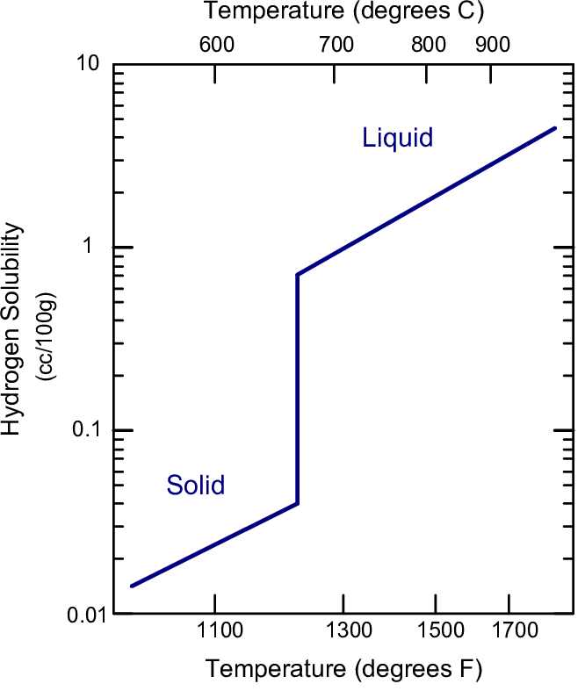
Figure 1. Temperature-dependent increase in hydrogen solubility in liquid aluminum [8].

2.2. Reduced Pressure Test and Density Index
The Reduced Pressure Test (RPT) Device, also known as the vacuum solidification method, is utilized to assess the quality of liquid metal. Determining the quality of liquid metal is a critical step in ensuring the production of the final product meets high standards. Consequently, the RPT device is frequently employed in the industry to evaluate liquid metal quality. The device operates as follows: Molten metal is transferred into the device’s crucible using a ladle, a vacuum environment is then created, and the metal solidifies under reduced pressure. Once solidification is complete, the sample takes on a puffed, cake-like structure due to the vacuum effect. Gas voids (porosities) in the liquid metal expand approximately 10-12 times, depending on the applied vacuum level. By examining cross-sections of the sample, the size and number of porosities are analyzed, allowing for an evaluation of the liquid metal’s quality [9].
In the casting industry, the density index measurement, a widely used method, calculates the porosity ratio in liquid metal. The results obtained from this method enable judgments about the quality of the liquid metal, making the density index measurement highly significant. The Modified Density Measurement Device operates based on Archimedes’ principle, calculating density by measuring the material’s weight in air and water. To determine the porosity level, the reduced pressure test (RPT) is applied. In this test, a molten alloy (100-120 g) is placed in a preheated, thin-walled iron container and solidified under a pressure of 80-100 mbar. The density values of RPT samples are determined using the density measurement technique, which involves weighing the sample both in air and in water for analysis. The density of the sample, ρ, is calculated using the following equation: In this formula, W_{a} and W_{w} represent the measured weights of the sample in air and water, respectively, while ρ_{air} denotes the density determined under air conditions in the RPT device, and ρ_{vacuum} indicates the density of the sample solidified in a vacuum environment. [10]
$ρ=W_{a}/W_{w}$ (1)
$ρ_{index}=100 x \frac{ρ_{air}- ρ_{vacuum}}{ρ_{air}}$ (2)

2.3. Bifilm Index
A factor that significantly influences numerous properties, particularly the mechanical characteristics, of aluminum alloys has been proposed [9]. This factor is based on the bifilm formation theory, which posits that the oxide layer on the surface of liquid metal folds into the molten metal and, during solidification, opens up to create porosity. Using a method developed by Dispinar and Campbell [11, 12, 13], a new criterion for measuring melt quality has been established based on RPT results. This criterion enables the simultaneous evaluation of parameters such as inclusions and hydrogen level through digital image analysis applied to the cross-sectional surface of the RPT sample. Researchers have suggested using the maximum length of pores as an indicator representing bifilm length, and in this context, they have defined a unique measurement unit called the bifilm index (B_{I}) [13, 14]. Bifilms have been identified as the primary source of porosity formation in liquid metal. It is believed that hydrogen and shrinkage voids, which are present in the literature, are not the main sources of porosity but rather act as triggering factors. The lower the bifilm index value in a liquid metal, the higher its mechanical properties tend to be [4, 15, 16].

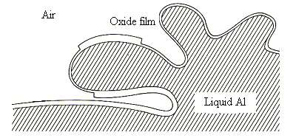
Figure 2. Formation of a bifilm in a liquid metal [17]
Oxide layers form on the surface of liquid metal. If these oxide layers are subjected to splashing due to turbulence, as shown in Figure 2, they fold over, trapping air between two oxide layers and entering the liquid metal. This process results in the formation of undesirable structures known as bifilms [7].
Bifilm index = ∑ (maximum length of pores) (3)
Therefore, in aluminum casting, the primary source of porosity is the oxide layer on the surface, along with the bifilm layers formed due to turbulence.
2.4. Chemical Composition
Chemical composition measurements were made on a spectrometer analyzer. The final chemical compositions of the two castings are given in Table 1.
Table 1. Chemical compositions of the castings
 | Al% | Si% | Fe% | Cu% | Mn% | Mg% | Ti% | Cr% | Zn%
Cast-1 | 98,72 | 0,474 | 0,193 | 0,043 | 0,021 | 0,472 | 0,016 | 0,022 | 0,008
Cast-2 | 98,68 | 0,492 | 0,231 | 0,025 | 0,014 | 0,484 | 0,016 | 0,009 | 0,008

2.5. Microstructure
Sections were taken from two castings after the annealing process for microstructure and grain size analysis. Following the sectioning of the parts, they were embedded in bakelite for examination under an optical microscope. Subsequently, the surfaces were smoothed using three different grades of sandpaper and polished with diamond paste. The samples were then etched using HF and Barker solutions and examined.
3. Results and Discussion
Sample codes taken for liquid metal determination from two castings are in Table 2.
Table 2. Locations where samples were taken in the casting
Sample Location | Cast-1 | Cast-2
Before Flux Air Solidification | W1 | WA
Before Flux Reduced Pressure Solidification | W2 | WB
After Flux Air Solidification | W3 | WC
After Flux Reduced Pressure Solidification | W4 | WD
After Filter Air Solidification (casting length 2 meters) | W5 | WE
After Filter Reduced Pressure Solidification (casting length 2 meters) | W6 | WF
After Filter Air Solidification (casting length 4 meters) | W7 | WG
After Filter Reduced Pressure Solidification (casting length 4 meters) | W8 | WH

3.1. Density Index
The mass measurements of the samples taken in Tables 3 and 4 given below, their densities in water and air were calculated. Then, their density index was calculated.
Table 3. Weight and density of samples taken from Cast-1
 | Pressure (mbar) | Air Mass (gr) | Water Mass(gr) | Air (ρ) | Vacuum (ρ) | Density Index (D_{I})
W1 | atm | 97,78 | 59,24 | 2,537 | 2,344 | 7,60
W2 | 80 | 75,49 | 43,28 | 2,537 | 2,344 | 7,60
W3 | atm | 83,47 | 51,69 | 2,626 | 2,370 | 9,75
W4 | 80 | 86,52 | 50,02 | 2,626 | 2,370 | 9,75
W5 | atm | 83,76 | 52,13 | 2,647 | 2,464 | 6,90
W6 | 80 | 88,89 | 52,82 | 2,647 | 2,464 | 6,90
W7 | atm | 88,37 | 54,98 | 2,647 | 2,457 | 7,16
W8 | 80 | 84,72 | 50,24 | 2,647 | 2,457 | 7,16

Table 4. Weight and density of samples taken from Cast-2
 | Pressure (mbar) | Air Mass (gr) | Water Mass(gr) | Air (ρ) | Vacuum (ρ) | Density Index (D_{I})
WA | atm | 83,67 | 52 | 2,64 | 2,44 | 7,59
WB | 80 | 88 | 52,8 | 2,64 | 2,44 | 7,59
WC | atm | 110,05 | 68,1 | 2,623 | 2,495 | 4,58
WD | 80 | 106,8 | 64 | 2,623 | 2,495 | 4,58
WE | atm | 82,81 | 51,51 | 2,647 | 2,572 | 2,83
WF | 80 | 91,7 | 56,05 | 2,647 | 2,572 | 2,83
WG | atm | 86,73 | 54,04 | 2,65 | 2,59 | 2,32
WH | 80 | 92,82 | 57,01 | 2,65 | 2,59 | 2,32

When Table-3 and Table-4 are examined, it is seen that there are irregularities in the samples taken from Cast-1, while Cast-2 follows a decreasing graph as it should be.
The explanations of the names of the Cast-1 samples given in Figure 3 are as follows:
W12: Before degassing and fluxing
W34: After degassing and fluxing
W56: After filter during casting and at 2 meters
W78: After filter during casting and at 4 meters
The explanations of the names of the Cast-2 samples given in Figure 4 are as follows:
WAB: Before degassing and fluxing
WCD: After degassing and fluxing
WEF: After filter during casting and at 2 meters
WGH: After filter during casting and at 4 meters
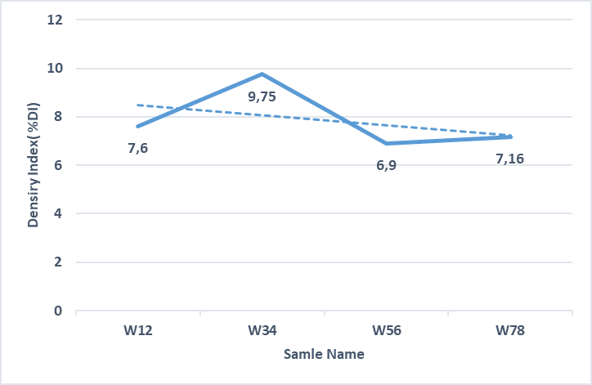
Figure 3. Density index graph of Cast-1 samples (why not a direct relationship?)
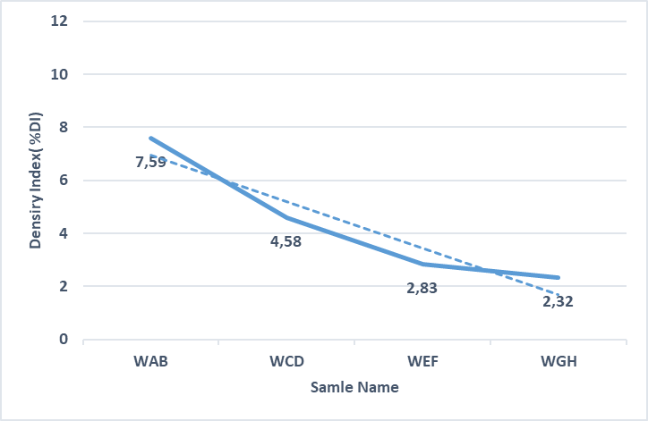
Figure 4. Density index graph of Cast-2 samples

3.2. Bifilm Index
The bifilm index measurement is essentially performed to validate density index measurements. Unlike the density-based approach, this method relies on measuring porosity in the cross-section. The samples are cut in half, and their surfaces are sanded until surface roughness is eliminated. Subsequently, to obtain clearer images, the surfaces are scanned using a scanner at a minimum resolution of 600 dpi. Then, with the aid of a program, the pores are simply calculated as a ratio to the total area [13].
Figure 5 shows images of the samples after being cut in half.
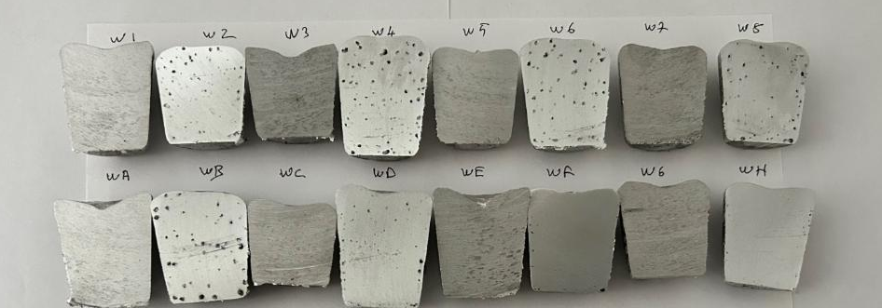
Figure 5. Half sections of all samples taken(it is necessary to indicate where the cast 1 and cast 2 samples are?)
Table 5 shows the B_{I}% and hydrogen levels of Cast-1 and Cast-2.
Table 5. Bifilm indexes and hydrogen levels of Cast-1 and Cast-2
Sample Location | Cast-1 |  | Cast-2
 | B_{I} (mm) | Hydrogen  (ml/100 g Al) | B_{I} (mm) | Hydrogen  (ml/100 g Al)
Before Flux | 127 | 0,245 | 119 | 0,244
After Flux | 155 | 0,321 | 63,9 | 0,143
After Filtre (Casting length 2 meters) | 110 | 0,221 | 19,3 | 0,086
After Filtre (Casting length 4 meters) | 114 | 0,230 | 10,4 | 0,070
(What is the reason for the low level of hydrogen in cast 2 samples)
Bifilm indexes of Cast-1 and Cast-2 are given in Figure 6.
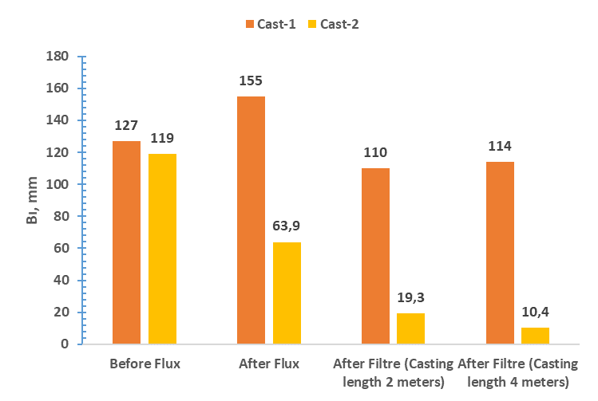
Figure 6. Cast-1 and Cast-2 Bifilm indexes
The hydrogen levels of Cast-1 and Cast-2 are given in Figure 7.
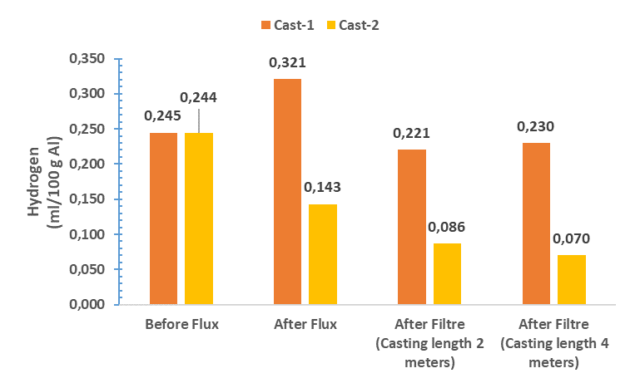
Figure 7. Cast-1 and Cast-2 hydrogen levels
The examination of Cast-1 revealed that the bifilm index, which was approximately 127 mm before the flux treatment, increased to as high as 155 mm after the flux process. This clearly indicates that the refining process was not performed effectively. The faulty execution of the refining process, possibly due to high flow rates or prolonged processing times, may have caused more oxidized compounds to remain in the liquid metal. This suggests that the refining process did not achieve the desired efficiency. On the other hand, when a filtration process was applied after casting, the bifilm index dropped to around 110 mm. This demonstrates that the filter successfully retained certain oxidized components, providing a degree of effectiveness in filtration. However, if the refining process had been conducted more efficiently, the bifilm index values could have decreased to much lower levels, resulting in more effective oxide removal.
In contrast, the examination of Cast-2 showed that the initial bifilm index, which was around 119 mm, decreased to 63.9 mm after the refining process, indicating a significant improvement. This reflects that the refining process was highly successful, effectively removing a substantial amount of oxidized compounds. Measurements taken during the casting process revealed extremely low values, such as 19.3 mm and 10.4 mm, highlighting an excellent level of success in oxide removal. Unlike Cast-1, the filter used in this casting had lower porosity. (Yes, but why did this affect the sharp decrease in hydrogen content to 0.086 and 0.070 ml/100g Al? It is not clear). The use of a filter with smaller pores resulted in an initial bifilm index measurement below 100 mm, indicating a low likelihood of clogging and justifying the use of a low-porosity filter. However, although some clogging was observed in this filter during the casting process, it did not negatively impact the casting operation or allow oxidized compounds to mix with the liquid metal. This suggests that the filter design was appropriate and oxide removal was successfully achieved.
3.3. Microstructure

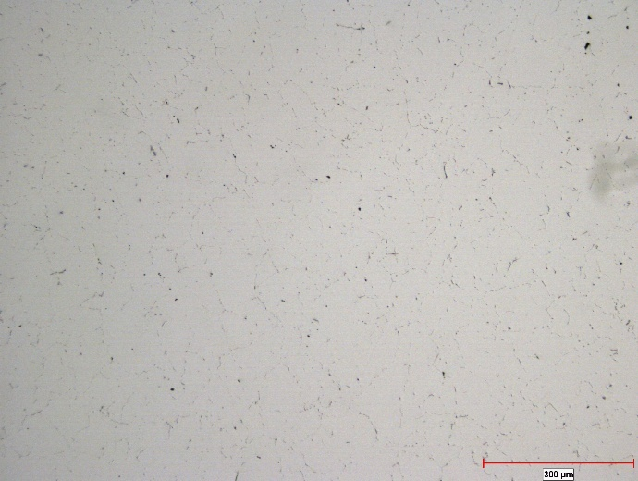  300 μm  Magnification 100x – No etching | 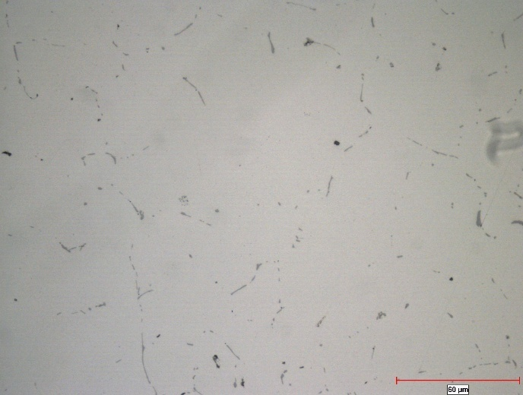  60 μm  Magnification 500x – No etching
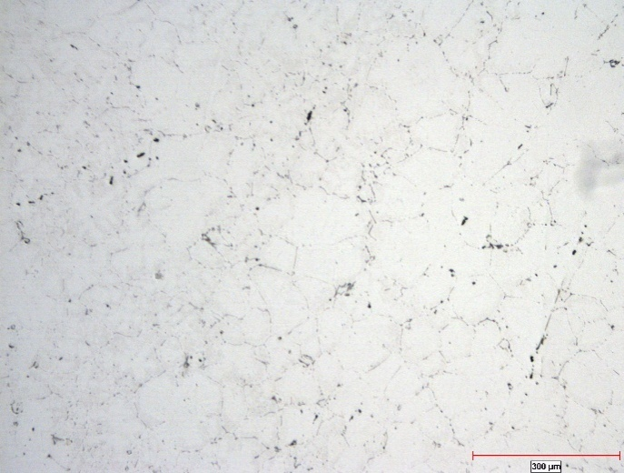  300 μm  Magnification 100x- Etching HF | 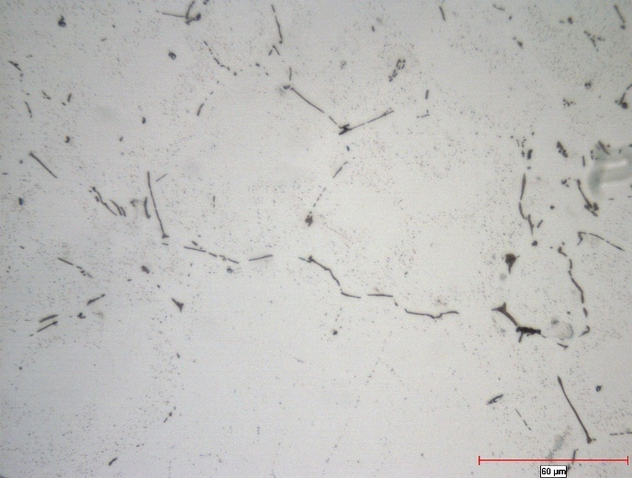  60 μm  Grain boundry  Fe-phases  Oxides  Pores  Magnification 500x- Etching HF
Figure 8. Microstructure analysis of Cast-1

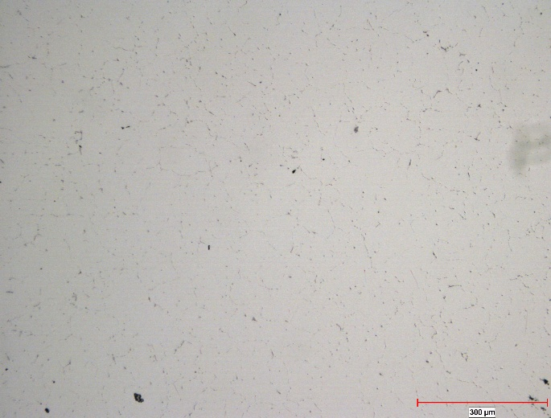  300 μm  Magnification 100x – No etching | 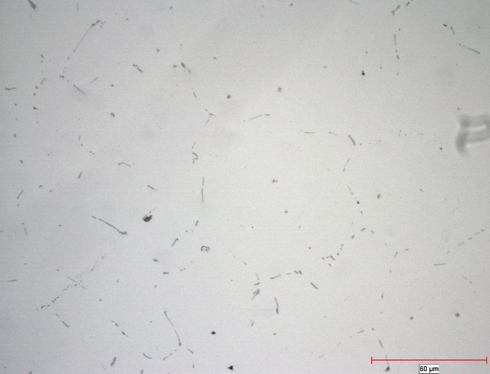  60 μm  Magnification 500x – No etching
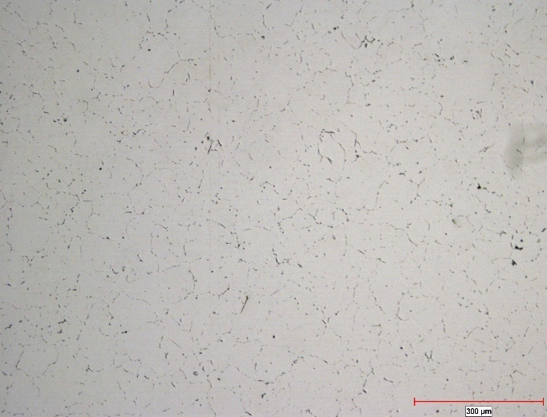  300 μm  Magnification 100x- Etching HF | 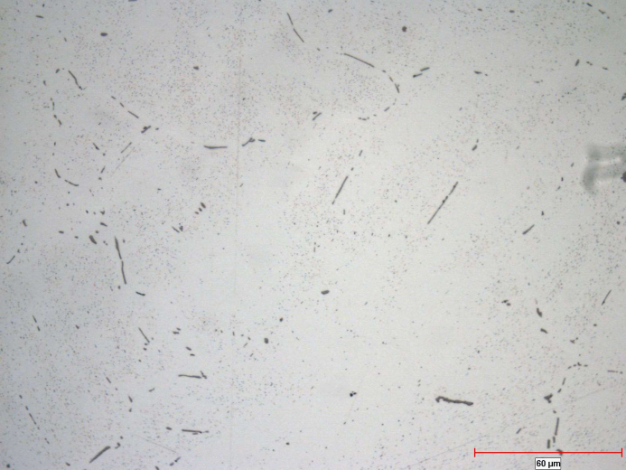  60 μm  Pores  Oxides  Grain boundry  Magnification 500x- Etching HF
Figure 9. Microstructure analysis of Cast-2

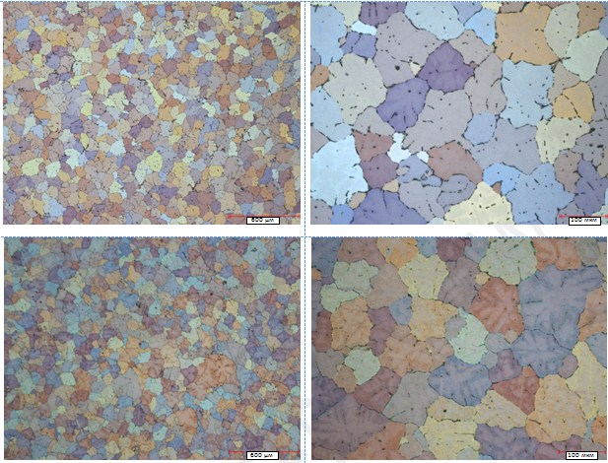Fig. 10 Comparison of grain sizes using cast 1 (a,b) and cast 2 (c,d)

As presented in Figure 8, metallographic examinations were conducted on samples taken from 6060 aluminum alloy billets with a diameter of 7 inches (approximately 178 mm). The analysis revealed an average grain size of approximately 120 µm. Grain size measurements were performed in accordance with the ASTM E112 standard, and a total of 95 grains were counted within the analyzed area. The grain distribution homogeneity was quantitatively determined to be around 76%, indicating a partially homogeneous microstructure with some local heterogeneities. Microstructural images revealed significant voids (microporosity) and shrinkage cavities (shrinkage porosity) along grain boundaries. Such defects may arise from process-related factors, such as gas entrapment or volumetric shrinkage during solidification. Furthermore, the microstructure exhibited a high presence of intermetallic phases, both at grain boundaries and within the matrix. These intermetallic compounds are likely Al-Fe-Si or Mg-Si-based phases (It is necessary to provide the results of EDS analysis), formed due to the segregation of alloying elements during solidification. The presence of these phases is a critical factor that could influence the material’s mechanical properties and corrosion resistance.
In Figure 9, the analysis of a different set of samples from the same 6060 alloy billets with a 7-inch diameter is presented. The average grain size in these samples was measured to be approximately 111 µm, with a total of 148 grains counted in the analyzed region. The homogeneity of the grain size distribution was approximately 80%, demonstrating a higher degree of uniformity compared to the samples in Figure 8. Nevertheless, voids and shrinkage cavities were again observed along grain boundaries, though their intensity appeared lower than in the Figure 8 samples. Microstructural images confirmed the presence of intermetallic phases; however, their quantity was reduced compared to the Cast-1 sample in Figure 8. This difference may be attributed to variations in solidification conditions or improvements in the purity of the molten metal.
Comparative Analysis of Cast-1 and Cast-2 Samples: Examination of grain size and homogeneity in both sample sets indicates a general similarity in microstructural characteristics. In Cast-1, the average grain size was 120 µm with a homogeneity of 76%, while in Cast-2, the grain size was 111 µm with a homogeneity of 80%. Although these differences may not be statistically significant, they reflect the subtle influence of process parameter variations on the microstructure. Etched microstructure examinations revealed a notably higher presence of oxide-containing compounds (likely Al₂O₃ or MgO inclusions) in Cast-1. The abundance of these oxide compounds could stem from inadequate molten metal cleaning prior to casting or atmospheric contamination during melting. In contrast, Cast-2 exhibited fewer oxide inclusions, which can be attributed to the use of a ceramic filter with smaller pore sizes (what is the pore size in the filter?).. Finer-pored filters enhance the retention of solid particles and oxides in the molten metal, thereby improving microstructural purity. This suggests that Cast-2 underwent a more optimized casting process compared to Cast-1, as evidenced by its enhanced microstructural homogeneity and reduced defect density.

4. Conclusion
This study investigated the effects of refining processes on the liquid metal quality of 6060 aluminum alloy castings, focusing on two distinct casting batches (Cast-1 and Cast-2) subjected to varying degassing durations and filtration conditions. The results demonstrate that the optimization of refining parameters plays a pivotal role in enhancing the quality of molten aluminum, as evidenced by significant differences in density index (D_{I}), bifilm index (B_{I}), hydrogen level, and microstructural characteristics between the two casts.
For Cast-1, the refining process proved ineffective, as indicated by an increase in the bifilm index from 127 mm to 155 mm post-fluxing, alongside a persistently high-density index (ranging from 6.9% to 9.75%) and elevated hydrogen levels (up to 35.59 ml/100 g Al). These findings suggest that inadequate process control—potentially due to excessive flow rates or prolonged refining durations—resulted in the retention of oxide compounds and the introduction of additional defects. Although subsequent filtration reduced the bifilm index to approximately 110 mm, the overall liquid metal quality remained suboptimal, with microstructural analysis revealing a grain size of 120 µm, 76% homogeneity, and a high prevalence of voids, shrinkage cavities, and intermetallic phases.
In contrast, Cast-2 exhibited a marked improvement in liquid metal quality following refining and filtration. The bifilm index decreased progressively from 119 mm before fluxing to as low as 10.4 mm after filtration at a casting length of 4 meters, accompanied by a reduction in density index (from 7.59% to 2.32%) and hydrogen level (from 0.24 ml/100 g Al to 0.07 ml/100 g Al). Microstructural analysis further confirmed higher quality, with a finer grain size of 111 µm, higher homogeneity of 80%, and reduced defect density. The success of Cast-2 can be attributed to the effective removal of oxide inclusions during refining and the use of a ceramic filter with smaller pore sizes, which minimized the entrainment of non-metallic impurities without compromising filter performance.
Comparative analysis highlights that while both casts share similar chemical compositions and initial microstructural traits, the optimization of refining and filtration processes in Cast-2 yielded a cleaner melt with enhanced mechanical potential. The higher presence of oxide inclusions in Cast-1 underscores the necessity of precise process control to prevent contamination, whereas the low bifilm index and defect levels in Cast-2 validate the efficacy of smaller-pored filters in achieving high-purity liquid metal. These findings align with prior research emphasizing the critical role of bifilms as primary initiators of porosity and mechanical degradation, reinforcing the utility of the bifilm index and reduced pressure test (RPT) as reliable metrics for quality assessment.
In conclusion, this study underscores the importance of tailored refining strategies in aluminum casting to mitigate the adverse effects of oxide inclusions and hydrogen entrapment. The higher outcomes observed in Cast-2 provide practical insights for industrial applications, suggesting that optimized degassing durations and the adoption of finer filtration systems can significantly enhance liquid metal quality, thereby improving the mechanical performance and reliability of cast aluminum components. Future work should focus on refining process parameter thresholds and exploring advanced filtration technologies to further minimize bifilm formation and achieve consistent high-quality castings.

Key Takeaways
- Refining Impact: Optimized refining processes significantly enhance liquid metal quality in 6060 aluminum alloy castings, as evidenced by reduced density index (D_{I}), bifilm index (B_{I}), and hydrogen levels in Cast-2 compared to the ineffective refining in Cast-1.
- Filtration Efficacy: Smaller-pored ceramic filters in Cast-2 effectively minimized oxide inclusions, achieving a bifilm index as low as 10.4 mm, highlighting their superiority over less optimized filtration in Cast-1.
- Microstructural Differences: Cast-2 exhibited finer grain size (111 µm) and higher homogeneity (80%) with fewer defects than Cast-1 (120 µm, 76%), reflecting the influence of process optimization on microstructure.
- Bifilm Significance: The study reinforces bifilms as primary porosity initiators, with lower B_{I} values correlating with improved mechanical potential, validated by RPT and microstructural analysis.
- Practical Insight: Tailored degassing and filtration strategies are critical for high-quality castings, offering a pathway to enhance mechanical performance in industrial applications.

COMPETING INTERESTS DISCLAIMER:
Authors have declared that they have no known competing financial interests OR non-financial interests OR personal relationships that could have appeared to influence the work reported in this paper.

References
- Hatch, J. E. (1984). Aluminum: Properties and physical metallurgy. ASM International.
- Talbot, D. E. J. (1975). The effects of hydrogen in aluminium and its alloys. Pergamon Press.
- Gruzleski, J. E., & Closset, B. M. (1990). The treatment of liquid aluminum-silicon alloys. American Foundry Society.
- Tiryakioglu, M., J. Campbell and N. D. Alexopoulos (2009). "On the Ductility of Cast Al-7 Pct Si-Mg Alloys." Metallurgical and Materials Transactions a-Physical Metallurgy and Materials Science 40A(4): 1000-1007.
- Tigli, A., Tokatli, M., Uslu, E., Colak, M., & Dispinar, D. (2023). Correlation between K-value, density index and bifilm index in determination of liquid Al cleanliness. Archives of Foundry Engineering, 23(3), 22-29. https://doi.org/10.24425/afe.2023.144311
- Tunca, B., İnce, B., & Deniz, D. (2025). Enhancing liquid metal quality in aluminum alloys: A study on refining techniques. Journal of Engineering Research and Reports, 27(2), 104-113. https://doi.org/10.9734/jerr/2025/v27i21398
- Dispinar, D., & Campbell, J. (2006). Use of bifilm index as an assessment of liquid metal quality. International Journal of Cast Metals Research, 19(1), 5–17. https://doi.org/10.1179/136404606225023300
- Zalensas Donna L. (1986), ‘’Aluminum castinh technology’’, Des Plaines 3. American Foundrymen’s Society
- Dispinar, D., & Campbell, J. (2004). Critical assessment of reduced pressure test. Part 1: Porosity phenomena. International Journal of Cast Metals Research, 17, 280–286. https://doi.org/10.1179/136404604225020696
- Tunca, B., Ince, B., & Deniz, D. (2025). Advancements in Refining Techniques for Improving Liquid Metal Quality in Aluminum Alloys. Engineering Research: Perspectives on Recent Advances Vol. 4, 157–176. https://doi.org/10.9734/bpi/erpra/v4/4481
- Campbell, J. (2003). Castings (2nd ed.), Butterworth-Heinemann Ltd., Oxford, Elsevier
- Campbell, J. (2006). Entrainment defects. Materials Science and Technology, 22, 127–145. https://doi.org/10.1179/174328406X74248
- Dispinar, D., & Campbell, J. (2014). Reduced pressure test (RPT) for bifilm assessment. In M. Tiryakioğlu, J. Campbell, & G. Byczynski (Eds.), Shape casting: 5th international symposium 2014 (pp. 243-251). Springer. https://doi.org/10.1007/978-3-319-48130-2_30
- Dispinar, D., & Campbell, J. (2007). A comparison of methods used to assess aluminium melt quality. Shape Casting: 2nd International Symposium, 25 February- 1 March 2007(pp.11–18). Orlando-FL, United States: The Minerals, Metals and Materials Society (TMS)
- Dispinar, D., S. Akhtar, A. Nordmark, M. Di Sabatino and L. Arnberg (2010). "Degassing, hydrogen and porosity phenomena in A356." Materials Science and Engineering: A 527(16–17): 3719-3725. https://doi.org/10.1016/j.msea.2010.01.088
- Dispinar, D. and J. Campbell (2011). "Porosity, hydrogen and bifilm content in Al alloy castings." Materials Science and Engineering: A 528(10–11): 3860-3865. https://doi.org/10.1016/j.msea.2011.01.084
- Campbell, J., & Tiryakioḡlu, M. (2012). Bifilm defects in Ni-based alloy castings. Metallurgical and Materials Transactions B, 43(4), 902–914. https://doi.org/10.1007/s11663-012-9655-1

