*Original Research Article*

Characterizing Aquifer Properties Using Vertical Electrical Sounding: A Geophysical Study in Perumatty Panchayat, Palakkad District

ABSTRACT

|  |
| --- |
| Groundwater is an essential resource for drinking water, agriculture, and industrial use, particularly in regions where surface water is scarce. . This study delineates subsurface aquifer configurations using the Vertical Electrical Sounding (VES) method to examine the hydrogeological features of the overfished Perumatty Panchayat in Kerala's Palakkad District. IPI2WIN software was used to evaluate the results of 13 VES surveys that were carried out over a 30.99 km² area using the Schlumberger electrode design. Three primary curve types were identified by the resistivity sounding: the H-type, K-type, and A-type. These types correlate to various aquifer conditions. The existence of lateritic topsoil, weathered zones, and basement rock strata was indicated by the 13 sites' 5 H-type, 5 K-type, and 3 A-type curves. Layer thicknesses ranged from 0.325 m to 11.43 m, while resistivity values ranged from 23.7 Ω-m to 43421 Ω-m, according to quantitative research. Aquifer potential varied spatially, with depth to foundation rock ranging from 2.68 m (VES 9) to 16.82 m (VES 5). Interestingly, VES 6 recorded an exceptionally low third-layer resistivity of 0.734 Ω-m, suggesting water-saturated zones, while VES 3 showed a second-layer resistivity of 43421 Ω-m, indicating a highly resistant compact rock. According to the study, fractured weathered zones favour borewells, especially in K-type and A-type curves, although H-type profiles suggest that dug wells may be possible. The effectiveness of VES as an affordable, non-invasive method for identifying aquifer structures in intricate geological terrains is demonstrated by this study. The results provide vital information for planning and managing groundwater resources sustainably in semi-arid and water-stressed areas. |

*Keywords: Groundwater exploration; Geophysical methods; Vertical Electrical Sounding; Resistivity meter; Subsurface layers; Laterite; Aquifer characteristics; IPI2WIN Software; Schlumberger Electrode Configuration*

1. INTRODUCTION

Water is a fundamental resource for sustaining life, agriculture, industry, and the environment, with groundwater representing one of the most crucial reserves, particularly in regions with scarce surface water resources. Groundwater aquifers are natural underground reservoirs often hidden beneath layers of soil, sediment, and rock, where they serve as vital sources of water. Globally, more than one-third of the water used originates underground (Famiglietti 2014). In many areas, the increasing demand for freshwater coupled with concerns about groundwater depletion, contamination, and climate variability has underscored the importance of accurately identifying and characterizing aquifers. To address these challenges, hydrogeologists and researchers have relied on subsurface investigation techniques such as resistivity studies to reveal essential information about aquifers. In particular, earth resistivity studies have gained prominence for their non-invasive, cost-effective approach to mapping and characterizing the subsurface properties of groundwater systems.

In geophysical exploration, resistivity refers to the ability of subsurface materials to resist the flow of electric currents. Because different geological layers and materials exhibit distinct resistivity values, earth resistivity studies can help identify subsurface features and delineate aquifer boundaries. This technique, which involves injecting current into the ground and measuring the resulting voltage, has proven to be effective for investigating the distribution, thickness, and depth of aquifers. By interpreting the resistivity data, scientists can deduce the types of materials present in the subsurface, distinguish between saturated and unsaturated zones, and identify features such as clay layers, which act as barriers to water movement, and sand and gravel layers, which are typically good aquifer materials. The use of geophysical methods for both groundwater resource mapping and water quality evaluation has increased dramatically over the last decade, owing to rapid advances in electronic technology and the development of numerical modeling solutions.

Vertical Electrical Sounding (VES) is one of the most commonly employed resistivity methods in aquifer exploration. This method involves taking measurements at specific points to assess resistivity variations with depth, which provides a vertical profile of the subsurface resistivity at each location. VES studies are particularly useful for determining the extent of aquifers, identifying water-bearing layers, and distinguishing freshwater and saline water zones. The resistivity of subsurface materials is influenced by several factors, including porosity, water saturation, and mineral composition, allowing for indirect inference of important hydrogeological properties. The VES is an invaluable tool for groundwater research and management because it enables the characterization of hydrogeological properties.

Various studies have suggested that complex geohydrological problems related to the occurrence of groundwater can be solved using geophysical methods, particularly the electrical resistivity method, along with geological methods (Sajeena et al., 2014). Electrical resistivity meter studies were conducted in various areas, and groundwater potential zones were determined using Vertical Electrical Sounding (VES) data (Olandunjoye *et al*., 2013; Sikah *et al*., 2016; Golekar *et al*., 2016). Accurate aquifer mapping is essential for sustainable water resource management in regions where groundwater is the primary water source. Furthermore, resistivity studies are advantageous for areas where drilling is challenging or costly because they provide valuable preliminary data that can guide drilling and water extraction efforts. Resistivity surveys have been successfully employed in various environments, ranging from arid regions, where groundwater is often the only reliable water source, to densely populated urban areas, where aquifer contamination and depletion are significant concerns.

Recent advances in resistivity data acquisition and interpretation have improved the accuracy and efficiency of these methods. Software tools such as IP12WIN have enhanced the ability to process and analyze resistivity data, allowing researchers to obtain detailed images of the subsurface. These tools facilitate the interpretation of complex resistivity data, enabling better differentiation between aquifer and non-aquifer materials and more accurate estimation of aquifer properties, such as thickness, depth, and lateral extent. With the integration of modern technology and data processing techniques, resistivity studies have become increasingly effective in addressing diverse hydrogeological challenges, from identifying suitable drilling sites to assessing aquifer vulnerability to contamination.

The study presented in this paper focuses on using Vertical Electrical Sounding (VES) to investigate the subsurface properties of an aquifer in the Perumatty Panchayat of the Palakkad district. This study aimed to determine the resistivity distribution and depth of various subsurface layers, identify potential aquifer zones, and provide a comprehensive understanding of the hydrogeological conditions of the area. By examining the resistivity profiles obtained from VES measurements, this study seeks to provide valuable insights into the distribution and characteristics of groundwater resources. In particular, this study intends to support sustainable water resource management by providing reliable data for aquifer assessment and planning.

In conclusion, as the demand for groundwater resources continues to increase, the need for effective subsurface exploration techniques has become increasingly critical. Earth resistivity studies, such as those employing the VES method, represent a valuable approach for characterizing aquifers and supporting groundwater management. This research aims to provide insights into the effectiveness of resistivity studies for aquifer characterization, offering a model that can be applied to other regions to improve their understanding and management of groundwater resources.

2. material and METHODS

**2.1 Study Area**

This study focuses on the Perumatty Panchayat in the Palakkad District, Kerala, which has been classified as an overexploited region for groundwater resources. Groundwater is the primary source of water for domestic use, agriculture, and irrigation. The research examines four distinct micro-watersheds: Muthuswamy Pudur (6.912 km²), Sarkarpathy (8.061 km²), Mullanthodu (7.693 km²), and Kambalathara-Kalyanpetta (8.322 km²). The study area was situated between 10.66° N latitude and 76.79° E longitude, near the border with Tamil Nadu, in a semi-arid region. Muthuswamy Pudur, Sarkarpathy, and Kambalathara-Kalyanpetta are classified as highland areas, while Mullanthodu is categorized as a midland area. These watersheds are part of the Chitturpuzha sub-basin, which lies within the larger Bharathapuzha River Basin, a key hydrological system in the region.

The area experiences an average annual rainfall ranging from 800 to 1100 mm, with an average daily maximum temperature around 34ºC and a minimum temperature of about 21ºC. Groundwater is present across various geological formations, from archaean crystalline rocks to recent alluvial deposits. The major rock formations in the area include hornblende biotite gneiss, hornblende biotite schists, and granite, with groundwater primarily found in semi-confined to confined conditions within deep fractured aquifers. The landscape includes various land use types, such as rivers, streams, water bodies, plantations, arable land, forested areas, and wastelands. Agriculture is the primary livelihood for approximately 75% of the local population and depends on a combination of rain-fed, groundwater-based, and canal-fed irrigation systems. The primary crops cultivated include paddy, coconut, banana, cashew, areca nut, and spices, such as nutmeg and pepper. The location map of the study area is shown in Fig. 1.

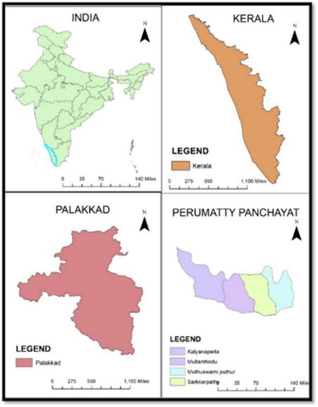

**Fig. 1. Location map of the study area**

**2.2 Geophysical Investigation of Aquifer Characteristics Using Resistivity Methods**

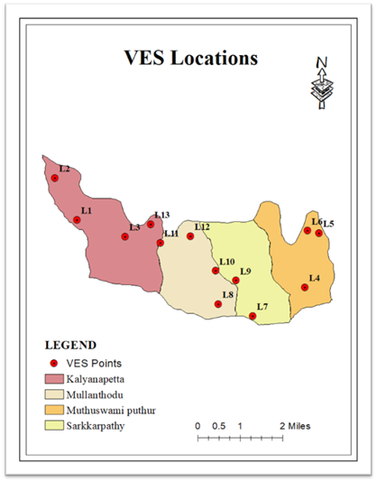

**Fig. 2. VES location map of the study area**

This study employed the Vertical Electrical Sounding (VES) technique to examine subsurface electrical resistivity property within the Perumatty Panchayat, focusing on characterizing aquifer properties. This technique works of the principle of Ohm’s law, which be expressed as:



Due to the non-homogeneity nature of the subsurface, the apparent resistivity ($ρ_{a}$) is estimated as:



Where k is the geometric factor (K-factor). The value of K-factor usually depend on the four electrode configuration (Fig 2), [1], [14]. According to Fig 2; ($AC=BD=\left(\frac{L-a}{2}\right) and CB=AD=\left(\frac{L+a}{2}\right)$. so that, the geometry factor for Schlumberger array, becomes:

$K=2π\frac{V}{I}{\left[\left(\frac{2}{L-a}-\frac{2}{L+a}\right)-\left(\frac{2}{L+a}-\frac{2}{L-a}\right)\right]}^{-1}$ (3)

Equation (3), can be expressed further, so that:



Field measurements were conducted with a Signal Stacking Resistivity Meter (Model SSR-MP-ATS) across 13 selected locations within the study area, as shown in Fig. 2, using the Schlumberger electrode configuration to acquire apparent resistivity data for subsequent analysis. Details of the VES locations are listed in Table 1.

**Table 1. VES location details**

|  |  |  |  |
| --- | --- | --- | --- |
| Locations | Latitude | Longitude | Elevation (m) |
| L1 | 10040'09'' | 76047'42'' | 181.74 |
| L2 | 10041'01'' | 76047'15'' | 176.43 |
| L3 | 10039'48'' | 76048'42'' | 189.79 |
| L4 | 10038'44'' | 76052'26'' | 233.46 |
| L5 | 10039'51'' | 76052'44'' | 217.75 |
| L6 | 10039'54'' | 76052'30'' | 207.45 |
| L7 | 10038'09'' | 76051'21'' | 234.89 |
| L8 | 10038'24'' | 76050'38'' | 226 |
| L9 | 10038'53'' | 76051'00'' | 224.7 |
| L10 | 10039'05'' | 76050'35'' | 223.36 |
| L11 | 10039'40'' | 76049'26'' | 197.89 |
| L12 | 10039'48'' | 76047'42'' | 204.47 |
| L13 | 10040'03'' | 76049'14'' | 205.6 |

During the survey, the current electrode spacing (AB) varied between 3 and 60 m (with AB/2 = 3–30 m), while the potential electrode spacing (MN) ranged from 2 to 20 m (MN/2 = 1–10 m). For each measurement, the electrodes were aligned in a straight line, with the spacing gradually increased around a fixed central point where the resistivity meter was stationed. An electrical current (I) was applied to the current electrodes, and the resulting potential difference (V) was measured for each configuration. As the current electrode spacing increases, the current penetrates deeper into the subsurface, enabling the analysis of deeper geological layers. The apparent resistivity (ρa) values were calculated from the current and potential difference readings across each configuration, with values fluctuating in response to subsurface conditions; areas exhibiting fractures, joints, or increased water content showed lower resistivity values.

Field data were initially processed and interpreted using IPI2WIN, a specialized Windows-based software designed for analyzing VES data and deriving subsurface layer properties. The software supports several electrode configurations, including Schlumberger, Wenner α, Wenner β, and dipole, and provides tools for data input, error correction, adding data points, and generating pseudo cross-sections. In this study, IPI2WIN facilitated the preliminary estimation of the resistivity and thickness of each layer, which served as foundational data for more detailed analysis.

The parameters used in IPI2WIN included field data such as AB/2 spacing, voltage (V), current (I), and a geological factor (K), along with the Schlumberger configuration and initial estimates of layer count, resistivity (ρ), and thickness (h) based on early interpretations of the sounding curves. An iterative least-squares inversion method was used within the IPI2WIN to refine the accuracy of the subsurface model. This approach allowed for adjustments to the initial resistivity and thickness estimates, minimizing the differences between the measured and calculated resistivities to produce a more accurate model of subsurface conditions. The final model outputs included layer resistivity, thickness, and depth from the ground surface, which are key parameters for understanding the aquifer characteristics and groundwater potential in the area.

The interpretation steps within IPI2WIN included launching the program, initiating a new VES point, selecting the correct electrode configuration, and entering the field data into specified columns to plot the data points on a graph. After data entry, the values were confirmed and saved using the data stored in. txt format using the Save TXT function for future use as a VES data file. From this saved data, IPI2WIN automatically generated curves and tabulated the results. Additional VES points were inputted by restarting the software and repeating the entry and saving processes.

3. results and discussion

The field data were interpreted and processed qualitatively and quantitatively using the IPI2WIN software to obtain the resistivity values of different subsurface layers and their corresponding thicknesses, as shown in Table 2. Based on the interpretation of the VES curves, three subsurface layers were identified within the study area. The curves were prominent for the H, K, and A types, indicating the presence of three layers.

|  |  |  |  |  |  |  |  |  |
| --- | --- | --- | --- | --- | --- | --- | --- | --- |
| **Location No.** | **Resistivity of 1st layer (ρ1), [Ohm-meter]** | **Resistivity of 2nd layer (ρ2), [Ohm-meter]** | **Resistivity of 3rd layer (ρ3), [Ohm-meter]** | **Thickness of 1st layer (h1), [Meter]** | **Thickness of 1st layer (h2), [Meter]** | **Depth of 1st layer (d1), [Meter]** | **Depth of 1st layer (d2), [Meter]** | **Depth to basement, [Meter]** |
| VES 1 | 39.9 | 496 | 13.2 | 1.44 | 6.8 | 1.44 | 8.28 | 9.72 |
| VES 2 | 42.7 | 114 | 12931 | 1.1 | 7.64 | 1.1 | 8.74 | 9.84 |
| VES 3 | 31.5 | 43421 | 58.6 | 1.64 | 8.74 | 1.64 | 10.4 | 12.04 |
| VES 4 | 684 | 160 | 1055 | 0.967 | 1.45 | 0.967 | 2.42 | 3.387 |
| VES 5 | 151.1 | 331.9 | 9974 | 2.699 | 11.43 | 2.699 | 14.12 | 16.819 |
| VES 6 | 60.2 | 63.5 | 0.734 | 0.889 | 8.1 | 0.889 | 8.99 | 9.879 |
| VES 7 | 159 | 23.7 | 32825 | 0.877 | 1.45 | 0.877 | 2.32 | 3.197 |
| VES 8 | 1148 | 120 | 1595 | 0.325 | 4.53 | 0.325 | 4.85 | 5.175 |
| VES 9 | 182 | 25.4 | 256 | 0.727 | 1.22 | 0.727 | 1.95 | 2.677 |
| VES 10 | 197.2 | 3273 | 39.58 | 2.798 | 4.277 | 2.798 | 7.075 | 9.873 |
| VES 11 | 141 | 78.9 | 24210 | 1.44 | 4.5 | 1.44 | 5.94 | 7.38 |
| VES 12 | 43.98 | 193.7 | 9437 | 2.064 | 6.193 | 2.064 | 8.256 | 10.32 |
| VES 13 | 28.3 | 4070 | 40.7 | 1.33 | 3.13 | 1.33 | 4.46 | 5.79 |

**Table 2. Resistivity data interpretation and corresponding thickness**

Curves with a maximum (hump) flanked by low resistivity values (ρ₁ < ρ₂ > ρ₃) are classified as K’ type curves. This curve type is observed in soundings VES1, VES3, VES6, VES10, and VES13, as shown in Fig. 3. These areas are characterized by a resistive layer sandwiched between two relatively conductive layers, suggesting the presence of a hard and compact lateritic or gneiss layer between a more conductive topsoil and a saturated weathered rock layer below. The resistivity of the first layer (topsoil) in these locations ranges from 28.3 Ω-m to 197.2 Ω-m, with thicknesses between 0.877 m and 2.798 m, indicating the presence of hydromorphic or lateritic topsoil, which is predominantly clay-rich or moderately weathered. The second layer shows significantly higher resistivity values, ranging from 63.5 Ω-m to 43421 Ω-m, with thicknesses of 1.33 m to 8.1 m, likely due to hard and compact laterites or gneiss supported by previous studies . The third layer, with lower resistivity values from 0.734 Ω-m to 58.6 Ω-m, suggests water saturation within weathered rock. These geological configurations make these areas suitable for borewells due to the presence of an intermediate fractured layer that can act as a reservoir.

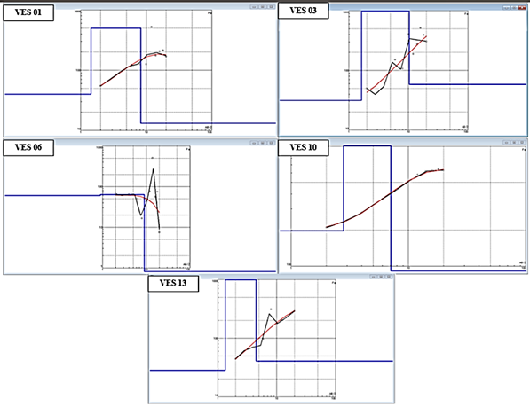

**Fig. 3. Resistivity sounding curves (K-type)**

Another distinct pattern observed in the data is the ‘A’ type curve (ρ₁ < ρ₂ < ρ₃), present in soundings VES2, VES5, and VES12 as shown in Fig. 4. This three-layer model often suggests a conductive topsoil, followed by a more resistive weathered rock layer, and finally a highly resistive bedrock. The first layer, representing the topsoil, has resistivity values between 42.7 Ω-m and 151.1 Ω-m with thicknesses around 1.1 m to 2.699 m. The second layer, likely representing a weathered zone, shows resistivities between 114 Ω-m and 331.9 Ω-m with thicknesses from 7.64 m to 11.43 m. Beneath this is the third layer, which demonstrates resistivity values ranging from 9974 Ω-m to 12931 Ω-m, characteristic of hard and compact bedrock, suggesting these areas are suitable

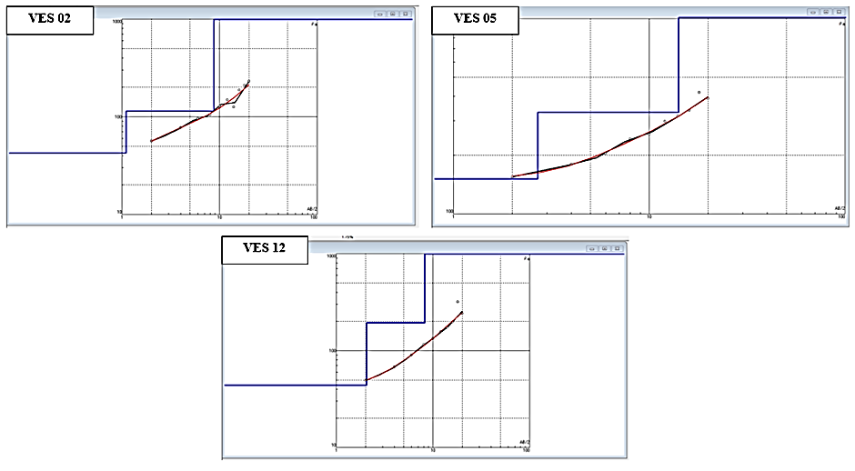

**Fig. 4. Resistivity sounding curves (A-type)**

A third observed curve type is the ‘H’ type (ρ₁ > ρ₂ < ρ₃), represented in VES4, VES7, VES8, VES9, and VES11 as shown in Fig. 5. The ‘H’ type curve is typically found in hard rock terrains and indicates a high-resistivity dry topsoil as the first layer, a water-saturated weathered layer as the second layer, and a highly resistive compact rock as the final layer. In these locations, the first layer resistivity ranges from 141 Ω-m to 1148 Ω-m, with thicknesses between 0.325 m and 1.45 m, suggesting a lateritic aquifer suitable for dug wells. The second layer, indicative of clay-rich laterite or a weathered zone, has lower resistivities ranging from 23.7 Ω-m to 160 Ω-m, with thicknesses between 1.22 m and

4.53 m. The third layer, with resistivities ranging from 256 Ω-m to 24210 Ω-m, represents the hard bedrock, potentially gneiss or massive laterite.

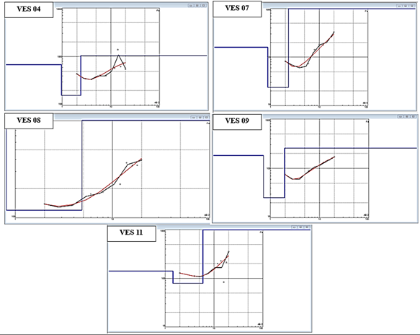

**Fig. 5. Resistivity sounding curves (H-type)**

From the data, it can be observed that out of the 13 VES locations, there are three main curve types—K, A, and H types—indicating varying subsurface configurations. These curve types align with litholog data from regional surveys, suggesting consistency in subsurface geology across the study area. The K and A type curves, with intermediate conductive layers, support groundwater storage and are favorable for borewell installations. The H type curve, prevalent in VES locations with lateritic topsoil and deeper weathered zones, shows potential for groundwater through dug wells in weathered layers.

This study's conclusions have significant ramifications for groundwater potential and sustainable resource management in Perumatty Panchayat, a region experiencing critical water stress. By identifying three different types of subsurface resistivity curves—K, A, and H—the research offers a scientific basis for focused groundwater extraction strategies. The presence of fractured and weathered aquifers suitable for high-yield borewells is suggested by the identification of high-resistivity intermediate layers in K-type curves and deep, highly resistive bedrock in A-type curves, while H-type curves reveal shallow saturated zones that are best suited for dug wells, providing a low-cost substitute for household and agricultural water requirements. The spatial variation in resistivity (23.7 to 43421 Ω-m) and aquifer depth (2.68 to 16.82 m) underscores the importance of site-specific assessment, enabling precise drilling to optimize water yield while minimizing environmental impact and financial cost. These results will help the decision-makers groundwater management. With these data, farmers with actionable data to prioritize drilling in high-potential zones and avoid overexploitation of less productive areas. This geophysical framework supports long-term water security by enabling informed. Ultimately, this study will advances scientific understanding of regional hydrogeology, which can also serves as a practical blueprint for achieving groundwater sustainability amid increasing demand and climatic variability.

4. Conclusion

This study employed the Vertical Electrical Sounding (VES) technique to investigate the subsurface hydrogeological conditions of Perumatty Panchayat in Palakkad District, Kerala. The primary goal was to assess the distribution and depth of groundwater aquifers, identify potential water-bearing zones, and provide valuable insights into the region’s groundwater resources for sustainable management. The VES survey revealed three distinct types of subsurface configurations—K-type, A-type, and H-type—each indicative of different aquifer characteristics and groundwater potential.

The interpretation of the resistivity data from the 13 VES locations highlighted the presence of both shallow and deeper groundwater zones. The K-type curves, characterized by an intermediate conductive layer, suggest the presence of fractured aquifers that are favorable for borewell installations. The A-type curves indicate a conductive topsoil followed by a more resistive weathered rock layer, which is suitable for dug wells, particularly in areas where a deeper bedrock layer exists. The H-type curves, typically found in hard rock terrains, suggest the presence of a dry topsoil, a saturated weathered zone, and a compact rock layer, making these areas more appropriate for dug wells targeting groundwater stored within the weathered rock.

The study's findings underscore the potential of VES as a reliable, cost-effective, and non-invasive technique for characterizing aquifers in regions with complex subsurface conditions. The results can serve as an important tool for informed groundwater resource planning and management, particularly in areas facing water scarcity and overexploitation. Given the region’s dependence on groundwater for domestic, agricultural, and irrigation purposes, these insights are crucial for developing sustainable water management strategies.

Furthermore, the use of modern data processing software like IPI2WIN has improved the accuracy and efficiency of subsurface modeling, enabling more precise delineation of aquifer zones and their potential for water extraction. The study also highlights the importance of integrating geophysical methods with traditional hydrogeological surveys for a comprehensive understanding of groundwater systems.

In conclusion, this research contributes valuable information to the field of groundwater exploration in Perumatty Panchayat and similar semi-arid, overexploited regions. By providing detailed subsurface profiles, the study offers a scientific basis for better water resource management, supporting both current and future water supply needs in the region. The findings can be extended to other regions facing similar challenges in aquifer characterization and sustainable groundwater management.

References

Oladunjoye, H. T., Odunaike, R. K., Ogunsola, P., & Olaleye, O. A. (2013). Evaluation of groundwater potential using electrical resistivity method in Okenugbo area, Ago-Iwoye, southwestern, Nigeria. International Journal of Engineering and Applied Sciences, 4(5), 22-30.

Sajeena, S., Hakkim, A., & Kurien, V. M. E. K. (2014). Identification of groundwater prospective zones using geoelectrical and electromagnetic surveys. International journal of engineering inventions, 3(6), 17-21.

Golekar, R. B., Baride, M. V., Patil, S. N., & Patil, Y. M. (2016). Groundwater Exploration Using Electrical Resistivity Method in Anjani and Jhiri River Basin, Jalgaon District Maharashtra (India) Proc. In Of International Conference on Advances in Civil Infrastructure and Development of Smart Cities (ICACIDS-2K16) organized by RIT, Rajaramnagar (pp. 530-542).

Sikah, J. N., Aning, A. A., Danuor, S. K., Manu, E., & Okrah, C. (2016). Groundwater exploration using 1D and 2D electrical resistivity methods.

Famiglietti, J. S. (2014). The global groundwater crisis. Nature climate change, 4(11), 945-948.