Original Research Article

**Dynamics of Land Use/Land Cover Change in Kargil Town, Ladakh, India: A Remote Sensing & GIS Approach**

ABSTRACT

|  |
| --- |
| Understanding land use and land cover (LULC) changes is critical for effective resource management, ecosystem protection, sustainable development, land use and urban planning. LULC maintains a dynamic interface between human activities and natural processes, always in change due to anthropogenic and environmental factors. Monitoring and analyzing these changes over time can be effectively done using remote sensing and GIS techniques. This research is an attempt to assess LULC changes from 1990 to 2022 in Kargil Town situated in the arid and rugged region of the Union Territory of Ladakh. Multi-temporal satellite imagery has been used to prepare LULC maps covering the years 1990, 2000, 2010, and 2022, using different GIS software like ArcGIS Pro, ERADAS Imagine, and Google Earth Pro, showing substantial alteration in land cover classification over the period. The study shows a remarkable increase in built-up areas, with a proportionate rise of around 326.90% throughout this period of study, which corresponds to an observable spread of urbanization owing to population increase, development of infrastructure, immigration and tourist influx. In contrast, agricultural land has also been observed to decrease by -27.62%, indicating a conversion from traditional farming to urbanization and commercial activities; vegetation cover in the area diminished by -10.50% primarily due to encroachment for urban development and deforestation. Barren land, the dominant category, decreased by -17.21%, as it was increasingly converted for residential, commercial, and institutional purposes. Water bodies are also reduced by about -17.52% due to seasonal variation, climate change, and human interventions. Therefore, this study highlights urban expansion in Kargil Town, which threatens the already fragile ecosystem of the region. Unplanned urbanization and land use changes are expected to keep applying pressure on the local ecosystems, thus threatening biodiversity, water regime, and overall environmental sustainability. The results indicate the need for land use planning and sustainable development strategies to lessen the negative effects of rapid LULC changes in Kargil Town. |

*Keywords:* Urbanization, Remote Sensing, Sustainable Development, Environmental Sustainability.

1. INTRODUCTION

Land use and land cover (LULC) change is a critical aspect of environmental studies, reflecting the dynamic interplay between human activities and natural processes. It is a critical indicator of ecological health and resource availability and socio-economic development (Turner et al., 2007). Recognizing the LULC change is a prerequisite for sustainable land management and core to ecosystem conservation and climate change mitigation (Foley et al., 2005). Remote sensing and GIS have become important tools for monitoring and analyzing LULC changes over time, offering an understanding of the space-time patterns of land-cover change (Jensen, 2005). In this study, LULC changes in Kargil Town, a high-altitude settlement in the Indian Himalayas, are appraised for urbanization, population growth, and economic development impacts on a fragile ecosystem between 1990 and 2022.

Kargil Town is located in the Union Territory of Ladakh, endowed with an arid and cold climate. Rugged topography and limited availability of natural resources characterize the Kargil environment. Historically, the region has been characterized by barren land where a scanty cover of vegetation occurs, more or less in extremis from any agricultural activities due to harsh climatic conditions and poor soil fertility (Akbar et al., 2013). However, the last two or three decades have seen the area go through a major socio-economic transformation brought about precisely by infrastructure development, tourism, and military activity. These have led to quick urbanization and land use intensification, overtly changing the LULC structure in a way that questions the environmental sustainability of the region.

Given the prominence of geographical and ecological contexts, the investigation of LULC changes in Kargil Town assumes high relevance. This region belongs to the Trans-Himalayan zone, which is among the most climate-change and environmentally degrading areas (Barrett & Bosak, 2018) (Chevuturi et al., 2018). With built-up areas fast encroaching and with agricultural and vegetated lands in decline, the consequences to water resources, biodiversity, and ecological balance in the region are alarming. The consignment of barren land into urban and agricultural zones reflects the mounting pressures for land from economic and developmental activities, thus enhancing socioeconomic pressures on the region's natural resource base. The study utilizes remote sensing and GIS techniques applied to multiple temporal satellite images, leading to the preparation of LULC maps of Kargil Town for 1990, 2000, 2010, and 2022. The analysis is concentrated on five major LULC: built-up area, agriculture, vegetation, waterbodies, and barren land; the purpose of the study is to quantify the extent and rate of LULC change over the last three decades, identify reasons for change, and assess the impact on environmental sustainability of the region.

The findings of the study are expected to be helpful to policymakers, urban planners, and environmental managers to decide on strategies for sustainable land use planning and resource management in Kargil Town. These stakeholders are expected to combine their efforts in viewing balancing urbanization and economic demand against the need to counter-check the ecological integrity and resilience of the region through understanding the patterns and drivers of LULC changes.

**2. STUDY AREA**

Kargil District is located between 34°33′ N Latitude and 76°08′E Longitude (Fig.1). Surrounded by Baramulla, Srinagar and Doda District in the South-west, the district lies in high altitude, remote and inaccessible parts of India, covering an area of 14,036 square *kilometres*. It occupies unique position because of its high-altitude area in the country which ranges from 2,438 to 7,000 *meters* above the mean sea level.

The district consists of four high level natural Valleys namely the Suru Valley, the Drass Valley, the Indus Valley and the Upper Sindh Valley of Kanji Nalla Valley. Administratively, it has Four Sub-Divisions viz Kargil, Zanskar, Sankoo and Shakar-Chiktan and seven Tehsils namely, Drass, Kargil, Chiktan, Shargole, Taisuru, Sankoo and Zanskar. Zojila and Fotulla passes situated at the height of 3,567 and 4,192 *meters* above the sea level are called gateways for Kashmir valley and Leh District for entry in Kargil District. The district has two high peaks of Namkila and Penzila, which are called the Sky pillars of the district.

The entire district is of high mountains, desert arid, snow bound and devoid of natural vegetation. The mountains are of sedimentary rocks and are in process of disintegration due to weathering. The terrain being hilly, available land for agriculture is meagre. The summer being short, only one crop of local grim or wheat is grown. The District Headquarter is situated at a distance of 205 kms from Srinagar and 230 kms from Leh, Kargil district comprises of Kargil town and 127 inhabited villages and 2 un- inhabited villages. According to 2011 census Kargil district has a population of 140,802, comprised of 124464 rural and 16338 urban population, 77,785 male and 63,017 female. The district has a population density of 10 *persons* per square kilometer. Its population growth rate over the decade 2001-2011 was 18.02 %, and a sex ratio of 810 females per 1000 males, and a literacy rate of 71.34 %. The people of Kargil district are primarily of Tibetan descent, with a mix of Tibetan, Balti, and Dardic cultural influences. The region is known for its rich cultural heritage, which includes vibrant festivals, traditional music, dance forms, and handicrafts. The local population practices Islam, Buddhism, and animistic traditions, contributing to the cultural diversity and social fabric of the area.

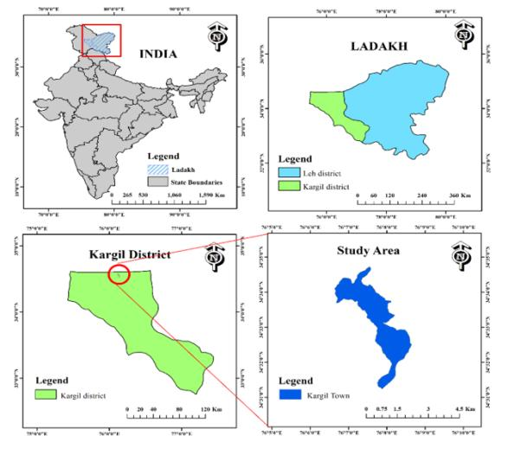

***Figure 1:*** *Study Aera Map* (Prepared by one of the author)

**3. DATABASE & METHODOLOGY**

**3.1 Database:**

The current study will utilize the following spatial and non-spatial datasets. • The majority of spatial data used in this research is sourced from the USGS. Satellite imagery has been acquired from the United States Geological Survey. Multi-temporal data from LANDSAT 4-5 TM, LANDSAT-7 ETM+, and LANDSAT-8,9 OLI (table 1) has been processed, classified, and analyzed to assess the changes in land use and land cover within the study area.

• Secondary data including population, climate, tourist arrivals, etc., have been gathered from:

* Census of India (2001, 2011)
* District Census Handbook Kargil (Ladakh): VILLAGE AND TOWN WISE PRIMARY CENSUS ABSTRACT (PCA)
* District Statistical Handbook.
* Tourism directories.

The Landsat satellite series offers an essential source of remote sensing data for analyzing changes in land use and land cover. In this research, Landsat imagery will be sourced for the specified study area from USGS Earth Explorer (<https://earthexplorer.usgs.gov/>). The selection of the Landsat scenes will depend on their availability, cloud cover, and suitable temporal resolution. The Landsat scenes encompass the necessary time frame to effectively capture the changes in land use and land cover. The datasets from LANDSAT 4-5, LANDSAT-7 ETM+, and LANDSAT-8,9 OLI, which have a spatial resolution of 30 m and 15 m for the Panchromatic band, were downloaded as per the required time frame.

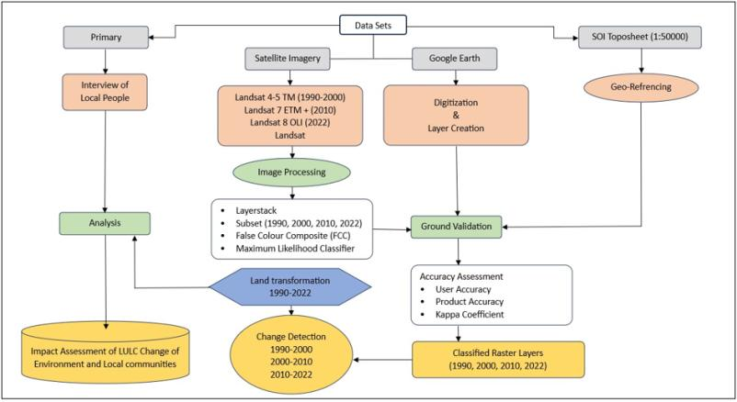

**Figure 2: Methodology Flowchart for the following study**

|  |  |  |  |  |
| --- | --- | --- | --- | --- |
|  | Data type | Source | Data specifications | Time Period |
| LANDSAT 4-5 TM | Spatial | USGS | (30 m resolution) Path/Row 148/36 | 19/August/1991 |
| LANDSAT 4-5 TM | Spatial | USGS | (30 m resolution) Path/Row 148/36 | 27/August/2000 |
| LANDSAT-7 ETM+ | Spatial | USGS | (30 m resolution) Path/Row 148/36 | 31/August/2010 |
| LANDSAT-8,9 OLI | Spatial | USGS | (PAN 15 m, 30 m resolution) Path/Row 148/36 | 29/June/2022 |
| Google Earth Pro |  |  |  |  |
| OSM |  |  |  |  |

**Table 1:** Spatial data (Kargil)

**3.2 Land use and land cover classification:**

Obtaining accurate image classifications is a vital part of analyzing changes in land use and land cover. This process entails assigning specific land cover types to each pixel in the imagery according to their spectral features (Zhu & Woodcock, 2014). In this study, the rule-based maximum likelihood classification (MLC) algorithm was utilized through ERDAS IMAGINE software, as nonparametric approaches have demonstrated high accuracy levels (Rwanga & Ndambuki, 2017). Additionally, Google Earth Pro serves as an excellent resource for executing such analyses, thanks to its extensive satellite imagery database and easy-to-navigate interface (Webster et al., 2016), allowing for manual digitization of built-up areas and other classes to improve the precision of the LULC maps. The resulting digitized polygons for various categories were saved in (.kml) format. These files were subsequently transformed into shapefiles (.shp) format in ArcMap 10.8.1 using the conversion tool. Then, these files were selected within ERDAS Imagine software and recoded to align with the previously classified map, enhancing the precision and clarity of the LULC classification maps. The final classified maps were processed in ArcMap 10.8.1, where titles, legends, a north arrow, and grids were incorporated into the output map (fig 2).

**Table 2:** LULC classification scheme.

|  |  |  |
| --- | --- | --- |
| S. No | Class name | Description |
| 1 | Built-up | Residential areas, commercial structures, government offices, paved structures, army camps and other infrastructures are included in this category. |
| 2 | Agriculture | Wheat, barley, mustard, peas and fodder is dominated by this category**.** |
| 3 | Vegetation | Trees like willows, poplars, fruit trees like walnut, apricot, apple, pears and grasses and shrubs ate included in this category |
| 4 | Waterbodies | This class consists of rivers and streams. |
| 5 | Barren | All the land not favorable for cultivation and un-inhabited land are included in this class. |

**3.4 Accuracy Assessment:**

When it comes to Land Use and Land Cover (LULC) classification, errors of accuracy can occur from many sources which can diminish the potential of the results (Foody, 2002). Due to spectral resemblance, a number of land covers for instance urban and bare soils can be haphazardly classified. There is also an issue of temporal variability, such as seasonal variation, which makes the matter even more complex. As with the identification of objects, the spatial resolution is critical here and low one can miss out on certain features. Inter-class noise, or the presence of mixed pixels, pixels that contain more than one type of land cover, also contribute to the errors. Mistakes made when processing the obtained information can also lead to errors. These problems can be solved by using high resolution image, better training data, better algorithms, and field checking for better LULC classification (Rwanga & Ndambuki, 2017). To overcome these errors accuracy assessment through Kappa Coefficient assessment is among the widely used accuracy assessment processes for measuring the reliability of classification systems (Quang et al., 2020). The Kappa coefficient, called Cohen’s Kappa evaluates how well the observed classification matches the reference data. It considers both the expected chance accuracy and the actual accuracy, from the classification process. This evaluation is especially valuable, in scenarios involving imbalanced class distributions or were relying solely on accuracy might be deceptive. The kappa coefficient ranges from -1 to 1, where 1 indicates perfect agreement, 0 indicates no agreement beyond chance, and negative values indicate less agreement than expected by chance (Congalton & Green, 1999).

For this study stratified random sampling technique was used to collect 50 samples from each category from the classified maps of 1990, 2000, 2010 & 2022. The Stratified random sampling technique is a systematic random sampling approach that ensures an unbiased representation of the study area. Thus, integrating the stratified random sampling technique to the assessment makes it more credible since it randomly samples the whole study area and provides a reliable estimate of the points that the classification has gotten right. The collected sample points serve as a reference location for collecting ground truth data. Subsequently, the Kappa coefficient is calculated between the LULC classification map derived from remote sensing data details and the ground truth details from the sample.

Land use and land cover (LULC) accuracy assessment for Kargil town from 1990-2022 showed significant improvements. The overall accuracy increased from 74.80% in 1990 to 90.00% in 2022, with improving Kappa coefficient from 0.738 to 0.8741 (table 3,4,5&6). The 1990 map, produced in a poor resolution using Landsat 5 TM, was not very effective in differentiating land covers that were spectrally similar, hence some misclassifications. The maps for 2000, 2010, and 2022 have an overall accuracy of above 79% and were gained owing to the usage of high-resolution data, advanced algorithms, and better processing techniques. The 2022 map is the best and most reliable representation of Kargil land cover and shows the development made in remote sensing and classification methods. The Overall Accuracy was calculated using the following formula:

$$\sum_{i=1}^{r}{X_{ii}} (i)$$ Where,

xii=diagonal elements in the error matrix;

x=total number of samples in the error matrix.

The Kappa Coefficient

$\hat{K}=$ $\frac{n\sum_{i=1}^{r}{X_{ii}-\sum_{i=1}^{r}{(X_{i}+X_{+i})}}}{n^{2}-\sum_{i=1}^{r}{(X_{i}+X_{+i})}}$ ($ii$)

Where,

r = number of rows in the matrix;

xii = number of observations in row i and column i.

xi+ and x+i=marginal totals of row i and column i respectively and

n=total number of observations (samples/pixels).

Table 3a: Accuracy totals for the year 1990

|  |  |  |  |  |  |
| --- | --- | --- | --- | --- | --- |
| **Class Name** | **Reference**  **Totals** | **Classified**  **Totals** | **Number**  **Correct** | **Producers**  **Accuracy** | **Users**  **Accuracy** |
| Built-Up | 42 | 31 | 23 | 54.76% | 74.19% |
| Vegetation | 48 | 47 | 36 | 75.00% | 76.60% |
| Barren | 51 | 55 | 40 | 78.43% | 72.73% |
| Agriculture | 53 | 59 | 45 | 84.91% | 76.27% |
| Waterbody | 56 | 58 | 43 | 76.79% | 74.14% |
| Totals | 250 | 250 | 187 |  |  |

Overall Classification Accuracy = 74.80%

Kappa (K) Statistics

Overall, Kappa Statistics = 0.738

Table 3b: Conditional Kappa for each Category

|  |  |
| --- | --- |
| **Class Name** | **Kappa** |
| Build-up | 0.6898 |
| Vegetation | 0.7103 |
| Barren | 0.6574 |
| Agriculture | 0.6989 |
| Waterbody | 0.6667 |

Table 4a: Accuracy totals for the year 2000

|  |  |  |  |  |  |
| --- | --- | --- | --- | --- | --- |
| Class Name | **Reference**  **Totals** | **Classified**  **Totals** | **Number**  **Correct** | **Producers**  **Accuracy** | **Users**  **Accuracy** |
| Built-Up | 37 | 31 | 23 | 62.16% | 74.19% |
| Vegetation | 50 | 47 | 38 | 76.00% | 80.85% |
| Barren | 50 | 55 | 42 | 84.00% | 76.36% |
| Agriculture | 56 | 59 | 49 | 87.50% | 83.05% |
| Waterbody | 57 | 58 | 46 | 80.70% | 79.31% |
| Totals | 250 | 250 | 198 |  |  |

Overall Classification Accuracy = 79.20%

Kappa (K) Statistics

Overall, Kappa Statistics = 0.7381

Table 4b: Conditional Kappa for each Category

|  |  |
| --- | --- |
| **Class Name** | **Kappa** |
| Build-up | 0.6971 |
| Vegetation | 0.7606 |
| Barren | 0.7045 |
| Agriculture | 0.7816 |
| Waterbody | 0.7320 |

|  |  |  |  |  |  |
| --- | --- | --- | --- | --- | --- |
| **Class Name** | **Reference**  **Totals** | **Classified**  **Totals** | **Number**  **Correct** | **Producers**  **Accuracy** | **Users**  **Accuracy** |
| Built-Up | 36 | 31 | 23 | 63.89% | 74.19% |
| Vegetation | 48 | 47 | 38 | 79.17% | 80.85% |
| Barren | 54 | 55 | 44 | 81.48% | 80.00% |
| Agriculture | 54 | 59 | 47 | 87.48% | 79.66% |
| Waterbody | 58 | 58 | 46 | 79.31% | 79.31% |
| Totals | 250 | 250 | 198 |  |  |

Table 5a: Accuracy totals for the year 2010

Overall Classification Accuracy = 79.20%

Kappa (K) Statistics

Overall, Kappa Statistics = 0.7379

Table 5b: Conditional Kappa for each Category

|  |  |
| --- | --- |
| **ass Name** | **Kappa** |
| Build-up | 0.6985 |
| Vegetation | 0.7630 |
| Barren | 0.7449 |
| Agriculture | 0.7406 |
| Waterbody | 0.7306 |

Table 6a: Accuracy totals for the year 2022

|  |  |  |  |  |  |
| --- | --- | --- | --- | --- | --- |
| **Class Name** | **Reference**  **Totals** | **Classified**  **Totals** | **Number**  **Correct** | **Producers**  **Accuracy** | **Users**  **Accuracy** |
| Built-Up | 35 | 31 | 28 | 80.00% | 90.32% |
| Vegetation | 52 | 47 | 45 | 86.54% | 95.74% |
| Barren | 55 | 55 | 50 | 90.91% | 90.91% |
| Agriculture | 53 | 59 | 52 | 98.11% | 88.14% |
| Waterbody | 55 | 58 | 50 | 90.91% | 86.21% |
| Totals | 250 | 250 | 225 |  |  |

Overall Classification Accuracy = 90.00%

Kappa (K) Statistics

Overall, Kappa Statistics = 0.8741

Table 6b: Conditional Kappa for each Category

|  |  |
| --- | --- |
| **Class Name** | **Kappa** |
| Build-up | 0.8875 |
| Vegetation | 0.9463 |
| Barren | 0.8834 |
| Agriculture | 0.8494 |
| Waterbody | 0.8232 |

**4. RESULTS AND DISCUSSIONS**

**Table 7: Land Use Land Cover Structure of Kargil Town (1990-2022)**

|  |  |  |  |  |  |  |  |  |  |
| --- | --- | --- | --- | --- | --- | --- | --- | --- | --- |
| **LULC Classes** | **Area in hectare (1990)** | **Area in % (1990)** | **Area in hectare (2000)** | **Area in % (2000)** | **Area in hectare (2010)** | **Area in % (2010)** | **Area in hectare (2022)** | **Area in % (2022)** | **Change (%)**  **(1990-2022)** |
| **Built-up** | 27.62 | 5.04 | 50.52 | 9.23 | 85.67 | 15.66 | 117.91 | 21.55 | **326.90** |
| **Agriculture** | 88.70 | 16.12 | 79.54 | 14.54 | 69.83 | 12.76 | 64.02 | 11.70 | **-27.62** |
| **Vegetation** | 127.60 | 23.32 | 126.12 | 23.05 | 118.38 | 21.64 | 114.20 | 20.87 | **-10.50** |
| **Waterbody** | 12.10 | 2.21 | 11.11 | 2.03 | 9.93 | 1.81 | 9.98 | 1.82 | **-17.52** |
| **Barren** | 290.98 | 53.19 | 279.71 | 51.13 | 263.19 | 48.11 | 240.89 | 44.03 | **-17.21** |

**4.1 Land Use Land Cover Structure of Kargil Town**

***4.1.1: LULC Structure 1990:***

In 1990 Kargil’s LULC structure was dominated by barren land (fig 3), covering 290.98 ha (53.19% of the total area) (table 7), this reflects the region's arid and rugged terrain with limited developmental activities. The dominance barren land indicates that the area was still underutilized and relatively underdeveloped, with wide area pockets still remaining undeveloped for purposes of agriculture or urbanization. Vegetation accounted for 127.6 ha (23.32%), indicating natural greenery distributed in patches throughout the area. However, this vegetation was sparse and restricted due to the harsh climatic conditions and poor soil fertility, principally consisting of grasslands and low shrubs. Uncultivated land constituted only 88.7 ha (16.12%), which indicates that the region is quite dependent on farming, though this is not extensive because of poor accessibility in terms of both topography and water availability. Built-ups were little represented, only 27.62 ha (5.04%) (table 7) in extent, indicating a small population density in the town at the time and limited infrastructure development. Urbanization had not yet progressed tremendously, and much of the built-up area consisted of small residential and commercial structures. Water bodies, mainly

represented by Suru River and Wakha Nala, accounted for 12.1 ha (2.21%) and these water bodies play a critical role in agriculture and as an asset for the local population, although their area kept changing due to seasonal variations of water flow. The 1990 LULC arrangement shows that there was minimal human intervention and that the landscape was primarily determined by natural characteristics. A more rural environment is suggested by the low concentration of built-up area, where agriculture is not currently given much emphasis. A sizable portion of the land would be made up of barren land, suggesting future growth potential.

***4.1.2: LULC Structure 2000:***

By 2000, LULC of Kargil town showed the first signs of the urban expansion indicating that the town started to follow its gradual shift towards urbanization (fig 3). Barren land decreased to 279.71 ha (51.13%) (table 7), indicating a slight reduction as other areas were being used for urban expansion and infrastructure growth. This change mirrored early signs of urban sprawl that used up more land for residential, commercial and transportation uses. Vegetation received a small decrease of 126.12 ha (23.05%), indicating that even the natural landscapes began to be used for built-up at this time, but at this stage it was not as severely affected as other categories. Agricultural land continued to decrease to 79.54 ha (14.54%), where farmland was being increasingly developed into urban land use, the most important being for housing and infrastructure. Built-up areas increased significantly to an increase of 82.91% from their initial values to 50.52 ha (9.23%), indicating the start of a more pronounced urban growth pattern. Such expansion was spurred on by population growth, economic projection, developing tourism sector and the onset of infrastructure development. A decrease of the waterbodies

area was noted, down to 11.11 ha (2.03%) (table 7), ascribable to seasonal changes in water levels, accompanied by little change in river morphology. All in all, Kargil is showing indications of early urbanization by 2000, marked with advancing conversion of barren land and agriculture into urban development, signalling a transformational phase in its LULC structure.

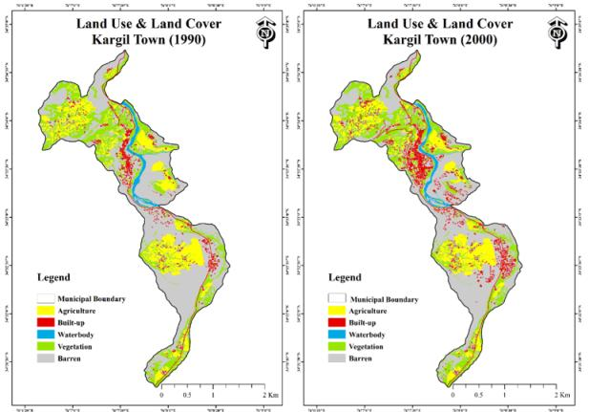

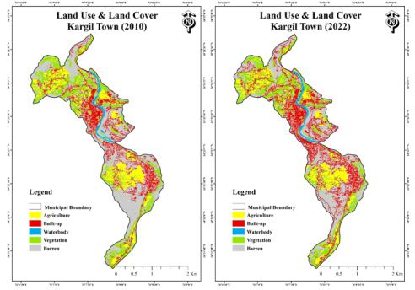

**Fig.3: LULC Structure of Kargil Town (1990-2022)**

***4.1.3: LULC Structure 2010:***

By 2010, Kargil was changing fast. The once vast stretches of barren land kept shrinking (fig 3), dropping to 263.19 hectares (about 48.11% of the area) (table 7), as more space was taken up for housing, roads, tourism infrastructure and other development projects. This shift showed how the demand for homes, businesses, and public buildings was growing. Vegetation showed a further sharp decline to a figure of 118.38 ha (21.64%) as human-induced urban sprawl and human infrastructure projects encroach further into natural landscapes, reducing the amount of green cover within the area. Besides, agricultural land dwindled to 69.83 ha (12.76%), reflecting the continuous shift from agrarian base to a quite urbanized economy. There is shrinkage of agricultural land due to conversion of agricultural areas to built-up zones, especially areas like Goma Kargil and Baroo, which were constructed over time. Built-up areas saw another increase in their number, raising by 69.57% and now measuring 85.67 ha (15.66%) (table 7), driven by enhanced population growth and increase in tourists visits, the number of tourists visits increased form 332 in 2 the year 2000 to 28927 in 2010 (Tourism Department Kargil) which led to the increased construction of hotels and guesthouses and other tourism related infrastructure development in the region, further economic activity, and the critical infrastructural development also contributed in the expansion of the built-up category. Waterbodies also reduced further to only 9.93 ha (1.81%), due to the seasonal variations, and also because of the Chutuk Hydel Power Project, as it soon left a strong effect on the water levels of the Suru River. By 2010, rapid urbanization was visible in Kargil and significant changes were witnessed in the structure of land use, owing to increased needs for infrastructure, population pressure, and economic development.

***4.1.4: LULC Structure 2022:***

By 2022, Kargil had undergone substantial urban growth, with its LULC structure reflecting a highly urbanized and developed landscape (fig 3). Barren land continued its downward trend, decreasing to 240.89 ha (44.03%), as more areas were converted into built-up zones for residential, commercial, and institutional purposes. This decline in barren land was a direct result of the ongoing urbanization and infrastructure development projects in Kargil. Vegetation also continued to decrease, though at a slower pace, down to 114.2 ha (20.87%), which was a net decrease of 3.53%. Although the loss of vegetation slowed relative to the past decades, urban encroachment and development still eroded the natural green cover. Agricultural land also continued to drop to 64.02 ha (11.7%) (table 7), with a net decrease of 8.32% from 2010, as farming areas were increasingly converted into built-up areas owing to rising demand for residential, guesthouses, and hotels. 117.91 ha (21.55%) of the built-up area proved a continuous and steady urban expansion, marking a 37.63% increase. Population growth, migration, increased tourism and a new buildup of military and government infrastructure all fuelled this growth. Waterbodies showed a non-zero increase to 9.98 ha (1.82%) but it can be expected that seasonal increase of the water level in this period might counter the overall effect on this category was minimal. Overall, by 2022, Kargil's LULC had undergone a remarkable transformation, with a significant increase in urbanization and a continued decline in barren, agricultural, and vegetated areas (fig 3), driven by population growth, infrastructure development, and increased tourism activity.

***4.2:* LULC Changes in Kargil from 1990 to 2022:**

***4.2.1: Built-up:***  
The built-up category in Kargil Town saw remarkable expansion from 27.62 ha in 1990 to 117.91 ha in 2022, affirming continued urban expansion in this landscape. It grew from 27.62 ha in 1990 to 50.52 ha in 2000 to 85.76 ha in 2010 and finally to 117.91 ha in 2022 (fig 6) with a net increase of 326.90% (table 8). Infrastructure for residential, commercial, and institutional use has mainly been the contributor for this increase. The urban population of Kargil town has, perhaps, seen a tenfold increase from 1681 in the year 1961 to 16338 in 2011 (Hussain et al., 2023. The population of the town increased from 8718 in 1981 to 41566 in 2022 because of both natural population growth and rural-urban migration. The urban population of Kargil town increased as the proportion of the urban population increased from 3.7% in 1961 to 8.9% in 2000 (Census of India). Continuous construction has been noticed in areas such as Balti Bazaar, Changchik, Baroo Colony, Bemathang, and the Main Market Area since the last decade of the previous century. The tourism development can also be seen as a strong factor, the number of tourists visits increased form 1134in the year 1990 to 225543 in 2022 (Fig 5) which led to the increased construction of hotels and guesthouses and other tourism related infrastructure development in the region, further economic activity, and the critical infrastructural development also contributed in the expansion of the built-up category. The post-1999 Kargil War also led to the construction of many army areas which can also be considered a reason for this increase. The built area has greatly increased and supports mountain urbanization trends (Uddin et al., 2023). Effects of changing land use and the urban landscape of Kargil are profound. Continuous monitoring and sustainable design are required, to attain success in managing this growth.

**Table 8: Percentage changes in each category (1990-2022)**

|  |  |  |  |  |
| --- | --- | --- | --- | --- |
| **LULC Classes** | **Change (%)**  **(1990-2000)** | **Change (%)**  **(2000-2010)** | **Change (%)**  **(2010-2022)** | **Change (%)**  **(1990-2022)** |
| **Built-up** | 82.91 | 69.57 | 37.63 | **326.90** |
| **Agriculture** | -10.32 | -12.20 | -8.32 | **-27.62** |
| **Vegetation** | -1.15 | -6.13 | -3.53 | **-10.50** |
| **Waterbody** | -8.18 | -10.62 | 0.53 | **-17.52** |
| **Barren** | -3.87 | -5.90 | -9.44 | **-17.21** |

***4.2.2: Agriculture:***  
Agriculture has been steadily decreasing from 88.7 ha in 1990 to 64.02 ha in 2022. Conversions were mainly registered in the Goma Kargil, Lankore, Poyen, and Shelikchey areas. Through these three decades it decrased from 88.7 ha in 1990 to 79.54 ha in 2000 to 69.83 ha in 2010 and further decreased to 64.02 ha till the year 2022 (fig 6) with a net decrease of (-27.62%) (table 8). Urbanization, change in land-use priorities, and climate-related challenges could be responsible for the decline of agricultural land. With increasing urbanization and establishment of infrastructure development, agricultural lands have been encroached upon incrementing a gradual shift from traditional agricultural practices to commercial and urban economic activities. The decline in agricultural land could be attributed to several factors, including urbanization and changing land use priorities (Alam et al., 2019). The variation of climate factors could have impacted on the irrigation depending on glacial and river systems, leading on some occasions to decreased agricultural yield. Also, erratic weather patterns, water scarcity, and changing temperatures in the region have made farming a rather marginal activity in some areas, leading to a decline in cultivated land. Need for hotels, guesthouses and habitation areas for the increasing number of tourists and migrants further accelerated agricultural land loss. The above picture heralds the changing time concerning the transition of the city from an agrarian economy into a more urbanized and diversified economy.

***4.2.3: Vegetation:***  
The vegetation cover also suffered a continuous depletion at a slow rate from 127.6 ha in 1990 to 114.2 ha in 2022. (table 8) The trend in this category indicates scant vegetation and deforestation trends in the area, both from anthropogenic and natural causes. This category recorded (127.6 ha, 126.12 ha, 118.38 ha & 114.2) ha during the years (1990, 2000, 2010 & 2022) respectively. Major vegetation loss happened between 2000 and 2010; probably due to development activities like construction of roads, military installations, and residential settlements. Also, climatic changes like increasing temperature, variable rainfall, and altering seasons were likely to stress vegetation. Low productivity, coupled with lesser natural vegetation cover in the region, is another major reason for a declining trend in this land cover category. Furthermore, land conversion for non-agricultural uses, combined with a lack of active reforestation or conservation efforts, results in a net decrease in overall vegetation coverage, affecting biodiversity and ecosystem services (Alam et al., 2019). This continuous drop for several years has been impacted by seasonal variations in addition to green areas being cut for construction works. Addressing deforestation through reforestation and sustainable land management practices is vital for conserving biodiversity and the prosperity of the ecosystem.

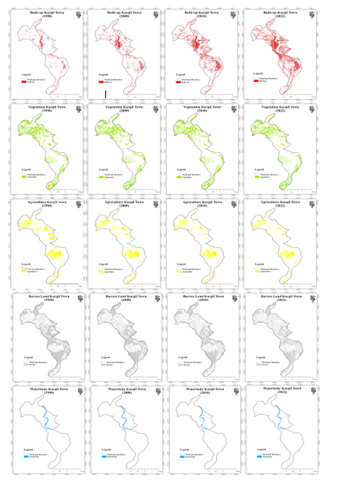

**Figure 4: LULC dynamics of different categories (1990-2022)**

**Fig.4: LULC Cover of different categories (1990-2022)**

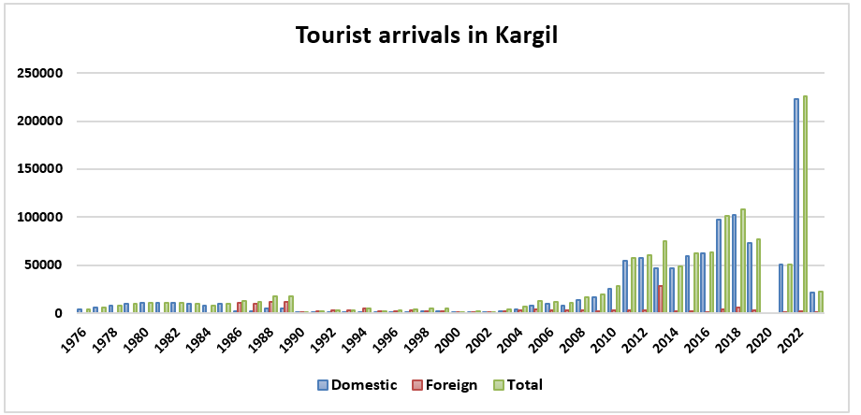

**Figure 5: Arrivals of tourists in Kargil District (1976-2022)**

***4.2.4: Waterbody:***  
The category has also recorded a decrease from 12.1 ha in 1990 to 9.98 ha in 2022 (fig 6) with a net total decrease of (-17.52%) (table 8). The loss in water bodies could be attributed to glacier-based shrinking, diversion of water courses, or anthropogenic interference in riverbeds and its courses. Furthermore, these seasonal variations in water content in the Suru River and Wakha Nala and also the construction of Chutuk Hydel Power Project on Suru River in the year 2006 have played their part in diminishing the water availability in the river system. The increased demand for irrigation and drinking and industrial purposes may have led to the depletion of natural water sources. The longer-term decrease could be due to shrinking glaciers or human activities affecting riverbeds and lakes (Rafiq et al., 2018). Other factors, including an overall decrease in precipitation and warming temperature, might have a role in the reduced river flow. Nevertheless, from 9.93 ha in 2010, there was a slight increase to 9.98 ha in 2022 (table). This can be attributed to seasonal variations in the water content of local rivers, particularly after heavy winter snowfall. It's important to monitor these water systems in the face of climate change and existing water management practices (Badar et al., 2013).

***4.2.5: Barren Area:***  
The barren category in Kargil Town showed a declining trend (fig 4), with an area of 290.98 ha in 1990 now reduced to 240.89 ha in 2022, thus showcasing a net decrease of (-17.21%) (table 8). in the barren area. This decrease may primarily be attributed to the conversion of barren land into settlement, courtesy of house and government office construction. This category recorded (290.98 ha, 279.71 ha, 263.19 ha & 240.89 ha) during the years (1990, 2000, 2010 & 2022) respectively table. Another significant reason that contributes to this modification is the construction of the army cantonment zones. The more urban Kargil becomes, such barren lands are converted into construction and infrastructure projects (Hussain et al., 2023). Unlike some regions where barren lands might be converted for agriculture, Kargil's climate and terrain make such conversions less viable (Raghuvanshi et al., 2019). Instead, the focus is on essential infrastructure and residential development. While the decrease in barren land might seem positive in terms of land utilization, it raises concerns about the long-term ecological impact and potential loss of natural habitats. Sustainable land management practices are crucial to balance development with environmental conservation (Alam et al., 2019)

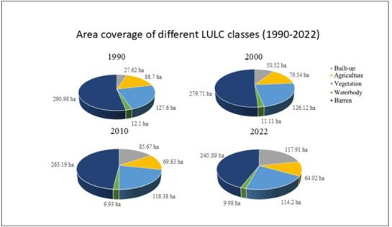

**Fig.6: Area coverage of different categories (1990-2022)**

**5: CONCLUSION:**

The study reveals significant transformations in Kargil's land use and urban landscape. Agricultural land and the vegetation cover experienced a steady decline, while the built-up area has increased, indicating a transition from an agrarian to more urbanized economy (Hussain et al., 2023). It's the growth of tourism, infrastructure development, and the geopolitical context that has strengthened this growth. Tourist influx increased widely from 1,134 visitors in 1990 to 225,543 in 2022 and has developed hotels and guesthouses. The Kargil War of 1999 also triggered the creation of army zones in the region. The waterbody category also experienced an overall decline due to receding glaciers and anthropogenic interferences. While the barren area has decreased due to construction, this raises concerns about ecological impacts. Particularly, agricultural land reduced from 88.7 ha in 1990 to 64.02 ha in 2022 with conversions that involve predominantly Goma Kargil, Lankore, Poyen, and Shelikchey locations. Similarly, vegetation cover showed a decrease of 127.6 ha in 1990 to 114.2 ha in 2022 with a considerable loss between the years 2000 to 2010, which was due to construction work. Sustainable land management becomes necessary to reconcile development and environmental protection amid these changes.

References

Chevuturi, A., A. P. Dimri, and R. J. Thayyen. "Climate change over Leh (Ladakh), India." Theoretical and Applied Climatology 131 (2018): 531-545.

Foley, J. A., DeFries, R., Asner, G. P., Barford, C., Bonan, G., Carpenter, S. R., ... & Snyder, P. K. (2005). Global consequences of land use. Science, 309(5734), 570-574.

Jensen, J. R. (2005). Introductory digital image processing: A remote sensing perspective. Prentice Hall.

Turner, B. L., Lambin, E. F., & Reenberg, A. (2007). The emergence of land change science for global environmental change and sustainability. Proceedings of the National Academy of Sciences, 104(52), 20666-20671.

Hussain, A., Schmidt, S., & Nüsser, M. (2023). Dynamics of mountain urbanisation: Evidence from the Trans-Himalayan town of Kargil, Ladakh, India. Land, 12(4), 920.

Uddin, S., Kausar, A., Afsar, S., Afzal, A., Lahori, A. H., Stepova, O., ... & Bredun, V. (2023). Exploring the Complexities of Urbanization and Socio-Ecological Challenges in the High Mountainous Region of Chitral, Khyber Pakhtunkhwa (KPK), Pakistan. Proceedings of the Pakistan Academy of Sciences: A. Physical and Computational Sciences, 60(1), 47-54.

Alam, A., Bhat, M. S., & Maheen, M. (2020). Using Landsat satellite data for assessing the land use and land cover change in Kashmir valley. GeoJournal, 85(6), 1529-1543.

Rafiq, M., Mishra, A. K., & Meer, M. S. (2018). On land-use and land-cover changes over Lidder Valley in changing environment. Annals of GIS, 24(4), 275-285.

Badar, B., Romshoo, S. A., & Khan, M. A. (2013). Modelling catchment hydrological responses in a Himalayan Lake as a function of changing land use and land cover. Journal of earth system science, 122, 433-449.

Raghuvanshi, M. S., Dorjay, N., Singh, R. K., Manjunatha, B. L., Moharana, P. C., Spalbar, E., ... & Saxena, A. (2019). Ladakh traditional farming: an approach to resource utilization under changing climate. Int. J. Curr. Microbiol. App. Sci, 8(9), 654-666.

Foody, G. M. (2002). Status of land cover classification accuracy assessment. Remote sensing of environment, 80(1), 185-201.

Rwanga, S. S., & Ndambuki, J. M. (2017). Accuracy assessment of land use/land cover classification using remote sensing and GIS. International Journal of Geosciences, 8(04), 611.

Quang, N. H., Quinn, C. H., Stringer, L. C., Carrie, R., Hackney, C. R., Van Hue, L. T., ... & Nga, P. T. T. (2020). Multi-decadal changes in mangrove extent, age and species in the Red River Estuaries of Viet Nam. Remote Sensing, 12(14), 2289.

Zhu, Z., & Woodcock, C. E. (2014). Continuous change detection and classification of land cover using all available Landsat data. Remote sensing of Environment, 144, 152-171.

Webster, K., Arroyo-Mora, J. P., Coomes, O. T., Takasaki, Y., & Abizaid, C. (2016). A cost path and network analysis methodology to calculate distances along a complex river network in the Peruvian Amazon. Applied Geography, 73, 13-25.

Barrett, K., & Bosak, K. (2018). The role of place in adapting to climate change: A case study from Ladakh, Western Himalayas. Sustainability, 10(4), 898.