**DEVELOPMENT AND PERFOMANCE EVALUATION OF A MOBILE SOLAR COOLING SYSTEM FOR POST-HARVEST LOSSES REDUCTION IN ORANGE FRUITS**

ABSTRACT

A mobile solar cooling system (MSCS) for fruits and vegetables of 0.2 m3 was designed, fabricated in order to overcome the deficiencies in handling, distribution systems, processing and storage methods which significantly added up to post-harvest losses of oranges especially in regions with limited access to grid electricity. The evaluation of the MSCS was specifically on sweet orange fruits for its performance. The experimental design used was a 2 by 3 factorial complete randomized block design. The Coefficient of Performance (COP) of the system was assessed through various parameters including cooling demand and energy consumption by the compressor and was calculated to be 2.02. The effect of the storage using the MSCS compare with ambient was done. The quality assessment tests of the stored oranges that were carried out include changes in physiological weight, sample rottenness, colour change and firmness. The determination of the chemical and microbial quality of the test samples as affected by the storage environment was also carried out. Storage temperatures and relative humidities recorded were (30 ± 6°C) and (78 ± 19%), (14 ±4°C) and (85 ± 10%) for ambient and MSCS respectively. The results of storage data were statistically analyzed using IBM SPSS statistics 25. The statistic results were highly significant among all the observations at probability level of (P<0.01). Results indicated that increase in storage temperature and time increases the chemical compositions in the stored oranges, except for acidity, fruit firmness and vitamin C that were decreased with the increase of storage time. Besides, MSCS increases the shelf life of the stored oranges for 33 days as compared to storage under ambient which stored for 20 days. The results of this study would provide valuable insights into the potential benefits of using mobile solar cooling systems for fruit and vegetables preservation.

Key words: Mobile Solar Cooling System, Coefficient of Performance, Ambient, Temperature, and Humidity.

1. INTRODUCTION

Nigeria is the one hundred and fifty ninth largest producer of fruits and vegetables in the world, A huge investment of resources are being channeled to production, distribution, storage and marketing of about 102 million metric tons per annum in order to maintain continuous supply of these commodities FAO (2018).

One of the major challenges of orange production is lack of infrastructure for storage and preservation and poor handling of the fruits during harvesting and transportation. Over 50% of the fruits produced in Nigeria are lost in transit between farms and major urban markets.  The consumption of fruits and vegetables is important due to the nutrients they contain, which can limit the risk of cardiovascular diseases and cancer (Verploegen *et al.*, 2019). They possess considerable quantities of vitamins A, B, C, D, E and K, which generally help in protecting the human body against diseases and contribute in no small measure to good health (Okanlawon and Olorunnisola, 2017). Poor and inadequate post-harvest infrastructure results to significant losses of these produces. Due to their high moisture content, fruits and vegetables are liable to spoil and as such, making post-harvest losses to result in direct food and income losses to farmers and consumers globally (Stathers, 2017). Storage of fresh fruits and vegetables after harvest is one of the most pressing problems faced by farmers and handlers of these commodities. Losses of fruits and vegetables occur everywhere from the field to the ultimate consumer and depend on the degree of perishability of the produce. Fresh fruits and vegetable deteriorate easily when stored under ambient condition, mainly due to physiological and microbial activities, which are accelerated at high temperature and low relative humidity of the storage environment. Most of the fruits and vegetables produce require a cooling temperature between 0 °C and 15 °C for safe storage and transit purposes (Akorede *et al.*, 2017). In the absence of cold storage and related cold chain facilities, the farmers are forced to sell their produce immediately after harvest which results to glut and low price realization. The usage of electrically powered cold storage is a challenge in Nigeria due to non-availability of electricity and in some areas where it is available, it is epileptic in supply. The purposes of storage are to preserve crops to be consumed when they are out of season, keep food in good conditions, slow down ageing, protect from frost, provide even supply, avoid gluts (surplus), prevent shortages and to obtain higher prices (Chijioke, 2017). Several researchers have investigated the application of solar cooling system in so many applications ranging from cooling building, preserving medical vaccines, solar lights, water pumping and farm irrigation (Olosunde *et al*. 2019).. However, none of these studies consider the usage of mobile solar cooling system in extending the shelf life of fruits and vegetables. Therefore, the objective of this study was to develop a mobile solar cooling system for fruits and vegetable shelf life extension and to evaluate its efficiency and the performance using sweet oranges.

1. MATERIALS AND METHODS

***2.1 Design Considerations***

In carrying out this design work, the following were put into consideration

1. Capacity and total weight of the MSCS
2. Insulation materials
3. Heat load calculations
4. Compactness and availability of construction materials

***2.2 Materials Used for the Mobile Solar Cooling System Construction (MSCS)***

The materials used for this work are classified into:

1. **Construction materials:**
2. Mobile devise: A tricycle
3. Solar components: solar panels, charge controller, deep cycle solar battery, circuit breakers, cable and cable connectors and switch board.
4. Cooling component materials: DC compressor accessories, condenser with fan, water bath with water as phase change material, evaporator plates on which ice was formed, a brush-less DC water pump to convey chilled water to the storage chamber, water hoses, clips and refrigerant (R600a) isobutene which is environmental friendly.
5. Storage chamber component materials: polyurethane panels of 60 mm insulation thickness for rectangular shape storage chamber construction, stainless pipe for construction of racks and shelves, stainless mesh was used for construction of trays where produce were arranged, heat exchanger (evaporator) with fan to circulate thermal cooling energy in the storage chamber.
6. Other items for construction are galvanized metal sheets, bolts, nuts and screws to fasten the walls of storage chamber and other parts together, a 45 litres (from calculation) insulated plastic container was used for water chiller bath to avoid thermal losses, electrodes (both stainless and mild steel type will be used for welding the various metal parts.

### Instrumentation devises for the research work

The following instruments, equipment and apparatus were used in the study,

1. A digital camry weighing scale (30 kg) and (600 g) capacity of 0.001 kg accuracy, ACS – 30 – JE 11, made in China – was used for measuring the weights of samples.
2. Hobo Humidity/Temperature automated Data logger (ONSET MX2301, WXF – ONST3) - It monitors temperatures from -40 to +85°C. It has built-in temperature sensor, Case waterproof to ip68, User programmable alarms, User-replaceable battery, 32,000 reading capacity, High reading resolution, Fast data offload and Low-battery monitor.
3. Fruit and vegetable portable colourimeter (WR10QC – 8, 10QC230754) was used to monitor the test commodity’s colour change.
4. Compression testing machine (Testometric X350 – 10); was used to test for the force that can break the test commodities thus indicating the level of firmness/hardness quality of the fruits.
5. Solar power meter (NO. 11128388, LCD display, w/m2 or BTU) – this was used in measuring solar insolation of the sun in the study location.
6. AC and DC multimetre (Etekcity-C600 digital clamp metre) – this was used to measure the current in solar panels, batteries, compressors and charge controller.
7. Four channel thermocouple: 3 (three) of this channel was used to record the temperature of water in the water chiller bath and the remaining 1 channel is to record ambient temperature.
8. Vernier caliper was used to measure the dimensions (diameters) of test samples
9. Thermostat was used to control the temperature both in the storage chamber and in the water chiller bath.
10. Smart Sensor Digital Anemometer AR826 (Graigar, China) measuring to an accuracy of 0.3 m/s. This is to measure the air velocity in the storage chamber

***2.3 Design Calculations***

***Calculation of total heat loads***

Heat loads is the total amount of heat that the cooling system will remove from the storage chamber. The leaks and splashes of heat transmitted in a storage chamber of a cold room will be generated from several critical heat sources which are: heat of conduction, infiltration heat load, product heat load (sensible and respiration) and miscellaneous heat load

1. The total heat of conduction through the insulated walls of the storage chamber of the MSCS was obtained using equation 1 as reported by Ogumo *et al.,* (2020)

 1

Where Q is heat load kWh/day

U is thermal conductivity of insulation material (0.023 to 0.026)

A is Area of sides, roof and floor of storage chamber (m2) = 3.68 m2

isAir temperature inside storage chamber (10 0C) for orange

Ambient temperature (28 0C) average of min. and max. temperature

d is thickness of the wall (m) = 0.06

***Calculation of field heat of produce in the storage chamber***

This is the sensible heat /field heat load that is needed to be extracted from the

produce, heat that is picked up by produce from the farm and it is required to be cooled to

the required storage temperature, this was obtained in line with Kazem *et al.,* (2017) using equation 2

 2

Where:

QPS is Produce sensible heat (kwh/day),

M is Mass of produce (kg), = 25 kg

*Cp* is Specific heat of orange (3.77 kJ /kg 0C)

t *2* is initial temperature of produce (0C), = 28 0C

t*1*is Storage temperature (0C), = 10 0C

***Calculation of heat of respiration of produce in the storage chamber***

This is heat generated by the produce as a natural by-product of its respiration, this was obtained using equation 3 in accordance with Kazem *et al*., 2017.

 3

Where Q resp is Heat of respiration of produce (kwh/day)

m is mass of produce to be stored in (kg) = 25 kg

h is heat transfer coefficient of mango = 0.55 (w/m2 k)

***Calculation of air infiltration load in the storage chamber***

This is heat generated from lights, and warm or moist air entering through cracks or through the door when opened. This was calculated with values from psychometric chart and in accordance with Ogumo *et al*., (2020) using standard equation as shown in equation 4

 4

Where $P_{a}$ is air infiltration load

$M_{a}$ is mass of air entering the storage chamber $/{hr.Kgs}^{-1}$ (calculated)

$h_{a}$ is enthalpy of ambient air $kj.{kg}^{-1}$ (psychometric chart)

$m_{w}$ is mass of water condensing in storage chamber /hr kg (psychometric chart)

h is enthalpy of air in storage chamber $\left({kj.kg}^{-1}\right)$ (psychometric chart)

${CP}_{w}$ is specific heat capacity of water (4.186 j/g 0C)

is ambient air temperature in $℃$

T is air temperature in storage chamber

Mass of air (Ma) entering the storage chamber was obtained according to Ogumo *et al*., (2020) as shown in equation 5

Density (δ) = $\frac{mass (m)}{volume (v)}$ 5

Where density is the density of ambient air entering the storage chamber = 1.29 kg/m3

Mass was calculated and Volume is the volume of the storage chamber of the MSCS = 0.19 m3



Mass of air is 1.29 x 0.19 = 0.25 kg of air entering the storage chamber

Calculation of miscellaneous heat load (Equipment load) in the storage chamber of the MSCS

Miscellaneous heat load is made of heat generated from equipment (evaporator fan), lights and people in the cold room. Heat generated by number of people working in the cold rooms and lightening will not be applicable in this work (Since it is a prototype). Heat generated by DC evaporator motor and fan was calculated using the formula according to Ogumo *et al*., (2020) as shown in equation 6

+ (p x t x η) 6

Where Qequip is equipment heat load

Fn is number of fans (4 fans on heat exchanger and 1 fan on the condenser)

Fp is power rating on fan = (0.61 + 0.29) amps = 0.9 amps, P = IV = 0.9 x 12 = 10.8 W

t is time of operating the fan (hr) = 14 hr

p is power rating of motor heating element =1.2 W

t1 is motor run time = 14 hr

η is efficiency (% of heat transferred to cooling space) = 30 %

Q total = ΣQcond + Qair + Qequip + ΣQresp + Q sens 7

Qtotal = 0.68 + 0.002+ 0.16 + 0.00382 + 0.47 = 1.32 kwh/day

Total heat load and the volume of storage chamber were used in selection of cooling units to extract the total heat load from the storage chamber.

***2.4 Safety factor for the calculated total heat loads***

According to American Society of Heating, Refrigerating and Air Conditioning Engineers (ASHRAE) 2002, applying a safety factor to the calculation is to take care of errors and the risk of failure and any incompatibility between the design criteria and actual calculation. A factor of safety between the ranges of 10 to 30 percent of the calculation is recommended, for this work, 20% of the heat load is chosen in line with Babaremu *et al.,* (2018).

Safety factor = ${20}/{100} x 1.32=0.26$

Thus the heat load safety factor of 0.26 was added to the calculated heat load to give us the total cooling load

0.26 + 1.32 = 1.58 kWh/day

***2.5 Determination of refrigeration cooling capacity of the MSCS***

The total refrigeration cooling capacity of the MSCS was determined according to method use by Sharad and Virendra (2015) and Babaremu *et al*, (2018) as expressed in equation 8. This was done by dividing the total heat load by the run time of the refrigeration unit (D.C compressor). Considering the off and on time of the cooling unit, it is estimated to run for fourteen (14) hours in a day (Babaremu *et al*, 2018).

Table 1 : Summary of the Heat Load of the MSCS

|  |  |
| --- | --- |
| Source of Heat | Quantity of Heat (Kwh/day) |
| Heat of conduction | 0.68 |
| Produce heat (sensible) | 0.47 |
| Produce heat (respiration) | 0.00382 |
| Air infiltration heat | 0.002 |
| Miscellaneous (equipment) heat | 0.16 |
| Total heat load  Safety factor (20%) of total heat load  Total heat load + safety factor calculated | 1.32  0.26  1.58 |

Refrigeration cooling capacity = ${total heat load}/{compressor run time}$ 8

= ${1.58}/{14}$ = 0.113 kW

The cooling unit needs to have a capacity of 0.113 kW to sufficiently overcome the total heat load. Aglag compressor having 120 - 350 w was selected to meet this heat load and cooling capacity.

**Fabrication Process**

The procedure adopted in the fabrication (construction) of the MSCS is as presented:

A 60 mm polyurethane panel was purchased and cut into length = 0.59 m, breadth = 0.4 m and height = 0.79 m to make the storage chamber which has 4 trays made of stainless materials, this was fastened together with galvanized metal plates, screws, bolts and nuts. The solar panel of 550W was connected to the 12 v solar charge controller and charge controller connected to 12/24 V 150 AH battery and DC compressor was used to power the solar cold room. Coupling of the components of the MSCS begins by filling the compressor with 43.73 g (0.04 ltrs) of R600a refrigerant which is environmental friendly. The construction of each unit was assembled to form a single system and mounted and tightened properly on a mobile devise (tricycle) using bolts and nuts. The discharge low suction line (pipe) of the compressor was welded to the inlet of the condenser pipe coils mounted at the back of the cold room. Welded to the outlet of the condenser pipe coils was a capillary tube. The capillary tube in turns welded to the inlet of the evaporator pipe, coils and outlet of the evaporator pipe coils welded back to the return low suction line of the D.C compressor, the cold room was put to a test to ensure that all the parts were properly fixed before the evaluation.

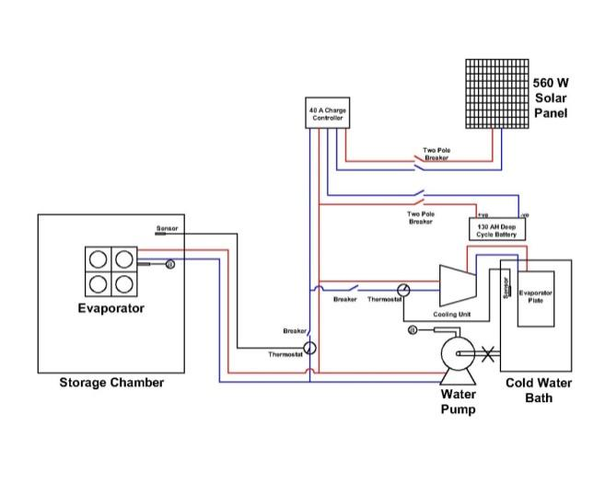

Fig.1: Circuit diagram of the MSCS

The developed mobile solar cooling system costs ₦1,209,500:00 (One million, two hundred and nine thousand, five hundred Naira and zero kobo) which is equivalent to USD 806.33.

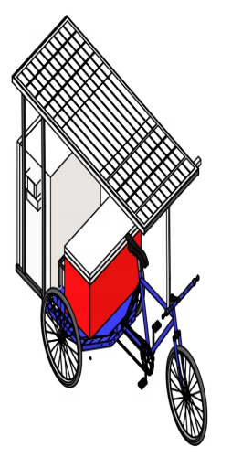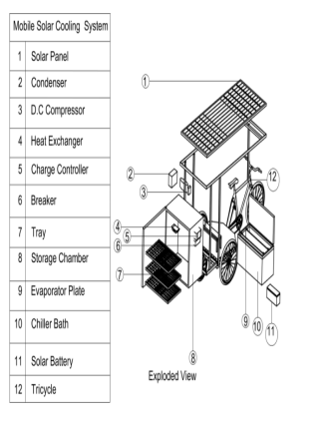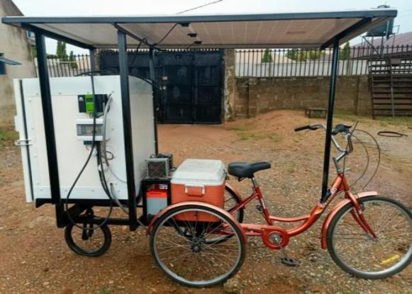

**Plate1: Exploded view, isometric and pictorial view of the MSCS**

**EVALUATION OF THE MSCS**

To evaluate the MSCS for performance at no load test and load test using the sweet orange cultivar.

No load test (testing without test samples) was carried out stepwise as follows:

1. Testing the cooling unit to ascertain ice formation test in the water chiller bath (Preconditioning). The environmental conditions in the storage chamber (temperature and relative humidity) data were obtained using measuring devises. The temperature of the ice formation in the water chiller bath and that of ambient were recorded, the voltage and current reading data for the compressor were also recorded and were used for calculation of COP (Coefficient of Performance) of the system.

A DC solar cooling unit (CU) made up of a 75 W, 12 V (AGLAC model: SCZH55G) compressor was coupled with (2) evaporator plates of 40 x 21 cm rectangular size looped at a distance of 12 cm from each other and at distance 5 cm and 9cm at both sides of the chiller bath wall respectively, a dryer, a condensing unit base on the working principle of refrigeration cycle. This was assembled and filled with 43.73 g (0.04 ltrs) of isobutane (R600a) refrigerant as shown in Figure 1. The evaporator plate of the cooling unit was immersed inside the 40 ltr water chiller bath, and the cooling unit (compressor and accessories) was installed by the side of the water chiller, filled with water to 36 litres and was powered from the Solar PV of 550 W with constant DC power supply at 12V, the experimental set-up is shown in Figure 2. The temperature of the evaporator plate, water inside the chiller bath and ambient temperature were monitored with digital K-type thermocouples as shown in Figure 2. The functioning of the water chiller bath was ascertained to ensure if there is temperature drop and fluctuations in relative humidity in the storage chamber as compared to that of ambient condition. This was done to ensure that the cooling chamber has achieved the required condition for the storage of the commodities, thus pre-conditioning. Temperature and relative humidity data loggers EL-USB-2 (LASCAR, England, UK) was used for the collection of no load test data of the storage chamber’s temperature and relative humidity. The data loggers were programmed to record the temperatures and relative humidity under no load test in the storage chamber, The data were recorded at every 30 minutes. Data was retrieved from the logger via USB port connected to a Laptop computer according to method reported by (Olosunde *et al*., 2019).

Air velocity measurement in the storage chamber was done using airflow metre measuring to an accuracy of 0.3 m/s. The air velocity was measured by placing the air flow meter vane at the front of the heat exchanger which has fans installed at the opposite face and the air velocity values were read directly from the Liquid Crystal Display (LCD).

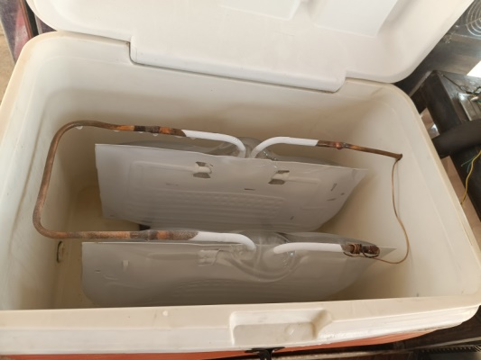

Figure 2: 40 litres water chiller bath of inner dimension (49 x 26 x 30) cm for the cooling unit for ice production

To determine the rate of ice production of the cooling unit these protocols were employed,

1. The weight and litres of water was measured and poured to fill the chiller bath with the cooling unit by using weighing balance (30 kg) and graduated plastic bucket (36 litres). Initial water temperature was measured by mercury in glass thermometer.
2. K-Type thermocouple was placed in the water chiller bath, another one on the evaporator plate and the third in air to record ambient and log the temperature of the water, evaporator plate and ambient at 1 hour intervals.
3. The cooling unit was switched on and current through the cable was measured with a digital multi-meter and recorded. This was repeated at hour intervals. After 24 hours water from the water chiller was pumped out into a container and the volume and weight measured using a graduated cylinder and weighing balance respectively and recorded.
4. This was repeated until about 90% ice has been formed. Weight of ice formed was calculated and COP of the system was determined.

**LOAD TEST**

60 kg of the test commodity, sweet orange (*Citrus sinensis)* was purchased and transported from Lasoju farms along Ogbomoso road to NSPRI, Ilorin using the developed MSCS. The experimental design used was the 2 by 3 factorial complete randomized block design. On getting to the study location, the samples were sorted, weighed, washed and 5 kg each weight sample of oranges were stored inside NSPRI ventilated plastic vegetable crates under shed (Control experiment) under ambient environmental conditions each having three (3) replicates, also 25 kg was stored on trays in the storage chamber of the MSCS. Some samples were taken to laboratory for analysis (before storage) to determine their initial conditions. Sampling for physicochemical quality parameters of stored oranges were done every four days, also commodity weight loss, fruit firmness/hardness, colour changes and rottenness (sorting and removal of rot samples) also other chemical and microbial parameters were monitored from test samples for laboratory analysis and results were obtained..

Temperature, relative humidity and other ambient weather data of the control experiment was monitored throughout the study with the help of data loggers to measure and log the ambient storage data till the experiment is terminated. The effect of the storage treatment on the physicochemical characteristics of orange stored is as follows:

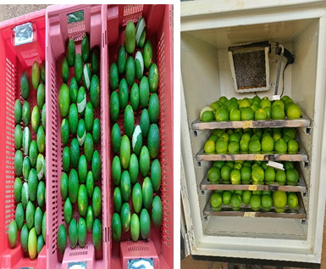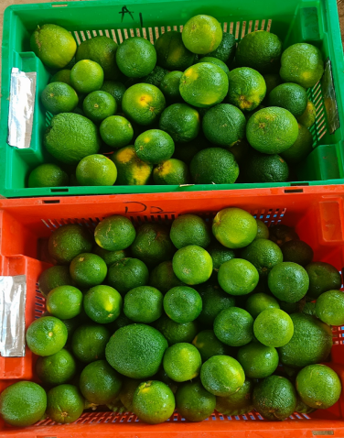

1. Matured orange from farm (b) Arrangement of fresh oranges in Ambient and MSCS

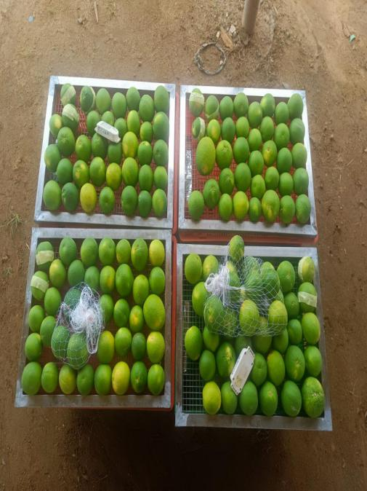

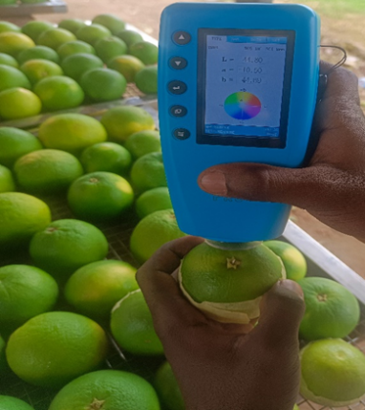

(c)Tagged orange for colour change monitoring (d) Net samples for laboratory analysis

Plate 2: Arrangement of Samples for Experimental Tests (a-d)

**RESULTS AND DISCUSSION**

**Table 2: No Load Test (testing the cooling unit and water bath for Ice Formation)**

|  |  |  |  |  |  |  |  |
| --- | --- | --- | --- | --- | --- | --- | --- |
| S/NO | Date | Time | Water(ltrs) | Water Kg) | Ice (Kg) | Evaporator 0C | Ambient 0C |
| 1 | 15/4/24 | 5:00 pm | 36 | 32.41 | 0 | 14.1 | 27.5 |
| 2 | 16/4/24 | 12 noon | 28 | 22.44 | 9.77 | -4.3 | 31.3 |
| 3 | 17/4/24 | 5:30pm | 22 | 17.97 | 14.24 | -7.0 | 36.3 |
| 4 | 18/4/24 | 9:17 am | 17 | 14.54 | 17.7 | -6.0 | 28.5 |
| 5 | 19/4/24 | 5:30pm | 11 | 10.07 | 22.17 | -8.9 | 34.8 |
| 6 | 20/4/24 | 9:20 am | 7 | 6.64 | 25.60 | -7.5 | 28.9 |
| 7 | 21/4/24 | 5:30 pm | 4 | 3.21 | 30.07 | -9.3 | 35.9 |

From the no load test carried out on the MSCS, results from Table 2 shows that the chiller bath contains 36 ltr (32.4 kg) of water at initial temperature of 27 0C in the chiller bath at 0 hr, after 19 hr, the temperature of the water in the chiller bath was -4.3 0C and (9 litres) 9.77 kg of ice has formed from the water, at 24 hrs 14 litres (14.24 kg) of ice has formed. At 3 days, more than 80% of the water has turned to ice. This showed that since enough ice is available, the storage experiment has commenced. The average solar radiation at that period (15th to 21st April, 2024) was 459.08 w/m2, while the average ambient temperature was31.88 0C.

**Energy output of the compressor**

Energy output = M x C x Ɵ

= 32.21 x 4.184 x14-0 = 1886.7 + Qlosses

**Energy input into the compressor**

P mean = V x I = 12.01 x 4.1 = 49.61

E daily wps7 = 49.61 x 24 h = 1190

Where P is Power (watt), V is voltage (V) and I is current (A),

E daily and P mean are daily energy consumption (Wh) and mean power consumption (W) respectively

**Determination of coefficient of performance (COP) of the system**

wps10 = wps11

COP = 2.02

A COP of 2.02 from the system indicates that the system is outputting 2 units of energy for every 1 unit of energy input. This is a good result as it means the system is operating efficiently.

**LOAD TEST RESULT**

***Result of Evaluation***

The storage experiment considered temperature and relative humidity as key factors influencing the preservation of oranges. Ambient storage exhibited higher temperatures and fluctuating relative humidity of 30±6 °C and 78.±8% compared to the stable environmental conditions maintained by the Mobile Solar Cooling System (MSCS). The MSCS effectively stabilized temperature at 14±4 °C and relative humidity at 85±10% while ambient storage conditions showed significant variability. These controlled conditions in the MSCS extended the shelf life of oranges to 33 days, compared to 20 days under ambient storage. This aligns with findings by Yousuf (2018), who emphasized the effectiveness of low-temperature storage in preserving the chemical composition of perishable crops. Throughout the experiment, two main factors temperature was high for ambient storage but low for MSCS, and relative humidity was high and fluctuating for ambient but low and steady for MSCS. Various parameters related to the storage quality indices of the produce was measured during the storage experiment and the result showed that the storage time and storage environment cause increase weight loss, rot, color changes, TSS, pH, Vit A and Beta carotene but a decrease in Firmness, crude fibre, and Vit C. However, that of ambient is more faster and well pronounced than that of MSCS. The bacterial and fungal count also increase in the two storage compared. But that of MSCS is still within the limit as recommended by International Commission for Microbial Specification for Foods (2006). The details are shown in Figure 4 to figure 6

Table 3: Statistical Analysis of Storage Data

|  |  |  |  |
| --- | --- | --- | --- |
|  | Control/ambient | MSCS | Significant level |
| Temperature | 30 ± 6ᵃ | 14 ± 4ᵃ | F(1, 68) = 516.999, p=0.000 |
| Relative humidity | 78 ± 8ᵃ | 85 ± 10ᵃ | F(1, 68) = 43.353, p=0.000 |
| Dewpoint temperature | 27.77 ± 0.066ᵇ | 16.37 ± 0.355ᵃ | F(1, 68) = 516.999, p=0.000 |
| Total | 20.65 ± 1.876ᵇ | 6.96 ± 1.545ᵃ | F(1, 5) = 32.314, p=0.002 |
| Total colour index | 9.16 ± 1.236ᵃ | 7.84 ± 0.34ᵃ | F(1, 18) = 2.212, p=0.154 |
| Colour change | 24.14 ± 2.391ᵇ | 54.77 ± 2.079ᵃ | F(1, 18) = 84.454, p=0.000 |
| Firmness | 10.34 ± 0.168ᵇ | 6.62 ± 0.174ᵃ | F(1, 14) = 235.969, p=0.000 |
| Ash Content | 0.53 ± 0.003ᵃ | 0.54 ± 0.002ᵃ | F(1, 4) = 5.644, p=0.076 |
| Crude Fibre | 1.51 ± 0.008ᵃ | 1.28 ± 0.04ᵇ | F(1, 4) = 34.078, p=0.004 |
| TSS | 16.54 ± 0.001ᵃ | 16.51 ± 0.0ᵇ | F(1, 4) = 2080.800, p=0.000 |
| Vitamin A | 6.41 ± 0.002ᵃ | 6.62 ± 0.003ᵇ | F(1, 4) = 4725.000, p=0.000 |
| Vitamin C | 105.8 ± 0.126ᵃ | 64.56 ± 0.006ᵇ | F(1, 4) =107395.574, p=0.000 |
| pH | 3.95 ± 0.003ᵃ | 5.93 ± 0.0ᵇ | F(1, 4) =351649.000, p=0.000 |
| Fe | 1.34 ± 0.001ᵃ | 0.91 ± 0.001ᵇ | F(1, 4) =204480.125, p=0.000 |
| K | 13.76 ± 0.001ᵃ | 9.99 ± 0.006ᵇ | F(1, 4) =388447.527, p=0.000 |
| Beta-carotene | 0.42 ± 0.001ᵃ | 0.4 ± 0.001ᵇ | F(1, 4) =225.083, p=0.000 |

Note: Means with different superscripts on a row are significantly different at (P˂0.01) along the column. Values are Mean ±SEM of triplicate determination. Fe = iron, k = potassium, TSS = Total Suspended solid %, tci = total colour index, rh= relative humidity.

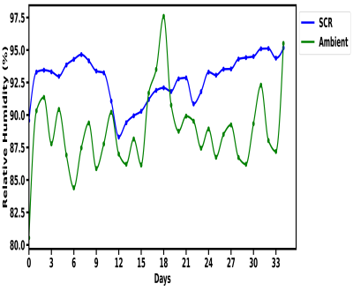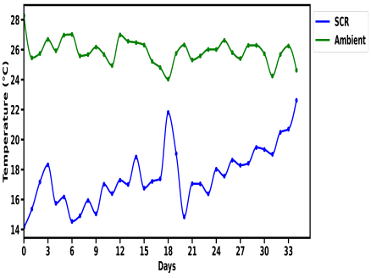

1. (b)

Fig. 3 : Temperature and Relative Humidity variation in ambient and MSCS storage of Orange

According to Fig. 3 a&b, ambient storage exhibited higher temperatures and fluctuating relative humidity of 26±2 °C and 82±8% compared to the stable environmental conditions maintained by the Mobile Solar Cooling System (MSCS). The MSCS effectively stabilized temperature at 14±4 °C and relative humidity at 85±10% while ambient storage conditions showed significant variability. These controlled conditions in the MSCS extended the shelf life of oranges to 33 days, compared to 20 days under ambient storage. This aligns with findings by Yousuf *et al* (2018), who emphasized the effectiveness of low-temperature storage in preserving the chemical composition of perishable crops. Throughout the experiment, temperature is high for ambient storage but low for MSCS and relative humidity was high and fluctuating for ambient but low and steady for MSCS.

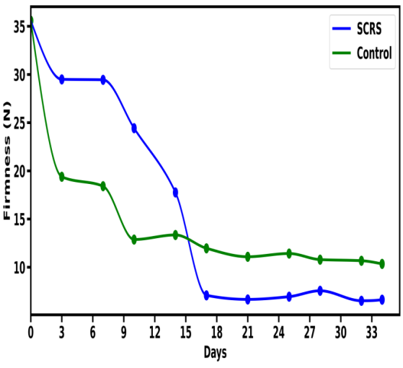

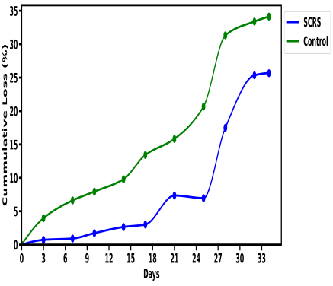

1. (b)

Fig 4: Effect of storage environment on weight loss and firmness index of oranges at ambient and MSCS

The average weight loss as shown in Figure 4a for orange experiment in ambient storage were (5, 15, 20 and 35%) of total weight for sampling day 3, 18, 25 and 33 respectively, while in MSCS storage it was (1, 3, 7, and 25%) of total weight for sampling days 3, 18, 25 and 33 respectively. Similar results have been reported by Gupta and Dubey, (2018) and also Cherono and Workneh, (2018) on how temperature and relative humidity of storage environment caused decrease in weight of stored samples but the MSCS performs better than ambient storage in terms of weight loss which is attributed to uncontrolled high temperature and relative humidity variation in ambient which allowed rapid loss of moisture in stored commodities resulting in weight loss. In Fig 4b, the initial firmness was recorded at 35 N. As storage continued, the firmness in ambient storage decreased to 20 N, 18 N and 14 N on sampling days 4, 8 and 16 respectively. Meanwhile, it was 30 N, 30 N and 19 N for MSCS on same sampling days.

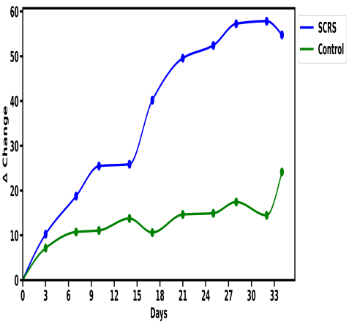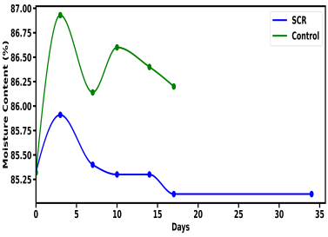

(a) ( b)

Fig.5: Effect of storage environment on colour change and moisture content of oranges

The average colour values obtained for orange as shown in Fig. 5a indicated progressive change from greenness to yellowness in ambient storage and MSCS but MSCS is not fast in colour change as rapid as ambient. In the storage of orange, it was discovered that the colour of oranges in MSCS was ripening rapidly and uniformly while the control samples were still green but shrinkage was rapid. This is because of the climacteric nature of orange, and during ripening, ethylene production is more, there is constant production and escape of ethylene in the ambient sample which reduces the ripening rate, but in the MCSC storage, there is ethylene production and accumulation due to enclosed nature of the cooling system, this is also reported by Adekalu *et al.* (2022). Fig. 5b shows the initial moisture content for fresh orange was 85%, as storage continued, ambient storage recorded 87. 86%% on day 5 and 20 but MSCS recorded 86, 85and 83% respectively.

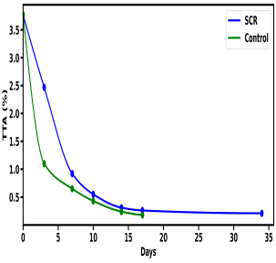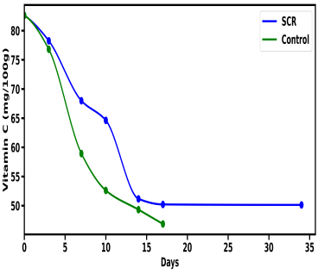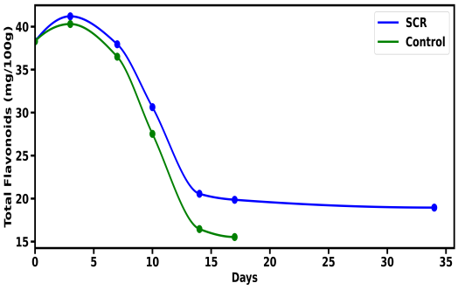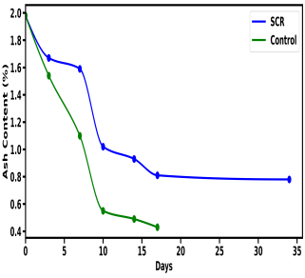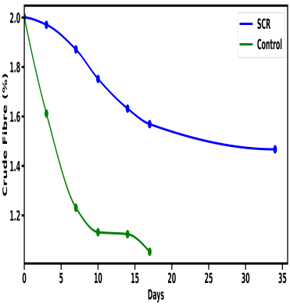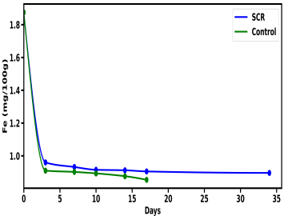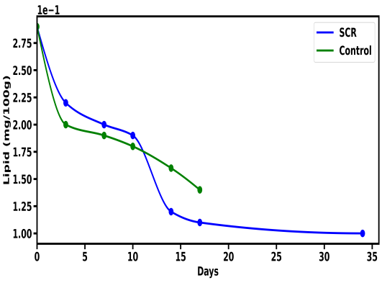

Fig 6(a-g): Effect of storage environment on proximate composition of orange fruit

The result in Fig. 6(a-g) showed that the storage time and storage environment cause a decrease in Firmness, crude fibre, ash content, lipids, iron, vit C, total titratable acidity, and total flavonoids. However, that of ambient is faster and well pronounced than that of MSCS. The bacterial and fungal count also increase in the two storage compared. But that of MSCS is still within the limit as recommended by international commission for microbial specification for foods (2006). The decline in these proximate compositions can be attributed to various metabolic processes occurring in the tissues of the stored commodities, as they remain living and continue to respire. Cherono and Workneh (2018) highlighted that nutritional values of fruits and vegetables decrease during storage, but storage at low temperatures helps preserve these values better than ambient conditions. The MSCS storage environment, therefore, preserved the nutritional and proximate compositions of the samples more effectively than ambient storage.

**CONCLUSION**

The MSCS demonstrated a high efficiency with a COP of 2.02, utilizing renewable (solar) energy effectively to maintain optimal storage conditions. The system extended the shelf life of oranges by approximately 60% compared to ambient storage. The MSCS significantly preserved the nutritional quality and safety of the produce, meeting international microbiological standards throughout the storage period. The prototype MSCS presents a scalable and sustainable solution for post-harvest preservation, particularly in off-grid regions.

**COMPETING INTERESTS DISCLAIMER:**

Authors have declared that they have no known competing financial interests OR non-financial interests OR personal relationships that could have appeared to influence the work reported in this paper.

**REFERENCES**

Adekalu, O. A., Akande, S. A., Fashanu, T. A., Adeiza, A. O. and Lawal, I. O. (2022). Evaluation of improved vegetable baskets for storage of *Amaranthus viridis* (Green amaranths) and *Telfaria occidentalis H*. (Fluted pumpkin leaves). *Journal of Food Science and Nutrition* 7(4): 111-119. Article Number: B3DC44673 ISSN 2536-7080

Akorede M.F, Ibrahim O., Amuda S. A., Otuoze A. O and Olufeagba B. J. (2017) *Nigerian Journal of Technology (NIJOTECH)* Vol. 36, No. 1, pp. 196 – 212 Copyright© Faculty of Engineering, University of Nigeria, Nsukka,Print ISSN: 0331-8443, ElectronicISSN:2467-2467-821www.nijotech.com<http://dx.doi.org/10.4314/njt.v36i1.25>

Babaremu K.O., Omodara M.O., Fayomi O.S.I., Okokpujie I.P., and Oluwafemi J.O., (2018). Design and optimization of an active Evaporative cooling system. *International Journal of Mechanical Engineering and Technology (IJMET)* Volume 9, Issue 10, pp. 1051–1061.

Cherono, K. and Workneh, T. S. (2018). A review of the role of transportation on the quality of fresh tomatoes and their management in South Africa and other emerging markets. *International Food Research Journal*, 25(6): 2211-2228

Chijioke, O. V. (2017). Review of evaporative cooling systems. *Greener Journal of Science, Engineering and Technological Research,* 7(1), 1-20. ISSN: 2276-7835.

FAO (Food and Agriculture Organization) (2018). Gender and food loss in sustainable food value chains.United Nations Population at [http://www.usatoday.com/story/news/world/2013/ 06/13/un-world](http://www.usatoday.com/story/news/world/2013/06/13/un-world) population-8.1- billion-2025

Gupta, J. and Dubey, R. K. (2018). Factors affecting post-harvest life of flower crops: A Review. *International Journal of Current microbiology and Applied Sciences* 7(1): 548-557.doi.org/10.20546/ijcmas.2018.701.065

Kazem, H. A, Al-Waeli, A.H.A, Chaichan, M.T, Al-Mamari, A.S and Al-Kabi, A.H. (2017). Design, measurement and evaluation of photovoltaic pumping system for rural areas in Oman. Environmental Development Sustain, 19, 1041–1053. doi.10.1007/s10668-016-9773-z.

Ogumo, E. O., Kunyanga, C. N., Kimenju, J., & Okoth, M. (2020). Performance of a fabricated solar-powered vapour compression cooler in maintaining post-harvest quality of French beans in Kenya. African Journal of Food Science, 14(7), 192-200.

Okanlawon, S.A and Olorunnisola, A.O. (2017)). Development of passive evaporative cooling systems for tomatoes Part 1: construction material characterization. Agricultural Engineering International: CIGR Journal, 19(1), 178-186.

Olosunde W.A., AremuA. K., Umani K. C. (2019). Performance optimization of a solar-powered evaporative cooling system. Journal of Agricultural Engineering and Technology (JAET). Vol. 24(2):21-34.

Sharad C. and Virendra S. (2015). Thermal system design of a cold storage for 1500 metric tonne potatoes. International journal of Engineering Sciences and Research Technology. Vol. 4(7).12OR 370-385

Sitorus, T, Ambarita, H, Ariani, F and Sitepu, T. (2018). Performance of the natural cooler to keep the freshness of vegetables and fruits in Medan City. IOP Conference Series: Materials Science and Engineering, 309, 012089. doi.10.1088/1757-899X/309/1/012089. Solar cooling engineering@ selfchill.com (2023) online training.

Stathers, T. (2017). Quantifying postharvest losses in Sub-Saharan Africa with focus on cereals and pulses. [Internet]. Presentation at the Bellagio workshop on Postharvest management 12-14 September 2017. Available from: <http://www.fao.org/fileadmin/user_upload/food-loss-reduction/Bellagio/T.Stathers> QuantifyingPHLinSSA.PDF.

Verploegen E, Ekka R, Gill G (2019). Evaporative Cooling for Improved Vegetable and Fruit Storage in Rwanda and Burkina Faso. D-Lab. Available at: <https://dspace.mit.edu/handle/1721.1/121582>.

Yahaya, S and Akande, K. (2018). Development and Performance Evaluation of Pot-in-pot Cooling Device for Ilorin and its Environ. Journal of Research Information in Civil Engineering, 15(1), 2045-2059.

Yousuf, B, Qadri, O.S and Srivastava, A.K. (2018). Recent developments in shelf-life extension of fresh-cut fruits and vegetables by application of different edible coatings: A review. LWT, 89, 198-209. doi.org/10.1016.

Muhammad S., Saghir A. S and Shahzor G.K (2012). Effect of storage on the physicochemical characteristics of the mango (Mangifera indica L.) variety, Langra. African Journal of Biotechnology Vol. 11(41), pp. 9825-9828, Available online at http://www.academicjournals.org/AJB DOI: 10.5897/AJB11.3487 ISSN 1684–5315.