Design and simulation of automatic cartoning machine

Abstract:
In this paper, the various mechanisms of the automatic cartoning machine are designed, including the box taking mechanism, the silo, the pushing mechanism, the raw material conveying device, the carton conveying device and the sealing mechanism. After comparing a variety of pushing methods, this paper adopts the slide rail as the design scheme of the pushing mechanism, and calculates the pushing stroke of the pushing mechanism. The crank slider mechanism was used for the sealing mechanism, and the parameters were calculated. And designed with adjustable size silo, which can be adapted to the cartoning requirements of different sizes of cartons. Subsequently, based on the finite element analysis software, the finite element static analysis was carried out on the frame of the automatic cartoning machine, the maximum stress of the frame was 36.929MPa, and the maximum deformation of the frame was 0.027mm, and the strength of the frame was checked, which proved that the designed frame met the design requirements.
Keywords: automatic packing machine; feeding mechanism; box sealing mechanism; finite element analysis

introduction
Carton packaging is an important part of the packaging machinery industry. With the continuous development of technology, automatic packaging is widely used in the manufacturing industry. Compared with foreign countries, China's carton packaging equipment has a certain gap in technology, quality, production efficiency, etc., and many enterprises lack theoretical research on core components^{[1]}. The reason is that relying solely on surveying and mapping to imitate foreign models, the size of many parts has a large deviation from the actual situation, and the vibration is large when working, and the efficiency will be low^{[2]}. Domestic carton packaging enterprises have basically mastered the working principle and production process of the core components and parts of the medium and low-speed automatic cartoning machine, but in terms of speed and technical reliability of equipment, the gap between companies is larger than that of foreign carton packaging machinery, and the competition in the market is relatively weak^{[3]-[7,18]}.
Li Yan, Zhang Wei and others put forward the research and development design scheme of the combined cam mechanism to avoid the impact phenomenon that is easy to occur in the process of high-speed operation.^{[8]}
Tong Junhua, Tang Ququ, Wu Chuanyu et al. proposed an elliptical-circular gear planetary gear train to replace the existing circular gear planetary system box taking mechanism based on the requirements of the cycloid motion characteristics of the output end of the planetary gear box taking mechanism and the variable transmission ratio of non-circular gears, so that the motion trajectory and characteristics of the output end were optimized^{[9,14]}.
Yu Jie first studied the planetary wheel box picking-opening mechanism that realizes the movement trajectory of the cycloid, and used Matlab software to simulate the motion trajectory, displacement, velocity and acceleration of the suction head in the mechanism and draw the corresponding curves^{[10,15-17]}.
The purpose of this paper is to study and design an automatic cartoning machine that can be applied to different sizes of boxes. The difficulty in the research and design of the automatic cartoning machine lies in the design of the mechanical structure, so it is necessary to design the mechanical structure of the cartoning machine from the actual needs. The focus of this paper is on the study of the mechanical structure of the cartoning machine.。

Main design parameters

Design Functional Requirements
In order to improve the scope of application of the automatic cartoning machine, suitable for cartons of different sizes, a device that can adjust the position distance is set up to meet the cartoning requirements of different sizes of cartons. For example, the position of the support frame of the silo is adjustable, and different sizes of cartons can be loaded in the silo; The distance between the limit blocks on the carton conveyor is adjustable, which can transport cartons of different sizes; The pushing stroke of the pushing mechanism can be adjusted, etc.
In this project, the carton development diagram shown in the figure below (in figure 1) is the basic size to design the dimensions of each component. The carton has a size of 200g/mm2 and a thickness of 2.3mm when folded in the silo. The dimensions of the carton are 75 mm long, 75 mm wide, and 175 mm high. (Tolerance is ±1mm).
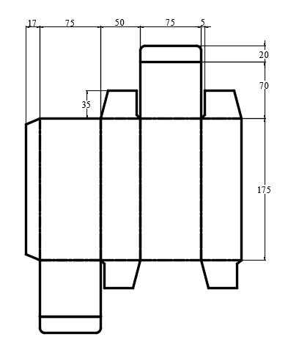
Figure 1 Carton unfolding

Process analysis
The workflow of this automatic cartoning machine box picking-unpacking device is: the process flow of the automatic cartoning machine as shown in the figure below (in figure 2) . Firstly, the suction cup in the box taking mechanism sucks the carton blank out of the silo, and completes the pre-opening action in the air, and then the carton after completing the unpacking is smoothly put into the carton conveying device, and is fixed by the card slot, and then the left and right two small tongues of the carton are folded by the folding tongue mechanism on the back side of the carton conveying device, and the tongue is folded through the tongue insertion mechanism at the same time, and then the tongue insertion is carried out to complete the sealing of the box bottom. The raw material conveying device transports the raw material to the designated position, and then the pushing mechanism will push the raw material that needs to be packed into the carton that has completed the bottom of the box and the box is closed by the push rod, and then fold the left and right two small tongues of the carton through the folding tongue mechanism on the left and right sides of the box top, and at the same time fold the top of the box through the tongue insertion mechanism and then insert the tongue, and finally send it out to complete the cartoning.
Figure -2 Automatic cartoning machine process

The design of the box taking mechanism

The working principle of the box taking mechanism
The design of the box taking mechanism is shown in the figure below (in figure 3), and the nozzle mounting shaft with three intervals of 120° is evenly arranged on the turntable, and the efficiency of taking the box can be significantly improved by using three groups of suction nozzles. By controlling the airflow of the suction cups on the nozzle mounting shaft, it is possible to take and unload the cartons . The suction nozzle sucks the carton from the carton silo, the carton moves in a circular motion with the turntable, after rotating 120 °, the carton is in a semi-open state in the air, and then arrives at the card slot of the carton conveyor belt, and with the forward movement of the carton conveyor belt, the suction nozzle releases the carton at this time, so that the box taking action process is completed.
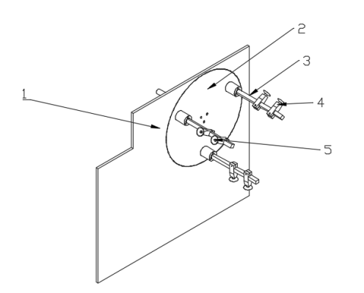
1、Turntable coaming2、turntable 3、Nozzle mounting shaft4、Nozzle mounting block
5、Nozzle
Figure 3Pick-up mechanism

Silo design
According to the design requirements of the silo, the maximum capacity of the silo is 350, and the thickness of the carton is 2.3mm. Because the carton is pre-folded, the carton is not tightly fit in the silo, but will have a certain fluffiness, so the thickness of the carton is set at 3mm. In order to make the bin suitable for a variety of carton sizes, the silo should be designed with adjustable capacity, and the adjustable direction is the length of the carton (X) and the width of the carton (Y).
The length (X) of the carton is adjustable: the side baffle of the bin has two shafts stretched out and is connected to the two optical shafts respectively, the upper end of the optical shaft has a threaded hole, which can be fixed with a hold-down screw, and the side baffle is limited to move along the horizontal direction, the optical axis is connected with the fixed block on the adjusting side plate below, and the threaded hole is opened on the fixed block, and the optical axis can be fixed by adjusting the bolt, and the height control of the side baffle plate of the adjusting bin can be further realized^{[11]}.
The width of the carton (Y) is adjustable: the bracket side plate is fixed to the side plate by three bolts, and there is a threaded hole on the bottom fixing block of the fixed shaft of the upper baffle, which can be fixed by bolts, when adjusting the width of the carton Y, only need to loosen the bolt of the bottom fixing block, and adjust the width Y according to the needs of the width of the carton. The upper baffle of the carton is fixed to the fixed shaft of the upper baffle through the locking block, and the upper baffle of the carton can be adjusted in a small range of front and back through the reserved waist slot.
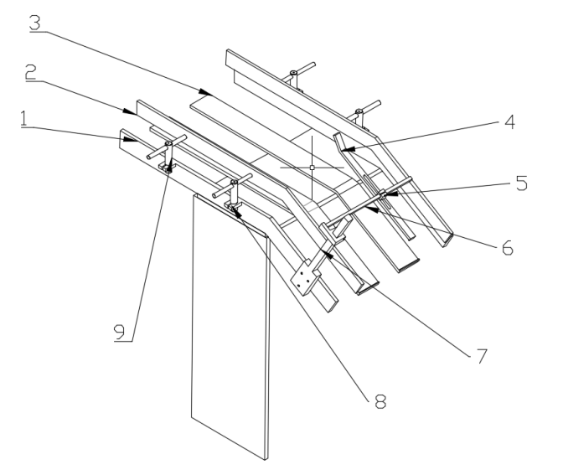
1, side plate 2, side baffle plate 3, bottom plate 4, carton upper baffle plate 5, locking block 6, upper baffle fixed shaft 7, bracket side plate8, side plate fixed block 9, optical axis
Figure 4 The overall design of the silo

Design of pushing mechanism
Compared with the above different pushing methods, this paper plans to adopt a feeding method similar to the spiral pushing mechanism, and adopt the method of guide rail. As shown in the figure below (As shown in figure 5), this kind of pushing mode, the pushing process is stable, the stroke impact is small, the pushing stroke is easy to adjust, the thrust is larger, the pushing speed is more uniform, the structure is compact, safe and reliable, and the structure is relatively simple compared with the spiral pushing mechanism^{[12]}.
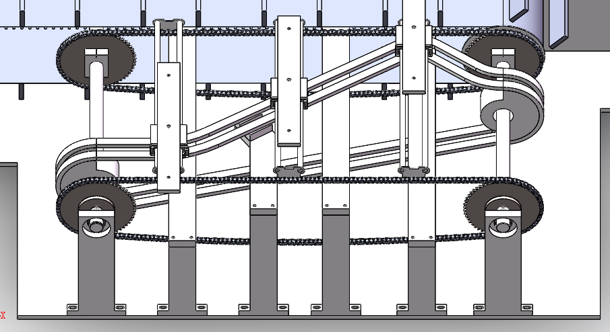
Figure5The overall scheme of the pusher mechanism
Working principle: the pusher mechanism adopts the chain to provide power, the pusher guide rail is fixed on the chain with the chain connecting plate, two pusher guide rods are installed on the chain connecting plate, the slider is installed on two pusher guide rails, the pusher plate is installed above the slider, the limiting block is set up below the slider, the limiting block slides along the guide rail, and the slider and the pusher plate do reciprocating linear motion in the horizontal direction, and finally complete the pusher action.

The design of the sealing mechanism

Carton conveyor
The carton conveyor consists of a drive sprocket, a drive chain, and a welded baffle on the drive chain, and in order to transport different sizes of cartons, the distance between the card slots must be set to adjustable. The carton conveyor in this article is planned to consist of four drive chains, and the baffles on the two drive chains cooperate with each other to form a card slot with adjustable distance. The adjustment mode of the distance of the card groove is as follows: the conveyor chain is installed on different sprockets, and the baffle plate welded on the two transmission chains can be controlled by rotating one of the sprockets, so that the width of the card groove can be controlled.
As shown in the figure below (As shown in figure 6), the chain in the carton conveyor is located on the two unpacking chains, and the carton is located in the middle of the two card slots, moving forward with the chain.
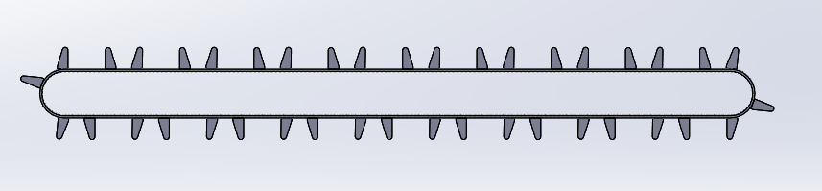
Figure 6 Carton conveyor chain =

Tongue folding mechanism
After the pushing mechanism pushes the material into the carton, the next step is to seal the box, and the first step of the sealing action is to fold the small tongue, and the folding small tongue mechanism should fold the left and right small tongues inward. As shown in the figure below (As shown in figure 7) , the rotary motion of the folded ear is used to realize the folded tongue of the left little tongue of the carton. Since the carton moves forward intermittently with the carton conveyor, it is necessary to make the time for one rotation of the fold lugs equal to the time between the carton conveying and loading.
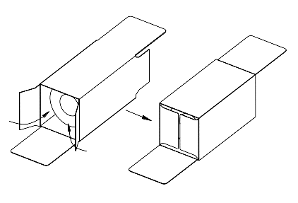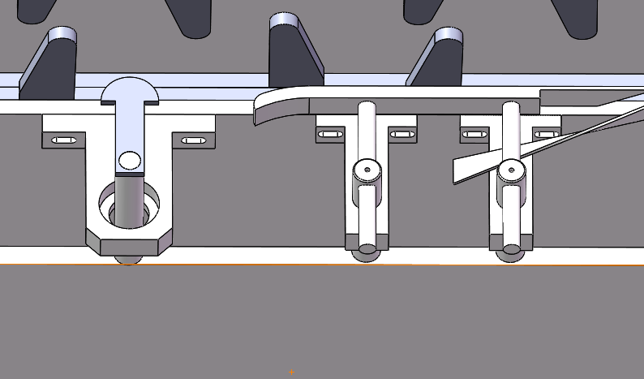

Figure 7 Folded tongue mechanism
Pre-fold tongue action: As shown in the figure below (As shown in figure 8) , you need to fold the tongue upwards in advance to facilitate one-step tongue insertion. The pre-folding action is completed by folding the tongue guide page.
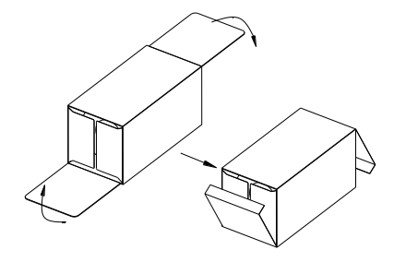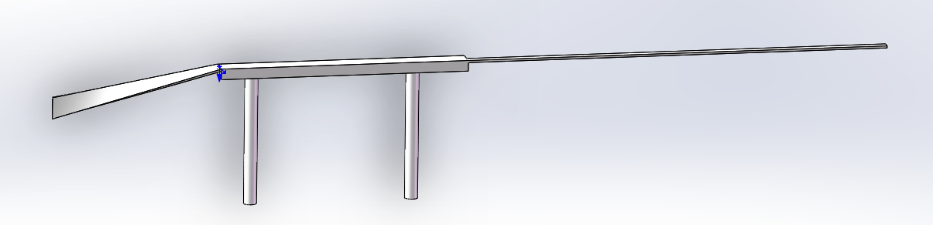

Figure8Schematic diagram of the pre-folded tongue

Tongue insertion mechanism
As shown in the figure below (As shown in figure 9) , the process of inserting the tongue is completed, and the tongue insertion mechanism designed in this paper is to use the crank slider mechanism to complete the tongue insertion action. The crank slider mechanism is one of the four-bar mechanisms, and the pole angle is 0°, so the crank slider mechanism is relatively stable in operation, almost no impact, and when approaching the pole position, the speed along the displacement direction is very low, which will greatly reduce the impact when sealing the box, will not damage the surface of the carton, and is conducive to improving the success rate of the sealing.
The original mover of the tongue insertion mechanism is the main shaft, the main shaft drives the crank wheel to rotate by the key, the thrust plate is installed on two slide rails, the slide rail limits the thrust plate five degrees of freedom, only the movement along the X direction remains, the tongue plate is fixed to the thrust plate by the rocker, and two tongues are fixed on the tongue plate, and the pre-folding tongue and the tongue insertion are completed respectively.
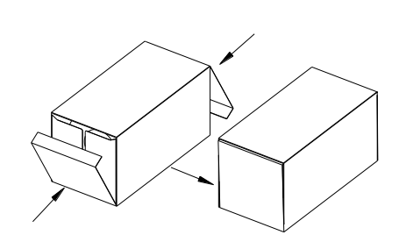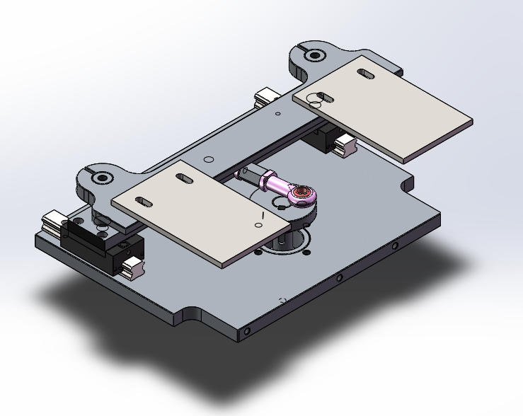
Figure 9 Schematic diagram of inserting a big tongue

Finite element analysis of the rack
After applying a load to the frame, the equivalent stress contours and deformation contours of the frame can be obtained by using ANSYS Workbench for finite element solving. As can be seen from the figure, the maximum stress is 36.929MPa, and the maximum deformation of the frame is 0.027mm^{[13]}.
Strength check: The material of the frame of the automatic cartoning machine is structural steel, and the third strength theory should be selected for checking, that is, the maximum stress of the frame should be guaranteed to be less than the maximum allowable stress of the material [σ], that is, its allowable stress is：
$\left[σ\right]=σ_{b}/n$（5.2）(1)
Wherein: σb is the yield limit strength of the material, unit: MPa, σ_b=235MPa $σ_{b}$=235MPa
[σ] is the allowable stress of the material, unit: MPan is the safety factor, consult the mechanical design manual to know that for the construction of stable conditions, the safety factor n=1.5~2, here take n=2.
The calculation is calculated by substituting the numerical values：
$\left[σ\right]=σ_{b}/n$=117.5MPa＞$σ_{max}=36.929MPa$（5.3）(2)
Explain that the rack meets the design requirements.

Figure 10 Stress contour diagram
(Give detailed description to Figure 10)
Figure 11 Anamorphic contours
(Give detailed description to Figure 11)

References
  - Pan Xiaoqing. Development status of foreign packaging machinery[J].Shandong Industrial Technology,2016,(12):215. (Provide link)
  - Li Sanjiang, Li Yana. The status quo and development trend of foreign packaging machinery and the development strategy of domestic packaging machinery[J].Science and technology information,2015,13(35):154-156. (Provide link)
  - Lina Jie. Analysis of the current situation and development trend of China's commodity packaging technology[J].China's packaging industry,2016,(04):172-174. (Provide link)
  - Dong Zhonghua. Key technologies for the development and manufacturing of packaging machinery and equipment[J].China's strategic emerging industries,2017,(20):179. (Provide link)
  - Han Xiaoliang. The status quo and development of China's printing and packaging equipment manufacturing industry[J].Printing Magazine,2017,(03):6-15. (Provide link)
  - Yang Tan. Discussion on the application of automation in packaging machinery[J].Science and Technology Prospects,2016,26(14):77. (Provide link)
  - Liu Yibo, Zhang Guangwen. The development trend and development strategy of packaging machinery in China[J].Science and technology prospects,2017,27(27):62. (Provide link)
  - Li Yan, Zhang Wei. Design of box picking-opening mechanism of automatic cartoning machine[J].Mechanical and electrical engineering technology,2016,45(10):53-56. (Provide link)
  - Tong Junhua, Tang Ququ, Wu Chuanyu et al. Analysis and design of trajectory of elliptical-circular gear planetary gear train box taking mechanism of automatic cartoning machine[JME].Journal of Mechanical Engineering ,2018,54(11):173-179. (Provide link)
  - Yu Jiexian. Design and research of automatic cartoning machine for cosmetics[D].Guangzhou, Guangdong,Guangdong University of Technology,2014. (Provide link)
  - Zeng Shanqi, Cheng Dayong. Research and design of automatic cartoning machine silo[J]. Packaging & Food Machinery ,2011,29(4):41-43. (Provide link)
  - Jiang Yong. Research on automatic cartoning machine and control system of teabags[D].Xi'an, Shaanxi:Shaanxi University of Science and Technology,2014. (Provide link)
  - Han Rui. Research on mechanism motion simulation based on SolidWorks[D].Shaanxi:Xi'an University of Technology,2004. (Provide link)
  - 14. Yining, H. A. O., &Zhiqiang, Z. H. A. N. G. (2024). Design of the shaping and cartoning device for sheet-like flexible products. Packaging & Food Machinery, 42(1). (Provide link)

  - 15. Bin, L. I. U., Jianchun, L. I. U., Zhichao, L. I. U., & Da, F. A. N. (2024). Design and analysis of key parameters of finished product output mechanism of cartoning machine. Packaging & Food Machinery, 42(1). (Provide link)

  - 16. Wu, G., & Yuan, X. (2021). Design and Test of Box Suction and Opening Mechanism of the Medicine Carton Packaging Machine. International Core Journal of Engineering, 7(8), 338-343. (Provide link)

  - 17. Zheng, M., Yang, C., Yao, J., Bai, F., Zhou, X., Bai, H., ... & Zhang, X. (2024, October). Cartoning Robot Kinematics and Dynamics Numerical Simulation and Analysis. In International Workshop of Advanced Manufacturing and Automation (pp. 634-646). Singapore: Springer Nature Singapore. (Provide link)

  - 18. Bandara, Y. M. U. S. Y., Alahakoon, P. K. D. B. K., Rathnayake, R. L., Premarathna, W. P. L. M., Wickramasinghe, K. C., & De Silva, K. T. K. M. (2024, August). Design of a Fully Automated Soap Multipack Packaging System. In International Engineering Research Symposium (pp. 299-307). Singapore: Springer Nature Singapore. (Provide link)

