Trade Disruptions in the Dairy Sector: Analyzing EU Exports to China under Tariff Pressures

*Abstract* - This study analyzes the impact of trade policies, including tariffs and subsidies, on agricultural trade, with a focus on dairy products, using a Computable General Equilibrium (CGE) model based on the GTAP framework. Specifically, the research explores the imposition of tariffs on EU dairy imports to China and retaliatory measures on automotive imports. The results show that tariffs on EU dairy products lead to significant reductions in exports and output across EU countries, while benefiting non-EU producers. Additionally, tariffs on Chinese automotive imports cause trade imbalances and output declines for China, while the EU experiences increased production but reduced welfare. The findings highlight the complexities and global consequences of protectionist policies.

*Index Terms* - Agricultural trade, CGE model, Dairy tariffs, Global Trade Analysis Project (GTAP), Protectionist policies.

Introduction

The dynamics of global trade are increasingly shaped by the interdependence of countries, particularly in the realm of commodity trade. This interdependence is especially pronounced in agricultural products, including milk and its processed derivatives, which play a vital role in international trade (Marques, 2024). Agricultural products are not only crucial for the economic support of various nations but also address global food security issues. The dairy sector, specifically, is an integral part of this agricultural trade network, with regions like the European Union and New Zealand being major global exporters (Kryvenko, 2023). The demand for processed milk products has surged in recent years due to changing consumer preferences and dietary habits, further solidifying the importance of dairy in international trade.

In 2023, China imported significant quantities of dairy products, including milk and cream in solid forms, from several European Union (EU) countries. The most substantial imports came from the Netherlands and France, with 5,626,300 kg and 4,400,130 kg, respectively. Other notable EU exporters included Italy, Germany, and Finland. However, some EU countries such as Austria, Belgium, and Portugal reported minimal exports.

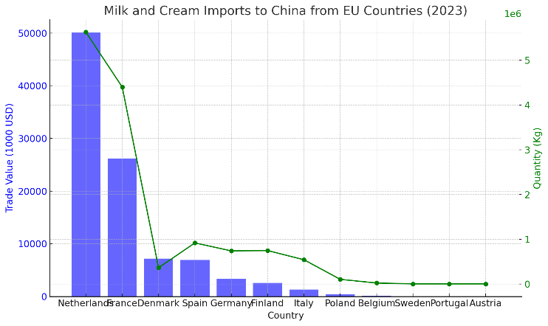

Figure 1. Milk and Cream Imports to China from EU Countries (2023)

The European Union (EU) is a major exporter of dairy products, particularly cheese, to China, with Denmark, Italy and France leading the trade, exporting 9,315 metric tons ($55 million), 8,546 metric tons ($60.2 million), and 6,187 metric tons ($38.2 million) respectively. These countries hold the largest share of the EU's cheese exports to China and are expected to be most affected by the tariffs imposed by China on EU dairy products. Other exporters like the Netherlands and Germany may also face challenges, while smaller EU countries such as Austria, Spain and Ireland, with lower export volumes (937–1,003 metric tons), could see their market share in China shrink further due to these tariffs.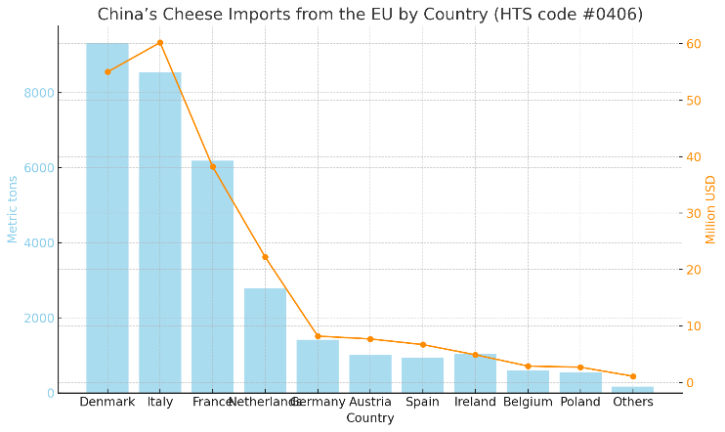

Figure 2. China’s Cheese Imports from the EU by Country

The European Union (EU) is often criticized for the role of its subsidies in distorting international markets. For instance, EU-subsidized dairy products have been shown to negatively impact farmers in developing countries like Mozambique and Jamaica by undermining their local markets. This issue is central to China’s recent anti-subsidy investigation into European dairy imports, initiated on August 21, 2024.

This inquiry focuses on large agricultural producers such as Germany and France, while also targetin Netherlands, which is the largest exporter of dairy products to China. Although China has not yet imposed tariffs on EU dairy imports, there is a possibility that future tariffs could be implemented if the investigation reveals that these subsidies have adversely affected China’s domestic dairy industry (The Guardian, 2024). Such actions would have a significant impact on the global dairy market, particularly given the increasing tension between China and the EU in the context of rising trade disputes.

The EU has responded by seeking consultations through the WTO to challenge China’s anti-subsidy actions, signaling its commitment to defending its dairy sector and the Common Agricultural Policy, which has been instrumental in supporting EU farmers. Simultaneously, the EU has proposed punitive tariffs on Chinese imports, including electric vehicles, with tariffs ranging from 17% to 36.3 per cent, highlighting the deteriorating trade relationship between the two economies (Reuters, 2024). This rising trade tension could extend beyond the current investigation, potentially affecting other sectors like dairy.

Research on this issue is critical for understanding how tariffs, imposed by China could reduce the competitiveness of European dairy products in global markets. Moreover, the ripple effects of these tariffs extend beyond the dairy sector. The EU's retaliatory measures, particularly with imposition of tariffs, further complicate trade relations. These retaliatory actions by the EU highlight the interconnection between trade sectors and the far-reaching consequences of protectionist policies.

To examine these trade dynamics, the use of CGE (Computable General Equilibrium) and GTAP (Global Trade Analysis Project) models is essential. These models provide a comprehensive framework to analyze the economic impacts of trade policies on various sectors in both China and the EU, as well as on other countries involved in global trade (Hertel, 1997). By employing CGE and GTAP models, this study will provide valuable insights into the broader effects of anti-subsidy investigations on international trade dynamics.

Given the limited research in applying CGE and GTAP models to anti-subsidy investigations in agricultural trade, this study fills a crucial gap. It will help policymakers in both China and the EU understand the economic consequences of such investigations and guide future negotiations on trade policy. Moreover, in the current uncertain geopolitical and global trade environment, a deeper understanding of the impacts of these trade policies is urgently needed, particularly as they may have wider implications beyond the dairy sector.

Literature Review

Agricultural production plays a critical role in international commerce, with the trade of commodities significantly enhancing global interdependence. Ramesh (2021) emphasizes that agricultural trade leverages comparative advantages, optimizing resource allocation and promoting economic growth. Models such as CGE (Computable General Equilibrium) and GTAP (Global Trade Analysis Project) are essential in evaluating the impacts of agricultural policies and market dynamics. These models offer insights into the socio-economic implications of global agricultural production and the interconnectedness of nations, shaping global economic landscapes.

The interdependence of global agricultural markets is further explored by Dupas *et al.* (2022), who observe that agricultural production, including dairy products, is increasingly centralized among a few countries, posing risks to global food security. This centralization creates a dependency on a small number of key producers, which could lead to vulnerabilities in supply chains. Dupas et al. (2022) argue that this concentration, particularly in dairy and other essential commodities, requires careful analysis to mitigate potential disruptions in the global food system.

Dong et al. (2022) examine the evolving trade patterns in agricultural products, noting that from 2000 to 2016, distinct trade communities formed around core countries like the United States, Germany, and Brazil. The disappearance of China from these trade communities in 2007 highlights the dynamic nature of global agricultural trade networks. This evolution reflects the increasing complexity and interconnectedness of agricultural markets, particularly in dairy production and trade.

Agricultural subsidies also play a significant role in shaping international trade dynamics. Mishra et al. (2024) and Heyl et al. (2022) both discuss the distortive effects of subsidies on global markets. Mishra et al. (2024) highlight that subsidies can enhance short-term farm profitability but often result in market distortions that undermine sustainability. This imbalance is particularly evident in the dairy sector, where overproduction and environmental degradation are common consequences. Heyl et al. (2022) call for a reassessment of subsidy frameworks to better align with sustainability goals, particularly within the European Union.

In the dairy sector, subsidies have a measurable, though temporary, impact on trade. Kondaridze (2023) finds that a 1% increase in subsidies leads to a 0.02% rise in dairy product trade, with these effects diminishing after two years. This suggests that while subsidies can temporarily boost trade, their long-term impact on market dynamics is limited. Similarly, Cima and Chepeliev (2024) argue that WTO frameworks on subsidies need reform to prioritize sustainability over trade distortion, particularly in the dairy industry, where such reforms could mitigate environmental impacts.

China's role in the global dairy market is critical, particularly in light of its increasing demand for dairy imports. Wang et al. (2023) highlight the volatility in China's raw milk markets due to the interconnectedness with international dairy powder markets. This volatility can be exacerbated by tariffs on European dairy products, which could disrupt global trade patterns and pricing strategies. Bai et al. (2022) further emphasize the impact of imported dairy products on China's domestic production, suggesting that tariffs could stabilize or increase local production while also affecting global dairy prices.

The consumer perspective on dairy products in China is also crucial. Shao et al. (2020) examine the implications of a domestic dairy scandal, which led to a significant shift in consumer trust and demand for imported products. Tariffs on European dairy products may further complicate the Chinese market, increasing domestic prices and exacerbating existing distrust among consumers, potentially leading to broader shifts in global dairy trade.

The use of CGE and GTAP models provides a comprehensive framework for assessing the impacts of these trade policies. Chepeliev et al. (2018) and Sue Wing et al. (2018) highlight how these models can simulate the effects of anti-subsidy measures, offering insights into production, consumption, and welfare changes. These models are instrumental in analyzing specific contexts, such as the dairy sector, where trade policies significantly influence market dynamics and international relations.

Lastly, trade policy uncertainty plays a significant role in shaping global markets, as highlighted by Zhu et al. (2024) and Wang et al. (2023). Zhu et al. (2024) note that increased trade policy uncertainty reduces the volume of imported intermediates, affecting production and innovation within Chinese companies. Similarly, Wang et al. (2023) explore how this uncertainty impacts China's energy sector and economy, influencing investment decisions and hindering economic cooperation between China and the EU.

Methodology

This study employs a Computable General Equilibrium (CGE) model based on GTAP to analyze the impacts of trade policies, subsidies, and market dynamics on agricultural trade, particularly dairy products. The CGE model utilizes empirical data to simulate the responses of various economic sectors to policy changes or external shifts.

The model aims to evaluate the effects of tariffs policies on trade balance patterns, exports, and overall economic welfare. The research employs the GTAP 8 database, which includes comprehensive data on bilateral trade, production, consumption, and trade policies of various countries. GTAP 8 provides extensive coverage relevant to the agricultural and dairy sectors.

Secondary data will be gathered from various reports, including those from the WTO regarding subsidies and tariffs, the Food and Agriculture Organization (FAO) on dairy production and trade, as well as national statistical data from major countries (e.g., USDA for the U.S., Eurostat for the EU and BPS for Indonesia).

The GTAP model facilitates a quantitative analysis of the impacts of trade policies on related sector outputs, including agriculture and dairy products. The research will conduct several simulations related to trade policies. To analyze the trade and welfare impacts, we consider scenarios:

Scenario 1: The implementation of tariffs on dairy imports from EU countries to China will be examined, specifically targeting products such as cheese and milk, with tariffs reaching up to 25%.

Scenario 2: This scenario will explore potential retaliatory measures by the EU, including the imposition of tariffs or other trade barriers on Chinese goods. In particular, we will analyze the impact of 35% tariffs on motor vehicles and parts imported from China, focusing on sectors like automotive and technology.

Results and Discussion

**Impact of Tariffs on Dairy Product Exports and Trade Balances Between the EU and China**

The analysis of dairy product exports from EU countries to China, following the imposition of up to 25% tariffs on cheese and milk, provides critical insights into how trade policies influence export performance, trade balances, and overall economic welfare. In this study, key metrics such as export sales, trade balances, output changes, and welfare impacts are examined to understand the full scope of these tariffs on both EU and global dairy markets.

The figure 3 explained EU countries significant reductions in export sales, with most countries showing a negative percentage change. Countries such as Bulgaria, Croatia, Estonia, and Hungary face the most substantial declines, each registering a -78.72% drop in dairy exports. These sharp reductions reflect the severity of the tariffs' impact on smaller EU dairy producers, many of whom rely heavily on exports to China as part of their broader market strategy. With tariffs making EU dairy products more expensive and less competitive in the Chinese market, demand has plummeted, especially for non-essential dairy goods such as specialty cheeses.

Other major EU dairy exporters, such as Austria (-72.9%), Poland (-72.15%) and Finland (-74.24%), also experience significant losses. The widespread nature of the declines suggests that these tariffs have severely disrupted the EU's access to the Chinese market, one of the largest consumers of imported dairy products. Even countries with robust dairy industries, such as France and Germany, experienced declines of -64.69% and -63.03%, respectively.

However, there are notable exceptions. Greece and the Rest of the World show slight increases in export sales, with 7.26% and 7.24% increases, respectively. This positive outcome for Greece suggests that certain niche dairy products, perhaps unique cheeses like Feta, have maintained demand despite the tariffs, possibly due to their strong cultural or culinary significance in China. Similarly, the Rest of the World may have benefited from China's shift in sourcing away from the EU, as other non-EU dairy producers capitalize on the void left by reduced EU imports.

The data also highlights varied outcomes among EU countries. While most EU member states experienced negative impacts, some, like Denmark (-59.3%) and Italy (-54.54%), managed to perform slightly better than others, indicating that specific dairy products from these countries may have retained some market share despite the tariffs.

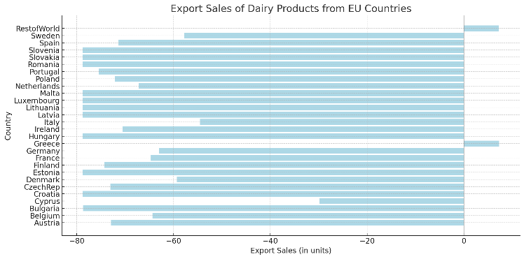

Figure 3. Export Sales of Dairy Products from EU Countries

The figure 4 simulation results indicate significant shifts in the dairy product trade balance across both China and EU countries, reflecting the impact of these protectionist measures. China experiences a substantial negative change in its dairy trade balance, with a decline of -111.67 million USD. This result suggests that the imposition of tariffs has reduced the competitiveness of EU dairy products, particularly cheese and milk, in the Chinese market. Despite these tariffs aiming to protect China's domestic dairy industry, the negative trade balance may imply that China is still heavily reliant on imports to meet its dairy demands, possibly due to insufficient domestic production or lower quality compared to imported goods. The tariffs, while reducing EU imports, may also drive up consumer prices and limit the variety of available dairy products in the Chinese market, potentially straining consumers and retailers.

Among the EU countries, France stands out with the largest positive change in the dairy trade balance, recording a surplus of 377.58 million USD. France is known for its strong dairy industry, particularly in cheese production, and the positive balance suggests that French dairy exports remain competitive in the global market despite the tariffs imposed by China. It is possible that France has shifted its focus toward other markets or has maintained a niche demand in China for premium products less affected by the tariff. Germany also shows a significant trade surplus of 206.95 million USD, likely reflecting the strength of its dairy sector, which benefits from efficient production and strong global demand.

On the other hand, several EU countries experience negative impacts. Italy, for instance, faces a dramatic negative change in its dairy trade balance, with a deficit of -236.56 million USD. This suggests that Italian dairy exports, particularly those of high-quality cheeses like Parmigiano-Reggiano, have been disproportionately affected by the tariffs. The negative trade balance for Italy may indicate a reliance on the Chinese market for premium dairy exports, and the tariffs have likely led to a sharp drop in demand for Italian products. Similarly, Spain shows a large negative trade balance of -146.76 million USD, reflecting the broader challenges faced by southern European dairy producers in adapting to the new trade environment.

Smaller EU countries also display varying outcomes. Denmark emerges with a notable trade surplus of 171.42 million USD, potentially due to the country's focus on niche dairy products such as butter and specialty cheeses, which may be less affected by tariffs or have successfully found alternative markets. Ireland also benefits from a positive balance of 171.59 million USD, as its dairy industry is globally competitive, with a strong focus on milk and cheese exports. In contrast, countries like Greece (-52.91 million USD), Portugal (-31.44 million USD), and Finland (-9.26 million USD) experience negative trade balances, indicating that their dairy sectors have been adversely affected by the reduced demand in China.

Outside of the EU, the Rest of the World (RoW) experiences the largest negative change in the dairy trade balance, with a deficit of -1,035.14 million USD. This significant reduction suggests that the tariffs not only affect EU countries but also other dairy-exporting nations, which may have previously benefited from access to the Chinese market. The negative trade balance for the RoW indicates that China's protectionist measures have had a global ripple effect, reducing dairy imports from non-EU countries as well, possibly as a result of overall weakened demand for foreign dairy products in China.

.

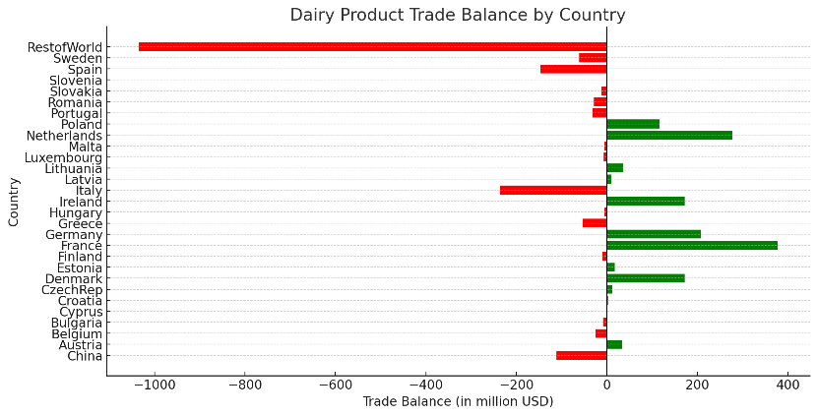

Figure 4. Dairy Product Trade Balance by Country

The Figure 5 simulation results illustrate how the tariffs have affected both China and the EU member states in terms of overall economic welfare, highlighting both gains and losses across different countries. China shows the most significant welfare loss, with a -49.45 million USD decrease. This outcome reflects the broader negative effects of the tariffs on the Chinese economy, as higher import costs lead to increased prices for dairy products such as cheese and milk. The reduction in imports not only affects consumers by limiting access to high-quality dairy products but also impacts local businesses that rely on these imports for production. The decline in welfare underscores the adverse impact of trade protectionism, where tariffs aimed at shielding domestic industries can inadvertently hurt consumers and reduce overall economic well-being.

In the EU, several countries exhibit modest welfare gains despite the tariffs. Finland reports the largest increase in welfare, with a 2.85 million USD gain, possibly due to a shift in demand toward domestically produced dairy products or an increase in exports to non-tariffed regions. Germany (1.54 million USD) and Italy (1.45 million USD) also experience positive welfare changes, which might indicate that their dairy sectors are less dependent on the Chinese market or have managed to reallocate their trade focus toward other markets. Smaller welfare gains in countries like Austria (0.61 million USD) and Sweden (1.41 million USD) suggest that these nations have also adapted to the changing trade dynamics, benefiting from shifts in global dairy trade patterns.

However, many other EU countries experience welfare losses. France, a major dairy exporter, faces a substantial welfare decrease of -11.60 million USD. This reflects the negative impact of reduced demand for French dairy products in China, which has historically been a significant market for premium French cheeses. Similarly, the Netherlands (-2.47 million USD) and Poland (-2.25 million USD) experience welfare declines, likely due to their reliance on dairy exports to China. These countries may struggle to find alternative markets or to absorb the impact of the tariffs within the domestic economy.

Interestingly, the Rest of the World sees a significant welfare gain of 23.67 million USD. This increase suggests that countries outside the EU and China have benefited from the reconfiguration of global dairy trade. As China reduces imports from the EU, other dairy-exporting countries have likely stepped in to fill the gap, leading to increased demand and higher welfare in those regions. This highlights the broader global impacts of trade policies, where disruptions between major trading partners can create opportunities for others.

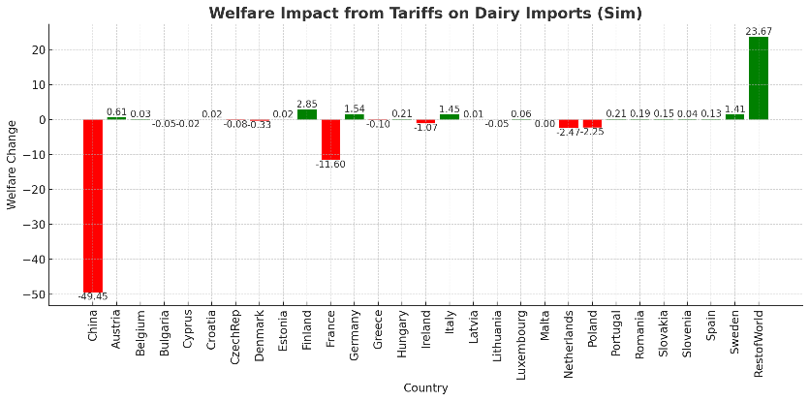

Figure 5. Welfare Impact by Country (in million USD)

The Figure 6 explores the percentage change in output before and after the tariff implementation, highlighting both increases and declines in production. The results indicate widespread declines in dairy product output across most EU countries, with some countries experiencing larger reductions than others. France sees the most substantial decline, with a -173.92% change, reflecting the severe impact of reduced access to the Chinese market. France, known for its strong dairy industry, particularly in premium products like cheese, has faced a significant reduction in demand due to the tariffs. Similarly, Germany experiences a -99.17% drop in output, further emphasizing the challenges faced by large dairy exporters in the EU, who rely on China as a key market.

Other countries, including Ireland (-54.8%), Netherlands (-47.03%), and Finland (-45.26%), also suffer notable declines in output. These countries are major dairy producers and exporters, and the tariffs have likely caused a substantial contraction in production as exports to China become less competitive due to increased costs.

In contrast, smaller percentage declines are observed in countries like Austria (-2.95%) and Belgium (-12.52%), indicating that their dairy industries may be less dependent on exports to China, or they may have diversified their markets. Countries such as Bulgaria and Slovenia see minimal changes, each recording less than -1% in output reductions. These smaller shifts could suggest that these nations are not as exposed to the Chinese market or their dairy industries focus more on domestic or regional markets.

The Rest of the World stands out with a significant increase of 208.13% in dairy product output. This rise indicates that as EU dairy products become more expensive and less competitive in the Chinese market, other countries have stepped in to fill the demand. The Rest of the World, likely including major dairy producers outside the EU, has benefited from the disruption in EU-China trade, capturing a larger share of the Chinese dairy market.

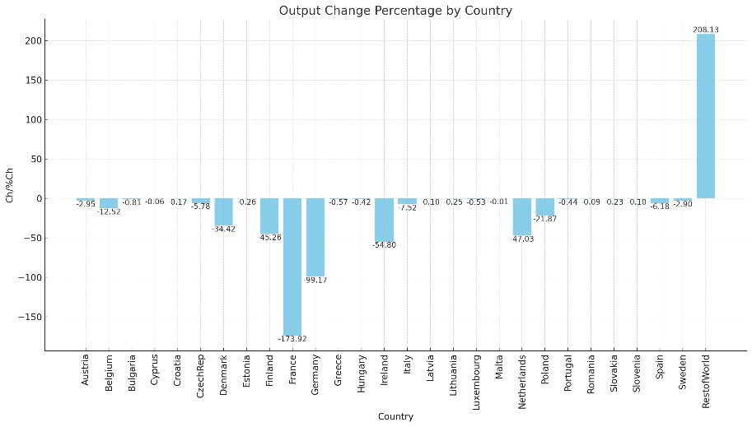

Figure 6. Output Change Percentage by Country

**Impact of EU Retaliatory Tariffs on Chinese Motor Vehicle and Parts Exports: A Trade Balance and Welfare Analysis**

The simulation of potential retaliatory measures by the European Union (EU), involving tariffs of up to 35% on motor vehicles and parts imported from China, reveals substantial shifts in trade dynamics, particularly in trade balances, export sales, output variations and welfare outcomes across the EU, China, and the rest of the world (RoW).

Figure 7 explained that the European Union (EU) experiences a substantial trade surplus in motor vehicles and parts, with a positive balance of 18,397.93 million USD. This suggests that the imposition of tariffs has benefited the EU's automotive sector, likely due to a combination of reduced competition from Chinese imports and an increase in domestic or intra-EU production and consumption. The tariff barrier appears to have shielded EU manufacturers, allowing them to capture a larger share of the local market and improve their competitive stance in global markets.

In contrast, China faces a significant trade deficit of -6,555.59 million USD, indicating a substantial reduction in its exports of motor vehicles and parts to the EU. The high tariff has likely made Chinese automotive products less competitive in the EU market, leading to a decline in demand. This outcome aligns with the intended impact of the tariff, as it discourages imports from China by making them more expensive, while simultaneously protecting domestic producers within the EU. Additionally, China may have limited capacity to redirect these products to other global markets, as indicated by the overall negative trade balance for the rest of the world.

The rest of the world (RoW) also registers a large negative trade balance of -15,679.54 million USD. This suggests that the global automotive supply chain has been disrupted by the tariffs, affecting countries outside of both the EU and China. These countries may be experiencing a spillover effect from the EU-China trade conflict, as they are unable to absorb the excess supply of Chinese motor vehicles and parts or compensate for the reduction in EU demand for Chinese goods. Moreover, this negative trade balance for the rest of the world may reflect a shift in global market dynamics, where alternative suppliers struggle to fill the gap left by the reduction in Chinese exports, leading to broader imbalances in the global automotive trade.

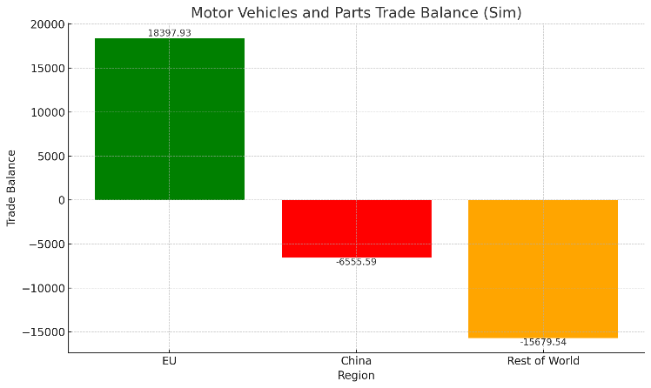

Figure 7. Motor Vehicles and Parts Trade Balance (Million USD)

Figure 8 highlights the changes in welfare for the EU, China, and the rest of the world (RoW) as a result of these trade barriers. The EU experiences a welfare loss of -114.04 million USD. This decline suggests that, despite the protective effects of the tariff on the domestic automotive industry, the overall economic welfare in the EU decreases. The welfare loss can be attributed to the higher costs of imported goods from China, which may lead to increased prices for consumers and potentially reduced consumption in sectors reliant on Chinese motor parts. Additionally, the EU may face inefficiencies in reallocating resources to domestic industries, which could further strain the economy. While the trade policy might support certain sectors, the broader negative welfare impact reflects the potential downside of protectionism, where consumer losses and reduced economic efficiency outweigh industry gains.

China faces a significantly larger welfare loss of -606.73 million USD. This substantial reduction underscores the adverse effects of the tariffs on Chinese exports, particularly in the automotive sector. The imposition of tariffs raises the price of Chinese motor vehicles and parts in the EU, reducing their competitiveness and sharply decreasing demand. Consequently, Chinese manufacturers face lower export volumes, leading to decreased production, income, and overall economic welfare. The magnitude of the welfare loss in China highlights the dependence of the Chinese automotive sector on the EU market and the significant disruption that tariffs can cause to export-driven economies. Furthermore, this loss may ripple through related sectors in China, further exacerbating the economic strain.

In contrast, the rest of the world (RoW) experiences a welfare gain of 172.05 million USD. This positive outcome may indicate that some countries outside the EU and China are benefiting from the trade disruption between these two major economies. As the EU seeks alternative suppliers for motor vehicles and parts, other nations might step in to fill the gap left by China, potentially boosting their own exports and production in the automotive sector. Additionally, countries not directly involved in the tariff dispute may experience increased market opportunities or improved terms of trade, leading to welfare gains. This gain for the rest of the world underscores the complex dynamics of global trade, where protectionist measures between two regions can have spillover effects, benefiting third parties that are not directly involved in the trade conflict.

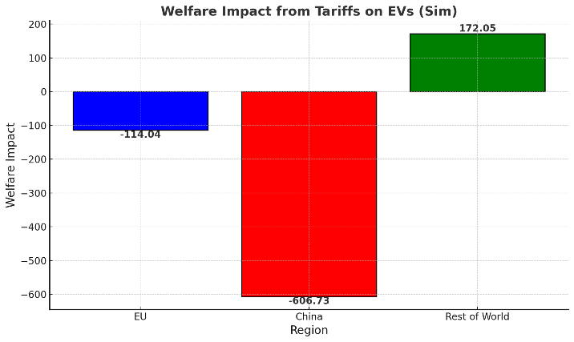

Figure 8. Welfare Impact (in Million USD)

The table 1 presents the percentage change in the quantity of motor vehicle and parts exports for each region, both internally and across the other regions. For the EU, the export quantity increases by 0.66% within its own region. This positive effect reflects how the tariffs create a more favorable environment for intra-EU trade by limiting competition from Chinese imports. The tariff provides domestic producers with a competitive edge in the automotive market, leading to an increase in the demand for EU-produced vehicles and parts within the region. However, the EU’s exports to China decline by -0.46%, indicating that retaliatory measures from China or the general disruption in trade between the two regions have negatively affected the EU's ability to export to the Chinese market. This decline is compounded by the smaller decrease in exports to the rest of the world (-0.14%), suggesting that global disruptions in supply chains and potential shifts in demand preferences also affect the EU's external trade.

For China, the impact is much more pronounced. The export quantity to the EU plummets by a substantial -75.9%. This sharp decline is expected, as the high 35% tariff drastically reduces the competitiveness of Chinese motor vehicles and parts in the EU market. The reduction in exports to the EU significantly harms China's automotive sector, which has been reliant on the EU as a major export destination. The decline of -0.14% in China's internal exports and -0.28% to the rest of the world further indicates that China's automotive industry faces widespread challenges, possibly due to spillover effects from the tariffs and disruptions in global demand. However, China's exports to the rest of the world increase slightly by 0.17%, suggesting that China is attempting to offset its losses in the EU by seeking other markets for its automotive products. Nevertheless, the scale of this increase is too small to make up for the substantial losses in its trade with the EU.

The Rest of the World (RoW) emerges as a region with relatively balanced outcomes. The quantity of exports within its own region grows by 0.85%, and there is a small positive change of 0.17% in exports to China, likely benefiting from the void left by Chinese exports to the EU. The RoW's exports to the EU, however, experience a slight decline of -0.28%. This suggests that while some RoW countries are benefiting from increased demand for motor parts in China, the overall disruption in global trade, particularly in relation to the EU, has affected their ability to sustain or grow exports to the European market. The minor change in intra-regional exports (0.05%) reflects the relatively stable position of the RoW's automotive sector, indicating that the overall impact of the tariffs on the rest of the world is moderate compared to the dramatic shifts seen in China and the EU.

Table 1. Quantity of Exports (Percentage Change)

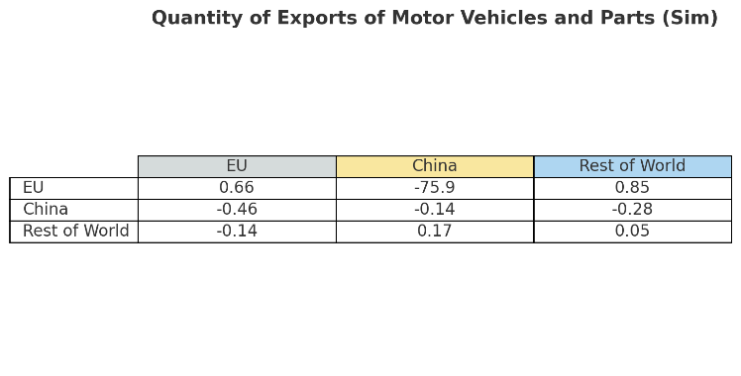

Figure 9 below highlights the changes in industry output for motor vehicles and parts before and after the tariff imposition. For the EU, the quantity of output for motor vehicles and parts shows a notable increase, with a percentage change of 3,082.5%. The output rises from 1,069,606.25 million USD pre-tariff to 1,072,688.75 million USD post-tariff. This increase in output can be attributed to the protective nature of the tariff, which discourages imports from China and encourages domestic production. By imposing the tariff, the EU has effectively supported its local automotive industry, allowing it to expand production and capture a larger market share. This increase also reflects the EU’s ability to meet domestic demand through local production rather than relying on imports, which not only strengthens the region’s industrial base but also contributes positively to employment and economic growth in the automotive sector.

In contrast, China experiences a significant decline in the quantity of output for motor vehicles and parts, with a percentage decrease of -4,375.63%. The output falls from 654,269.19 million USD pre-tariff to 649,893.56 million USD post-tariff. This sharp decline is a direct consequence of the reduced demand for Chinese motor vehicles and parts in the EU market, which is a major export destination for China. The tariff makes Chinese products less competitive, leading to a significant contraction in production. As a result, the automotive sector in China faces excess capacity, potentially leading to layoffs and reduced investment in the industry. The negative impact on China's output reflects the vulnerability of its export-oriented industries to trade protectionism measures, particularly in sectors where they have been heavily reliant on foreign markets.

For the Rest of the World, the quantity of output also increases, but at a more moderate rate of 1,277%. The output rises from 2,152,457 million USD pre-tariff to 2,153,734 million USD post-tariff. This increase suggests that countries outside the EU and China are benefiting from the trade disruptions caused by the tariffs. As the EU reduces its reliance on Chinese imports, it turns to alternative suppliers, boosting production in the rest of the world. While the percentage increase is smaller compared to the EU, it still reflects an opportunity for the rest of the world to expand their production and potentially strengthen their foothold in the global automotive supply chain. The relatively stable growth in output in these regions indicates that they are able to absorb some of the market share lost by China, albeit on a smaller scale.

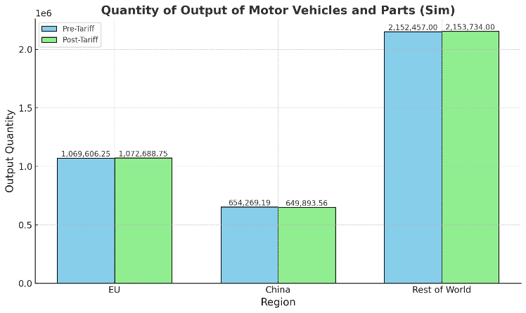

Figure 9. Quantity of Output (Million USD)

Policy Implications and Strategic Recommendations

To mitigate the negative effects of protectionist measures and strengthen global trade resilience, several strategic policy actions are recommended. First, countries heavily reliant on specific markets, such as EU dairy exporters, should diversify their trade partnerships to reduce risks from sudden tariffs. Exploring new markets through strategic trade agreements can help stabilize export flows. Additionally, investing in domestic production is crucial for regions like China’s automotive sector, which faces significant import reductions. Technological upgrades and subsidies can enhance local industry competitiveness and reduce dependency on foreign imports.

Furthermore, rebalancing trade agreements is essential to address global trade disruptions caused by protectionist policies. Policymakers should prioritize renegotiating multilateral agreements to lower tariffs and create more predictable trade environments, especially in key sectors like agriculture and technology. Lastly, supporting small and medium enterprises (SMEs) in the EU’s dairy sector is also critical, as they are disproportionately affected by tariffs. Financial assistance and market access programs can help SMEs adapt and explore alternative markets.

Conclusion

The imposition of tariffs on EU dairy imports by China and on Chinese automotive exports by the EU has significant economic consequences across global markets. The study finds that the dairy sector in the EU suffers substantial losses, particularly in countries heavily reliant on Chinese markets, such as France, Germany, and Ireland. These countries face sharp reductions in dairy product output, while the Rest of the World benefits from an increase in dairy exports. In contrast, the EU’s automotive sector benefits from tariffs on Chinese imports, leading to a boost in domestic production. However, China faces a dramatic decline in motor vehicle exports to the EU, contributing to a significant reduction in output and welfare.

These findings underscore the complex interplay between trade protectionism and global supply chains. While tariffs can protect local industries by reducing foreign competition, they also lead to inefficiencies and welfare losses in importing and exporting countries. The research illustrates that while the EU benefits from tariff barriers in the automotive sector, its dairy industry suffers from similar trade restrictions imposed by China. The results of this study emphasize the need for careful consideration of the broader economic impacts of trade policies, especially in sectors with strong global interdependencies such as dairy and automotive production.

Future research should focus on a more granular analysis of sectoral impacts within the EU and China, particularly examining how small and medium enterprises (SMEs) are affected by these tariffs. Additionally, further studies could investigate the long-term effects of trade protectionism on innovation and competitiveness within the affected industries, especially in automotive and dairy sectors. Another important area for future research is the role of global supply chain diversification, particularly for countries heavily dependent on a limited number of export markets.

References

[1] Akritidis, V., 2023. Analysis of the Foreign Subsidies Regulation From an International Trade Law Perspective on Trade in Goods. *Global Trade and Customs Journal*, 1 October.

[2] Hertel, T.W., 1997. *Global Trade Analysis: Modeling and Applications*. Cambridge University Press.

[3] Kryvenko, N., 2023. International trade in agri-food products in the context of regional peculiarities and international economic integration. *Economics & Education*, 29 December.

[4] Marques, A., 2024. The role of nature's contributions to people in sustaining international trade of agricultural products. *People and Nature*, 17 February.

[5] Reuters, 2024. EU to impose multi-billion euro tariffs on Chinese EVs. *Reuters*, 12 June. Available at: <https://www.reuters.com/business/autos-transportation/eu-impose-multi-billion-euro-tariffs-chinese-evs-ft-reports-2024-06-12/>

[6] The Guardian, 2024. China begins anti-subsidy investigation into European dairy imports. *The Guardian*, 21 August. Available at: <https://www.theguardian.com/world/article/2024/aug/21/china-begins-anti-subsidy-investigation-into-european-dairy-imports>

[7] Bai, Y., et al., 2022. Impact of imported dairy products on China's raw milk production. *Journal of Intelligent and Fuzzy Systems*, 31 July.

[8] Chepeliev, M. and Wing, I.S., 2018. Agricultural production targeting in the GTAP data base: a look ahead. 5 Citations, 13 April.

[9] Cima, E. and Chepeliev, M., 2024. Making international trade work for sustainable development: toward a new WTO framework for subsidies. *Journal of International Economic Law*, 22 February.

[10] Dong, J., et al., 2022. Identification of international trade patterns of agricultural products: the evolution of communities and their core countries. *Geo-spatial Information Science*, 30 September.

[11] Dupas, M.-C., et al., 2022. Power law scaling and country-level centralization of global agricultural production and trade. *Environmental Research Letters*, 14 February.

[12] Heyl, K., et al., 2022. Potentials and limitations of subsidies in sustainability governance: the example of agriculture. *Sustainability*, 28 November.

[13] Kondaridze, M., 2023. Determinants of dairy‐product trade: do subsidies matter? *Journal of Agricultural Economics*, 21 March.

[14] Mishra, N., et al., 2024. Assessing the impact of agricultural subsidies on farm profitability and sustainability. *Journal of Experimental Agriculture International*, 24 July.

[15] Ramesh, S., 2021. The crucial role of agricultural production in facilitating international commerce and trade. *International Journal of Agriculture and Animal Production*, 26 September.

[16] Shao, Y., et al., 2020. Government regulation and consumer evaluation after dairy products scandal in China. *Acta Alimentaria*, 01 March.

[17] Sue Wing, I. and Chepeliev, M., 2018. Computable general equilibrium models for policy evaluation and economic consequence analysis. 9 Citations, 22 February.

[18] Wang, F., et al., 2023. How does trade policy uncertainty affect China's economy and energy? *Journal of Environmental Management*, 03 January.

[19] Wang, Q., et al., 2023. Assessing volatility spillover effect between international milk powder and China’s raw milk markets in the context of import growth. *Cogent Food & Agriculture*, 06 September.

[20] Zhu, H., et al., 2024. Does trade policy uncertainty affect firms' imported intermediates? *Journal of Environmental Management*, 22 February.

.