ORIGINAL RESEARCH ARTICLE

HIV positive status disclosure and associated factors among clients in some selected health facilities of Buea Health District

ABSTRACT
Disclosure of disease status deals with sharing one’s health status/test results with another. This could be difficult especially when the disease condition is associated with stigmatization such as in HIV/AIDS. According to WHO, understanding which factors influence the rate of transmission of the HIV virus is critical in attempting to contain and ultimately eradicate the disease. Determining which factors influence a person’s decision to disclose his/her positive status to others, particularly the sexual partner, is essential in understanding this complex process and thereby improving disclosure rates. The main objective of this study was to assess HIV positive status disclosure and associated factors among clients in some selected health facilities of Buea Health District. This study was a descriptive study with a quantitative approach involving a total of 455 HIV positive clients in some selected sites in the Buea Health District. The convenient sampling method was used to select the sample of participants who met the criteria and voluntarily agreed to participate in the study. Informed consent and ethical clearance was obtained. A self-administered questionnaire was used, to collect data. The data was analyzed using Excel version 2010, SPSS version 20 and data was presented using figures and tables. The mean age of the participants was 39yeas ± 10 years. There were more females (61.3%) than males (38.7%). Numerous factors influenced HIV status disclosure such as, marital status, age and gender. The results also showed that awareness of the sexual partner’s HIV status remained relatively low (n=71.9%), with awareness of the partner’s status highest among married participants. Respondents took a shorter time to disclose their status to anyone (1.64 ± 1.39 years) compared to their sexual partners (1.16 ± 1.39 years). Sixty-five (14.3%) preferred not to disclose their HIV status to nobody while 151 (33.2%) preferred disclosure of status to their family members. It was concluded that disclosure is a gradual process and one particular factor does not necessarily influence disclosure of HIV positive status but most often a combination of factors. It was recommended that clinics/hospitals should routinely hold counseling sessions focusing on disclosure and partner notification.
Key words: HIV, positive status, disclosure, HIV prevention, associated factors to disclosure.
  - Introduction
Disclosing one’s HIV status to a sexual partner means talking honestly about one’s sexual orientation, possible drug use, and results of HIV testing [1]. Disclosure has been shown to result in better adherence to therapy, good clinical outcomes, and reduction in the risk of HIV transmission among couples [2]. Worldwide, HIV status disclosure rates vary from 7% to 79%. [3]. Disclosure of HIV sero status is critical to controlling the spread of HIV, and understanding the reasons for disclosure will enhance the development of prevention interventions and ultimately lead to better control of the spread of the disease [4]. The disclosure rate is notably lower in developing countries than in the developed world (17% vs 86%, respectively)

Disclosure is an important public health goal for a number of different reasons. First, disclosure may motivate sexual partners to seek testing, change behavior and ultimately decrease transmission of HIV. In addition, disclosure has a number of potential benefits for the individual including increased opportunities for social support, improved access to necessary medical care including antiretroviral treatment, increased opportunities to discuss and implement HIV risk reduction with partners, and increased opportunities to plan for the future [5].
Along with these benefits, however, HIV status disclosure to sexual partners has a number of potential risks for the individual including loss of economic support, blame, abandonment, physical and emotional abuse, discrimination, and disruption of family relationships [4].
HIV and AIDS still continue to be a serious global public health problem. Globally it causes 1.8 million new infections each year. About 36.7 million people reported to live with HIV and one million people dead from HIV related illnesses in 2016. In the same year, 19.4 million people were reported to live with HIV in Eastern and Southern Africa. In these areas, 790,000 new infections reported to occur, accounting 43% of global new HIV infections, and 420,000 dead due to HIV related illnesses. Continentally the prevalence of HIV infection in sub Saharan Africa is the highest in the world [5].
Cameroon’s HIV/AIDS prevalence values vary from one region to the other and from one locality to the other within the same region [8]. National HIV incidence is 0.27% among the population aged 15-64. Four out of five new infections are among women aged 15-64. The overall adult HIV prevalence is steadily decreasing (3.7% in 2017 to 3.4% in 2018). Prevalence among women is more than twice that of men (4.8% vs. 2.0%) [7]. HIV prevalence is highest among women between 40-44 years of age (9.3%) and over 8% among women aged 35-39 and 45-49. For men, HIV prevalence is highest in the 50-54 age range (6.0%), and over 5.3% among men in the age group 40-44. In previous country operation procedures, the highest prevalence was among women between 35-39 and men 45-49. Adolescent girls and young women are more affected than their male counterpart: 1.2% vs. 0.2% in the 15-19 age range, and 2.9% vs. 0.6% in the 20-24 age range. HIV prevalence remains high among key populations at 24.3% for female sex workers and 20.7% for men who sex men [6].
From the Cameroon Population-based HIV Impact Assessment [7], the economic capital, Douala, and the capital, Yaoundé, together have an overall HIV prevalence of 3.4% with 5.2% among women and 1.7% among men. Other cities combined have an overall HIV prevalence of 3.7% with a 5.3% among women and 2.1% among men, while rural areas have HIV prevalence of 4.3% among women and 2.1% among men. The regions with prevalence above 5% are the three southeastern regions of the country (South, East, and Center), with prevalence of 6.3%, 5.9% and 5.8% respectively and the Northwest region, with a prevalence of 5.1% and the south west region has a prevalence rate of (7.2%) [1].
Disclosure of HIV status to sexual partners has increasingly gained prominence in management of Human Immunodeficiency Virus/Acquired Immune Deficiency Syndrome (HIV/AIDS). According to [8], many public health officials have shifted their HIV prevention methods from targeting populations at risk of HIV infection to those infected with HIV. The thinking behind this policy is based on the premise that if those infected with HIV disclose their status, then safer sex will occur and lead to reduced HIV transmission. According to Norman et al in 2007 [9] also in some resource-limited settings, disclosure of HIV status is one of the prerequisites for enrolment into national HIV programs. In Cameroon, the National Aids Control Committee [10] operates an “index testing system” whereby each patient is encouraged to form a special bond with someone close, to enhance adherence to HIV treatment. The patients therefore are encouraged to disclose their HIV status to the sexual partners.
There is no previous work in Buea in relation to HIV status disclosure. In this study, there would be a deeper understanding of the reasons why Human Immunodeficiency Virus (HIV) infected people in Buea health district choose whether to tell or not to tell their partners that they are HIV positive. Secrets exist because people decide to keep private certain information about them. Disclosure of private information is likely to be complex, and even more so in the context of disclosing one’s HIV status, which involves sensitive, potentially life-threatening information and the stigma that can be associated with the condition [5].
In Cameroon in 2018, 540 000 people were living with HIV [10]. HIV incidence per 1000 uninfected. The number of new HIV infections among the uninfected population over one year among all people of all ages was 1.02%. The percentage of people living with HIV among adults (15–49 years) was 3.6% [10].
The Cameroon government in its sustainable development plan is to attain Zero new HIV infections, Zero HIV-related deaths and Zero HIV-related discrimination in all region where people living with HIV are able to live long and healthy lives by 2030 [10]. The disclosure process is voluntary and the patient is the one who discloses his or her results to the third party. The fear to disclose is associated with the negative outcomes like blame, violence, abandonment, abuse, discrimination, broken relationships and even loss of support. In the fight of HIV epidemic, delay of disclosure accounts for a lot of harm than good to the person himself as well as the loved ones. Disclosure is vital in the fight against HIV/AIDS, thus a suitable approach, as well as a preferred third party who can be trusted as well as supportive should join in order to facilitate disclosure, respect people’s rights and protect others from getting infected [1]. The consequences of non-disclosure, specifically to sexual partners, increase the transmission of the virus. Looking at the Buea health district with a capacity of about 3500 clients [11], it is necessary to know which proportion of the clients have disclosed their HIV positive status to their sexual partners.
It is therefore important to investigate factors influencing HIV positive status disclosure to sexual partners among clients on ART and receiving HIV care services in Buea health district.
The main objective of this study was to assess HIV positive status disclosure and associated factors among clients in some selected health facilities of Buea Health District. The specific research objectives were:
- To bring out the proportion of HIV positive status disclosure among clients in some selected health facility in Buea Health District.
- To identify factors affecting disclosure among HIV positive clients in some selected health facility in the Buea health district.
- To assess client’s knowledge on the effect of non-disclosure of HIV status to sexual partners in some selected health facility in Buea health district.
- To identify measures that can be put in place to assist HIV infected people in disclosing their HIV status to their sexual partners.

1.6 Conceptual/Theoretical Framework

This conceptual model is constructed using the theory of planned behavior. It is a theory that may help address issues associated to HIV disclosure to sexual partners like fear of abandonment, sexual partner violence, and blame (figure 1).
CONTEXT (e.g., gender, relational)
TRIGGER EVENT. (e.g., new partner, starting ART, HIV-positive diagnosis)
HIV CORE BELIEFS/HIV STIGMA. (e.g., being HIV-positive is shameful)
CONDITIONAL ASSUMPTIONS (e.g., “Hiding being HIV-positive avoids rejection”)
AFFECTIVE. (e.g., anxiety, low mood, withdrawal syndrome and depression)
PHYSIOLOGICAL. (e.g., arousal, physical reaction and violence)
BEHAVIORAL. (e.g., avoidance, safety seeking behavior, seeking reassurance)

90
COGNITIVE. (e.g., syndrome, preoccupation)
THREAT INTERPRETATION. (e.g. “People will think I have HIV Model of planned behavioral HIV disclosure and will reject me. I wouldn’t be able to cope”)

Figure 1: conceptual Theoretical Framework

1.6.1 HIV Core Beliefs/HIV Stigma and Conditional Assumptions
Feelings of shame, based on difficulties in adjusting to an HIV-positive diagnosis, are predisposed factors to individuals to HIV disclosure to sexual partner. Indeed, feelings of shame have been reported to inhibit HIV disclosure to sexual partner. Negative beliefs about HIV (e.g., ‘‘People who are HIV-positive will have a short life expectancy’’) are likely to contribute to stigma. A belief that HIV is shameful may lead the individual to believe that they must hide their status from others to avoid being rejected (e.g., ‘‘If I hide my status, then I will be safe’’). This was as said by a client during an interview session in the hospital (personal communication).

1.6.2 Trigger Event
Observation in the field shows that when a client is newly diagnosed with HIV, taking ART medication in social situations, or attending clinic, where HIV disclosure is thought to be required or wanted (direct disclosure), or where there might be a concern that one’s status will be revealed involuntarily or guessed (indirect or guessed disclosure) the patient may be uncomfortable. This may trigger disclosure in latter situation where the individuals may be concerned that taking antiretroviral drugs or visits to the hospital or clinic can be observed by others.
Within sexual relationships, a sense of responsibility to one’s partner and/or a concern about onward HIV transmission may trigger anxiety about disclosing the status to the sexual partner. This may occur in new relationships. Within friendships, a desire for closeness may trigger a perceived need to disclosure to a sexual partner. Such situations may trigger disclosure approach goals (e.g., sharing one’s status to enhance relationship quality) or disclosure avoidance goals (e.g., hiding one’s status to avoid rejection and reduce potential relationship conflict). So therefore, HIV diagnosis is likely to be an initial trigger to HIV disclosure to sexual partner [13]

1.6.3 Threat Interpretation and HIV Disclosure
A sense of threat may occur to the client with the thoughts of rejection from the sexual partner, family members and friends. This further leads to negative outcome where the client may start having suicidal thoughts. The client will be facing difficulties coping or sharing one’s HIV status and the outcome of HIV disclosure [14].

1.6.4 Behavioural Factors
The individual may, for example, avoid telling others about being HIV- positive and as a result may use condoms in sexual relationships rather than disclosing, only take medication when alone, and avoid sexual relationships completely to avoid sharing one’s status to the sexual partner. Some may prefer to disclose only to other known HIV-positive people [1].

1.6.5 Cognitive Factors
Cognitive factors might be noticed were the client watch videos about HIV, how the sample of patients looks like then she compares with her/his looks. This type of client has a negative self-esteem and pre occupies his/her mind with HIV [1].

1.6.6 Affective and Physiological Factors
When a client receives a positive HIV result, very few would accept immediately. Some may present with signs of denial, sweating, feeling hot, and crying [1].

1.7 Scope of the Work
This study involved 455 HIV positive clients receiving ART in Buea Health District with a minimum age of 21 years. The study ran from March to June 2021.

2.0 MATERIALS AND METHODS

2.1 Research Area
This study was carried out within “care and treatment centers of the Buea health District” Situated in the Fako Division, Buea sub-division in the Southwest Region of Cameroon. Buea is situated at an elevation of 3000 feet (900 meters) above sea level and is located on the southeast slope of mount Cameroon. Buea is bounded to the north by tropical forest on the slope of Mount Cameroon (4100m above sea level). The mountain range extends to the beautiful sandy beaches of the Atlantic Ocean. The town also shares boundaries with other major towns like the City of Limbe to the Southwest, Tiko municipality to the Southeast, Muyuka municipality to the east and Idenau district to the West. It has two season the dry and the raining season. The raining season is the longest with 8months. And four months for the dry season. It has two government hotels, the mountain hotel and the parliamentarian flats hotel located around the government residential area.
The Buea Health District was created in 1995 and has 6 Health areas. Bokwango, Bova, Buea road, Buea town, Tole and Muea Health areas, with a population of over 177297 people. It has 39 Health facilities and 9 retail pharmacies., Mountain pharmacy, Salvation Pharmacy, Amazing pharmacy, Winners pharmacy, Mount Zion pharmacy, professional pharmacy, and compassionate health pharmacy. Among the 39 Health Facilities in Buea are 2 confessionals. Mount Zion and 7days Adventist, 13 integrated Health centers, 1 sub-divisional Hospital (CMA Muea) and 1 Regional hospital.
Buea is cosmopolitan town with people of all works of life. It has four functional HIV care and treatment centers with about 4000 HIV clients (statistics from Buea Health District, personal communication). This makes it suitable for this study because access to HIV patients through the care Service providers is made easier.

2.2 Study Design
It was a cross-sectional descriptive study design involving the use of questionnaire for data collection.

2.3 Study Population
The study was conducted at Buea Health District involving HIV positive patients presenting for treatment in the health facilities (health Centers, clinics and hospitals) in the health District have a capacity of about 4000 PLHIV and receiving HIV care services. To be eligible for inclusion in the study, all adult PLHIV both male and female aged 21 years and above and on follow-up in the health facilities and who consent shall be enrolled in the study.

2.4 Sample Size
The convenient sampling method was used to make up a sample size of 450 participants using the Lorentz formula
Z = statistical power =1.9
P = the estimated prevalence. In this study P was considered to be the estimated prevalence/proportion of disclosure. Considering that such study has not been done in our locality, the study by Gari et al., in Ethopia in 2010 was used. They reported a prevalence of disclosure ranging from 17 to 55% [15]. Therefore P was 55%. Q= 1-P, D= it is the significance level (0.05)
N= (1.9)² X 0.55 X ( 1-0.55)
(0.05)² N = 357.39
The minimum sample size for this study was calculated to be 357 clients living with HIV. However, 500 consent forms were distributed in order to maximize the chances of getting the expected sample size.

2.5 Sampling Techniques
This was a descriptive quantitative study, which used a cross-sectional design to collect information from HIV patients reporting for care in the Buea Health District. The sampling technique was the convenient/’in situ’ sampling technique.
2.5.1 Selection of data collection sites
There are four main HIV care and treatment centers in Buea but the number of patients registered per site and for treatment is different. There are approximately 4000 registered people living with HIV and presenting for care in the various care centers (statistics from treatment/care centers in Buea Health District). In order to obtain proportionate distribution of the clients, the calculations were done as follows:
Five hundred participants from a total of 4000 gives a percentage of 12.5%. For proportions and numbers from various sites, the calculations are as shown in table 1.
Table 1: Calculations of participants per study site
Facility | Total number of HIV client following treatment and care | Proportion to be sampled (25%) | Number of people to be sampled
PMI Buea Road Intergrated Health Centre | 283 | 35.38 | 35
Mount Mary Hospital | 350 | 43.75 | 44
Muea Sub-divisional hospital | 210 | 26.75 | 26
Buea Regional Hospital | 3157 | 394.6 | 395
Total | 4000 | 500 | 500

2.6 Selection Criteria

2.6.1 Inclusion Criteria
All adult PLHIV both male and female aged 21 years and above and on follow-up in the health facilities and who consented were enrolled in the study.

2.6.2 Exclusion Criterion
Those excluded from the study were:
- HIV positive children less than 21 year of age.
- People living with HIV who were too sick to be interviewed.
- All those that were incoherent and could not withstand the interview process.
- HIV positives clients who were recently (less than six months) transferred into the clinic.
- Those who did not consent to participate in the study.

2.7 Instrumentation and Validation
Structured questionnaire was used to collect the information that was typed in sections. Section A: demographic data, Section B: Proportion of HIV positive status disclosure, Section C: Factors influencing HIV positive status disclosure, Section D: Client’s knowledge on the effects of non-disclosure, Section E: measures taken to enhance HIV disclosure among HIV patients in Buea Health District.
2.7.1 Pre-testing of questionnaire/validation of research instrument
The questionnaire was pretested among HIV patients in Limbe Regional Hospital after validation from supervisors

2.9 Data Management and Analysis
Data that was obtained from the field, coded and entered into Microsoft excel version 2010 and saved in 4GB flash and in the investigator email address as backup. The data was imported into statistical package for social sciences (SPSS) version 20 and analyzed using frequency distribution tables and figures, pie charts and histograms.

2.10 Administrative and Ethical Considerations
Ethical clearance was applied for and obtained from the research and ethics committee of the Faculty of Health sciences at the University of Buea. Site approval was obtained form the Regional Hospital Buea, Mount Mary hospital Buea, CMA Muea. PMI Buea refused consent and so was removed from the study sites. Participants signed consent form after a thorough explanation of the study. The researcher ensured that all the participants were comfortable and were interview in private room away from noise and distraction s confidentiality and privacy were also maintain throughout the study. Participants were reassured that the information they provided would not be traceable to them and that their names would not be mentioned in any documents emanating from the study. They were further informed that they had the right to refuse to participate in the study and that they could withdraw from it at any time during the course of the study.

3.0 RESULTS

3.1. Demographic Characteristics of the Study Population
For this study, 500 consent forms were issued out and a total of 312 clients on antiretroviral therapy attending treatment in HIV Care Services in the Buea Health district consented and participated in the study. Out of the 312, most were in the age range 41- 50 years (n = 185, 59.3%). There were more females (n = 176, 56.4%) than males (n = 136, 43.6%). Most of the participants were single (n = 249, 79.8%), a majority had secondary education (n = 182, 58.3%) and there were more Christians (n = 271, 86.9%) than Muslims (n = 41, 13.1%) as shown in table 2.
Table 2: Demographic characteristics of the study population
Characteristics | Category | Number examined | Percentage
Age (years) | 21 – 3  0 | 16 | 5.1
Age (years) | 31 – 40 | 100 | 32.1
Age (years) | 41 – 50 | 185 | 59.3
Age (years) | >50 | 11 | 3.5
Age (years) | Total | 312 | 100
Marital Status | Single | 249 | 79.8
Marital Status | Married | 63 | 20.2
Marital Status | Total | 312 | 100
Sex | Male | 136 | 43.6
Sex | Female | 176 | 56.4
Sex | Total | 312 | 100
Education | Primary | 32 | 10.3
Education | Secondary | 182 | 58.3
Education | Tertiary | 98 | 31.4
Education | Total | 312 | 100
Religion | Christians | 271 | 86.9
Religion | Muslims | 41 | 13.1
Religion | Total | 312 | 100

3.2 Proportion of HIV positive status disclosure among clients
In this study, it was observed that the HIV patients presenting for care have been living with the virus for many years. Most of the patients (n = 171, 54.8%) were diagnosed between 2001 and 2005 and so have been living with the virus for more than 21 years. Only a minority of the participants who were diagnosed from 2016 to 2020 (n = 2, 0.64%) and 2021 (n = 2 0.64%) took part in the study. This is as shown in table 3.
Table 3: Year in which clients learnt about their HIV positive results
Year in which clients learnt about their HIV positive results | Number | Frequency  (%)
2001 – 2005 | 171 | 54.8
2006 – 2010 | 95 | 30.4
2011 – 2015 | 42 | 13.5
2016 – 2020 | 2 | 0.64
2021 | 2 | 0.64
Total | 312 | 100

In relation to disclosure of HIV positive status, most of the clients (n = 270, 86.5%) indicated that they had disclosed their status to at least one person (n = 42, 13.5%) a few had not yet disclosed to anyone (figure 2).
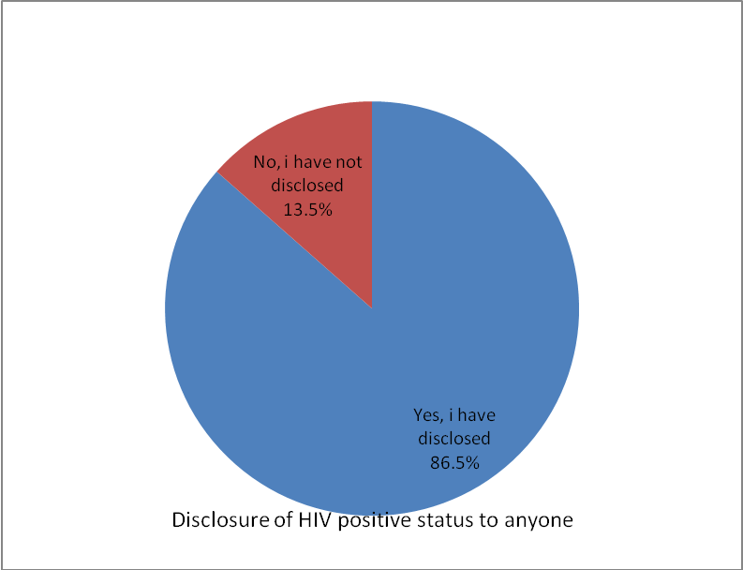
Figure 2: Proportion of HIV positive status disclosure.
As to who they first disclosed their HIV status to, most of them (n = 156, 50%), said they first disclosed their status to their spouse/life partner. This was followed by 30.1% (n = 94) who disclosed to religious leader. Few (n = 11, 3.5%) disclosed to boyfriend/girl friend, 1.6 % (n = 5) disclosed to causal partner, 1.3% (n = 4) disclosed to family members, and 13.5% (n = 42) had not yet disclosed their HIV positive status to anyone (figure 4).
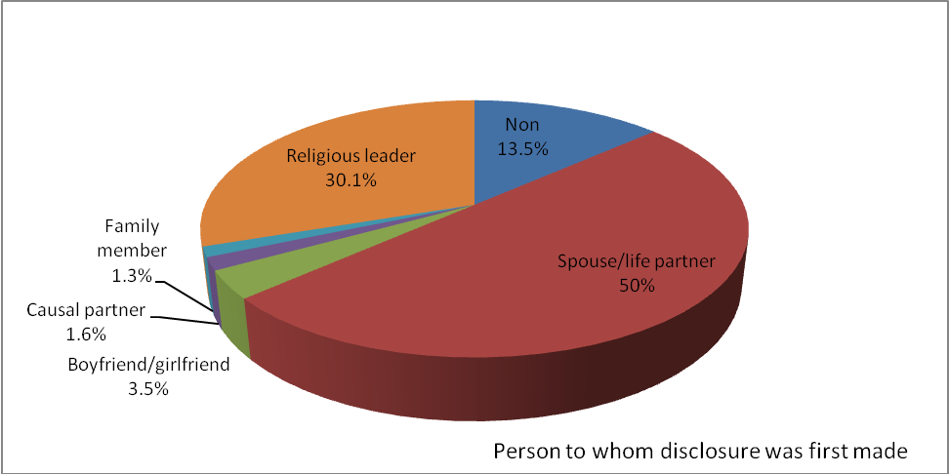
Figure 3: The person to whom disclosure was first made following diagnosis
In relation to the length of time that passed from the time of first diagnosis to the time of disclosure, it was observed that most clients took weeks (n = 138, 44.2%) to disclose their positive results to anyone. Some of them took 1 – 5 days to disclose (32%, n = 100), and some took years to disclose as shown in figure 4.
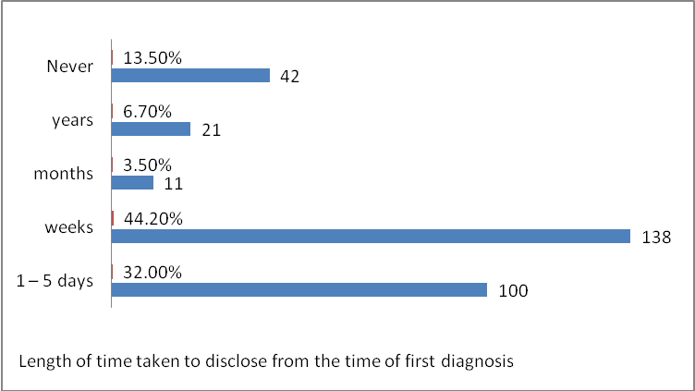
Figure 4: How long it took for disclosure following first diagnosis of HIV positive status
When clients were asked if they were aware of their sex partner’s HIV status, most accepted (n = 226, 72.4%) and few were not aware (n = 86, 14.7%) (figure 5).
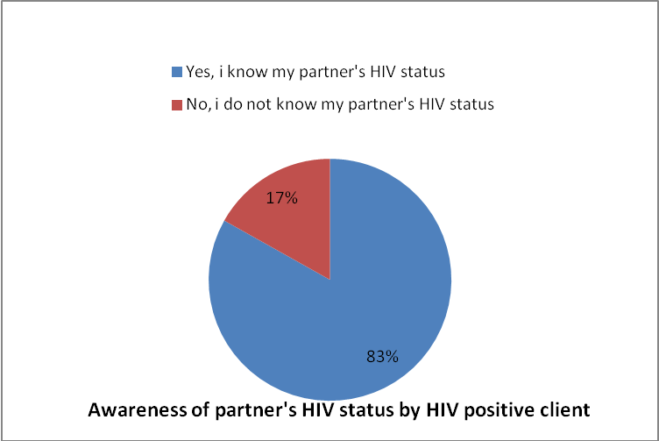
Figure 5: Client’s awareness of Sex partners HIV status

3.3. Factors influencing HIV positive status disclosure
Most of the client acknowledged that several factors influenced disclosure. The majority accepted that blame 86.5%), fear of rejection 90.1%), loss of financial support (91.6%), fear of abuse /violence 91.8%) and fear of stigmatization (86.5%) all influenced the disclosure of HIV positive status (figure 6).
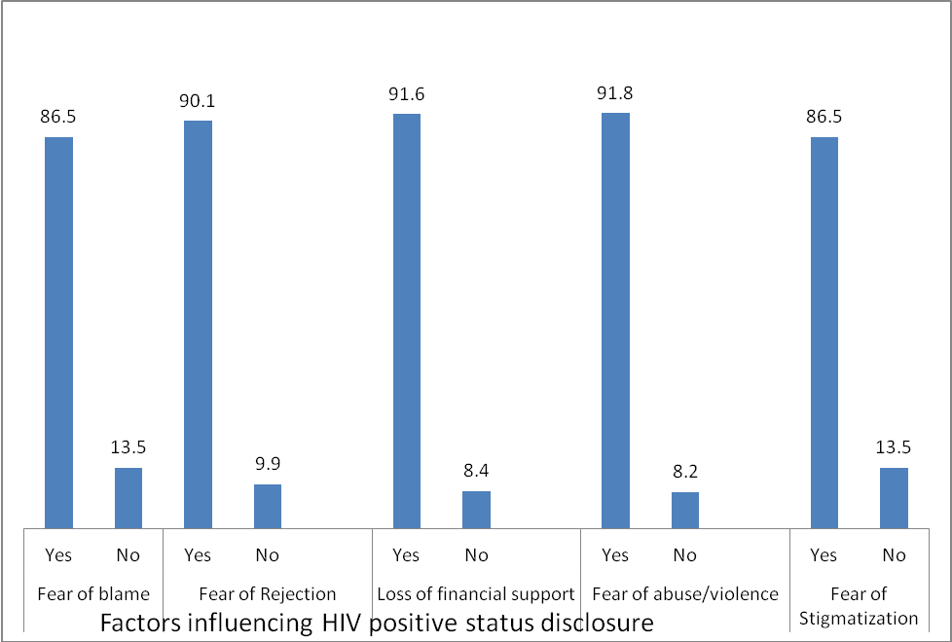
Figure 6: Factors influencing HIV positive status disclosure among the study participants
More females accepted that ‘the fear of being blamed’, ‘rejected’ and ‘abused’ was associated with HIV status disclosure than men. In relation to financial support, more females were also afraid of losing financial support than males and were afraid of violence and abuse.. However, in relation to stigmatization, more men approved that it was the main factor affecting disclosure than females and the difference was not significant (P>0.005) as shown in table 4).
Table 4: Factors influencing HIV positive status disclosure in relation to gender
 |  | Gender
Factors that prevent HIV positive clients from disclosing their status to sexual partners | Category and Number responded (%) | Male  N = 136 | Female  N = 176 | P-value
Fear of blame | Yes = 270(86.5) | 123(39.4) | 147(47.1) | P = 0.061
Fear of Rejection | Yes = 281(90.1) | 129(41.3) | 152 (48.7) | P = 0.061
Loss of financial support | Yes = 286(91.6) | 125 (40.1) | 161 (51.6) | P = 0.061
Fear of abuse/violence | Yes = 267(91.8) | 147(47.1) | 120(38.5) | P = 0.061
Fear of Stigmatization | Yes = 270(86.5) | 130 (41.7) | 140 (44.8) | P = 0.061

Factor influencing disclosure was appreciated differently between clients with respect to marital status. More singles indicated fear of stigma, abuse, loss of financial support, and fear of rejection than married people. However, more married people indicated the fear of being blamed (Table 5). Out of 63 married people who were involved in the study, 60 expressed fears of being blamed as a factor affecting disclosure. There was significant difference between singles and married people with respect to the factors influencing HIV positive status disclosure (P<0.05).
Table 5: Factors influencing HIV positive status disclosure in relation to marital status
 |  | Marital Status
Factors that prevent HIV positive clients from disclosing their status to sexual partners | Category and Number responded (%) | Single  N = 249 | Married  N = 63 | P-value
Fear of blame | Yes = 270(86.5) | 189(60.6) | 60(19.2) | P = 0.031
Fear of Rejection | Yes = 281(90.1) | 224(71.8) | 57(18.3) | P = 0.031
Loss of financial support | Yes = 286(91.6) | 240(76.9) | 46 (14.7) | P = 0.031
Fear of abuse/violence | Yes = 267(91.8) | 248(79.5) | 19(6.9) | P = 0.031
Fear of Stigmatization | Yes = 270(86.5) | 250(80.1) | 20(6.4) | P = 0.031

There was significant difference in client’s response as to the factors that influence the disclosure of HIV positive status (p<0.5). Looking within the specific age ranges, out of 16 people in the age group 21 – 30 years, 15 expressed the fear of being blamed, 12 expressed the fear of rejection, 13 expressed the fear of losing financial support. The older people (41 – 50 years) and > 50 years expressed less fear than those in the younger age ranges (table
Table 6: Factors influencing HIV positive status disclosure in relation to age of client
 |  | Age of Client (years)
Factors that prevent HIV positive clients from disclosing their status to sexual partners | Category and Number responded (%) | 21 -30  N = 16 | 31 – 40  N = 100 | 41 – 50  N = 185 | >50  N = 11 | P-value
Fear of blame | Yes = 270(86.5) | 15(4.8) | 92(29.5) | 161(51.6) | 2(0.64) | P = 0.001
Fear of Rejection | Yes = 281(90.1) | 12(3.8) | 82(26.3) | 182(58.3) | 5(1.6) | P = 0.001
Loss of financial support | Yes = 286(91.6) | 13(4.2) | 92(29.5) | 175(56.1) | 6(1.9) | P = 0.001
Fear of abuse/violence | Yes = 267(91.8) | 8(2.6) | 97(3.1) | 159(60.0) | 3(0.1) | P = 0.001
Fear of Stigmatization | Yes = 270(86.5) | 9(2.9) | 82(26.3) | 175(50.1) | 5(1.6) | P = 0.001
3.4. Clients’ Knowledge on the effects of disclosure
Most Clients indicated that the disclosure of HIV positive status does not encourage the infected to take and stay on treatment (n = 296, 94.90%) nor does it reduce stigma (n = 292, 96.3%). They however indicated that it may encourage the other partner to go for testing, (84.3%, n = 263) and may ease communication (79.8%, n = 249) as shown in figure 7.
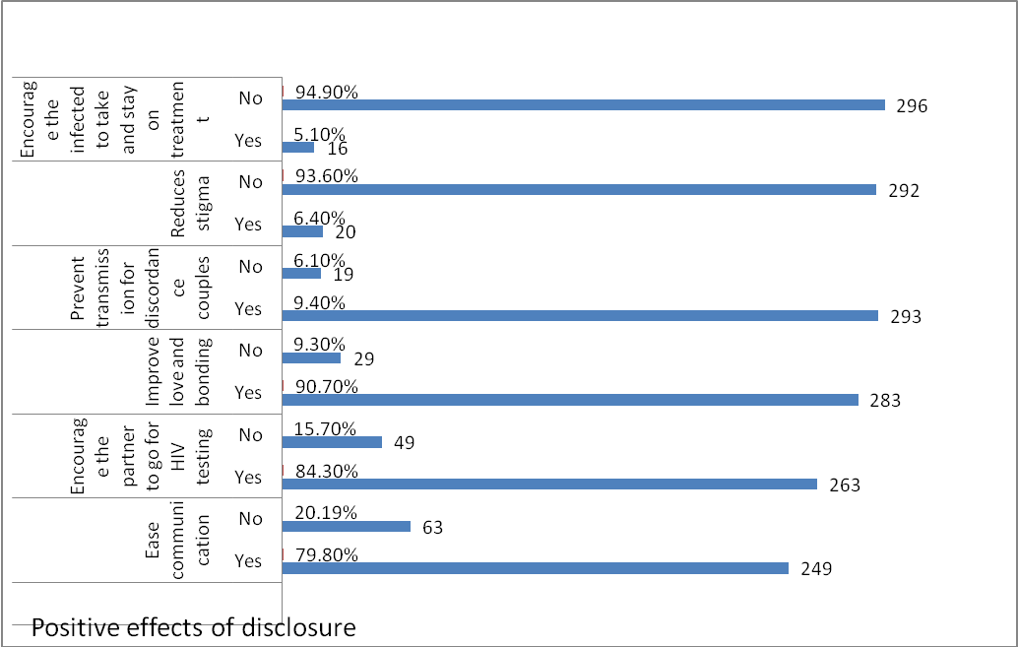
Figure 7: Some positive effects of HIV positive status disclosure
In relation to the negative effects most the clients agreed that non-disclosure could lead to broken relationship (97.1%) when the other partner or family member eventually finds out. Most also indicated that if not disclosed, there could be a lack of economic support (94.2%), partner violence (94.2%), abandonment (84.3%), or stigma (94.2%) when eventually the status are known (figure 8).
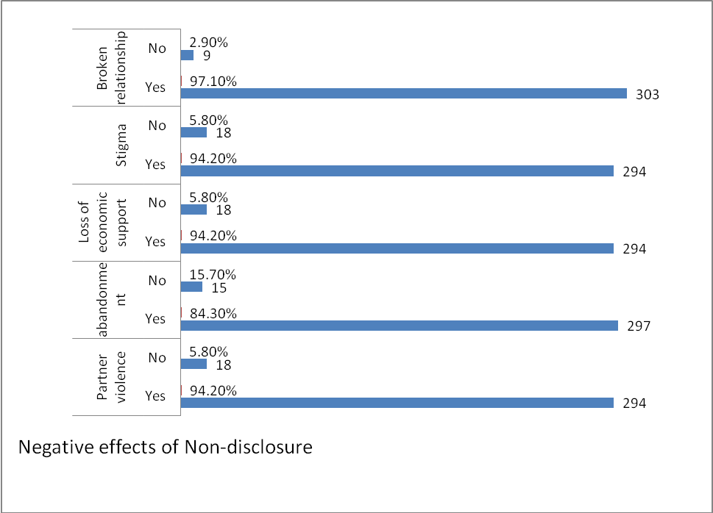
Figure 8: Negative impact of non-disclosure when partner/family or others eventually know of positive HIV status.
3.5: Measures taken to enhance HIV positive status disclose to sexual partner
In relation to measures that can enhance disclosure, multiple responses were given. Most clients gave more than one way of enhancing disclosure. Out of the 312 participants in this study, 311 (99.7%) said that they believe that HIV counselling by a health worker can assist the patients to disclose their status. Again, three hundred (96.2%) of them said that there could be some form of community - based initiative to empower the clients, reduce stigma, and make the patients feel free. Three hundred and eight clients (98.7%) also said that proper follow up could be provided and support (financial and material support) given to clients that were not financially viable. Two hundred and ninety- three clients (95.5%) said that more treatment centers could be created and extended to rural areas to ease the aspect of transportation for some of the clients who travel from far to come and HIV care services.

4.0 DISCUSSION

4.1 Proportion of HIV Positive Status and Disclosure among Clients
The population most affected by HIV was made up of people in the age group 21 to 50 years. This agrees with the findings of WHO in 2011 [16] stating that globally people aged between 15 - 49 years are in the group most affected with HIV. Furthermore, women were more likely to acquire HIV infections due to biological characteristics. Male to female transmission of HIV is between two to four times higher than female to male. Women with sexually transmitted diseases are often asymptomatic which results in delayed treatment and increases the transmission of HIV tenfold. More women visit the HIV care centers. This could be because they are the ones who quickly go to the hospital for medical care as compared to the men especially when pregnant or for pre-conception care and services. More singles were infected with HIV than married people. This could be because the most sexually active and infectious time is when the adults are singles and also when they are in search of life partners.
In relation to disclosure of HIV positive status, most of the clients indicated that they had disclosed their status to at least one person. A few had not yet disclosed to anyone. This finding is line with Seid et al in 2012 [17 ] who reported 93.1% disclosure rate to sexual partners.
As concern who they first disclosed their HIV status to, the spouses were mostly the
first to be informed. The prevalence of disclosure in this study, especially to sexual partners, was much higher than the 27.2% which was reported in other parts of the world [13]. The increased level of disclosure, could be due to widespread availability of ART which has transformed HIV into a manageable chronic condition. It could also be due to possibly reduction of HIV related stigma, resulting from increase in awareness amongst the public. Although the prevalence of HIV status disclosure to sexual partners is high, the non-disclosure is a call for concern, especially considering that this occurred in a group that reported to be sexually active and could therefore be fueling HIV transmission.
In relation to HIV disclosure also, it was observed that participants who had secondary education as their highest level of education had the highest rate of HIV-positive status disclosure (58.3%). Considering that there were respondents with tertiary and university education in this category, it would have been expected that the higher the educational level, the higher the chances of HIV positive status disclosure. This finding highlights the difference between being educated and being cognizant of HIV-related issues. With reason being that the more someone is educated the more they turn to be secretive and the rate of trust starts dropping. In comparing the disclosure rates based upon age, it was observed that respondents who were greater than 50 years had the least level of disclosure. The highest disclosure rate was found among respondents between the ages of 41 to 50 years.

4.2 Factors Influencing HIV Positive Status Disclosure
Most of the client acknowledged that several factors influenced disclosure. The majority accepted that blame, fear of rejection, loss of financial support, fear of abuse/violence, and fear of stigmatization, all influenced the disclosure of HIV positive status.
More females accepted that ‘the fear of being blamed’, ‘rejected’ and ‘abused’ was associated with HIV status disclosure than men. In relation to financial support, more females were also afraid of losing financial support than males and were afraid of violence and abuse. This is in line with a report of WHO in 2011 [16] stating that the fear of abandonment among women is most often cited in developing countries. Cameroon is in this cartegory and as such, is not an exception. This is directly related to the loss of financial support from the partner. Consequently, this reluctance to disclose their HIV positive status may be the result. Similar results were found by Greig et al. in 2008 in South Africa [18] which revealed that “poorer women were more likely to have an early sexual debut, a non-consensual first sexual encounter and higher rates of physically forced sex or having exchanged sex for money, goods or favours – all significant risk factors for HIV”. It also indicates that women who have some financial security are better able to avoid these relationships and their empowerment helps to reduce the risk of HIV.
Religious beliefs, such as not following the word of God, can powerfully influence shame-related stigma. Religious leaders have an additional supportive role, as one can normally share confidential information without fear of reproach. However, in this study it appeared that individuals preferred not to discuss their HIV positive status with their religious leader as seen with only 2 clients (0.4%) choosing to disclose to their religious leaders. The reason for this could be because most HIV positive clients have realized that in the periods of testimonies-giving in church they turn to disclose their status to the whole world.

4.3 Client’s Knowledge on the Effects of Disclosure
The level of knowledge on the positive effects of HIV disclosure was moderate, as most respondents knew that disclosing their status was important. This ﬁnding does not agree with the study carried out by Alema et al. in 2015 [1], who reported a good level of knowledge on the importance of disclosure. Most of the respondents in this study agreed that it was important to disclose their HIV status. However, the clients indicated that it may encourage the other partner to go for testing, and may ease communication.
In relation to the negative effects, most the clients agreed that non-disclosure could lead to broken relationship (97.1%) when the other partner or family member eventually finds out. Most also indicated that if not disclosed, there could be a lack of economic support (94.2%), partner violence (94.2%), abandonment (84.3%), or stigma (94.2%) when eventually the status are known. This agrees with findings from Cohort files in the treatment centers (personal communication) were most couples have separated because of the positive status of partner.
Using the theory of planned behavior, factors associated to HIV disclosure to sexual partners like fear of abandonment, sexual partner violence, and blame. As seen in conditional assumption, feelings of shame, based on difficulties in adjusting to an HIV-positive diagnosis, are predisposing factors to individuals disclosing their HIV status to their sexual partner.
Trigering factors include HIV positive results for a newly diagnosed where the client will prefer disclosing to family member first and letting them come to the ART clinic visit. Secondly, they may be a sense of threat that may occur to the client with the thoughts of rejection from the sexual partner, family members and friends leading to suicidal thoughts in mind. This same client may find it difficult coping nor sharing one’s HIV status and the outcome of HIV disclosure. Thirdly, they could be behavioural factors were the positive individual find it very difficult having a sexual relationship. Fourthly, they could be cognitive factors were the client watch videos about HIV critically ill patients and develops negative self-esteem and depression. Lastly, there are affective and physiological factors we noticed that when a client receives a positive HIV result, very few would accept immediately. Some may present with signs of denial, sweating, feeling hot, and crying.
4.4: Measures taken to enhance HIV positive status disclose to sexual partner
Multiple responses were given in relation to measures that can enhance disclosure. Most clients gave more than one way of enhancing disclosure. Participants said they believe that HIV counselling by a health worker can assist the patients to disclose their status. Again, three some said that there could be some form of community-based initiative to empower the clients, reduce stigma, and make the patients feel free. Some also said that proper follow up could be provided and support (financial and material support) given to clients that were not financially viable. Some said that more treatment centers could be created and extended to rural areas to ease the aspect of transportation for some of the clients who travel from far to come and HIV care services. These measures if properly applied can go a long way to assist clients in disclosing HIIV positive status. It will also enable them to feel accepted in the community and may may increase their life expectancy.
5.0 CONCLUSIONS
The HIV patients presenting for care have been living with the virus for many years. Most of the patients (n = 171, 54.8%) were diagnosed between 2001 and 2005 and so have been living with the virus for more than 21 years. Only a minority of the participants who were diagnosed from 2016 to 2020 (n = 2, 0.64%) and 2021 (n = 2 0.64%) took part in the study. Most of the clients (n = 270, 86.5%) indicated that they had disclosed their status to at least one person (n = 42, 13.5%) a few had not yet disclosed to anyone.
Most of them (n = 156, 50%), said they first disclosed their status to their spouse/life partner.
Most clients took weeks (n = 138, 44.2%) to disclose their positive results to anyone. Some of them took 1 – 5 days to disclose (32%, n = 100), and some took years to disclose as shown in figure 5.
There was significant difference in client’s response as to the factors that influence the disclosure of HIV positive status and they included the fear of being blamed, fear of rejection, the fear of losing financial support. The older people (41 – 50 years) and > 50 years expressed less fear than those in the younger age ranges.
In relation to measures that can enhance disclosure included counselling by a health worker, some form of community - based initiative to empower the clients, reduce stigma, and make the patients feel free and proper follow up could be provided and support (financial and material support) given to clients that were not financially viable and the creation of more treatment centers with extension to rural areas to ease the aspect of transportation for some of the clients who travel from far to come and HIV care services.
6.0 RECOMMENDATIONS
The moderate level (84.4%) of general disclosure is encouraging; the same cannot be said of disclosure to sexual partners (64.8%). There is need to look at ways of improving this prevalence of disclosure at both levels to realize the many public health benefits of disclosure.
- HIV prevention
Condoms distribution should be systematic and education on safe sex practices should be done.
- Disclosure counseling
The clinics should routinely holds counseling sessions focusing on disclosure and partner notification. The finding in this study showed that these sessions did not positively affect disclosure should serve as an eye opener for the clinic staff. This warrants a formal evaluation of this intervention with a view to make it more effective, therefore reviewing the approach and the way it is conducted may help improve disclosure. Especially if targeted on potential non-disclosers.
- Timing of disclosure
Most PLHIV disclosed on the same day that they received their HIV positive results. This finding underscores the role of HIV testing approach in disclosure. Pre and post HIV test counseling should therefore put more emphasis on HIV status disclosure, with a special focus on those identified as potential non disclosers in this and other studies.
- HIV testing of children.
Although it is the country’s recommendation that parents who are HIV infected bring all their children aged less than fifteen years of age for HIV testing, this study found that less than half of those who had children, had brought at least a child for testing. There is need therefore to strengthen this specific arm of HIV/AIDS management to ensure children are enrolled into care programs early when the benefits are many.
- Patient’s support groups
Patient support groups have been identified as a key intervention in promoting disclosure as well as influencing safe sex behaviors through peer and social support. The clinic therefore needs to assist the support groups to become active and self-sustaining hence improve social support for the patients on follow up.
- Antiretroviral therapy
Taking of ART properly by HIV infected clients properly serves as a preventive measure.
- Family support
The relatively high level of disclosure to extended family members underscores the role played by this special subset of the society in HIV/AIDS management. This means the target for interventions should be the entire society and not the nuclear family as has been the case.
- Populations to target
At general disclosure level those not on ART and at both disclosure levels, patients who were recently or newly registered and those who were single, separated/divorced or widowed were unlikely to disclose. Identifying this subset of the clinic population and targeting interventions to them may help reduce non-disclosure. Counseling at enrollment and follow-up visits must therefore focus on partner notification and safe sex practices together with enhancing linkages to existing patient support groups for peer support. Assisted disclosure such as anonymous couple testing should also be offered to those afraid of disclosing.
- Policy formulation.
This research found a small proportion of the sexually active had not disclosed to their sexual partners. To date, most of the HIV prevention strategies except PMTCT tend to focus on the HIV negative people. This study demonstrates the need for a policy formulation focusing on “Prevention With Positives” aiming to increase disclosure, safe sex and probably adherence to ART and ultimately reduce HIV transmission.
REFERENCES
- Alema, W.A. Yalew, M.B. Beyene, M.G. Woldu HIV positive status disclosure and associated factors among HIV positive adults in Axum health facilities, Tigray, Northern Ethiopia Science Journal of Public Health, 3 (1) (2015), pp. 61-66, 10.11648/j.sjph.20150301.2 Google Scholar
- E. Kenu, A. Obo-Akwa, G.B. Nuamah, A. Brefo, M. Sam, M. Lartey Knowledge and disclosure of HIV status among adolescents and young adults attending an adolescent HIV clinic in Accra, Ghana BMC Research Notes, 7 (1) (2014), p. 844, 10.1186/1756-0500-7-844(1–6)
- Atwiine, B., Kiwanuka, J., Musinguzi, N., Atwine, D., & Haberer, J. E. (2015). Understanding the role of age in HIV disclosure rates and patterns for HIV-infected children in southwestern Uganda. AIDS Care, 27(4), 424–430. https://doi.org/10.1080/09540121.2014.978735.
- Clarke, T. R., Gibson, R., Barrow, G., James, S., Abel, W. D., & Barton, E. N. (2010).
Disclosure of HIV status among HIV Clinic attendees in Jamaica. West Indian Medical
Journal, 59(4), 445–449.
- Cohen T, Murray M, Wallengren K, Alvarez GG, Samuel EY,Wilson D. The prevalence and drug sensitivity of tuberculosis among patients dying in hospital in KwaZulu-Natal, South Africa:a postmortem study. PLoS Med 2010; 7: e1000296.
- CAMPHIA 2018. This project is supported by the U.S. President’s Emergency Plan for AIDS Relief (PEPFAR) through CDC under the terms of cooperative agreement #U2GGH001226. The findings and conclusions in this report are those of the authors and do not necessarily represent the official position of the funding agencies.
- Simoni, J. M., Mason, H. R., Marks, G., Ruiz, M. S., Reed, D. & Richardson, J. L. (1995) Women's self-disclosure of HIV infection: rates, reasons, and reactions. J Consult Clin Psychol, 63, 474-8. South African Communities. American Journal of Public Health 97(10): 1775-1781.
- Norman, A., Chopra, M. & Kadiyala, S. 2007. Factors related to HIV Disclosure in 2 South African Communities. American Journal of Public Health 97(10): 1775-1781. [Online]. Available: http://www.ncbi.nlm.nih.gov/pmc/articles/PMC1994182/ [2010, June 3].
- World Health Organization (2017). Number of people (all ages) living with HIV: Estimates by WHO region. Global Health Observatory data repository. (accessed 06 25, 2017)
http://apps.who.int/gho/data/node.main?lang=en
- National AIDS Control Council, K. (December 2006) Final report of the Socio-economic impact of HIV & AIDS on key sectors in Kenya.
http://www.nacc.or.ke/2007/default2.php?active_page_id=247&id=266
- Cohort files of Buea regional hospital 2020. Files on HIV positive clients indicating level of status disclosure, years of treatment, regimens, and follow - up (personal communication)
- UNAIDS. (2000). Opening up the HIV/AIDS Epidemic: Guidance on Encouraging Beneficial Disclosure, Ethical Partner Counselling & Appropriate Use of HIV Case Reporting. Geneva, Switzerland:UNAIDS. UNAIDS Reference Group on HIV and Human Rights (2008). Statement on Criminalization of HIV Transmission and Exposure, Geneva. UNAIDS Reference Group on HIV and Human Rights. http:// data.unaids.org/pub/Report/2009/
20090303_hrrefgroupcrimexposure_en.pdf (Accessed March 2014).
- Centers for Disease Control and Prevention. Vital signs: HIV prevention through care and treatmentUnitedStates2011.http://www.cdc.gov/mmwr/preview/mmwrhtml/mm6047a4.htm
(accessed June 3, 2014).
- UNAIDS 2016–2021 Strategy: on the Fast-Track to end AIDS. Geneva, Joint United Nations Programme on HIV/AIDS, 2015.
(http://www.unaids.org/sites/default/files/media_asset/20151027_UNAIDS_
PCB37_15_18_EN_rev1.pdf, accessed 15 January 2019).
- Gari, T., Habte, D. & Markos, E. 2010. HIV positive status disclosure to sexual partners among women attending ART clinic at Hawassa University Referral Hospital, SNNPR, Ethiopia. Ethiopia Journal of Health Development 24(1):9-14.
- WHO, UNICEF and UNAIDS. A guide on indicators for the monitoring and reporting on the health sector response to HIV/AIDS. Geneva, World Health
Organization, 2011. (http://www.who.int/hiv/data/tool2011/en, accessed 15 October 2011).
- Seid M, Wasie B, Admassu M (2012). Disclosure of HIV positive result to a sexual partner among adult clinical service users in Kemissie district, northeast Ethiopia. Afr. J. Reprod. Health 16(1):97-104.
- Greig, A., Peacock, D., Jewkes, R. & Msimang,S. 2008. Gender and AIDS: time to act. AIDS 2:35-43. [Online], Available: http://www.ncbi.nlm.nih.gov/pubmed/18641466 [2011, June 11].

