Case report

Case Series on Hepatobronchial fistula and liver Abscess in Nigerian patients

**Abstract**

**Background**

Hepato-bronchial fistula is an abnormal communication between the liver parenchyma and the bronchial tree through the diaphragm. It is a rare complication of Liver abscess.

**Methods**

This study was case series report on a 69-year-old woman and 70 year old male with hepatobronchial fistula a rare complication of Liver abscess. And summaries of various cases of liver abscess managed in our health facility between 2022 to 2024. The case notes of the patients was retrieved and their clinical history, physical examination findings and relevant imaging and laboratory results were summarized;

**Results**

The two patients with hepatobronchial fistula were both elderly (a male and a female). The female had hypoproteinemia probably from malnutrition. While case two was an elderly man with background type diabetes mellitus and colorectal carcinoma. Both patients presented with expectoration of anchovy sauce paste. They were chronically ill- looking and had tender hepatomegaly. Their Antibody based Enzyme linked immunosorbent assay (ELISA) for Entamoeba histolytica results were positive. The abdominal ultrasound reported a solitary homogenous hypoechoic round lesion in the right lobes of the liver suggestive of Liver abscess.

**Conclusion**s: Hepatobronchial fistula though a very rare occurrence may complicate amoebic liver abscess and should be looked out for in patients expectorating anchovy sauce like paste.

.

**Keywords:**  Hepatobronchial fistula, Amoebic Liver Abscess.

**Introduction**

A liver abscess is defined as a localized collection of pus surrounded by inflamed tissue in the liver1. It was first described by Hippocrates (400BCE) and published by Bright in1936.2 The mortality used to be as high as 60-80%.2 The development of new radiologic techniques, the improvement in microbiologic identification, and the advancement of drainage techniques, as well as improved supportive care, have reduced mortality to 5-30%.3 Untreated cases remain uniformly fatal. Hepatobronchial fistula is rare complication of Amoebic Liver abscess caused by Entamoeba histolytic and accounts for 10% of cases of liver abscess. While Pyogenic-80%, fungal, tuberculous and others account for 10%.4

This case series summarized the clinical history, general and systemic examinations findings, laboratory and imaging reports of our patients presented with features of hepatobronchial fistula on background amoebic liver abscess. Several factors such as hypoproteinemia malnutrition, diabetes mellitus and colorectal cancer were present in our patients. Other liver abscesses managed within the study period were also summarized in tabular forms.

Although Amoebic liver abscess is rare in the developed world, it is still present in African, about 4 cases of uncomplicated Amoebic liver abscess was diagnosed in our centre in the past 2 years. This study acts as a reminder for high index of suspicion of Amoebic liver abscess and hepatic bronchial fistula in patients presenting with tender hepatomegaly, previous history of bloody diarrhea and expectoration of anchovy sauce paste and background panhypoproteinaemia. A study involving larger sample size or multi-center will be needed to properly characterize the patients.

**Case presentation**

**CASE 1**

The case wasa 67-year-old female farmer who hails and resides at number 14 Ngbu Street, Okundi Boki Local Government Area, Cross-River State. She is a Christian of Catholic denomination. She presented to our health facility in October, 2023 with abdominal pain and fever of one-month duration (1/12) and expectoration of anchovy-sauce like sputum of two weeks duration (2/52). The abdominal pain was localized at the right upper quadrant, gradual at onset, biting in character, aggravated by movement and radiated to the right shoulder and chest. The intensity varied between scales of 2/10 to 8/10 and had no relationship with meals, changes in position, nocturnal nor daytime variations. The pain was continuous on most time of the day and occasionally relieved by ingestion of paracetamol. There was associated loss of appetite, easy satiety and nausea. She developed fever about the same time that was intermittent, varying between low and high grades, was worse at night, associated with chills and rigors and temporally relieved by ingestion of paracetamol. Two weeks prior to presentation, she developed expectoration of anchovy-sauce like sputum, the volume of each episode was estimated to about 30mls, she usually had multiple episodes per day but occasionally can stay up to one week without producing sputum. There was associated pleuritic chest pain, breathlessness, unintentional weight loss and drenching night sweats. No previous history of bloody nor mucoid diarrhea. For the above complaints she took some herbal remedies and also presented to a private hospital where she received antibiotics and paracetamol but her symptoms persisted necessitating her referral to our health facility.She is not known to be hypertensive nor diabetic. She had Cesarean section in 1980. No past history of appendectomy nor biliary tract interventions. No known family history of similar illness nor liver disease. She is married in a monogamous family setting with 2 children and does not use alcohol or tobacco

On examination, she was acute on chronically Ill- looking, in painful distress, febrile (38.6c),her abdomen was asymmetrical distended with right hypochondrial and epigastric preponderance and moved with respiration. There was tenderness at the right hypochondrium and epigastrium. Her liver was enlarged about 8cm below the right costal margin with span of 18cm, markedly tender, had smooth surface and blunt edge. The spleen was not palpable enlarged. Kidneys were not ballotable. Ascites was not demonstrable and bowel sounds were present and normoactive. Liver Aspiration under aseptic procedure was carried out and it yielded about 50mls of anchovy sauce like substance. Her respiratory rate was 34 cycles per minute and oxygen saturation was 94% on room air. The trachea was deviated to the left. She had reduced lung excursions on the right mid and lower zones, stony dull percussion notes on the right mid and lower zones and reduced breath sounds on the right mid and lower zones. She had tachycardia of 120 beats per minutes. Other systemic examinations were unremarkable.

An assessment of Liver Abscess likely Amoebic background suspected primary liver cell cancer (PLCC) rule out disseminated tuberculosis with right pleural effusion.

Her abdominal ultrasound showed enlarged with regular outline and homogeneous echo pattern measuring 18.7cm in its craniocaudal axis. There is a well circumscribed fairly rounded homogeneous hypoechoic round solitary lesion of 12.1cm x11.5cm seen on the right posterior aspect of liver. It has a wall thickness of 10.7mm and irregular inner margin. Other organs are unremarkable. Conclusion features are suggestive of hepatic abscess. The Chest x – ray demonstrated homogeneous opacity of the right mid and lower lung zones with obliteration of cardiothoracic, cardio phrenic angles and elevated right hemidiaphragm suggestive of right pleural effusion.

**Chest CT** Scan showed a large cavitated lesion with air-fluid level located at the middle lobe fistulizing to the bronchus and some moderate right pleural effusion. Alkaline phosphatase (ALP) were elevated and antibody-based Enzyme linked immunosorbent assay (ELISA) for Entamoeba histolytica was positive. The full blood count revealed leukocytosis with differential neutrophilia, mild anaemia with hemoglobin (11.3g/dl), normal platelets count (229 x10^9/L) and elevated erythrocyte sedimentation rate (113mm/1st hour). The total protein, albumin and globulin were reduced (42g/l, 20g/l, 22g/l) Hepatitis B surface Antigen, Hepatitis C virus antibody and HIV1 and 2 were Non-Reactive. Sputum culture yielded no pathogen after 24hrs incubation at 37°c, sputum GeneXpert did not detect any mycobacterium tuberculosi and Mantoux test was negative (0mm). Prothrombin time and international normalized ratio were normal (PT- 18 and, INR 1.1). The patient was placed on both systemic and luminal Amoebicides, broad-spectrum antibiotics, analgesics and intravenous fluid (Parenteral Metronidazole, Tab Paromomycin, Ceftriaxone sulbactam paracetamol, tab tramadol and normal saline). The Cardiothoracic Unit were invited who aspirated and also inserted a closed tube thoracostomy drainage (CTT) that drained about 1.3 liters of serosanguinous effluent. Chest tube drained for 12 days with alternate days dressing of CTTD wound and yielded a total of 3720ml of effluent. Improvised incentive Spirometry as often as patient can tolerate and double clamp using artery forceps of the CTTD prior to emptying or patient wants to ambulate. Pleural aspirate cytology smear showed marked infiltration of mixed inflammatory cells predominantly neutrophils, lymphocytes and a few macrophages in a bloody background. No atypical cells nor malignant cells were seen. Right thoracotomy tube was been extubated after it has stopped draining zero effluent. The general surgery unit was also invited who drained about 1500mls of anchovy-sauce like matter. She was discharged after 1 month of hospitalization

**Case 2**

A 70 year old man who hails from and resides at Ndufu-Alike Ikwo, Eboyi State. He presented in February 2022 with Constipation alternating with Diarrhea of 2 months duration and expectoration of anchovy sauce like substance for 2 weeks. There was associated haematochezia, easy tiredness, intentional weight loss and loss of appetite. No hemoptysis.

He was a known diabetic diagnosed in 10 years prior to presentation and he was adherent with his medications (tab Glucophage 1g b.d and tab glimepiride 2mg o.d. On examination, he was chronically ill-looking, afebrile with temperature of 36.7 degree Celsius, pale with PCV of 26%, dehydrated. His presenting Random blood sugar was 157mg/dl, later Fasting blood sugar was 109mg/dl, and glycatted hemoglobin was 4.6%.

Abdomen was full moves with respiration, left mid-abdominal fullness and tenderness were noted. Digital rectal examination revealed grade 3 haemorrhoids (prolapsed hemorrhoid that was manually reducible). His abdominal ultrasound showed enlarged with regular outline and homogeneous echo pattern measuring 18.7cm in its craniocaudal axis. There were two well circumscribed fairly rounded homogeneous hypoechoic round solitary lesion of 14.1cm x16.5cm vs 10.5 x12.6 seen on the right posterior aspect of liver. It has a wall thickness of 10.2mm and irregular inner margin. Other organs are unremarkable. Conclusion features are suggestive of hepatic abscess. The Chest x – ray demonstrated homogeneous opacity of the lower lung zones with obliteration of cardiothoracic, cardio phrenic angles and elevated right hemidiaphragm. Consolidations with air-Broncho grams were noted on the right mid-lung zone suggestive of right lobar pneumonia with pleural effusion.

**Chest CT** Scan showed two large cavitated lesions with air-fluid level located at the middle lobe fistulizing to the bronchus and some moderate right pleural effusion. Antibody-based Enzyme linked immunosorbent assay (ELISA) for Entamoeba histolytica was positive. The full blood count revealed leukocytosis with differential neutrophilia, mild anaemia with hemoglobin (8.2g/dl), normal platelets count (1798 x10^9/L) and elevated erythrocyte sedimentation rate (113mm/1st hour). Sputum culture yielded no pathogen after 24hrs incubation at 37°c, sputum GeneXpert did not detect any mycobacterium tuberculosi and Mantoux test was negative (0mm). Full-length colonoscopy done after resuscitation, bowel preparation and written and signed consent was obtained revealed a mass at the recto-sigmoid junction, which is circumferential and narrowing upto 80% of the colonic lumen, it had irregular border and multiple necrotic areas, bleeds at minimal contact. And Histology confirmed adenocarcinoma of the colon. The patient was managed for Amoebic liver abscess with hepaticobronchial fistula background type 2 diabetes mellitus and colorectal adenocarcinoma. The patient was placed on both systemic and luminal Amoebicides, broad-spectrum antibiotics, analgesics and intravenous fluid (Parenteral Metronidazole, Tab Paromomycin, Ceftriaxone sulbactam paracetamol, tab tramadol and normal saline).

The General Surgery Unit was invited who drained the abscess surgical, draining about 1200mls anchovy sauce paste. Effluent cytology smear showed marked infiltration of mixed inflammatory cells predominantly neutrophils, lymphocytes and a few macrophages in a bloody background. No atypical cells nor malignant cells were seen. He was managed multidisciplinary management team of Gastroenterologist, General surgery and Oncologist.+

**Table 1- Details of** **Liver Abscess Admissions in GI/Hepatology Unit, AEFUTHA (September 2022 & October 2024)**

|  |  |  |  |  |
| --- | --- | --- | --- | --- |
| **Patients Initials** | **Risk factors** | **Type of abscess** | **Complication** | **Outcome of admission** |
| UC/female/32 years | Cholecystitis, Diabetes Mellitus | Pyogenic |  | Discharged |
| OB/female/78 year | Hypoproteinemia, malignancy | Amoebic | Hepaticobronchial  fistula | Discharged & referred to oncology |
| NS/male/16 years | Malnutrition, Hypoproteinemia | Pyogenic |  | Discharged |
| OAO/male/50 years | Cryptogenic | Pyogenic |  | Discharged |
| AS /male/54 years | Diabetes Mellitus | Pyogenic |  | Discharged |
| EA/female/30years | PLCC, Hypoproteinemia, CKD | Pyogenic |  | Discharged |
| OP/Male/70 years | Colorectal carcinoma, diabetes mellitus | Amoebic | Hepaticobronchial  fistula | Discharged & referred to oncology /general surgeons |

**Discussion**

Amoebic liver abscess is caused by entamoeba histolytic is transmitted primarily through the fecal-oral route (contaminated food, water and hands of food handle, Sexual route via oral-anal practices (anilingus) has been reported. Ingestion of E histolytica cysts is followed by excystation in the terminal ileum or colon to form highly motile trophozoites and cold migrate through the mesenteric veins to the liver.5

Patients with hepatobronchial fistula usually present with expectoration of anchovy paste. It is one of the manifestations of complicated amebic liver abscess and associated with very high mortality if not identified and treated. Hepatobronchial fistula is one of the indications for surgical drainage of amebic liver abscess.6

Antigenic based tests using ELISA or PCR remains the gold standard and have been endorsed by WHO for establishing the diagnosis of Entamoeba histolystica. Overall sensitivity of 71-100% and a specificity of 93-100%. Loop-mediated isothermal amplification assay (LAMP) assay has been applied to the detection of E histolytica in cases of hepatic amebiasis. The rapidity, operational simplicity, high specificity and sensitivity.7

Radiological investigations can aid in the diagnosis of liver abscess and hepatobronchial fistula. Chest radiography: may reveal an elevated right hemidiaphragm and a right-side pleural effusion in patients with amebic liver abscess. Both ultrasonography (USS) and CT scanning are sensitive but nonspecific for amebic liver abscess. USS is preferred (its low cost, rapidity, and lack of adverse effects). CT is slightly more sensitive than USS and can also identify hepatobronchial fistula.8

On ultrasonograms, amebic liver abscesses usually appear as a solitary homogenous hypoechoic round lesion in the posterosuperior aspect of the right lobe of the liver (70-80% of cases), may be multiple. 8

On CT scans with IV contrast, amebic liver abscess usually appears as a rounded, low-attenuation lesion (hypodense) with an enhancing rim. May be homogenous or spectated, with or without observable fluid levels. MRI high signal intensity on T2-weighted shows Perilesional edema and enhancement of rim are noted after injection of gadolinium (86% of cases) and can also identify and define hepatobronchial fistula.9 Complete resolution of liver abscess may take as long as 2 years. Repeat imaging is not indicated if the patient is otherwise doing well. Early treatment of carriers in non-endemic areas, avoiding sexual practices that involve fecal-oral contact may reduce sexual transmission of infective cysts. Family members or Household contacts, close contacts of an index case should be screened to prevent reinfection and spread.10 Screen for Amebiasis prior to corticosteroid or other immunosuppressive therapy, especially in patients with a new diagnosis of IBD and history of travel to an endemic area as fulminant amebic colitis may occur   Development of a vaccine for invasive amebiasis is still in its infancy. Many components of the ameba are immunogenic and may serve as targets for a future vaccine, including the galactose/N -acetyl galactosamine lectin, the serine-rich E histolytica protein, cysteine proteinases, lipophosphoglycans, amebapores, and the 29-kd protein. Quach et al.11 reviewed current strategies involved in the development of a vaccine against E histolytica.

Individuals traveling to endemic areas should be advised on practices that minimize the risk of amebiasis, such as the following: Avoid drinking contaminated water; use bottled water while traveling if possible. If local water is to be drunk, purify it by (a) boiling it for more than 1 minute, (b) using 0.22 µm filtration, or (c) iodinating it with tetraglycine hydroperiodide. Avoid eating raw fruits and salads, which are difficult to sterilize; eat only cooked food or self-peeled fruits if possible. Wash uncooked vegetables and soak them in acetic acid or vinegar for 10-15 minutes.10

In our study, the patients had multiple risk factors such as older age, malnutrition, diabetes and malignancies. All these factors are causes of immunosuppression which may be responsible for their development of liver abscess and hepatobronchial fistula.

They are paucity of studies in hepatobronchial fistula as a complication of liver abscess in Nigeria, this may be due to rareness of the complication. Obiozor et al at12 FMC Umuahia, reported a case of Amoebic liver abscess which was also the only case that has been reported in the centre, the risk factor was not identified and the patient had no hepatobronchial fistula. A case report by Chukwurah et al13 discussed a pyogenic liver abscess caused by a multi-drug resistant klebsiella pneumonia this further emphasize the rarity of the condition. Bosan et al.14 in Zaria reported a case in an elderly patient that posed serious diagnostic dilemma but was later diagnosed as an amoebic liver abscess using multiple diagnostic modalities. Balogun et al.15 reported unusual two cases of pyogenic liver abscess due to foreign body, impaled broom splinter swallowed unnoticed during consumption of jute leaves (corchorus olitolus) in Ewedu soup. In South African Jones et al.16 in their study noted that liver abscess occur commonly in males of median age of 48 years, majority had pyogenic liver abscess and common risk factors were HIV, Diabetes mellitus. This is similar to what was obtained in our study were majority were more than 40 years and DM was a common risk factor. Though in our study none of the case series had HIV as a risk factor this discrepancy may be related to our small sample size and relatively lower prevalence of HIV in our environment. Kassam et al.17 in Tanzania reported an invasive form of liver abscess with endophthalmitis and meningitis caused by klebsiella pneumonia. In Asia, Alvi et al.19 in their study in Pakistan had 77 patients within a period of 7 years from 2000 to 2007. Majority had amoebic liver abscess showing that the Amoebiasis is highly endemic in their region. Luo et al.19 conducted a meta-analysis on several published studies in China and found that majority of the abscesses were pyogenic and commonly caused by klebsiella spp and the major risk factor was diabetes mellitus. In the US, studies.20,21 suggest a small but slight increase in frequency of liver abscess partly due to influx of migrants from highly endemic countries. Currently commoner in extremes of age and in those with immunosuppression. Common comorbidities were liver cirrhosis, chronic renal failure and cancers. ERCP and surgical drainage were associated with high mortality.

In Europe, a study in Germany by Zimmermann et al.22 showed majority of patients with pyogenic liver abscess were older than 60 years, predominantly males and common aetiologies were biliary tract malignancies, cholelithiasis and ishaemic biliary tract disease and common comorbidities were malignancies and diabetes mellitus, liver cirrhosis, pancreatitis. Isolated case of amoebic liver abscess was diagnosed in a German patient after a stay in Sudan who presented atypically with expectoration of sputum.23 Giogio et al in their study, reported lower prevalence of Amoebic liver abscess in Europe with few isolated imported cases.24

**In conclusion,** Hepaticobronchial fistula is a very rare complication of hepatic abscess, and its associated with poor quality of life and had been reported to be associated with higher incidence of mortality. Surgical drainage is universally indicated alongside with best supportive care in the management. Systemic and luminal amoebicides or combined systemic and luminal agents such as Nitazozanide are usually indicated.

**References**

1. Chiche L, Dargère S, Le Pennec V, Dufay C, Alkofer B. Pyogenic liver abcess: diagnosis and managment. Gastroenterol clin Biol 2008; 32:1077–1091
2. Ochsner A, DeBakey M, Murray S. Pyogenic Abscess of the liver II. An Analysis of forty-seven cases with review of the literature. Am J Surg. 1938: XL:292-319
3. Chen SC, Huang CC, Tsai SJ, Yen CH, Lin DB, Wang PH et al. severity of disease as main predictor of mortality in patients with pyogenic liver abscess. Am J Surg. 2009:198( 2): 164-72
4. Othman M, Mohammed Z, Yahya MM, Leo VM, Lim BH, Noordin R. Entamoeba histolystica antigen protein detected in pus aspirates from patients with amoebic liver abscess. Exp Parasitol: 2013: 134 (4) 504-510.
5. Kannathasan S, Murugananthan A, Kumman T, de Silva NR, Rajeshkannan N, Haque R, Iddawela D. Epidemiology and factors associated with amoebic liver abscess in Northern Scri Lanka. BMC Public Health: 2018:10(18):118.
6. Feldman M, Friedman SL, Brandt JL. Sleisenger and Fordtran's Gastrointestinal and Liver .Disease 10th Edition page 1375. ( Missing year and place of Publication )
7. Solaymani MS, Rezalan M, Babaei Z.Comparison of a stool antigen detection kit and PCR for diagnosis of entamoeba histolytica and entamoeba dispar infections in asymptomatic cyst passers in Iran. J Clin Microbiol. 2006: 44(6):2258-61
8. Khim G, Em S, Mo S, Townell N. Liver abscess: diagnostic and managent issues found in low resource setting. British Medical Bulletin. 2019:132(1): 45-52
9. Mendez RJ, Schiebler ML, Outwater EK, Kressel HY. Hepatic abscesses, MRI Findings. Radiology. 1994: 190 (2)>431-6
10. Cope J, Ali I. Center for Disease Control and Prevention (CDC), Amoebiasis. 2024
11. Quach J, St-Pierre J, Chadee K. The future for vaccine development against Entamoeba histolytica. *Hum vaccine immunotherapy*: 2014: 10 (6): 1514-21 (Delete space)
12. Obiozor AA, Obiozor AC. Amoebic liver abscess in an adult Nigerian: A case report. Ibom Medical Journal. 2024. 17 (2): 385 – 38
13. Chukwurah SN, Ushie SN, Ezenekwe FE, Ugwunze EO, Ufoaroh CU, Maduekwe NP. Community Acquired Pyogenic Liver Abscess Caused by A Nosocomial Organism: A Case Report. Orient Journal of Medicine. 2021: 33[3-4]
14. Bosan IB, Baduku TS. Amoebic Liver Abscess: a diagnostic dilemma in the elderly.Annals of African medicine. 2003:2(1):33-35.
15. Balogun OS, Jeje EA, Fatuga AL, Atoyebi OA. An unusual cause of pyogenic liver abscess. The Conundrum of Broom Splinter. Report of two cases. Nigerian journal of medicine. 2022: 31(2): 225-228.
16. Jones J. Clinicopathological presentations of liver abscesses and hydatid liver disease from two South African tertiary Hospitals. World journal Hepatol. 2024:16(12):1417-1428.
17. Kassam NM, Aziz OM, Somji SS, Fidati ZY, Surani SR. Invasive liver abscess syndrome caused by klebsiella pneumonia, first Tanzania experience. Pan-African medical journal. 2020: 36 191.
18. Alvi AR, Rizvi F, Rehman ZU., Ejaz K, Zafar H, Chawia T et al. Amoebic liver abscess: experience in South East Asian country. Sage journals. 2009:40 (1) 107-109.
19. Luo M, Yang XX, Tan B, Zhuo XP, Xia MH, Xue J et al. Distribution of common pathogen in patient with liver abscess in China: Amta-analysis. European journal of Clinical microbiology and infectious diseases. 2016: 35: 1557-1565.
20. Meddings L, Myers LP, Hubbard J, Shaheen AA, Laupland K, Dixon E, et al.A population-based study of pyogenic liver abscesses in the United States. Incidence, mortality and temporal trends. Am J Gastroenterol.2010: 105(1):117-24.
21. Rahimian J, Wilson T, Oram V, Holzman RS. Pyogenic liver abscess most recent trends in mortality and aetiology. Clinical infectious disease, 2004. 39(11):1654-1659
22. Zimmermann L, Wendt S, Lubbert C, Karlas T. Epidemiology of pyogenic liver abscess in Germany: Analysis of incidence, risk factors and mortality rate based on routine data from statutory health insurance. United European Gastroenterol J. 2021: 30:9(9(:1039-1047.
23. Weinke T, Friedrich-janicke B, Sargeaunt PG, Trautmann M, Janitschke K. Amoebic liver abscess in European patient: Molecular medicine. 1988: 66:( ) 37-44.
24. Giorgio A, Ciraci E, De Luca M, Stella G, Giorgio V. Hepatic abscess and Hydatid liver cyst: European infectious disease point of view. Wirld J Hepatol: 2025:17(2):103325.

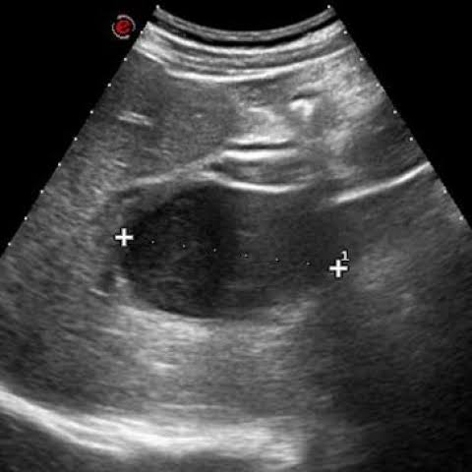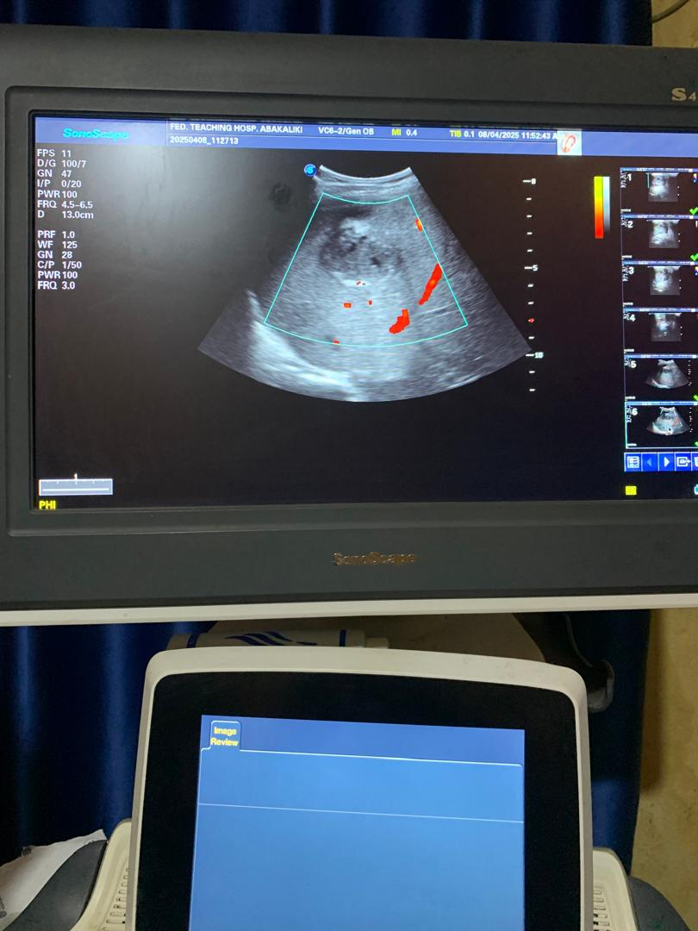

**Fig 1-Ultrasonography indicating liver abscess appeared as a solitary homogenous hypoechoic round lesion in the posterosuperior aspect of the right lobe of the liver**

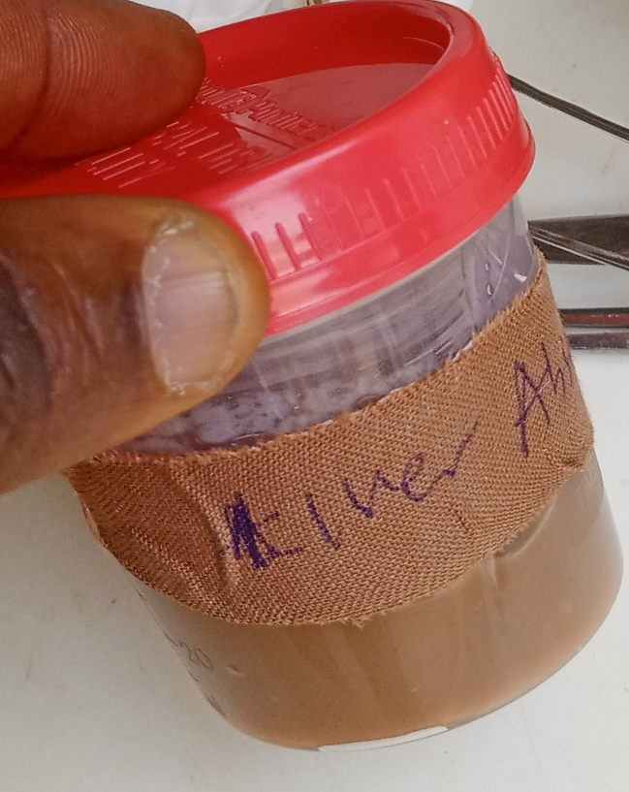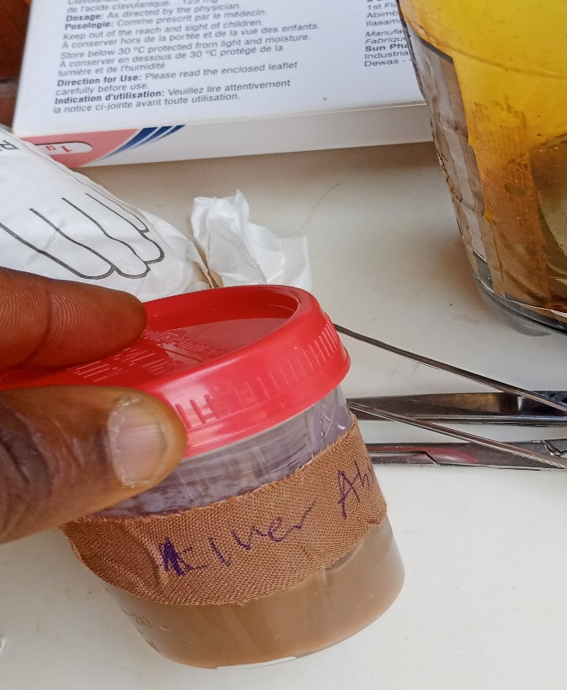

**Fig 2- Anchovy sauce-like liver abscess**

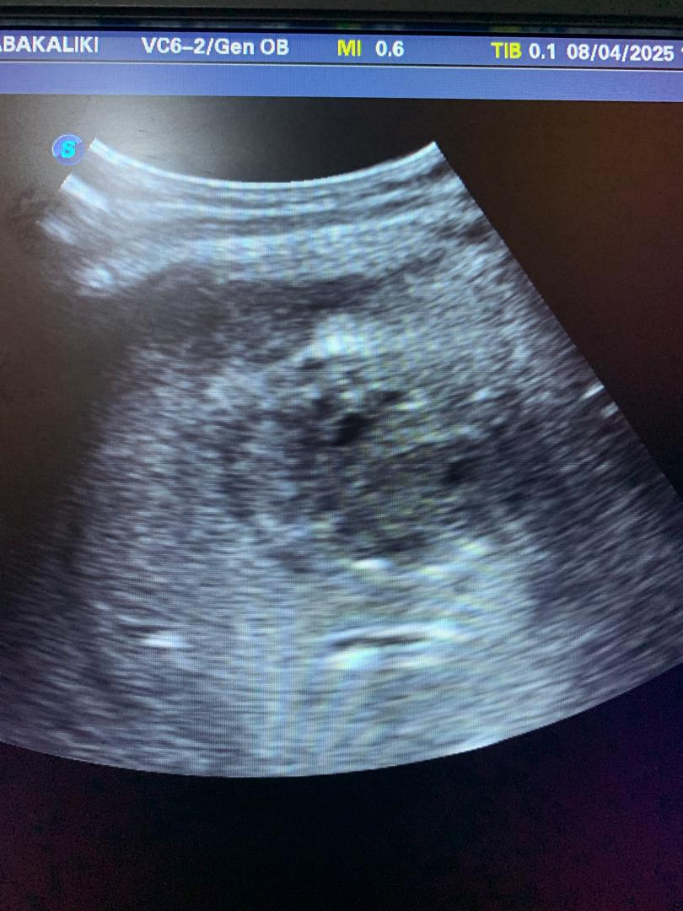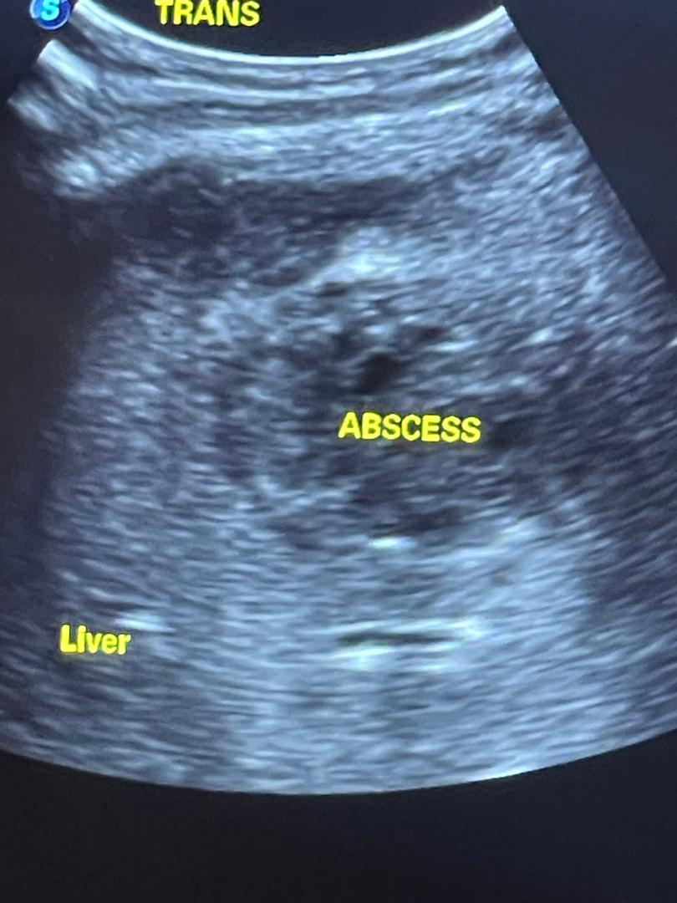

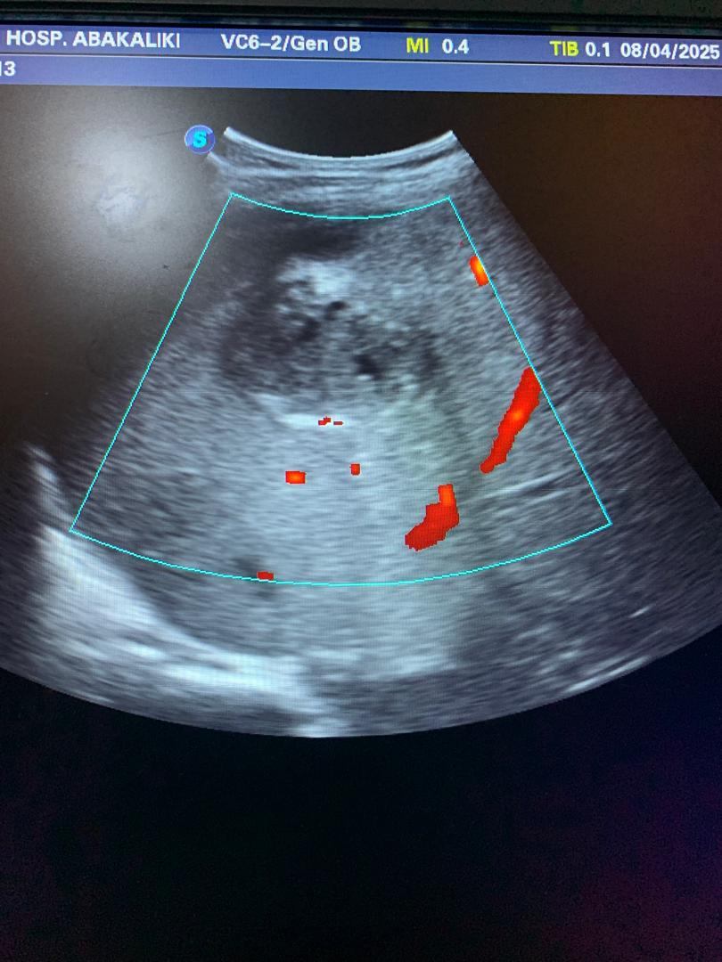

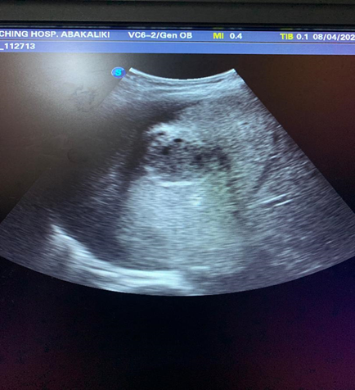

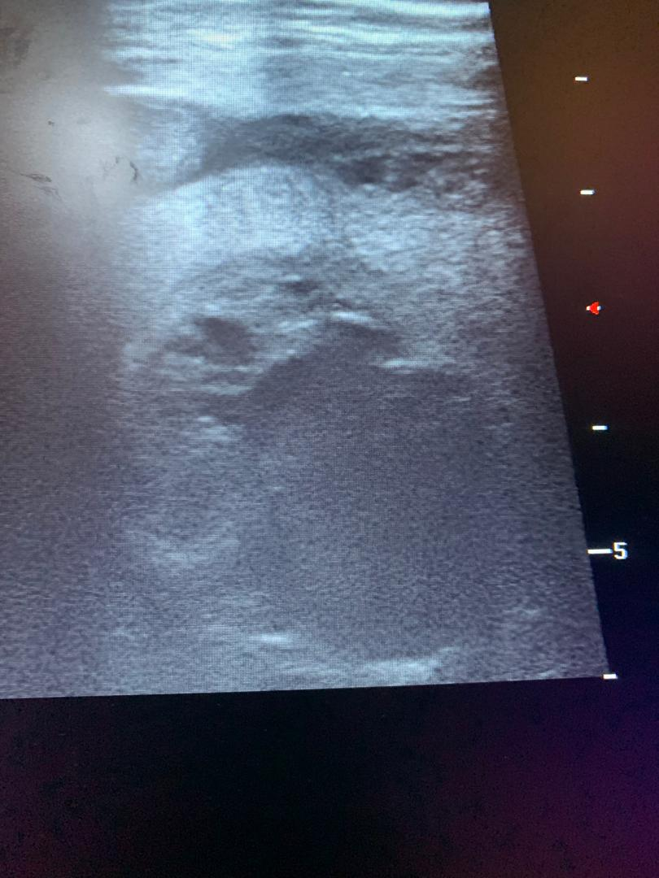

**Fig 3-** **Ultrasonography indicating liver abscess**