*Original Research Article*

Assessing wastewater and excreta management in rural areas on the coast of Grand Lahou, South-West Côte D'Ivoire

.

ABSTRACT

|  |
| --- |
| **Aims:** Inadequate wastewater management combined with a lack of sanitation facilities has exacerbated sanitation problems in Sub-Saharan Africa. The aim of this study is to assess wastewater and excreta management in villages of Braffédon, Lahou-Kpanda, Groguida and Likpillassié located on Grand Lahou coast in South-West of Côte D'Ivoire.  **Place and Duration of Study:** The research was conducted from June to September 2021 in Groguida, Likpilliassé, Lahou-Kpanda and Braffedon.  **Methodology:** Data collection consisted of field observations and a survey. The sample size of the survey population was determined using simple random sampling (SRS). A total of 290 people were interviewed, including 100 in Braffédon, 60 in Groguida, 70 in Lahou-Kpanda and 60 in Likpillassié.  **Results:** Wastewater in the villages studied came from four (4) main sources: bathing (100%), laundry (83-98%), dishwatering (66.66-89%) and attiéké wastewater (30-45%). The study found that sewage disposal was either in septic tanks (15-25%), directly on the sandy ground in the yard (25-40%), in the backyard (80-95%) or in the lagoon (15-65%). Modern latrines were found in 5%, 45%, 30% and 60% of households in Groguida, Lipkilliassé, Lahou-Kpanda and Braffedon respectively. However, 10% of households in Braffedon use traditional latrines. About 30% - 89% of households in the villages defecated in the open, either in the bush in Braffedon or on the edge of the lagoon and the sea (Groguida, Likpilliassé and Lahou-Kpanda). Households using latrines reported that they either added chemicals to the septic tanks to digest the organic matter and reduce the sludge volume when the tanks are full, or they emptied the tanks either mechanically or manually. If the tanks were emptied manually, the sludge was poured into a hole dug near the tank in the yard or by the side of the road. Though there were no rainwater drains in the four (4) villages studied, floods did not occur in the rainy season.  **Conclusion:** For the preservation of potential tourism, the environment, and public health, the local authorities should establish a sustainable sanitation management system in these villages |

*Keywords: Wastewater, excreta,* *rural areas, coast, Grand Lahou, Côte d’Ivoire*

1. INTRODUCTION

Access to adequate sanitation remains a problem for a significant proportion of the population in developing countries, particularly in Africa (Black *et al.,* 2013). Despite governments commitment to the United Nations’ (UN) Sustainable Development Goals (SDGs) and the African Union's Agenda 2063, most countries are far from achieving the goal of ensuring the availability and sustainable management of water and sanitation for all (United Nations, 2023; African Union, 2023). Less than a third of the African population has access to adequate sanitation (Saad *et al.,* 2024). An unhygienic environment is a source of health risks. Diarrhoeal diseases (including cholera) kill 1.8 million people every year, 90% of them children under five (5), mostly in developing countries, and 88% of this morbidity is due to poor water quality, inadequate sanitation and poor hygiene (Umesh *et al.,* 2003 ; UNICEF-WHO, 2009). Diarrhoea alone is responsible for 5,000 child deaths per day worldwide, and children in developing countries suffer five to six episodes of diarrhoea per year (Umesh *et al.,* 2003 ; UNICEF-WHO, 2009).

The overall sanitation situation in Côte d'Ivoire is unsatisfactory. Approximately 49% of households have access to adequate sanitation. Only the city of Abidjan has a relatively extensive urban sanitation network, but not all communities are connected. As a result, untreated wastewater is discharged into the natural environment. (USAID, 2020). This is compounded by the malfunctioning of existing treatment plants, resulting in domestic wastewater being discharged into streets, pavements and drains, causing foul odours (Ballet *et al.,* 2007). Malfunctioning treatment plants mean that domestic wastewater comes into direct contact with people, exposing them to possible diseases associated with poor wastewater treatment, such as malaria, cholera, diarrhoea, etc (Hounga, 2015). These discharges result in permanent pollution of the environment. Whereas the Ivorian government is addressing the sanitation access challenges in urban areas through investment, sparsely-populated towns with acute sanitation problems, such as Grand Lahou, are not supported. The work of Adaye *et al.* (2021) revealed poor wastewater management practices and the absence of wastewater treatment systems in the town. However, Grand Lahou has important tourist attractions in the southern part, in the villages of Braffedon, Lahou Kpdanda, Groguida and Likpillassié. The strategic location of these villages gives provides a panoramic view of the estuary, the riverbanks and the lagoon, and allows them to benefit from a temperature that varies little between 24° and 27°C, with a high relative humidity of around 60%, which means that they enjoy a mild climate favourable to seaside and nautical tourism (SODEXAM, 2018). The Azagny National Park (ANP) also boasts the colonial remains of Lahou-Kpanda and the Groguida Canal, which are of great interest to tourists. For preservation of the tourist potential of the area and the entire ecosystem of the local population, this study aims to assess wastewater and excreta management in villages of Braffédon, Lahou-Kpanda, Groguida and Likpillassié located on Grand Lahou coast in South-West of Côte D'Ivoire.

2. materialS and methods

**2.1 Study area**

The department of Grand-Lahou is in the southwest of Côte D'Ivoire, on the shores of the Gulf of Guinea, at the mouth of the Bandama River. Grand-Lahou lies between latitudes 5°12'N and 5°9'N and longitudes 4°56W and 5°70W (Reference required here). The villages of Braffédon, Lahou-Kpanda, Groguida and Likpillassié, which were the subject of this study, are located on the coastal strip of the department of Grand-Lahou. The climate of Grand-Lahou is equatorial, with a long dry season from December to March, a long rainy season from April to July, a short dry season from August to September (upwelling period) and a short rainy season from October to November (Konan *et al.,* 2013). Geologically, Grand-Lahou lies within the Côte d'Ivoire sedimentary basin, which was formed in the Lower Cretaceous. These are generally sands, clays and ferruginous sandstones (Soro *et al.,* 2011). Two types of aquifers, continuous aquifers and discontinuous aquifers overlain by alterites, form the groundwater reservoirs of the region (Soro *et al.,* 2011).



Fig. 1. Location of study area

**2.2 Data collection**

Data collection took place during the period from June to September 2021 and consisted of field observations and a survey. The field observations consisted of visits to the study villages to assess their sanitation conditions and wastewater and rainwater management practices. During the visits, photographs were taken to illustrate the situations observed. As for the survey, it consisted of administering the form designed for this purpose to the adults encountered in the households, in order to collect information on the origin of the wastewater, the place of defecation and the method of disposal of wastewater and excreta. The sample size of the survey population was determined using simple random sampling (SRS) (Dhaval *et al.,* 2023). A total of 290 people were interviewed, including 100 in Braffédon, 60 in Groguida, 70 in Lahou-Kpanda and 60 in Likpillassié.

**2.3 Data analysis**

The data collected from the survey form were grouped into categories. The relative frequencies of each variable (gender, age, education level, occupation of the head of the household, origin of wastewater, presence of drainage works and presence of flooding) were calculated in relation to the number of respondents using the formula: $F=\frac{X}{Y}×100$ With : F: Frequency (%); X: Number of respondents; Y: Total number of respondents.

3. results and discussion

**3.1 Sociodemographic characteristics of the respondents**

Table 1 shows the socio-demographic characteristics of the respondents. The table shows that more than 80% of the respondents in the different villages were male, likely explained by the mechanisms of social control of individual behaviour in traditional communities. Social values and norms sometimes require women to remain silent, values and norms that position men as the holders of political and economic power and relegate women to the background (Obasola, 2013). Furthermore, the age of the respondents ranges from 25 to 50 years. In fact, more than 60% of the respondents were in this age group. This age group, which constitutes the labour force, is also better represented in the fishing sector (Diaby *et al.,* 2022), which is the most common activity of the respondents (58-86.67%). In fact, indigenous populations are traditionally fishermen. These populations live along the Atlantic Ocean, the Tagba Lagoon and the Bandama River, which has created a favourable climate for the development of fishing. With little space left for agriculture, fishing seems to be the main activity of these people. Fishing products were mainly intended for subsistence. Today, however, this activity also has a commercial character (Koffie-Bikpo, 2006).

**Table 1. Sociodemographic characteristics of the respondents**

|  |  |  |  |  |  |
| --- | --- | --- | --- | --- | --- |
| Sociodemographic characteristics | | Groguida | Lahou Kpanda | Lipkilliassé | Braffedon |
| **n=60** | **n=70** | **n=60** | **n=100** |
| Sex | Male | 80% | 91.43% | 93.33% | 92% |
| Female | 20% | 8.57% | 6.66% | 8% |
| Age | 25-50 | 60% | 71.43% | 66.66% | 70% |
| 50-70 | 33.34% | 20% | 25.34% | 20% |
| < 70 | 6.66% | 8.57% | 8% | 10% |
| Profession of head households | Fisherman | 86.67% | 62.67% | 76. 67% | 58% |
| Trader | 10% | 5.27% | 13.33% | 12% |
| Farmer | 0% | 32.06% | 0% | 30% |
| Housewife | 3.33% | 0% | 6.67% | 0% |
| Retired | 0% | 0% | 3.33% | 0% |

**3.2 Origin of wastewater and disposal methods**

In Braffedon, Groguida, Likpilliassié and Lahou-Kpanda, wastewater comes from normal domestic processes: bathing, laundry, dishwashing and attiéké effluent (Table 2). Apart from bathing, toilet flushing and dishwashing, which are regularly observed in domestic wastewater, attiéké wastewater is common in the lagoon areas of Côte d'Ivoire. Attiéké, a semolina made from fermented cassava, is the staple food of lagoon dwellers in Côte d'Ivoire (Kouakou *et al.,* 2023). The women who produce attiéké generally settle along the edges of the lagoons to carry out their activities, and the liquid waste from this activity is discharged directly into these lagoons (Eba, 2020). This same practice was observed in the villages studied in this study (Figure 2A). Overall, the wastewater produced in the villages studied is either discharged into septic tanks (15-25%) or dumped directly onto the sandy soil in the courtyard (25-40%), backyard (80-95%) or lagoon (15-65%). (Figure 2). All these methods of wastewater management could be explained by the lack of a wastewater drainage network in these villages. However, this way of managing domestic wastewater poses serious threats to the environment and the health of populations. The constant discharge of this wastewater into the environment near to the houses encourages the proliferation of vectors of many diseases such as mosquitoes, flies, cockroaches and other onychophores (Omohwovo, 2024). Furthermore, this situation contributes to the pollution of the Grand-lahou lagoon complex, negatively affecting aquatic biodiversity and altering the quality of water and fishery products.

**Table 2. Origins and methods of wastewater disposal in study area**

|  |  |  |  |  |  |
| --- | --- | --- | --- | --- | --- |
|  |  | Groguida | Lahou Kpanda | Lipkilliassé | Braffedon |
|  | n=60 | n=70 | n=60 | n=100 |
| Origins of wastewater | Bathing | 100% | 100% | 100% | 100% |
| Laundry | 83% | 80% | 85% | 98% |
| Dishwashing | 70% | 68.57% | 66.66% | 89% |
| Attiéké effluent | 40% | 30% | 40% | 45% |
| Methods of wastewater disposal | Septic tanks | 20% | 25% | 15% | 20% |
| Backyard | 80% | 80% | 90% | 95% |
| Courtyard | 30% | 40% | 25% | 28% |
| Lagoon | 65% | 50% | 60% | 15% |

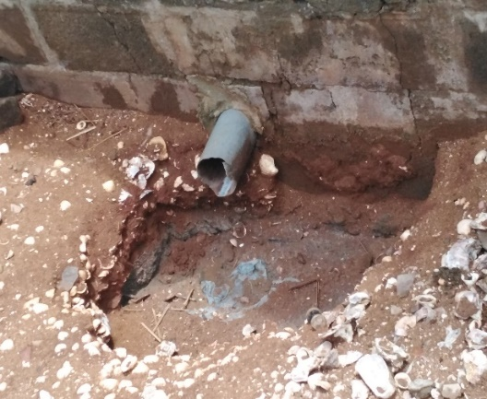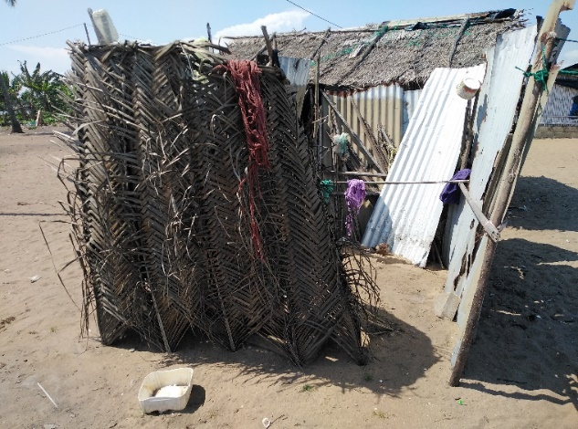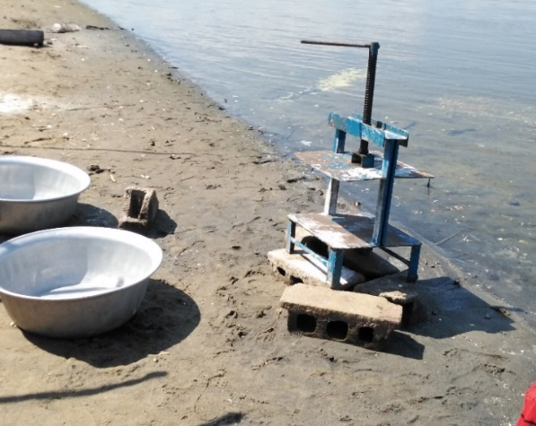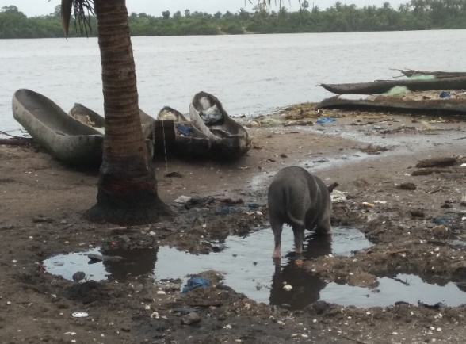

**Fig. 2.** **View of wastewater disposal methods in study area; A = discharge of attieké effluent into the lagoon at Groguida; B = discharge of shower wastewater at Lahou-Kpanda; C = shower placed on the sand at Groguida; D = stagnation and discharge of wastewater into the lagoon at Lahou-Kpanda.**

**3.3 Excreta management**

In the villages studied, modern latrines were found in 5%, 45%, 30%, and 60% of households in Groguida, Lipkilliassé, Lahou-Kpanda, and Braffedon, respectively (Figure 3; 4A). Furthermore, 10% of households in Braffédon used traditional latrines (Figure 3; 4B). It should be noted that the modern latrines built in the villages of Groguida, Likpilliassé and Lohou-Kpanda were equipped with permeable pits, which allow wastewater to seep into the ground. The households justified this choice on the grounds that their villages are located on the sandy coastal strip, which is only accessible via the lagoon. If the pits are impermeable, septic tank trucks cannot empty them once they are full. However, this situation can facilitate the contamination of shallow groundwater in these villages (Hounsinou *et al.,* 2015). In addition, 30 to 89% of households were found to practice open defecation in the bush in Braffedon or along the lagoon and sea in Groguida, Likpilliassé and Lahou-Kpanda.

In fact, some households prefer to relieve themselves near the sea or lagoon, despite the presence of latrines. These situations can be potential sources of pollution of the water table, the lagoon and even the sea (Rosillon *et al.,* 2012; Rajgire, 2013). They also contribute to environmental and livelihood degradation through the release of foul odours, the proliferation of mosquitoes and disease vectors, and the contamination of fish products (Dandabathula *et al.,* 2019).

Households using latrines report adding chemicals to their septic tanks to digest organic matter and reduce the volume of sludge when they are full, or emptying them either mechanically or manually. When the pits are emptied manually, the sludge is dumped into a hole dug near the pit in the yard or by the side of the road. If the pits are emptied mechanically, the sludge is dumped into the environment. All these practices are sources of pollution.

**Fig. 3. Household defecation sites in localities in study area.**

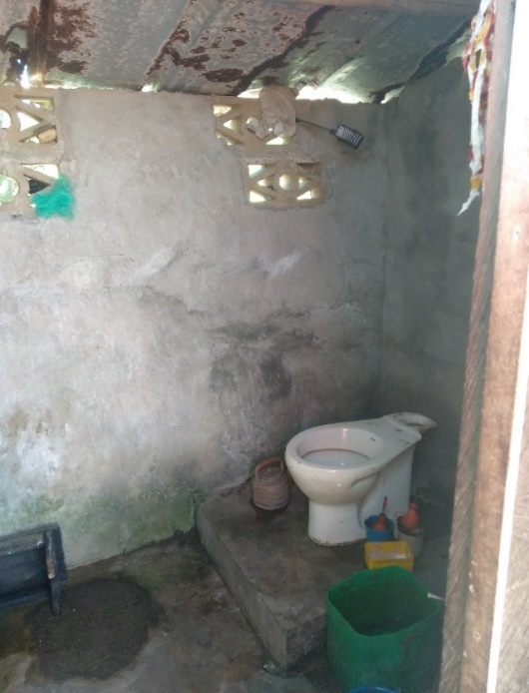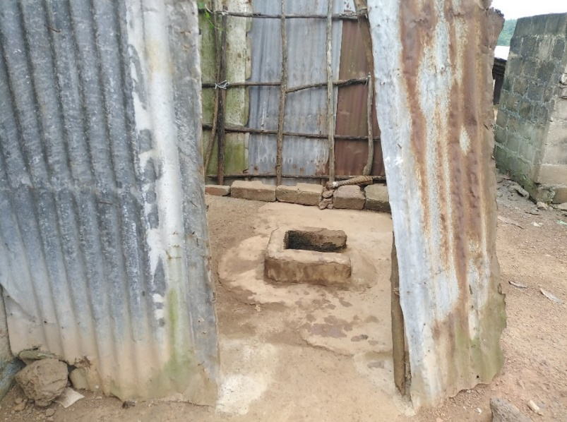

**Fig. 4. Overview of latrines used in the villages; A = modern latrine in Groguida and B = traditional latrine in Braffedon.**

**3.1.4 Rainwater drainage**

There are no rainwater drainage systems at villages studied (Table 3). During the rainy season, rainwater seeps into the sandy soil in the villages of Groguida, Likpilliassé and Lahou-Kpanda. As a result, these villages have problems with flooding due to rising water levels, especially in Lahou-Kpanda (70%) and sometimes in Groguida (40%) and Likpilliassé (35%), at the level of the houses on the edge of the lagoon. In Braffedon, on the other hand, the clayey-sandy nature of the soil does not allow for good rainwater infiltration. As a result, the village is constantly flooded during the rainy season (Table 3; Figure 5), forcing the young people of the village to organize themselves to dig pipes to drain the water into the bandama (Figure 6).

**Table 3. Presence of rainwater drainage systems and flooding in study area**

|  |  |  |  |  |  |  |
| --- | --- | --- | --- | --- | --- | --- |
|  |  | Groguida | | Lahou Kpanda | Lipkilliassé | Braffedon |
|  | **n=60** | | **n=70** | **n=60** | **n=100** |
| Presence of rainwater drainage systems | **Yes** | | 0% | 0% | 0% | 0% |
| **No** | | 100% | 100% | 100% | 100% |
| Presence of flooding | **Yes** | | 40% | 70% | 35% | 90% |
| **No** | | 60% | 30% | 65% | 10% |

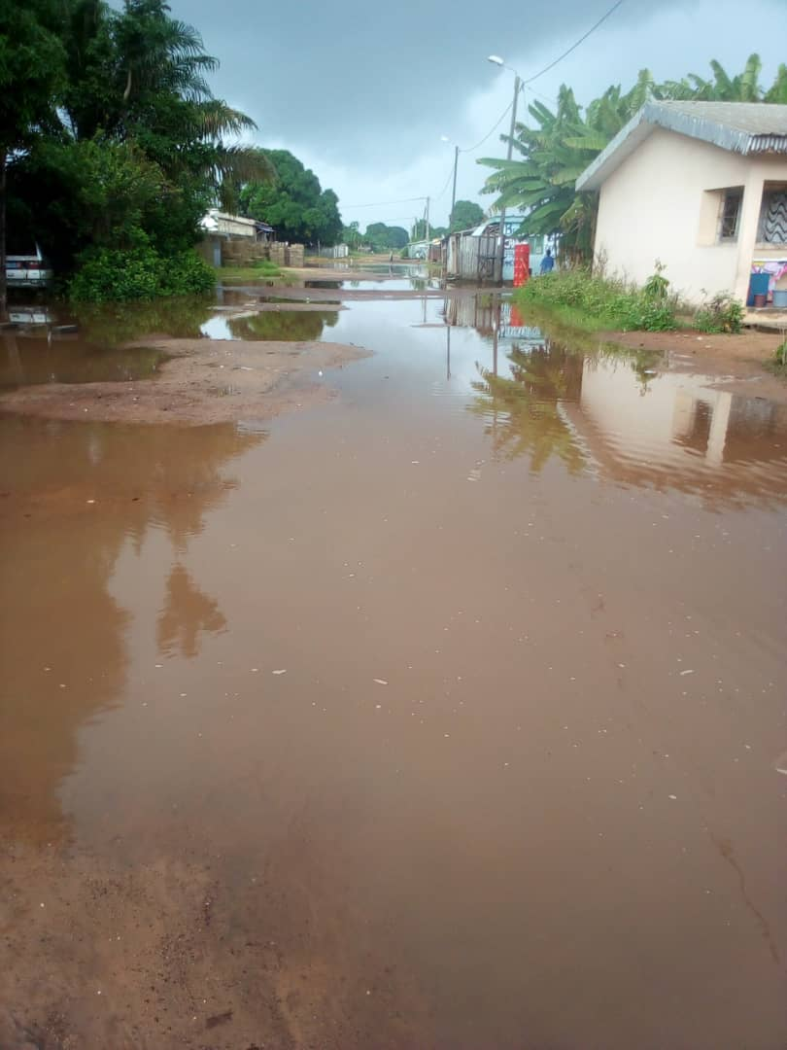 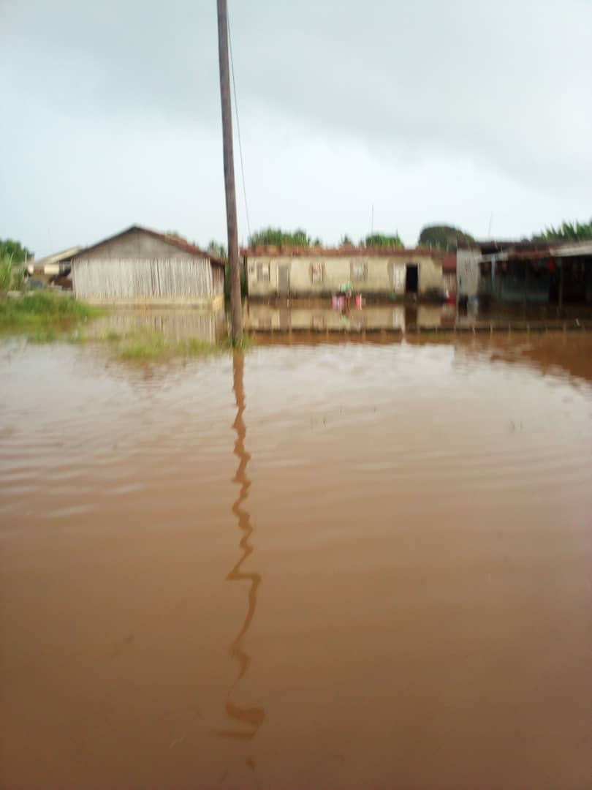

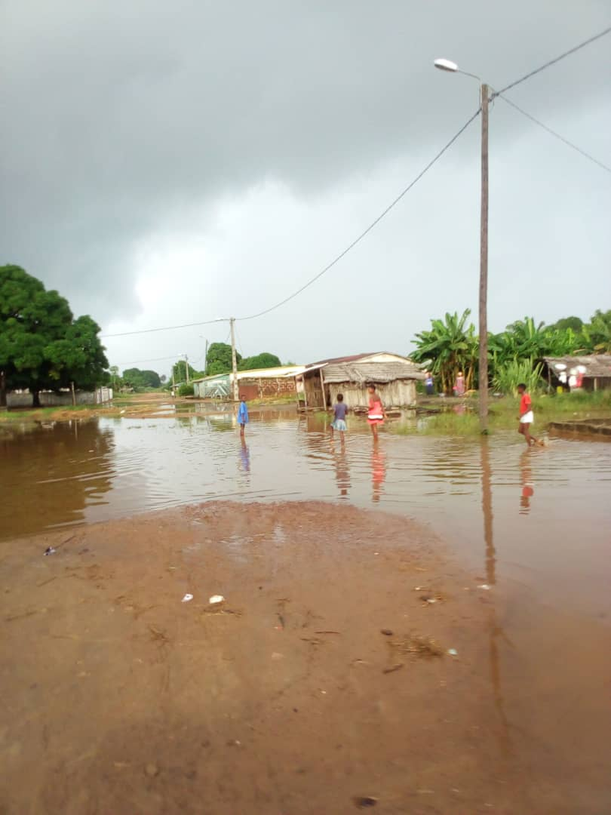 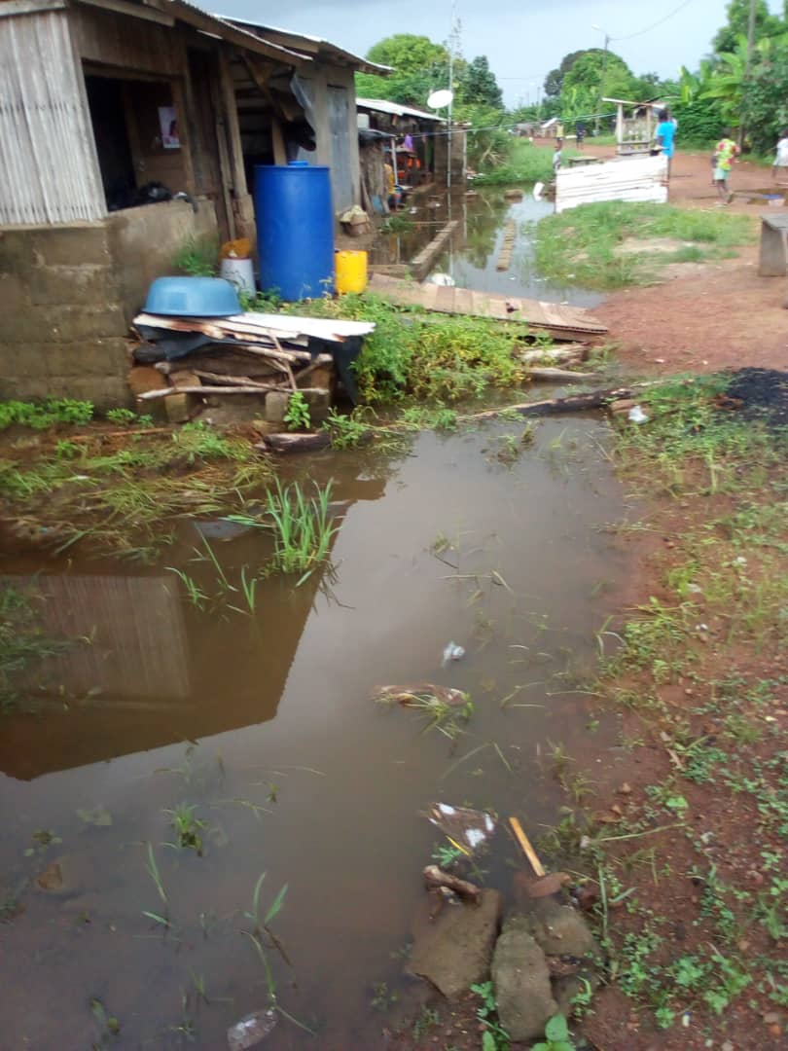

**Fig. 5. Flooding at Braffedon in June 2021.**

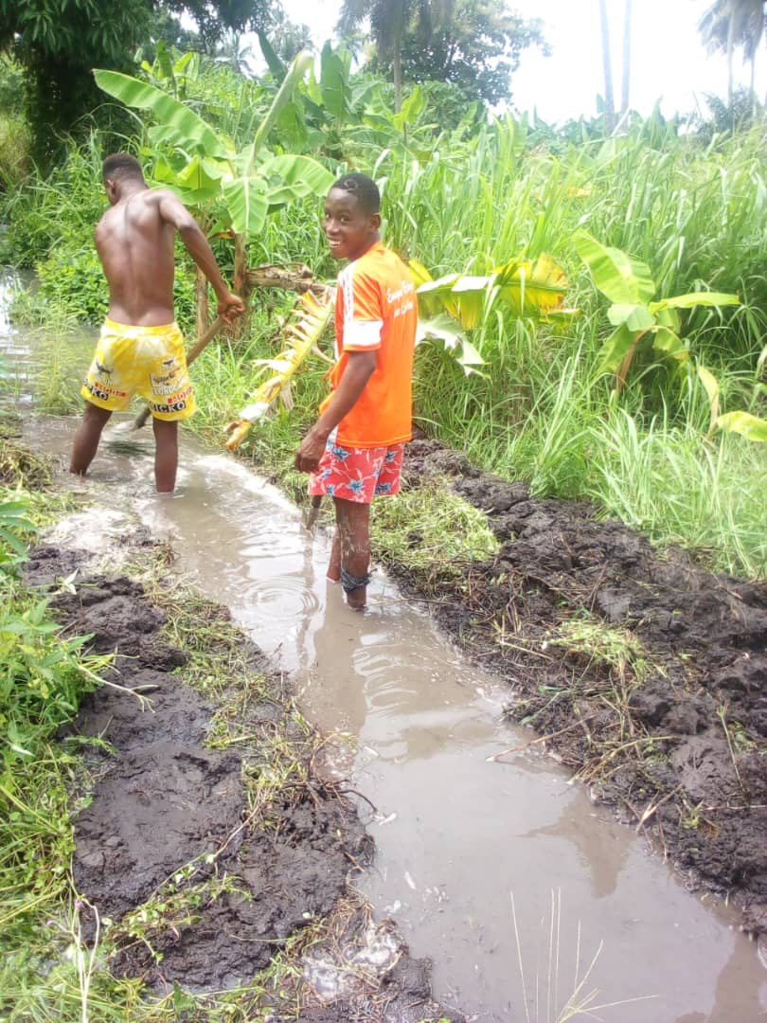 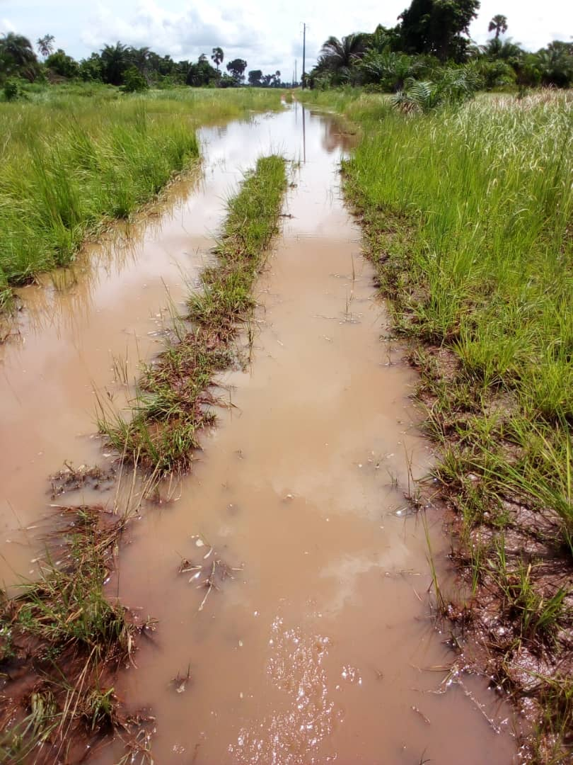

**Fig. 6. People opening pipes to evacuate Braffedon flooded (June 2021).**

4. Conclusion

This study analyzed wastewater and excreta management in the villages of Braffédon, Lahou-Kpanda, Groguida and Likpillassié on the Grand Lahou coast in southwest Côte d'Ivoire. The results showed that wastewater in the villages studied consisted of bathing (100%), laundry (83-98%), dishwashing (66.66-89%) and attiéké effluent (30-45%). These wastewaters are either discharged into septic tanks (15-25%) or directly into the sandy soil of the yard (25-40%), backyard (80-95%) or lagoon (15-65%). In terms of defecation facilities, modern latrines were recorded in 5%, 45%, 30% and 60% of households in the villages of Groguida, Lipkilliassé, Lahou-Kpanda and Braffedon respectively. 10% of households in Braffédon use traditional latrines. 30 to 89% of households in the villages defecate in the open, either in the bush in Braffedon or along the lagoon and sea (Groguida, Likpilliassé and Lahou-Kpanda). Households using latrines reported the addition of chemicals to septic tanks to digest organic matter and reduce the volume of sludge when they are full, or emptying them either mechanically or manually. When pits are emptied manually, the sludge was dumped into a hole dug near the pit in the yard or along the roadside. The four (4) villages surveyed had no rainwater drainage system. Flooding of homes is recorded during the rainy season.

Consent

All contributing authors read and approved the final manuscript for publication.

References

Adaye, K. A., Koffi, N. J. M. & Yeo, T. M. (2021). Household wastewater management: the case of the new city of Grand-Lahou (Côte d'Ivoire). International Journal of Educational Science and Technology, 15, 123-155.

African Union (2023). Concrete actions towards water security in Africa brought forward as the continent prepares its water investment action plan. https://au.int/en/pressreleases/20230918/concrete-actions-towards-water-security-africa-brought-forward-continent. Accessed 15 Feb 2025

Ballet, T. G. N., Yapo, O. B., Gnagne, A. E. J. E. Y., Effebi, K. R. & Aka, E. N. (2017). Socio-sanitary and environmental impact of the sanitation network dysfunctions on Niangon Nord and Toit Rouge populations (Yopougon, Abidjan). International Journal of Current Research, 9(10), 60012-60019

Black, R. E., Victora, C. G., Walker, S. P., Bhutta, Z. A., Christian, P., De Onis, M., Ezzati, M., Grantham-McGregor, S., Katz, J., Martorell, R. & Uauy, R., 2013. Maternal and child undernutrition and overweight in low-income and middle-income countries. Lancet 382 (9890), 427–451. https://doi.org/10.1016/S0140-6736(13)60937-X

Dandabathula, G., Pankaj B., Rutvik S., Mithilesh B., Peddineni P. R. & Chintala, S. R. (2019). Combating open defecation through community-led sanitation. Dr. Sulaiman Al Habib Medical Journal, 1(3-4), 45–51. https://doi.org/10.2991/dsahmj.k.190626.001

Dhaval, M., Priti, E., Amisha, D. & Hardik, C. (2023). Sampling Methods in Research: A Review. International Journal of Trends in Scientific Research and Development,7(3), 762-768.

Diaby, M., Agnissan J.-P. A., Kouassi, D. & N’da, K. (2022). Fishing Activity on Solomougou Dam Lake (Northern Côte d'Ivoire): Synthesis of Recent Data and Additional Information. Scholars Academic Journal of Biosciences, 10(6), 116-121. https://doi.org/10.36347/sajb.2022.v10i06.001

Eba, M.-L. B. (2020). Lagoon Insalubrity and Social Representations of Women Producers of “Attiéké” in the District of Abidjan (Côte d'Ivoire). European Scientific Journal, 16(11), 223. https://doi.org/10.19044/esj.2020.v16n11p223

Hounga, A., Alegbeh, E. S., Biga, A. & Sessi, S. (2015). Study of water-related diseases, hygiene, and sanitation and their impact on socioeconomic life: The case of the populations of Danyi Apeyeme in Togo. Journal of Scientific Research of the University of Lomé, Series B, 17(2), 111-121.

Hounsinou, P., Mama, D., Dovonou, F. & Alasane. A. (2015). Seasonal evolution of the microbiological quality of natural waters in the township of Abomey-Calavi (South Benin). British Journal of Earth Sciences Research, 3(1), 30-41.

Koffie-Bikpo, C. Y. (2006). Changes in hydrological conditions and evolution of fishing methods in the Grand-Lahou lagoon. CAMES Review - New Series B, 007, 2, 121-131.

Konan, K. S., Kouakou, K. L., Kouame K. I., Kouassi A. M. & Gnakri D. (2013). Hydrology and hydrochemistry of water in the construction area of ​​the Grand-Lahou fishing port channel, Ivory Coast. International Journal of Biological and Chemical Sciences, 7(2), 819-831. http://dx.doi.org/10.4314/ijbcs.v7i2.37]

Kouakou, P. K., Nindjin C., Kouassi B. K., Mobio J. A., Amanzou A. A. N. & Amani, G. N. (2023). Attiéké of the lagoons, Geographical origins of a local product in Côte d’Ivoire. Geotrop, 1, 59-68.

Obasola, K. E. (2013). Gender Discrimination and Cultural Anachronisms in African Societies: Implication for Girl Child Education. International Journal of Social Sciences and Education, 3(4), 1027-1034.

Omohwovo, E. J. (2024). Wastewater Management in Africa: Challenges and Recommendations. Environmental Health Insights, 18, 1-6. http://dx.doi.org/10.1177/11786302241289681

Rajgire, A. V. (2013). Open defecation: a prominent source of pollution in drinking water in villages. International Journal of Life Sciences Biotechnology and Pharma Research, 2, 2250–3137. http://dx.doi.org/10.1177/1178630217735539

Rosillon, F., Savadogo, B., Kabore A., Bado S. H. & Dianou D. (2012). Attempts to answer of the origin of the high nitrate concentrations in groundwater of the Sourou Valley in Burkina Faso. Journal of Water Resources and Protection, 4, 663-673. http://dx.doi.org/10.4236/Jwarp.2012.48077

Saad M. N. B., Kayanja G. W. & Ssevume S. M. (2024). Water and sanitation still major challenges in Africa, especially for rural and poor citizens. Afrobarometer Dispatch, 784, 1-24.

SODEXAM, (2018). Temperatures and rainfall data for the city of Grand-Lahou. SODEXAM Bulletin, Abidjan, Côte d’Ivoire, 1 p.

Soro, T. D., Soro, N., Oga, Y. M. S., Lasm, T., Soro, G., Ahoussi, K. E. & Biémi, J. (2011). Climate variability and its impact on water resources in the Grand-Lahou square degree (Southwest Côte d’Ivoire). Physio-Geo - Physical Geography and Environment, 5, 56-73.

Umesh, D, Bresee, J. S. & Glass, R.I. (2003). The global burden of diarrheal disease in children. Bulletin of the World Health Organization, 81(4), 236-7.

UNICEF-WHO (2009). Diarrhoea: Why children are still dying and what can be done. The United Nations Children’s Fund (UNICEF)/World Health Organization (WHO), Genève, 68 p.

United Nations (2023). 2023 Africa sustainable development report. accelerating recovery from the coronavirus disease (COVID-19) and the full implementation of the 2030 Agenda. African Union Commission, United Nations Economic Commission for Africa, and African Development Bank, 116 p.

USAID (2020). Municipal Water, Sanitation and Hygiene Project in West Africa (MUNIWASH). Quantified Needs Assessment Report—Côte d’Ivoire. https://pdf.usaid.gov/pdf_docs/PA00XD8R.pdf. Accessed 12 Sept 2024

Definitions, Acronyms, Abbreviations

**SODEXAM** : Société d’Exploitation et Développement Aéroportuaire

**UNICEF** : United Nations International Children's Emergency Fund

**USAID** : U.S. Agency for International Development

**WHO** : World Health Organization